Bethlehem Lutheran Church
Established 1874


Rev. Kerry B. Eversole, Pastor
Deacon Cindy Cordes-Eversole, Associate in Ministry

Mailing Address: P.O. Box 314, Lanesboro, MN 55949-0314
Physical Address: 200 Kenilworth Ave S, Lanesboro, Minn.

Telephone: 507.467.3344
E-mail Address: bethlehem@acegroup.cc
Website: www.staronthehill.com
Facebook Page: www.facebook.com/BethlehemLutheranLanesboro

Office Hours: Tuesday, Wednesday, Thursday 10 a.m. to 3 p.m.
Parsonage Phone: 507.467.3017
Pastor Kerry’s Cell Phone: 507.951.3954

Bethlehem Lutheran Church
Lanesboro, Minnesota

Fifth Sunday in Lent

March 26, 2023


Jesus said to [Martha], “I am the resurrection and the life. Those who believe in me, even though they die, will live, and everyone who lives and believes in me will never die. Do you believe this?” She said to him, “Yes, Lord, I believe that you are the Messiah, the Son of God, the one coming into the world.” John 11:25-27
Welcome to worship at Bethlehem Lutheran Church
and the season of Lent!
Lent is the forty-day period before Easter. It’s a time for reflection, penitence, and preparation for new life.

COVID-19 Practices — Out of love for God and Neighbor

1) Use hand sanitizer upon entry. Wash your hands and use hand sanitizer often while in the facility.
2) Members and visitors who are vaccinated and boosted are not required to wear a mask.
3) Members and visitors are free to wear a mask if they wish to do so.
4) Unvaccinated and not boosted members and visitors must wear a mask.
5) There are no physical distancing requirements, but you are welcome to keep a distance from others in the sanctuary as you are able.
6) All are welcome to enjoy coffee fellowship in the dining room following worship.

Worship Book and Hymns. This morning’s service is printed in this bulletin. Portions can also be found with all the hymns in Evangelical Lutheran Worship (ELW), “the red book” in the pews. Hymns in ELW are indicated by a large bold number in each page’s left or right margin.

Abbreviations. Hymns are signified throughout this worship folder by the pound symbol (#); Pastor: refers to the presiding minister or preacher; Reader: denotes an assisting minister; and People: or All: and/or bold text indicates the congregation.

Offering. Later in our service, we will be receiving an offering. The offering is an opportunity to worship God with our money. We know that the money you give to Bethlehem Lutheran Church represents your lives — your time, talents, and hard work. We recognize that and we appreciate your generosity. Your support not only helps all of us to fulfill God’s call on our lives, but it also makes an impact, and we thank you! Lastly, our visitors are not expected to give. After all, you are our guests! We’re glad you’re here and we want you to feel welcomed!

Mistakes do not happen in our worship service;
only unexpected events which are opportunities for joy!

An asterisk () signifies that you may stand, as you are comfortably able.

Gathering

The Holy Spirit calls us together as the people of God.

Introduction to the Season. On Ash Wednesday, we began the season of Lent and our annual baptismal journey with Jesus to his death on the cross and his glorious resurrection. The forty days of Lent are like no other. It is our opportune time to return to the God who rescues; to receive the gifts of God’s grace; to believe with the heart and confess with the mouth the wonder of God’s love in Jesus.

Introduction to the Day. In today’s gospel Jesus reveals his power over death by raising Lazarus from the dead. The prophet Ezekiel prophesies God breathing new life into dry bones. To those in exile or living in the shadows of death, these stories proclaim God’s promise of resurrection. In baptism we die with Christ that we might also be raised with him to new life. At the Easter Vigil we will welcome the newly baptized as we remember God’s unfailing promise in our baptism.

MUSIC AS WE COME TOGETHER

RINGING OF THE BELL, WELCOME, AND INTRODUCTION TO THE DAY

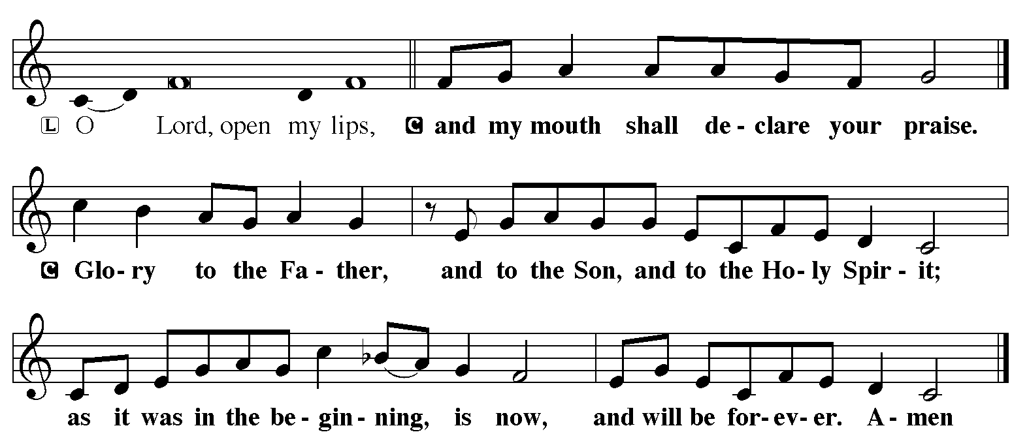DIALOGUE

SONG OF PRAISE Printed on the next page

L = Pastor Kerry C, I and II = All

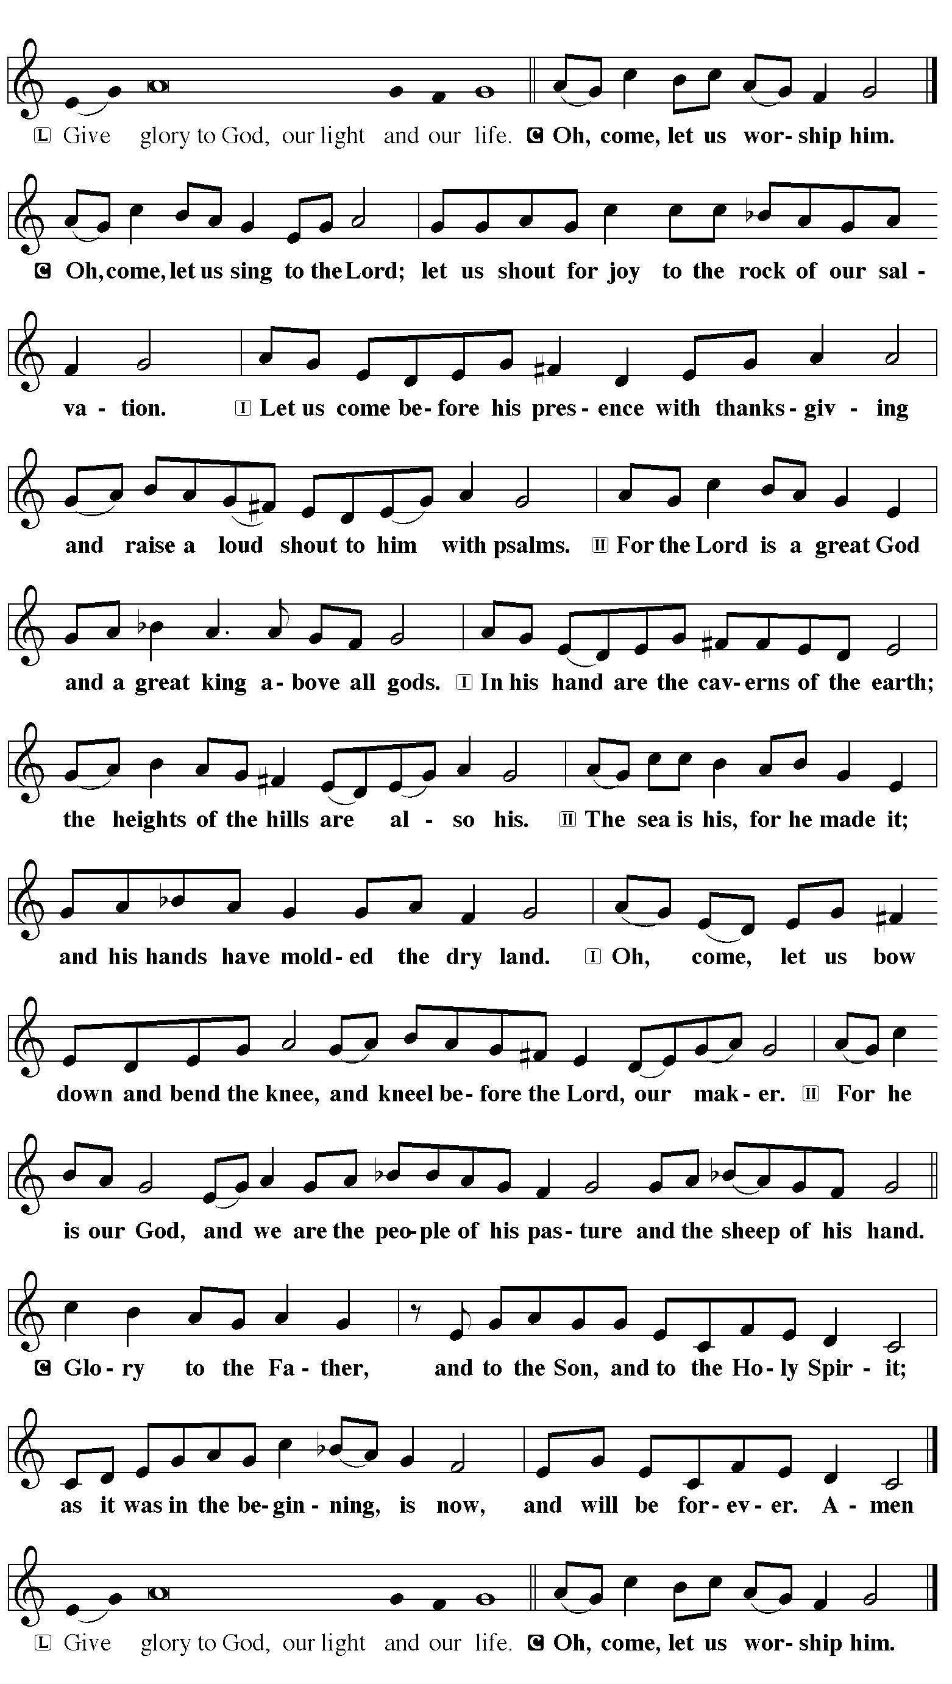SONG OF PRAISE based on Psalm 95

L = Pastor Kerry C, I and II = All

Continued on the next page.

OPENING HYMN Oh, for a Thousand Tongues to Sing ELW # 886

Stanzas, 1, 2, 3, 4 and 5

GREETING

Pastor: The grace of our Lord Jesus Christ, the love of God, and the communion of the Holy Spirit be with you all.

People: And also with you.

PRAYER OF THE DAY

Pastor: Let us pray together.

Almighty God, your Son came into the world to free us all from sin and death.

All: Breathe upon us the power of your Spirit, that we may be raised to new life in Christ and serve you in righteousness all our days, through Jesus Christ, our Savior and Lord, who lives and reigns with you and the Holy Spirit, one God, now and forever. Amen.

God’s Lenten Word

God speaks to us in scripture reading, preaching, and song.

FIRST READING Ezekiel 37:1-14

Ezekiel’s vision of the valley of dry bones is a promise that Israel as a nation, though dead in exile, will live again in their land through God’s life-giving spirit. Three times Israel is assured that through this vision they will know that “I am the Lord.”

¹The hand of the Lord came upon me, and he brought me out by the spirit of the Lord and set me down in the middle of a valley; it was full of bones. ²He led me all around them; there were very many lying in the valley, and they were very dry. ³He said to me, “Mortal, can these bones live?” I answered, “O Lord God, you know.” ⁴Then he said to me, “Prophesy to these bones, and say to them: O dry bones, hear the word of the Lord. ⁵Thus says the Lord God to these bones: I will cause breath to enter you, and you shall live. ⁶I will lay sinews on you, and will cause flesh to come upon you, and cover you with skin, and put breath in you, and you shall live; and you shall know that I am the lord.”
⁷So I prophesied as I had been commanded; and as I prophesied, suddenly there was a noise, a rattling, and the bones came together, bone to its bone. ⁸I looked, and there were sinews on them, and flesh had come upon them, and skin had covered them; but there was no breath in them. ⁹Then he said to me, “Prophesy to the breath, prophesy, mortal, and say to the breath: Thus says the Lord God: Come from the four winds, O breath, and breathe upon these slain, that they may live.” ¹⁰I prophesied as he commanded me, and the breath came into them, and they lived, and stood on their feet, a vast multitude.
¹¹Then he said to me, “Mortal, these bones are the whole house of Israel. They say, ‘Our bones are dried up, and our hope is lost; we are cut off completely.’ ¹²Therefore prophesy, and say to them, Thus says the Lord God: I am going to open your graves, and bring you up from your graves, O my people; and I will bring you back to the land of Israel. ¹³And you shall know that I am the Lord, when I open your graves, and bring you up from your graves, O my people. ¹⁴I will put my spirit within you, and you shall live, and I will place you on your own soil; then you shall know that I, the Lord, have spoken and will act, says the Lord.”

A: The word of the Lord.

C: Thanks be to God.

GOSPEL John 11:1-7, 11b-45

Pastor: Announcement of the Gospel.

People: Glory to you, O Lord.

Jesus is moved to sorrow when his friend Lazarus falls ill and dies. Then, in a dramatic scene, he calls his friend out of the tomb and restores him to life.

¹Now a certain man was ill, Lazarus of Bethany, the village of Mary and her sister Martha. ²Mary was the one who anointed the Lord with perfume and wiped his feet with her hair; her brother Lazarus was ill. ³So the sisters sent a message to Jesus, “Lord, he whom you love is ill.” ⁴But when Jesus heard it, he said, “This illness does not lead to death; rather it is for God’s glory, so that the Son of God may be glorified through it.” ⁵Accordingly, though Jesus loved Martha and her sister and Lazarus, ⁶after having heard that Lazarus was ill, he stayed two days longer in the place where he was.
⁷Then after this he said to the disciples, … ^{11b}“Our friend Lazarus has fallen asleep, but I am going there to awaken him.” ¹²The disciples said to him, “Lord, if he has fallen asleep, he will be all right.” ¹³Jesus, however, had been speaking about his death, but they thought that he was referring merely to sleep. ¹⁴Then Jesus told them plainly, “Lazarus is dead. ¹⁵For your sake I am glad I was not there, so that you may believe. But let us go to him.” ¹⁶Thomas, who was called the Twin, said to his fellow disciples, “Let us also go, that we may die with him.”
¹⁷When Jesus arrived, he found that Lazarus had already been in the tomb four days. ¹⁸Now Bethany was near Jerusalem, some two miles away, ¹⁹and many of the Jews had come to Martha and Mary to console them about their brother. ²⁰When Martha heard that Jesus was coming, she went and met him, while Mary stayed at home. ²¹Martha said to Jesus, “Lord, if you had been here, my brother would not have died. ²²But even now I know that God will give you whatever you ask of him.” ²³Jesus said to her, “Your brother will rise again.” ²⁴Martha said to him, “I know that he will rise again in the resurrection on the last day.” ²⁵Jesus said to her, “I am the resurrection and the life. Those who believe in me, even though they die, will live, ²⁶and everyone who lives and believes in me will never die. Do you believe this?” ²⁷She said to him, “Yes, Lord, I believe that you are the Messiah, the Son of God, the one coming into the world.”
²⁸When she had said this, she went back and called her sister Mary, and told her privately, “The Teacher is here and is calling for you.” ²⁹And when she heard it, she got up quickly and went to him. ³⁰Now Jesus had not yet come to

Continued on the next page.
the village, but was still at the place where Martha had met him. ³¹The Jews who were with her in the house, consoling her, saw Mary get up quickly and go out. They followed her because they thought that she was going to the tomb to weep there. ³²When Mary came where Jesus was and saw him, she knelt at his feet and said to him, “Lord, if you had been here, my brother would not have died.” ³³When Jesus saw her weeping, and the Jews who came with her also weeping, he was greatly disturbed in spirit and deeply moved. ³⁴He said, “Where have you laid him?” They said to him, “Lord, come and see.” ³⁵Jesus began to weep. ³⁶So the Jews said, “See how he loved him!” ³⁷But some of them said, “Could not he who opened the eyes of the blind man have kept this man from dying?”
³⁸Then Jesus, again greatly disturbed, came to the tomb. It was a cave, and a stone was lying against it. ³⁹Jesus said, “Take away the stone.” Martha, the sister of the dead man, said to him, “Lord, already there is a stench because he has been dead four days.” ⁴⁰Jesus said to her, “Did I not tell you that if you believed, you would see the glory of God?” ⁴¹So they took away the stone. And Jesus looked upward and said, “Father, I thank you for having heard me. ⁴²I knew that you always hear me, but I have said this for the sake of the crowd standing here, so that they may believe that you sent me.” ⁴³When he had said this, he cried with a loud voice, “Lazarus, come out!” ⁴⁴The dead man came out, his hands and feet bound with strips of cloth, and his face wrapped in a cloth. Jesus said to them, “Unbind him, and let him go.”
⁴⁵Many of the Jews therefore, who had come with Mary and had seen what Jesus did, believed in him.

Pastor: Affirmation of the Gospel.

People: Praise to you, O Christ.

GOSPEL HYMN You Are the Way ELW # 758

SERMON

HYMN OF THE DAY Restore in Us, O God ELW # 328

Responding to God’s Lenten Word

We act on God’s word for us.

OFFERING AND MUSIC

At this point in our service, we worship God with our money. The ushers will pass plates down the pews to receive your gifts of cash and checks made out to Bethlehem Lutheran Church. You can even give online at https://secure.myvanco.com/L-Z22R/. Your gifts support the worship, faith formation, administration, and other ministries of
Bethlehem Lutheran as well as the mission of the Southeastern Minnesota Synod, and the whole Evangelical Lutheran Church in America. Loose change goes to the Fillmore County Food Shelf in Preston. God bless your giving and your generosity. And thank you!

OFFERING SONG Create in Me a Clean Heart ELW # 186

PRAYERS OF GOD’S PEOPLE

Each petition ends with these words and response:

Pastor: Merciful God,

People: receive our prayer.

Concluding petition and response:

Pastor: We lift our prayers to you, O God, trusting in your steadfast love and your promise to renew your whole creation; through Jesus Christ our Savior.

People: Amen.

LORD’S PRAYER Traditional Wording

Pastor: Lord, remember us in your kingdom and teach us to pray.

All: Our Father, who art in heaven, hallowed be thy name, thy kingdom come, thy will be done, on earth as it is in heaven. Give us this day our daily bread; and forgive us our trespasses, as we forgive those who trespass against us; and lead us not into temptation, but deliver us from evil. For thine is the kingdom, and the power, and the glory, forever and ever. Amen.

Sending

God blesses us and sends us in mission to the world.

ANNOUNCEMENTS

BLESSING

Pastor: God, the giver of love, ☩ Christ, the resurrection and the life, and the Holy Spirit of rebirth bless you in this Lenten journey.

People: Amen.

CLOSING HYMN Let Us Ever Walk with Jesus ELW # 802

Stanzas 1, 3 and 4

DISMISSAL

Pastor: Go in peace. Serve in love.

People: Thanks be to God.

RINGING OF THE BELL

DEPARTING MUSIC

Commemorations

Wednesday, March 29, 2023

Hans Nielsen Hauge, renewer of the church, died 1824

Hans Nielsen Hauge was a layperson who began preaching about "the living faith" in Norway and Denmark after a mystical experience that he believed called him to share the assurance of salvation with others. At the time, itinerant preaching and religious gatherings held without the supervision of a pastor were illegal, and Hauge was arrested several times. He also faced great personal suffering: his first wife died and three of his four children died in infancy.
Some might remember Hauge during Lent by reading the lyrics or singing the Norwegian hymn "My heart is longing" (Lutheran Book of Worship 326), with its devotional response to the death of Christ.

Friday, March 31, 2023

John Donne, poet, died 1631

This priest of the Church of England is commemorated for his poetry and spiritual writing. Most of his poetry was written before his ordination and is sacred and secular, intellectual and sensuous. He saw in his wife, Anne--their marriage resulted in his imprisonment--glimpses of the glory of God and a human revelation of divine love. In 1615 he was ordained and seven years later he was named dean of St. Paul's Cathedral in London. By that time his reputation as a preacher was firmly in place.
In his poem "Good 1613. Riding westward," he speaks of Jesus' death on the cross: "Who sees God's face, that is self life, must die; What a death were it then to see God die?"

Today’s Assistants and Ministers

Greeters & Ushers ……………..……….…… Mark & Pam Ruen, Phil & Kathie Rogers, and
Theodore Pruett
Pianist ………………………….…………........……...…...………………..…… Sharon Boyum
Presiding Minister …………………...................................…………… Pastor Kerry Eversole
Reader ………………………………………..………………...…….……………. Andrew Pruett
Altar Care …..............................................................…….. Pastor Kerry and Deacon Cindy
Refreshments ……………....…..… Lois Peterson, Mavis Musselman, and Joan Groszbach
Custodian ………………………………………………………..…………….. Wayne Lukkason

Presence Last Week and February Presents

Attendance Sunday, March 19 = 48
Average Sunday Worship Attendance for February = 48

February Contributions: General Fund = $11,369 Designated Giving = $1,630
Jan-Feb Income = $22,509 Jan-Feb Expenses = $28,621 Deficit = $6,112

This Week in Our Congregation

Today, March 26 — Fifth Sunday in Lent

Sunday School after the children’s message
Refreshments in the Fellowship Hall for everyone following worship
7th & 8th Grade Confirmation Session 10:15 AM

Tuesday, March 28

Men’s breakfast at Home Sweet Home, Lanesboro 7:00 AM
LYO takes out trash at Kenilworth & Sylvan Manor afternoon or evening

Wednesday, March 29

Midweek Lenten Worship Light Supper 6:00 PM
Service and live stream 7:00 PM

Next Sunday, April 2 — Palm Sunday/Sunday of the Passion

Worship, NO Communion 9:00 AM
7th & 8th Grade Confirmation Session 10:15 AM

News and Notes

Join us for Lenten supper at 6 pm, followed by our Amazing Grace Lenten series based on the beloved song that celebrates its 250th anniversary this year! Service is at 7 pm. Or view the live stream at 7 pm. In this week’s service, we marvel at the story of amazing grace in the life of Paul, who turned from persecutor of Christ to proclaimer of our Lord through the mighty power of the Holy Spirit. In the same way, cross of Christ changes us all from enemy to friend. See the insert for a detailed description of the series and each week’s Bible figure focus.

Good Earth Village Early Bird registration deadline for summer camp is Sunday, April 2. Receive 10 percent off the cost of camp plus a free t-shirt. Our congregation and the WELCA will provide financial assistance to our members who attend.

Andrew, JoAnna and Theodore Pruett have eggs for sale! $6 per dozen. $3 will be donated to the church. See them after worship to purchase what they’ve brought or to place an order. Andrew’s cell: 507-993-8069. E-mail: pruettfamily2011@gmail.com.

2023 Root River Conference WELCA Spring Gathering, Saturday, April 15, North Prairie Lutheran Church, rural Lanesboro. Registration and Coffee fellowship 8 am. Program 9 am. Lunch 12:30 pm and wrap up. $10 registration fee includes coffee, program, and lunch. Sign up by Sunday, March 26.

Prayer Requests

In Our Community. For our church members and friends living with chronic illness and other diseases, who are homebound, residing in care facilities, and hospitalized. See the newsletter for our members living in area nursing homes. And let us not forget those sick and dying of COVID-19, those entrusted with the authority of government, justice, and law enforcement, as well as our fallen and wounded soldiers and those still serving.

In Our Synod. Bishop Regina Hassanally invites the people and congregations of our Southeastern Minnesota Synod to make a commitment to pray this week for the following faith communities: Union Prairie Lutheran Church, Lanesboro; East St. Olaf Lutheran Church, Byron; Evanger Lutheran Church, Dexter; LeRoy Lutheran Church, LeRoy; Mampanta Lutheran Church, Tanzania; and Choma Lutheran Church, Tanzania.

Community Activities

Lanesboro Area Community Foundation Annual Banquet, Sunday, April 2, from 5 to 8 pm, at the Lanesboro Community Hall. $50 per person. Keynote speaker is Al Batt. Music by Sarah Peterson. Dinner Catered by the Lanesboro Pastry Shoppe. Dessert by Home Sweet Home Café & Cakery. Tickets available at Granny’s Liquor and Merchant’s Bank, or call Andrea Miehlisch at 507-696-5500.

Acknowledgments

Graphics, worship texts, service music, readings, and commemorations are from sundaysandseasons.com © 2023 Augsburg Fortress. Used by permission under Augsburg Fortress Liturgies Annual License SAS103296.

Permission to project, live stream, or podcast liturgy and music content under copyright to or administered by Augsburg Fortress provided under Augsburg Fortress Liturgies Annual License SAS103296.

Permission to Podcast / Stream provided by One License, Inc., under License # A-735588. An additional fee was paid. www.onelicense.net.

