Bethlehem Lutheran Church
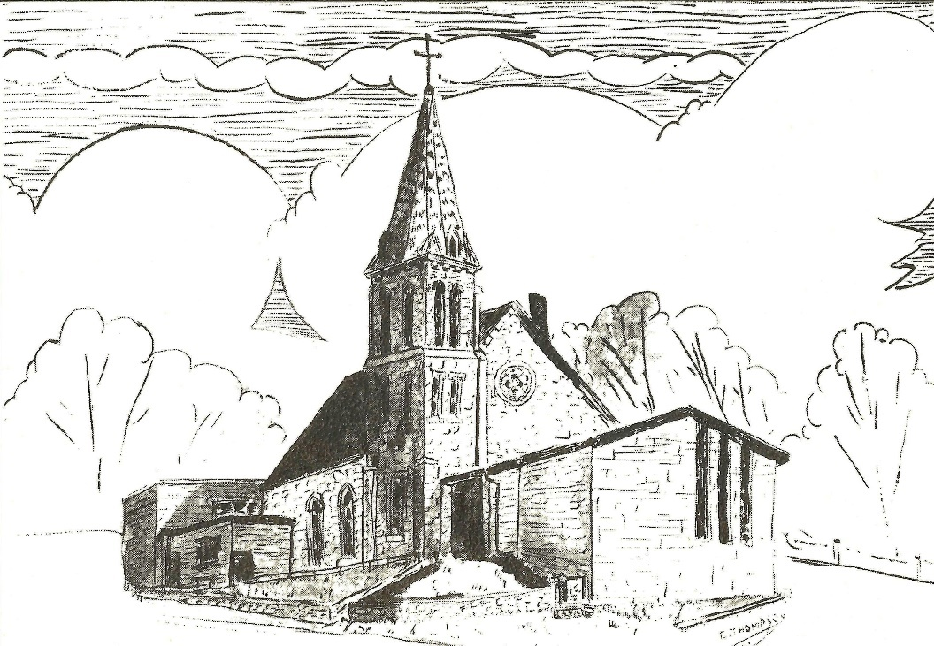Established 1874

Rev. Kerry B. Eversole, Pastor
Deacon Cindy Cordes-Eversole, Associate in Ministry

Mailing Address: P.O. Box 314, Lanesboro, MN 55949-0314
Physical Address: 200 Kenilworth Ave S, Lanesboro, Minn.

Telephone: 507.467.3344
E-mail Address: bethlehem@acegroup.cc
Website: www.staronthehill.com
Facebook Page: www.facebook.com/BethlehemLutheranLanesboro

Office Hours: Tuesday, Wednesday, Thursday 10 a.m. to 3 p.m.
Parsonage Phone: 507.467.3017
Pastor Kerry’s Cell Phone: 507.951.3954

Bethlehem Lutheran Church
Lanesboro, Minnesota

Transfiguration of Our Lord
Last Sunday after Epiphany

February 19, 2023

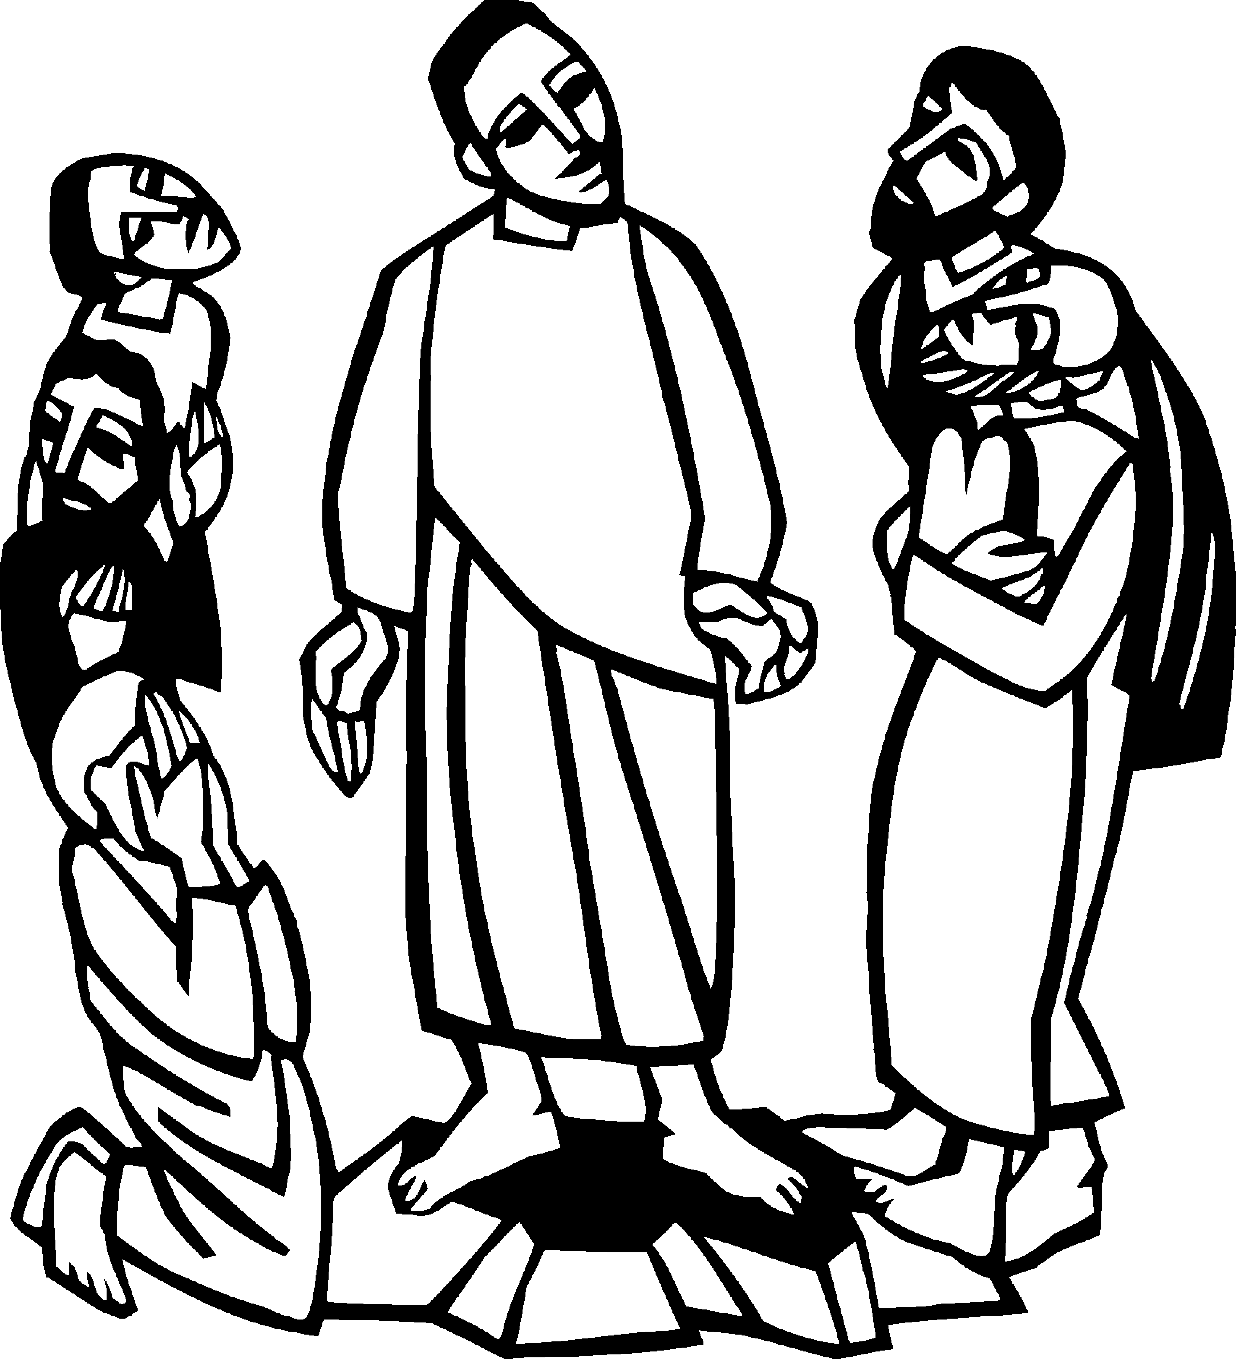
Jesus took with him Peter and James and his brother John and led them up a high mountain, by themselves. And he was transfigured before them, and his face shone like the sun, and his clothes became dazzling white. Suddenly there appeared to them Moses and Elijah, talking with him.
Matthew 17:1-3
Welcome to worship at Bethlehem Lutheran Church!
We are “The star on the hill”
“You are the light of the world…let your light shine!”
Matthew 5:14-16

COVID-19 Practices — Out of love for God and Neighbor

1) Use hand sanitizer upon entry. Wash your hands and use hand sanitizer often while in the facility.
2) Members and visitors who are vaccinated and boosted are not required to wear a mask.
3) Members and visitors are free to wear a mask if they wish to do so.
4) Unvaccinated and not boosted members and visitors must wear a mask.
5) There are no physical distancing requirements, but you are welcome to keep a distance from others in the sanctuary as you are able.
6) All are welcome to enjoy coffee fellowship in the dining room following worship.

Worship Book and Hymns. This morning’s service is printed in this bulletin and can also be found with all the hymns in Evangelical Lutheran Worship (ELW), “the red book” in the pews. Hymns in ELW are indicated by a large bold number in each page’s left or right margin.

Abbreviations. Hymns are signified throughout this worship folder by the pound symbol (#); P: refers to the presiding minister or preacher; A: denotes an assisting minister; and C: and/or bold text indicates the congregation.

Offering. Later in our service, we will be receiving an offering. The offering is an opportunity to worship God with our money. We know that the money you give to Bethlehem Lutheran Church represents your lives — your time, talents, and hard work. We recognize that and we appreciate your generosity. Your support not only helps all of us to fulfill God’s call on our lives, but it also makes an impact, and we thank you! Lastly, our visitors are not expected to give. After all, you are our guests! We’re glad you’re here and we want you to feel welcomed!

Mistakes do not happen in our worship service;
only unexpected events which are opportunities for joy!

An asterisk () signifies that you may stand, as you are comfortably able.

Gathering

The Holy Spirit calls us together as the people of God.

Introduction to the Day. Today’s festival is a bridge between the Advent-Christmas-Epiphany cycle that comes to a close today and the Lent-Easter cycle that begins in a few days. Today, on a high mountain Jesus is revealed as God’s beloved Son, echoing the words at his baptism. This vision of glory sustains us as Jesus faces his impending death in Jerusalem. We turn this week to Ash Wednesday and our yearly baptismal journey with Jesus to the cross and his resurrection on Easter.

PRELUDE

RINGING OF THE BELL

WELCOME AND INTRODUCTION TO THE DAY

CONFESSION AND FORGIVENESS

All may make the sign of the cross, the sign that is marked at baptism, as the presiding minister begins.

P: Blessed be the holy Trinity, ☩ one God, who makes all things new,
whose mercy endures forever.

C: Amen.

P: Trusting in God’s mercy, let us confess our sin.

Silence is kept for reflection.

P: Holy One, source of our renewal,

All: we confess that we are wrapped up in sin, and cannot free ourselves. We have not practiced your righteousness. Our hearts have turned away from you. For the sake of the world you so love, forgive us, that we may be reconciled to one another for the glory of your holy name. Amen.

P: Thus says our God: “The former things have come to pass and new things I now declare.” God’s mercy makes us new. We are forgiven in the name of ☩ Jesus our Savior.

C: Thanks be to God.

OPENING HYMN Immortal, Invisible, God Only Wise ELW # 834

Stanzas 1, 3 and 4

GREETING ELW p. 213

P: The grace of our Lord Jesus Christ, the love of God, and the communion of the Holy Spirit be with you all.

C: And also with you.

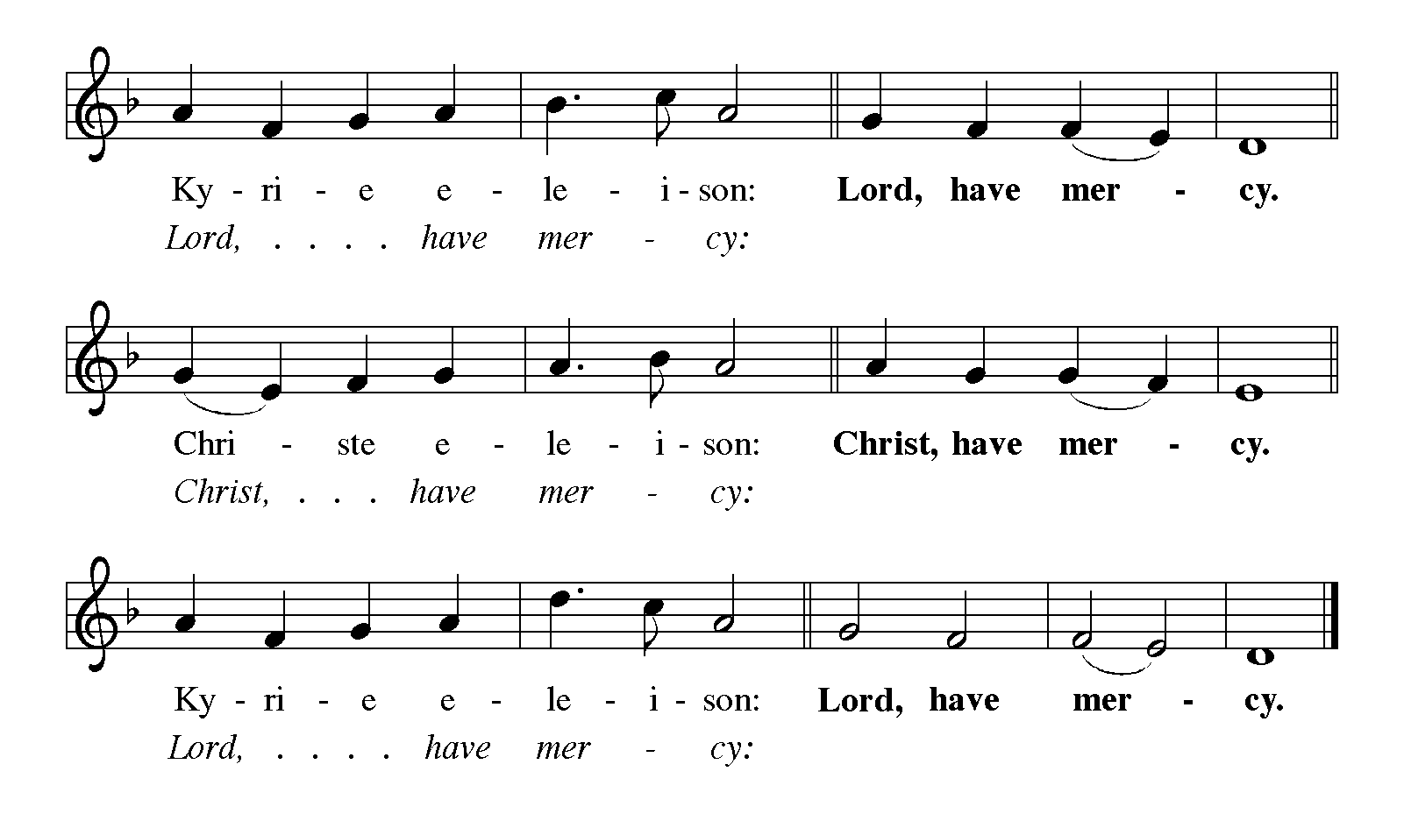KYRIE ELW p. 213

CANTICLE OF PRAISE Glory to God ELW p. 213

Printed on the next page.

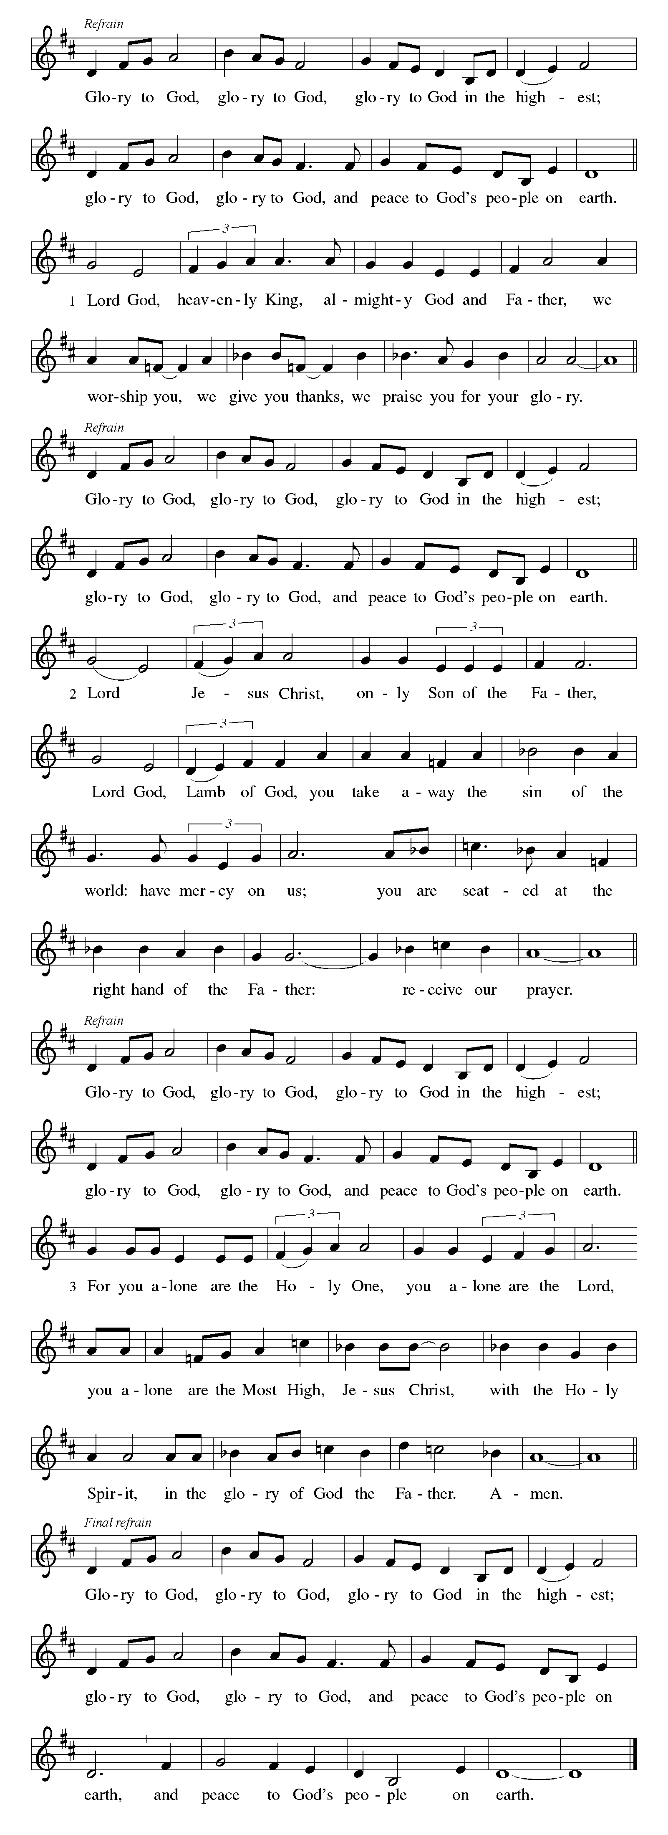CANTICLE OF PRAISE ELW pp. 213-214

Continued on the next page.

CANTICLE OF PRAISE concluded ELW pp. 214-215

Continued on the next page.

CANTICLE OF PRAISE concluded ELW p. 215

PRAYER OF THE DAY

P: O God, in the transfiguration of your Son you confirmed the mysteries of the faith by the witness of Moses and Elijah, and in the voice from the bright cloud declaring Jesus your beloved Son, you foreshadowed our adoption as your children. Make us heirs with Christ of your glory, and bring us to enjoy its fullness, through Jesus Christ, our Savior and Lord, who lives and reigns with you and the Holy Spirit, one God, now and forever.

C: Amen.

Word

God speaks to us in scripture reading, preaching, and song.

FIRST READING Exodus 24:12-18

At Mount Sinai, Moses experienced the presence of God for forty days and forty nights. The “glory of the Lord settled on the mountain, and on the seventh day God called out to Moses. On the mountain, God gave Moses the stone tablets inscribed with the ten commandments.

¹²The Lord said to Moses, “Come up to me on the mountain, and wait there; and I will give you the tablets of stone, with the law and the commandment, which I have written for their instruction.” ¹³So Moses set out with his assistant Joshua, and Moses went up into the mountain of God. ¹⁴To the elders he had said, “Wait here for us, until we come to you again; for Aaron and Hur are with you; whoever has a dispute may go to them.”
¹⁵Then Moses went up on the mountain, and the cloud covered the mountain. ¹⁶The glory of the Lord settled on Mount Sinai, and the cloud covered it for six days; on the seventh day he called to Moses out of the cloud. ¹⁷Now the appearance of the glory of the Lord was like a devouring fire on the top of the mountain in the sight of the people of Israel. ¹⁸Moses entered the cloud, and went up on the mountain. Moses was on the mountain for forty days and forty nights.

A: The word of the Lord.

C: Thanks be to God.

SECOND READING 2 Peter 1:16-21

At the transfiguration, God’s voice was heard, declaring Jesus to be the beloved Son. By the activity of the Holy Spirit, God’s voice continues to be heard through the word of scripture.

¹⁶For we did not follow cleverly devised myths when we made known to you the power and coming of our Lord Jesus Christ, but we had been eyewitnesses of his majesty. ¹⁷For he received honor and glory from God the Father when that voice was conveyed to him by the Majestic Glory, saying, “This is my Son, my Beloved, with whom I am well pleased.” ¹⁸We ourselves heard this voice come from heaven, while we were with him on the holy mountain.
¹⁹So we have the prophetic message more fully confirmed. You will do well to be attentive to this as to a lamp shining in a dark place, until the day dawns and

Continued on the next page.
the morning star rises in your hearts. ²⁰First of all you must understand this, that no prophecy of scripture is a matter of one’s own interpretation, ²¹because no prophecy ever came by human will, but men and women moved by the Holy Spirit spoke from God.

A: The word of the Lord.

C: Thanks be to God.

GOSPEL ACCLAMATION Alleluia ELW p. 216

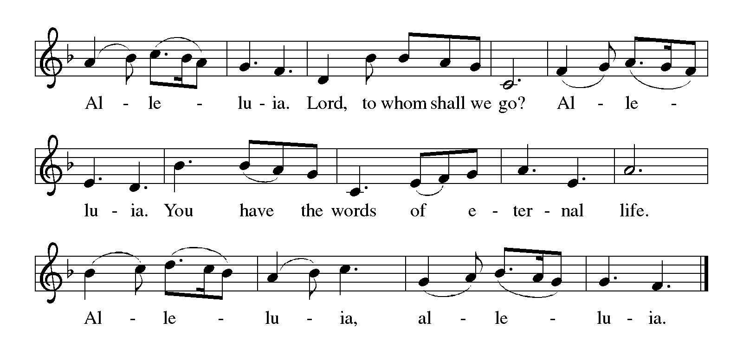

GOSPEL Matthew 17:1-9

P: The Holy Gospel according to Matthew.

C: Glory to you, O Lord.

Shortly before Jesus enters Jerusalem, where he will be crucified, he is revealed to Peter, James, and John in a mountaintop experience of divine glory called the transfiguration.

¹Jesus took with him Peter and James and his brother John and led them up a high mountain, by themselves. ²And he was transfigured before them, and his face shone like the sun, and his clothes became dazzling white. ³Suddenly there appeared to them Moses and Elijah, talking with him. ⁴Then Peter said to

Continued on the next page.

Jesus, “Lord, it is good for us to be here; if you wish, I will make three dwellings here, one for you, one for Moses, and one for Elijah.” ⁵While he was still speaking, suddenly a bright cloud overshadowed them, and from the cloud a voice said, “This is my Son, the Beloved; with him I am well pleased; listen to him!” ⁶When the disciples heard this, they fell to the ground and were overcome by fear. ⁷But Jesus came and touched them, saying, “Get up and do not be afraid.” ⁸And when they looked up, they saw no one except Jesus himself alone.
⁹As they were coming down the mountain, Jesus ordered them, “Tell no one about the vision until after the Son of Man has been raised from the dead.”
found alone. And they kept silent and in those days told no one any of the things they had seen.

P: The gospel of our Lord.

C: Praise to you, O Christ.

GOSPEL HYMN How Good, Lord, to be Here! ELW # 315

Stanzas 1, 2, 3 and 5

SERMON

HYMN OF THE DAY Shine, Jesus, Shine ELW # 671

PRAYERS OF INTERCESSION

Each petition ends with these words and response:

P: Merciful God,

C: receive our prayer.

Concluding petition and response:

P: We bring to you our needs and hopes, O God, trusting your wisdom and power revealed in Christ crucified.

C: Amen.

Thanksgiving

We show our gratitude for God’s word.

OFFERING Music by Sharon Boyum

CANTICLE OF THANKSGIVING ELW # 815

I Want to Walk as a Child of the Light

THANKSGIVING FOR THE WORD ELW p. 220

P: Praise and thanks to you, holy God, for by your Word you made all things: you spoke light into darkness, called forth beauty from chaos, and brought life into being. For your Word of life, O God,

C: we give you thanks and praise.

P: By your Word you called your people Israel to tell of your wonderful gifts: freedom from captivity, water on the desert journey, a pathway home from exile, wisdom for life with you. For your Word of life, O God,

C: we give you thanks and praise.

P: Through Jesus, your Word made flesh, you speak to us and call us to witness: forgiveness through the cross, life to those entombed by death, the way of your self-giving love. For your Word of life, O God,

C: we give you thanks and praise.

P: Send your Spirit of truth, O God; rekindle your gifts within us: renew our faith, increase our hope, and deepen our love, for the sake of a world in need. Faithful to your Word, O God, draw near to all who call on you; through Jesus Christ, our Savior and Lord, to whom, with you and the Holy Spirit, be honor and glory forever.

C: Amen.

LORD’S PRAYER Traditional Wording ELW p. 221

P: Gathered into one by the Holy Spirit, let us pray as Jesus taught us.

All: Our Father, who art in heaven, hallowed be thy name, thy kingdom come, thy will be done, on earth as it is in heaven. Give us this day our daily bread; and forgive us our trespasses, as we forgive those who trespass against us; and lead us not into temptation, but deliver us from evil. For thine is the kingdom, and the power, and the glory, forever and ever. Amen.
Sending

God blesses us and sends us in mission to the world.

ANNOUNCEMENTS

BLESSING

P: The God who faithfully brings forth justice
and breaks the oppressor’s rod
☩ bless, strengthen, and uphold you,
today and always.

C: Amen.

DEPARTING HYMN Alleluia, Song of Gladness ELW # 318

With the conclusion of today’s service, we say farewell to the Alleluia.
This word of joy will be put aside during the penitential season of Lent and will
be sung again at Easter. Our closing hymn, Alleluia, Song of Gladness, is a tribute
to this acclamation in the church’s worship life.

DISMISSAL

P: Go in peace. Follow the way of Jesus.

C: Thanks be to God.

RINGING OF THE BELL

POSTLUDE





Today’s Assistants and Ministers

Greeters & Ushers …………………………....….……..……… Tim & Jody and Lynsey Ruen
Pianist ………………………………...…………....….……………………..…… Sharon Boyum
Presiding Minister ……………………………….........…….…………… Pastor Kerry Eversole
Reader ……………………………………….……………..…...…….……………. Charles Ruen
Altar Care ………………………………...…….....………….. Pastor Kerry and Deacon Cindy
Refreshments ……………........……… Chris Olson, Judy Kingsbury, and Tim & Jody Ruen

Presence Last Week and January Presents

Attendance Sunday, February 12 = 59
Average Sunday Worship Attendance for January = 45

January Contributions: General Fund = $ Designated Giving = $260
Jan Income = $11,140 Jan Expenses = $14,699 Deficit = $3,559

This Week in Our Congregation

Today, February 19 — Transfiguration of Our Lord — Last Sunday after Epiphany

Sunday School after the children’s message
Refreshments in the Fellowship Hall for everyone following worship
7th & 8th Grade Confirmation Session 10:15 AM
Root River Conference Assembly, First Lutheran Church, Mabel 2:00 PM

Tuesday, February 21

Men’s breakfast at Home Sweet Home, Lanesboro 7:00 AM
LYO takes out trash at Kenilworth & Sylvan Manor afternoon or evening

Wednesday, February 22 — Ash Wednesday

WELCA Bible Study in the Fellowship Hall, men are welcome! 9:00 AM
Deacon Cindy at Harmony Care Center, Harmony, for chapel 2:00 PM
Worship with Imposition of Ashes and Holy Communion 7:00 PM

Next Sunday, February 26 — First Sunday in Lent

Worship with Hymn Sing, come with some favorites in mind 9:00 AM
Sunday School after the children’s message
7th & 8th Grade Confirmation Session 10:15 AM

News and Notes

Root River Conference Assembly, today, 2:00 p.m., at Mabel First Lutheran Church. Bob & Phyllis Penheiter are Bethlehem’s voting members, but we can have up to 4 more. Contact Pastor Kerry if you would like to attend.

The season of Lent begins this Wednesday, February 22, with the liturgy for Ash Wednesday. Service time is 7:00 p.m. Join us for our Amazing Grace Lenten series based on the beloved song that celebrates its 250th anniversary this year. In our Ash Wednesday service, which will include the Imposition of Ashes and Holy Communion, we will focus on the amazing grace of God King David experienced when he confessed his sins and was forgiven. We experience that same amazing grace of God in confession and forgiveness this Lent as we look toward the cross of Christ that made our freedom from sin possible. See the insert for a detailed description of the series and each week’s focus.

Let’s revive light meals before our midweek Lenten services! Volunteers are needed for five Wednesday evenings beginning March 1. Signup on the sheets located in the Fellowship Hall. If all five slots cannot be filled, there will be no suppers only services.

Prayer Requests

In Our Community. For our church members and friends living with chronic illness and other diseases, who are homebound, residing in care facilities, and hospitalized. See the newsletter for our members living in area nursing homes. And let us not forget those sick and dying of COVID-19, those entrusted with the authority of government, justice, and law enforcement, as well as our fallen and wounded soldiers and those still serving.

In Our Synod. Bishop Regina Hassanally invites the people and congregations of our Southeastern Minnesota Synod to make a commitment to pray this week for the following faith communities: Stordahl Lutheran Church, Zumbrota; Grace Lutheran Church, Austin; St. Paul ELCA/UCC Church, Lewiston; Kinambeu Lutheran Church, Tanzania; Itigi Lutheran Church, Tanzania; and Solo Por Fe Lutheran Church, Colombia.

Community Activities

Red Cross Blood Drive, Wednesday, March 8, from 12 noon to 6 pm, in the Lanesboro Community Center. You can schedule an appointment at www.redcross.org or by calling Kathryn Wade (507-272-6864) or Gwen Harmon (507-272-3136). Bring your donor card or a photo ID. You must be at least 16 years old. Youths under the age of 18 need a signed parental consent form, which will be available at the Community Center.

Acknowledgments

Graphics, worship texts, prayers, and readings are from sundaysandseasons.com © 2023 Augsburg Fortress. Used by permission under Augsburg Fortress Liturgies Annual License SAS103296.

Permission to project, live stream, or podcast liturgy and music content under copyright to or administered by Augsburg Fortress provided under Augsburg Fortress Liturgies Annual License SAS103296.

Permission to Podcast / Stream provided by One License, Inc., under License # A-735588. An additional fee was paid. www.onelicense.net.

Mayo Clinic Hospice is seeking compassionate and caring volunteers to support the hospice philosophy of care and mission. The role of a Mayo Clinic Hospice Volunteer is very dynamic and will utilize your interests, hobbies, passions, and skills. Volunteers assist with administrative tasks, provide supportive companionship to patients, and grief support. We also welcome registered pet therapy teams. If you are interested or would like to learn more about all the exciting and diverse volunteer opportunities Mayo Clinic Hospice has to offer, please contact Amy Stelpflug or Pam Roe, Volunteer Coordinators at mchospicevolteam@mayo.edu or 507-284-4002. Please visit https://volunteer.mayoclinic.org/ for more information and to submit an application.

