Bethlehem Lutheran Church
Established 1874

Rev. Kerry B. Eversole, Pastor
Deacon Cindy Cordes-Eversole, Associate in Ministry

Mailing Address: P.O. Box 314, Lanesboro, MN 55949-0314
Physical Address: 200 Kenilworth Ave S, Lanesboro, Minn.

Telephone: 507.467.3344
E-mail Address: bethlehem@acegroup.cc
Website: www.staronthehill.com
Facebook Page: www.facebook.com/BethlehemLutheranLanesboro

Office Hours: Tuesday, Wednesday, Thursday 10 a.m. to 3 p.m.
Parsonage Phone: 507.467.3017
Pastor Kerry’s Cell Phone: 507.951.3954

Bethlehem Lutheran Church
Lanesboro, Minnesota

Fifth Sunday after Epiphany

February 5, 2023


Jesus said, “You are the salt of the earth…. You are the light of the world. A city built on a hill cannot be hid. No one after lighting a lamp puts it under the bushel basket, but on the lampstand, and it gives light to all in the house. In the same way, let your light shine before others, so that they may see your good works and give glory to your Father in heaven.” Matthew 5:13-16
Welcome to worship at Bethlehem Lutheran Church
and our celebration of God’s Light arising upon us!
Isaiah 60:1-3; John 1:1-5

COVID-19 Practices — Out of love for God and Neighbor

1) Use hand sanitizer upon entry. Wash your hands and use hand sanitizer often while in the facility.
2) Members and visitors who are vaccinated and boosted are not required to wear a mask.
3) Members and visitors are free to wear a mask if they wish to do so.
4) Unvaccinated and not boosted members and visitors must wear a mask.
5) There are no physical distancing requirements, but you are welcome to keep a distance from others in the sanctuary as you are able.
6) All are welcome to enjoy coffee fellowship in the dining room following worship.

Worship Book and Hymns. This morning’s service is printed in this bulletin and can also be found with all the hymns in Evangelical Lutheran Worship (ELW), “the red book” in the pews. Hymns in ELW are indicated by a large bold number in each page’s left or right margin.

Abbreviations. Hymns are signified throughout this worship folder by the pound symbol (#); P: refers to the presiding minister or preacher; A: denotes an assisting minister; and C: and/or bold text indicates the congregation.

Offering. Later in our service, we will be receiving an offering. The offering is an opportunity to worship God with our money. We know that the money you give to Bethlehem Lutheran Church represents your lives — your time, talents, and hard work. We recognize that and we appreciate your generosity. Your support not only helps all of us to fulfill God’s call on our lives, but it also makes an impact, and we thank you! Lastly, our visitors are not expected to give. After all, you are our guests! We’re glad you’re here and we want you to feel welcomed!

Mistakes do not happen in our worship service;
only unexpected events which are opportunities for joy!

An asterisk () signifies that you may stand, as you are comfortably able.

Gathering

The Holy Spirit calls us together as the people of God.

Introduction to the day. The Epiphany (January 6) commemorates the appearance, the manifestation, or simply, the revelation of God’s long-awaited Messiah to all the peoples of the world by means of the magi coming to the young Jesus (Matthew 2:1-12). Jesus’s baptism reveals him as the Spirit-anointed and beloved Son of God (Matthew 3:13-17). John the Baptist announces that Jesus is the Lamb of God who takes away the sin of the world (John 1:29-35). Today, Isaiah declares that when we lose the bonds of injustice and share our bread with the hungry, the light of the world breaks forth like the dawn. The psalmist sings that the light of the world shines in the darkness for the upright. In another passage from the Sermon on the Mount, Jesus calls his followers to let the light of their good works shine before others. Through baptism, we are sent into the world to shine with the light of Christ.

PRELUDE

RINGING OF THE BELL

WELCOME AND INTRODUCTION TO THE DAY

OPENING HYMN Gather Us In ELW # 532

Stanzas 1, 2 and 3

GREETING ELW p. 138

P: The grace of our Lord Jesus Christ, the love of God, and the communion of the Holy Spirit be with you all.

C: And also with you.

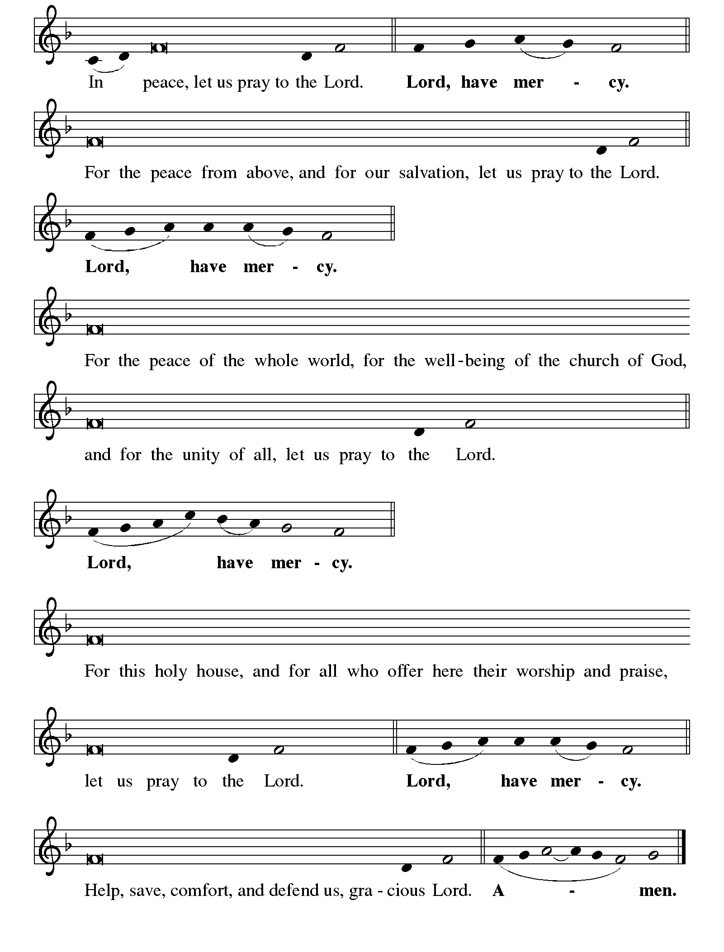KYRIE ELW p. 138

Continued on the next page

KYRIE concluded ELW pp. 138-139

CANTICLE OF PRAISE Glory to God ELW p. 139-140
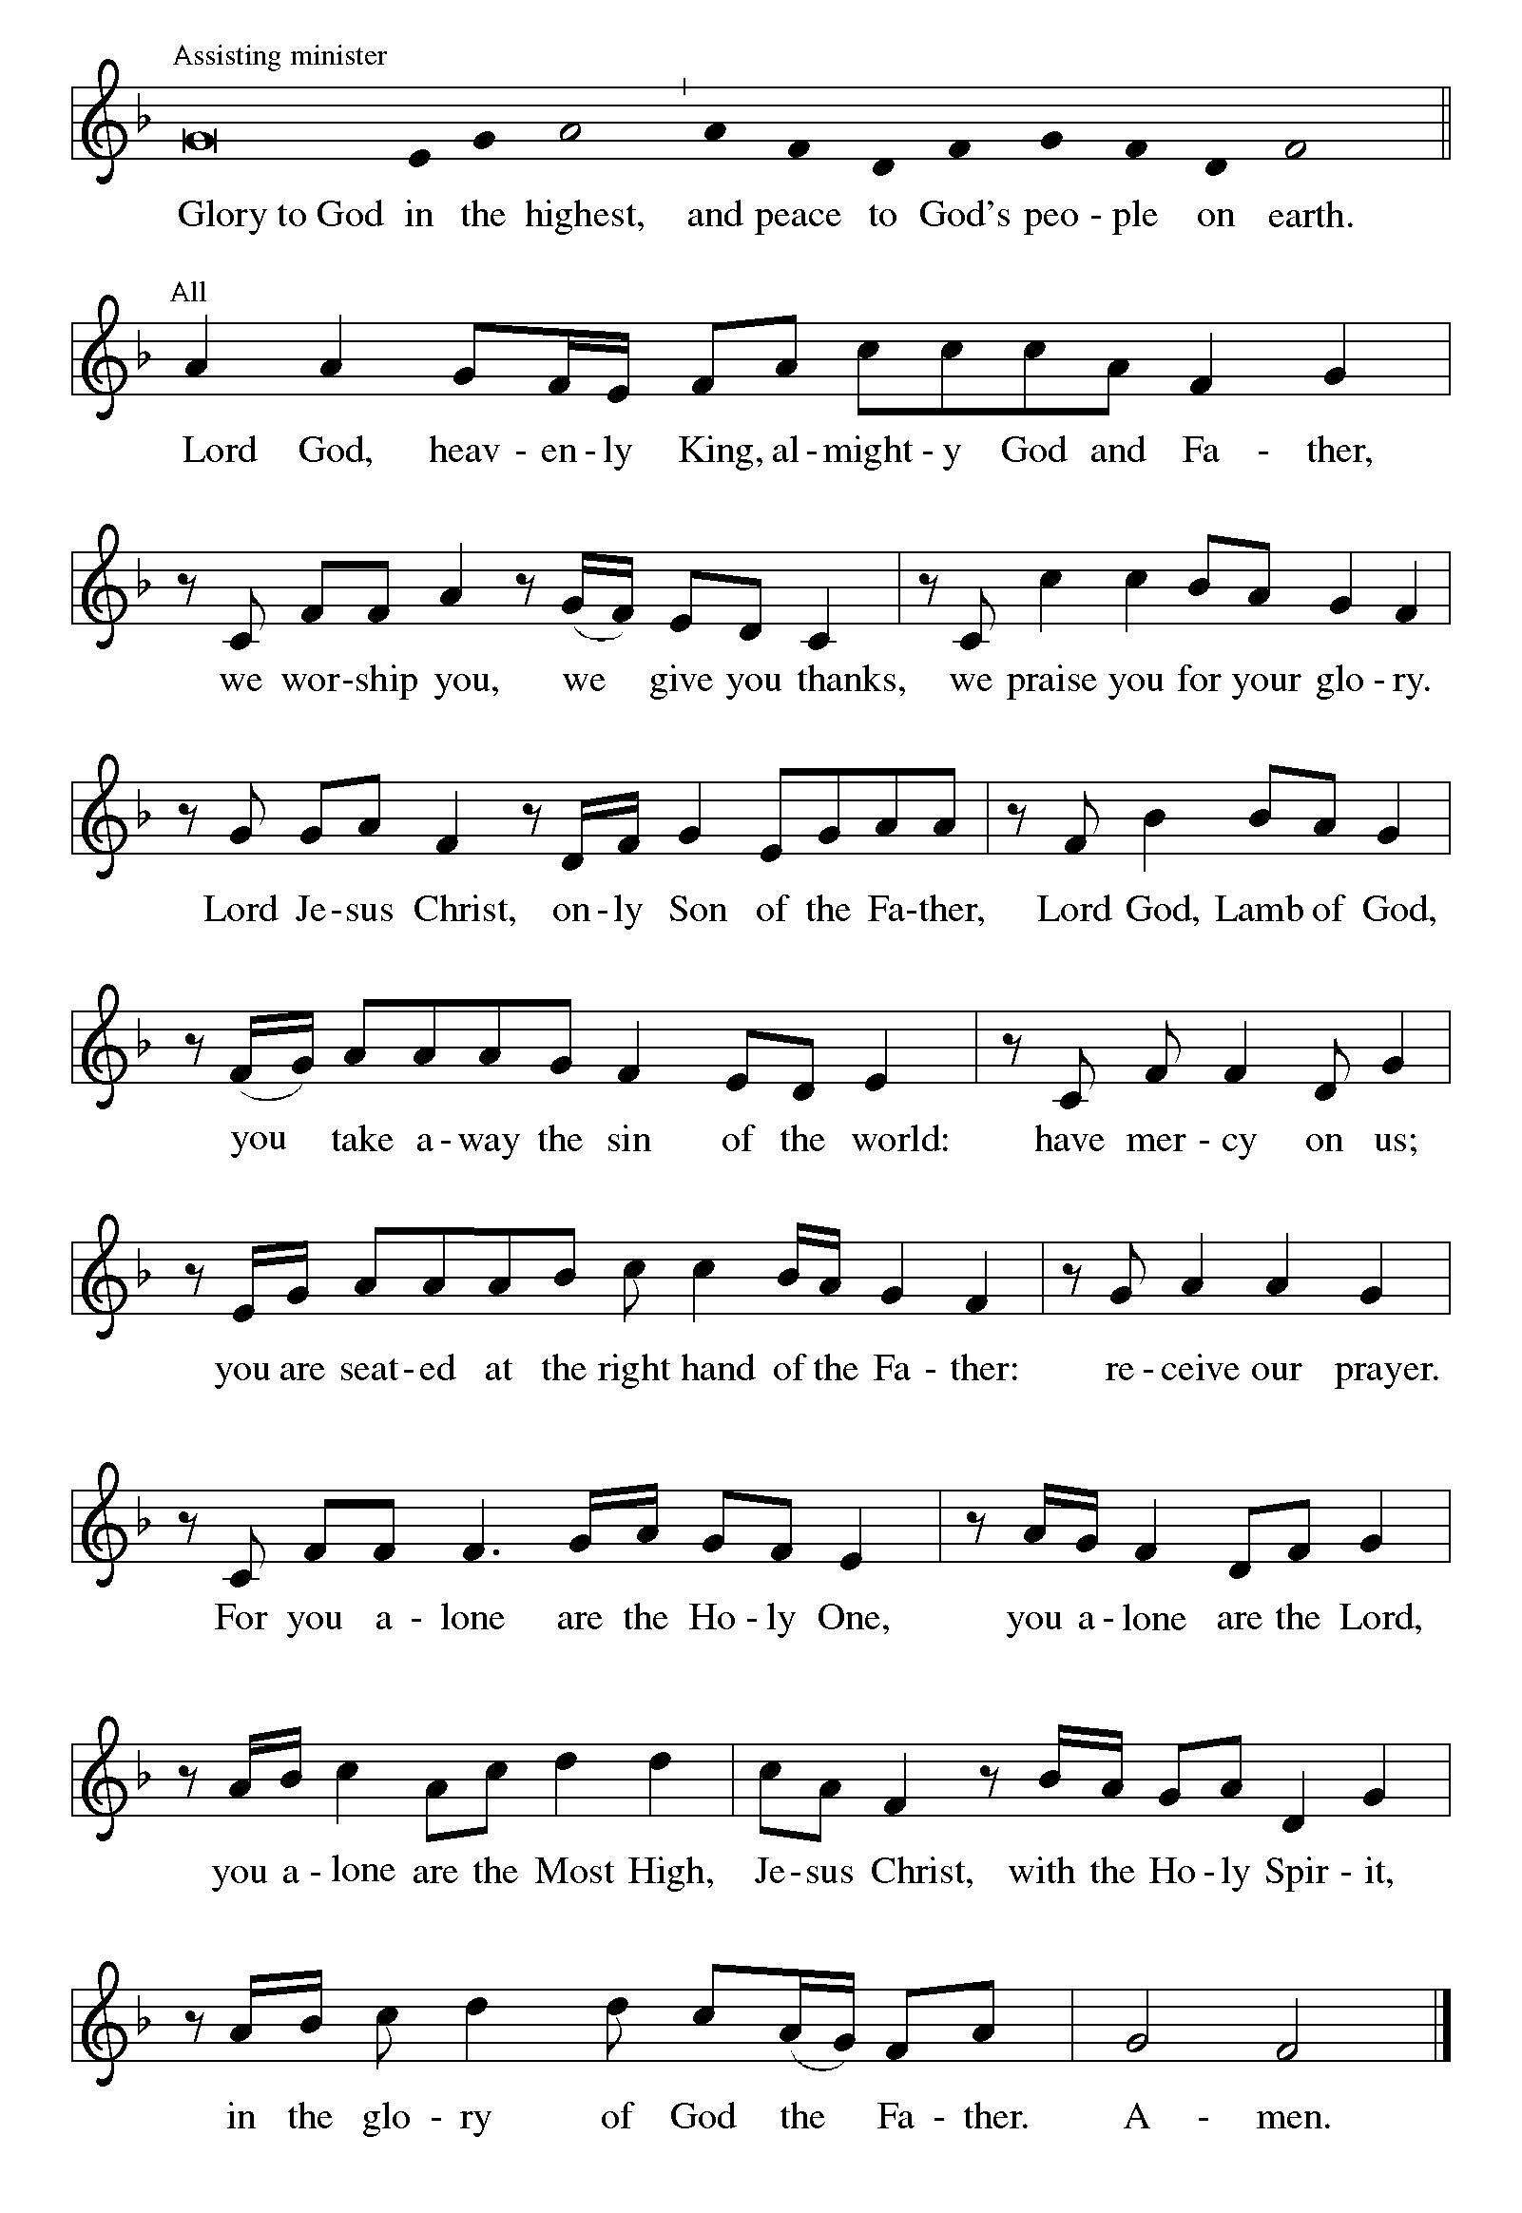

Continued on the next page.
CANTICLE OF PRAISE concluded ELW p. 140

PRAYER OF THE DAY

P: Lord God, with endless mercy you receive the prayers of all who call upon you. By your Spirit show us the things we ought to do, and give us the grace and power to do them, through Jesus Christ, our Savior and Lord.

C: Amen.

Word

God speaks to us in scripture reading, preaching, and song.

FIRST READING Isaiah 58:1-9a

Shortly after the return of Israel from exile in Babylon, the people were troubled by the ineffectiveness of their fasts. God reminds them that outward observance is no substitute for genuine fasting that results in acts of justice, such as feeding the hungry, sheltering the homeless, and clothing the naked.

¹Shout out, do not hold back!
Lift up your voice like a trumpet!
Announce to my people their rebellion,
to the house of Jacob their sins.
²Yet day after day they seek me
and delight to know my ways,
as if they were a nation that practiced righteousness
and did not forsake the ordinance of their God;
they ask of me righteous judgments,
they delight to draw near to God.

Continued on the next page.
³“Why do we fast, but you do not see?
Why humble ourselves, but you do not notice?”
Look, you serve your own interest on your fast day,
and oppress all your workers.
⁴Look, you fast only to quarrel and to fight
and to strike with a wicked fist.
Such fasting as you do today
will not make your voice heard on high.
⁵Is such the fast that I choose,
a day to humble oneself?
Is it to bow down the head like a bulrush,
and to lie in sackcloth and ashes?
Will you call this a fast,
a day acceptable to the Lord?
⁶Is not this the fast that I choose:
to lose the bonds of injustice,
to undo the thongs of the yoke,
to let the oppressed go free,
and to break every yoke?
⁷Is it not to share your bread with the hungry,
and bring the homeless poor into your house;
when you see the naked, to cover them,
and not to hide yourself from your own kin?
⁸Then your light shall break forth like the dawn,
and your healing shall spring up quickly;
your vindicator shall go before you,
the glory of the Lord shall be your rear guard.
^{9a}Then you shall call, and the Lord will answer;
you shall cry for help, and he will say, Here I am.

A: The word of the Lord.

C: Thanks be to God.

MUSIC MESSAGE Heidi Dybing

PSALM 112:1-9 Read Responsively

¹Hallelujah! Happy are they who fear the Lord and have great delight in God’s commandments!

Continued on the next page.

²Their descendants will be mighty in the land; the generation of the upright will be blessed.

³Wealth and riches will be in their house, and their righteousness will last forever.

⁴Light shines in the darkness for the upright; the righteous are merciful and full of compassion.

⁵It is good for them to be generous in lending and to manage their affairs with justice.

⁶For they will never be shaken; the righteous will be kept in everlasting remembrance.

⁷They will not be afraid of any evil rumors; their heart is steadfast, trusting in the Lord.

⁸Their heart is established and will not shrink, until they see their desire upon their enemies.

⁹They have given freely to the poor, and their righteousness stands fast forever; they will hold up their head with honor.

⁴Light shines in the darkness for the upright; the righteous are merciful and full of compassion.

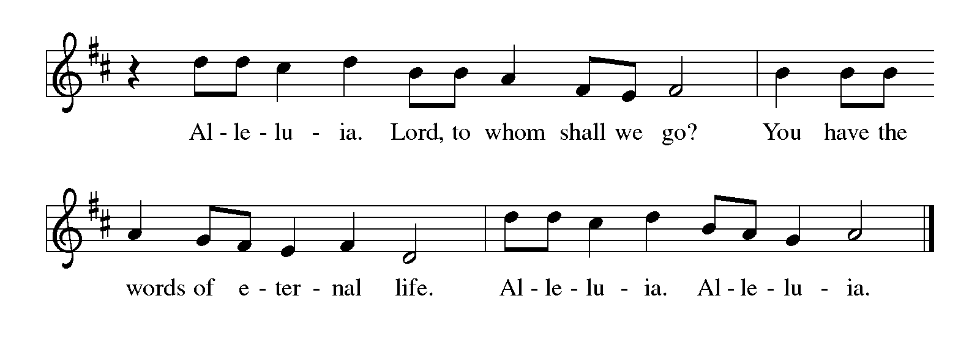GOSPEL ACCLAMATION Alleluia ELW p. 142

GOSPEL Matthew 5:13-20

P: Announcement of the Gospel.

C: Glory to you, O Lord.

Continued on the next page.
In the Sermon on the Mount, Jesus encourages his followers to be the salt of the earth and the light of the world, doing good works and keeping God’s commandments.

[Jesus said:] ¹³“You are the salt of the earth; but if salt has lost its taste, how can its saltiness be restored? It is no longer good for anything, but is thrown out and trampled underfoot.
¹⁴“You are the light of the world. A city built on a hill cannot be hid. ¹⁵No one after lighting a lamp puts it under the bushel basket, but on the lampstand, and it gives light to all in the house. ¹⁶In the same way, let your light shine before others, so that they may see your good works and give glory to your Father in heaven.
¹⁷“Do not think that I have come to abolish the law or the prophets; I have come not to abolish but to fulfill. ¹⁸For truly I tell you, until heaven and earth pass away, not one letter, not one stroke of a letter, will pass from the law until all is accomplished. ¹⁹Therefore, whoever breaks one of the least of these commandments, and teaches others to do the same, will be called least in the kingdom of heaven; but whoever does them and teaches them will be called great in the kingdom of heaven. ²⁰For I tell you, unless your righteousness exceeds that of the scribes and Pharisees, you will never enter the kingdom of heaven.”

P: Affirmation of the Gospel.

C: Praise to you, O Christ.

SERMON

HYMN OF THE DAY Christ, Be Our Light ELW # 715

Stanzas 1, 2, 3 and 5

PRAYERS OF GOD’S PEOPLE

Each petition ends with these words and response:

A: Merciful God,

C: receive our prayer.

Concluding petition and response:

P: We bring to you our needs and hopes, O God, trusting your wisdom and power revealed in Christ crucified.

C: Amen.

Meal

God feeds us with the presence of Jesus Christ.

OFFERING Music by Heidi Dybing

OFFERING SONG This Little Light of Mine ELW # 677

Stanzas 1 and 2

OFFERING PRAYER

A: Liberating God, you break the bonds of injustice and let the oppressed go free. Receive these offerings in thanksgiving for all your works of merciful power, and shape us as people of your justice and freedom. You we magnify and adore, through Jesus our Savior,

C: Amen.

GREAT THANKSGIVING

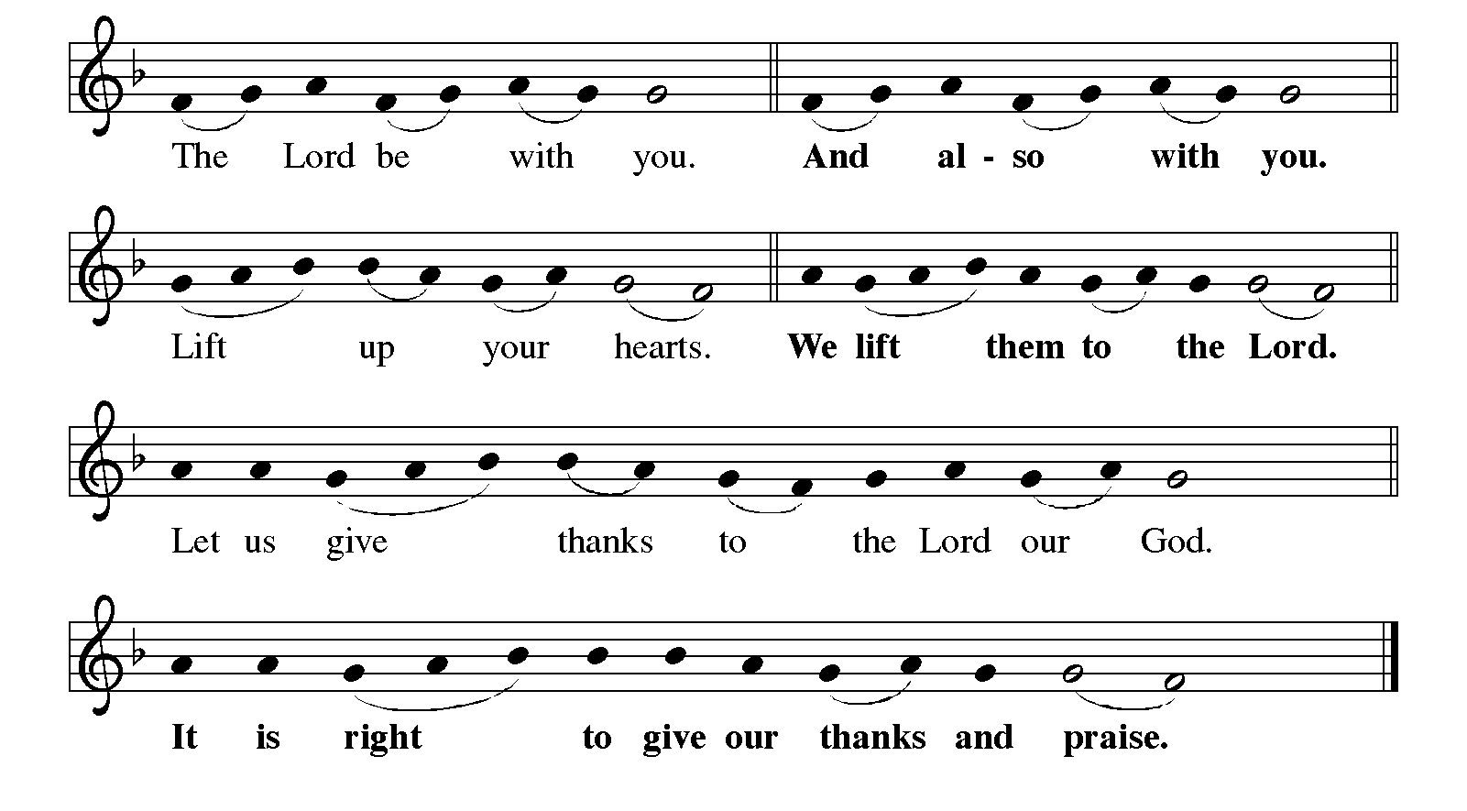Dialogue ELW p. 144

Preface

P: It is indeed right, our duty and our joy, that we should at all times and in all places give thanks and praise to you, almighty and merciful God, through our Savior Jesus Christ; who on this day overcame death and the grave, and by his glorious resurrection opened to us the way of everlasting life. And so, with all the choirs of angels, with the church on earth and the hosts of heaven, we praise your name and join their unending hymn:

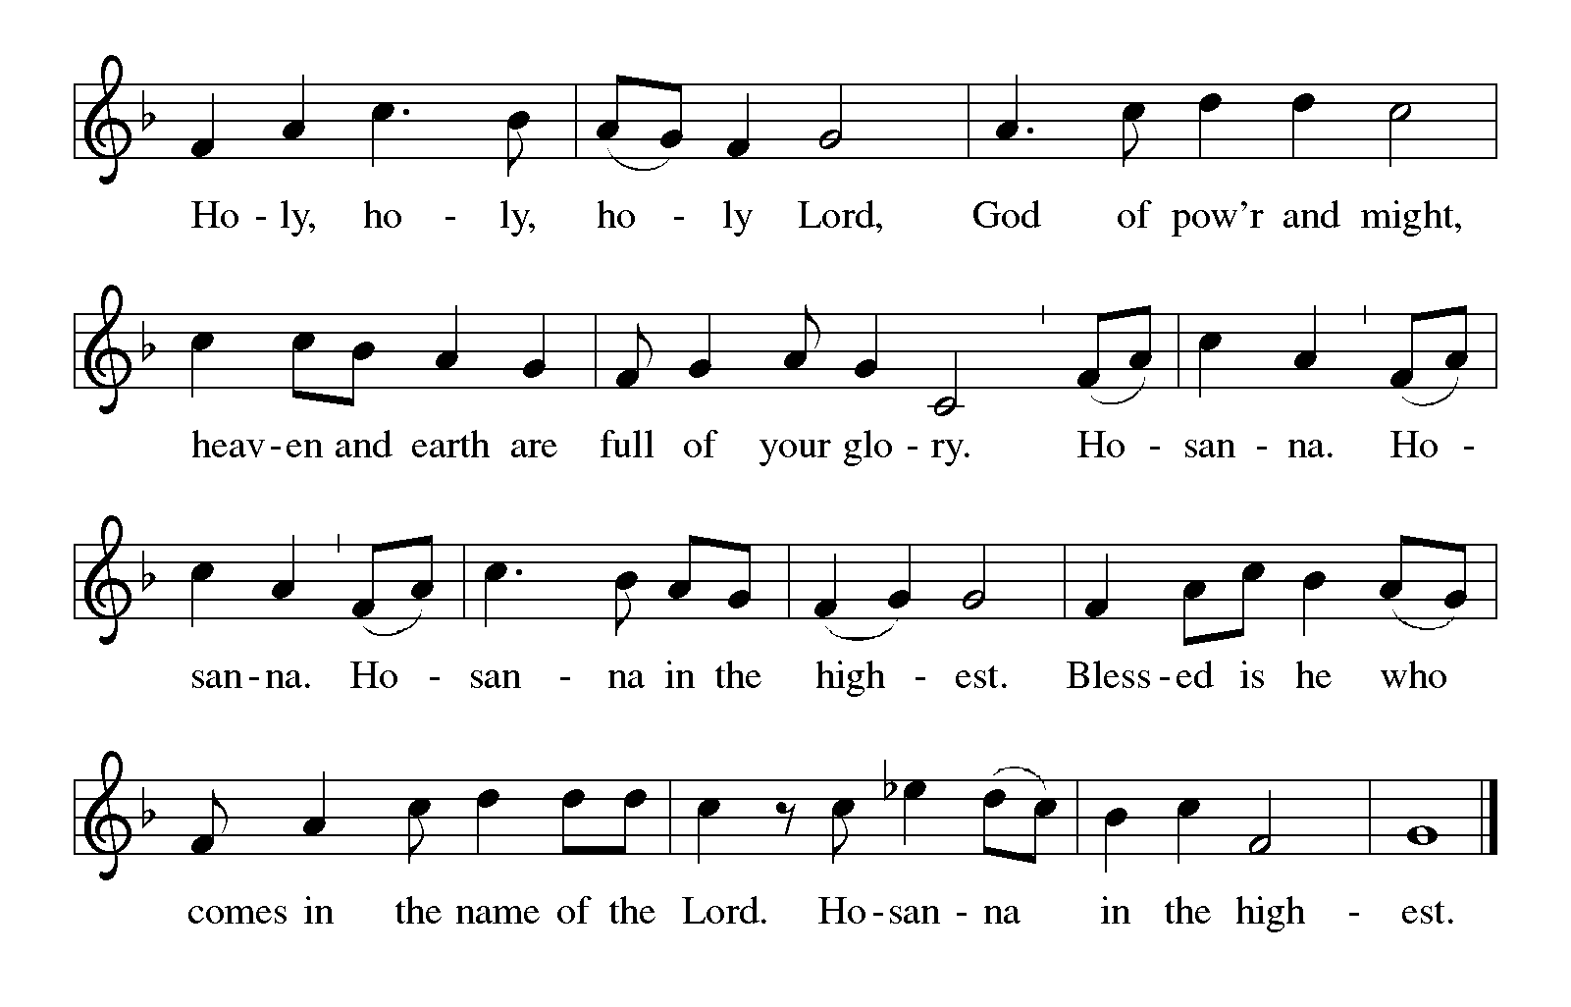Holy, Holy, Holy (the angels’ song) ELW p. 144

Thanksgiving at the Table

P: You are indeed holy, almighty and merciful God. You are most holy, and great is the majesty of your glory.

You so loved the world that you gave your only Son, so that everyone who believes in him may not perish but have eternal life.

Continued on the next page.

P: We give you thanks for his coming into the world to fulfill for us your holy will and to accomplish all things for our salvation.

In the night in which he was betrayed, our Lord Jesus took bread, and gave thanks; broke it, and gave it to his disciples, saying: Take and eat; this is my body, given for you. Do this for the remembrance of me.

Again, after supper, he took the cup, gave thanks, and gave it for all to drink, saying: This cup is the new covenant in my blood, shed for you and for all people for the forgiveness of sin. Do this for the remembrance of me.

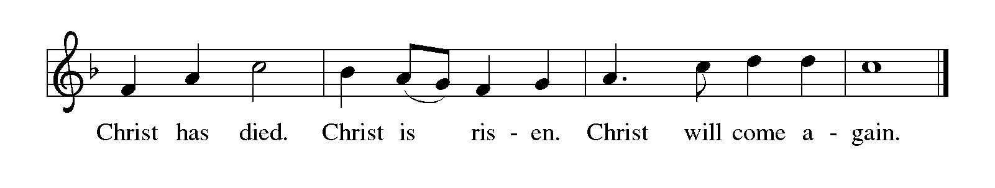For as often as we eat of this bread and drink from this cup, we proclaim the Lord's death until he comes.

P: Remembering, therefore, his salutary command, his life-giving passion and death, his glorious resurrection and ascension, and the promise of his coming again, we give thanks to you, O Lord God Almighty, not as we ought but as we are able; we ask you mercifully to accept our praise and thanksgiving and with your Word and Holy Spirit to bless us, your servants, and these your own gifts of bread and wine, so that we and all who share in the body and blood of Christ may be filled with heavenly blessing and grace, and, receiving the forgiveness of sin, may be formed to live as your holy people and be given our inheritance with all your saints.

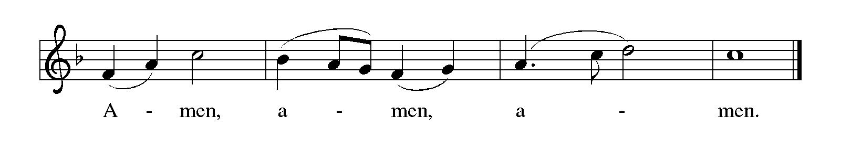To you, O God, Father, Son, and Holy Spirit, be all honor and glory in your holy church, now and forever.

Lord’s Prayer Traditional Wording ELW p. 145

P: Gathered into one by the Holy Spirit, let us pray as Jesus taught us.

All: Our Father, who art in heaven, hallowed be thy name, thy kingdom come, thy will be done, on earth as it is in heaven. Give us this day our daily bread; and forgive us our trespasses, as we forgive those who trespass against us; and lead us not into temptation, but deliver us from evil. For thine is the kingdom, and the power, and the glory, forever and ever. Amen.

INVITATION TO COMMUNION

P: Come and taste the joy of God!

COMMUNION

What We Believe

Who May Receive. We welcome all baptized Christians to the Lord's Table. In our parish baptized children who have entered the 5th grade are instructed in this sacrament and receive their First Communion; younger children come to the altar and receive a blessing. If your baptized child has received such instruction, or if you want your baptized child to receive Communion, then he or she is welcome to partake.

Proper Preparation. In his Small Catechism, Martin Luther asks, "When is a person rightly prepared to receive this sacrament?" He answers, "Fasting and other outward preparations serve a good purpose. However, that person is well prepared and worthy who believes these words, given and shed for you for the remission of sins. But anyone who does not believe these words, or doubts them, is neither prepared nor worthy, for the words for you require simply a believing heart.”

Real Presence. We believe that the bread and wine truly are the body and blood of Christ given and shed for the forgiveness of sins.

Distribution

Holy Communion will be served in procession, one side of the sanctuary at a time; please keep some distance from the person in front of you. The ushers will direct you when to make your way to the front of the church using the center aisle. You will receive the elements near the chancel. Please extend your hands, palms up, if you will be receiving the bread. Gluten-free wafers are also available; please ask for one. Proceed to your right or to your left to receive the wine. White grape juice is also available in the center ring of each tray for those who prefer an alcohol-free element. You may say “Amen” after receiving each element. If you will not be receiving Communion, keep your hands folded for a blessing. Place your empty cup in the basket and then return to your seat by the side aisle.
Music During Communion Heidi Dybing

PRAYER AFTER COMMUNION

A: Holy One, we thank you for the healing that springs forth abundantly from this table. Renew our strength to do justice, love kindness, and journey humbly with you.

C: Amen.

Sending

God blesses us and sends us in mission to the world.

ANNOUNCEMENTS

BLESSING

P: The God who faithfully brings forth justice
and breaks the oppressor’s rod
☩ bless, strengthen, and uphold you,
today and always.

C: Amen.

DEPARTING HYMN Rise, Shine, You People ELW # 665

DISMISSAL

A: Go in peace. Follow the way of Jesus.

C: Thanks be to God. Alleluia!

RINGING OF THE BELL

POSTLUDE



You are the light of the world.
Let your light shine before others,
so that they may see your good works
and give glory to your Father in heaven.

Today’s Assistants and Ministers

Greeters & Ushers …………………………….……..……… Dave Ruen and Laurie Overland
Pianist …………………………………...…...……….….……………………..…… Heidi Dybing
Presiding Minister ……………………....…………….…….…………… Pastor Kerry Eversole
Reader ……………………………………….……………..…………….……………. Dave Ruen
Altar Care & Communion Preparation ……………………………….....………….. Joan Ruen
Refreshments …………………………….....……… Laurie Overland and Dave & Joan Ruen

Presence Last Week and January Presents

Attendance Sunday, January 29 = 38
Average Sunday Worship Attendance for January = 45

December Contributions: General Fund = $20,356 Designated Giving = $2,155
Jan-Dec Income = $160,742 Jan-Dec Expenses = $167,925 Deficit = $7,183

This Week in Our Congregation

Today, February 5 — Fifth Sunday after Epiphany

Sunday School after the children’s message
Refreshments in the Fellowship Hall for everyone following worship
7th & 8th Grade Confirmation Session 10:15 AM

Tuesday, February 7

Men’s breakfast at Home Sweet Home, Lanesboro 7:00 AM
LYO takes out trash at Kenilworth & Sylvan Manor afternoon or evening

Wednesday, February 8

Church Council Meeting 6:30 PM

Thursday, February 9

Deacon Cindy at Park Lane Estates for Bible study/chapel 9:30 AM

Next Sunday, February 12 — Sixth Sunday after Epiphany

Worship 9:00 AM
Sunday School after the children’s message
March Service Group meets in the Fellowship Hall after worship
7th & 8th Grade Confirmation Session 10:15 AM

News and Notes

Attention youth! Help takeout trash at Kenilworth & Sylvan Manor. Volunteer on Tuesday afternoon or evening for about 30-45 minutes to pick up trash bags and carry them out to the dumpsters for garbage or recycling. Sign up by using the following sign-up genius link at www.signupgenius.com/go/20F0D4DAFA82DA2F58-manor. One slot per week is available until the end of April, so sign up for two or more dates. Bring your siblings along to help. Friends from outside our church are welcome of course! Contact Kristi Ruen at 507- 421-2924 (cell) or kristiruen@lanesboroschools.com if you have any questions.
Thank you for contributing to our Noisy Offering! $105.13 was recently given to the Food Shelf in Preston.

Print & mail forms are available and online registration is open for Summer 2023 at Good Earth Village Bible Camp! Use code EARLY23 to save 10% on registration fees, excludes preschool play day. For a limited time, each camper registered can receive a free summer theme t-shirt. One t-shirt per camper if registered for multiple camps. Siblings each receive a 25% discount with code SIBLING23. Go to www.goodearthvillage.org to register or call (507) 346-2494 or email info@goodearthvillage.org.

Prayer Requests

In Our Community. For our church members and friends living with chronic illness and other diseases, who are homebound, residing in care facilities, and hospitalized. See the newsletter for our members living in area nursing homes. And let us not forget those sick and dying of COVID-19, those entrusted with the authority of government, justice, and law enforcement, as well as our fallen and wounded soldiers and those still serving.

In Our Synod. Bishop Regina Hassanally invites the people and congregations of our Southeastern Minnesota Synod to make a commitment to pray this week for the following faith communities: Trondhjem Lutheran Church, Lonsdale; Vasa Lutheran Church, Welch; Bear Creek Lutheran Church, Grand Meadow; Ruruma Lutheran Church, Tanzania; Mazoezi Kikio Lutheran Church, Tanzania; and Iglesia San Lucas Lutheran Church, Colombia.

Community Event

2023 Lanesboro Memorial Ice Fishing Tournament, Saturday, February 18, at the Lanesboro Bass Pond. Registration opens at 11 am. Adults $15. Youth $5. Fishing starts at 12 noon and ends at 2 pm. Must have a valid MN Fishing License. One line per person. No fishing shacks or portables allowed. Prizes for first fish and biggest fish, youth fish prizes, door prizes, silent auction, and lots of fun! Proceeds support Lanesboro Senior Scholarships and local communities. Food will be available for purchase from the Lanesboro High School Senior Class. Income helps fund their trip to Washington D.C.

Acknowledgments

Graphics, worship texts, prayers, and readings are from sundaysandseasons.com © 2023 Augsburg Fortress. Used by permission under Augsburg Fortress Liturgies Annual License SAS103296.

Permission to project, live stream, or podcast liturgy and music content under copyright to or administered by Augsburg Fortress provided under Augsburg Fortress Liturgies Annual License SAS103296.

Permission to Podcast / Stream provided by One License, Inc., under License # A-735588. An additional fee was paid. www.onelicense.net.

Permission to Podcast / Stream provided by Christian Copyright Licensing International, Inc., under License # 11459672. An additional fee was paid. www.ccli.com.

