Bethlehem Lutheran Church
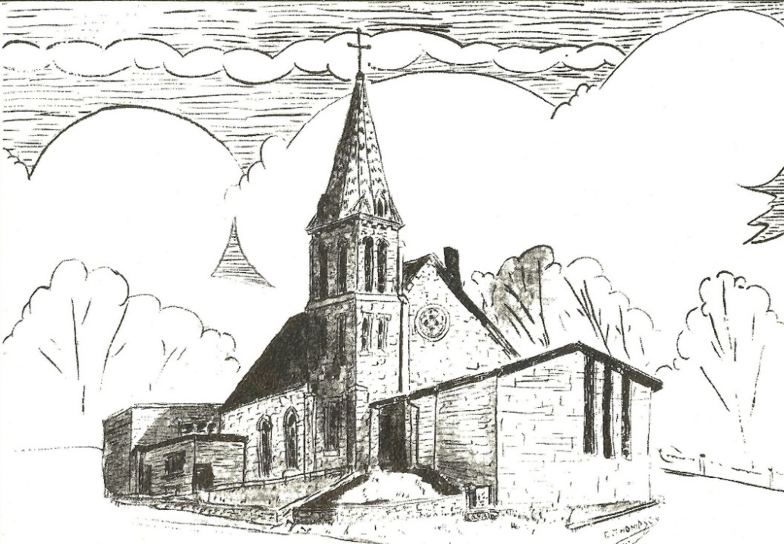
Established 1874

Rev. Kerry B. Eversole, Pastor
Deacon Cindy Cordes-Eversole, Associate in Ministry

Mailing Address: P.O. Box 314, Lanesboro, MN 55949-0314
Physical Address: 200 Kenilworth Ave S, Lanesboro, Minn.

Telephone: 507.467.3344
E-mail Address: bethlehem@acegroup.cc
Website: www.staronthehill.com
Facebook Page: www.facebook.com/BethlehemLutheranLanesboro

Office Hours: Tuesday, Wednesday, Thursday 10 a.m. to 3 p.m.
Parsonage Phone: 507.467.3017
Pastor Kerry’s Cell Phone: 507.951.3954

Bethlehem Lutheran Church
Lanesboro, Minnesota

Ash Wednesday

February 22, 2023 7:00 p.m.


Welcome to worship at Bethlehem Lutheran Church
and the service for Ash Wednesday

Gathering

Introduction to the Season and the Day. Christians gather on Ash Wednesday to mark the beginning of Lent, our annual journey to the baptismal waters of the Great Three Days: Maundy Thursday, Good Friday, and Easter. During Lent, we reflect on the meaning of our baptism into Christ’s death and resurrection. On this special day, and throughout Lent, we hear a solemn call to “Return to the Lord, your God, for he is gracious and merciful, slow to anger, and abounding in steadfast love” (Joel 2:13), because “now is the acceptable time…now is the day of salvation!” (2 Corinthians 6:2). Today, we also receive an ashen cross. These crosses mimic our baptismal marking and anointing when we were made daughters and sons of God and initiated into the Lord's death and resurrection. The sign of ashes is also a chilling reminder of our human mortality and frailty. However, because our death is now in Christ, what seems like an ending is really an invitation to make each day a new beginning, in which we are washed in God’s mercy and forgiveness. The Lenten disciplines of acts of kindness, prayer, and fasting are signs of this new beginning, our discipleship, which can lead us to the spiritual renewal that flows from the springtime Easter feast to come.

This year’s Lenten worship theme is AMAZING grace. In honor of the 250th anniversary of the writing of “Amazing Grace”, this worship series for Lent by theologian Michael Hoy ties the words of the beloved song to our lives today as Christ’s disciples. Those in the Bible who experienced the amazing grace of God help us each week to realize that though we once were lost in sin, we now have been found by Jesus, and though we once were blind to God’s mercy, we now can see his love at work in us through our Savior’s death and resurrection.

The focus of tonight’s Ash Wednesday service is the amazing grace of God King David experienced when he confessed his sins and was forgiven. We experience that same amazing grace of God in confession and forgiveness this Lent as we look toward the cross of Christ that made our freedom from sin possible.

Worship Resources. AMAZING grace Lent. Sermons by Michael Hoy. Orders of service by Carol Geisler. Art and design: Jamie Wyatt. © 2023 Creative Communications for the Parish, a division of Bayard, Inc., 1564 Fencorp Dr., Fenton, MO 63026. 800-325-9414. www.creativecommunications.com. All rights reserved. Printed in the USA. Purchase of this series gives the purchaser the copyright release to use the material in any format for use in worship. Some worship texts and prayers are from sundaysandseasons.com Copyright © 2023 Augsburg Fortress. All rights reserved. Reprinted by permission under Augsburg Fortress Liturgies Annual License SAS103296.

Worship Book and Hymns. The words to the hymns in tonight’s service are printed in the bulletin. Some hymns can also be found in Evangelical Lutheran Worship (ELW), “the red book” in the hymnal racks. Hymns in ELW are indicated by a large bold number in the left or right margin of each page.

Abbreviations. Throughout this worship folder, P: refers to the presiding minister or preacher, and C: and or bold text indicates the congregation.

Today’s Theme Verse—Have mercy on me, O God, according to your steadfast love; according to your abundant mercy blot out my transgressions.
Psalm 51:1

PRELUDE

INVITATION TO LENT

P: Dear friends in Christ, today with the whole church we enter the time of remembering Jesus’s passover from death to life, and renewing our life as disciples of Christ.

We begin this holy season by acknowledging our need for repentance and for God’s mercy. We are created to experience joy in communion with God, to love one another, and to live in harmony with creation. But our sinful rebellion separates us from God, our neighbors, and creation, so that we do not enjoy the life our creator intended.

As followers of Jesus, we are called to a discipline that contends against evil and resists whatever leads us away from love of God and neighbor. I invite you, therefore, to the discipline of Lent—self-examination and repentance, prayer and fasting, sacrificial giving and works of love—strengthened by the gifts of word and sacrament. Let us continue our journey through these forty days to the great Three Days of Jesus’ death and resurrection.

OPENING HYMN I Lay My Sins on Jesus LBW # 305

I lay my sins on Jesus, the spotless Lamb of God;
He bears them all and frees us from the accursed load.
I bring my guilt to Jesus to wash my crimson stains
Clean in his blood most precious till not a spot remains.

Continued on the next page.

I lay my wants on Jesus; all fullness dwells in him;
He heals all my diseases; my soul he does redeem.
I lay my griefs on Jesus, my burdens and my cares;
He from them all releases; he all my sorrows shares.

I rest my soul on Jesus, this weary soul of mine;
His right hand me embraces; I on his breast recline.
I love the name of Jesus, Imman-uel, Christ, the Lord;
Like fragrance on the breezes his name abroad is poured.

CONFESSION

P: King David sinned against the Lord, committing murder and adultery. When he was confronted by the prophet Nathan, the king repented of his sins. In the Spirit-inspired words of a psalm, David expressed his sorrow over his sins and his trust in God’s mercy: “Have mercy on me, O God, according to your steadfast love; according to your abundant mercy blot out my transgressions.” God, in his grace, forgave the repentant king. As we begin our Lenten journey on this Ash Wednesday, we repent of our sins, and, using the words of David’s psalm, we seek God’s amazing grace and ask God to have mercy on us.

All: “Have mercy on me, O God, according to your steadfast love; according to your abundant mercy, blot out my transgressions. Wash me thoroughly from my iniquity, and cleanse me from my sin. For I know my transgressions, and my sin is ever before me. Against you, you alone, have I sinned and done what is evil in your sight, so that you are justified in your sentence and blameless when you pass judgment. … Hide your face from my sins, and blot out all my iniquities.” (Psalm 51:1-4, 9)

IMPOSITION OF ASHES

Introduction

In repentant humility, the Old Testament figure Job said, “I despise myself, and repent in dust and ashes” (Job 42:6). In ancient times, God’s people often demonstrated sorrow for their sins by putting dust and ashes on their heads, a reminder of the penalty of death decreed in Eden, when God said, “Remember that you are dust, and to dust you shall return” (Genesis 3:19). Today on Ash Wednesday, we remember that we are sinners and that we need a Savior. We receive ashes in the shape of a cross, remembering that, on the cross, Jesus took on himself the penalty of death for our sins. You are invited to come forward and receive the mark of ashes.
Instructions

Those who wish to receive ashes may come forward by way of the center aisle. In front of the steps to the chancel, the minister(s) will apply ashes to your forehead. Please assist by holding your hair up out of the way with your hand.

During the placement of ashes, you may meditate on Psalm 90 and/or Psalm 103:8-18. The Psalms begin on page 339 in the front section of ELW.

FORGIVENESS

P: Just as God did in the life of his servant David, God has showered us with God’s grace, his undeserved favor for sinners. God sent his Son into the world to be our Savior. On the cross, Jesus took on himself the penalty of death that we deserved for our sins and now those sins are washed away by his shed blood and broken body. Know that our sins are forgiven, let us proclaim together:

All: “Create in me a clean heart, O God, and put a new and right spirit within me. Do not cast me away from your presence, and do not take your holy spirit from me. Restore to me the joy of your salvation, and sustain in me a willing spirit.” (Psalm 51:10-12)

HYMN Savior, When in Dust to Thee

Sung to Come, Ye Thankful People, Come ELW # 693

Savior, when in dust to thee low we bow the adoring knee;
When, repentant, to the skies scarce we lift our weeping eyes;
O, by all thy pains and woe suffered once for us below,
Bending from thy throne on high, hear our penitential cry!

By thy helpless infant years, by thy life of want and tears,
By thy days of deep distress in the savage wilderness,
By the dread, mysterious hour of the insulting tempter’s pow’r
Turn, O turn a fav’ring eye; hear our penitential cry!

By thine hour of dire despair, by thine agony of prayer,
By the cross, the nail, the thorn, piercing spear, and torturing scorn,
By the gloom that veiled the skies o’er the dreadful sacrifice,
Listen to our humble sigh; hear our penitential cry!

By thy deep expiring groan, by the sad sepulchral stone,
By the vault whose dark abode held in vain the rising God,
O, from earth to heav’n restored, mighty, reascended Lord,
Bending from thy throne on high, hear our penitential cry!
PRAYER OF THE DAY

P: Almighty God, you showed grace and mercy to your servant David, granting him forgiveness. According to your perfect plan, David the king became an ancestor of a greater King, the Savior called the Son of David, Jesus the Messiah. Through the death and resurrection of Jesus, we too know and experience your amazing grace. During this season of Lent, lead us to true repentance and renew your Spirit within us so that we might serve you by living as witnesses and sharing your love with others. Hear our prayer in Jesus’s name.

C: Amen.

Hearing God’s Word of Amazing Grace

OLD TESTAMENT READING 2 Samuel 12:1-13

¹And the Lord sent Nathan to David. He came to him and said to him, “There were two men in a certain city, the one rich and the other poor. ²The rich man had very many flocks and herds, ³but the poor man had nothing but one little ewe lamb that he had bought. He brought it up, and it grew up with him and with his children; it used to eat of his meager fare and drink from his cup and lie in his bosom, and it was like a daughter to him. ⁴Now there came a traveler to the rich man, and he was loath to take one of his own flock or herd to prepare for the wayfarer who had come to him, but he took the poor man’s lamb and prepared that for the guest who had come to him. ⁵Then David’s anger was greatly kindled against the man. He said to Nathan, “As the Lord lives, the man who has done this deserves to die; ⁶he shall restore the lamb fourfold because he did this thing and because he had no pity.”
⁷ Nathan said to David, “You are the man! Thus says the Lord, the God of Israel: I anointed you king over Israel, and I rescued you from the hand of Saul; ⁸I gave you your master’s house and your master’s wives into your bosom and gave you the house of Israel and of Judah, and if that had been too little, I would have added as much more. ⁹Why have you despised the word of the Lord, to do what is evil in his sight? You have struck down Uriah the Hittite with the sword and have taken his wife to be your wife and have killed him with the sword of the Ammonites. ¹⁰Now, therefore, the sword shall never depart from your house, for you have despised me and have taken the wife of Uriah the Hittite to be your wife. ¹¹Thus says the Lord: I will raise up trouble against you from within your own house, and I will take your wives before your eyes and give them to your neighbor, and he shall lie with your wives in broad daylight.

Continued on the next page.
¹²For you did it secretly, but I will do this thing before all Israel and in broad daylight.” ¹³David said to Nathan, “I have sinned against the Lord.” Nathan said to David, “Now the Lord has put away your sin; you shall not die.

NEW TESTAMENT READING Romans 4:4-8

[Saint Paul writes] ⁴Now to one who works, wages are not reckoned as a gift but as something due. ⁵But to one who does not work but trusts him who justifies the ungodly, such faith is reckoned as righteousness. ⁶So also David pronounces a blessing on those to whom God reckons righteousness apart from works:
⁷“Blessed are those whose iniquities are forgiven
and whose sins are covered;
⁸blessed is the one against whom the Lord will not reckon sin.”

GOSPEL Luke 15:1-3, 8-10

¹Now all the tax collectors and sinners were coming near to listen to [Jesus]. ²And the Pharisees and the scribes were grumbling and saying, “This fellow welcomes sinners and eats with them.” ³So he told them this parable …
⁸“[W]hat woman having ten silver coins, if she loses one of them, does not light a lamp, sweep the house, and search carefully until she finds it? ⁹And when she has found it, she calls together her friends and neighbors, saying, ‘Rejoice with me, for I have found the coin that I had lost.’ ¹⁰Just so, I tell you, there is joy in the presence of the angels of God over one sinner who repents.”

SERMON HYMN sung to Faith of Our Fathers ELW # 812

To thee, omniscient Lord of all, in grief and shame I humbly call
I see my sins against thee, Lord, the sins of thought and deed and word.
They press me sore; I cry to thee; O God, be merciful to me!

SERMON Grace for the Humble

HYMN OF RESPONSE sung to Faith of Our Fathers ELW # 812

O Jesus, let thy precious blood be to my soul a cleansing flood.
Turn not, O Lord, thy guest away, but grant that justified I may
Go to my house at peace with thee O God, be merciful to me!

PRAYERS

Each petition ends with these words and response:

P: Gracious Lord,

C: have mercy on us and hear our prayer.

Concluding petition and response:

P: All these things and whatever else you see that we need, we ask it Jesus’s name.

C: Amen.

God’s Word of Amazing Grace in the Holy Meal

OFFERING AND MUSIC

OFFERING SONG Create in Me a Clean Heart ELW # 186

GREAT THANKSGIVING

Dialogue

P: The Lord be with you.

C: And also with you.

P: Lift up your hearts.

C: We lift them to the Lord.

P: Let us give thanks to the Lord our God.

C: It is right to give our thanks and praise.

Thanksgiving at the Table

P: Blessed are you, Lord of heaven and earth. In mercy for our fallen world you gave your only Son, that all those who believe in him should not perish, but have eternal life. We give thanks to you for the salvation you have prepared for us through Jesus Christ. Send now your Holy Spirit into our hearts, that we may receive our Lord with a living faith as he comes to us in his holy supper.

C: Amen. Come, Lord Jesus.

Continued on the next page.

P: In the night in which he was betrayed, our Lord Jesus took bread, and gave thanks; broke it, and gave it to his disciples, saying: Take and eat; this is my body, given for you. Do this for the remembrance of me.

Again, after supper, he took the cup, gave thanks, and gave it for all to drink, saying: This cup is the new covenant in my blood, shed for you and for all people for the forgiveness of sin. Do this for the remembrance of me.

Lord's Prayer Traditional Wording

P: Lord, remember us in your kingdom and teach us to pray.

All: Our Father, who art in heaven, hallowed be thy name, thy kingdom come, thy will be done, on earth as it is in heaven. Give us this day our daily bread; and forgive us our trespasses, as we forgive those who trespass against us; and lead us not into temptation, but deliver us from evil. For thine is the kingdom, and the power, and the glory, forever and ever. Amen.

COMMUNION

What We Believe

Who may receive. We welcome all baptized Christians to the Lord's Table. In our congregation baptized children who have entered the 5th grade are instructed in this sacrament and receive their First Communion; younger children come to the altar and receive a blessing. If your baptized child has received such instruction, or if you want your baptized child to receive Communion, then he or she is welcome to partake.

Proper Preparation. In his Small Catechism, Martin Luther asks, "When is a person rightly prepared to receive this sacrament?" He answers, "Fasting and other outward preparations serve a good purpose. However, that person is well prepared and worthy who believes these words, given and shed for you for the remission of sins. But anyone who does not believe these words, or doubts them, is neither prepared nor worthy, for the words for you require simply a believing heart.”

Real Presence. We believe that the bread and wine truly are the body and blood of Christ given and shed for the forgiveness of sins.

Distribution

Holy Communion will be served at the altar rail. The ushers will direct you to the chancel by way of the side aisles. Proceed to the altar rail when space is available. You may kneel as you are comfortably able or stand. Extend your hands, palms up, if you will be receiving the bread and wine.

Continued on the next page.
Gluten-free wafers are available; please ask for one. White Grape juice is also available in the center ring of each tray of wine for those who prefer an alcohol-free element. You may say “Amen” after receiving each element. If you will not be receiving Communion, then keep your hands folded for a blessing. After receiving Communion, you are free to return to your seat using the center aisle.

Music During Communion by Our Organist/Pianist

PRAYER AFTER COMMUNION

P: Embodied God, at your table, we have tasted the goodness of Jesus. With the eyes of our hearts open to your amazing grace, empower us to hear the needs of our neighbors and touch them with your love.

C: Amen.

Sending

BENEDICTION Romans 4:7-8 and Numbers 6:24-26

P: Blessed are those whose iniquities are forgiven and whose sins are covered;

C: blessed is the one against whom the Lord will not reckon sin.

P: The Lord bless you and keep you;
The Lord make his face to shine upon you and be gracious to you;
The Lord lift up his countenance upon you and give you peace.

C: Amen.

CLOSING HYMN Amazing Grace, How Sweet the Sound ELW # 779

Amazing grace!— how sweet the sound— that saved a wretch like me!
I once was lost, but now am found; was blind, but now I see.

’Twas grace that taught my heart to fear, and grace my fears relieved;
how precious did that grace appear the hour I first believed!

Through many dangers, toils, and snares I have already come;
’Tis grace has brought me safe thus far, and grace will lead me home.

POSTLUDE

Today’s Assistants and Ministers

Greeters & Ushers …....................................................................…...… Tim & Julie Kiehne
Organist-Pianist ……………….…………………………………………………..…… Sue Holst
Presiding Minister …………………………….…………….…………… Pastor Kerry Eversole
Reader ……………………………………………………….....……….…….. Volunteer needed
Altar Care & Communion Preparation …………………………..………… Tim & Julie Kiehne

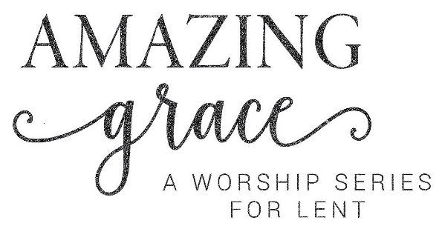
In honor of the 250th anniversary of the writing of “Amazing Grace,” this worship series for Lent by theologian Michael Hoy ties the words of the beloved song to our lives today as Christ’s disciples. Those in the Bible who experienced the amazing grace of God help us each week to realize that though we once were lost in sin, we now have been found by Jesus, and though we once were blind to God’s mercy, we now can see his love at work in us through Jesus’s death and resurrection.

Week 1 • Isaiah of Babylon • Isaiah 6:7. We see God’s amazing grace at work in the life of the prophet Isaiah, who proclaimed to God’s people the salvation that was to come through the Suffering Servant.

Week 2 • The Prodigal Son • Luke 15:32. We hear of the great love of a father who lavished amazing grace upon the Prodigal Son, a picture of our Heavenly Father’s lavish compassion toward us.

Week 3 • The Blind Man • John 9:24. We witness Jesus bringing sight to a man born blind, giving the man the added spiritual vision to see the amazing grace of God found in Jesus, who heals us all.

Week 4 • The Woman at the Well • John 4:13-14. We listen to Jesus teach a woman at the well of his amazing grace poured out for us abundantly, which satisfies our thirsting souls for all eternity.

Week 5 • Paul • 1 Timothy 1:15. We marvel at the story of amazing grace in the life of Paul, who turned from persecutor of Christ to proclaimer of our Lord through the mighty power of the Holy Spirit.

