Contact us at:

200 Kenilworth Ave S.
P.O. Box 314
Lanesboro, MN 55949
507-467-3344
bethlehem@acegroup.cc
Facebook: Bethlehem Lutheran Church, Lanesboro

Daylight Saving Time ends Sunday, November 6

Inside this issue

Service Opportunities 2

Prayer List 3

WELCA News 4



Bethlehem’s Windsor Chop Drive-thru Dinner is Sunday, November 13
The church council is excited to resume a congregational fall dinner, albeit with a few new features. The dinner will be Sunday, November 13, 11:00 am to 2:00 pm, drive-thru only. Cars will be directed down the alley and into the church parking lot, where you will pay and receive your meals. The menu includes a freshly grilled Windsor smoked pork chop, baked potato, glazed carrots, dinner roll and apple crisp. Cost is $15 per meal. We plan to sell 350 meals on a first come, first served basis.

Please help spread the word about our dinner! If you would like to work on November 13 or help with preparations, please contact council president Dave Ruen (507-259-7095 or dave.ruen1961@gmail.com).

Each service group is asked to provide three pans of apple crisp. If you are baking an apple crisp, help yourself to apples in the church refrigerator. Thank you to Kate Glor for donating the apples!

 Sunday, November 6

Bethlehem tenth graders, Taylor Hanson, Dayton Haugen, Cora Schnebly and Holdyn Willford, have completed their Confirmation instruction and will publicly affirm their baptism during worship on November 6.

New Member Reception Sunday, November 13

Several families have expressed interest in joining our congregation. We will receive these new members during worship on November 13. If you or someone you know would like to join Bethlehem at this time, please contact the church office.
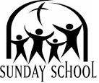

Thank you to Hollie Clarke for leading our Sunday school! Hollie would like Sunday school families to know that there will be no class on November 13 and 27. The Sunday school Christmas program will be December 11.

November 7
November 21

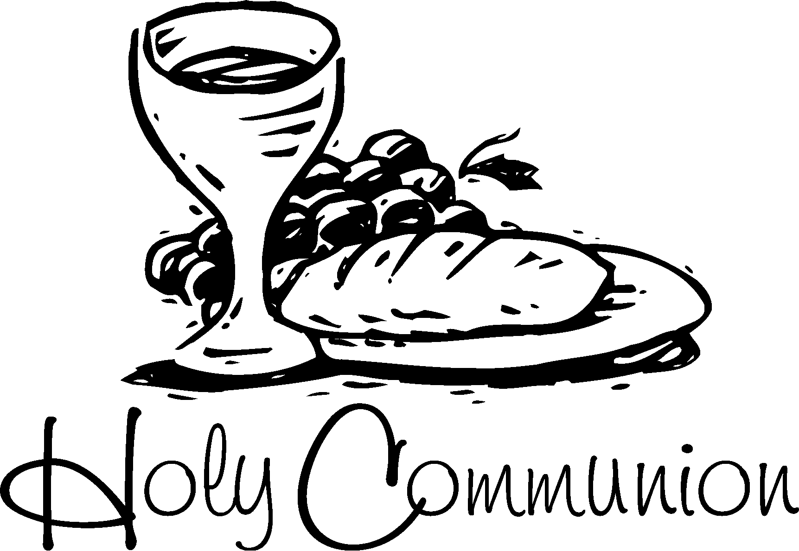We will continue to celebrate Communion while seated in the pews in order to maintain social distancing. As you enter the sanctuary, each worshiper will receive an individual, prefilled Communion kit containing a wafer and grape juice. At the appropriate time in the service, we will eat and drink together.

First Communion class for 5th graders
First Communion classes for fifth graders and parents will take place Wednesdays, November 4, 11, 18 and December 2, at 6:30 pm. First Communion for students who complete these classes will be Sunday, December 6.


Check Your Email for “At Home” Lessons
The website that has been the source of most of our Sunday School lessons for many years is putting together lessons adapted for parents to do at home with their children. We hope you can use these to create a “Sunday School” time for your family until it is safe to gather again. Thank you to Chris Troendle for coordinating the weekly lessons. Please contact the church office to be added to the email list.

GEV Run4Camp November 1
Good Earth Village is part of the national organization of Lutheran Outdoor Ministries. LOM is hosting a Run4Camp 5K on November 1 for camps across the country. As you know, COVID 19 has hit many hard; camps and retreat centers in particular. This nationwide 5K is a fun way to run or walk in support of outdoor ministries. 100% of your registration and sponsorship proceeds go directly to Good Earth Village. Participate wherever you are or come to camp to complete your 5K. Registration fee is $25. Find sponsors to pledge donations to support you. If you raise an additional $20+, you will receive a GEV face mask. Register at goodearthvillage.org.
Worship & Evangelism

There will not be a community Thanksgiving eve service this year.

Highway Clean-up
Bethlehem’s section of Highway 16 was cleaned on October 8. Thank you to volunteers, John Peterson, Nathan Boyum, Cindy Eversole, David & Joan Ruen.
Worship & Evangelism

Thank you, November Volunteers
November 1
Ushers: Luther, Corky & Trent Olson; Nathan & Aaron Eversole
Reader: Ed Taylor

November 8
Ushers: Bob & Phyllis Penheiter; Brett & Hollie Clarke
Reader: Phyllis Penheiter

November 15
Ushers: Brett & Hollie Clarke; Luther & Corky Olson
Reader: Brett Clarke

November 22
Ushers: Luther, Corky & Trent Olson
Reader: Volunteer needed

November 29
Ushers: Luther, Corky & Trent Olson; Nathan & Aaron Eversole
Worship & Evangelism
Worship & Evangelism
Worship & Evangelism
Worship & Evangelism
Reader: Ed Taylor

Banners:
Deane Benson and Jennifer Wood

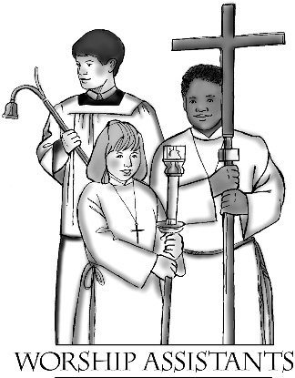
November 6
In procession

In response to feedback we received from the Stewardship survey, the church council has decided that Holy Communion will be celebrated on the first Sunday of four-Sunday months, and on the first and fourth Sundays of five-Sunday months.

Sunday, November 6—White
Worship & Evangelism

Ushers: Bob & Phyllis Penheiter, Paul & Darcy Peterson, Sasha Holst & family
Altar Care/Communion: Bob & Phyllis Penheiter
Reader: Phyllis Penheiter
Refreshments: Sasha Holst and Darcy Peterson

Sunday, November 13—White

Ushers: Bob & Phyllis Penheiter and Glen & Julie Jensson
Altar Care: Phyllis Penheiter
Reader: Phyllis Penheiter
Refreshments: None today

Sunday, November 20—White

Ushers: Mike & Raquel Torgerson family
Altar Care: Glen & Julie Jensson
Reader: Glen Jensson
Refreshments: Mike & Raquel Torgerson and Glen & Julie Jensson

Sunday, November 27—Blue
Worship & Evangelism

Ushers: James & Brenda Semmen family
Altar Care: Glen & Julie Jensson
Reader: Semmen family
Refreshments: James & Brenda Semmen and Bob & Phyllis Penheiter

Senior Dining Servers
at Kenilworth Apartments

November 4: Phyllis Penheiter and Dianne Dunn
November 11: Kathie Rogers and Diann Groen
November 18: Mavis Musselman and Jennifer Wood
November 25: No meal today

Service Group Updates
Input from the coordinators of our monthly service groups has led the stewardship ministry team to make several changes for next year. Beginning in January 2023, we will have eight service groups instead of ten. The April and October 2022 groups will disband and their members will be spread among the remaining groups to strengthen

them. Now each group will serve every eight months instead of every ten months, but the groups will consist of more members to meet our monthly volunteer needs.

Volunteer Opportunities
The 2023 Service Group Booklet will go to print soon. If you would like to join the prayer chain or add your name to the list of volunteers who are willing to serve in addition to their monthly service group, please contact the church office.

December Service Group meets soon
Members of the December service group are Eric Decker, Darrell Egge, Jeff & Carrie Hanson, Chris & Anna Hanson, Corey & Michelle Hanson, Winston & Christine Howerton, Mike & Kelly Lawstuen, Jim & Lolly Melander, Marlin & Ardella Miner, Luther & Corky Olson, Trent & Tracy Olson, Jon & Sarah Pieper, Ben & Darla Taylor, James & Stephanie Waldow, and Sara Xavier. Group coordinators are Luther & Corky Olson and Ben & Darla Taylor.

Highway Clean-up
Bethlehem members cleaned the ditches along our section of MN Highway 16 on October 16. Thank you to volunteers, John Peterson, Nathan Boyum, Cindy Eversole, David & Joan Ruen.

Children, Youth & Families



Our Confirmands
Children, Youth & Families

10th grade: Taylor Hanson, Dayton Haugen, Cora Schnebly, Holdyn Willford
9th grade: Elizabeth Clarke, Mason Gilbertson, Morgan Hanson, Tristen Hareldson, Reid Olson, Levi Rogers
8th grade: Hunter Kelly, Jentrey Schreiber, Grace Tufte
7th grade: Preston Clarke, Kaylee Gilbertson, Trinity Hareldson, Isabelle Peterson, McKenna Peterson, Henry Semmen, Prailey Willford

Those Living with Cancer

Carroll Danielson, Diane Haugen, Tom Papenfuss


Those Living in Care Centers

Marge Drake at Chosen Valley Care Center, Chatfield
Lois Gilbertson and Evelyn Larson at Chosen Valley Assisted Living, Chatfield
Everett Johnson at Harmony Place
Sandy Dybing at Birchwood Cottages, North Mankato
Jerry Johnson at River Bend Assisted Living, Rochester

Our members in the Military

Nicholas Benson, son of Deane Benson
Esme Decker, daughter of Sara Xavier and Eric Decker
Lisa Peterson Abell, daughter of Linda (Hareldson) Peterson
Leon Peterson, son of Linda (Hareldson) Peterson
Tom Moen, son of Lolly Melander, grandson of Everett Johnson
Claire Peterson, daughter of Joe & Jody Peterson
Devin Troendle, son of Pat & Chris Troendle, grandson of Ed Taylor

Thank you for contributing to our weekly “noisy offering.” We recently donated $96.95 in loose change to the Preston food shelf.

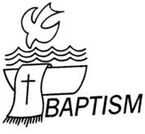
Check Out Our New Library Books
Thank you to everyone who has contributed books to our church library. The response to our request for donations has been fantastic! We recently received over twenty novels by award-winning author, Lauraine Snelling. Please feel free to borrow any of the books on the north wall of the narthex. (New arrivals are located on the bottom shelf). More donations are always welcome. Share both Christian and secular books, novels, periodicals, documentaries, etc. that you think others will enjoy.

Hugs Help Is in Our Library
Bethlehem recently hosted a book-reading by Randy Stocker, author of Hugs Help. Randy shared how he and his wife have experienced grief over the death of their daughters. Pastor Kerry and Cindy purchased a copy of Hugs Help for our church library. Feel free to borrow it.


Pastoral Acts

Mary Mindrum, age 92, passed through death into the eternal care of our Lord on September 21. Pastor Kerry presided at her graveside service in the Lanesboro Cemetery on October 1.
Quinn Victoria Aiken was welcomed into the family of God through the sacrament of Holy Baptism on October 23. Quinn is the daughter of Alex and Paige Aiken. Her godparents are April Royet, Brandy Royet, and Cole & Bailey Schwichtenberg.


WELCA activities this month

Wednesday, November 2

9:00 am WELCA Sew Day

Wednesday, November 23

9:30 am WELCA Bible Study
at church

Quilts & Kits Ship to LWR

Our quilting group completed 30 quilts this year! Your donations also allowed us to compile 32 school kits, four personal care kits, and two baby care kits. Thank you! Bob and Phyllis Penheiter brought our gifts to the Lutheran World Relief ingathering in La Crosse on October 8. From there they began their journey to help people around the world.

Donate to the Mitten Basket
Please place winter hats, gloves, mittens, scarves and socks in the basket in the fellowship hall. All items will be given to SEMCAC for distribution to those in need.
The fall Bible study is entitled Jesus and Nature: Teachers of Faith.

Jesus often turned to the natural world in teaching, opening our eyes to see creation not just as something to be cared for, but as our teacher and kindred. It is no mistake that Jesus, who lovingly spoke of soil and plants, was thought to be a gardener that first Easter morning. This three-session Bible study will shift our perspectives and allow nature to be our teacher, through the words of Jesus and other parts of Scripture. The trees, the soil and the creatures will offer us new perspectives on the character of God and challenge us to deepen our stewardship of God’s precious creation.


Session Three: Creatures, offers us an opportunity to observe and learn about God from birds, foxes, sheep, dogs and other animals, while considering habitat protection, food justice and the model of trust.

The Bible study is included in every issue of Gather magazine. To begin a subscription to Gather, go to www.gathermagazine.org or call 844-409-0576.

Attention Secret Prayer Partners
It’s time to reveal ourselves to our prayer partners. Once again, we will not have a face-to-face revelation on a Sunday morning. Instead, I suggest that each of you choose a way to reveal your identity to your prayer partner in early December (in person, via the mail, etc.).
In the past we have collected donations for the Preston food shelf on the day of our revelation. If you would like to take part in this special offering, please send your donations to Harriet Lawston (PO Box 408, Lanesboro) with a memo that it is for the food shelf from the prayer partner program.
Please let me know if you would like a new partner for 2023. Call or text me (507-259-2453) and I will send you a new partner card during the first week of January.
I’m looking forward to hearing from you. Jacque Crutcher

Cookie Walk News
Thank you to the many people who donated the cost of their baking supplies when the 2022 Cookie Walk was canceled. The WELCA is still accepting donations to benefit our ministries and charities. Please send them to Harriet Lawston, PO Box 408, Lanesboro.

Bethlehem Lutheran Church  P.O. Box 314  Lanesboro, MN 55949-0314  ADDRESS SERVICE REQUESTED |  | NONPROFIT ORGANIZATION  STD MAIL  US POSTAGE PAID  LANESBORO, MN  PERMIT NO. 16


Star on the Hill
November 2022

