Bethlehem Lutheran Church
Established 1874


Rev. Kerry B. Eversole, Pastor
Deacon Cindy Cordes-Eversole, Associate in Ministry

Mailing Address: P.O. Box 314, Lanesboro, MN 55949-0314
Physical Address: 200 Kenilworth Ave S, Lanesboro, Minn.

Telephone: 507.467.3344
E-mail Address: bethlehem@acegroup.cc
Website: www.staronthehill.com
Facebook Page: www.facebook.com/BethlehemLutheranLanesboro

Office Hours: Tuesday, Wednesday, Thursday 10 a.m. to 3 p.m.
Parsonage Phone: 507.467.3017
Pastor Kerry’s Cell Phone: 507.951.3954

Bethlehem Lutheran Church
Lanesboro, Minnesota

Fourth Sunday after Epiphany

January 29, 2023


When Jesus saw the crowds, he went up the mountain; and after he sat down, his disciples came to him. Then he began to speak, and taught them, saying: “Blessed are the poor in spirit, for theirs is the kingdom of heaven. Blessed are those who mourn, for they will be comforted. Blessed are the merciful, for they will receive mercy.” Matthew 5:1-4, 7
Welcome to worship at Bethlehem Lutheran Church
and our celebration of God’s Light arising upon us!
Isaiah 60:1-3; John 1:1-5

COVID-19 Practices — Out of love for God and Neighbor

1) Use hand sanitizer upon entry. Wash your hands and use hand sanitizer often while in the facility.
2) Members and visitors who are vaccinated and boosted are not required to wear a mask.
3) Members and visitors are free to wear a mask if they wish to do so.
4) Unvaccinated and not boosted members and visitors must wear a mask.
5) There are no physical distancing requirements, but you are welcome to keep a distance from others in the sanctuary as you are able.
6) All are welcome to enjoy coffee fellowship in the dining room following worship.

Worship Book and Hymns. This morning’s service is printed in this bulletin and can also be found with all the hymns in Evangelical Lutheran Worship (ELW), “the red book” in the pews. Hymns in ELW are indicated by a large bold number in each page’s left or right margin.

Abbreviations. Hymns are signified throughout this worship folder by the pound symbol (#); P: refers to the presiding minister or preacher; A: denotes an assisting minister; and C: and/or bold text indicates the congregation.

Offering. Later in our service, we will be receiving an offering. The offering is an opportunity to worship God with our money. We know that the money you give to Bethlehem Lutheran Church represents your lives — your time, talents, and hard work. We recognize that and we appreciate your generosity. Your support not only helps all of us to fulfill God’s call on our lives, but it also makes an impact, and we thank you! Lastly, our visitors are not expected to give. After all, you are our guests! We’re glad you’re here and we want you to feel welcomed!

Mistakes do not happen in our worship service;
only unexpected events which are opportunities for joy!

An asterisk () signifies that you may stand, as you are comfortably able.


Gathering

The Holy Spirit calls us together as the people of God.

Introduction to the day. The Epiphany (January 6) commemorates the appearance, the manifestation, or simply, the revelation of God’s long-awaited Messiah to all the peoples of the world by means of the magi coming to the young Jesus (Matthew 2:1-12). Jesus’s baptism reveals him as the Spirit-anointed and beloved Son of God (Matthew 3:13-17). John the Baptist declares that Jesus is the Lamb of God who takes away the sin of the world (John 1:29-35). Today, as we mature in our discipleship, the question is, who are the blessed ones of God? For Micah, they are those who do justice, love kindness and walk humbly with God. For Paul, they are the ones who find wisdom in the weakness of the cross. For Jesus, they are the poor in spirit, those who mourn, the meek, the merciful, the pure in heart, the peacemakers, and those who hunger for righteousness. In baptism, we find our blessed identity and calling in this countercultural way of living and serving.

MUSIC AS WE COME TOGETHER

RINGING OF THE BELL

WELCOME

OPENING SONG Suggested by the Congregation

GREETING

P: The grace of our Lord Jesus Christ, the love of God, and the communion of the Holy Spirit be with you all.

C: And also with you.

KYRIE ELW # 155

SONG OF PRAISE Suggested by the Congregation

PRAYER OF THE DAY

P: Let us pray together. Holy God,

All: you confound the world’s wisdom in giving your kingdom to the lowly and the pure in heart. Give us such a hunger and thirst for justice, and perseverance in striving for peace, that in our words and deeds the world may see the life of your Son, Jesus Christ, our Savior and Lord. Amen.
Word

God speaks to us in scripture reading, preaching, and song.

SONG Holy Wisdom, Holy Word Printed at the end of the bulletin

FIRST READING Micah 6:1-8

With the mountains and the foundations of the earth as the jury, God brings a lawsuit against Israel. God has “wearied” Israel with a long history of saving acts. God does not want or expect lavish sacrifices to attempt to earn divine favor. Rather God empowers the people to do justice, to love loyalty to God, and to walk shrewdly in God’s service.

¹Hear what the Lord says:
Rise, plead your case before the mountains,
and let the hills hear your voice.
²Hear, you mountains, the controversy of the Lord,
and you enduring foundations of the earth;
for the Lord has a controversy with his people,
and he will contend with Israel.
³“O my people, what have I done to you?
In what have I wearied you? Answer me!
⁴For I brought you up from the land of Egypt,
and redeemed you from the house of slavery;
and I sent before you Moses,
Aaron, and Miriam.
⁵O my people, remember now what King Balak of Moab devised,
what Balaam son of Beor answered him,
and what happened from Shittim to Gilgal,
that you may know the saving acts of the Lord.
⁶“With what shall I come before the Lord,
and bow myself before God on high?
Shall I come before him with burnt offerings,
with calves a year old?
⁷Will the Lord be pleased with thousands of rams,
with ten thousands of rivers of oil?
Shall I give my firstborn for my transgression,
the fruit of my body for the sin of my soul?”

Continued on the next page.

⁸He has told you, O mortal, what is good;
and what does the Lord require of you
but to do justice, and to love kindness,
and to walk humbly with your God?

A: The word of the Lord.

C: Thanks be to God.

PSALM 15 Read Responsively

¹Lord, who may dwell in your tabernacle? Who may abide upon your holy hill?

²Those who lead a blameless life and do what is right, who speak the truth from their heart;

³they do not slander with the tongue, they do no evil to their friends; they do not cast discredit upon a neighbor.

⁴In their sight the wicked are rejected, but they honor those who fear the Lord. They have sworn upon their health and do not take back their word.

⁵They do not give their money in hope of gain, nor do they take bribes against the innocent.

Those who do these things shall never be overthrown.

SECOND READING 1 Corinthians 1:18-31

According to the world’s standards of power and might, the message of the cross seems stupid and offensive. Yet this word reveals the paradoxical way God has chosen to work power and salvation through weakness, rejection, and suffering. Hence the message of the cross becomes true wisdom and power for believers.

¹⁸The message about the cross is foolishness to those who are perishing, but to us who are being saved it is the power of God. ¹⁹For it is written,
“I will destroy the wisdom of the wise,
and the discernment of the discerning I will thwart.”
²⁰Where is the one who is wise? Where is the scribe? Where is the debater of this age? Has not God made foolish the wisdom of the world? ²¹For since, in the wisdom of God, the world did not know God through wisdom, God decided, through the foolishness of our proclamation, to save those who believe. ²²For Jews demand signs and Greeks desire wisdom, ²³but we proclaim Christ crucified, a stumbling block to Jews and foolishness to Gentiles, ²⁴but to those who are the called, both Jews and Greeks, Christ the power of God and the

Continued on the next page.
wisdom of God. ²⁵For God’s foolishness is wiser than human wisdom, and God’s weakness is stronger than human strength.
²⁶Consider your own call, brothers and sisters: not many of you were wise by human standards, not many were powerful, not many were of noble birth. ²⁷But God chose what is foolish in the world to shame the wise; God chose what is weak in the world to shame the strong; ²⁸God chose what is low and despised in the world, things that are not, to reduce to nothing things that are, ²⁹so that no one might boast in the presence of God. ³⁰He is the source of your life in Christ Jesus, who became for us wisdom from God, and righteousness and sanctification and redemption, ³¹in order that, as it is written, “Let the one who boasts, boast in the Lord.”

A: The word of the Lord.

C: Thanks be to God.

GOSPEL SONG Suggested by the Congregation

GOSPEL Matthew 5:1-12

P: Announcement of the Gospel.

C: Glory to you, O Lord.

Jesus opens the Sermon on the Mount by naming those who are blessed in the reign of God.

¹When Jesus saw the crowds, he went up the mountain; and after he sat down, his disciples came to him. ²Then he began to speak, and taught them, saying:
³“Blessed are the poor in spirit, for theirs is the kingdom of heaven.
⁴“Blessed are those who mourn, for they will be comforted.
⁵“Blessed are the meek, for they will inherit the earth.
⁶“Blessed are those who hunger and thirst for righteousness, for they will be filled.
⁷“Blessed are the merciful, for they will receive mercy.
⁸“Blessed are the pure in heart, for they will see God.
⁹“Blessed are the peacemakers, for they will be called children of God.
¹⁰“Blessed are those who are persecuted for righteousness’ sake, for theirs is the kingdom of heaven.
¹¹“Blessed are you when people revile you and persecute you and utter all kinds of evil against you falsely on my account. ¹²Rejoice and be glad, for your reward is great in heaven, for in the same way they persecuted the prophets who were before you.”

Continued on the next page.
P: Affirmation of the Gospel.

C: Praise to you, O Christ.

CHILDREN’S MESSAGE

SERMON

GOD’S BLESSINGS AT THE LUTHERAN CAMPUS CENTER, WINONA

SONG OF THE DAY To Be Your Presence ELW # 546

Responding to the Word

OFFERING Music by Sue Holst

At this point in our service, we worship God with our money. The ushers will pass plates down the pews to receive your gifts of cash and checks made out to Bethlehem Lutheran Church. You can even give online at https://secure.myvanco.com/L-Z22R/. Your gifts support the worship, faith formation, administration, and other ministries of
Bethlehem Lutheran as well as the mission of the Southeastern Minnesota Synod, and the whole Evangelical Lutheran Church in America. Loose change goes to the Fillmore County Food Shelf in Preston. God bless your giving and your generosity. And thank you!

OFFERING SONG Suggested by the Congregation

PRAYERS OF GOD’S PEOPLE

Each petition ends with these words and response:

A: Merciful God,

C: receive our prayer.

Concluding petition and response:

P: We bring to you our needs and hopes, O God, trusting your wisdom and power revealed in Christ crucified.

C: Amen.

LORD’S PRAYER Traditional Wording

P: Gathered into one by the Holy Spirit, let us pray as Jesus taught us.

Continued on the next page.

All: Our Father, who art in heaven, hallowed be thy name, thy kingdom come, thy will be done, on earth as it is in heaven. Give us this day our daily bread; and forgive us our trespasses, as we forgive those who trespass against us; and lead us not into temptation, but deliver us from evil. For thine is the kingdom, and the power, and the glory, forever and ever. Amen.

Sending

God blesses us and sends us in mission to the world.

ANNOUNCEMENTS

BLESSING

P: The God who faithfully brings forth justice
and breaks the oppressor’s rod
☩ bless, strengthen, and uphold you,
today and always.

C: Amen.

CLOSING SONG Suggested by the Congregation

DISMISSAL

A: Go in peace. Follow the way of Jesus.

C: Thanks be to God.

RINGING OF THE BELL

DEPARTING MUSIC

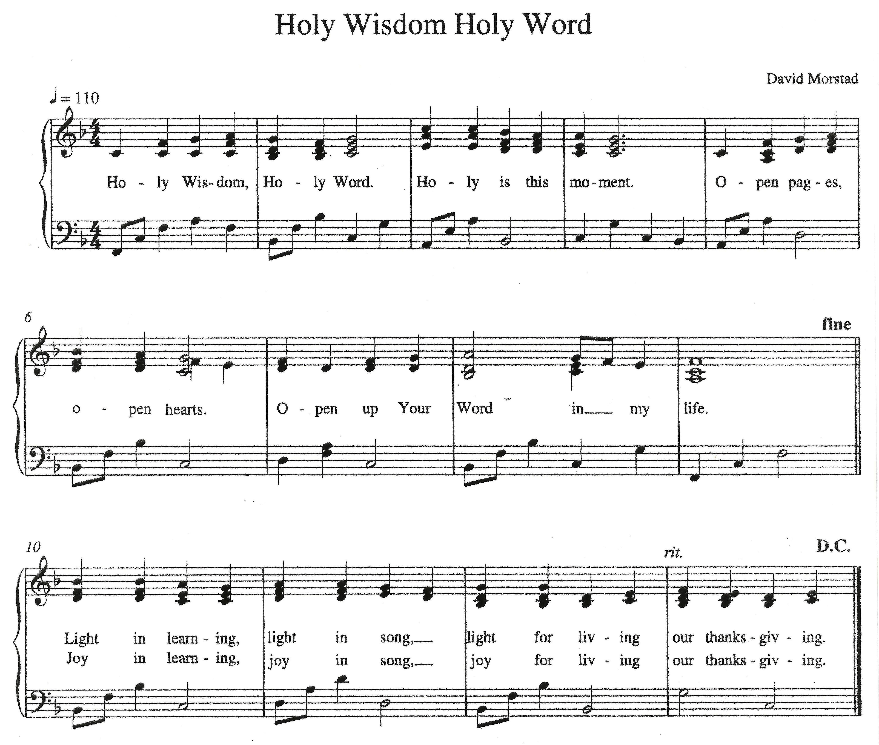Holy Wisdom, Holy Word?

Holy Wisdom, Holy Word Text and Music: David Morstad, My Word! The Bible for EveryOne 2009-2010 Christian Education Planning Guide developed by ELCA Christian Education of the Evangelical Outreach and Congregational Mission unit. Copyright © 2009 Evangelical Lutheran Church in America. All rights reserved. Permission is granted to photocopy this resource provided copies are for local use only and each copy carries all copyright acknowledgments.

Today’s Assistants and Ministers

Greeters & Ushers ……………………………..……… Lee Peterson and students from LCC
Organist-Pianist ………………………………...……….….……………………..…… Sue Holst
Presiding Minister ……………………....……….…………… Deacon Cindy Cordes-Eversole
Reader ……………………………………….…………..…………….……………. LCC students
Altar Care ……………………………………………………….....………….. Michele Peterson
Refreshments ……………………………....…..………

Presence Last Week and December Presents

Attendance Sunday, January 22 = 57
Average Sunday Worship Attendance for December = 57

December Contributions: General Fund = $20,356 Designated Giving = $2,155
Jan-Dec Income = $160,742 Jan-Dec Expenses = $167,925 Deficit = $7,183

This Week in Our Congregation

Today, January 29 — Fourth Sunday after Epiphany

Sunday School after the children’s message
Refreshments in the Fellowship Hall for everyone following worship
7th & 8th Grade Confirmation Session 10:15 AM

Tuesday, January 31

Men’s breakfast at Home Sweet Home, Lanesboro 7:00 AM
LYO takes out trash at Kenilworth & Sylvan Manor afternoon or evening

Wednesday, February 1

WELCA Sew Day 9:00 AM
Appreciation lunch for our quilters and knitters 11:30 AM
WELCA Business meeting following lunch

Next Sunday, February 5 — Fifth Sunday after Epiphany

Worship with Holy Communion 9:00 AM
Sunday School after the children’s message
7th & 8th Grade Confirmation Session 10:15 AM

News and Notes

Lutheran Campus Ministry and Hymn Sing today! Students from the Lutheran Campus Center in Winona are assisting with our worship service this morning. They will be receiving a free-will offering to benefit Lutheran collegiate ministry in the Winona area. In addition, our worship leaders will be asking for hymn requests throughout the service, so be ready to shout out your favorites.

Quilters and Knitters Gratitude Lunch Wednesday, February 1! The WELCA wishes to thank the members of our Lutheran World Relief quilting group and our knitting ministry.

Continued on the next page.
The WELCA officers will serve lunch in their honor at 11:30 am on Wednesday, February 1. The WELCA will have a business meeting following lunch. All women are invited to attend.

Attention youth! Help takeout trash at Kenilworth & Sylvan Manor. Volunteer on Tuesday afternoon or evening for about 30-45 minutes to pick up trash bags and carry them out to the dumpster for garbage or recycling. You can sign up by using the following sign-up genius link at https://www.signupgenius.com/go/20F0D4DAFA82DA2F58-manor. We have one slot per week available until the end of April, so feel free to sign up for two or more dates. Bring your siblings along to help. Friends are welcome from outside our church of course! Contact Kristi Ruen at 507- 421-2924 (cell) or kristiruen@lanesboroschools.com if you have any questions.

Thank you for contributing to our Noisy Offering! $105.13 was recently given to the Food Shelf in Preston.

Print & mail forms are available and online registration is open for Summer 2023 at Good Earth Village Bible Camp! Use code EARLY23 to save 10% on registration fees, excludes preschool play day. For a limited time, each camper registered can receive a free summer theme t-shirt. One t-shirt per camper if registered for multiple camps. Siblings each receive a 25% discount with code SIBLING23. Go to www.goodearthvillage.org to register or call (507) 346-2494 or email info@goodearthvillage.org.

Prayer Requests

In Our Community. For our church members and friends living with chronic illness and other diseases, who are homebound, residing in care facilities, and hospitalized. See the newsletter for our members living in area nursing homes. And let us not forget those sick and dying of COVID-19, those entrusted with the authority of government, justice, and law enforcement, as well as our fallen and wounded soldiers and those still serving.

In Our Synod. Bishop Regina Hassanally invites the people and congregations of our Southeastern Minnesota Synod to make a commitment to pray this week for the following faith communities: First Evangelical Lutheran Church, Kenyon; United Lutheran Church, Red Wing; St. Michael Lutheran Church, Waltham; Msingi Lutheran Church, Tanzania; Mazoezi Nkhoiree Lutheran Church, Tanzania; and San Marcos Lutheran Church, Colombia.

Acknowledgments

Graphics, worship texts, prayers, and readings are from sundaysandseasons.com © 2023 Augsburg Fortress. Used by permission under Augsburg Fortress Liturgies Annual License SAS103296.

Permission to project, live stream, or podcast liturgy and music content under copyright to or administered by Augsburg Fortress provided under Augsburg Fortress Liturgies Annual License SAS103296.

Permission to Podcast / Stream provided by One License, Inc., under License # A-735588. An additional fee was paid. www.onelicense.net.

Permission to Podcast / Stream provided by Christian Copyright Licensing International, Inc., under License # 11459672. An additional fee was paid. www.ccli.com.

