Bethlehem Lutheran Church
Established 1874


Rev. Kerry B. Eversole, Pastor
Deacon Cindy Cordes-Eversole, Associate in Ministry

Mailing Address: P.O. Box 314, Lanesboro, MN 55949-0314
Physical Address: 200 Kenilworth Ave S, Lanesboro, Minn.

Telephone: 507.467.3344
E-mail Address: bethlehem@acegroup.cc
Website: www.staronthehill.com
Facebook Page: www.facebook.com/BethlehemLutheranLanesboro

Office Hours: Tuesday, Wednesday, Thursday 10 a.m. to 3 p.m.
Parsonage Phone: 507.467.3017
Pastor Kerry’s Cell Phone: 507.951.3954

Bethlehem Lutheran Church
Lanesboro, Minnesota

Third Sunday after Epiphany

January 22, 2023


As [Jesus] walked by the Sea of Galilee, he saw two brothers, Simon, who is called Peter, and Andrew his brother, casting a net into the sea—for they were fishermen. And he said to them, “Follow me, and I will make you fish for people.” Immediately they left their nets and followed him. Matthew 3:18-20
Welcome to worship at Bethlehem Lutheran Church
and our celebration of God’s Light arising upon us!
Isaiah 60:1-3; John 1:1-5

COVID-19 Practices — Out of love for God and Neighbor

1) Use hand sanitizer upon entry. Wash your hands and use hand sanitizer often while in the facility.
2) Members and visitors who are vaccinated and boosted are not required to wear a mask.
3) Members and visitors are free to wear a mask if they wish to do so.
4) Unvaccinated and not boosted members and visitors must wear a mask.
5) There are no physical distancing requirements, but you are welcome to keep a distance from others in the sanctuary as you are able.
6) All are welcome to enjoy coffee fellowship in the dining room following worship.

Worship Book and Hymns. This morning’s service is printed in this bulletin and can also be found with all the hymns in Evangelical Lutheran Worship (ELW), “the red book” in the pews. Hymns in ELW are indicated by a large bold number in each page’s left or right margin.

Abbreviations. Hymns are signified throughout this worship folder by the pound symbol (#); P: refers to the presiding minister or preacher; A: denotes an assisting minister; and C: and/or bold text indicates the congregation.

Offering. Later in our service, we will be receiving an offering. The offering is an opportunity to worship God with our money. We know that the money you give to Bethlehem Lutheran Church represents your lives — your time, talents, and hard work. We recognize that and we appreciate your generosity. Your support not only helps all of us to fulfill God’s call on our lives, but it also makes an impact, and we thank you! Lastly, our visitors are not expected to give. After all, you are our guests! We’re glad you’re here and we want you to feel welcomed!

Mistakes do not happen in our worship service;
only unexpected events which are opportunities for joy!

An asterisk () signifies that you may stand, as you are comfortably able.


Gathering

The Holy Spirit calls us together as the people of God.

Introduction to the day. The Epiphany (January 6) commemorates the appearance, the manifestation, or simply, the revelation of God’s long-awaited Messiah to all the peoples of the world by means of the magi coming to the young Jesus (Matthew 2:1-12). Jesus’s baptism reveals him as the Spirit-anointed and beloved Son of God (Matthew 3:13-17). Last Sunday’s Gospel told us that Jesus is the Lamb of God who takes away the sin of the world (John 1:29-35). Today, Jesus begins his public ministry by calling fishers to leave their nets and follow him. In Jesus, the kingdom of God has come near. We who have walked in darkness have seen a great light. We see this light most profoundly on the cross—as God suffers with us and all who are oppressed by sickness, sin, or evil. Light dawns for us as we gather around the word, the font, and the holy table. We are then sent to share the good news that others may be “caught” in the net of God’s grace and mercy.

MUSIC AS WE COME TOGETHER

RINGING OF THE BELL

WELCOME

OPENING SONG I Love to Tell the Story ELW # 661

GREETING ELW p. 213

P: The grace of our Lord Jesus Christ, the love of God, and the communion of the Holy Spirit be with you all.

C: And also with you.

KYRIE ELW p. 213
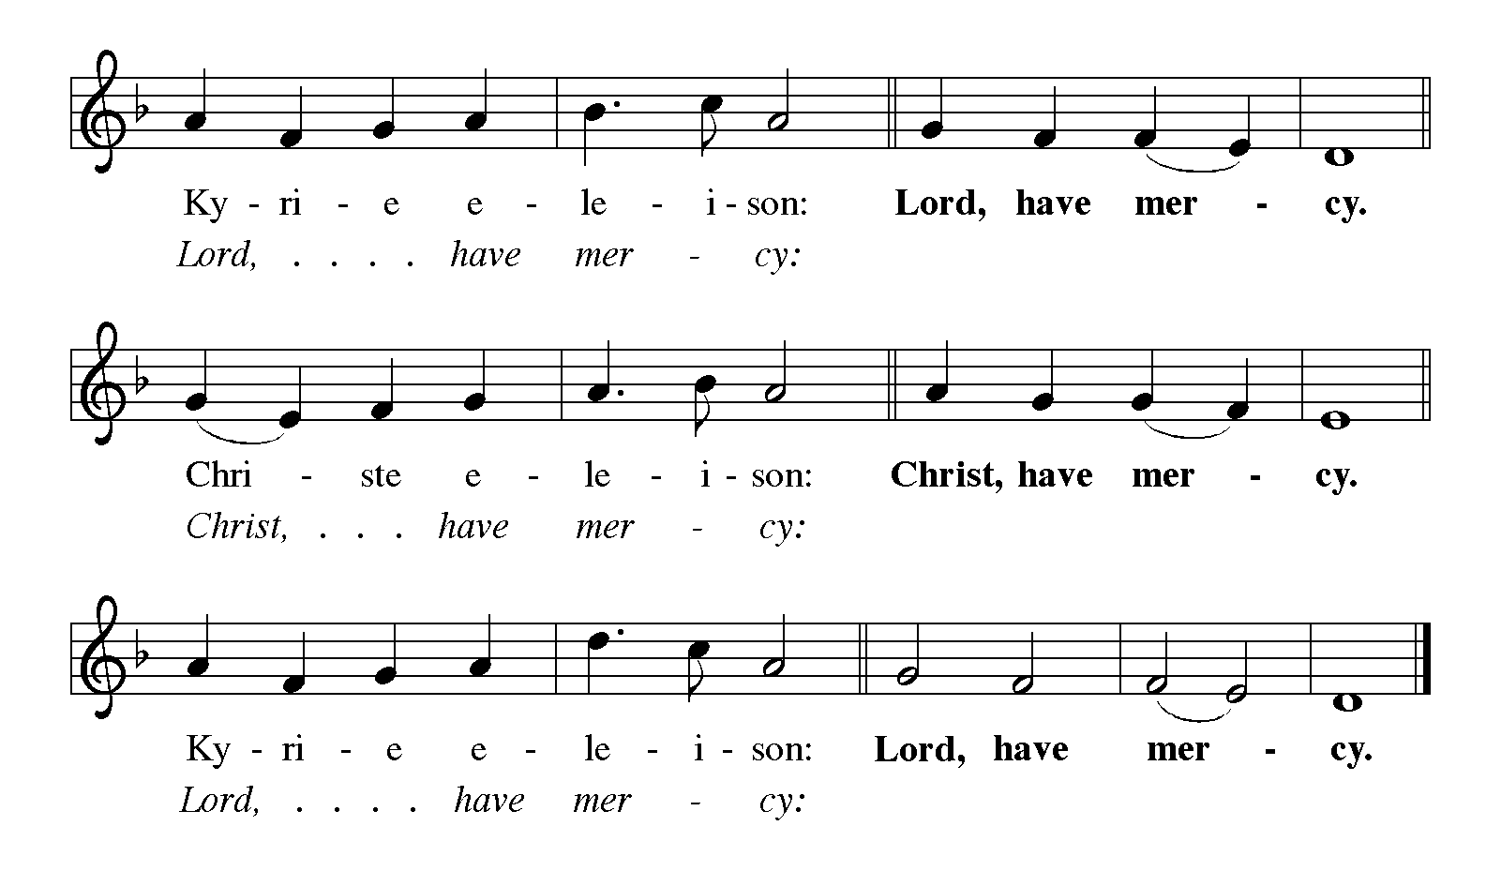

Continued on the next page.

KYRIE continued ELW p. 213

CANTICLE OF PRAISE Glory to God ELW pp. 213-214
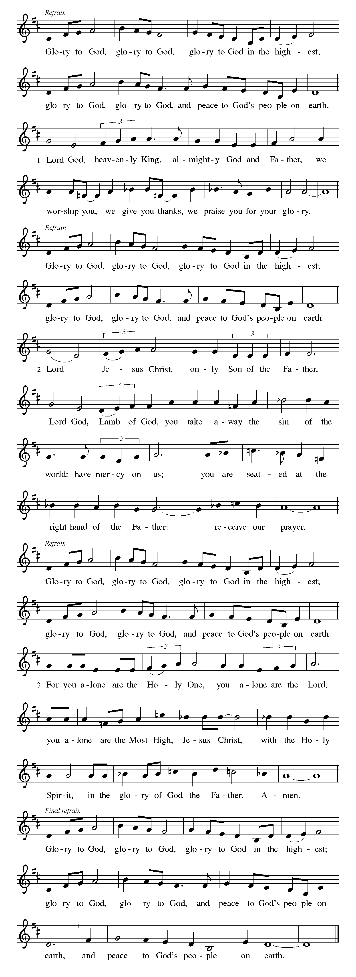

Continued on the next page.

CANTICLE OF PRAISE continued ELW p. 214

Continued on the next page.

CANTICLE OF PRAISE continued ELW pp. 214-215

PRAYER OF THE DAY

P: Let us pray together.

Lord God,

All: your lovingkindness always goes before us and follows after us. Summon us into your light and direct our steps in the ways of goodness that come through the cross of your Son, Jesus Christ, our Savior and Lord. Amen.

Word

God speaks to us in scripture reading, preaching, and song.

FIRST READING Isaiah 9:1-4

The northern tribes of Zebulun and Naphtali experienced the gloom of defeat by Assyrian military forces, but they are assured that their condition will be reversed when God makes a light-filled appearance. The joy they will experience will resemble celebrations of great harvests, because God will deliver them from everything that diminishes or oppresses them.

¹There will be no gloom for those who were in anguish. In the former time [the Lord] brought into contempt the land of Zebulun and the land of Naphtali, but in the latter time he will make glorious the way of the sea, the land beyond the Jordan, Galilee of the nations.
²The people who walked in darkness
have seen a great light;
those who lived in a land of deep darkness—
on them light has shined.
³You have multiplied the nation,
you have increased its joy;
they rejoice before you
as with joy at the harvest,
as people exult when dividing plunder.
⁴For the yoke of their burden,
and the bar across their shoulders,
the rod of their oppressor,
you have broken as on the day of Midian.

A: The word of the Lord.

C: Thanks be to God.

SECOND READING Psalm 27:1, 4-9 Read Responsively

¹The Lord is my light and my salvation; whom then shall I fear? The Lord is the stronghold of my life; of whom shall I be afraid?

⁴One thing I ask of the Lord; one thing I seek; that I may dwell in the house of the Lord all the days of my life; to gaze upon the beauty of the Lord and to seek God | in the temple.

⁵For in the day of trouble God will give me shelter, hide me in the hidden places of the sanctuary, and raise me high upon a rock.

⁶Even now my head is lifted up above my enemies who surround me. Therefore I will offer sacrifice in the sanctuary, sacrifices of rejoicing; I will sing and make music to the Lord.

⁷Hear my voice, O Lord, when I call; have mercy on me and answer me.

⁸My heart speaks your message—“Seek my face.” Your face, O Lord, I will seek.

⁹Hide not your face from me, turn not away from your servant in anger. Cast me not away—you have been my helper; forsake me not, O God of my salvation.

¹The Lord is my light and my salvation; whom then shall I fear? The Lord is the stronghold of my life; of whom shall I be afraid?

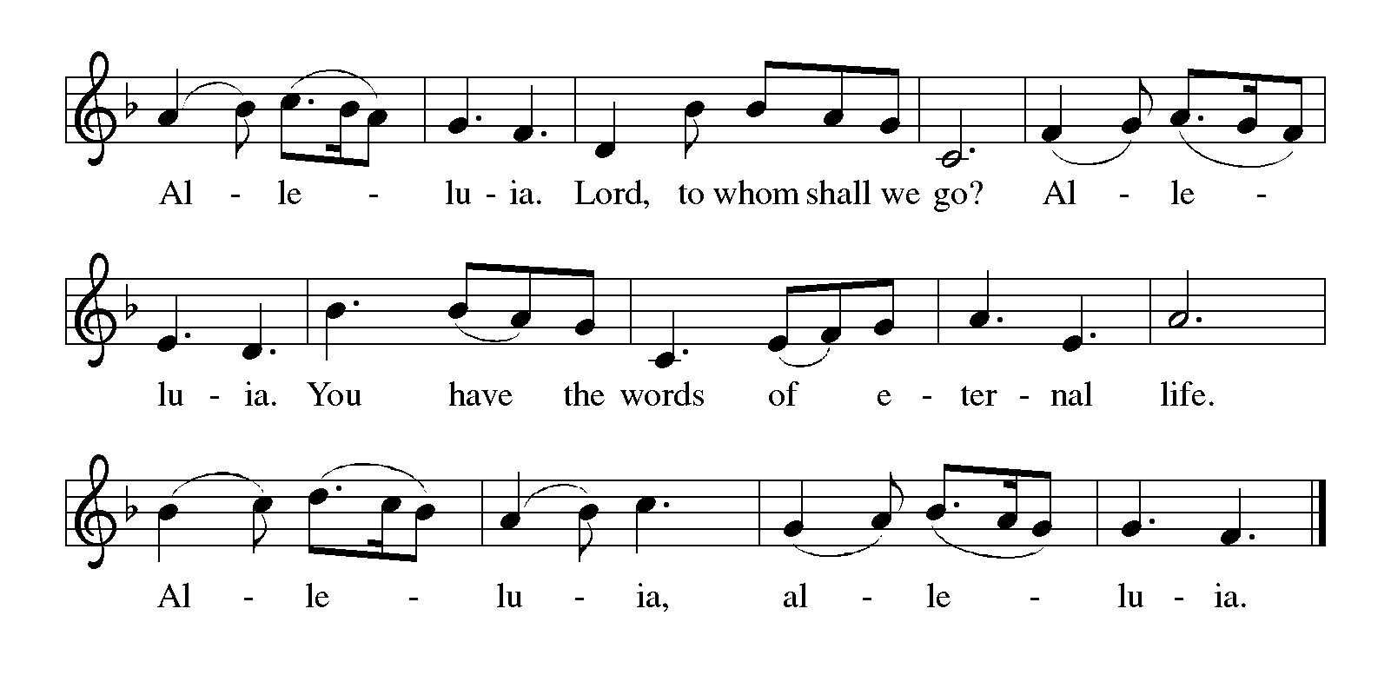GOSPEL ACCLAMATION Alleluia ELW p. 216

GOSPEL Matthew 4:12-23

P: Announcement of the Gospel.

C: Glory to you, O Lord.

Jesus begins his public ministry shortly after John the Baptist is imprisoned by Herod. He proclaims the nearness of God’s reign and calls four fishermen to be his first disciples.

¹²Now when Jesus heard that John had been arrested, he withdrew to Galilee. ¹³He left Nazareth and made his home in Capernaum by the sea, in the territory of Zebulun and Naphtali, ¹⁴so that what had been spoken through the prophet Isaiah might be fulfilled:
¹⁵“Land of Zebulun, land of Naphtali,
on the road by the sea, across the Jordan, Galilee of the Gentiles—
¹⁶the people who sat in darkness
have seen a great light,
and for those who sat in the region and shadow of death
light has dawned.”
¹⁷From that time Jesus began to proclaim, “Repent, for the kingdom of heaven has come near.”
¹⁸As he walked by the Sea of Galilee, he saw two brothers, Simon, who is called Peter, and Andrew his brother, casting a net into the sea—for they were fishermen. ¹⁹And he said to them, “Follow me, and I will make you fish for people.” ²⁰Immediately they left their nets and followed him. ²¹As he went from there, he saw two other brothers, James son of Zebedee and his brother John, in the boat with their father Zebedee, mending their nets, and he called them. ²²Immediately they left the boat and their father, and followed him.
²³Jesus went throughout Galilee, teaching in their synagogues and proclaiming the good news of the kingdom and curing every disease and every sickness among the people.

P: Affirmation of the Gospel.

C: Praise to you, O Christ.

SERMON

SONG OF THE DAY Will You Come and Follow Me ELW # 798

Stanzas 1, 2, 4 and 5

PRAYERS OF GOD’S PEOPLE

After the last petition, all sing ELW # 752

Lord, Listen to Your Children Praying

Meal

God feeds us with the presence of Jesus Christ.

OFFERING Music by the Praise Band

At this point in our service, we worship God with our money. The ushers will pass plates down the pews to receive your gifts of cash and checks made out to Bethlehem Lutheran Church. You can even give online at https://secure.myvanco.com/L-Z22R/. Your gifts support the worship, faith formation, administration, and other ministries of
Bethlehem Lutheran as well as the mission of the Southeastern Minnesota Synod, and the whole Evangelical Lutheran Church in America. Loose change goes to the Fillmore County Food Shelf in Preston. God bless your giving and your generosity. And thank you!

OFFERING SONG What Have We to Offer?

Printed at the end of the bulletin.

OFFERING PRAYER

P: Liberating God, you break the bonds of injustice and let the oppressed go free. Receive these offerings in thanksgiving for all your works of merciful power, and shape us as people of your justice and freedom. You we magnify and adore, through Jesus our Savior,

C: Amen.

THE GREAT THANKSGIVING

Dialogue Spoken, Not Sung

P: The Lord be with you.

C: And also with you.

P: Lift up your hearts.

C: We lift them to the Lord.

P: Let us give thanks to the Lord our God.

C: It is right to give our thanks and praise.

Preface

P: It is indeed right, our duty and our joy, that we should at all times and in all places give thanks and praise to you, almighty and merciful God, through our Savior Jesus Christ; who on this day overcame death and the grave, and by his glorious resurrection opened to us the way of everlasting life. And so, with all the choirs of angels, with the church on earth and the hosts of heaven, we praise your name and join their unending hymn:

Holy, Holy, Holy (the angels’ song) Spoken, Not Sung

All: Holy, holy, holy Lord, God of power and might, heav'n and earth are full of your glory. Hosanna in the highest. Blessed is he who comes in the name of the Lord. Hosanna in the highest, hosanna in the highest.

Thanksgiving at the Table

P: Holy, mighty, and merciful Lord, heaven and earth are full of your glory. In great love you sent to us Jesus, your Son, who reached out to heal the sick and suffering, who preached good news to the poor, and who, on the cross, opened his arms to all.

In the night in which he was betrayed, our Lord Jesus took bread, and gave thanks; broke it, and gave it to his disciples, saying: Take and eat; this is my body, given for you. Do this for the remembrance of me.

Again, after supper, he took the cup, gave thanks, and gave it for all to drink, saying: This cup is the new covenant in my blood, shed for you and for all people for the forgiveness of sin. Do this for the remembrance of me.

Remembering, therefore, his death, resurrection, and ascension, we await his coming in glory.

Pour out upon us the Spirit of your love, O Lord, and unite the wills of all who share this heavenly food, the body and blood of Jesus Christ, our Lord; to whom, with you and the Holy Spirit, be all honor and glory, now and forever.

C: Amen.

LORD’S PRAYER Traditional Wording

P: Gathered into one by the Holy Spirit, let us pray as Jesus taught us.

All: Our Father, who art in heaven, hallowed be thy name, thy kingdom come, thy will be done, on earth as it is in heaven. Give us this day our daily bread; and forgive us our trespasses, as we forgive those who trespass against us; and lead us not into temptation, but deliver us from evil. For thine is the kingdom, and the power, and the glory, forever and ever. Amen.

INVITATION TO COMMUNION

P: Come and taste the joy of God!

COMMUNION

What We Believe

Who May Receive. We welcome all baptized Christians to the Lord's Table. In our church baptized children who have entered the 5th grade are instructed in this sacrament and receive their First Communion; younger children come to the altar and receive a blessing. If your baptized child has received such instruction, or if you want your baptized child to receive Communion, then he or she is welcome to partake.

Proper Preparation. In his Small Catechism, Martin Luther asks, “When is a person rightly prepared to receive this sacrament?” He answers, “Fasting and other outward preparations serve a good purpose. However, that person is well prepared and worthy who believes these words, given and shed for you for the remission of sins. But anyone who does not believe these words, or doubts them, is neither prepared nor worthy, for the words for you require simply a believing heart.”

Real Presence. We believe that the bread and wine truly are the body and blood of Christ given and shed for the forgiveness of sins.

Distribution

Holy Communion will be served in procession, one side of the sanctuary at a time; please keep some distance from the person in front of you. The ushers will direct you when to make your way to the front of the church using the center aisle.
You will receive the elements near the chancel. Please extend your hands, palms up, if you will be receiving the bread. Gluten-free wafers are also available; please ask for one. Proceed to your right or to your left depending on which side of the sanctuary you are seated on to receive the wine. White grape juice is also available in the center ring of each tray for those who prefer an alcohol-free element. You may say “Amen” after receiving each element.

Continued on the next page.
If you will not be receiving Communion, especially young children, then keep your hands folded for a blessing. Place your empty cup in the basket and then return to your seat by the side aisle.

Congregational Songs During Communion

One Bread, One Body ELW # 496

Here I Am, Lord ELW # 574

Shine, Jesus, Shine ELW # 671

Jesus Calls Us; o’er the Tumult ELW # 696

PRAYER AFTER COMMUNION

P: Holy One, we thank you for the healing that springs forth abundantly from this table. Renew our strength to do justice, love kindness, and journey humbly with you.

C: Amen.

Sending

God blesses us and sends us in mission to the world.

ANNOUNCEMENTS

BLESSING

P: The God who faithfully brings forth justice
and breaks the oppressor’s rod
☩ bless, strengthen, and uphold you,
today and always.

C: Amen.

CLOSING SONG We Are Marching in the Light ELW # 866

DISMISSAL

A: Go in peace. Follow the way of Jesus.

C: Thanks be to God.

RINGING OF THE BELL

DEPARTING MUSIC

What Have We to Offer?
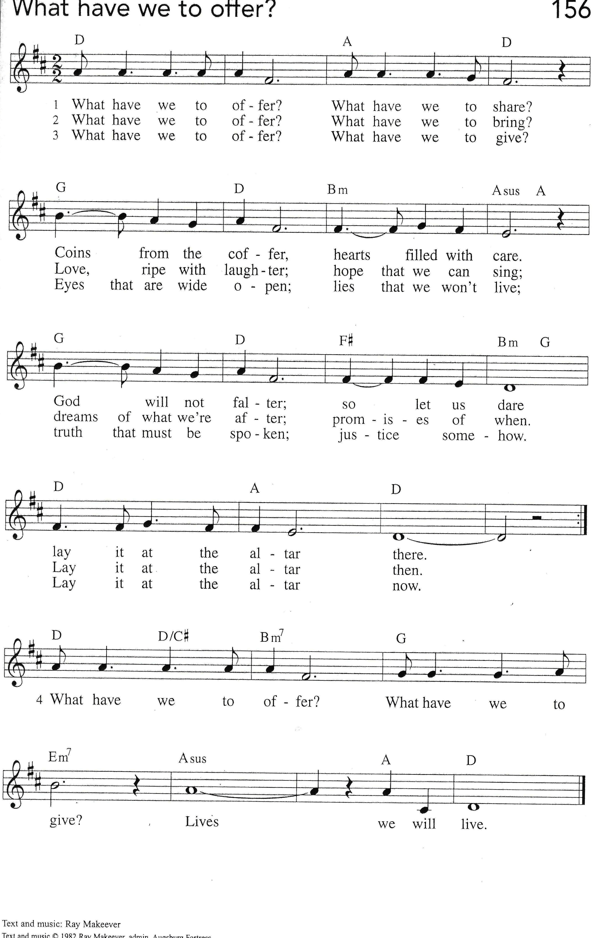
Today’s Assistants and Ministers

Greeters & Ushers …………………………..……....…..……… Tom Holst and Lee Peterson
Musicians ……………………………………….………..……………………..…… Praise Band
Presiding Minister ………………………………….……….…………… Pastor Kerry Eversole
Reader ……………………………………….…………..…………..…………………. Tom Holst
Altar Care & Communion Preparation ………………………....……… ….. Michele Peterson
Refreshments ……………………………....…..……… Tom & Sue Holst and Julie Schreiber

Presence Last Week and December Presents

Attendance Sunday, January 15 = 45
Average Sunday Worship Attendance for December = 57

December Contributions: General Fund = $20,356 Designated Giving = $2,155
Jan-Dec Income = $160,742 Jan-Dec Expenses = $167,925 Deficit = $7,183

This Week in Our Congregation

Today, January 22 — Third Sunday after Epiphany

Sunday School after the children’s message
Annual Meeting of the Congregation after worship and following a brief time for
refreshments in the Fellowship Hall
NO 7th & 8th Grade Confirmation Session because of the annual meeting

Tuesday, January 24

Men’s breakfast at Home Sweet Home, Lanesboro 7:00 AM
LYO takes out trash at Kenilworth & Sylvan Manor afternoon or evening

Wednesday, January 25

WELCA Bible study in the Fellowship Hall 9:00 AM

Thursday, January 26

Pastor Kerry at Park Lane Estates, Preston, for Bible study/chapel 9:30 AM

Next Sunday, January 29 — Fourth Sunday after Epiphany

Worship with the Lutheran Campus Center 9:00 AM
Sunday School after the children’s message
7th & 8th Grade Confirmation Session

News and Notes

Annual meeting of the congregation, today, following the worship service. The meeting will take place in the Fellowship Hall/Dining room. The purpose of this meeting is to present the mission and ministries carried out in 2022, elect leaders, adopt a spending plan for 2023, and conduct any other business that may properly come before the congregation. All members who are both baptized and confirmed are voting members.

Continued on the insert.
News and Notes continued

Lutheran Campus Ministry and Hymn Sing Sunday, January 29. Students from the Lutheran Campus Center in Winona will be assisting with our worship service next Sunday, January 29. They will be receiving a free-will offering to benefit Lutheran collegiate ministry in the Winona area. In addition, our worship leaders will be asking for hymn requests throughout the service, so come to worship with a few of your favorites in mind.

Looking ahead! Thank you, Quilters and Knitters! The WELCA wishes to thank the members of our Lutheran World Relief quilting group and our knitting ministry. WELCA officers will serve lunch in your honor at 11:30 am on Wednesday, February 1. The WELCA will have a business meeting following lunch. All women are invited to attend.

Attention youth! Help takeout trash at Kenilworth & Sylvan Manor. Volunteer on Tuesday afternoon or evening for about 30-45 minutes to pick up trash bags and carry them out to the dumpster for garbage or recycling. You can sign up by using the following sign-up genius link: Click here for Garbage Pick-Up Sign-up or use this web address https://www.signupgenius.com/go/20F0D4DAFA82DA2F58-manor. We have one slot per week available until the end of April, so feel free to sign up for two or more dates. Bring your siblings along to help. Friends are welcome from outside our church of course! Contact Kristi Ruen at 507- 421-2924 (cell) or kristiruen@lanesboroschools.com if you have any questions.

Print & mail forms are available and online registration is open for Summer 2023 at Good Earth Village Bible Camp! Use code EARLY23 to save 10% on registration fees, excludes preschool play day. For a limited time, each camper registered can receive a free summer theme t-shirt. One t-shirt per camper if registered for multiple camps. Siblings each receive a 25% discount with code SIBLING23, excludes Intergen Family Camp. Discounts cannot be combined. Go to www.goodearthvillage.org to register or call (507) 346-2494 or email info@goodearthvillage.org.

Prayer Requests

In Our Community. For our church members and friends living with chronic illness and other diseases, who are homebound, residing in care facilities, and hospitalized. See the newsletter for our members living in area nursing homes. And let us not forget those sick and dying of COVID-19, those entrusted with the authority of government, justice, and law enforcement, as well as our fallen and wounded soldiers and those still serving.

In Our Synod. Bishop Regina Hassanally invites the people and congregations of our Southeastern Minnesota Synod to make a commitment to pray this week for the following faith communities: Oakland Lutheran Church, Albert Lea; Christ Lutheran Church, Faribault; Cedar Valley Lutheran Church, Winona; Christ Lutheran Church, Preston; Grace Lutheran Church, Albert Lea; Nuer Sudanese Worshipping Community in Austin; and Mazoezi Minyughe Lutheran Church, Tanzania.

Acknowledgments

What Have We to Offer? Text and music by Ray Makeever. Text and tune: © 1982, Augsburg Fortress. Reprinted by permission of One License, Inc., under license # A-735588, song # 85939.

Graphics, worship texts, prayers, and readings are from sundaysandseasons.com © 2023 Augsburg Fortress. Used by permission under Augsburg Fortress Liturgies Annual License SAS103296.

Permission to project, live stream, or podcast liturgy and music content under copyright to or administered by Augsburg Fortress provided under Augsburg Fortress Liturgies Annual License SAS103296.

Permission to Podcast / Stream provided by One License, Inc., under License # A-735588. An additional fee was paid. www.onelicense.net.

Permission to Podcast / Stream provided by Christian Copyright Licensing International, Inc., under License # 11459672. An additional fee was paid. www.ccli.com.



FOLLOW ME
and I will make you fish for people.

