Bethlehem Lutheran Church
Established 1874
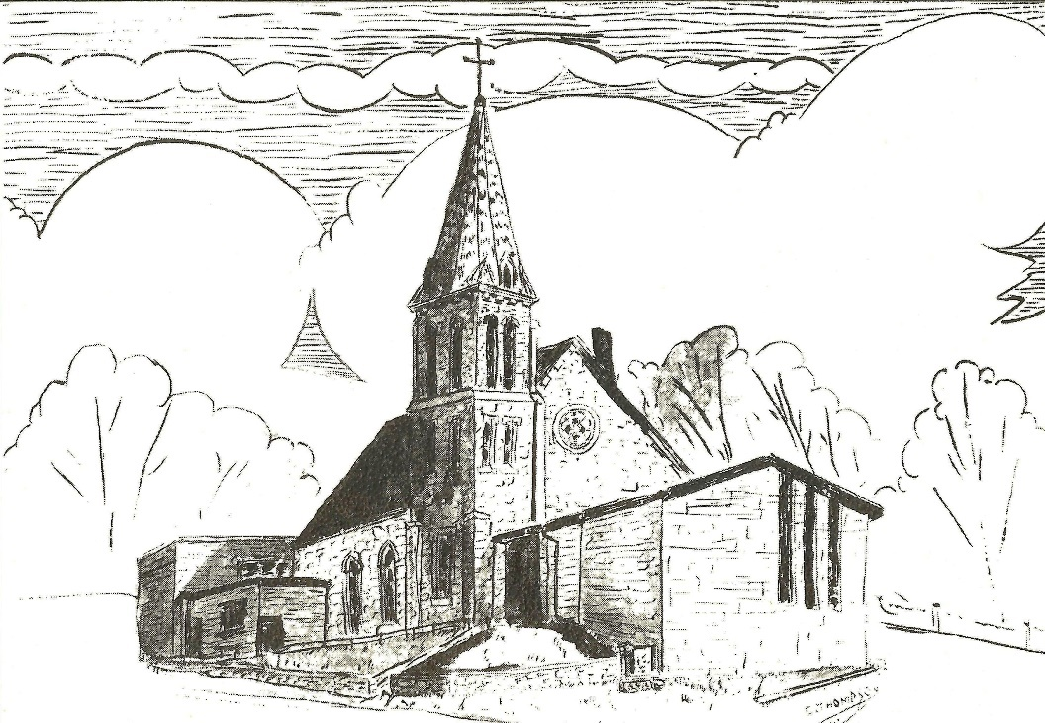

Rev. Kerry B. Eversole, Pastor
Deacon Cindy Cordes-Eversole, Associate in Ministry

Mailing Address: P.O. Box 314, Lanesboro, MN 55949-0314
Physical Address: 200 Kenilworth Ave S, Lanesboro, Minn.

Telephone: 507.467.3344
E-mail Address: bethlehem@acegroup.cc
Website: www.staronthehill.com
Facebook Page: www.facebook.com/BethlehemLutheranLanesboro/

Office Hours: Tuesday, Wednesday, Thursday 10 a.m. to 3 p.m.
Parsonage Phone: 507.467.3017
Pastor Kerry’s Cell Phone: 507.951.3954

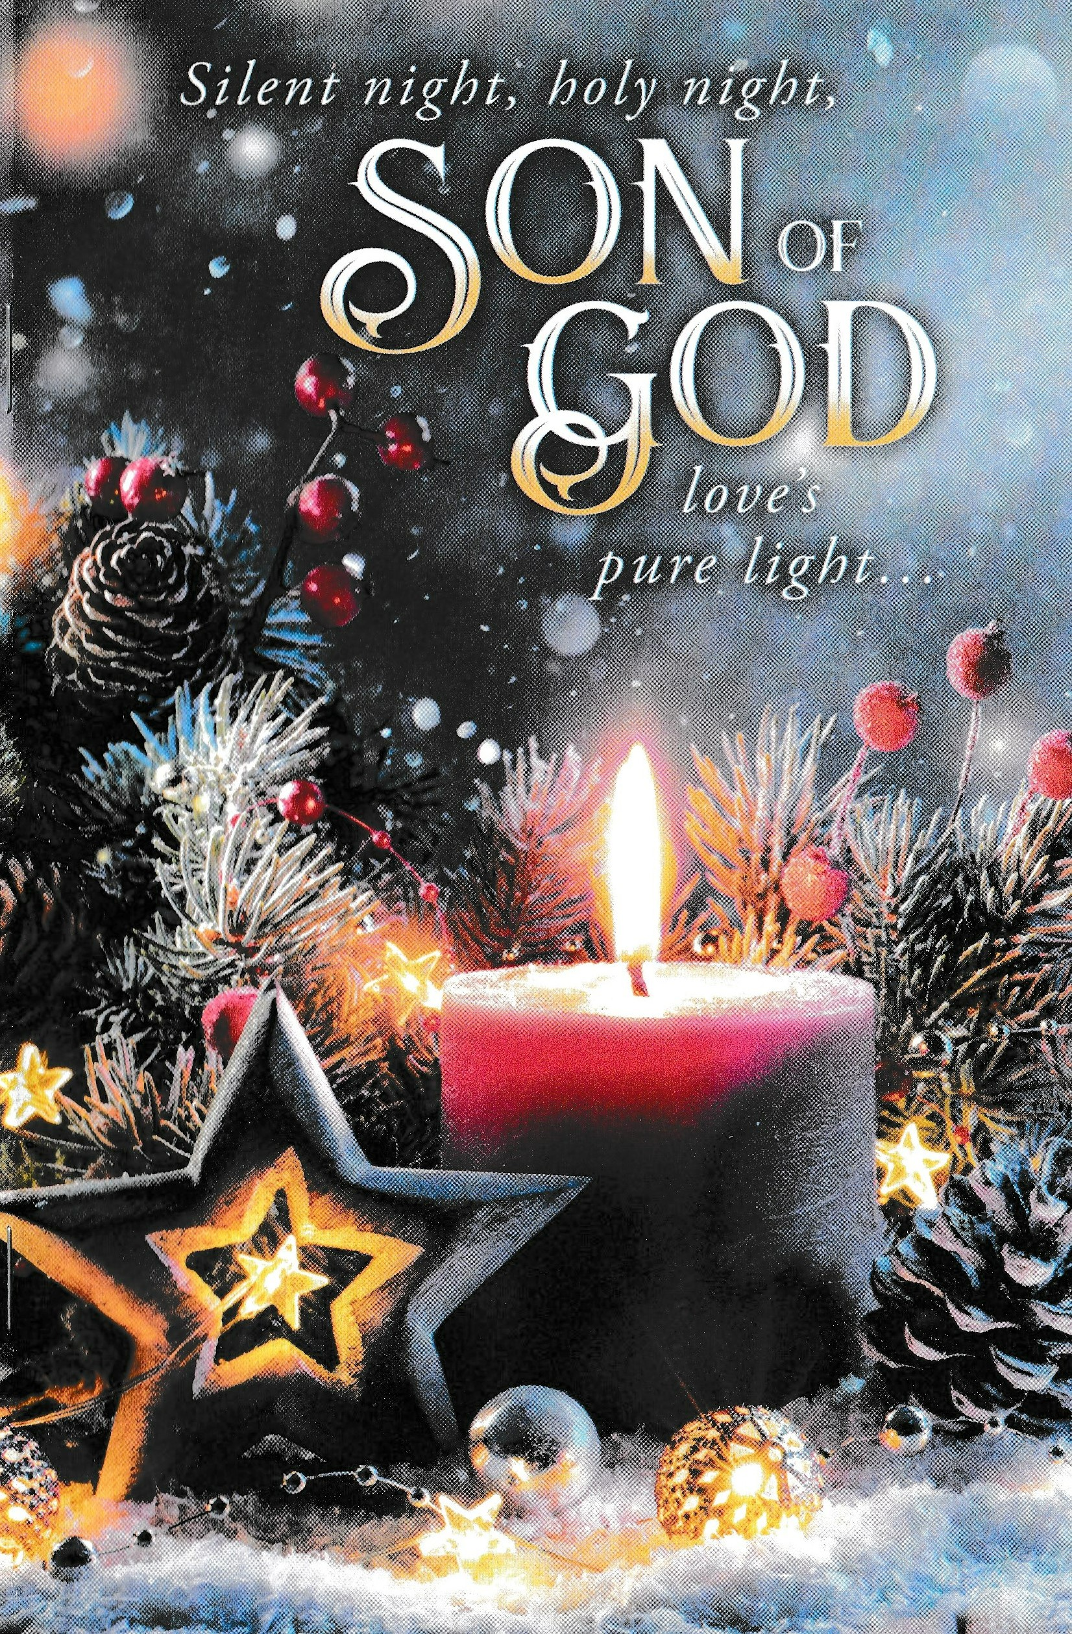

Welcome to Bethlehem Lutheran Church
and our celebration of the

Nativity of our Lord
Christmas Eve

Saturday, December 24, 2022

COVID-19 Practices — Out of love for God and Neighbor
1) Use hand sanitizer upon entry. Wash your hands and use hand sanitizer often while in the facility.
2) Members and visitors who are vaccinated and boosted are not required to wear a mask.
3) Members and visitors are free to wear a mask if they wish to do so.
4) Unvaccinated and not boosted members and visitors must wear a mask.
5) There are no physical distancing requirements, but you are welcome to keep a distance from others in the sanctuary as you are able.

Worship Book and Hymns. All the carols in this evening’s service can be found in Evangelical Lutheran Worship (ELW), “the red book” which is in the pews. Hymns in ELW are indicated by a large bold number on each page’s left or right margin.

Introduction to the Day. The word Christmas is based on the Latin phrase Cristes maesse or Christ mass. It really means “Christ’s feast” or the “celebration of Christ”. Tonight, we join with Christians all over the world to celebrate the great light of our salvation (see Isaiah 9:2 and Titus 2:11), as the evening sky is bright with the heavenly host singing, “Glory to God in the highest” (Luke 2:14). More than the celebration of a birth, Christmas marks the mystery of the incarnation: God sharing our humanity. In tonight’s worship, Christ is present among us as the word of hope and peace proclaimed to us, and as the Word made flesh in Holy Communion. Like the shepherds, we return to our homes, communities, and workplaces to tell of the wonders we have seen and heard, and to be bearers of the divine light to all the world.

Welcome to the party!
Gathering

MUSIC AS WE COME TOGETHER

RINGING OF THE BELL

LIGHTING THE CHRISTMAS WREATH

Responsive Litany

Pastor: Tonight, we celebrate our Savior’s birth with bold faith.

People: Our hearts are willing.

Pastor: Like Mary, who showed humble surrender:

People: Our hearts are willing.

Pastor: Like Joseph, who exhibited unconditional trust:

People: Our hearts are willing.

Pastor: Like the angels, who sang glorious praise:

People: Our hearts are willing.

Pastor: Like the shepherds, who displayed awestruck wonder:

People: Our hearts are willing.

Pastor: For all who are willing to receive the gift of the babe born in Bethlehem:

People: Grant that we might have the peace, love, and grace of the Christ child, tonight, tomorrow, and always.

Candle Lighting

Pastor: This evening, we light all the candles on the Christmas wreath. The first candle is the hope shining for those worn thin by times of waiting. The second candle is the hope shining for those worn down with wearied souls. The third candle captures the hopeful expectation of those eagerly watching for God’s glory in our day. The fourth candle is the hope of a new tomorrow shining for those seeking freedom from the wounds of this world. Finally, we light the Christ candle. This candle radiates the hope that Jesus the Christ brings for all who are willing to receive him.

OPENING CAROL O Come, All Ye Faithful ELW # 283

All sing stanzas 1, 2 and 3

PRAYER FOR CHRISTMAS EVE

Pastor: Let us pray together. Almighty God, you made this holy night shine with the brightness of the true Light.

All: Grant that here on earth we may walk in the light of Jesus's presence and in the last day wake to the brightness of his glory; through your Son, Jesus Christ our Lord, who lives and reigns with you and the Holy Spirit, one God, now and forever. Amen.

The Glad Tidings of
God’s Gift of Light & Grace & Truth

THE CHRISTMAS GOSPEL ACCORDING TO SAINT LUKE

Luke 2:1-7 Jesus is born of Mary in Bethlehem

Carol O Little Town of Bethlehem ELW # 279

All sing stanzas 1 and 2

Luke 2:8-12 An angel appears to shepherds

Carol The First Noel ELW # 300

All sing stanzas 1 and 2

Luke 2:13-14 A host of angels sing praises to God

Carol Hark! The Herald Angels Sing ELW # 270

All sing stanzas 1 and 3

Luke 2:15-16 The shepherds go to Bethlehem and find the Savior

Carol Away in a Manger ELW # 277

All sing stanzas 1, 2 and 3

Luke 2:17-20 The shepherds tell others of the Savior & praise God

Anthem Come See the Bethlehem Choir

CHRISTMAS MESSAGE

CAROL I Am So Glad Each Christmas Eve ELW # 271

Glen Jensson sings stanza 1 in Norwegian, sing along if you can
All sing stanzas 1, 2, 3 and 4 in English

OUR CHRISTMAS PRAYERS
God’s Gift of Light & Grace & Truth
in the Holy Meal

OUR CHRISTMAS GIFTS Music by the Bethlehem Choir

OFFERING CAROL What Child Is This ELW # 296

All sing stanzas 1 and 3

PRAYER FOR THE PRESENTS

Pastor: God of abundance, receive and bless these gifts we have offered. Join our hearts with the song of the angels and gather us at your table of celebration. Strengthen us to share with all the world the abundance of your grace upon grace, poured out in Jesus Christ, the Word made flesh.

People: Amen.

GREAT THANKSGIVING

DIALOGUE sung to O Come, All Ye Faithful ELW # 283

Pastor: The Lord be with you.

People: And with you, his servant.

Pastor: Oh, come, let us lift our hearts unto the Lord.

People: With hearts uplifted
Thanks to him we render:
With joy we come before him,
In gratefulness implore him
With thankful hearts adore him evermore!

PREFACE

Pastor: We indeed give thanks and praise to you, almighty Creator, heavenly Father, and merciful Lord…. And so, with the church on earth and the hosts of heaven, we praise your name and join their unending hymn:

SANCTUS sung to Hark! The Herald Angels Sing ELW # 270

Holy, holy, holy Lord! God of hosts, by all adored!
Heav’n and earth cannot contain all the glory of your name!
Hail, hosanna, God on high! Blest is he who now draws nigh
In the name of God the Son, hallelujahs glad we sing.
Hail, hosanna! Praises due be forever, Lord, to you!

THANKSGIVING AT THE TABLE

Pastor: You are indeed holy, God of heaven and earth, … Send now your Holy Spirit into our hearts, that we may receive our Lord Immanuel with a living faith as he comes to us in his holy Supper.

People: Amen. Come, Lord Jesus.

Pastor: In the night in which he was betrayed, our Lord Jesus took bread…. Do this for the remembrance of me.
Again, after supper, he took the cup…. Do this for the remembrance of me.

LORD’S PRAYER sung to Away in a Manger ELW # 278

Our Father in heaven, all praise to your name.
Your kingdom come to us, your will done the same.
Through angels and mortals you work, Lord, alone,
Oh, hear us and bless us from heaven’s high throne.

The bread that we yearn for provide us each day;
As we forgive others, our sins take away;
In times of temptation be with us so near;
From evil deliver your children most dear.

For yours is the kingdom, o’er all things you reign.
And yours is the power, all things you maintain.
To you be the glory, resounding again
From all of creation, forever! Amen.

INVITATION TO COMMUNION

Pastor: Glory to God in the highest! Come to the table of peace.

COMMUNION

What We Believe

Who May Receive. We welcome all baptized Christians to the Lord's Table. In our church, baptized children who have entered the 5th grade are instructed in this sacrament and receive their First Communion; younger children come and receive a blessing. If your baptized child has received such instruction, or if you want your baptized child to receive Communion, then he or she is welcome to partake.

Proper Preparation. In his Small Catechism, Martin Luther asks, “When is a person rightly prepared to receive this sacrament?” He answers, “Fasting and other outward preparations serve a good purpose. However, that person
is well prepared and worthy who believes these words, given and shed for you for the remission of sins. But anyone who does not believe these words, or doubts them, is neither prepared nor worthy, for the words for you require simply a believing heart.”

Real Presence. We believe that the bread and wine truly are the body and blood of Christ given and shed for the forgiveness of sins.

Distribution

Holy Communion will be served in procession. The ushers will direct you down the center aisle in two lines. Stand to the right side of the aisle if you are seated on the pulpit side of the church; stand to the left side of the aisle if you are seated on the organ side of the church. Keep some distance from the person(s) in front of you. You will receive the elements near the chancel. Extend your hands, palms up, in the shape of a manger, if you will be receiving the bread. Gluten-free wafers are available; please ask for one. Proceed to your right or to your left to receive the wine. White grape juice is also available in the center ring of each tray for those who prefer an alcohol-free element. You may say “Amen” after receiving each element. If you will not be receiving Communion, keep your hands folded. Place your empty cup in the basket and then return to your seat by the side aisle.

Carols by the Congregation During Communion

Angels, from the Realms of Glory ELW # 275 Sts. 1, 2, 3

Infant Holy, Infant Lowly ELW # 276 Sts. 1, 2

It Came Upon the Midnight Clear ELW # 282 Sts. 1, 2, 3

Your Little Ones, Dear Lord ELW # 286 Sts. 1, 2, 3

Go Tell It on the Mountain ELW # 290 Sts. 1, 2, 3

Love Has Come ELW # 292 Sts. 1, 2, 3

The Bells of Christmas ELW # 298 Sts. 1, 2, 3

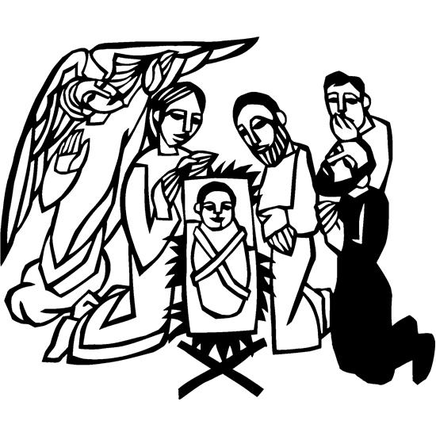PRAYER AFTER COMMUNION

Pastor: God our redeemer, you have fed us at this table with gifts of grace, truth, and life. As you have gathered us in joy, send us forth as messengers of your peace. Make us shine with the good news of your glory, born to us in Jesus Christ, our Savior and Lord.

People: Amen.

Service of Light

As the overhead lights are turned off, the ushers will light the candle of each worshipper nearest the aisle. Share the light! Lighted candles should not be tipped but held upright to prevent wax from dripping. Only the unlighted candle should be tilted when receiving light from a neighbor's candle.

THE CHRISTMAS GOSPEL ACCORDING TO SAINT JOHN

John 1:1-14, 16 Jesus is the Word of God made flesh, the one
who reveals God to be “full of grace and truth”

Carol Silent Night, Holy Night! ELW # 281

All sing stanzas 1, 2 and 3

Sending

BLESSING

Pastor: May the Lord God, who has called you out of darkness to live in his marvelous light, grant you the wonder of Mary, the commitment of Joseph, the joy of the angels, the eagerness of the shepherds, and the peace of the Christ Child. Almighty God, Father, Son, and Holy Spirit, bless you now and forever.

People: Amen.

As the overhead lights are turned on,
you may extinguish your candles.
Let the wax cool and harden before setting your candle down.

CLOSING CAROL Joy to the World ELW # 267

All sing stanzas 1, 2 and 4

SENDING MUSIC

Assistants and Ministers

Greeters-Ushers ……...…………………. Trent & Traci Olson and family
Organist-Pianist ……………..…………..………………………….Sue Holst
Presiding Minister ……….….….………. Deacon Cindy Cordes-Eversole
Altar Care & Communion Preparation ……………........….. Corky Olson
Communion Assistants ………………………….….…………. Volunteers
Custodian ………………………….……...…………….. Wayne Lukkason

Acknowledgments

Worship texts, readings, and graphics are from sundaysandseasons.com © 2022 Augsburg Fortress. Used by permission under Augsburg Fortress Liturgies Annual License SAS103296.

Permission to project, live stream, or podcast liturgy and music content under copyright to or administered by Augsburg Fortress provided under Augsburg Fortress Liturgies Annual License SAS103296.

Permission to Podcast / Stream provided by Christian Copyright Licensing International, Inc., under License # 11459672. An additional fee was paid. www.ccli.com.

Permission to Podcast / Stream provided by One License, Inc., under License # A-735588. An additional fee was paid. www.onelicense.net.

Lighting the Christmas Wreath written by Rev. Rich Davis, Senior Pastor, First Presbyterian Church, River Forest, IL. A date was not indicated.

We gratefully acknowledge the following individuals and families who donated poinsettias and other flowers to decorate
the church this Christmas season.
We sincerely apologize for any errors or omissions.

In loving memory of Mary Peterson
from Lee Peterson

In loving memory of Lucille and Orris Hareldson
from Diane Hareldson & Raymond Reese,
Caleb & Samantha, Daxyn and Charlie Hareldson, and
Kevin & Jackie, Tristen, Trinity and Jasper Hareldson

In loving memory of Jim Wagner
from Kim Wagner and the Wagner family

In loving memory of Brent and Loren & Carol Tufte
from Blaine, Mary, Grace, Kim, Alison, Rick and Peighton

In loving memory of Blake Overland
from Erik & Laurie Overland

In loving memory of Gloria Ruen and Andrew Ruen
from Mark & Pam Ruen

In loving memory of Gloria Ruen, Andrew Ruen,
and Howard & Lyla Ruen
from Charles Ruen

In loving memory of Kris and Eric Hall
from Curt & Jean Hall and family

In loving memory of Robert & Dartha Eversole and
Henry & Evalee Cordes
from Kerry & Cindy and
Rachel, Nathan, Matthew, Aaron, Benjamin and Sarah Eversole

In loving memory of Gloria Ruen, Andrew Ruen and Mary Ruen
from Eric & Kristi and
Leah, Bailey, Adam, Brielle, Carson and Luke Ruen



