Bethlehem Lutheran Church
Established 1874
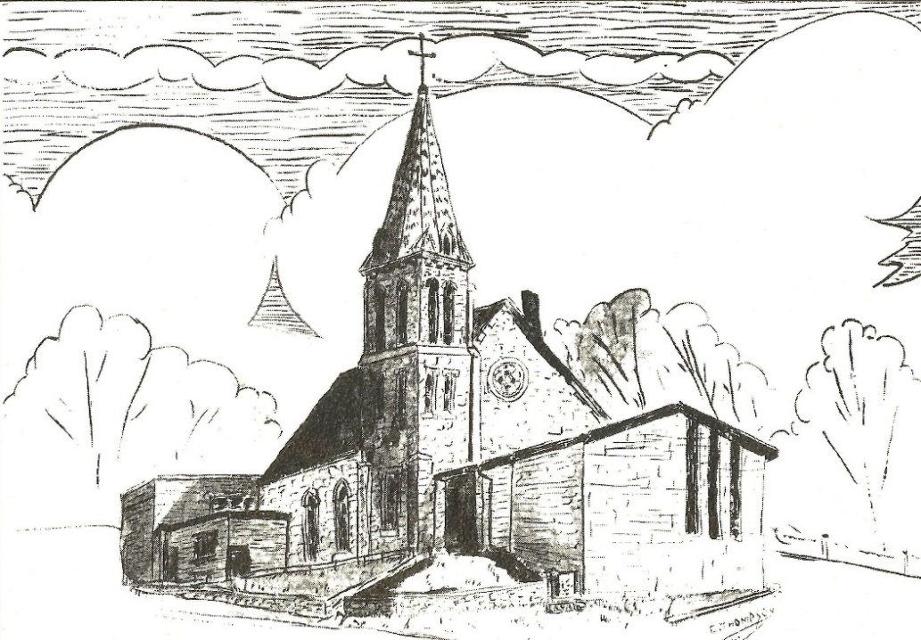

Rev. Kerry B. Eversole, Pastor
Deacon Cindy Cordes-Eversole, Associate in Ministry

Mailing Address: P.O. Box 314, Lanesboro, MN 55949-0314
Physical Address: 200 Kenilworth Ave S, Lanesboro, Minn.

Telephone: 507.467.3344
E-mail Address: bethlehem@acegroup.cc
Website: www.staronthehill.com
Facebook Page: www.facebook.com/BethlehemLutheranLanesboro/

Office Hours: Tuesday, Wednesday, Thursday 10 a.m. to 3 p.m.
Parsonage Phone: 507.467.3017

Pastor Kerry’s Cell Phone: 507.951.3954



Welcome to Bethlehem Lutheran Church
and our celebration of the

Nativity of our Lord
Christmas Day

Sunday, December 25, 2022 9:00 a.m.

COVID-19 Practices — Out of love for God and Neighbor
1) Use hand sanitizer upon entry. Wash your hands and use hand sanitizer often while in the facility.
2) Members and visitors who are vaccinated and boosted are not required to wear a mask.
3) Members and visitors are free to wear a mask if they wish to do so.
4) Unvaccinated and not boosted members and visitors must wear a mask.
5) There are no physical distancing requirements, but you are welcome to keep a distance from others in the sanctuary as you are able.

Worship Book and Hymns. All the carols in this morning’s service can be found in Evangelical Lutheran Worship (ELW), “the red book” which is in the pews. Hymns in ELW are indicated by a large bold number on each page’s left or right margin

Introduction to the Day. On this Christmas morning, the people of God gather to celebrate the incarnate Word, God becoming flesh to live among us in the person of Jesus Christ, then and now. Luke recounts the familiar story of the manger, shepherds, and angels; John’s gospel tells of the Word that dwells among us “full of grace and truth”. The meaning of Christmas is made clear: God’s light shines in the darkness. It is in the liturgy that we encounter the Word made flesh — in the people of God come together as the body of Christ, and in the bread and wine of the holy Eucharist. We go forth to declare to the world that we have indeed seen and been transformed by the arrival of “the salvation of our God”. O come, let us adore him!

Gathering

PRELUDE

RINGING OF THE BELL

PROCLAMATION OF THE BIRTH OF CHRIST

OPENING CAROL O Come, All Ye Faithful ELW # 283

GREETING

P: The grace of our Lord Jesus Christ, the love of God, and the communion of the Holy Spirit be with you all.

C: And also with you.

KYRIE

P: In peace, let us pray to the Lord.

C: Lord, have mercy.

P: For the peace from above, and for our salvation, let us pray to the Lord.

C: Lord, have mercy.

P: For the peace of the whole world, for the well-being of the church of God, and for the unity of all, let us pray to the Lord.

C: Lord, have mercy.

P: For this holy house, and for all who offer here their worship and praise, let us pray to the Lord.

C: Lord, have mercy.

P: Help, save, comfort, and defend us, gracious Lord.

C: Amen.

CAROL OF PRAISE Angels We Have Heard on High ELW # 289

Stanzas 1, 2 and 3

PRAYER FOR CHRISTMAS DAY

P: All-powerful and unseen God, the coming of your light into our world has brightened weary hearts with peace. Call us out of darkness, and empower us to proclaim the birth of your Son, Jesus Christ, our Savior and Lord, who lives and reigns with you and the Holy Spirit, one God, now and forever.

C: Amen.

Hearing the Good News of
God’s Gift of Light & Grace & Truth

FIRST READING Isaiah 62:6-12

The prophet invites the people to give God no rest until God reestablishes Jerusalem. In turn, they will receive names full of promise: Holy People, the Redeemed of the Lord, a City Not Forsaken.

⁶Upon your walls, O Jerusalem,
I have posted sentinels;
all day and all night
they shall never be silent.
You who remind the Lord,
take no rest,
⁷and give him no rest
until he establishes Jerusalem
and makes it renowned throughout the earth.
⁸The Lord has sworn by his right hand
and by his mighty arm:
I will not again give your grain
to be food for your enemies,
and foreigners shall not drink the wine
for which you have labored;
⁹but those who garner it shall eat it
and praise the Lord,
and those who gather it shall drink it
in my holy courts.
¹⁰Go through, go through the gates,
prepare the way for the people;
build up, build up the highway,
clear it of stones,
lift up an ensign over the peoples.
¹¹The Lord has proclaimed
to the end of the earth:
Say to daughter Zion,
“See, your salvation comes;
his reward is with him,
and his recompense before him.”
¹²They shall be called, “The Holy People,
The Redeemed of the Lord;
and you shall be called, “Sought Out,
A City Not Forsaken.”

SECOND READING Titus 3:4-7

God saves us not because of what we do. Rather, God is a God of mercy and salvation who graciously cleanses us in baptism and renews our lives through the Holy Spirit.

⁴When the goodness and loving kindness of God our Savior appeared, ⁵he saved us, not because of any works of righteousness that we had done, but according to his mercy, through the water of rebirth and renewal by the Holy Spirit. ⁶This Spirit he poured out on us richly through Jesus Christ our Savior, ⁷so that, having been justified by his grace, we might become heirs according to the hope of eternal life.

GOSPEL ACCLAMATION ELW # 270
Hark! The Herald Angels Sing

Stanza 1

CHRISTMAS GOSPEL Luke 2:1-20

The world’s deep night is shattered by the light of God’s new day. The glory of God is revealed to poor shepherds, who share the good news with others.

¹In those days a decree went out from Emperor Augustus that all the world should be registered. ²This was the first registration and was taken while Quirinius was governor of Syria. ³All went to their own towns to be registered. ⁴Joseph also went from the town of Nazareth in Galilee to Judea, to the city of David called Bethlehem, because he was descended from the house and family of David. ⁵He went to be registered with Mary, to whom he was engaged and who was expecting a child. ⁶While they were there, the time came for her to deliver her child. ⁷And she gave birth to her firstborn son and wrapped him in bands of cloth, and laid him in a manger, because there was no place for them in the inn.
⁸In that region there were shepherds living in the fields, keeping watch over their flock by night. ⁹Then an angel of the Lord stood before them, and the glory of the Lord shone around them, and they were terrified. ¹⁰But the angel said to them, “Do not be afraid; for see—I am bringing you good news of great joy for all the people: ¹¹to you is born this day in the city of David a Savior, who is the Messiah, the Lord. ¹²This will be a sign for you: you will find a child wrapped in bands of cloth and lying in a manger.” ¹³And suddenly there was with the angel a multitude of the heavenly host, praising God and saying,

¹⁴“Glory to God in the highest heaven,
and on earth peace among those whom he favors!”
¹⁵When the angels had left them and gone into heaven, the shepherds said to one another, “Let us go now to Bethlehem and see this thing that has taken place, which the Lord has made known to us.” ¹⁶So they went with haste and found Mary and Joseph, and the child lying in the manger. ¹⁷When they saw this, they made known what had been told them about this child; ¹⁸and all who heard it were amazed at what the shepherds told them. ¹⁹But Mary treasured all these words and pondered them in her heart. ²⁰The shepherds returned, glorifying and praising God for all they had heard and seen, as it had been told them.

GOSPEL ACCLAMATION ELW # 270
Hark! The Herald Angels Sing

Stanza 3

CHRISTMAS SERMON

CAROL OF THE DAY ELW # 288
Good Christian Friends, Rejoice

NICENE CREED ELW p. 104

All: We believe in one God, the Father, the Almighty, maker of heaven and earth, of all that is, seen and unseen.

We believe in one Lord, Jesus Christ, the only Son of God, eternally begotten of the Father, God from God, Light from Light, true God from true God, begotten, not made, of one Being with the Father; through him all things were made. For us and for our salvation he came down from heaven, was incarnate of the Holy Spirit and the virgin Mary and became truly human. For our sake he was crucified under Pontius Pilate; he suffered death and was buried. On the third day he rose again in accordance with the scriptures; he ascended into heaven and is seated at the right hand of the Father. He will come again in glory to judge the living and the dead, and his kingdom will have no end.

We believe in the Holy Spirit, the Lord, the giver of life, who proceeds from the Father and the Son, who with the Father and the Son is worshiped and glorified, who has spoken through the prophets. We believe in one holy catholic and apostolic church.

We acknowledge one baptism for the forgiveness of sins. We look for the resurrection of the dead, and the life of the world to come. Amen.

PRAYERS OF INTERCESSION

Each prayer ends with these words and response:

A: God of grace.

C: hear our prayer.

Concluding prayer:

A: Hear the hopes and prayers of all people on this holy day, O God, and increase our joy at the birth of your light, grace, and truth among us, Jesus Christ, our Savior and Lord.

C: Amen.

God’s Gift of Light & Grace & Truth
in the Sacrament of Holy Communion

OFFERING Music by Heidi Dybing

OFFERING CAROL What Child Is This ELW # 296

Stanzas 1 and 3

OFFERING PRAYER

A: God of abundance, receive and bless these gifts we have offered. Join our hearts with the song of the angels, and gather us at your table of celebration. Strengthen us to share with all the world the abundance of your grace upon grace, poured out in Jesus Christ, the Word made flesh.

C: Amen.

GREAT THANKSGIVING

Dialogue sung to Good Christians Friends, Rejoice ELW # 288

P: Oh, may the good Lord be with you.

C: And may the Lord be with you too.

P: Lift up your hearts to him in praise.

C: To the Lord our hearts we raise.

P: Let us offer thanks true.

C: It is fitting so to do. Gratefully we sing, to the Lord, our King!
Preface

P: It is indeed right, our duty and our joy…. And so, with all the choirs of angels, with the church on earth and the hosts of heaven, we praise your name and join their unending hymn:

Sanctus sung to Hark! The Herald Angels Sing ELW # 270

Holy, holy, holy Lord! God of hosts, by all adored!
Heav’n and earth cannot contain all the glory of your name!
Hail, hosanna, God on high! Blest is he who now draws nigh
In the name of God the Son, hallelujahs glad we sing.
Hail, hosanna! Praises due be forever, Lord, to you!

Thanksgiving at the Table

P: Holy one, the beginning and the end, ….

In the night in which he was betrayed, our Lord Jesus took bread, ... Do this for the remembrance of me.

Again, after supper, he took the cup, …. Do this for the remembrance of me.

Let us proclaim the mystery of faith:

C: Christ has died. Christ has risen. Christ will come again.

P: With this bread and cup we remember your Word … We look with hope for his coming.

C: Come, Lord Jesus.

P: Holy God, we long for your Spirit. … Bring the gift of peace on earth.

C: Come, Holy Spirit.

P: All praise and glory are yours Holy One of Israel … one God, now and forever.

C: Amen.

Lord’s Prayer sung to Away in a Manger ELW # 277

Our Father in heaven, all praise to your name.
Your kingdom come to us, your will done the same.
Through angels and mortals you work, Lord, alone,
Oh, hear us and bless us from heaven’s high throne.

The bread that we yearn for provide us each day;
As we forgive others, our sins take away;

Continued on the next page.
In times of temptation be with us so near;
From evil deliver your children most dear.

For yours is the kingdom, o’er all things you reign.
And yours is the power, all things you maintain.
To you be the glory, resounding again
From all of creation, forever! Amen.

INVITATION TO COMMUNION

P: Glory to God in the highest! Come to the table of peace.

COMMUNION

What We Believe

Who May Receive. We welcome all baptized Christians to the Lord's Table. In our church, baptized children who have entered the 5th grade are instructed in this sacrament and receive their First Communion; younger children come to the altar and receive a blessing. If your baptized child has received such instruction, or if you want your baptized child to receive Communion, then he or she is welcome to partake.

Proper Preparation. In his Small Catechism, Martin Luther asks, "When is a person rightly prepared to receive this sacrament?" He answers, "Fasting and other outward preparations serve a good purpose. However, that person is well prepared and worthy who believes these words, given and shed for you for the remission of sins. But anyone who does not believe these words, or doubts them, is neither prepared nor worthy, for the words for you require simply a believing heart.”

Real Presence. We accept that the bread and wine truly are the body and blood of Christ given and shed for the forgiveness of sins, new life, and salvation.

Distribution

Holy Communion will be served in procession, one side of the sanctuary at a time; please keep some distance from the person in front of you. The ushers will direct you when to make your way to the front of the church using the center aisle.
You will receive the elements near the chancel. Please extend your hands, palms up, in the form of a manger, if you will be receiving the bread. Gluten-free wafers are also available; please ask for one. Proceed to your right or to your left depending on which side of the sanctuary you are seated on to receive the wine. White grape juice is also available in the center ring of each tray for those who prefer an alcohol-free element.

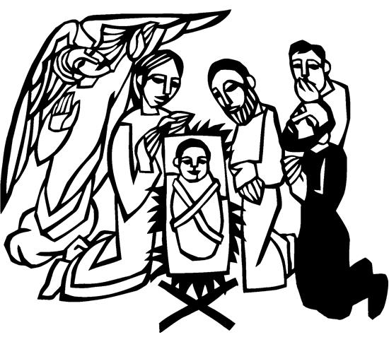
You may say “Amen” after receiving each element. If you will not be receiving Communion, especially young children, then keep your hands folded for a blessing. Place your empty cup in the basket and then return to your seat by the side aisle.

Carols During Communion by Karen Schreiber

CANTICLE sung to Angels, from the Realms of Glory ELW # 275

Thank the Lord, his praises voicing, for his promised faithfulness!
All who see, the Lord, rejoicing, tell his love, his name confess.
For he leads us, with thanksgiving, in the paths of righteousness.

At your Word, Lord, let your servant go in peace, for with my eyes
I have seen your bright salvation, Israel’s Light, begin to rise.
As the glory of the nations, leading us to Paradise.

PRAYER AFTER COMMUNION

A: God our redeemer, you have fed us at this table with gifts of grace, truth, and life. As you have gathered us in joy, send us forth as messengers of your peace. Make us shine with the good news of your glory, born to us in Jesus Christ, our Savior and Lord.

C: Amen.

Sending

BLESSING

P: God bless you and keep you,
☩ Jesus grant you grace and truth,
and the Spirit send peace upon your hearts,
now and forever.

C: Amen.

DEPARTING CAROL Let Altogether Praise Our God ELW # 287

Stanzas 1, 2, 3, 4 and 5

DISMISSAL

A: Christ the Savior is born! Go in peace. Proclaim this good news.

C: Thanks be to God.

RINGING OF THE BELL

POSTLUDE

Assistants and Ministers

Greeters-Ushers ……...…………………. Trent & Traci Olson and family
Pianist ……………..…………..………………………………. Heidi Dybing
Presiding Minister …………………………………. Pastor Kerry Eversole
Assisting Minister ……….….….………. Deacon Cindy Cordes-Eversole
Altar Care & Communion Preparation ……………........….. Corky Olson
Custodian ………………………….……...…………….. Wayne Lukkason

Acknowledgments

Some worship texts, prayers, readings, and graphics are from sundaysandseasons.com © 2022 Augsburg Fortress. Used by permission under Augsburg Fortress Liturgies Annual License SAS103296.

Permission to project, live stream, or podcast liturgy and music content under copyright to or administered by Augsburg Fortress provided under Augsburg Fortress Liturgies Annual License SAS103296.

Permission to Podcast / Stream provided by Christian Copyright Licensing International, Inc., under License # 11459672. An additional fee was paid. www.ccli.com.

Permission to Podcast / Stream provided by One License, Inc., under License # A-735588. An additional fee was paid. www.onelicense.net.

Proclamation of the Birth of Christ

Many ages after God created the heavens and the earth,
when man and woman were formed
in God’s own image;
long after the great flood, when God set the rainbow
in the clouds as a sign of the covenant;
twenty-one centuries from the time of Abraham and Sarah;
thirteen centuries after Moses led God’s people to freedom;
eleven centuries from the time of Ruth and the Judges;
a thousand years from the anointing of David as king;
in the sixty-fifth week as Daniel’s prophecy takes note;
In the one hundred and ninety-fourth Olympiad;
the seven hundred and fifty-second year
from the founding of the city of Rome;
the forty-second year of the reign of Octavian Augustus;
in the sixth age of the world,
all earth being at peace,
Jesus Christ, eternal God, Son of the eternal Father,
willing to hallow the world by his coming in mercy,
was born of the virgin Mary in Bethlehem of Judea.
Today is the birth of our Lord Jesus Christ,
God made flesh.

From sundaysandseasons.com. Copyright 2022 Augsburg Fortress. All rights reserved. Reprinted by permission under Augsburg Fortress Liturgies Annual License SAS103296.
Proclamation of the Birth of Christ

Many ages from the time when God created
the heavens and the earth
and then formed man and woman in God’s own image;
long after the great flood, when God made the rainbow
shine forth as a sign of the covenant;
twenty-one centuries from the time the promise
was given to Abraham and Sarah;
thirteen centuries after Moses led the people of Israel
out of Egypt and Miriam danced in freedom;
eleven hundred years from the time of Ruth and the judges;
one thousand years from the anointing of David as king,
in fulfillment of the times and years and months and days
discerned by the prophets;
in the one hundred and ninety-fourth Olympiad;
the seven hundred and fifty-second year
from the foundation of the city of Rome;
the forty-second year of the reign of Octavian Augustus;
while the whole world enjoyed a span of peace,
Jesus Christ, eternal God and Son of the eternal Father,
desiring to sanctify the world by his most merciful coming,
being conceived by the Holy Spirit and
nine months of growth in the womb of his mother, Mary —
now in our own time is the nativity of our Lord Jesus Christ,
God made flesh.

Text: Traditional, adapt. Brian T. Johnson. From sundaysandseasons.com. Copyright © 2022 Augsburg Fortress. All rights reserved. Reprinted by permission under Augsburg Fortress Liturgies Annual License SAS103296.
We gratefully acknowledge the following individuals and families who donated poinsettias and other flowers to decorate
the church this Christmas season.
We sincerely apologize for any errors or omissions.

In loving memory of Mary Peterson
from Lee Peterson

In loving memory of Orris and Lucille Hareldson
from Diane Hareldson & Raymond Reese,
Caleb & Samantha, Daxyn and Charlie Hareldson, and
Kevin & Jackie, Tristen, Trinity and Jasper Hareldson

In loving memory of Jim Wagner
from Kim Wagner and the Wagner family

In loving memory of Loren & Carol and Brent Tufte
from Blaine, Mary, Grace, Kim, Alison, Rick and Peighton

In loving memory of Blake Overland
from Erik & Laurie Overland

In loving memory of Gloria Ruen and Andrew Ruen
from Mark & Pam Ruen

In loving memory of Gloria Ruen, Andrew Ruen,
and Howard & Lyla Ruen
from Charles Ruen

In loving memory of Kris and Eric Hall
from Curt & Jean Hall and family


In loving memory of Robert & Dartha Eversole and
Henry & Evalee Cordes
from Kerry & Cindy and
Rachel, Nathan, Matthew, Aaron, Benjamin and Sarah Eversole

In loving memory of Gloria Ruen, Andrew Ruen and Mary Ruen
from Eric & Kristi Ruen
Leah, Bailey, Adam, Brielle, Carson and Luke Ruen



