Bethlehem Lutheran Church
Established 1874

Rev. Kerry B. Eversole, Pastor
Deacon Cindy Cordes-Eversole, Associate in Ministry

Mailing Address: P.O. Box 314, Lanesboro, MN 55949-0314
Physical Address: 200 Kenilworth Ave S, Lanesboro, Minn.

Telephone: 507.467.3344
E-mail Address: bethlehem@acegroup.cc
Website: www.staronthehill.com
Facebook Page: www.facebook.com/BethlehemLutheranLanesboro/

Office Hours: Tuesday, Wednesday, Thursday 10 a.m. to 3 p.m.
Parsonage Phone: 507.467.3017
Pastor Kerry’s Cell Phone: 507.951.3954

Bethlehem Lutheran Church
Lanesboro, Minnesota

Name of Jesus / First Sunday of Christmas

January 1, 2023

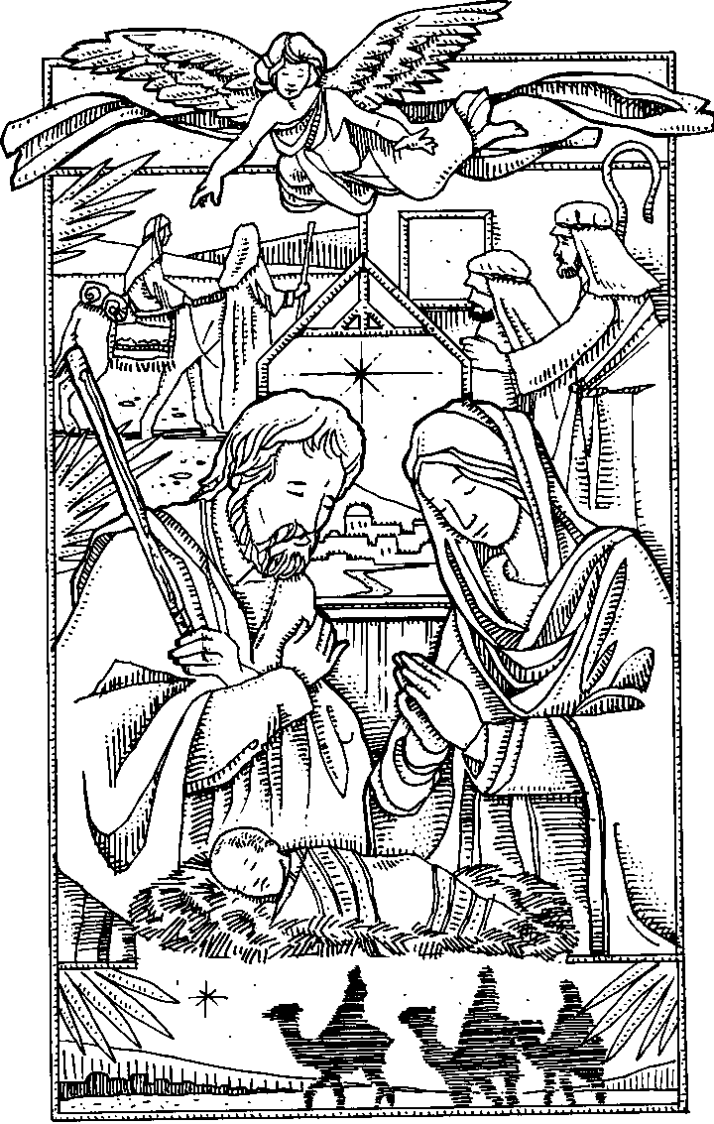
Welcome to worship at Bethlehem Lutheran Church
and our continuing celebration of the
Nativity of our Lord!

COVID-19 Practices — Out of love for God and Neighbor
1) Use hand sanitizer upon entry. Wash your hands and use hand sanitizer often while in the facility.
2) Members and visitors who are vaccinated and boosted are not required to wear a mask.
3) Members and visitors are free to wear a mask if they wish to do so.
4) Unvaccinated and not boosted members and visitors must wear a mask.
5) There are no physical distancing requirements, but you are welcome to keep a distance from others in the sanctuary as you are able.

Worship Book and Hymns. This morning’s service is printed in the bulletin. All the carols can be found in Evangelical Lutheran Worship (ELW), “the red book”, which is in the pews. Carols in ELW are indicated by a large bold number on each page’s left or right margin

An asterisk () signifies that you may stand, as you are comfortably able.


Gathering

Introduction to the Day. Today we continue our celebration of the coming of God’s light and grace and truth in human form: Jesus, God’s Messiah, our Savior and Lord. Matthew’s gospel narrates the story of Joseph and his obedience to God. Luke’s gospel recounts the familiar story of manger, angels, and shepherds. John’s gospel tells of God’s light and the Word made flesh that “lived among us…full of grace and truth.” The meaning of Christmas is clear: God’s light shines in our darkness! It is in the liturgy that we encounter the Word made flesh—in the people of God gathered as the body of Christ to worship, sing, pray, hear, and receive him in the sacraments. We go forth to be bearers of God’s Word and light as we proclaim this good news to all the ends of the earth!
PRELUDE

RINGING OF THE BELL

OPENING CAROL O Come, All Ye Faithful ELW # 283

All sing stanzas 1, 2 and 3

DIALOGUE based on Isaiah 9:2-7 and John 1:1-14

Leader: The people who walked in darkness have seen a great light.

People: The light shines in the darkness, and the darkness has not overcome it.

Leader: Those who dwell in the land of deep darkness, on them light has shined.

People: We have beheld Christ’s glory, glory as of the only Son from the Father.

Leader: To us a child is born, to us a Son is given.

People: In the Word was life, and the life was the light of all people.

OPENING PRAYER

Leader: The Lord be with you.

People: And also with you.

Leader: Let us pray together.

Almighty God,

All: you have filled us with the new light of the Word who became flesh and lived among us. Let the light of our faith shine in all we do; through your Son, Jesus Christ our Lord, who lives and reigns with you and the Holy Spirit, one God, now and forever. Amen.

Lessons and Carols Announcing
God’s Gift of Light & Grace & Truth

At the end of each reading, which is not printed in the bulletin, the reader will say,

“The word of the Lord.” All respond, “Thanks be to God.”

A carol follows the reading. Like the lessons, the carols are not printed but can be found in ELW, “the red book” in the pews.

FIRST READING Genesis 1:1-5a, 14-18

In the beginning, God created everything including light. Messiah Jesus is that light.

CAROL When Long before Time ELW # 861

Stanzas 1, 2 and 4

SECOND READING Isaiah 11:1-10

The peace and justice Messiah Jesus will bring is foretold.

CAROL O Come, O Come, Emmanuel ELW # 257

Stanzas 1, 4, 5 and 7

THIRD READING Micah 5:2-5a

Messiah Jesus will come from Bethlehem, says the prophet.

CAROL O Little Town of Bethlehem ELW # 279

Stanzas 1, 2, 3 and 4

FOURTH READING Luke 1:26-35, 38

The angel Gabriel announces to Mary that God has chosen her
to be the mother of Messiah Jesus.

CAROL Lo, How a Rose E’er Blooming ELW # 272

Stanzas 1, 2, 3 and 4

FIFTH READING Matthew 1:18-25

Matthew's story of Jesus's birth focuses on the role of Joseph,
who obediently gives him the name Jesus, which means, literally, “God saves”.

CAROL Savior of the Nations, Come ELW # 263

Stanzas 1, 2, 3 and 6

SIXTH READING Luke 2:1-14

Messiah Jesus is born of Mary in Bethlehem. Angels tell shepherds the good news.

CAROL Hark! The Herald Angels Sing ELW # 270

Stanzas 1, 2 and 3

SEVENTH READING Matthew 2:1-11

Magi from the East arrive and worship Messiah Jesus.

CAROL What Child is This ELW # 296

Stanzas 1, 2 and 3

EIGHTH READING John 1:1-14, 16

The prologue to John’s gospel describes Messiah Jesus as the Word of God made flesh, the one who reveals God to be “full of grace and truth.”

CAROL Of the Father’s Love Begotten ELW # 295

Stanzas 1, 2, 3 and 4

NINTH READING Luke 2:15-21

Eight days after his birth, Jesus is circumcised according to Jewish law and
given the name announced by the angel before his conception.

CAROL Love Has Come ELW # 292

Stanzas 1, 2 and 3

TENTH READING Psalm 148

¹Hallelujah! Praise the Lord from the heavens; praise God in the heights.

²Praise the Lord, all you angels; sing praise, all you hosts of heaven.

³Praise the Lord, sun and moon; sing praise, all you shining stars.

⁴Praise the Lord, heaven of heavens, and you waters above the heavens.

⁵Let them praise the name of the Lord, who commanded, and they were created,

⁶who made them stand fast forever and ever, giving them a law that shall not pass away.

⁷Praise the Lord from the earth, you sea monsters and all deeps;

⁸fire and hail, snow and fog, tempestuous wind, doing God’s will;

⁹mountains and all hills, fruit trees and all cedars;

¹⁰wild beasts and all cattle, creeping things and flying birds;

¹¹sovereigns of the earth and all peoples, princes and all rulers of the world;

¹²young men and maidens, old and young together.

Continued on the next page.
¹³Let them praise the name of the Lord, whose name only is exalted, whose splendor is over earth and heaven.

¹⁴The Lord has raised up strength for the people and praise for all faithful servants, the children of Israel, a people who are near the Lord. Hallelujah!

CAROL Let Altogether Praise Our God ELW # 287

Stanzas 1, 3, 4 and 5

Responding to God’s Gift of Light & Grace & Truth

NICENE CREED

Leader: We have been made God’s people through our baptism into Christ. Living together in trust and hope, we confess our faith, using the words of the Nicene Creed.

All: We believe in one God, the Father, the Almighty, maker of heaven and earth, of all that is, seen and unseen.

We believe in one Lord, Jesus Christ, the only Son of God, eternally begotten of the Father, God from God, Light from Light, true God from true God, begotten, not made, of one Being with the Father; through him all things were made. For us and for our salvation he came down from heaven, was incarnate of the Holy Spirit and the virgin Mary and became truly human. For our sake he was crucified under Pontius Pilate; he suffered death and was buried. On the third day he rose again in accordance with the scriptures; he ascended into heaven and is seated at the right hand of the Father. He will come again in glory to judge the living and the dead, and his kingdom will have no end.

We believe in the Holy Spirit, the Lord, the giver of life, who proceeds from the Father and the Son, who with the Father and the Son is worshiped and glorified, who has spoken through the prophets. We believe in one holy catholic and apostolic church. We acknowledge one baptism for the forgiveness of sins. We look for the resurrection of the dead, and the life of the world to come. Amen.

A WORD ABOUT OUR CHRISTMAS GIFTS

OFFERING music by Sharon Boyum
OFFERING CAROL From Heaven Above ELW # 268

Stanzas 1, 2, 3, 12, 13 and 14

RESPONSIVE PRAYER

Leader: Glory to God in the highest,

People: and peace to God’s people on earth.

Leader: Blessed are you Prince of peace. You rule the earth with truth and justice.

People: Send your gift of peace to all the nations of the world.

Leader: Blessed are you, Son of Mary. You share our humanity.

People: Have mercy on the sick, the dying, and all who are suffering this day in body, mind, or spirit.

Leader: Blessed are you, Son of God. You dwell among us as the Word made flesh.

People: Reveal yourself to us in word and sacrament throughout this new year, that we may bear your light to all the world.

Leader: Eternal Father, you gave your incarnate Son the holy name of Jesus to be a sign of our salvation.

People: Plant in every heart the love of the Savior of the world, Jesus Christ our Lord, who lives and reigns with you and the Holy Spirit, one God, now and forever. Amen.

LORD’S PRAYER Traditional Wording

Leader: As children of God, let us pray with confidence using the words our Savior gave us.

All: Our Father, who art in heaven, hallowed be thy name, thy kingdom come, thy will be done, on earth as it is in heaven. Give us this day our daily bread; and forgive us our trespasses, as we forgive those who trespass against us; and lead us not into temptation, but deliver us from evil. For thine is the kingdom, and the power, and the glory, forever and ever. Amen.

Sending

ANNOUNCEMENTS

BLESSING

Leader: Let us bless the Lord

People: Thanks be to God.

Leader: May you be filled with the wonder and submission of Mary, the obedience and commitment of Joseph, the joy of the angels, the eagerness of the shepherds, the determination of the magi, and the peace of the Christ child. Almighty God, Father, Son, and Holy Spirit, bless you now and forever.

People: Amen.

DEPARTING CAROL Go Tell It on the Mountain ELW # 290

Stanzas 1, 2 and 3

DISMISSAL

Leader: Christ the Savior is born! Go in peace. Proclaim this good news.

People: Thanks be to God.

RINGING OF THE BELL

POSTLUDE

Sundays, Festivals and Commemorations

Sunday, January 1

Name of Jesus

Introduction to the Day. The observance of the octave (eighth day) of Christmas has roots in the sixth century. Until the recent past, Lutheran calendars called this day “The Circumcision and Name of Jesus.” The emphasis on circumcision is the older emphasis. Every Jewish boy was circumcised and formally named on the eighth day of his life. Already in his youth, Jesus bears the mark of a covenant that he makes new through the shedding of his blood, now and on the cross. That covenant, like Jesus's name, is a gift to us and marks us as children of God. Baptized into Christ, the church begins a new year in Jesus's name.

Prayer of the Day. Eternal Father, you gave your incarnate Son the holy name of Jesus to be a sign of our salvation. Plant in every heart the love of the Savior of the world, Jesus Christ our Lord, who lives and reigns with you and the Holy Spirit, one God, now and forever.

Readings and Psalm. Numbers 6:22-27 The Aaronic blessing. Psalm 8 How majestic is your name in all the earth! (Ps.8:1). Galatians 4:4-7 We are no longer slaves but children or Philippians 2:5-11 God takes on human form. Luke 2:15-21 Mary’s child is circumcised and named Jesus.

Sunday, January 1

First Sunday of Christmas

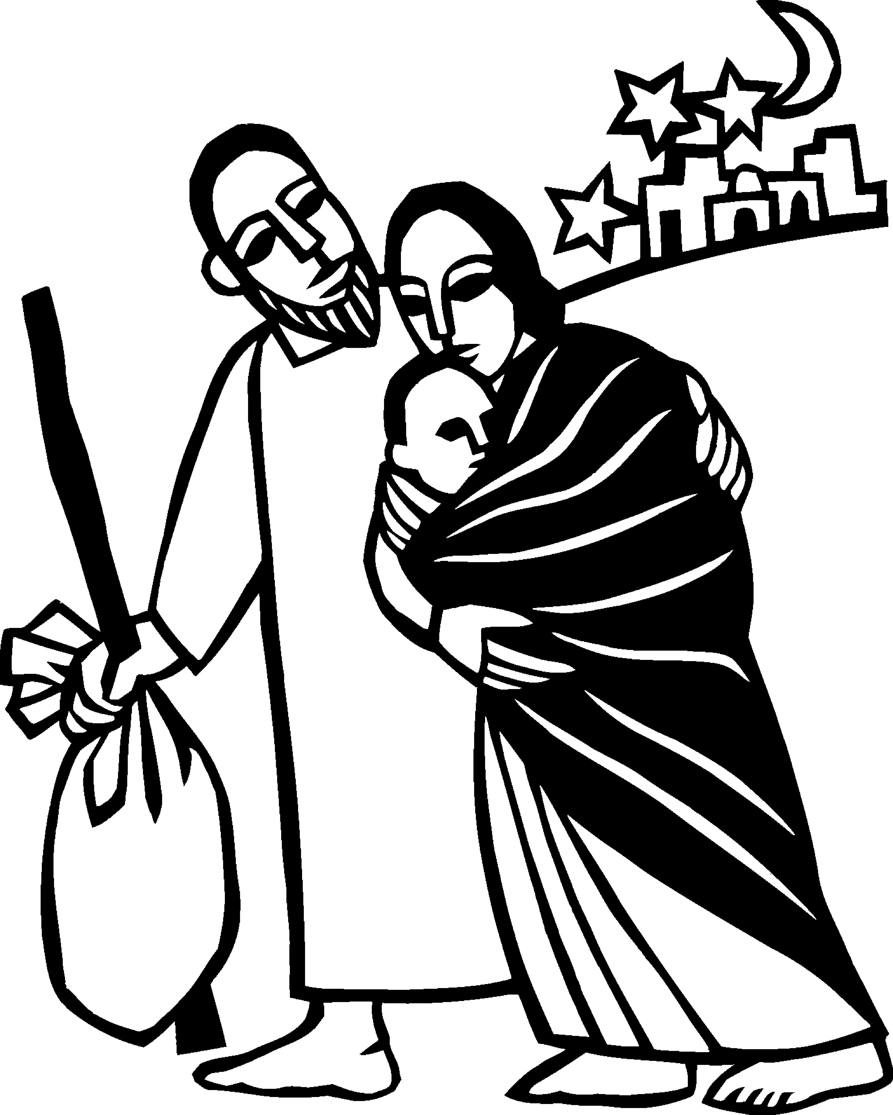Introduction to the Day. As we celebrate the Twelve Days of Christmas, today’s gospel confronts us with the death of innocent children at the hands of Herod. The birth of Christ does not remove the power of evil from our world, but its light gives us hope as we walk with all the “holy innocents” of past generations and today who have suffered unjustly. In our gathering around word and meal, God continues to redeem us, lift us up, and carry us as in days of old.

Prayer of the Day. O Lord God, you know that we cannot place our trust in our own powers. As you protected the infant Jesus, so defend us and all the needy from harm and adversity, through Jesus Christ, our Savior and Lord, who lives and reigns with you and the Holy Spirit, one God, now and forever.

Readings and Psalm. Isaiah 63:7-9 Israel is saved by God’s own presence. Psalm 148 The splendor of the Lord is over earth and heaven (Ps 148:13). Hebrews 2:10-18 Christ shares flesh and blood to free humankind. Matthew 2:13-23 The slaughter of innocent children.
Sundays, Festivals and Commemorations continued

Friday, January 6

Epiphany of Our Lord

Introduction to the Day. The feast of Epiphany (“manifestation”) concludes the Christmas season with a celebration of God’s glory revealed in the person of Jesus Christ. In Isaiah and Ephesians, that glory is proclaimed for all nations and people. Like the light of the star that guided the magi to Jesus, the light of Christ reveals who we are: children of God who are claimed and washed in the waters of baptism. We are sent out to be beacons of the light of Christ, sharing the good news of God’s love to all people.

Prayer of the Day. O God, on this day you revealed your Son to the nations by the leading of a star. Lead us now by faith to know your presence in our lives, and bring us at last to the full vision of your glory, through your Son, Jesus Christ our Lord, who lives and reigns with you and the Holy Spirit, one God, now and forever.

Readings and Psalm. Isaiah 60:1-6 Nations come to the light. Psalm 72:1-7, 10-14 All kings shall bow down before him (Ps 72:11). Ephesians 3:1-12 The gospel’s promise extends to all. Matthew 2:1-12 Revelation of Christ to the nations of the earth.

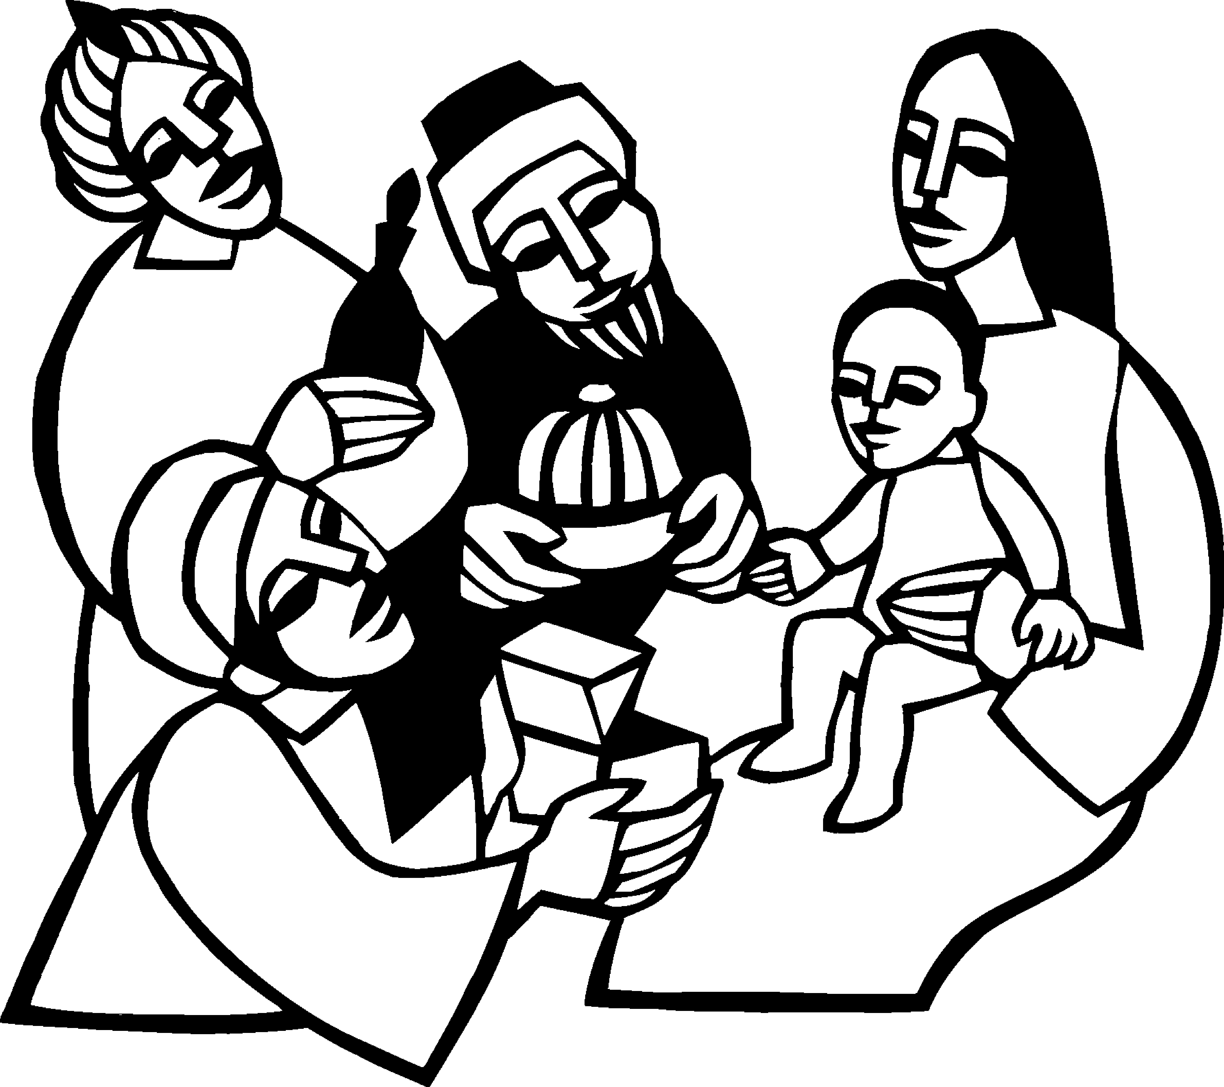

Today’s Assistants and Ministers

Greeters & Ushers ………………………….……...…………… Lee Peterson and Volunteers
Pianist …………………………………………..…..………………………..…… Sharon Boyum
Worship Leaders …………………………….…………………. Nate Boyum, Karen Schreiber
Altar Care: …………………………………….….…….……………………………... Kristi Ruen
Refreshments …………………………………………...……..………..……… Lindsay Hanson

Acknowledgments

Worship texts, prayers, readings, and graphics are from sundaysandseasons.com © 2023 Augsburg Fortress. Used by permission under Augsburg Fortress Liturgies Annual License SAS103296.

Permission to project, live stream, or podcast liturgy and music content under copyright to or administered by Augsburg Fortress provided under Augsburg Fortress Liturgies Annual License SAS103296.

Permission to Podcast / Stream provided by Christian Copyright Licensing International, Inc., under License # 11459672. An additional fee was paid. www.ccli.com.

Permission to Podcast / Stream provided by One License, Inc., under License # A-735588. An additional fee was paid. www.onelicense.net.

Presence Last Week and December Presents

Attendance Sunday, December 18 = 42, Christmas Eve = 187, Sunday, December 25 = 37
Average Sunday Worship Attendance for December = 57

November Contributions: General Fund = $18,613 Designated Giving = $140
Jan-Nov Income = $140,386 Jan-Nov Expenses = $151,528 Deficit = $11,142

Pastor Kerry and Deacon Cindy are on vacation thru January 2. In case of a pastoral emergency, contact Pastor Kerry on his cell phone: 507-951-3954

This Week in Our Congregation

Today, January 1, 2023 — First Sunday of Christmas — Name of Jesus

Refreshments in the Fellowship Hall for everyone after worship
NO Sunday School
NO 7th & 8th-grade Confirmation

Tuesday, January 3

Men’s breakfast at Home Sweet Home, Lanesboro 7:00 AM

Wednesday, January 4

WELCA Sew Day 9:00 AM

Continued on the next page.
This Week in Our Congregation continued

Friday, January 6 — Epiphany of Our Lord

Next Sunday, January 8 — Baptism of Our Lord

Worship with Affirmation of Baptism and Holy Communion 9:00 AM
Sunday School after the Children’s message
7th & 8th-grade Confirmation session 10:15 AM

News and Notes

Note to ministry teams, committees, and church groups: The deadline to turn in written reports for the 2022 Annual Report is Sunday, January 8, 2023.

The Church Council is seeking leaders and representatives for 2023. Three (3) people, each to serve a three-year term, are needed to fill approaching vacancies on the church council. One (1) person is needed to serve on next year’s Audit Committee, and one (1) person is needed to serve on next year’s Nominating Committee. In addition, voting members to forthcoming annual meetings are also needed: the Root River Conference Assembly, Good Earth Village, and the Southeastern Minnesota Synod Assembly. Please prayerfully consider accepting one of these important leadership roles in our congregation. Contact council president Dave Ruen (507-259-7095) or call the church office.

Notice of Congregational Meeting. In accordance with the constitution and bylaws of Bethlehem Lutheran Church of Lanesboro, Minnesota, official notice is hereby given of the annual meeting of the congregation on Sunday, January 22, 2023 immediately following the 9:00 a.m. worship service. The meeting will take place in the Fellowship Hall. The purpose of this meeting is to present the mission and ministries carried out in 2022, elect leaders, adopt a spending plan for 2023, and conduct any other business that may properly come before the congregation.

Prayer Requests

In Our Community. For our church members and friends living with chronic illness and other diseases, who are homebound, residing in care facilities, and hospitalized. See the newsletter for our members living in area nursing homes. And let us not forget those sick and dying of COVID-19, as well as our fallen and wounded soldiers and those still serving.

In Our Synod. Bishop Regina Hassanally invites the people and congregations of our synod to commit to praying this week for the following faith communities: Trinity Lutheran Church, Wanamingo; Faith Lutheran Church, Wabasha; St. John Lutheran Church, Elkton; Tulya Lutheran Church, Tanzania; Kaselya Lutheran Church, Tanzania; and Iambi Secondary School, Tanzania.




We gratefully acknowledge the following individuals and families who donated poinsettias and other flowers to decorate the church this Christmas season.
We sincerely apologize for any errors or omissions.

In loving memory of Mary Peterson
from Lee Peterson

In loving memory of Orris and Lucille Hareldson
from Diane Hareldson & Raymond Reese,
Caleb & Samantha, Daxyn and Charlie Hareldson, and
Kevin & Jackie, Tristen, Trinity and Jasper Hareldson

In loving memory of Jim Wagner
from Kim Wagner and the Wagner family

In loving memory of Loren & Carol and Brent Tufte
from Blaine, Mary, Grace, Kim, Alison, Rick and Peighton

In loving memory of Blake Overland
from Erik & Laurie Overland

In loving memory of Gloria Ruen and Andrew Ruen
from Mark & Pam Ruen

In loving memory of Gloria Ruen, Andrew Ruen,
and Howard & Lyla Ruen
from Charles Ruen

In loving memory of Kris and Eric Hall
from Curt & Jean Hall and family

In loving memory of Robert & Dartha Eversole and Henry & Evalee Cordes
from Kerry & Cindy and
Rachel, Nathan, Matthew, Aaron, Benjamin and Sarah Eversole

In loving memory of Gloria Ruen, Andrew Ruen and Mary Ruen
from Eric & Kristi and
Leah, Bailey, Adam, Brielle, Carson and Luke Ruen

In loving memory of Orvis & ElDoris Hanson,
Roger & Helen Benson, and Amy Thoen
from Lindsay Hanson and family



