Bethlehem Lutheran Church
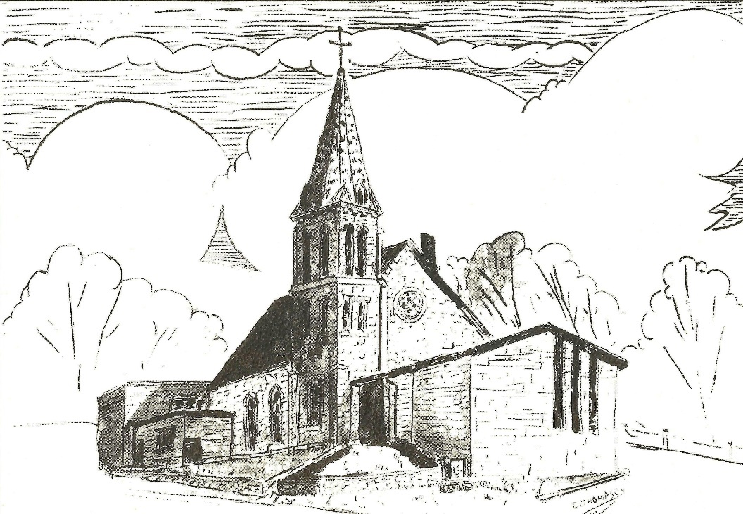
Established 1874

Rev. Kerry B. Eversole, Pastor
Deacon Cindy Cordes-Eversole, Associate in Ministry

Mailing Address: P.O. Box 314, Lanesboro, MN 55949-0314
Physical Address: 200 Kenilworth Ave S, Lanesboro, Minn.

Telephone: 507.467.3344
E-mail Address: bethlehem@acegroup.cc
Website: www.staronthehill.com
Facebook Page: www.facebook.com/BethlehemLutheranLanesboro/

Office Hours: Tuesday, Wednesday, Thursday 10 a.m. to 3 p.m.
Parsonage Phone: 507.467.3017
Pastor Kerry’s Cell Phone: 507.951.3954

Bethlehem Lutheran Church
Lanesboro, Minnesota

Fourth Sunday of Advent

December 18, 2022

An angel of the Lord appeared to Joseph in a dream and said, “Joseph, son of David, do not be afraid to take Mary as your wife, for the child conceived in her is from the Holy Spirit. She will bear a son, and you are to name him Jesus, for he will save his people from their sins.” This took place to fulfill what had been spoken by the Lord through the prophet: “Look, the virgin shall conceive and bear a son, and they shall name him Emmanuel,” which means, “God is with us.” Matthew 1:41-43
Welcome to worship at Bethlehem Lutheran Church
and our celebration of Christ’s coming!

We are “The star on the hill”
You are the light of the world … let your light shine before others, so that they may see your good works and give glory to your Father in heaven. Matthew 5:14-16

COVID-19 Practices — Out of love for God and Neighbor

1) Use hand sanitizer upon entry. Wash your hands and use hand sanitizer often while in the facility.
2) Members and visitors who are vaccinated and boosted are not required to wear a mask.
3) Members and visitors are free to wear a mask if they wish to do so.
4) Unvaccinated and not boosted members and visitors must wear a mask.
5) There are no physical distancing requirements, but you are welcome to keep a distance from others in the sanctuary as you are able.
6) All are welcome to enjoy coffee fellowship in the dining room following worship.

Worship Book and Hymns. This morning’s service is printed in the bulletin. The hymns can be found in Evangelical Lutheran Worship (ELW), “the red book” and With One Voice (WOV) “the blue book”, which are in the pews. Hymns in ELW and WOV are indicated by a large bold number on each page’s left or right margin.

Abbreviations. Hymns are signified throughout this worship folder by the pound symbol (#), P: refers to the presiding minister or preacher, A: denotes an assisting minister, and C: and/or bold text indicates the congregation.

Offering. Later in our service, we will be receiving an offering. The offering is an opportunity to worship God with our money. We know that the money you give to Bethlehem Lutheran Church represents your lives — your time, talents, and hard work. We recognize that and we appreciate your generosity. Your support not only helps all of us to fulfill God’s call on our lives, but it also makes an impact, and we thank you! Lastly, our visitors are not expected to give. After all, you are our guests! We’re glad you’re here and we want you to feel welcomed!

Mistakes do not happen in our worship service;
only unexpected events which are opportunities for joy!

An signifies that you may stand, as you are comfortably able.
Gathering

The Holy Spirit calls us together as the people of God.

Introduction to the Season. Once again, we have begun our journey around the great circle of the Christian calendar. The new church year begins with Advent, which means coming. God’s people have always lived in great expectation of the second coming of God’s Christ, the so-called end times, the end of the world. That expectation finds specific and repeated pronouncement in the readings for the four weeks of Advent.

Introduction to the Day. Today Isaiah prophesies that a young woman will bear a son and name him Emmanuel. The gospel is Matthew’s account of the annunciation and birth of the one named Emmanuel, God-with-us. During these final days of Advent we pray, “O come, O come, Emmanuel,” a beloved hymn based on the O Antiphons, ancient prayers appointed for the seven days preceding Christmas. On this final Sunday of Advent, we prepare to celebrate the birth of the one born to save us from the power of sin and death and who will again to judge the living and the dead.

PRELUDE

WELCOME

LIGHTING THE ADVENT WREATH Hope for Those Who Are Wounded
John, Sarah, Andrew and Isabelle Peterson

Responsive Litany

A: Advent is a time to bind up the brokenhearted.

C: Come, Lord, and make all things new.

A: For any action by which we have wounded others or that has wounded us:

C: Come, Lord, and make all things new.

A: For past wrongs that prevent us from moving forward:

C: Come, Lord, and make all things new.

A: For any bitterness that afflicts our souls:

C: Grant that we might have the peace of Christ as we wait, the love of Christ as we act, and the grace of Christ as we speak.

Continued on the next page.

Candle Lighting

A: This morning we light four candles. The first candle is the light of hope for those who find themselves waiting and wondering. The second candle is the light of hope for those who are feeling weak and weary by the circumstances of life. The third candle is the light of hope for those eagerly watching for God’s promised glory. The fourth candle is the light of hope for those injured by our words and deeds or those of others. As the light grows, we look to the Savior who comes to rescue the lost, help the hurting, and heal the suffering.

OPENING HYMN Savior of the Nations, Come ELW # 263

Stanzas 1, 2, 3 and 6

GREETING

P: The grace of our Lord Jesus Christ, the love of God, and the communion of the Holy Spirit be with you all.

C: And also with you.

PRAYER OF THE DAY

P: Let us pray together.

Stir up your power, Lord Christ, and come.

All: With your abundant grace and might, free us from the sin that hinders our faith, that eagerly we may receive your promises, for you live and reign with the Father and the Holy Spirit, one God, now and forever. Amen.

God’s Word About Christ’s Coming

God speaks to us in scripture reading, preaching, and song

FIRST READING Isaiah 7:10-16

An Israelite and Aramean military coalition presented a serious threat to King Ahaz of Judah. In response, Ahaz decided to secure his throne and kingdom by seeking Assyrian help. Isaiah reminds Ahaz that human attempts to establish security will fail. The prophet gives the sign that is the only source of true safety: Immanuel, God is with us!

¹⁰The Lord spoke to Ahaz, saying, ¹¹Ask a sign of the Lord your God; let it be

Continued on the next page.
deep as Sheol or high as heaven. ¹²But Ahaz said, I will not ask, and I will not put the Lord to the test. ¹³Then Isaiah said: “Hear then, O house of David! Is it too little for you to weary mortals, that you weary my God also? ¹⁴Therefore the Lord himself will give you a sign. Look, the young woman is with child and shall
bear a son, and shall name him Immanuel. ¹⁵He shall eat curds and honey by the time he knows how to refuse the evil and choose the good. ¹⁶For before the child knows how to refuse the evil and choose the good, the land before whose two kings you are in dread will be deserted.”

A: The word of the Lord.

C: Thanks be to God.

SECOND READING Psalm 80:1-5, 7, 17-19

¹Hear, O Shepherd of Israel, leading Joseph like a flock; shine forth, you that are enthroned upon the cherubim.

²In the presence of Ephraim, Benjamin, and Manasseh, stir up your strength and come to help us.

³Restore us, O God; let your face shine upon us, and we shall be saved.

⁴O Lord God of hosts, how long will your anger fume when your people pray?

⁵You have fed them with the bread of tears; you have given them bowls of tears to drink.

⁶You have made us the derision of our neighbors, and our enemies laugh us to scorn.

⁷Restore us, O God of hosts; let your face shine upon us, and we shall be saved.

¹⁷Let your hand be upon the one at your right hand, the one you have made so strong for yourself.

¹⁸And so will we never turn away from you; give us life, that we may call upon your name.

¹⁹Restore us, O Lord God of hosts; let your face shine upon us, and we shall be saved.

CANTICLE OF PRAISE The King Shall Come ELW # 260

Stanzas 1 and 5

GOSPEL Matthew 1:18-25

P: Announcement of the gospel.

C: Glory to you, O Lord.

Matthew’s story of Jesus’s birth focuses on the role of Joseph, who adopts the divinely-begotten child into the family of David and obediently gives him the name Jesus, which means “God saves.”

¹⁸Now the birth of Jesus the Messiah took place in this way. When his mother Mary had been engaged to Joseph, but before they lived together, she was found to be with child from the Holy Spirit. ¹⁹Her husband Joseph, being a righteous man and unwilling to expose her to public disgrace, planned to dismiss her quietly. ²⁰But just when he had resolved to do this, an angel of the Lord appeared to him in a dream and said, “Joseph, son of David, do not be afraid to take Mary as your wife, for the child conceived in her is from the Holy Spirit. ²¹She will bear a son, and you are to name him Jesus, for he will save his people from their sins.” ²²All this took place to fulfill what had been spoken by the Lord through the prophet:
²³“Look, the virgin shall conceive and bear a son,
and they shall name him Emmanuel,”
which means, “God is with us.” ²⁴When Joseph awoke from sleep, he did as the angel of the Lord commanded him; he took her as his wife, ²⁵but had no marital relations with her until she had borne a son; and he named him Jesus.

P: Affirmation of the gospel.

C: Praise to you, O Christ.

GOSPEL HYMN My Soul Proclaims Your Greatness ELW # 251

SERMON

HYMN OF THE DAY O Come, O Come, Emmanuel ELW # 257

Stanzas 1, 4, 5 and 7

Responding to God’s Word About Christ’s Coming

OFFERING AND MUSIC

At this point in our service, we worship God with our money. The ushers will pass plates down the pews to receive your gifts of cash and checks made out to Bethlehem Lutheran Church. You can even give online at https://secure.myvanco.com/L-Z22R/.

Continued on the next page.
Your gifts support the worship, faith formation, administration, and other ministries of Bethlehem Lutheran as well as the mission of the Southeastern Minnesota Synod, and the whole Evangelical Lutheran Church in America. Loose change goes to the Fillmore County Food Shelf in Preston. God bless your giving and your generosity. And thank you!

OFFERING SONG Come, Thou Long-Expected Jesus ELW # 254

PRAYERS OF INTERCESSION

Each prayer ends with these words and response:

P: God, in your mercy,

C: hear our prayer.

Concluding prayer and response:

P: God of our longing, you know our deepest needs. By your Spirit, gather our prayers and join them with the prayers of all your children. In Jesus’s name we pray.

C: Amen.

LORD’S PRAYER Traditional Wording

P: Gathered into one by the Holy Spirit, let us pray as Jesus taught us.

All: Our Father, who art in heaven, hallowed be thy name, thy kingdom come, thy will be done, on earth as it is in heaven. Give us this day our daily bread; and forgive us our trespasses, as we forgive those who trespass against us; and lead us not into temptation, but deliver us from evil. For thine is the kingdom, and the power, and the glory, forever and ever. Amen.

Sending

God blesses us and sends us in mission to the world.

ANNOUNCEMENTS

BLESSING

P: God the eternal Word, who dwells with us in Jesus, and who holds us in the grace of the Holy Spirit, ☩ bless you now and forever.

C: Amen.

DEPARTING HYMN People, Look East ELW # 248

DISMISSAL

P: Go in peace. Christ is near.

C: Thanks be to God.

POSTLUDE

Commemoration

Tuesday, December 20

Katharina von Bora Luther, renewer of the church, 1499–1552

Born to an impoverished nobleman, when Katharina was five her mother died and she was sent to live in a convent. She later took vows as a nun, but around age twenty-four she and several other nuns who were influenced by the writings of Martin Luther left the convent. Katie, as she was called, later married Martin and six children were born to them. Though initially, Luther felt little affection for Katie, she proved herself a gifted household manager and became a trusted partner. She was so influential that Luther took to calling her "my lord Katie".
Christmas Celebrations

Saturday, December 24, Christmas Eve, 5:00 p.m.
Service of Carols, Communion, and Candlelight

Sunday, December 25, Christmas Day, 9:00 a.m.
Festive service set to carols with Holy Communion
No service at our sister congregation, Fountain Lutheran

Sunday, January 1, First Sunday of Christmas, 9:00 a.m.
Service of Lessons and Carols
No service at our sister congregation, Fountain Lutheran

All services will be broadcast live on our Facebook page
www.facebook.com/BethlehemLutheranLanesboro/

Today’s Assistants and Ministers

Greeters & Ushers ………………………………………….....… Ben, Darla and Brock Taylor
Organist-Pianist ………………………….....……….…...………………….…..…….. Sue Holst
Advent Wreath Acolytes ………………...…….. John, Sarah, Andrew and Isabelle Peterson
Presiding Minister ……………………………….……...……….………. Pastor Kerry Eversole
Reader …………………………………………………………….………………… Sarah Pieper
Altar Care ..........................................................................................…………. Darla Taylor
Refreshments …….…………………………….……………… Sarah Pieper and Darla Taylor

Presence Last Week and November Presents

Attendance Last Sunday, December 11 = 83
Average Sunday Worship Attendance for November = 69

November Contributions: General Fund = $18,613 Designated Giving = $140
Jan-Nov Income = $140,386 Jan-Nov Expenses = $151,528 Deficit = $11,142

This Week in Our Congregation

Today, December 18 — Fourth Sunday of Advent

Refreshments in the Fellowship Hall for everyone after worship
January Service Group meets in the Fellowship Hall after worship
7th & 8th-grade Confirmation session 10:15 AM

Tuesday, December 20

Men’s breakfast at Home Sweet Home, Lanesboro 7:00 AM

Thursday, December 22

Pastor Kerry at Park Lane Estates for Bible study/chapel 9:30 AM
Pastor Kerry at Good Shepherd Lutheran Home, Rushford for chapel 1:30 PM

Friday, December 23

Deacon Cindy at Harmony Care Center, Harmony, for Christmas Chapel 2:00 PM

Saturday, December 24 — Christmas Eve

Worship with Carols, Communion & Candlelight 5:00 PM

Sunday, December 25 — Christmas Day

Festive Worship set to Carols with Holy Communion 9:00 AM
NO Refreshments
NO Sunday School
NO 7th & 8th-grade Confirmation session

Looking Ahead to Sunday, January 1, 2023 — First Sunday of Christmas

Service of Lessons and Carols 9:00 AM
NO Sunday School
NO 7th & 8th-grade Confirmation session
Prayer Requests

In Our Community. For our church members and friends living with chronic illness and other diseases, who are homebound, residing in care facilities, and hospitalized. See the newsletter for our members living in area nursing homes. And let us not forget those sick and dying of COVID-19, those entrusted with the authority of government, justice, and law enforcement, as well as our fallen and wounded soldiers and those still serving.

In Our Synod. Bishop Regina Hassanally invites the congregations of our synod to commit to praying this week for the following communities of faith: Faith Lutheran Church, Winona; Highland Prairie Lutheran Church, Peterson; St. John Lutheran Church, Owatonna; Hayward Lutheran Church, Hayward; Puma Lutheran Church, Tanzania; Castillo Fuerte Lutheran Church, Colombia; and Kule Lutheran Parish, South Sudan.

News and Notes

Today is the last day to turn in the information form if you will be providing a poinsettia or other flowers to decorate our sanctuary during the Christmas Season. Additional forms are available in the Fellowship Hall and the church office.

Be a 2023 Secret Prayer Partner! Sign up on the sheet in the Fellowship Hall or call Jacque Crutcher (507-259-2453).

The Mitten Basket is in the Fellowship Hall awaiting your donations of new or gently used mittens, gloves, hats, and scarves! All donations will be given to SEMCAC for distribution to those in need.

Pastor Kerry and Deacon Cindy will be on vacation from Monday, December 26 thru Monday, January 2. If you need pastoral care, you can call Pastor Kerry at 507-951-3954.

Acknowledgments

Graphics, worship texts, service music, and readings are from sundaysandseasons.com © 2022 Augsburg Fortress. Used by permission under Augsburg Fortress Liturgies Annual License SAS103296.

Permission to project, live stream, or podcast liturgy and music content under copyright to or administered by Augsburg Fortress provided under Augsburg Fortress Liturgies Annual License SAS103296.

Permission to Podcast / Stream provided by Christian Copyright Licensing International, Inc., under License # 11459672. Additional fee paid. www.ccli.com.

Permission to Podcast / Stream provided by One License, Inc., under License # A-735588. Additional fee paid. www.onelicense.net.

Lighting the Advent Wreath written by Rev. Rich Davis, Senior Pastor, First Presbyterian Church, River Forest, IL. A date was not identified

Families and individuals are cordially invited to provide poinsettias or other flowers to decorate our sanctuary during the Christmas Season.

Please tell us if the plant is given “in honor of” or “in memory of” a loved one, or even in celebration of a birthday, baptism, anniversary, etc., so this information can be included in our Christmas bulletins.

Please complete the form below and deliver it to the church office no later than Sunday, December 18.

Please bring your plant or flowers to the church by Thursday, December 22.

I am giving a plant or other flowers:

Your Name _______________________________________________________________

___ In memory of __________________________________________________________

___ In honor of ____________________________________________________________

___ In celebration of ________________________________________________________

