Bethlehem Lutheran Church
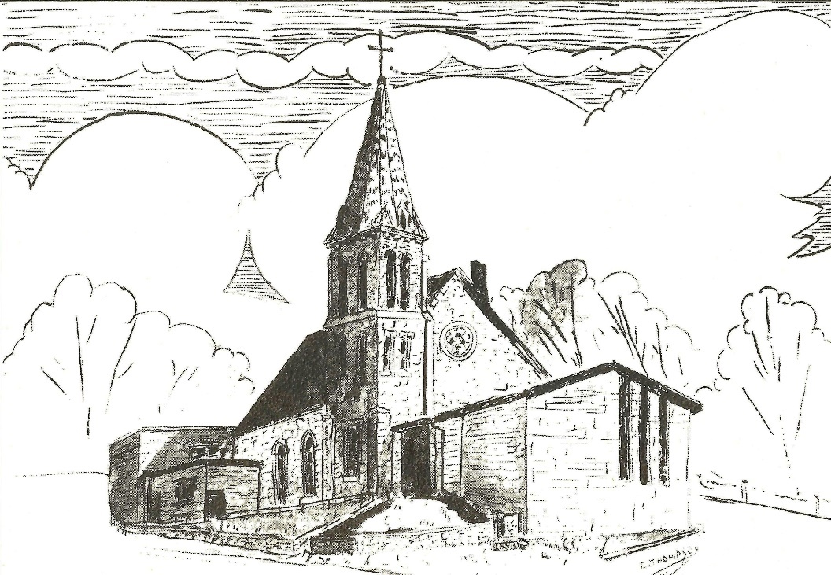Established 1874

Rev. Kerry B. Eversole, Pastor
Pastor Kerry Cordes-Eversole, Associate in Ministry

Mailing Address: P.O. Box 314, Lanesboro, MN 55949-0314
Physical Address: 200 Kenilworth Ave S, Lanesboro, Minn.

Telephone: 507.467.3344
E-mail Address: bethlehem@acegroup.cc
Website: www.staronthehill.com
Facebook Page: www.facebook.com/BethlehemLutheranLanesboro

Office Hours: Tuesday, Wednesday, Thursday 10 a.m. to 3 p.m.
Parsonage Phone: 507.467.3017
Pastor Kerry’s Cell Phone: 507.951.3954

Bethlehem Lutheran Church
Lanesboro, Minnesota

Third Sunday of Advent

December 11, 2022


Welcome to worship at Bethlehem Lutheran Church
and our celebration of Christ’s coming!

We are “The star on the hill”
You are the light of the world … let your light shine before others, so that they may see your good works and give glory to your Father in heaven. Matthew 5:14-16

COVID-19 Practices — Out of love for God and Neighbor

1) Use hand sanitizer upon entry. Wash your hands and use hand sanitizer often while in the facility.
2) Members and visitors who are vaccinated and boosted are not required to wear a mask.
3) Members and visitors are free to wear a mask if they wish to do so.
4) Unvaccinated and not boosted members and visitors must wear a mask.
5) There are no physical distancing requirements, but you are welcome to keep a distance from others in the sanctuary as you are able.
6) All are welcome to enjoy coffee fellowship in the dining room following worship.

Worship Book and Hymns. This morning’s service is printed in the bulletin. The hymns can be found in Evangelical Lutheran Worship (ELW), “the red book” and With One Voice (WOV) “the blue book”, which are in the pews. Hymns in ELW and WOV are indicated by a large bold number in each page’s left or right margin.

Abbreviations. Throughout this worship folder hymns are signified by the pound symbol (#), Pastor: refers to the presiding minister, Reader: denotes an assisting minister, and People: and/or bold text indicates the congregation.

Offering. Later in our service, we will be receiving an offering. The offering is an opportunity to worship God with our money. We know that the money you give to Bethlehem Lutheran Church represents your lives — your time, talents, and hard work. We recognize that and we appreciate your generosity. Your support not only helps all of us to fulfill God’s call on our lives, but it also makes an impact, and we thank you! Lastly, our visitors are not expected to give. After all, you are our guests! We’re glad you’re here and we want you to feel welcomed!

Mistakes do not happen in our worship service;
only unexpected events which are opportunities for joy!

An signifies that you may stand, as you are comfortably able.
Gathering

MUSIC AS WE COME TOGETHER

WELCOME

BLESSING THE CHRISTMAS DECORATIONS

Pastor Kerry: Gracious God, we offer to you these banners and paraments, these garlands and wreaths, these candles, lights, and ornaments that adorn our worship space, all of which have been inspired by our love for you. We especially praise you for this Christmas tree. It is a sign of your everlasting, evergreen presence. It is a sign of the reign of heaven, sheltering the creatures of the earth under its open arms. It is a sign of the cross, shining with the light of your grace and mercy. May everyone who stands in all this beauty and light eagerly welcome the true Light which never fades, whose coming we anticipate once again this season. We ask this through Jesus Christ, our Savior and Lord.

People: Amen.

LIGHTING THE ADVENT WREATH Hope for Those Who Are Watching
Brett, Hollie, Elizabeth, Preston and Bristol Clarke

Responsive Litany

Reader: Advent is a time to awaken our senses to God’s mighty acts.

People: We stand in awe of your words and deeds, O Lord. Repeat them in our day!

Reader: Grant us the vision to behold your promises and your work.

People: We stand in awe of your words and deeds, O Lord. Repeat them in our day!

Reader: Make us vessels of your compassion and mercy.

People: We stand in awe of your words and deeds, O Lord. Repeat them in our day!

Reader: For all of us eagerly looking for your glory in our midst:

People: Grant that we might have the peace of Christ as we wait, the love of Christ as we act, and the grace of Christ as we speak.

Continued on the next page.
Candle Lighting

Reader: This morning we light three candles. The first candle represents those who find themselves waiting patiently and hopefully for God’s activity. The second candle stands for anyone feeling weak and weary by the circumstances of life. God promises to renew your strength and increase your power. The third candle signifies our listening for God’s still, soft voice and embracing God’s movement as we anticipate our Savior’s certain coming.

OPENING HYMN Prepare the Royal Highway ELW # 264

Stanzas 1, 3 and 4

GREETING

Pastor Kerry: The grace of our Lord Jesus Christ, the love of God, and the communion of the Holy Spirit be with you all.

People: And also with you.

PRAYER OF THE DAY

Pastor Kerry: Let us pray together.

Stir up the wills of all who look to you, Lord God,

All: and strengthen our faith in your coming, that, transformed by grace, we may walk in your way; through Jesus Christ, our Savior and Lord, who lives and reigns with you and the Holy Spirit, one God, now and forever. Amen.

God’s Word About Christ’s Coming

ADVENT 3 READING Matthew 11:2-11

²When John heard in prison what the Messiah was doing, he sent word by his disciples ³and said to him, “Are you the one who is to come, or are we to wait for another?” ⁴Jesus answered them, “Go and tell John what you hear and see: ⁵the blind receive their sight, the lame walk, the lepers are cleansed, the deaf hear, the dead are raised, and the poor have good news brought to them. ⁶And blessed is anyone who takes no offense at me.”
⁷As they went away, Jesus began to speak to the crowds about John: “What did you go out into the wilderness to look at? A reed shaken by the wind? ⁸What then did you go out to see? Someone dressed in soft robes? Look, those who

Continued on the next page.
wear soft robes are in royal palaces. ⁹What then did you go out to see? A prophet? Yes, I tell you, and more than a prophet. ¹⁰This is the one about whom it is written,
‘See, I am sending my messenger ahead of you,
who will prepare your way before you.’
¹¹Truly I tell you, among those born of women no one has arisen greater than John the Baptist; yet the least in the kingdom of heaven is greater than he.”

HYMN Hark, the Glad Sound ELW # 239

Stanzas 1, 3 and 4

Sunday School Play About Christ’s First Coming

SONG O Little Town of Bethlehem ELW # 279

The congregation sings stanzas 1, 3 and 4

SONG Away in a Manger ELW # 277

The congregation sings stanzas 1, 2 and 3

SONG Come See Bethlehem Choir

SONG Go Tell It on the Mountain ELW # 290

The congregation sings stanzas 1 and 2

SONG Angels We Have Heard on High ELW # 289

The congregation sings stanzas 1 and 3

SONG What Child Is This ELW # 296

The congregation sings stanzas 1 and 2

SONG We Three Kings WOV # 646

The congregation sings stanzas 1 and 5

SONG Joy to the World ELW # 267

The congregation sings stanzas 1 and 2

Arranged in 2013 by the Rev. Matthew Kozlowski for St. Mary’s Episcopal Church in Stuart, Florida. Text is from the NRSV with occasional modifications. Permission is given by the author to use for any purpose and to modify as necessary.
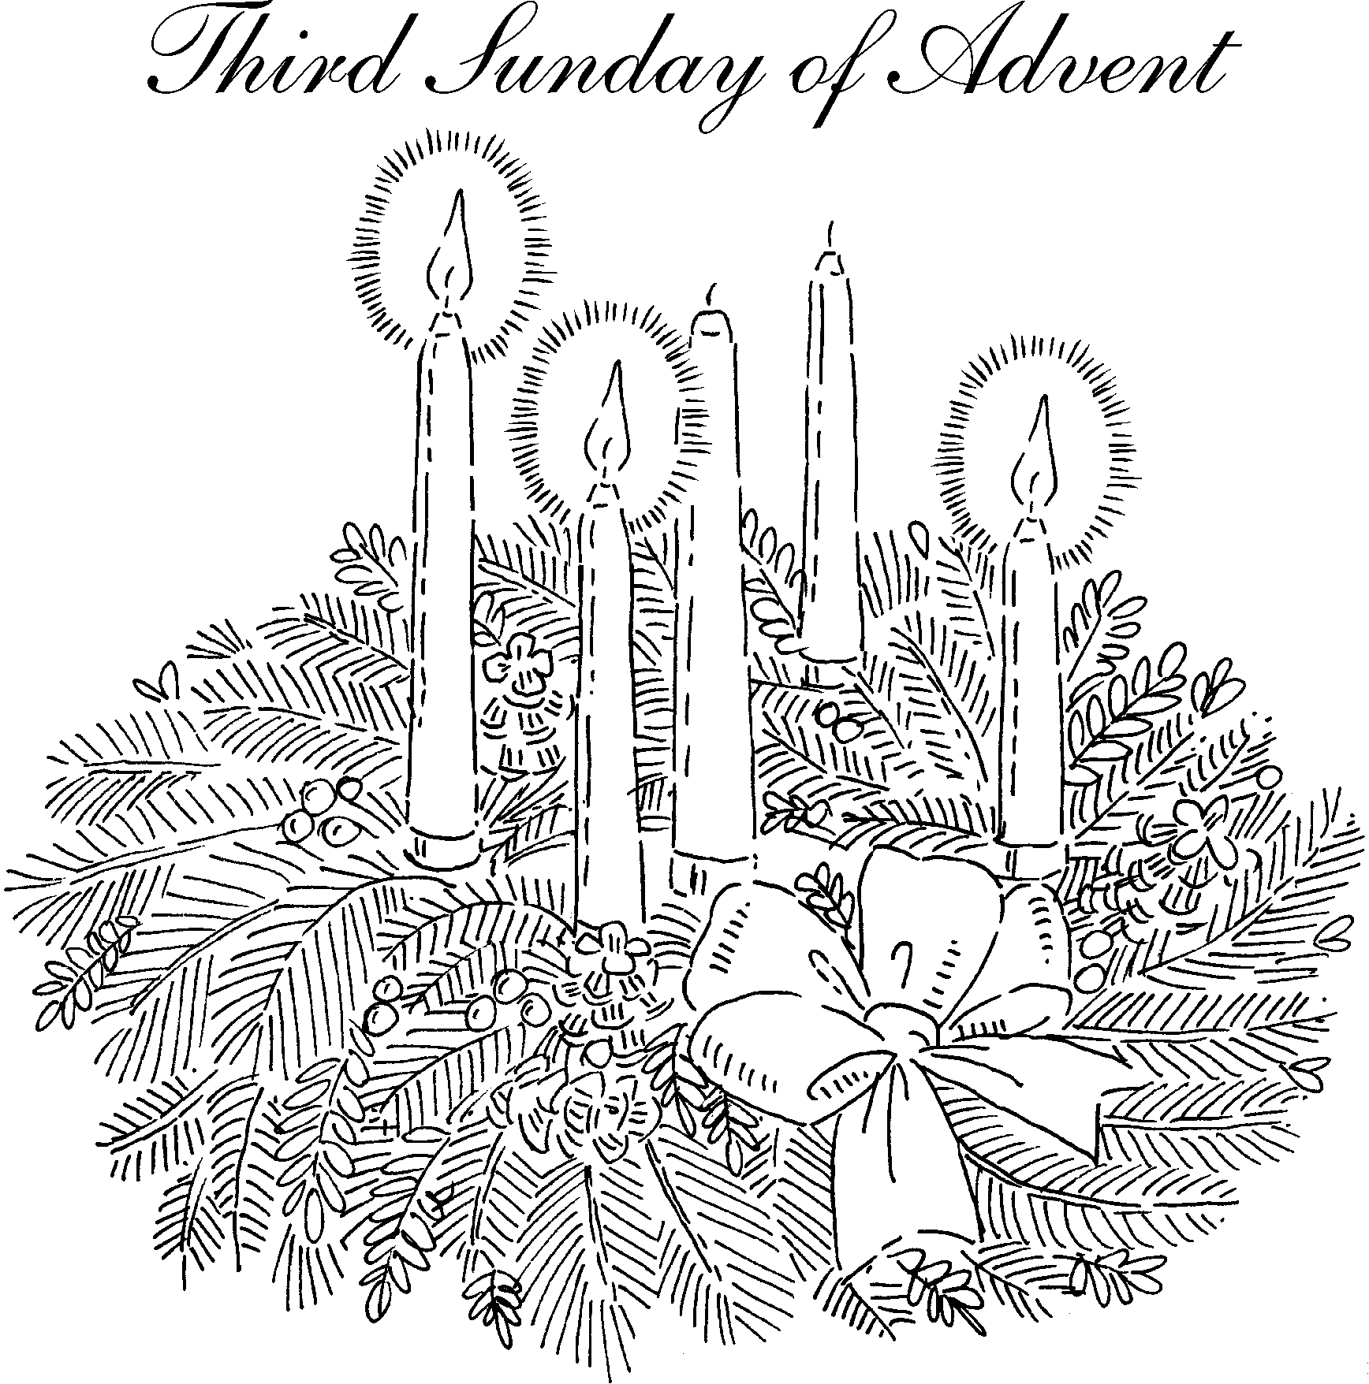Responding to the Story of Christ’s Coming

OFFERING Music by Eliza Cullen, Theodore Pruett and Sharon Boyum

OFFERING SONG He Came Down ELW # 253

PRAYERS OF GOD’S PEOPLE

After the last petition, all sing Hear Our Prayer ELW # 178

LORD’S PRAYER Traditional Wording

Pastor Kerry: Teach us to boldly pray in the words Jesus gave us:

All: Our Father, who art in heaven, hallowed be thy name, thy kingdom come, thy will be done, on earth as it is in heaven. Give us this day our daily bread; and forgive us our trespasses, as we forgive those who trespass against us; and lead us not into temptation, but deliver us from evil. For thine is the kingdom, and the power, and the glory, forever and ever. Amen.

Sending

ANNOUNCEMENTS

BLESSING

Pastor Kerry: God the eternal Word,
who dwells with us in Jesus,
and who holds us in the grace of the Holy Spirit,
☩ bless you now and forever.

People: Amen.

DEPARTING HYMN Joy to the World ELW # 267

Stanzas 3 and 4

DISMISSAL

Pastor Kerry: Go in peace. Christ is near.

People: Thanks be to God.

SENDING MUSIC

Introduction to the Day

A note of joyful expectation marks the readings for Advent 3. Isaiah announces that the desert shall rejoice and blossom, and Jesus points to the unexpected and transforming signs of God’s reign. We wait with patience for the coming of the Lord, even as we rejoice at his presence among us this day: in word, song, and drams, in church and in our homes, in silent reflection, and in works of justice and love. We pray that God would open our eyes and ears to the wonders of Christ’s advent among us.

Prayer of the Day

Stir up the wills of all who look to you, Lord God, and strengthen our faith in your coming, that, transformed by grace, we may walk in your way; through Jesus Christ, our Savior and Lord, who lives and reigns with you and the Holy Spirit, one God, now and forever. Amen.

Readings and Psalms

Isaiah 35:1-10 The desert blooms as God’s people return from exile
Psalm 146:5-10 The Lord lifts up those who are bowed down. (v. 8)
or Luke 1:46b-55 My spirit rejoices in God my Savior (v. 47)
James 5:7-19 Patience until the coming of the Lord;
Matthew 11:2-11 The forerunner of Christ.

Christmas Program Players

Narrators …………………………………………… Lux Holst, Isabelle Peterson, Eliza Cullen
Angels …………………………………………………..………. Bristol Clarke and Hailey Kelly
Mary …………………………………………………..………………………………. Aunyx Holst
Joseph ………………………………………………….……………………….. Theodore Pruett
Wise Men ……………………………… Skylah McQuay, Daxyn Hareldson, Kade Swygman
Shepherds ………………………………..………………… Knox Holst and Daxton Swygman
Donkey ………………………………………………………..………………. Charlie Hareldson

Today’s Assistants and Ministers

Greeters & Ushers ……………….....… Carrie Hanson, Tom Brudvig, Luther & Corky Olson
Organist-Pianist ………………………….....……….…...………………….…..…….. Sue Holst
Advent Wreath Acolytes ………….. Brett, Hollie, Elizabeth, Preston and Bristol Clarke
Flutists ………………………...………… Eliza Cullen, Theodore Pruett and Sharon Boyum
Presiding Minister ……………………………….……...……….………. Pastor Kerry Eversole
Altar Care ..........................................................................................…………. Corky Olson
Refreshments …….…………..……………… Carrie Hanson, Corky Olson and Darla Taylor

Presence Last Week and November Presents

Attendance Last Sunday, December 4 = 65
Average Sunday Worship Attendance for November = 69

October Contributions: General Fund = $11,638 Designated Giving = $35,789
Jan-Oct Income = $121,773 Jan-Oct Expenses = $138,866 Deficit = $17,093

This Week in Our Congregation

Today, December 11 — Third Sunday of Advent

Refreshments in the Fellowship Hall for everyone after worship

Tuesday, December 13

Men’s breakfast at Home Sweet Home, Lanesboro 7:00 AM
Pastor Kerry at Root River Conference Monthly Gathering, Root Prairie LC, 9:30 AM

Wednesday, December 14

WELCA Bible Study in the Fellowship Hall, note the change in date 9:00 AM
Church Council 6:30 PM

Next Sunday, December 18 — Fourth Sunday of Advent

Worship, NO Communion 9:00 AM
7th & 8th-grade Confirmation session 10:15 AM
January Service Group meets in the Fellowship Hall after worship

News and Notes

Be a 2023 Secret Prayer Partner! Sign up on the sheet in the Fellowship Hall or call Jacque Crutcher (507-259-2453).

The Mitten Basket is in the Fellowship Hall awaiting your donations of new or gently used mittens, gloves, hats, and scarves! All donations will be given to SEMCAC for distribution to those in need.

Prayer Requests

In Our Community. For our church members and friends living with chronic illness and other diseases, who are homebound, residing in care facilities, and hospitalized. See the newsletter for our members living in area nursing homes. And let us not forget those sick and dying of COVID-19, those entrusted with the authority of government, justice, and law enforcement, as well as our fallen and wounded soldiers and those still serving.

In Our Synod. Bishop Regina Hassanally invites the congregations of our synod to commit to praying this week for the following communities of faith: Immanuel Lutheran Church, Wykoff; Faith Lutheran Church, Janesville; Zumbro Lutheran Church, Rochester; Wanamingo Lutheran Church, Wanamingo; Sepuka Lutheran Church, Tanzania; and Gambella Lutheran Parish, South Sudan.

Community activities

Celebrate Christmas with the Luren Singers, today, 3:00 p.m., at Decorah Lutheran Church, Decorah, IA. Free will offering. All are welcome.

Good Earth Village is sponsoring Beer and Carols, Thursday, December 15, from 7:00 to 8:30 p.m. at the Chatfield Center for the Arts in Chatfield.

Acknowledgments

Graphics, worship texts, service music, and readings are from sundaysandseasons.com © 2022 Augsburg Fortress. Used by permission under Augsburg Fortress Liturgies Annual License SAS103296.

Permission to project, livestream, or podcast liturgy and music content under copyright to or administered by Augsburg Fortress provided under Augsburg Fortress Liturgies Annual License SAS103296.

Permission to Podcast / Stream provided by Christian Copyright Licensing International, Inc., under License # 11459672. An additional fee was paid. www.ccli.com.

Permission to Podcast / Stream provided by One License, Inc., under License # A-735588. An additional fee was paid. www.onelicense.net.

Lighting the Advent Wreath written by Rev. Rich Davis, Senior Pastor, First Presbyterian Church, River Forest, IL. A date was not identified.



Families and individuals are cordially invited to provide poinsettias or other flowers to decorate our sanctuary during the Christmas Season.

Please tell us if the plant is given “in honor of” or “in memory of” a loved one, or even in celebration of a birthday, baptism, anniversary, etc., so this information can be included in our Christmas bulletins.

Please complete the form below and deliver it to the church office no later than Sunday, December 18.

Please bring your plant or flowers to the church by Thursday, December 22.

I am giving a plant or other flowers:

Your Name _______________________________________________________________

___ In memory of __________________________________________________________

___ In honor of ____________________________________________________________

___ In celebration of ________________________________________________________

