Bethlehem Lutheran Church
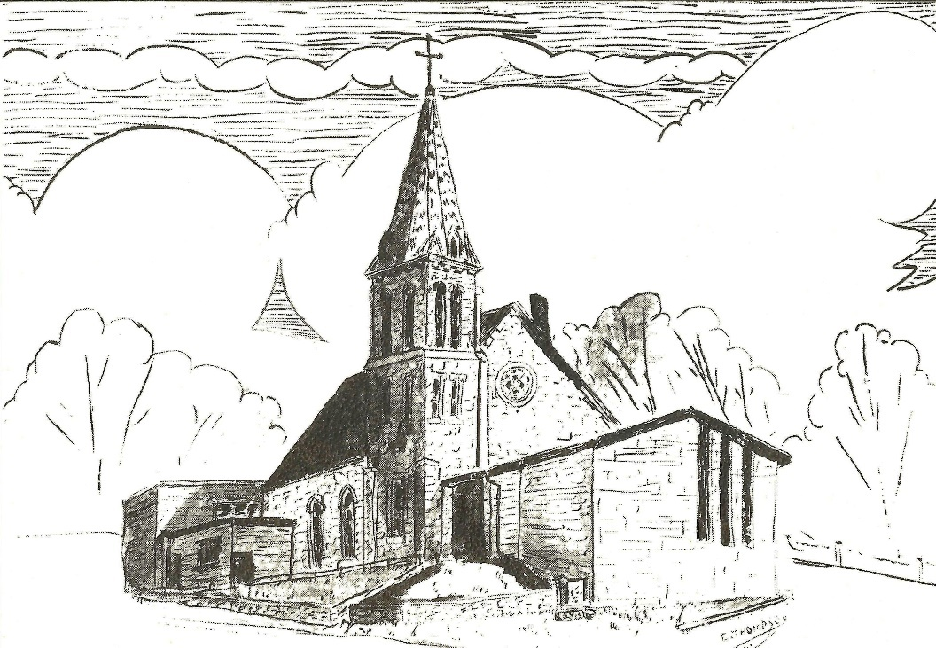
Established 1874

Rev. Kerry B. Eversole, Pastor
Deacon Cindy Cordes-Eversole, Associate in Ministry

Mailing Address: P.O. Box 314, Lanesboro, MN 55949-0314
Physical Address: 200 Kenilworth Ave S, Lanesboro, Minn.

Telephone: 507.467.3344
E-mail Address: bethlehem@acegroup.cc
Web Page: www.staronthehill.com
Facebook Page: www.facebook.com/BethlehemLutheranLanesboro

Office Hours: Tuesday, Wednesday, Thursday 10 a.m. to 3 p.m.
Parsonage Phone: 507.467.3017
Pastor Kerry’s Cell Phone: 507.951.3954

Bethlehem Lutheran Church
Lanesboro, Minnesota

Christ the King
The Last Sunday after Pentecost
November 20, 2022

One of the criminals who were hanged there kept deriding Jesus and saying, “Are you not the Messiah? Save yourself and us!” But the other rebuked him, saying, “Do you not fear God, since you are under the same sentence of condemnation? And we indeed have been condemned justly, for we are getting what we deserve for our deeds, but this man has done nothing wrong.” Then he said, “Jesus, remember me when you come into your kingdom.” Jesus replied, “Truly I tell you, today you will be with me in Paradise.” Luke 25:38-43
Welcome to worship at Bethlehem Lutheran Church
and our celebration of Christ the King!

We are “The star on the hill”
You are the light of the world … let your light shine before others, so that they may see your good works and give glory to your Father in heaven. Matthew 5:14-16

COVID-19 Practices — Out of love for God and Neighbor

1) Use hand sanitizer upon entry. Wash your hands and use hand sanitizer often while in the facility.
2) Members and visitors who are vaccinated and boosted are not required to wear a mask.
3) Members and visitors are free to wear a mask if they wish to do so.
4) Unvaccinated and not boosted members and visitors must wear a mask.
5) There are no physical distancing requirements, but you are welcome to keep a distance from others in the sanctuary as you are able.
6) All are welcome to enjoy coffee fellowship in the dining room following worship.

Worship Book and Hymns. This morning’s service is printed in the bulletin. The hymns can be found in Evangelical Lutheran Worship (ELW), “the red book”, which are in the pews. Hymns in ELW are indicated by a large bold number in each page’s left or right margin.

Abbreviations. Throughout this worship folder hymns are signified by the pound symbol (#), P: refers to the presiding minister or preacher, A: denotes an assisting minister, and C: and/or bold text indicates the congregation.

Offering. Later in our service, we will be receiving an offering. The offering is an opportunity to worship God with our money. We know that the money you give to Bethlehem Lutheran Church represents your lives — your time, talents, and hard work. We recognize that and we appreciate your generosity. Your support not only helps all of us to fulfill God’s call on our lives, but it also makes an impact, and we thank you! Lastly, our visitors are not expected to give. After all, you are our guests! We’re glad you’re here and we want you to feel welcomed!

Mistakes do not happen in our worship service; only unexpected events which are opportunities for joy!

An signifies that you may stand, as you are comfortably able.
Gathering

The Holy Spirit calls us together as the people of God.

Introduction to the Day. On this final Sunday of the church year, Jeremiah’s promise of the execution of “justice and righteousness in the land” finds ironic fulfillment in the execution of Jesus of Nazareth, the King of the Jews. It appears utterly contradictory that a king should be crucified with a criminal. To all the world this is a humiliating defeat. Yet through the gate of death, Jesus opens the door to paradise and victory.

PRELUDE

WELCOME AND INTRODUCTION TO THE DAY

CONFESSION AND FORGIVENESS

All may make the sign of the cross, the sign marked at baptism, as the presiding minister begins.

P: Blessed be the holy Trinity, ☩ one God, who redeems us in Christ Jesus, whose steadfast love endures forever.

C: Amen.

P: Let us confess our sin in the presence of God and of one another.

Silence is kept for reflection.

P: Most merciful God,

All: we confess that we have sinned against you and our neighbors. We have ignored voices that call for your justice. We have neglected actions that witness to your righteousness. We have spoken and acted in ways that disrupt your beloved community. We truly repent of the things we have done and left undone. For the sake of Jesus Christ, have mercy on us. Restore our troubled spirits, so that we may live in newness, follow the way of the Spirit, and build up the body of Christ. Amen.

P: Rejoice and be glad! God hears the prayers of all who cry out and restores us to life through the death, resurrection, and ascension of Jesus Christ. Therefore, I declare to you the forgiveness of all your sins, in the name of God’s Christ ☩ the King.

C: Amen.
OPENING HYMN Crown Him with Many Crowns ELW # 855

Stanzas 1, 2, 3 and 4

GREETING ELW p. 203

P: The grace of our Lord Jesus Christ, the love of God, and the communion of the Holy Spirit be with you all.

C: And also with you.

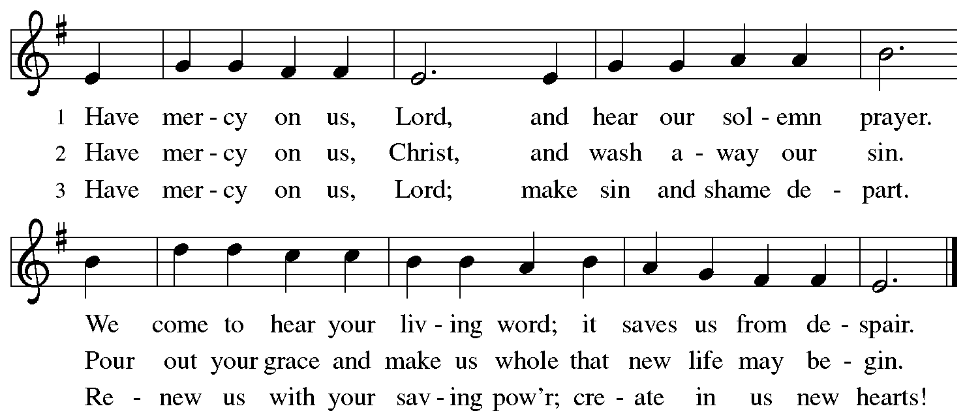
KYRIE ELW p. 203

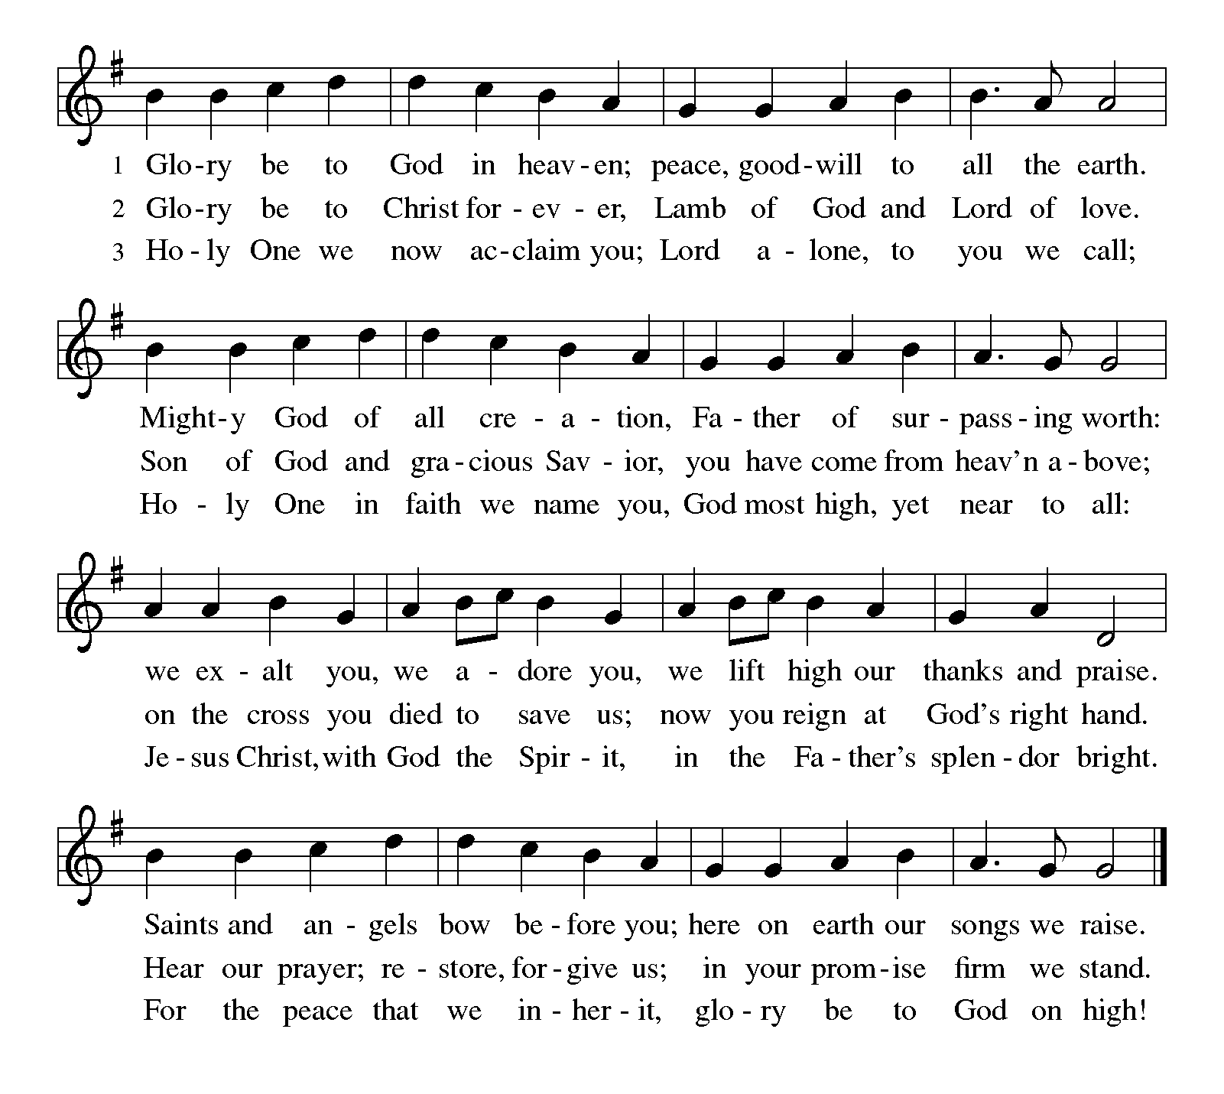
CANTICLE OF PRAISE Glory Be to God ELW p. 204

Continued on the next page.

CANTICLE OF PRAISE continued ELW p. 204

PRAYER OF THE DAY

P: Let us pray together. O God, our true life,

All: to serve you is freedom, and to know you is unending joy. We worship you, we glorify you, we give thanks to you for your great glory. Abide with us, reign in us, and make this world into a fit habitation for your divine majesty, through Jesus Christ, our Savior and Lord, who lives and reigns with you and the Holy Spirit, one God, now and forever. Amen.

Word

God speaks to us in scripture reading, preaching, and song

FIRST READING Jeremiah 23:1-6

Today’s reading builds on the common, ancient Near Eastern metaphor of the king as shepherd. Judah’s unjust rulers have caused their people, their “flock”, to be scattered. Nevertheless, God will raise up a new and righteous shepherd who will rule a restored Judah.

¹Woe to the shepherds who destroy and scatter the sheep of my pasture! says the Lord. ²Therefore thus says the Lord, the God of Israel, concerning the shepherds who shepherd my people: It is you who have scattered my flock, and have driven them away, and you have not attended to them. So I will attend to you for your evil doings, says the Lord. ³Then I myself will gather the remnant of my flock out of all the lands where I have driven them, and I will bring them back to their fold, and they shall be fruitful and multiply. ⁴I will raise up shepherds over them who will shepherd them, and they shall not fear any longer, or be dismayed, nor shall any be missing, says the Lord.
⁵The days are surely coming, says the Lord, when I will raise up for David a righteous Branch, and he shall reign as king and deal wisely, and shall execute justice and righteousness in the land. ⁶In his days Judah will be saved and Israel will live in safety. And this is the name by which he will be called: “The Lord is our righteousness.”

A: The word of the Lord.

C: Thanks be to God.

PSALM 46

¹God is our refuge and strength, a very present help in trouble.

²Therefore we will not fear, though the earth be moved, and though the mountains shake in the depths of the sea;

³though its waters rage and foam, and though the mountains tremble with its tumult.

⁴There is a river whose streams make glad the city of God, the holy habitation of the Most High.

Continued on the next page.

⁵God is in the midst of the city; it shall not be shaken; God shall help it at the break of day.

⁶The nations rage, and the kingdoms shake; God speaks, and the earth melts away.

⁷The Lord of hosts is with us; the God of Jacob is our stronghold.

⁸Come now, regard the works of the Lord, what desolations God has brought upon the earth;

⁹behold the one who makes war to cease in all the world; who breaks the bow, and shatters the spear, and burns the shields with fire.

¹⁰“Be still, then, and know that I am God; I will be exalted among the nations; I will be exalted in the earth.”

¹¹The Lord of hosts is with us; the God of Jacob is our stronghold.

I will be exalted among the nations.

ANTHEM Such an Out of the Ordinary Man Karen Schreiber

SECOND READING Colossians 1:11-20

An early Christian hymn praises the mystery of the political, personal, and mystical Christ, the one who was present at creation and is eternally reigning with God.

¹¹May you be made strong with all the strength that comes from his glorious power, and may you be prepared to endure everything with patience, while joyfully ¹²giving thanks to the Father, who has enabled you to share in the inheritance of the saints in the light. ¹³He has rescued us from the power of darkness and transferred us into the kingdom of his beloved Son, ¹⁴in whom we have redemption, the forgiveness of sins.
¹⁵He is the image of the invisible God, the firstborn of all creation; ¹⁶for in him all things in heaven and on earth were created, things visible and invisible, whether thrones or dominions or rulers or powers—all things have been created through him and for him. ¹⁷He himself is before all things, and in him all things hold together. ¹⁸He is the head of the body, the church; he is the beginning, the firstborn from the dead, so that he might come to have first place in everything. ¹⁹For in him all the fullness of God was pleased to dwell, ²⁰and through him God was pleased to reconcile to himself all things, whether on earth or in heaven, by making peace through the blood of his cross.

A: The word of the Lord.

C: Thanks be to God.

GOSPEL ACCLAMATION Alleluia ELW p. 205
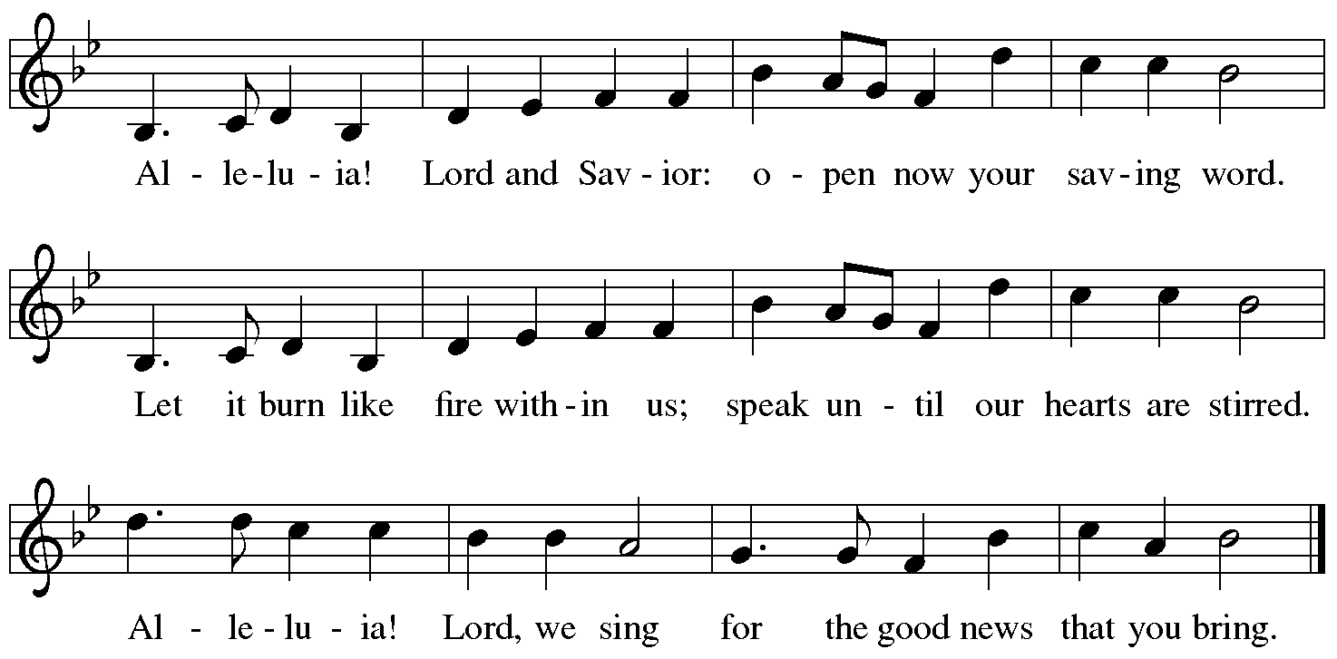

GOSPEL Luke 23:33-43

P: Announcement of the gospel.

C: Glory to you, O Lord.

Amid scoffing and slander from those who sarcastically call him Messiah and king, Jesus reveals that to be Messiah and king is to give one’s life for others. Here he uses his power to welcome a despised sinner to paradise but puts his own death into God’s hands.

³³When they came to the place that is called The Skull, they crucified Jesus there with the criminals, one on his right and one on his left. ³⁴Then Jesus said, “Father, forgive them; for they do not know what they are doing.” And they cast lots to divide his clothing. ³⁵And the people stood by, watching; but the leaders scoffed at him, saying, “He saved others; let him save himself if he is the Messiah of God, his chosen one!” ³⁶The soldiers also mocked him, coming up and offering him sour wine, ³⁷and saying, “If you are the King of the Jews, save yourself!” ³⁸There was also an inscription over him, “This is the King of the Jews.”
³⁹One of the criminals who were hanged there kept deriding him and saying, “Are you not the Messiah? Save yourself and us!” ⁴⁰But the other rebuked him,

Continued on the next page.
saying, “Do you not fear God, since you are under the same sentence of condemnation? ⁴¹And we indeed have been condemned justly, for we are getting what we deserve for our deeds, but this man has done nothing wrong.” ⁴²Then he said, “Jesus, remember me when you come into your kingdom.” ⁴³He replied, “Truly I tell you, today you will be with me in Paradise.”

P: Affirmation of the gospel.

C: Praise to you, O Christ.

SERMON

HYMN OF THE DAY Beautiful Savior ELW # 838

Responding

We respond to the word of Christ our King.

PROFESSION OF FAITH Nicene Creed ELW p. 104

All: We believe in one God, the Father, the Almighty, maker of heaven and earth, of all that is, seen and unseen.

We believe in one Lord, Jesus Christ, the only Son of God, eternally begotten of the Father, God from God, Light from Light, true God from true God, begotten, not made, of one Being with the Father; through him all things were made. For us and for our salvation he came down from heaven, was incarnate of the Holy Spirit and the virgin Mary and became truly human. For our sake he was crucified under Pontius Pilate; he suffered death and was buried. On the third day he rose again in accordance with the scriptures; he ascended into heaven and is seated at the right hand of the Father. He will come again in glory to judge the living and the dead, and his kingdom will have no end.

We believe in the Holy Spirit, the Lord, the giver of life, who proceeds from the Father and the Son, who with the Father and the Son is worshiped and glorified, who has spoken through the prophets. We believe in one holy catholic and apostolic church. We acknowledge one baptism for the forgiveness of sins. We look for the resurrection of the dead, and the life of the world to come. Amen.

OFFERING AND MUSIC

At this point in our service, we worship God with our money. The ushers will pass plates down the pews to receive your gifts of cash and checks made out to Bethlehem Lutheran Church. You can even give online at https://secure.myvanco.com/L-Z22R/. Your gifts support the worship, faith formation, administration, and other ministries of Bethlehem Lutheran—loose change goes to the Preston Food Pantry—as well as the mission of the Southeastern Minnesota Synod, and the whole Evangelical Lutheran Church in America. God bless your giving and your generosity. And thank you!

OFFERING SONG Jesus, Remember Me ELW # 616

Sing 3 times

PRAYERS OF INTERCESSION

Each prayer ends with these words and response:

P: Lord, in your mercy,

C: receive our prayer.

Concluding prayer and response:

P: Accept these prayers, gracious God, and those known only to you; through Jesus Christ, our Lord.

C: Amen.

LORD’S PRAYER Traditional Wording ELW p. 208

P: Gathered into one by the Holy Spirit, let us pray as Jesus taught us.

All: Our Father, who art in heaven, hallowed be thy name, thy kingdom come, thy will be done, on earth as it is in heaven. Give us this day our daily bread; and forgive us our trespasses, as we forgive those who trespass against us; and lead us not into temptation, but deliver us from evil. For thine is the kingdom, and the power, and the glory, forever and ever. Amen.

Sending

God blesses us and sends us in mission to the world.

ANNOUNCEMENTS

BLESSING

P: The God of peace, who creates all things and calls them good,
who makes us alive in Jesus,
and who breathes on us the Spirit of hope,
☩ bless you now and forever.

C: Amen.

DEPARTING HYMN Rejoice, for Christ Is King! ELW # 430

Sung to Before You, Lord, We Bow ELW # 893

DISMISSAL

P: Go in peace. Be a blessing in the world.

C: Thanks be to God.

POSTLUDE

Today’s Assistants and Ministers

Greeters & Ushers …………………………………...… Mike & Raquel Torgerson and family
Pianist ……………………………………………...………………….…..…….. Karen Schreiber
Presiding Minister …………………………….…….…..……….………. Pastor Kerry Eversole
Reader ……………………………………...…........………...…..…..…………… Glen Jensson
Altar Care …….……………..................................................…………. Glen & Julie Jensson
Refreshments ……………….………… Mike & Raquel Torgerson and Glen & Julie Jensson

Presence Last Week and October Presents

Attendance Last Sunday, November 13 = 45
Average Sunday Worship Attendance for October = 63

October Contributions: General Fund = $11,638 Designated Giving = $35,789
Jan-Oct Income = $121,773 Jan-Oct Expenses = $138,866 Deficit = $17,093

This Week in Our Congregation

Today, November 20 — Christ the King — Last Sunday after Pentecost

Sunday school meets after the children’s message
Refreshments in the Fellowship Hall for everyone after worship
7th & 8th-grade Confirmation session 10:15 AM

Tuesday, November 22

Men’s breakfast at Home Sweet Home, Lanesboro 7:00 AM

Thursday, November 24 — Thanksgiving Day — Church Office Closed

Next Sunday, November 27 — First Sunday of Advent

Worship with the Praise Band 9:00 AM
Refreshments in the Fellowship Hall for everyone after worship
NO Sunday School
NO 7th & 8th-grade Confirmation session

News and Notes

The Mitten Basket is awaiting your donations of new or gently used mittens, gloves, hats and scarves! The basket is in the Fellowship Hall. All donations will be given to SEMCAC for distribution to those in need.

Looking Ahead. The Sunday School Christmas Program is scheduled for Sunday, December 11 during the worship hour.

Help yourself to a Thrivent t-shirt or two or three! They are on the table in the narthex. Various sizes. FREE!

Prayer Requests

In Our Community. For our church members and friends living with chronic illness and other diseases, who are homebound, residing in care facilities, and hospitalized. See the newsletter for our members living in area nursing homes. And let us not forget those sick and dying of COVID-19, those entrusted with the authority of government, justice, and law enforcement, as well as our fallen and wounded soldiers and those still serving.

In Our Synod. Bishop Regina Hassanally invites the congregations of our synod to commit to praying this week for the following communities of faith: Gol Lutheran Church, Kenyon; Lands Lutheran Church, Zumbrota; North Waseca Lutheran Church, Waseca; Messiah Lutheran Church, North Mankato; Anuyak Sudanese Worshipping Community, Austin; Mgori Lutheran Church, Tanzania; and San Juan Lutheran Church, Colombia.

Community activities

Free Thanksgiving Dinner, Thanksgiving Day, Thursday, November 24. Serving from 11:30 a.m. to 1:00 p.m., at the Lanesboro Pastry Shoppe, 202 Parkway Ave N, Lanesboro. Menu: Turkey, mashed potatoes, gravy, dressing, corn, squash, cranberry relish, pumpkin pie, apple pie, and beverages. Dine in or carry out or have delivered within Lanesboro. Your freewill offering will go to the Fillmore County Food Shelf. For carryouts or deliveries, call Deb Danielson (507-459-3593).

Red Cross Blood Drive, Wednesday, November 30, from 1 to 6 pm, in the Lanesboro Community Center. Call Gwen Harmon (507-272-3136) or Kathryn Wade (507-272-6864) for an appointment. Bring a photo ID or your donor card. You must be at least 16 years old. Youths under the age of 18 need a signed parental consent form, which will be available at the Community Center.

Acknowledgments

Graphics, worship texts, service music, and readings are from sundaysandseasons.com © 2022 Augsburg Fortress. Used by permission under Augsburg Fortress Liturgies Annual License SAS103296.

Permission to project, livestream, or podcast liturgy and music content under copyright to or administered by Augsburg Fortress provided under Augsburg Fortress Liturgies Annual License SAS103296.

Permission to Podcast / Stream provided by Christian Copyright Licensing International, Inc., under License # 11459672. Additional fee paid. www.ccli.com.

Permission to Podcast / Stream provided by One License, Inc., under License # A-735588. Additional fee paid. www.onelicense.net.

