Bethlehem Lutheran Church
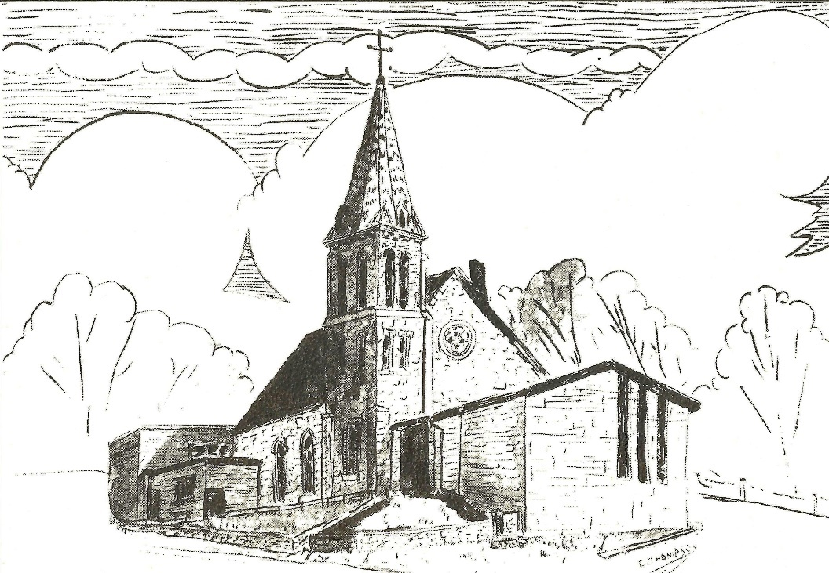
Established 1874

Rev. Kerry B. Eversole, Pastor
Deacon Cindy Cordes-Eversole, Associate in Ministry

Mailing Address: P.O. Box 314, Lanesboro, MN 55949-0314
Physical Address: 200 Kenilworth Ave S, Lanesboro, Minn.

Telephone: 507.467.3344
E-mail Address: bethlehem@acegroup.cc
Web Page: www.staronthehill.com
Facebook Page: www.facebook.com/BethlehemLutheranLanesboro

Office Hours: Tuesday, Wednesday, Thursday 10 a.m. to 3 p.m.
Parsonage Phone: 507.467.3017
Pastor Kerry’s Cell Phone: 507.951.3954

Bethlehem Lutheran Church
Lanesboro, Minnesota

Twenty-third Sunday after Pentecost

November 13, 2022


Jesus said concerning the end times, “Beware that you are not led astray; for many will come in my name and say, ‘I am he!’ and, ‘The time is near!’ Do not go after them. When you hear of wars and insurrections, do not be terrified; for these things must take place first, but the end will not follow immediately.” Then he said to them, “Nation will rise against nation, and kingdom against kingdom; there will be great earthquakes, and in various places famines and plagues; and there will be dreadful portents and great signs from heaven.” Luke 21:8-11
Welcome to worship at Bethlehem Lutheran Church!

We are “The star on the hill”
You are the light of the world … let your light shine before others, so that they may see your good works and give glory to your Father in heaven. Matthew 5:14-16

COVID-19 Practices — Out of love for God and Neighbor

1) Use hand sanitizer upon entry. Wash your hands and use hand sanitizer often while in the facility.
2) Members and visitors who are vaccinated and boosted are not required to wear a mask.
3) Members and visitors are free to wear a mask if they wish to do so.
4) Unvaccinated and not boosted members and visitors must wear a mask.
5) There are no physical distancing requirements, but you are welcome to keep a distance from others in the sanctuary as you are able.
6) All are welcome to enjoy coffee fellowship in the dining room following worship.

Worship Book and Hymns. This morning’s service is printed in the bulletin. The hymns can be found in Evangelical Lutheran Worship (ELW), “the red book”, which are in the pew racks. Hymns in ELW are indicated by a large bold number in each page’s left or right margin. One hymn is printed in the bulletin.

Abbreviations. Throughout this worship folder hymns are signified by the pound symbol (#), P: refers to the presiding minister or preacher, A: denotes an assisting minister, and C: and/or bold text indicates the congregation.

Offering. Later in our service, we will be receiving an offering. The offering is an opportunity to worship God with our money. We know that the money you give to Bethlehem Lutheran Church represents your lives — your time, talents, and hard work. We recognize that and we appreciate your generosity. Your support not only helps all of us to fulfill God’s call on our lives, but it also makes an impact, and we thank you! Lastly, our visitors are not expected to give. After all, you are our guests! We’re glad you’re here and we want you to feel welcomed!

Mistakes do not happen in our worship service; only unexpected events which are opportunities for joy!

An signifies that you may stand, as you are comfortably able.

Gathering

The Holy Spirit calls us together as the people of God.

Introduction to the Day. We are deep in the Season after Pentecost, the so-called Time of the Church. Today we hear that the end is near. There is no doubt about it. The warnings are dire. The tone of today’s texts is ominous. But the baptized know how to live in the meantime. The baptized are strengthened for the living of these days in word and sacrament. The baptized rally around the invitation of the apostle: “Do not be weary in doing what is right.”

PRELUDE

RINGING OF THE BELL AND WELCOME

CONFESSION AND FORGIVENESS

All may make the sign of the cross, the sign marked at baptism, as the presiding minister begins.

P: Blessed be the holy Trinity, ☩ one God, who redeems us in Christ Jesus, whose steadfast love endures forever.

C: Amen.

P: Let us confess our sin in the presence of God and of one another.

Silence is kept for reflection.

P: Most merciful God,

All: we confess that we have sinned against you and our neighbors. We have ignored voices that call for your justice. We have neglected actions that witness to your righteousness. We have spoken and acted in ways that disrupt your beloved community. We truly repent of the things we have done and left undone. For the sake of Jesus Christ, have mercy on us. Restore our troubled spirits, so that we may live in newness, follow the way of the Spirit, and build up the body of Christ. Amen.

P: Rejoice and be glad! God hears the prayers of all who cry out and restores us to life through the death and resurrection of Jesus Christ. Therefore, I declare to you the forgiveness of all your sins, in the name of the Father, and of the ☩ Son, and of the Holy Spirit.

C: Amen.
OPENING HYMN Rise, O Sun of Righteousness ELW # 657

Stanzas 1, 2, 3 and 4

GREETING

P: The grace of our Lord Jesus Christ, the love of God, and the communion of the Holy Spirit be with you all.

C: And also with you.

PRAYER OF THE DAY

P: Let us pray together.

O God, the protector of all who trust in you,

All: without you nothing is strong, nothing is holy. Embrace us with your mercy, that with you as our ruler and guide, we may live through what is temporary without losing what is eternal, through Jesus Christ, our Savior and Lord. Amen.

God’s Word for the End Times

God speaks to us in scripture reading, preaching, and song

FIRST READING Malachi 4:1-2a

Malachi, whose name means “my messenger,” warns that “the day is coming.” On that day, the evil will be destroyed like stubble in a fire, but the “sun of righteousness” will shine on those who honor God.

¹See, the day is coming, burning like an oven, when all the arrogant and all evildoers will be stubble; the day that comes shall burn them up, says the Lord of hosts, so that it will leave them neither root nor branch. ^{2a}But for you who revere my name the sun of righteousness shall rise, with healing in its wings.

A: The word of the Lord.

C: Thanks be to God.

HYMN OF PRAISE All Creatures, Worship God Most High! ELW # 835

Stanzas 1, 2, 4 and 5

A paraphrase of Psalm 98, the appointed psalm for today

SECOND READING 2 Thessalonians 3:6-13

Some members of the Thessalonian community, because of their belief in the nearness of Christ’s return, had ceased to work, living off the generosity of other members of the community. The writer of this letter warns them bluntly that if they want to eat, they need to work.

⁶Now we command you, beloved, in the name of our Lord Jesus Christ, to keep away from believers who are living in idleness and not according to the tradition that they received from us. ⁷For you yourselves know how you ought to imitate us; we were not idle when we were with you, ⁸and we did not eat anyone’s bread without paying for it; but with toil and labor we worked night and day, so that we might not burden any of you. ⁹This was not because we do not have that right, but in order to give you an example to imitate. ¹⁰For even when we were with you, we gave you this command: Anyone unwilling to work should not eat. ¹¹For we hear that some of you are living in idleness, mere busybodies, not doing any work. ¹²Now such persons we command and exhort in the Lord Jesus Christ to do their work quietly and to earn their own living. ¹³Brothers and sisters, do not be weary in doing what is right.

A: The word of the Lord.

C: Thanks be to God.

GOSPEL Luke 21:5-19

P: Announcement of the gospel.

C: Glory to you, O Lord.

As history moves toward God’s fulfillment there will be frightening signs and events. Before the end, believers will draw strength from their relationship with God and will be given the words they need to testify and endure without fear.

⁵When some were speaking about the temple, how it was adorned with beautiful stones and gifts dedicated to God, [Jesus] said, ⁶“As for these things that you see, the days will come when not one stone will be left upon another; all will be thrown down.”
⁷They asked him, “Teacher, when will this be, and what will be the sign that this is about to take place?” ⁸And he said, “Beware that you are not led astray;
for many will come in my name and say, ‘I am he!’ and, ‘The time is near!’ Do not go after them.
⁹“When you hear of wars and insurrections, do not be terrified, for these things

Continued on the next page.

must take place first, but the end will not follow immediately.” ¹⁰Then he said to them, “Nation will rise against nation, and kingdom against kingdom; ¹¹there will be great earthquakes, and in various places famines and plagues; and there will be dreadful portents and great signs from heaven.
¹²“But before all this occurs, they will arrest you and persecute you; they will hand you over to synagogues and prisons, and you will be brought before kings and governors because of my name. ¹³This will give you an opportunity to testify. ¹⁴So make up your minds not to prepare your defense in advance; ¹⁵for I will give you words and a wisdom that none of your opponents will be able to withstand or contradict. ¹⁶You will be betrayed even by parents and brothers, by relatives and friends; and they will put some of you to death. ¹⁷You will be hated by all because of my name. ¹⁸But not a hair of your head will perish. ¹⁹By your endurance you will gain your souls.”

P: Affirmation of the gospel.

C: Praise to you, O Christ.

GOSPEL HYMN How Firm a Foundation ELW # 796

Stanzas 1, 2 and 3

SERMON

HYMN OF THE DAY God of Grace and God of Glory ELW 705

RECEPTION OF NEW MEMBERS

HYMN Blest Be the Tie That Binds ELW 656

Stanzas 1, 2 and 3

PRAYERS OF INTERCESSION

Each prayer ends with these words and response:

P: Lord, in your mercy,

C: receive our prayer.

Concluding prayer and response:

P: Accept these prayers, gracious God, and those known only to you; through Jesus Christ, our Lord.

C: Amen.

Thanksgiving for God’s Word About the End Times

OFFERING AND MUSIC

At this point in our service, we worship God with our money. The ushers will pass plates down the pews to receive your gifts of cash and checks made out to Bethlehem Lutheran Church. You can even give online at https://secure.myvanco.com/L-Z22R/. Your gifts support the worship, faith formation, administration, and other ministries of Bethlehem Lutheran—loose change goes to the Preston Food Pantry—as well as the mission of the Southeastern Minnesota Synod, and the whole Evangelical Lutheran Church in America. God bless your giving and your generosity. And thank you!

OFFERING SONG God Whose Giving Knows No Ending ELW # 678

Sung to Joyful, Joyful We Adore Thee ELW # 836

THANKSGIVING FOR THE WORD ELW p. 220

P: Let us pray.

Praise and thanks to you, holy God, for by your Word you made all things: you spoke light into darkness, called forth beauty from chaos, and brought life into being. For your Word of life, O God,

C: we give you thanks and praise.

P: By your Word you called your people Israel to tell of your wonderful gifts: freedom from captivity, water on the desert journey, a pathway home from exile, wisdom for life with you. For your Word of life, O God,

C: we give you thanks and praise.

P: Through Jesus, your Word made flesh, you speak to us and call us to witness: forgiveness through the cross, life to those entombed by death, the way of your self-giving love. For your Word of life, O God,

C: we give you thanks and praise.

P: Send your Spirit of truth, O God; rekindle your gifts within us: renew our faith, increase our hope, and deepen our love, for the sake of a world in need. Faithful to your Word, O God, draw near to all who call on you; through Jesus Christ, our Savior and Lord, to whom, with you and the Holy Spirit, be honor and glory forever.

C: Amen.

LORD’S PRAYER Traditional Wording ELW p. 221

P: Gathered into one by the Holy Spirit, let us pray as Jesus taught us:

All: Our Father, who art in heaven, hallowed be thy name, thy kingdom come, thy will be done, on earth as it is in heaven. Give us this day our daily bread; and forgive us our trespasses, as we forgive those who trespass against us; and lead us not into temptation, but deliver us from evil. For thine is the kingdom, and the power, and the glory, forever and ever. Amen.

Sending

God blesses us and sends us in mission to the world.

ANNOUNCEMENTS

BLESSING

P: The God of peace, who creates all things and calls them good,
who makes us alive in Jesus,
and who breathes on us the Spirit of hope,
☩ bless you now and forever.

C: Amen.

DEPARTING HYMN My Lord, What a Morning ELW # 438

DISMISSAL

P: Go in peace. Be a blessing in the world.

C: Thanks be to God.

POSTLUDE

Today’s Assistants and Ministers

Greeters & Ushers …………….……...… Bob & Phyllis Penheiter and Glen & Julie Jensson
Organist-Pianist ……………………………………..…...………………….…..…….. Sue Holst
Presiding Minister ……………………….…..……….………. Deacon Cindy Cordes-Eversole
Reader ……………………………………...…...………...…..…..…………… Phyllis Penheiter
Altar Care …….…………….........................................................…………. Phyllis Penheiter

Presence Last Week and October Presents

Attendance Last Sunday, November 6 = 120
Average Sunday Worship Attendance for October = 63

October Contributions: General Fund = $11,638 Designated Giving = $35,789
Jan-Oct Income = $121,773 Jan-Oct Expenses = $138,866 Deficit = $17,093

This Week in Our Congregation

Today, November 13 — Twenty-third Sunday after Pentecost

NO Sunday School today
NO Refreshments today
7th & 8th-grade Confirmation session 10:15 AM
Drive-Thru Fall Dinner 11 AM-2 PM

Monday, November 14—Tuesday, November 15

Pastor Kerry at the SE MN Synod Fall Theological Conference, Onalaska, WI

Tuesday, November 15

Men’s breakfast at Home Sweet Home, Lanesboro 7:00 AM

Wednesday, November 16

First Communion Class 6:30 PM

Next Sunday, November 20 — Christ the King — Last Sunday after Pentecost

Worship 9:00 AM
7th & 8th-grade Confirmation session 10:15 AM

News and Notes

A heartfelt welcome to the following new members: Brian & Barb Jeffers, Andrew, JoAnna and Theodore Pruett, Marilyn O’Rourke, Tom Brudvig & Pam Engebretson.

Bethlehem’s Drive-Thru Fall Dinner is today! Serving from 11 am to 2 pm. Pick up on the south side of the church. Menu: Windsor chop, baked potato, glazed carrots, dinner roll, and apple crisp dessert. Cost: $15.

The Mitten Basket is awaiting your donations of new or gently used mittens, gloves, hats and scarves! The basket is in the Fellowship Hall. All donations will be given to SEMCAC for distribution to those in need.

News and Notes continued

Looking Ahead. The Sunday School Christmas Program is scheduled for Sunday, December 11 during the worship hour.

Prayer Requests

In Our Community. For our church members and friends living with chronic illness and other diseases, who are homebound, residing in care facilities, and hospitalized. See the newsletter for our members living in area nursing homes. And let us not forget those sick and dying of COVID-19, those entrusted with the authority of government, justice, and law enforcement, as well as our fallen and wounded soldiers and those still serving.

In Our Synod. Bishop Regina Hassanally invites the congregations of our synod to commit to praying this week for the following communities of faith: Christ Lutheran Church, Byron; St. Luke’s Lutheran Church, Goodhue; Grace Lutheran Church, Waseca; St. Paul Lutheran Church, Conger; Cannon River Lutheran Church, Welch; Mungaa Lutheran Church, Tanzania; and Pulguori Lutheran Parish, South Sudan.

Acknowledgments

Graphics, worship texts, service music, and readings are from sundaysandseasons.com © 2022 Augsburg Fortress. Used by permission under Augsburg Fortress Liturgies Annual License SAS103296.

Permission to project, livestream, or podcast liturgy and music content under copyright to or administered by Augsburg Fortress provided under Augsburg Fortress Liturgies Annual License SAS103296.

Permission to Podcast / Stream provided by Christian Copyright Licensing International, Inc., under License # 11459672. Additional fee paid. www.ccli.com.

Permission to Podcast / Stream provided by One License, Inc., under License # A-735588. Additional fee paid. www.onelicense.net.

New Member Reception – November 13, 2022

Brian & Barb Jeffers. Brian grew up in Chatfield and he comes to us from Chatfield Lutheran Church. He does custom ag work where he drives a tractor, payloader and other large equipment.
Barb was born and raised in Lanesboro. After living elsewhere for over 30 years, Barb was happy when she and Brian moved back to Lanesboro in 2015.
Barb has two businesses, Barb's Carpet Care and Bluff Country Photography. She’s also the Photo Journalist for the Fillmore County Journal.
Barb has four grown children and together Barb and Brian have 10 grandchildren.
Barb and Brian enjoy traveling and spending time at their camper with family and friends.

Andrew & JoAnna Pruett, their son, Theodore, and JoAnna’s mother Marilyn. Andrew works in Research at Mayo Clinic and has authored the book, Shaped by Water, a true adventure story great for all ages. Andrew loves the outdoors, especially mushroom foraging and fishing.
JoAnna is a nurse at Mayo Clinic. She loves to cook, birdwatch, and photograph the outdoors.
Theodore is in 5th grade at Lanesboro Elementary. He loves the outdoors, especially fishing. He also loves animals and has several.
Marilyn O’Rourke is a retired nurse who loves to read. She lives with Andrew and JoAnna.
The family attended Christ Community Church prior to moving to Lanesboro.

Pam Engebretson and Tom Brudvig. Pam is a Minnesota native who moved to Lanesboro from St. Paul last year. She has a son who lives in Tacoma, WA. She has worked as a speech pathologist in hospital and school settings. She loves animals, especially dogs, horses, and donkeys! She also enjoys reading, hiking, and biking. Pam comes to us from Hope Presbyterian Church in St. Paul.
Tom was born in Iowa but received his education primarily in MN – at the University of Minnesota, Morris, and William Mitchell College of Law. He has a son, daughter, and 5 grandchildren in the Twin Cities. He enjoys fitness activities, reading, theatre and listening to music. Tom retired (mostly) on June 1, 2022. He comes to us from Christ Lutheran Church in North St. Paul.

