Bethlehem Lutheran Church
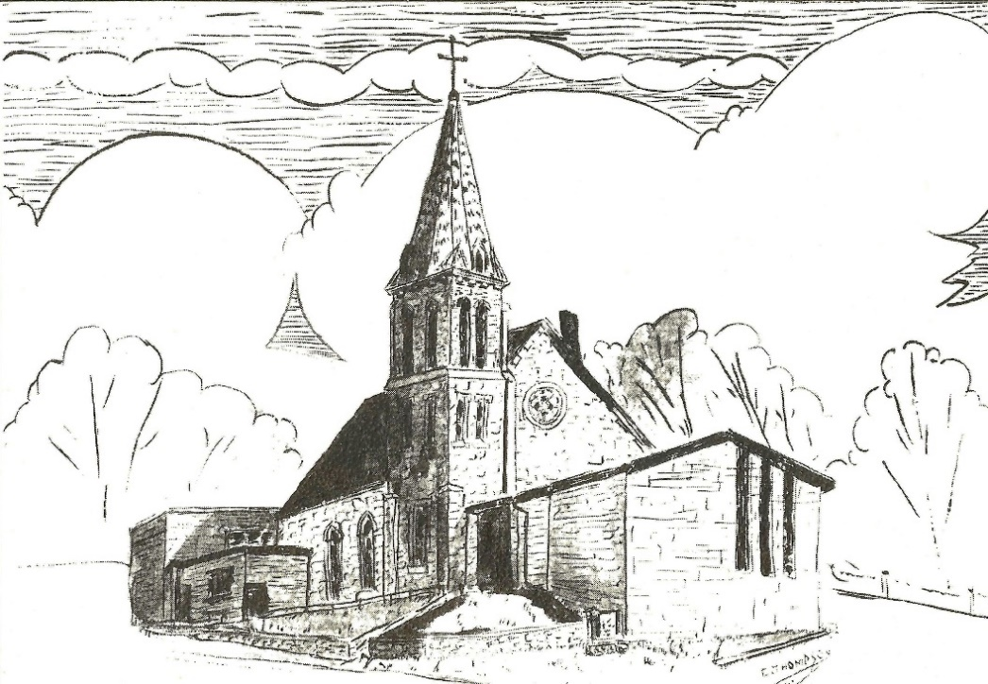
Established 1874

Rev. Kerry B. Eversole, Pastor
Deacon Cindy Cordes-Eversole, Associate in Ministry

Mailing Address: P.O. Box 314, Lanesboro, MN 55949-0314
Physical Address: 200 Kenilworth Ave S, Lanesboro, Minn.

Telephone: 507.467.3344
E-mail Address: bethlehem@acegroup.cc
Website: www.staronthehill.com
Facebook Page: www.facebook.com/BethlehemLutheranLanesboro/

Office Hours: Tuesday, Wednesday, Thursday 10 a.m. to 3 p.m.
Parsonage Phone: 507.467.3017
Pastor Kerry’s Cell Phone: 507.951.3954

Bethlehem Lutheran Church
Lanesboro, Minnesota

All Saints Sunday
Affirmation of Baptism

November 6, 2022

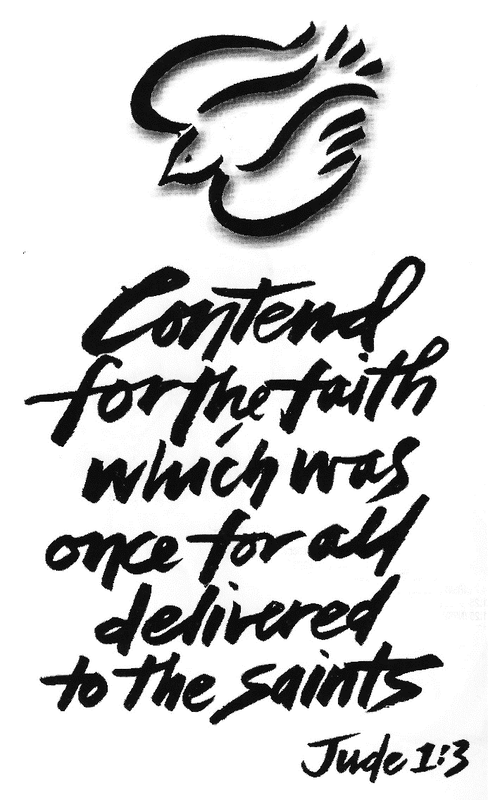
Welcome to worship at Bethlehem Lutheran
and our celebration of All the Saints and Confirmation!

COVID-19 Practices — Out of love for God and Neighbor

1) Use hand sanitizer upon entry. Wash your hands and use hand sanitizer often while in the facility.
2) Members and visitors who are vaccinated and boosted are not required to wear a mask.
3) Members and visitors are free to wear a mask if they wish to do so.
4) Unvaccinated and not boosted members and visitors must wear a mask.
5) There are no physical distancing requirements, but you are welcome to keep a distance from others in the sanctuary as you are able.
6) All are welcome to enjoy coffee fellowship in the dining room following worship.

Worship Book and Hymns. This morning’s service is printed in the bulletin. The hymns can be found in Evangelical Lutheran Worship (ELW), “the red book”, which are in the pew racks. Hymns in ELW are indicated by a large bold number in each page’s left or right margin.

Abbreviations. Throughout this worship folder hymns are signified by the pound symbol (#), P: refers to the presiding minister or preacher, A: denotes an assisting minister, and C: and/or bold text indicates the congregation.

Offering. Later in our service, we will be receiving an offering. The offering is an opportunity to worship God with our money. We know that the money you give to Bethlehem Lutheran Church represents your lives — your time, talents, and hard work. We recognize that and we appreciate your generosity. Your support not only helps all of us to fulfill God’s call on our lives, but it also makes an impact, and we thank you! Lastly, our visitors are not expected to give. After all, you are our guests! We’re glad you’re here and we want you to feel welcomed!

Mistakes do not happen in our worship service; only unexpected events which are opportunities for joy!

An signifies that you may stand, as you are comfortably able.

Gathering

The Holy Spirit calls us together as the people of God.

Introduction to the Day. In Holy Baptism God makes saints out of sinners. In Holy Communion God forgives the sins of the saints. In our assembly today, we give thanks for all the saints: the baptized and forgiven people of God, living and dead, who make up the Body of Christ, “the one holy, catholic and apostolic church,” the church on earth and the church in heaven. So, with thanksgiving we remember the saints “who from their labors rest,” who have fought the hard but good fight, who have finished the race, who have gained the crown (2 Timothy 3:7-8), especially those most dear to us who have died the past year. We also recall the saints who have become new members of the Lord's family through baptism. In addition, we bear in mind the saints who have affirmed their baptism, as well as the saints who are still living their baptism. On this festival day, may we petition our God for the strength to hear and to heed the admonitions of the Lord Jesus in today’s gospel. Recalling that we have been sealed by the Spirit and sustained by the Savior’s body and blood, we keep on keeping on as God gives us breath, to the praise of God’s glory!

Today’s Banner. God loves each one of us and calls each of us by name. The occasions exemplified by the banner are baptism, confirmation, and death. All are times to draw close to God. Water is the chief symbol, which is shown as a branching river (like the Root), flowing down a shell, which is the symbol for baptism. Water is present at our birth, our baptism, our affirmation of baptism, and the image of crossing to the other side portrays death. Baptism is like a bridge connecting us to God.

Baptized since November 1, 2021

Dylan Wagner Thomas Fitzpatrick
Kennedy Hungerholt Quinn Aiken
Edmund Burgeson Hadley Anderson

Affirmed their Baptism since November 1, 2021

Luke Ruen
Lynsey Ruen
Kaden Stettler

The Faithful Departed since November 1, 2021

Rodney Dybing Keith Burmeister
Lois M. Peterson Gerald Flaby
Henry “Doc” Lawston Bonnie Hanson

PRELUDE

RINGING OF THE BELL AND WELCOME

REMEMBERING THE SAINTS

OPENING HYMN For All the Saints ELW # 422

Stanzas 1, 2, 3, 4 and 5

GREETING

P: The grace of our Lord Jesus Christ, the love of God, and the communion of the Holy Spirit be with you all.

C: And also with you.

PRAYER OF THE DAY

P: Almighty God, you have knit your people together in one communion in the mystical body of your Son, Jesus Christ our Lord. Grant us grace to follow your blessed saints in lives of faith and commitment to proclaiming your gospel in both word and deed, that many may know your salvation and the inexpressible joys you have prepared for those who love you; through Jesus Christ, our Savior and Lord, who lives and reigns with you and the Holy Spirit, one God, now and forever.

C: Amen.

God's Word for All the Saints

God speaks to us in scripture reading, preaching, and song.

FIRST READING Psalm 149

¹Hallelujah! Sing to the Lord a new song, God’s praise in the assembly of the faithful.

²Let Israel rejoice in their maker; let the children of Zion be joyful in their ruler.

³Let them praise their maker’s name with dancing; let them sing praise with tambourine and harp.

⁴For the Lord takes pleasure in the people and adorns the poor with victory.

Continued on the next page.
⁵Let the faithful rejoice in triumph; let them sing for joy on their beds.

⁶Let the praises of God be in their throat and a two-edged sword in their hand,

⁷to wreak vengeance on the nations and punishment on the peoples,

⁸to bind their kings in chains and their nobles with links of iron,

⁹to inflict on them the judgment decreed; this is glory for all God’s faithful ones.

Hallelujah! ¹Sing the Lord’s praise in the assembly of the faithful.

SECOND READING Ephesians 1:11-23

After giving thanks for the faith of the Ephesians, the writer of this letter prays that they might understand the wisdom, hope, and power of God that is embodied in Jesus Christ.

¹¹In Christ we have also obtained an inheritance, having been destined according to the purpose of him who accomplishes all things according to his counsel and will, ¹²so that we, who were the first to set our hope on Christ, might live for the praise of his glory. ¹³In him you also, when you had heard the word of truth, the gospel of your salvation, and had believed in him, were marked with the seal of the promised Holy Spirit; ¹⁴this is the pledge of our inheritance toward redemption as God’s own people, to the praise of his glory.
¹⁵I have heard of your faith in the Lord Jesus and your love toward all the saints, and for this reason ¹⁶I do not cease to give thanks for you as I remember you in my prayers. ¹⁷I pray that the God of our Lord Jesus Christ, the Father of glory, may give you a spirit of wisdom and revelation as you come to know him, ¹⁸so that, with the eyes of your heart enlightened, you may know what is the hope to which he has called you, what are the riches of his glorious inheritance among the saints, ¹⁹and what is the immeasurable greatness of his power for us who believe, according to the working of his great power. ²⁰God put this power to work in Christ when he raised him from the dead and seated him at his right hand in the heavenly places, ²¹far above all rule and authority and power and dominion, and above every name that is named, not only in this age but also in the age to come. ²²And he has put all things under his feet and has made him the head over all things for the church, ²³which is his body, the fullness of him who fills all in all.

A: The word of the Lord.

C: Thanks be to God.

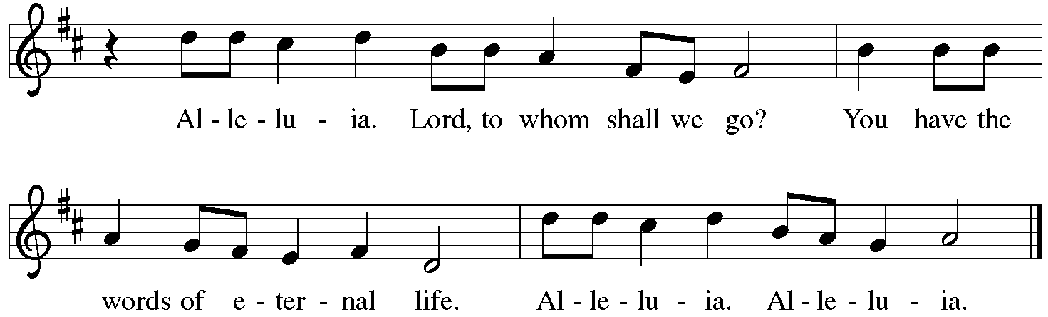
GOSPEL ACCLAMATION Alleluia ELW p. 142

GOSPEL Luke 6:20-31

P: Announcement of the Gospel.

C: Glory to you, O Lord.

In echoes of the prophet Isaiah and Mary’s song of praise, Jesus reveals surprising things about who enjoys blessing and who endures woe. He invites his disciples to shower radical love, blessing, forgiveness, generosity, and trust even on enemies and outsiders.

²⁰Then [Jesus] looked up at his disciples and said:
“Blessed are you who are poor,
for yours is the kingdom of God.
²¹“Blessed are you who are hungry now,
for you will be filled.
“Blessed are you who weep now,
for you will laugh.
²²“Blessed are you when people hate you, and when they exclude you, revile you, and defame you on account of the Son of Man. ²³Rejoice in that day and leap for joy, for surely your reward is great in heaven; for that is what their ancestors did to the prophets.
²⁴“But woe to you who are rich,
for you have received your consolation.
²⁵“Woe to you who are full now,
for you will be hungry.
“Woe to you who are laughing now,
for you will mourn and weep.

Continued on the next page.
²⁶“Woe to you when all speak well of you, for that is what their ancestors did to the false prophets.
²⁷“But I say to you that listen, Love your enemies, do good to those who hate you, ²⁸bless those who curse you, pray for those who abuse you. ²⁹If anyone strikes you on the cheek, offer the other also; and from anyone who takes away your coat do not withhold even your shirt. ³⁰Give to everyone who begs from you; and if anyone takes away your goods, do not ask for them again. ³¹Do to others as you would have them do to you.”

P: Affirmation of the Gospel.

C: Praise to you, O Christ.

SERMON

HYMN OF THE DAY Shall We Gather at the River ELW # 423

Stanzas 1, 2 and 3

AFFIRMATION OF BAPTISM ELW p. 234

CONFIRMATION ANTHEM You Are Mine Bethlehem Choir

PRAYERS OF INTERCESSION

Each petition ends with these words and response:

P: Lord, in your mercy,

C: receive our prayer.

Concluding petition and response:

P: Accept these prayers, gracious God, and those known only to you; through Jesus Christ, our Lord.

C: Amen.

God's Word for All the Saints
in the Sacrament of Holy Communion

God feeds us with the presence of Jesus Christ.

OFFERING AND MUSIC

At this point in our service, we worship God with our money. The ushers will pass plates down the pews to receive your gifts of cash and checks made out to Bethlehem Lutheran Church. You can even give online at https://secure.myvanco.com/L-Z22R/.
Your gifts support the worship, faith formation, administration, and other ministries of Bethlehem Lutheran—loose change goes to the Preston Food Pantry—as well as the mission of the Southeastern Minnesota Synod, and the whole Evangelical Lutheran Church in America. God bless your giving and your generosity. And thank you!

ASSEMBLY SONG For All Your Saints, O Lord ELW # 427

Stanzas 1, 3 and 4

OFFERING PRAYER

A: Holy God, the earth is yours and everything in it, yet you have chosen to dwell among your creatures. Come among us now in these gifts of bread and wine, and strengthen us to be your body for the world through Jesus Christ our Lord.

C: Amen.

THE GREAT THANKSGIVING

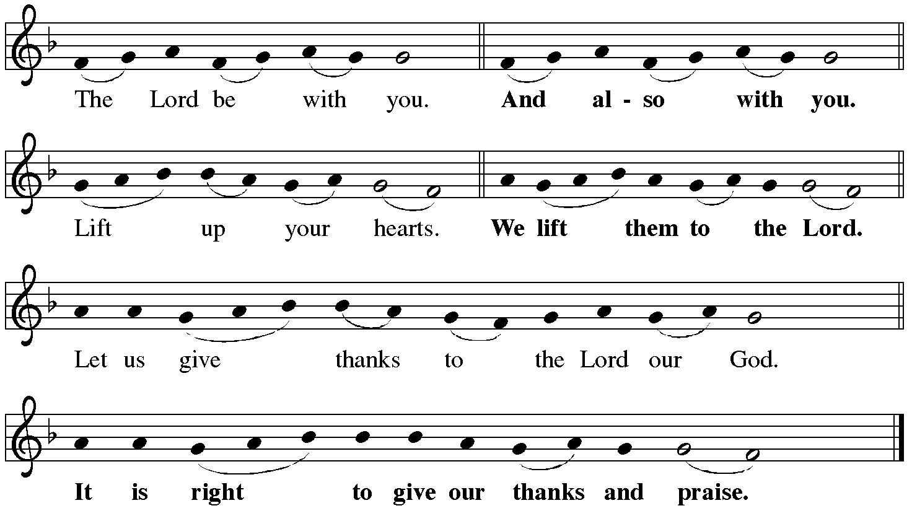
Dialogue ELW p. 144

Preface

P: It is indeed right, our duty and our joy, that we should at all times and in all places give thanks and praise to you, almighty and merciful God, through our Savior Jesus Christ. By the witness of the saints you show us the hope of our calling, and strengthen us to run the race set before us, that we may delight in your mercy, and rejoice with them in glory. And so, with our dear departed loved ones and all the saints, with the choirs of angels and the hosts of heaven, we praise your name and join their unending hymn:

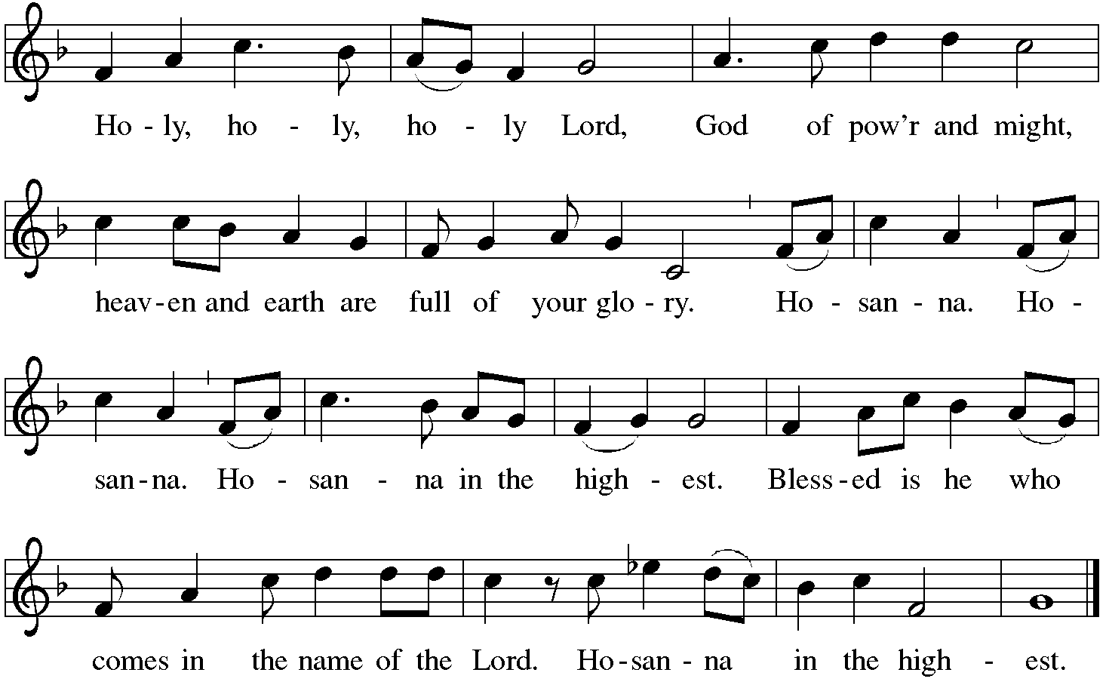
Holy, Holy, Holy (the angels song) ELW p. 144

Thanksgiving at the Table

P: You are indeed holy, almighty and merciful God. You are most holy, and great is the majesty of your glory.

You so loved the world that you gave your only Son, so that everyone who believes in him may not perish but have eternal life.

Continued on the next page
P: We give you thanks for his coming into the world to fulfill for us your holy will and to accomplish all things for our salvation.

In the night in which he was betrayed, our Lord Jesus took bread, and gave thanks; broke it, and gave it to his disciples, saying: Take and eat; this is my body, given for you. Do this for the remembrance of me.

Again, after supper, he took the cup, gave thanks, and gave it for all to drink, saying: This cup is the new covenant in my blood, shed for you and for all people for the forgiveness of sin. Do this for the remembrance of me.

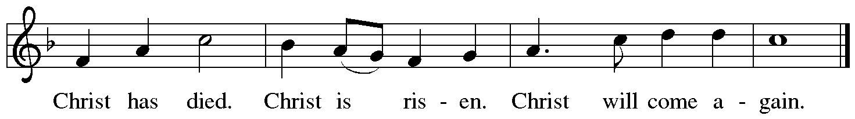
For as often as we eat of this bread and drink from this cup, we proclaim the Lord's death until he comes.

P: Remembering, therefore, his salutary command, his life-giving passion and death, his glorious resurrection and ascension, and the promise of his coming again, we give thanks to you, O Lord God Almighty, not as we ought but as we are able; we ask you mercifully to accept our praise and thanksgiving and with your Word and Holy Spirit to bless us, your servants, and these your own gifts of bread and wine, so that we and all who share in the body and blood of Christ may be filled with heavenly blessing and grace, and, receiving the forgiveness of sin, may be formed to live as your holy people and be given our inheritance with all your saints.

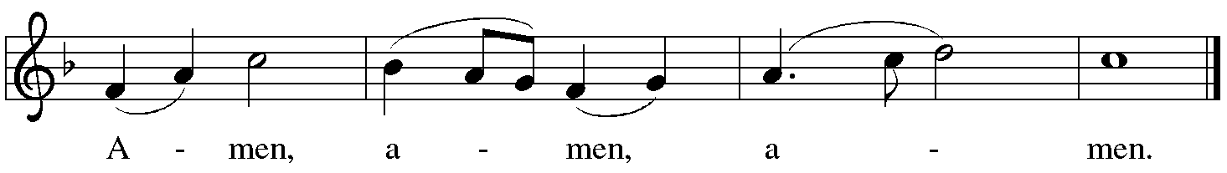
To you, O God, Father, Son, and Holy Spirit, be all honor and glory in your holy church, now and forever.

Lord’s Prayer ELW p. 145 Traditional Wording

P: Gathered into one by the Holy Spirit, let us pray as Jesus taught us.

All: Our Father, who art in heaven, hallowed be thy name, thy kingdom come, thy will be done, on earth as it is in heaven. Give us this day our daily bread; and forgive us our trespasses, as we forgive those who trespass against us; and lead us not into temptation, but deliver us from evil. For thine is the kingdom, and the power, and the glory, forever and ever. Amen.

INVITATION TO COMMUNION

P: Christ spreads a table before you. Gather here with all the saints.

COMMUNION

What We Believe

Who May Receive. We welcome all baptized Christians to the Lord's Table. In our church baptized children who have entered the 5th grade are instructed in this sacrament and receive their First Communion; younger children come to the altar and receive a blessing. If your baptized child has received such instruction, or if you want your baptized child to receive Communion, then he or she is welcome to partake.

Proper Preparation. In his Small Catechism, Martin Luther asks, "When is a person rightly prepared to receive this sacrament?" He answers, "Fasting and other outward preparations serve a good purpose. However, that person is well prepared and worthy who believes these words, given and shed for you for the remission of sins. But anyone who does not believe these words, or doubts them, is neither prepared nor worthy, for the words for you require simply a believing heart.”

Real Presence. We believe that the bread and wine truly are the body and blood of Christ given and shed for the forgiveness of sins.

Distribution

Confirmands will be served at the altar rail. The congregation will be served in procession. The ushers will direct you when to make your way to the front of the church using the center aisle. Stand to the right if you are seated on the pulpit side of the sanctuary, or to the left if you are seated on the organ side of the sanctuary. Keep some distance from the person(s) in front of you. You will receive the elements at the base of the chancel. Extend your hands, palms up, if you will be receiving the bread. Gluten-free wafers are also available; please ask for one.

Continued on the next page
White grape juice is also available in the center ring of the tray of wine for those who prefer an alcohol-free element. You may say “Amen” after receiving each element. If you will not be receiving Communion, especially young children, then keep their hands folded for a blessing.

Congregational Songs During Communion

We Come to the Hungry Feast ELW # 479 sts. 1, 2 & 3

For the Bread Which You Have Broken ELW # 494 sts. 1, 3 & 4

One Bread, One Body ELW # 496 sts. 1, 2 & 3

O Jesus, Joy of Loving Hearts ELW # 658 sts. 1, 2, 3 & 4

PRAYER AFTER COMMUNION

P: We give you thanks, most gracious God, that you have fed us with the bread of heaven and given us a foretaste of Paradise. Enliven us to be your body as we go forth to ventures of which we cannot see the ending, by paths as yet untrodden, through perils unknown. Give us faith to go out with good courage, not knowing where we go, but only that your hand is leading us and your love supporting us, and that we will, with all your saints, at length celebrate the marriage feast of the Lamb, Jesus Christ our Lord.

C: Amen.

Sending

God blesses us and sends us in mission to the world.

ANNOUNCEMENTS

CHORAL BENEDICTION & DEPARTING HYMN Bethlehem Choir

Let Us Serve Him

DISMISSAL

P: Go in peace. Be a blessing in the world.

C: Thanks be to God.

RINGING OF THE BELL

POSTLUDE

Let Us Serve Him

If we walk within His light
He will guide each step we take.
He will keep us in his sight
and bring us back if we go astray.

When the road is dark and cold
we will have His hand to hold,
and if we put our trust in Him,
we'll see a brand new day begin.

Let us go and let us serve Him with a love for all to see.
Let us show that we have heard Him
and we believe, yes we believe.

When we talk with Him in prayer
He will hear each word we say.
When we're safe within His care
we know that He will show us the way.

There's no need to live in fear
for our God is always near.
Yes, He loves us ev-'ry one
and we must see His work is done.

Let us go and let us serve Him with a love for all to see.
Let us show that we have heard Him
and we believe, yes we believe, yes we believe.

Let us go and let us serve Him with a love for all to see.
Let us show that we have heard Him
and we believe, we believe, yes, we believe.

Text: Don Besig and Nancy Price. Music: Don Besig. Text and Music © 1987 Shawnee Press, Inc. Used by permission of One License, Inc., under License #A-735588, Song #58066. www.onelicense.net.

Today’s Assistants and Ministers

Greeters & Ushers ……….……...… Bob & Phyllis Penheiter, Paul & Darcey Peterson, and
Sasha Holst and family
Organist-Pianist ……………………………………..…...………………….…..…….. Sue Holst
Presiding Minister …………………………………..…..……….………. Pastor Kerry Eversole
Reader ……………………………………...…...………...…..…..…………… Phyllis Penheiter
Altar Care & Communion Preparation …….……………...…………. Bob & Phyllis Penheiter
Refreshments …………..............................…..…..…….. Sasha Holst and Darcey Peterson

Presence Last Week and October Presents

Attendance Last Sunday, October 30 = 100
Average Sunday Worship Attendance for October = 63

October Contributions: General Fund = $ Designated Giving = $
Jan-Oct Income = $ Jan-Oct Expenses = $ Deficit = $

This Week in Our Congregation

Today, November 6 — All Saints Sunday — Affirmation of Baptism
Sunday School kids dismissed at the beginning of the regular sermon
Refreshments in the Fellowship Hall for everyone after worship
7th & 8th-grade Confirmation session 10:15 AM

Tuesday, November 8
Men’s breakfast at Home Sweet Home, Lanesboro 7:00 AM

Wednesday, November 9
Bethlehem Church Council meeting 6:30 PM

Next Sunday, November 13 — Twenty-third Sunday after Pentecost
Worship 9:00 AM
7th & 8th-grade Confirmation session 10:15 AM

News and Notes

Baptized yesterday was Hadley Alexandra Anderson, daughter of Adrian & Sarah (née Kalis) Anderson. AJ is the son of Dan & Maureen Anderson. Hadley’s godparents are Eric & Nichole Anderson and Adam & Amanda Schow. Welcome to the family of faith!

Affirmation of Baptism today at Fountain. One 9th-grade and two 10th grade confirmands — Fox Andersen, Lena Andersen, and Mara Schwarz — are making public affirmation of their baptism this morning at our sister congregation, Fountain Lutheran. Please remember these young people as well as Taylor, Dayton, Cora, and Holdyn in your devotions as they make this important step forward in their journey of faith.

Bethlehem Lutheran is hosting a Drive-Thru Fall Dinner next Sunday, November 13. Serving from 11 am to 2 pm. Pick up on the south side of the church. Menu: Windsor chop, baked potato, glazed carrots, dinner roll, and apple crisp dessert. Cost: $15.

The Mitten Basket is awaiting your donations of new or gently used mittens, gloves, hats and scarves! The basket is in the Fellowship Hall. All donations will be given to SEMCAC for distribution to those in need.

Prayer Requests

In Our Community. For our church members and friends living with chronic illness and other diseases, who are homebound, residing in care facilities, and hospitalized. See the newsletter for our members living in area nursing homes. And let us not forget those sick and dying of COVID-19.

In Our Synod. Bishop Regina Hassanally invites the congregations of our synod to commit to praying this week for the following communities of faith: East Freeborn Lutheran Church, Albert Lea; St. Peter’s Lutheran Church, Northfield; Grand Meadow Lutheran Church, Grand Meadow; Central Freeborn Lutheran Church, Albert Lea; Our Savior’s Lutheran Church, Kiester; Our Savior’s Lutheran Church, Cleveland; Emanuel Cathedral Lutheran Church, Tanzania; and Kiech Kuon Lutheran Parish, South Sudan.

Acknowledgments

Graphics, worship texts, service music, and readings are from sundaysandseasons.com © 2021 Augsburg Fortress. Used by permission under Augsburg Fortress Liturgies Annual License SAS103296.

Permission to project, livestream, or podcast liturgy and music content under copyright to or administered by Augsburg Fortress provided under Augsburg Fortress Liturgies Annual License SAS103296.

Permission to Podcast / Stream provided by Christian Copyright Licensing International, Inc., under License # 11459672. Additional fee paid. www.ccli.com.

Permission to Podcast / Stream provided by One License, Inc., under License # A-735588. Additional fee paid. www.onelicense.net.



