Bethlehem Lutheran Church
Established 1874


Rev. Kerry B. Eversole, Pastor
Deacon Cindy Cordes-Eversole, Associate in Ministry

Mailing Address: P.O. Box 314, Lanesboro, MN 55949-0314
Physical Address: 200 Kenilworth Ave S, Lanesboro, Minn.

Telephone: 507.467.3344
E-mail Address: bethlehem@acegroup.cc
Website: www.staronthehill.com
Facebook Page: www.facebook.com/BethlehemLutheranLanesboro/

Office Hours: Tuesday, Wednesday, Thursday 10 a.m. to 3 p.m.
Parsonage Phone: 507.467.3017
Pastor Kerry’s Cell Phone: 507.951.3954

Bethlehem Lutheran Church
Lanesboro, Minnesota

Reformation Sunday
Confirmation Faith Fair

October 30, 2022


Welcome to worship at Bethlehem Lutheran Church
and our Reformation festival!

We are “The star on the hill”
You are the light of the world … let your light shine before others, so that they may see your good works and give glory to your Father in heaven. Matthew 5:14-16

COVID-19 Practices — Out of love for God and Neighbor

1) Use hand sanitizer upon entry. Wash your hands and use hand sanitizer often while in the facility.
2) Members and visitors who are vaccinated and boosted are not required to wear a mask.
3) Members and visitors are free to wear a mask if they wish to do so.
4) Unvaccinated and not boosted members and visitors must wear a mask.
5) There are no physical distancing requirements, but you are welcome to keep a distance from others in the sanctuary as you are able.
6) All are welcome to enjoy coffee fellowship in the dining room following worship.

Worship Book and Hymns. This morning’s service is printed in the bulletin. The hymns can be found in Evangelical Lutheran Worship (ELW), “the red book”, which are in the pew racks. Hymns in ELW are indicated by a large bold number in each page’s left or right margin. One hymn is printed in the bulletin.

Abbreviations. Throughout this worship folder hymns are signified by the pound symbol (#), Leader: refers to the presiding minister or preacher or an assisting minister, and People: and/or bold text indicates the congregation.

Offering. Later in our service, we will be receiving an offering. The offering is an opportunity to worship God with our money. We know that the money you give to Bethlehem Lutheran Church represents your lives — your time, talents, and hard work. We recognize that and we appreciate your generosity. Your support not only helps all of us to fulfill God’s call on our lives, but it also makes an impact, and we thank you! Lastly, our visitors are not expected to give. After all, you are our guests! We’re glad you’re here and we want you to feel welcomed!

Mistakes do not happen in our worship service; only unexpected events which are opportunities for joy!

An signifies that you may stand, as you are comfortably able.
Gathering

Introduction to the Day. Tomorrow, October 31, marks 500+5 years since the beginning of the Lutheran Reformation, spurred by Martin Luther posting his Ninety-Five Theses, a list of problems and misuse of power in the church of his time. The center of the reform movement was the heart of the Christian faith: the gospel of Jesus Christ, the good news that it is by God’s grace through faith in Jesus that we are justified and made free! Though we give thanks for the events of the 16th-century Reformation that brought renewal to the church of that time, today we pray, “Come, Holy Spirit!” because the church is even now in need of reconciliation and rejuvenation, still in need of dying again in Christ and being raised from the dead in the waters of baptism so that it might truly be one body, one in its proclamation and witness to the world, and one at the Lord’s table.

MUSIC AS WE COME TOGETHER

RINGING OF THE BELL AND WELCOME

The Witness of the Lutheran Reformation

WORD ALONE Psalm 119:89, 105; John 8:31-32

Leader: “The LORD exists forever; your word is firmly fixed in heaven.”

People: “Your word is a lamp to my feet and a light to my path.”

Leader: Jesus said, “If you continue in my word, you are truly my disciples;”

People: “and you will know the truth, and the truth will make you free.”

Leader: Dedicated to the Bible as the source of all the church’s teachings, Luther spoke often of the supremacy of the Scriptures in the church’s life. “The Christian Church is God’s servant,” he said. “It listens to and does nothing but what it knows to be God’s Word and command.”

GRACE ALONE John 3:16; Ephesians 2:8-9

Leader: “For God so loved the world that he gave his only Son,”

People: “so that everyone who believes in him may not perish but may have eternal life.”

Leader: “For by grace you have been saved, through faith, and this is not your own doing;”

People: “it is the gift of God — not the result of works, so that no one may boast.”

Continued on the next page
Leader: For Martin Luther, no scriptural teaching mattered more than the theology of grace. He said, “A good song may well be sung often. Grace consists of this, that God is merciful to us, shows grace for the sake of the Lord Christ, forgives all sins, and will not charge them to us for eternal death. This is grace: the forgiveness of sins for the sake of the Lord Christ, the covering up of sins.”

FAITH ALONE Galatians 3:11; Habakkuk 2:4; Romans 5:1-2

Leader: “Now it is evident that no one is justified before God by the law;” just as it is written,

People: “The one who is righteous will live by faith.”

Leader: “Therefore, since we are justified by faith, we have peace with God through our Lord Jesus Christ,”

People: “through whom we have obtained access to this grace in which we stand; and we boast in our hope of sharing the glory of God.”

Leader: Martin Luther spoke for the truth which comes to us only through faith — not through the good works we accomplish. He said, “It is the will and pleasure of God that whoever sees the Son and believes in him has eternal life.”

PLEA FOR NEVER-ENDING REFORMATION

Leader: Word alone! Grace alone! Faith alone! These are the hallmarks of the Lutheran Reformation.

People: But they are truths for all Christians, in all times, and in all places.

Leader: In our celebration, we do not glory in the events of the past nor praise famous people.

People: Rather, we praise him who is Lord of life and Lord of the church, Jesus the Christ, our Savior.

Leader: He has raised up for us the truth of God’s word, which burns within each one of us.

People: And he has poured out on us the fire of the Holy Spirit.

Leader: May this flame continue to reform and renew the church in every age!

OPENING SONG A Mighty Fortress Is Our God ELW # 504

Based on Psalm 46, the appointed psalm for today
PRAYER FOR REFORMATION SUNDAY

Leader: Let us pray together.

Almighty God, gracious Lord,

All: we thank you that your Holy Spirit renews the church in every age. Pour out your Holy Spirit on your faithful people gathered here today. Keep us steadfast in your word, protect and comfort us in times of trial, defend us against all enemies of the gospel, and bestow on us and the whole church your saving peace. We ask this through Jesus Christ, our Savior and Lord, who lives and reigns with you and the Holy Spirit, one God, now and forever. Amen.

Hearing God’s Word of Reform and Renewal

OLD TESTAMENT READING Jeremiah 31:31-34

God’s prophet declares that the renewed covenant will not be breakable, but like the old covenant, it will expect people to live upright lives. To know the Lord means that one will defend the cause of the poor and needy (Jer. 22:16). The renewed covenant is possible only because the Lord will forgive iniquity and not remember sin. Our hope lies in a God who forgets.

The days are surely coming, says the LORD, when I will make a new covenant with the house of Israel and the house of Judah. ³²It will not be like the covenant that I made with their ancestors when I took them by the hand to bring them out of the land of Egypt—a covenant that they broke, though I was their husband, says the LORD.
³³But this is the covenant that I will make with the house of Israel after those days, says the LORD: I will put my law within them, and I will write it on their hearts; and I will be their God, and they shall be my people. ³⁴No longer shall they teach one another, or say to each other, “Know the LORD,” for they shall all know me, from the least of them to the greatest, says the LORD; for I will forgive their iniquity, and remember their sin no more.

NEW TESTAMENT READING Romans 3:19-28

Paul’s words stand at the heart of the preaching of Martin Luther and other Reformation leaders. Human beings cannot make themselves right with God through works of the law. We are brought into a right relationship with God through the divine activity centered in Jesus’s death and resurrection. This act is a gift of grace that liberates us from sin and empowers our faith in Jesus Christ.

Continued on the next page

Now we know that whatever the law says, it speaks to those who are under the law, so that every mouth may be silenced, and the whole world may be held accountable to God. ²⁰For “no human being will be justified in his sight” by deeds prescribed by the law, for through the law comes the knowledge of sin.
²¹But now, apart from law, the righteousness of God has been disclosed, and is attested by the law and the prophets, ²²the righteousness of God through faith in Jesus Christ for all who believe. For there is no distinction, ²³since all have sinned and fall short of the glory of God; ²⁴they are now justified by his grace as a gift, through the redemption that is in Christ Jesus, ²⁵whom God put forward as a sacrifice of atonement by his blood, effective through faith. He did this to show his righteousness, because in his divine forbearance he had passed over the sins previously committed; ²⁶it was to prove at the present time that he himself is righteous and that he justifies the one who has faith in Jesus. ²⁷Then what becomes of boasting? It is excluded. By what law? By that of works? No, but by the law of faith. ²⁸For we hold that a person is justified by faith apart from works prescribed by the law.

GOSPEL John 8:31-36

Jesus speaks of truth and freedom as spiritual realities known through his word. He reveals the truth that sets people free from sin to serve our loving God.

Jesus said to the Jews who had believed in him, “If you continue in my word, you are truly my disciples; ³²and you will know the truth, and the truth will make you free.” ³³They answered him, “We are descendants of Abraham and have never been slaves to anyone. What do you mean by saying, ‘You will be made free’?”
³⁴Jesus answered them, “Very truly, I tell you, everyone who commits sin is a slave to sin. ³⁵The slave does not have a permanent place in the household; the son has a place there forever. ³⁶So if the Son makes you free, you will be free indeed.”

CHILDREN’S MESSAGE

SONG Jesus is Calling Ann Lowe

CONFIRMATION FAITH FAIR

Responding to God’s Word of Reform and Renewal

SONG OF THE DAY By Grace We Have Been Saved Stanzas 1, 2, 3 & 5

Printed at the end of the bulletin.
PROFESSION OF FAITH from Martin Luther’s Small Catechism

Leader: With the whole church, let us confess our faith using Martin Luther’s explanation of the Apostles’ Creed.

All: I believe that God has created me and all that exists. God has given me and still preserves my body and soul with all their powers. God provides me with food and clothing, home and family, daily work, and all I need from day to day. God also protects me in time of danger and guards me from every evil. All this God does out of fatherly and divine goodness and mercy though I do not deserve it.

I believe that Jesus Christ—true God, Son of the Father from eternity, and true man born of the virgin Mary—is my Lord. At great cost he has saved and redeemed me, a lost and condemned person. He has freed me from sin, death, and the power of the devil—not with silver or gold, but with his holy and precious blood and his innocent suffering and death. All this he has done that I may be his own, live under him in his kingdom, and serve him in everlasting righteousness, innocence and blessedness, just as he is risen from the dead and lives and rules eternally.

I believe that I cannot by my own understanding or effort, believe in Jesus Christ my Lord or come to him. But the Holy Spirit has called me through the Gospel, enlightened me with his gifts, and sanctified and kept me in true faith. In the same way he calls, gathers, enlightens, and sanctifies the whole Christian church on earth and keeps it united with Jesus Christ in the one true faith. In this Christian church day after day he fully forgives my sins and the sins of all believers. On the last day he will raise me and all the dead and give me and all believers in Christ eternal life.

This is most certainly true.

OFFERING AND MUSIC

At this point in our service, we worship God with our money. The ushers will pass plates down the pews to receive your gifts of cash and checks made out to Bethlehem Lutheran Church. You can even give online at https://secure.myvanco.com/L-Z22R/. Your gifts support the worship, faith formation, administration, and other ministries of Bethlehem Lutheran—loose change goes to the Preston Food Pantry—as well as the mission of the Southeastern Minnesota Synod, and the whole Evangelical Lutheran Church in America. God bless your giving and your generosity. And thank you!

SONG AS THE GIFTS ARE RECEIVED ELW # 517

Lord, Keep Us Steadfast in Your Word

Stanzas 1 and 3

PRAYERS OF GOD’S PEOPLE

After the last petition all sing ELW # 752

Lord, Listen to Your Children Praying

LORD’S PRAYER Traditional Wording

Leader: Gathered into one by the Holy Spirit, let us pray as Jesus taught us.

All: Our Father, who art in heaven, hallowed be thy name, thy kingdom come, thy will be done, on earth as it is in heaven. Give us this day our daily bread; and forgive us our trespasses, as we forgive those who trespass against us; and lead us not into temptation, but deliver us from evil. For thine is the kingdom, and the power, and the glory, forever and ever. Amen.

Sending

ANNOUNCEMENTS

BLESSING

Leader: God, who gives life to all things and frees us from despair,
bless you with truth and peace.
And may the holy Trinity, ☩ one God,
guide you always in faith, hope, and love.

People: Amen.

DEPARTING SONG The Church of Christ in Every Age ELW # 729

DISMISSAL

Leader: Go in peace, with Christ beside you.

People: Thanks be to God.

RINGING OF THE BELL

SENDING MUSIC
Acknowledgments

The Witness of the Lutheran Reformation is from Plain Talk Before God: The Language of Worship. Compiled by Handt Hanson and Paul Murakami. Copyright © 1992 Prince of Peace Publishing, Inc./Changing Church, Inc., Burnsville, MN. The book is completely reproducible for the purpose of congregational worship.

By Grace We Have Been Saved Text: Rusty Edwards, stanzas, Frederic Whitfield, refrain © 1997, Selah Publishing Co., Inc. Music: North American Traditional, arr. Rusty Edwards. Tune: © 1999 Augsburg Fortress. Reprinted by permission of One License, Inc., under License # A-735588, song #s 00706 and 02557. www.onelicense.net

Graphics, worship texts, service music, and readings are from sundaysandseasons.com © 2022 Augsburg Fortress. Used by permission under Augsburg Fortress Liturgies Annual License SAS103296.

Permission to project, live stream, or podcast liturgy and music content under copyright to or administered by Augsburg Fortress provided under Augsburg Fortress Liturgies Annual License SAS103296.

Permission to Podcast / Stream provided by Christian Copyright Licensing International, Inc., under License # 11459672. An additional fee was paid. www.ccli.com.

Permission to Podcast / Stream provided by One License, Inc., under License # A-735588. An additional fee was paid. www.onelicense.net.

Today’s Assistants and Ministers

Greeters & Ushers …………..…………………………..…….......……..… Mike & Norine Ask
Organist/Pianist ………………………………………......………………….…..…….. Sue Holst
Presiding Minister ……………………….…..……….………. Deacon Cindy Cordes-Eversole
Reader ……………………………………………...…..…..…………… Nate or Sharon Boyum
Altar Care ……………………………………..………………. Pastor Kerry and Deacon Cindy
Refreshments ………….......................................................…..…..…….. Mike & Norine Ask
Custodian ……………………….………………..……………………………. Wayne Lukkason

Presence Last Week and September Presents

Attendance Last Sunday, October 23 = 48
Average Sunday Worship Attendance for September = 44

September Contributions: General Fund = $11,153 Designated Giving = $145
Jan-Sep Income = $110,136 Jan-Sep Expenses = $126,174 Deficit = $16,038

This Week in Our Congregation

Today, October 30 — Reformation Sunday & Confirmation Faith Fair

Sunday school meets after the children’s message
Refreshments in the Fellowship Hall for everyone after worship
7th- & 8th-grade Confirmation classes 10:15 AM
This Week in Our Congregation continued

Monday, October 31 — Reformation Day — All Hallow’s Eve — Halloween

Tuesday, November 1 — All Saints Day

Men’s breakfast at Home Sweet Home in Lanesboro 7:00 AM

Wednesday, November 2

WELCA Sew Day 9:00 AM

Next Sunday, November 6 — All Saints Sunday

Worship with Affirmation of Baptism and Holy Communion 9:00 AM
Sunday school meets after the children’s message
7th- & 8th-grade Confirmation classes at Bethlehem 10:15 AM

News and Notes

Confirmation Faith Fair today! This morning during worship, our 10th-grade confirmands – Taylor Hanson, Dayton Haugen, Cora Schnebly, and Holden Willford – will present their faith projects, favorite Bible verses, and stoles in preparation for their Affirmation of Baptism next Sunday, November 6. Greet and congratulate these young people after worship in the Fellowship Hall.

Today is the last Sunday to contribute to our special offering for the Preston Food Pantry to purchase items for Thanksgiving meals. Did you know that our weekly “Noisy Offering” (loose change) goes to the Preston Food Shelf? $96.95 was recently presented. Thank you for all your gifts!

Bethlehem is hosting a Drive-Thru Fall Dinner on Sunday, November 13. Please mark your calendar and watch for volunteer opportunities. If you’ve already offered to make apple crisp dessert, there are apples in the refrigerator in the kitchen. Help yourself.

Prayer Requests

In Our Community. For our church members and friends living with chronic illness and other diseases, who are homebound, residing in care facilities, and hospitalized. See the newsletter for our members living in area nursing homes. And let us not forget those sick and dying of COVID-19, those entrusted with the authority of government, justice, and law enforcement, as well as our fallen and wounded soldiers and those still serving.

In Our Synod. Bishop Regina Hassanally invites the people and congregations of our synod to commit to praying this week for the following faith communities: Salem Lutheran Church, Albert Lea; First English Lutheran Church, Cannon Falls; Peace Lutheran Church, Eyota; Mazoezi Muungano Lutheran Church, Tanzania; and Deng Hoth Lutheran Parish, South Sudan.

Commemorations

Reformation Day

Monday, October 31

Although Martin Luther posted his Ninety-Five Theses on the door of the castle church in Wittenberg on this day in 1517, it was John George II, the Elector of Saxony, who established a Reformation festival on this day in 1667.

Also, on this date in 1999, the Roman Catholic Church and several Lutheran bodies signed the Joint Declaration on the Doctrine of Justification. What this means is that Lutherans and Roman Catholics agree on the basic nature of the gospel. The question is, now what? How might the Reformation be celebrated appropriately? This commemoration is less a victory day for Lutherans than it is an opportunity to be reminded of the reformer’s belief that the church would always stand in need of reformation.
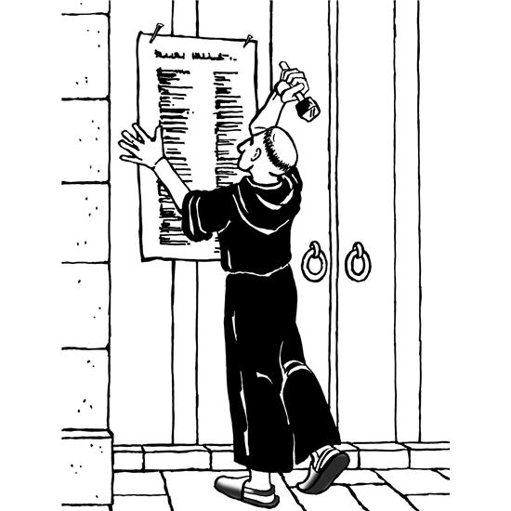

All Saints Day Eve

Monday, October 31

Like most great Christian festivals (Christmas, Easter, Pentecost), the celebration of All Saints Day (November 1) begins on the night before. The ancient name for All Saints Day was All Hallows’ Day or All Hallowmas (hallow = holy one or saint; mas = mass). Our word Halloween is a conjunction of All Hallows’ Evening. While children (and some adults!) will be dressed up in costumes and asking for tricks or treats, let us not forget that this is the beginning of the church’s annual celebration of “the communion of saints” — the baptized people of God, living and dead — who make up the body of Christ. We especially remember all who have died in the faith and now serve God around the heavenly throne.

Bible Quotes on Justification (RSV)

… no human being will be justified in [God’s] sight by works of the law, since through the law comes knowledge of sin. since all have sinned and fall short of the glory of God, they are justified by his grace as a gift, through the redemption which is in Christ Jesus, whom God put forward as an expiation by his blood, to be received by faith. … For we hold that a man is justified by faith apart from works of law. Romans 3:20, 23-25, 28

Therefore, since we are justified by faith, we have peace with God through our Lord Jesus Christ. Through him we have obtained access to this grace in which we stand, and we rejoice in our hope of sharing the glory of God.
Romans 5:1-2

We ourselves, who are Jews by birth and not Gentile sinners, yet who know that a man is not justified by works of the law but through faith in Jesus Christ, even we have believed in Christ Jesus, in order to be justified by faith in Christ, and not by works of the law, because by works of the law shall no one be justified. … For I through the law died to the law, that I might live to God. I have been crucified with Christ; it is no longer I who live, but Christ who lives in me; and the life I now live in the flesh I live by faith in the Son of God, who loved me and gave himself for me. I do not nullify the grace of God; for if justification were through the law, then Christ died to no purpose.
Galatians 2:15-16, 19-21

For all who rely on works of the law are under a curse; for it is written, “Cursed be every one who does not abide by all things written in the book of the law, and do them.” Now it is evident that no man is justified before God by the law; for “He who through faith is righteous shall live”; but the law does not rest on faith, for “He who does them shall live by them.” Christ redeemed us from the curse of the law…. Galatians 3:10-13

…when the goodness and loving kindness of God our Savior appeared, he saved us, not because of deeds done by us in righteousness, but in virtue of his own mercy, by the washing of regeneration and renewal in the Holy Spirit, which he poured out upon us richly through Jesus Christ our Savior, so that we might be justified by his grace and become heirs in hope of eternal life. The saying is sure. Titus 3:4-8

Martin Luther Quotes

Faith is a living daring confidence in God’s grace so sure and certain that the believer would stake his life on it a thousand times. This knowledge of and confidence in God’s grace makes men glad and bold and happy in dealing with God and all other creatures … without compulsion, a person is ready and glad to do good to everyone, to serve everyone, to suffer everything, out of love and praise to God who has shown him his grace.
~ in his work on the book of Romans

I must still read and study the catechism daily, yet I cannot master it as I wish, but must remain a child and a pupil of the catechism, and I do it gladly.
~ in his preface to the Large Catechism

A Christian is lord of all, completely free of everything; a Christian is a servant, completely attentive to the needs of all.
~ in The Freedom of a Christian

Who am I, miserable, stinking foul bag of maggots, that the church of Jesus Christ should be called by my miserable name? I am and will be no one’s master. Enough for me is the sweet name of my Lord and Savior, Jesus Christ, to whom I will always sing my song. If anyone will not sing with me, let him howl if he likes by himself.

Whoever drinks beer, he is quick to sleep; whoever sleeps long, does not sin; whoever does not sin, enters Heaven! Thus, let us drink beer!

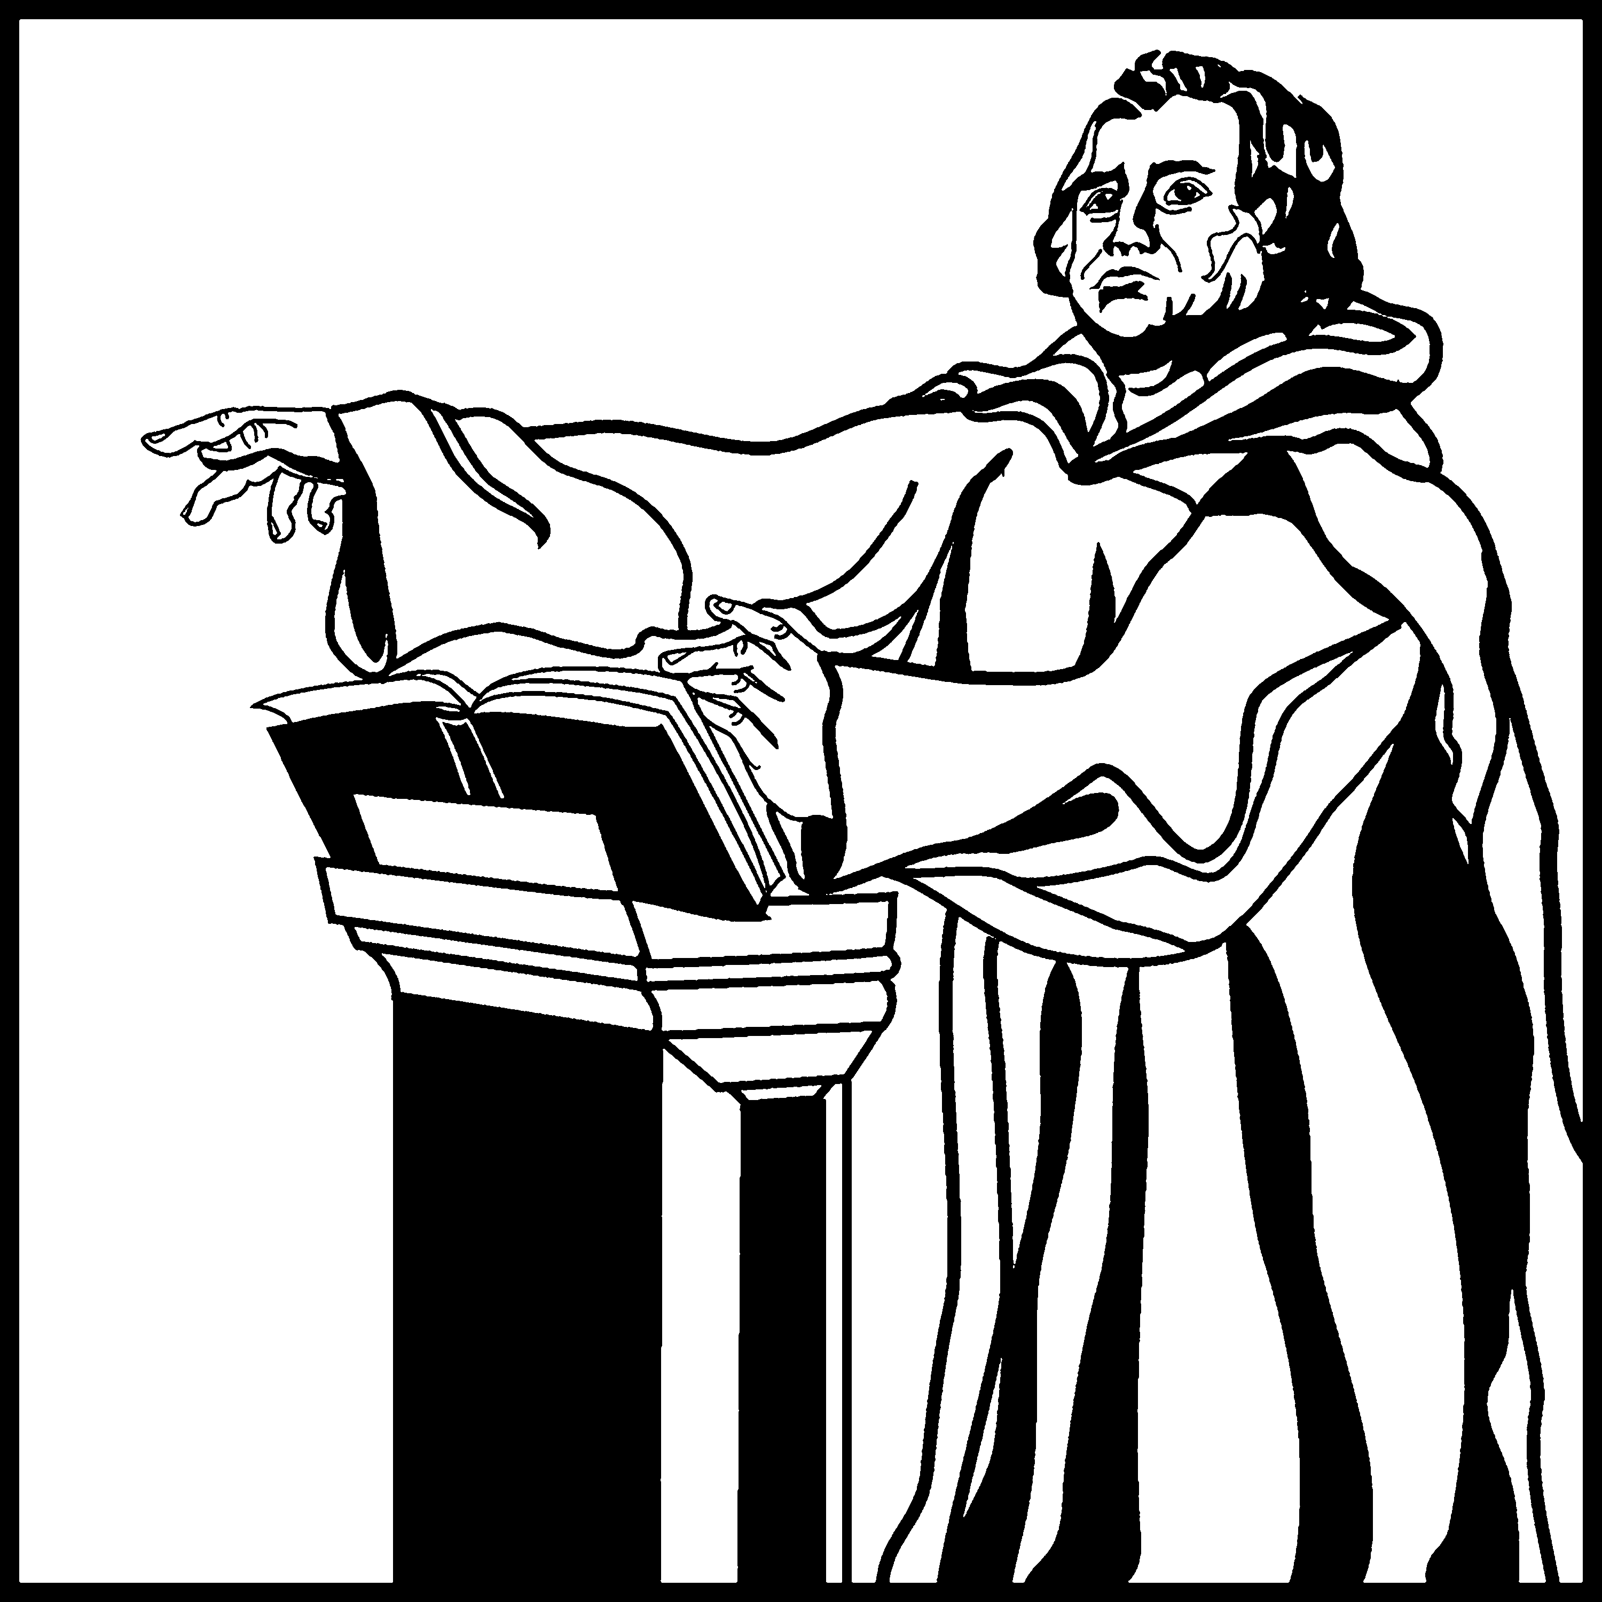

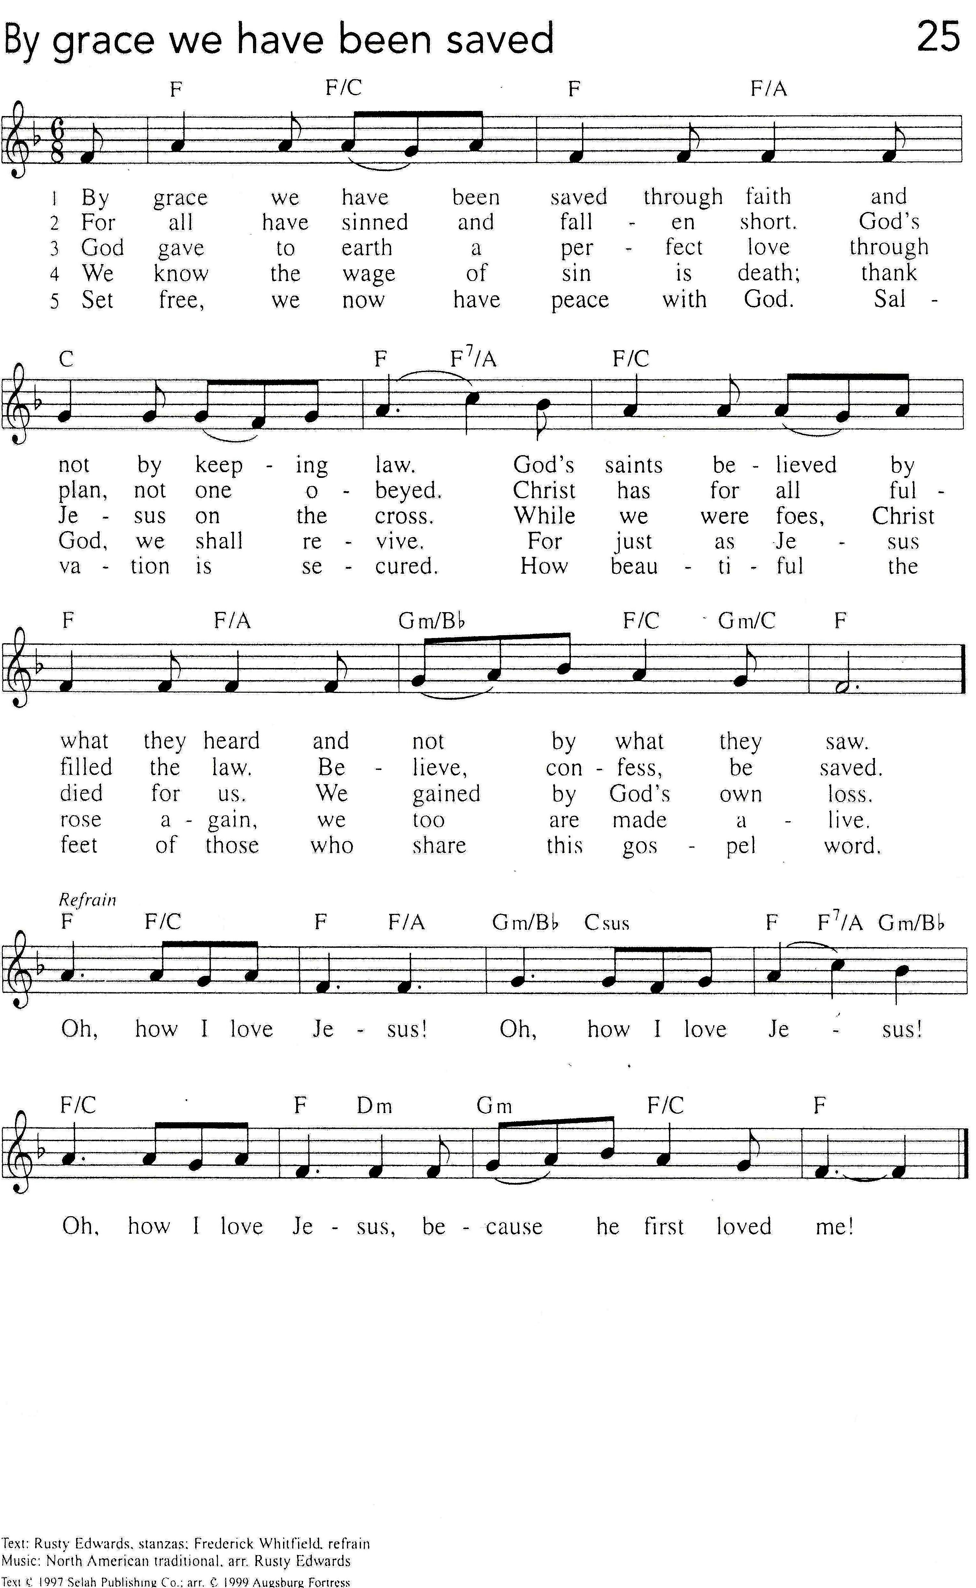By Grace We Have Been Saved

