Bethlehem Lutheran Church
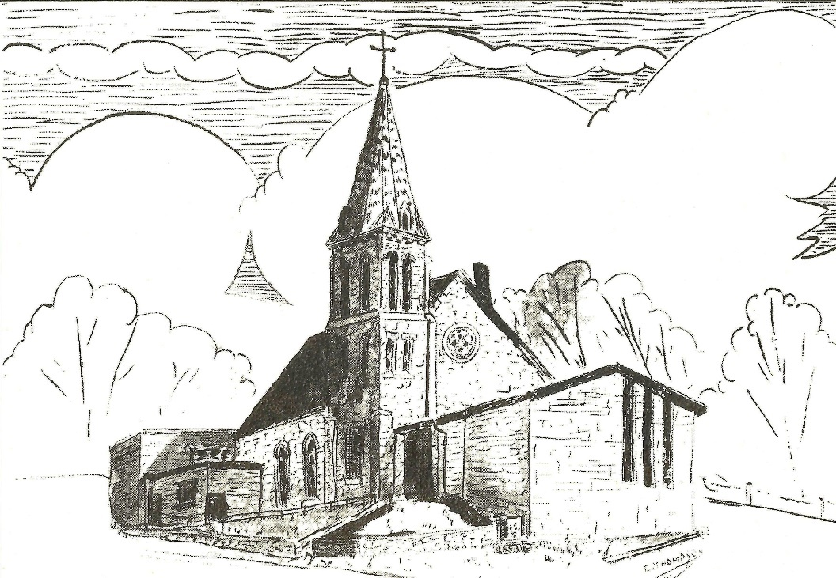
Established 1874

Rev. Kerry B. Eversole, Pastor
Deacon Cindy Cordes-Eversole, Associate in Ministry

Mailing Address: P.O. Box 314, Lanesboro, MN 55949-0314
Physical Address: 200 Kenilworth Ave S, Lanesboro, Minn.

Telephone: 507.467.3344
E-mail Address: bethlehem@acegroup.cc
Website: www.staronthehill.com
Facebook Page: www.facebook.com/BethlehemLutheranLanesboro/

Office Hours: Tuesday, Wednesday, Thursday 10 a.m. to 3 p.m.
Parsonage Phone: 507.467.3017

Pastor Kerry’s Cell Phone: 507.951.3954

Bethlehem Lutheran Church
Lanesboro, Minnesota

Nineteenth Sunday after Pentecost

October 16, 2022

Jesus told a parable about [our] need to pray always and not to lose heart. He said, “In a certain city there was a judge who neither feared God nor had respect for people. In that city, there was a widow who kept coming to him and saying, ‘Grant me justice against my opponent.’ Luke 18:1-3
Welcome to worship at Bethlehem Lutheran Church

We are “The star on the hill”
You are the light of the world … let your light shine before others, so that they may see your good works and give glory to your Father in heaven. Matthew 5:14-16

COVID-19 Practices — Out of love for God and Neighbor

1) Use hand sanitizer upon entry. Wash your hands and use hand sanitizer often while in the facility.
2) Members and visitors who are vaccinated and boosted are not required to wear a mask.
3) Members and visitors are free to wear a mask if they wish to do so.
4) Unvaccinated and not boosted members and visitors must wear a mask.
5) There are no physical distancing requirements, but you are welcome to keep a distance from others in the sanctuary as you are able.
6) All are welcome to enjoy coffee fellowship in the dining room following worship.

Worship Book and Hymns. This morning’s service is printed in the bulletin. All the hymns can be found in Evangelical Lutheran Worship (ELW), “the red book”, which are in the pew racks. Hymns in ELW are indicated by a large bold number in the left or right margin of each page.

Abbreviations. Throughout this worship folder hymns are signified by the pound symbol (#), P: refers to the presiding minister or preacher, A: denotes an assisting minister, and C: and/or bold text indicates the congregation.

Offering. Later in our service, we will be receiving an offering. The offering is an opportunity to worship God with our money. We know that the money you give to Bethlehem Lutheran represents your lives—your time, talents, and hard work. We recognize that and we appreciate your generosity. Your support not only helps all of us to fulfill God’s call on our lives, but it also makes an impact, and we thank you! Lastly, our visitors are not expected to give. After all, you are our guests! We’re glad you’re here and we want you to feel welcomed!

Mistakes do not happen in our worship service;
only unexpected events which are opportunities for joy!

An signifies that you may stand as you are comfortably able.

Gathering

The Holy Spirit calls us together as the people of God.

Introduction to the Day. Pray always. Do not lose heart. This is Christ’s encouragement in the gospel today. Wrestle with the word. Remember your baptism again and again. Come regularly to Christ’s table. Persistence in our every encounter with the divine will be blessed.

PRELUDE

WELCOME

CONFESSION AND FORGIVENESS

All may make the sign of the cross, the sign that is marked at baptism, as the presiding minister begins.

P: Blessed be the holy Trinity, ☩ one God, who is eager to forgive and who loves us beyond our days.

C: Amen.

P: Dear friends, together let us acknowledge our failure to love this world as Jesus does.

Silence is kept for reflection.

P: God of mercy and forgiveness,

All: we confess that sin still has a hold on us. We have harmed your good creation. We have failed to do justice, love kindness, and walk humbly with you. Turn us in a new direction. Show us the path that leads to life. Be our refuge and strength on the journey, through Jesus Christ, our redeemer and friend. Amen.

P: Beloved of God: your sins are forgiven ☩ and you are made whole. God points the way to new life in Christ, who meets us on the road. Journey now in God’s abiding love through the power of the Holy Spirit.

C: Amen.

OPENING HYMN My Hope is Built on Nothing Less ELW # 596

GREETING

P: The grace of our Lord Jesus Christ, the love of God, and the communion of the Holy Spirit be with you all.

C: And also with you.

PRAYER OF THE DAY

P: Let us pray together.

O Lord God, tireless guardian of your people,

All: you are always ready to hear our cries. Teach us to rely day and night on your care. Inspire us to seek your enduring justice for all this suffering world, through Jesus Christ, our Savior and Lord. Amen.

Word

God speaks to us in scripture reading, preaching, and song.

FIRST READING Genesis 32:22-31

Returning to the home he had fled many years before after stealing his brother’s birthright and his father’s blessing, Jacob wrestles all night long with a divine adversary who ultimately blesses him and changes his name to “Israel,” a name that means “he wrestles with God.”

²²The same night [Jacob] got up and took his two wives, his two maids, and his eleven children, and crossed the ford of the Jabbok. ²³He took them and sent them across the stream, and likewise everything that he had. ²⁴Jacob was left alone; and a man wrestled with him until daybreak. ²⁵When the man saw that he did not prevail against Jacob, he struck him on the hip socket; and Jacob’s hip was put out of joint as he wrestled with him. ⁶Then he said, “Let me go, for the day is breaking.” But Jacob said, “I will not let you go, unless you bless me.” ²⁷So he said to him, “What is your name?” And he said, “Jacob.” ²⁸Then the man said, “You shall no longer be called Jacob, but Israel, for you have striven with God and with humans, and have prevailed.” ²⁹Then Jacob asked him, “Please tell me your name.” But he said, “Why is it that you ask my name?” And there he blessed him. ³⁰So Jacob called the place Peniel, saying, “For I have seen God face to face, and yet my life is preserved.” ³¹The sun rose upon him as he passed Penuel, limping because of his hip.

A: The word of the Lord.

C: Thanks be to God.
ANTHEM With Grateful Heart, I Thank You, Lord Bethlehem Choir

SECOND READING 2 Timothy 3:14--4:5

The writer of this letter continues his instruction of Timothy, his younger colleague in ministry, by emphasizing the importance of faithful teaching despite opposition.

¹⁴But as for you, continue in what you have learned and firmly believed, knowing from whom you learned it, ¹⁵and how from childhood you have known the sacred writings that are able to instruct you for salvation through faith in Christ Jesus. ¹⁶All scripture is inspired by God and is useful for teaching, for reproof, for correction, and for training in righteousness, ¹⁷so that everyone who belongs to God may be proficient, equipped for every good work.
^{4:1}In the presence of God and of Christ Jesus, who is to judge the living and the dead, and in view of his appearing and his kingdom, I solemnly urge you: ²proclaim the message; be persistent whether the time is favorable or unfavorable; convince, rebuke, and encourage, with the utmost patience in teaching. ³For the time is coming when people will not put up with sound doctrine, but having itching ears, they will accumulate for themselves teachers to suit their own desires, ⁴and will turn away from listening to the truth and wander away to myths. ⁵As for you, always be sober, endure suffering, do the work of an evangelist, carry out your ministry fully.

A: The word of the word.

C: Thanks be to God.

GOSPEL ACCLAMATION O Word of God Incarnate ELW # 514

Stanza 1

GOSPEL Luke 18:1-8

P: Announcement of the Gospel.

C: Glory to you, O Lord.

Jesus tells a parable of an unjust judge who is worn down by a widow’s pleas. Jesus is calling God’s people to cry out for justice and deliverance. For if an unethical judge will ultimately grant the plea of a persistent widow, how much more will God respond to those who call.

¹Then Jesus told them a parable about their need to pray always and not to lose heart. ²He said, “In a certain city there was a judge who neither feared God nor

Continued on the next page.
had respect for people. ³In that city there was a widow who kept coming to him and saying, ‘Grant me justice against my opponent.’ ⁴For a while he refused;
but later he said to himself, ‘Though I have no fear of God and no respect for anyone, ⁵yet because this widow keeps bothering me, I will grant her justice, so that she may not wear me out by continually coming.’ ” ⁶And the Lord said, “Listen to what the unjust judge says. ⁷And will not God grant justice to his chosen ones who cry to him day and night? Will he delay long in helping them? ⁸I tell you, he will quickly grant justice to them. And yet, when the Son of Man comes, will he find faith on earth?”

P: Affirmation of the Gospel.

C: Praise to you, O Christ.

GOSPEL ACCLAMATION O Word of God Incarnate ELW # 514

Stanza 3

SERMON

HYMN OF THE DAY Rise Up, O Saints of God ELW # 669

Responding

We Respond to God’s word of persistent prayer and hope.

OFFERING Music by Sue Holst

At this point in our service, we worship God with our money. The ushers will pass plates down the pews to receive your gifts of cash and checks made out to Bethlehem Lutheran Church. You can even give online at secure.myvanco.com/L-Z22R/. Your gifts support the worship, faith formation, administration, and other ministries of Bethlehem Lutheran Church—loose change goes to the Preston Food Pantry—as well as the mission of the Southeastern Minnesota Synod, and the whole Evangelical Lutheran Church in America. God bless your giving and your generosity. And thank you!

OFFERING SONG Let Justice Flow Like Streams ELW # 717

PRAYERS OF INTERCESSION

After the last petition, all sing: O Lord, Hear My Prayer ELW # 751

LORD’S PRAYER Traditional Wording

Continued on the next page.
P: Gathered into one by the Holy Spirit, let us pray as Jesus taught us.

All: Our Father, who art in heaven, hallowed be thy name, thy kingdom come, thy will be done, on earth as it is in heaven. Give us this day our daily bread; and forgive us our trespasses, as we forgive those who trespass against us; and lead us not into temptation, but deliver us from evil. For thine is the kingdom, and the power, and the glory, forever and ever. Amen.

Sending

God blesses us and sends us in mission to the world.

ANNOUNCEMENTS

BENEDICTION

P: God, who gives life to all things and frees us from despair, bless you with truth and peace. And may the holy Trinity, ☩ one God, guide you always in faith, hope, and love.

C: Amen.

DEPARTING HYMN The Church of Christ in Every Age ELW # 729

DISMISSAL

A: Go in peace, with Christ beside you.

C: Thanks be to God.

RINGING OF THE BELL

POSTLUDE

Today’s Assistants and Ministers

Greeters & Ushers ….......................................................................…...… Brad & Rita Kelly
Organist/Pianist ……………………..…………………….….………..………………. Sue Holst
Presiding Minister …………...……………………….………. Deacon Cindy Cordes-Eversole
Reader ………………………………………….…...…....…….…….…………. Sarah Peterson
Altar Care ……..………..………...……………………..…………… Norine Ask and Rita Kelly
Refreshments ………….................................................….……… Norine Ask and Rita Kelly
Custodian ……………………….………………..……………………………. Wayne Lukkason
Presence Last Week and September Presents

Attendance Last Sunday, October 9 = 66
Average Sunday Worship Attendance for September = 44

September Contributions: General Fund = $11,153 Designated Giving = $145
Jan-Sep Income = $110,136 Jan-Sep Expenses = $126,174 Deficit = $16,038

This Week in Our Congregation

Today, October 16 — Nineteenth Sunday after Pentecost

Sunday school meets after the children’s message
Refreshments in the Fellowship Hall for everyone following worship
7th- & 8th-grade Confirmation classes at Bethlehem 10:15 AM

Tuesday, October 18

Men’s breakfast at Home Sweet Home in Lanesboro 7:00 AM

Wednesday, October 19

NO 10th-grade Confirmation session this week due to MEA and football games

Thursday, October 20

Deacon Cindy at Good Shepherd Lutheran Home, Rushford, for chapel 1:30 PM

Next Sunday, October 23 — Twentieth Sunday after Pentecost

Worship 9:00 AM
7th- & 8th-grade Confirmation classes at Bethlehem 10:15 AM

News and Notes

Donations to the Preston Food Pantry for Thanksgiving. Last Sunday we began a special appeal for money for the Preston Food Pantry because their food supplies are low. About $300 was given last Sunday. Wow! The request will continue through the end of October so a check can be sent right away in time to purchase items for Thanksgiving meals. Did you know that our weekly “Noisy Offering” (loose change) goes to the Preston Food Shelf? $96.95 was recently presented. Thank you for all your gifts!

Yardwork and kitchen cleaning Saturday, October 29, 8:30 AM. The property committee is asking for help to clean up around the outside of the church including the parking lot and hillside. Many hands make light work. Please come and help as your time allows. WELCA members are also invited to help clean the church kitchen and storeroom on Saturday, October 29 beginning at 8:30 a.m.

Reformation Sunday and Confirmation Faith Fair, October 30. WEAR RED! Mark your calendar! In addition to commemorating Martin Luther and the Protestant Reformation on this special Sunday, our tenth-grade confirmands — Taylor Hanson, Dayton Haugen, Cora Schnebly, and Holden Willford — will be talking about their faith in preparation for their affirmation of baptism on Sunday, November 6.

Bethlehem is hosting a Drive-Thru Fall Dinner on Sunday, November 13. Please mark your calendar and watch for volunteer opportunities. If you’ve already offered to make apple crisp dessert, there are apples in the refrigerator in the kitchen. Help yourself.

New suggestion boxes. Take advantage of this opportunity to share your suggestions, ideas, and comments to uplift Bethlehem Lutheran Church. Boxes are in the Narthex and the Dining Hall. Note paper is in the church pews and with the boxes. The Stewardship Committee will forward the information to the appropriate committee for consideration.

The WELCA has canceled this year's Cookie Walk but we still need your donations to support our Quilters and Knitters groups, gifts for confirmands and graduating seniors, Preston Food Shelf, Good Earth Village, and Christmas in Fillmore County, just to name a few. Send your donations to WELCA Treasurer Harriet Lawston, P.O. Box 408, Lanesboro, MN 55949.

Good Earth Village 2022 Rekindle: Fall Youth Retreats. Grades 3-5 & 6-8: Oct 21–22. Grades 9-12: Nov 4–5. Arrive Friday at 7:00 pm. Depart Saturday at 4:30 pm.
Rekindle Youth Retreats are one-night programs designed to give youth time away from the busyness of life, revitalize camp relationships, and spark new friendships. The cost is $60 per youth. A $25 non-refundable deposit is due at the time of registration. To register, call 507-346-2494 or go to goodearthvillage.org.

Prayer Requests

In Our Community. For our church members and friends living with chronic illness and other diseases, who are homebound, residing in care facilities, and hospitalized. See the newsletter for our members living in area nursing homes. And let us not forget those sick and dying of COVID-19, those entrusted with the authority of government, justice, and law enforcement, as well as our fallen and wounded soldiers and those still serving.

In Our Synod. Bishop Regina Hassanally invites the people and congregations of our synod to commit to praying this week for the following faith communities: St. John Lutheran Church, Mapleton; North Prairie Lutheran Church, Lanesboro; Spring Garden Lutheran Church, Cannon Falls; Msamaria Mwema Getwanasi Lutheran Church, Tanzania; Yiiw Lutheran Parish, South Sudan; and Venezuelan Ministry, Colombia.

Acknowledgments

Graphics, worship texts, readings, and service music are from sundaysandseasons.com, © 2022 Augsburg Fortress. Used by permission under Augsburg Fortress Liturgies Annual License SAS103296.

Permission to project, live stream, or podcast liturgy and music content under copyright to or administered by Augsburg Fortress provided under Augsburg Fortress Liturgies Annual License SAS103296.

Permission to Podcast / Stream provided by Christian Copyright Licensing International, Inc., under License # 11459672. Additional fee paid. www.ccli.com.

Permission to Podcast / Stream provided by One License, Inc., under License # A-735588. Additional fee paid. www.onelicense.net.

