Bethlehem Lutheran Church
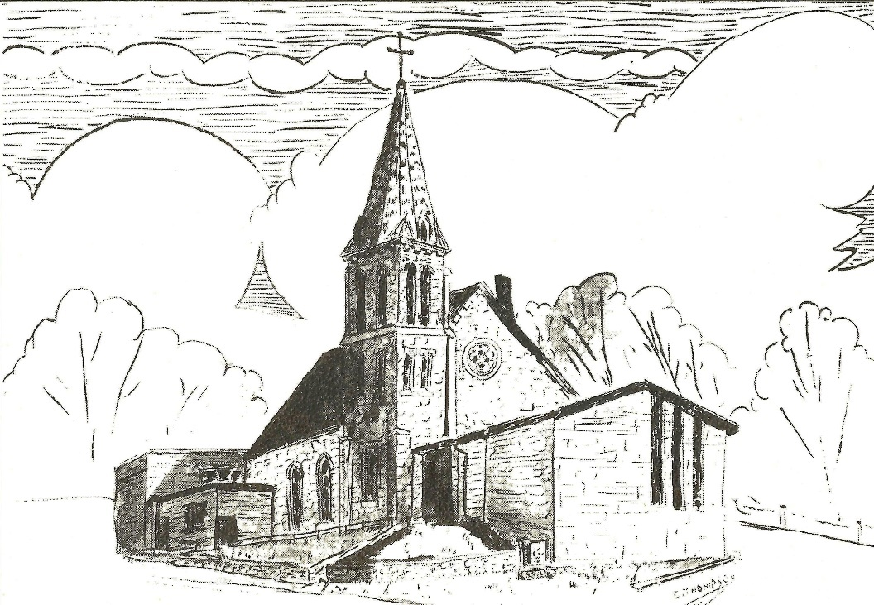
Established 1874

Rev. Kerry B. Eversole, Pastor
Deacon Cindy Cordes-Eversole, Associate in Ministry

Mailing Address: P.O. Box 314, Lanesboro, MN 55949-0314
Physical Address: 200 Kenilworth Ave S, Lanesboro, Minn.

Telephone: 507.467.3344
E-mail Address: bethlehem@acegroup.cc
Website: www.staronthehill.com
Facebook Page: www.facebook.com/BethlehemLutheranLanesboro/

Office Hours: Tuesday, Wednesday, Thursday 10 a.m. to 3 p.m.
Parsonage Phone: 507.467.3017

Pastor Kerry’s Cell Phone: 507.951.3954

Bethlehem Lutheran Church
Lanesboro, Minnesota

Eighteenth Sunday after Pentecost

October 9, 2022

As Jesus entered a village on the way to Jerusalem, ten lepers approached him. Keeping their distance, they called out, saying, “Jesus, Master, have mercy on us! When he saw them, he said to them, “Go and show yourselves to the priests.” As they went, they were made clean. When one of them saw that he was healed, he turned back, praising God with a loud voice. He was a Samaritan. Then Jesus asked, “Were not ten made clean? Where are the other nine? Jesus said to him, “Get up and go on your way; your faith has made you well.” Luke 17:11-19
Welcome to worship at Bethlehem Lutheran Church

We are “The star on the hill”
You are the light of the world … let your light shine before others, so that they may see your good works and give glory to your Father in heaven. Matthew 5:14-16

COVID-19 Practices — Out of love for God and Neighbor

1) Use hand sanitizer upon entry. Wash your hands and use hand sanitizer often while in the facility.
2) Members and visitors who are vaccinated and boosted are not required to wear a mask.
3) Members and visitors are free to wear a mask if they wish to do so.
4) Unvaccinated and not boosted members and visitors must wear a mask.
5) There are no physical distancing requirements, but you are welcome to keep a distance from others in the sanctuary as you are able.
6) All are welcome to enjoy coffee fellowship in the dining room following worship.

Worship Book and Hymns. This morning’s service is printed in the bulletin. All the hymns can be found in Evangelical Lutheran Worship (ELW), “the red book”, which are in the pew racks. Hymns in ELW are indicated by a large bold number in the left or right margin of each page.

Abbreviations. Throughout this worship folder hymns are signified by the pound symbol (#), P: refers to the presiding minister or preacher, A: denotes an assisting minister, and C: and/or bold text indicates the congregation.

Offering. Later in our service, we will be receiving an offering. The offering is an opportunity to worship God with our money. We know that the money you give to Bethlehem Lutheran represents your lives—your time, talents, and hard work. We recognize that and we appreciate your generosity. Your support not only helps all of us to fulfill God’s call on our lives, but it also makes an impact, and we thank you! Lastly, our visitors are not expected to give. After all, you are our guests! We’re glad you’re here and we want you to feel welcomed!

Mistakes do not happen in our worship service;
only unexpected events which are opportunities for joy!

An signifies that you may stand as you are comfortably able.

Gathering

The Holy Spirit calls us together as the people of God.

Introduction to the Day. It’s a miracle! Multiple miracles! In the waters of holy baptism, we have died with Christ and been raised with him. The body and blood of Jesus in holy communion have made us clean. By the word of God we have been healed. For all this we have returned to offer thanks. From this place we are sent on our way rejoicing to share the good news.

PRELUDE

RINGING OF THE BELL

WELCOME

CALL TO WORSHIP Psalm 111 Spoken responsively

¹Hallelujah! I will give thanks to the Lord with my whole heart, in the assembly of the upright, in the congregation.

²Great are your works, O Lord, pondered by all who delight in them.

³Majesty and splendor mark your deeds, and your righteousness endures forever.

⁴You cause your wonders to be remembered; you are gracious and full of compassion.

⁵You give food to those who fear you, remembering forever your covenant.

⁶You have shown your people the power of your works in giving them the lands of the nations.

⁷The works of your hands are faithfulness and justice; all of your precepts are sure.

⁸They stand fast forever and ever, because they are done in truth and equity.

⁹You sent redemption to your people and commanded your covenant forever; holy and awesome is your name.

¹⁰The fear of the Lord is the beginning of wisdom; all who practice this have a good understanding. God’s praise endures forever.

OPENING HYMN Praise My Soul, the God of Heaven ELW # 864
GREETING

P: The grace of our Lord Jesus Christ, the love of God, and the communion of the Holy Spirit be with you all.

C: And also with you.

PRAYER OF THE DAY

P: Let us pray together.

Almighty and most merciful God,

All: your bountiful goodness fills all creation. Keep us safe from all that may hurt us, that, whole and well in body and spirit, we may with grateful hearts accomplish all that you would have us do, through Jesus Christ, our Savior and Lord. Amen.

Word

God speaks to us in scripture reading, preaching, and song.

FIRST READING 2 Kings 5:1-3, 7-15c

Naaman, a Syrian general, suffers from leprosy. In this passage Elisha miraculously cures his illness, but only after Naaman realizes, with the help of his servants, that he also needs healing for his pride. This foreign general then acknowledges the sovereignty of the God of Israel.

¹Naaman, commander of the army of the king of Aram, was a great man and in high favor with his master, because by him the Lord had given victory to Aram. The man, though a mighty warrior, suffered from leprosy. ²Now the Arameans on one of their raids had taken a young girl captive from the land of Israel, and she served Naaman’s wife. ³She said to her mistress, “If only my lord were with the prophet who is in Samaria! He would cure him of his leprosy.” ⁷When the king of Israel read the letter, he tore his clothes and said, “Am I God, to give death or life, that this man sends word to me to cure a man of his leprosy? Just look and see how he is trying to pick a quarrel with me.”
⁸But when Elisha the man of God heard that the king of Israel had torn his clothes, he sent a message to the king, “Why have you torn your clothes? Let him come to me, that he may learn that there is a prophet in Israel.” ⁹So Naaman came with his horses and chariots, and halted at the entrance of Elisha’s house. ¹⁰Elisha sent a messenger to him, saying, “Go, wash in the Jordan seven times, and your flesh shall be restored and you shall be clean.”

Continued on the next page.
¹¹But Naaman became angry and went away, saying, “I thought that for me he would surely come out, and stand and call on the name of the Lord his God, and would wave his hand over the spot, and cure the leprosy! ¹²Are not Abana and Pharpar, the rivers of Damascus, better than all the waters of Israel? Could I not wash in them, and be clean?” He turned and went away in a rage. ¹³But his servants approached and said to him, “Father, if the prophet had commanded you to do something difficult, would you not have done it? How much more, when all he said to you was, ‘Wash, and be clean’?” ¹⁴So he went down and immersed himself seven times in the Jordan, according to the word of the man of God; his flesh was restored like the flesh of a young boy, and he was clean.
^{15a-c}Then he returned to the man of God, he and all his company; he came and stood before him and said, “Now I know that there is no God in all the earth except in Israel.”

A: The word of the Lord.

C: Thanks be to God.

SECOND READING 2 Timothy 2:8-15

Though Paul is chained as a prisoner, the word of God is never shackled or confined. Timothy is encouraged to proclaim that word of freedom in an honest and upright life as well as in his teaching and preaching.

⁸Remember Jesus Christ, raised from the dead, a descendant of David—that is my gospel, ⁹for which I suffer hardship, even to the point of being chained like a criminal. But the word of God is not chained. ¹⁰Therefore I endure everything for the sake of the elect, so that they may also obtain the salvation that is in Christ Jesus, with eternal glory. ¹¹The saying is sure:
If we have died with him, we will also live with him;
¹²if we endure, we will also reign with him;
if we deny him, he will also deny us;
¹³if we are faithless, he remains faithful—
for he cannot deny himself.
¹⁴Remind them of this, and warn them before God that they are to avoid wrangling over words, which does no good but only ruins those who are listening. ¹⁵Do your best to present yourself to God as one approved by him, a worker who has no need to be ashamed, rightly explaining the word of truth.

A: The word of the Lord.

C: Thanks be to God.

GOSPEL Luke 17:11-19

P: Announcement of the Gospel.

C: Glory to you, O Lord.

Jesus’ mission includes making people clean again. Unexpectedly, a Samaritan healed of leprosy becomes a model for those who would praise and worship God and give thanks for God’s mercy.

¹¹On the way to Jerusalem Jesus was going through the region between Samaria and Galilee. ¹²As he entered a village, ten lepers approached him. Keeping their distance, ¹³they called out, saying, “Jesus, Master, have mercy on us! ¹⁴When he saw them, he said to them, “Go and show yourselves to the priests.” And as they went, they were made clean. ¹⁵Then one of them, when he saw that he was healed, turned back, praising God with a loud voice. ¹⁶He prostrated himself at Jesus’ feet and thanked him. And he was a Samaritan. ¹⁷Then Jesus asked, “Were not ten made clean? But the other nine, where are they? ¹⁸Was none of them found to return and give praise to God except this foreigner?” ¹⁹Then he said to him, “Get up and go on your way; your faith has made you well.”

P: Affirmation of the Gospel.

C: Praise to you, O Christ.

SERMON

HYMN OF THE DAY We Come to You for Healing, Lord ELW # 617

Responding

We Respond to God’s healing word.

THANKSGIVING FOR BAPTISM ELW p. 97

P: Blessed be the holy Trinity, ☩ one God, the fountain of living water, the rock who gave us birth, our light and our salvation.

C: Amen.

P: Joined to Christ in the waters of baptism, we are clothed with God's mercy and forgiveness. Let us give thanks for the gift of baptism.

Continued on the next page.

P: We give you thanks, O God, for in the beginning, your Spirit moved over the waters, and by your Word you created the world, calling forth life in which you took delight.

Through the waters of the flood, you delivered Noah and his family. Through the sea, you led your people Israel from slavery into freedom. At the river, your Son was baptized by John and anointed with the Holy Spirit. By water and your Word, you claim us as daughters and sons, making us heirs of your promise and servants of all.

We praise you for the gift of water that sustains life, and above all, we praise you for the gift of new life in Jesus Christ. Shower us with your Spirit, and renew our lives with your forgiveness, grace, and love.

To you be given honor and praise through Jesus Christ our Lord in the unity of the Holy Spirit, now and forever.

C: Amen.

BAPTISM HYMN Baptized and Set Free ELW # 543

OFFERING Music by Sue Holst

At this point in our service, we worship God with our money. The ushers will pass plates down the pews to receive your gifts of cash and checks made out to Bethlehem Lutheran Church. You can even give online at secure.myvanco.com/L-Z22R/. Your gifts support the worship, faith formation, administration, Women’s, and other ministries of Bethlehem Lutheran Church, as well as the mission of the Southeastern Minnesota Synod, and the whole Evangelical Lutheran Church in America. God bless your giving and your generosity. And thank you!

OFFERING SONG Give Thanks Printed on the next page.

PRAYERS OF INTERCESSIONS

Each petition ends with these words and response:

P: Hear us, O God.

C: Your mercy is great.

Concluding petition and response:

P: With grateful hearts, we commend our spoken and silent prayers to you, O God; through Jesus Christ, our Lord.

C: Amen.

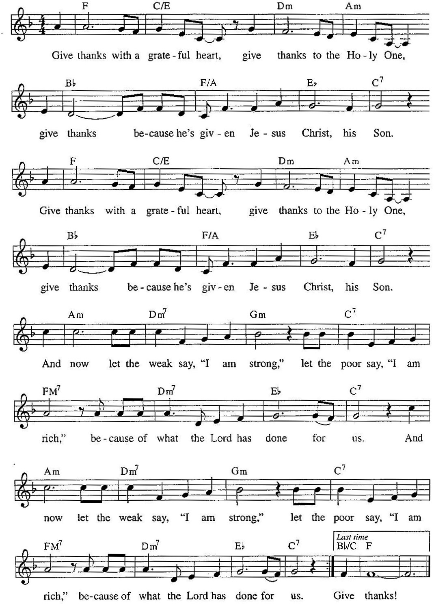
Give Thanks
LORD’S PRAYER Traditional Wording

P: Gathered into one by the Holy Spirit, let us pray as Jesus taught us.

All: Our Father, who art in heaven, hallowed be thy name, thy kingdom come, thy will be done, on earth as it is in heaven. Give us this day our daily bread; and forgive us our trespasses, as we forgive those who trespass against us; and lead us not into temptation, but deliver us from evil. For thine is the kingdom, and the power, and the glory, forever and ever. Amen.

Sending

ANNOUNCEMENTS

BENEDICTION AND DEPARTING HYMN ELW # 543

Go, My Children, with My Blessing

DISMISSAL

A: Go in peace, with Christ beside you.

C: Thanks be to God.

RINGING OF THE BELL

POSTLUDE

Today’s Assistants and Ministers

Greeters & Ushers …...........................................…...… Dave Campbell and Sue Miehlisch
Organist/Pianist ……………………..…………………….….………..………………. Sue Holst
Presiding Minister …………...………………………….….……………. Pastor Kerry Eversole
Reader ……………………………………….……...…...…....…….…….…………. Brett Clarke
Altar Care ……..………..……………………………………………..…………… Sue Miehlisch
Refreshments …………..................................….……… Dave Campbell and Sue Miehlisch
Custodian ……………………….………………..……………………………. Wayne Lukkason

Presence Last Week and September Presents

Attendance Last Sunday, October 2 = 48
Average Sunday Worship Attendance for September = 44

September Contributions: General Fund = $ Designated Giving = $
Jan-Sep Income = $ Jan-Sep Expenses = $ Deficit = $

This Week in Our Congregation

Today, October 9 — Eighteenth Sunday after Pentecost t

Sunday school meets after the children’s message
Refreshments in the Fellowship Hall for everyone following worship
November Service Group meets in the Fellowship Hall after worship
7th- & 8th-grade Confirmation classes at Bethlehem 10:15 AM

Tuesday, October 11

Men’s breakfast at Home Sweet Home in Lanesboro 7:00 AM
Pastor Kerry at Root River Conference gathering at GEV 9:00 AM-1:00 PM

Wednesday, October 12

Church Council 6:30 PM
10th-graders get ready to affirm their baptism 7:00 PM at Fountain Lutheran

Thursday, October 13

Deacon Cindy at Park Lane Estates, Preston, for Bible study/chapel 9:30 AM

Next Sunday, October 16 — Nineteenth Sunday after Pentecost

Worship 9:00 AM
7th- & 8th-grade Confirmation classes at Bethlehem 10:15 AM

News and Notes

Bethlehem is hosting a Drive Thru Fall Dinner on Sunday, November 13. Please mark your calendar and watch for volunteer opportunities.
Got a Great Idea? Take advantage of the opportunity to share your suggestions, ideas, and comments to uplift Bethlehem Lutheran Church. You will find one Suggestion Box located in the Narthex and one in the Dining Hall. You will find note paper in the church pews and with the boxes. Just slip your written comments in the box. The Stewardship Committee will manage the boxes and forward the information to the appropriate committee for consideration.

The WELCA has canceled this year's Cookie Walk. We still would appreciate your donations as our expenses continue. Locally, WELCA helps support its Quilters and Knitters groups, gifts for confirmands and graduating seniors, Preston food shelf, Good Earth Village, and Christmas in Fillmore County, just to name a few. Donations may be sent to WELCA Treasurer Harriet Lawston, P.O. Box 408, Lanesboro, MN 55949.

Good Earth Village 2022 Rekindle: Fall Youth Retreats. Grades 3-5 & 6-8: Oct 21 – 22. Grades 9-12: Nov 4 – 5. Arrive Friday at 7:00 pm - Depart Saturday at 4:30 pm.
Rekindle Youth Retreats are one-night programs designed to give youth time away from the busyness of life and rekindle camp relationships and spark new friendships. The cost is $60 per youth with a $25 non-refundable deposit due at the time of registration. To register, call 507-346-2494 or go to goodearthvillage.org.

Community Activities

St. Columban Catholic Church, Preston, Pork Dinner, today! Serving from 11:00 am to 1:00 pm or until gone. Natural pork loin, mashed potatoes, gravy, dressing, corn, coleslaw, applesauce, buns, and homemade pie. $15 per dinner. Carry-out only.

Prayer Requests

In Our Community. For our church members and friends living with chronic illness and other diseases, who are homebound, residing in care facilities, and hospitalized. See the newsletter for our members living in area nursing homes. And let us not forget those sick and dying of COVID-19, those entrusted with the authority of government, justice, and law enforcement, as well as our fallen and wounded soldiers and those still serving.

In Our Synod. Bishop Regina Hassanally invites the people and congregations of our synod to commit to praying this week for the following faith communities: St. John Lutheran Church, Montgomery; Vista Lutheran Church, New Richland; St. Paul’s Lutheran Church, Waseca; Bethel Lutheran Church, Rochester; Ikhanoda Lutheran Church, Tanzania; Mazoezi Singa Lutheran Church, Tanzania; and Nguony Keel Lutheran Parish, South Sudan.

Acknowledgments

Graphics, readings, and other worship texts are from sundaysandseasons.com, © 2022 Augsburg Fortress. Used by permission under Augsburg Fortress Liturgies Annual License SAS103296.

Permission to project, live stream, or podcast liturgy and music content under copyright to or administered by Augsburg Fortress provided under Augsburg Fortress Liturgies Annual License SAS103296.

Permission to Podcast / Stream provided by Christian Copyright Licensing International, Inc., under License # 11459672. Additional fee paid. www.ccli.com.

Permission to Podcast / Stream provided by One License, Inc., under License # A-735588. Additional fee paid. www.onelicense.net.

Give Thanks Used by permission under Christian Copyright Licensing International, Inc., License # 11459672. Text: Henry Smith © 1978 Integrity's Hosanna! Music (Admin. by Integrity Music), CCLI Song # 20285. Adapt. Stuart Dauermann. Music: Stuart Dauermann © 1972 Lilleans Publishing Co., admin. The Copyright Company.

