Bethlehem Lutheran Church
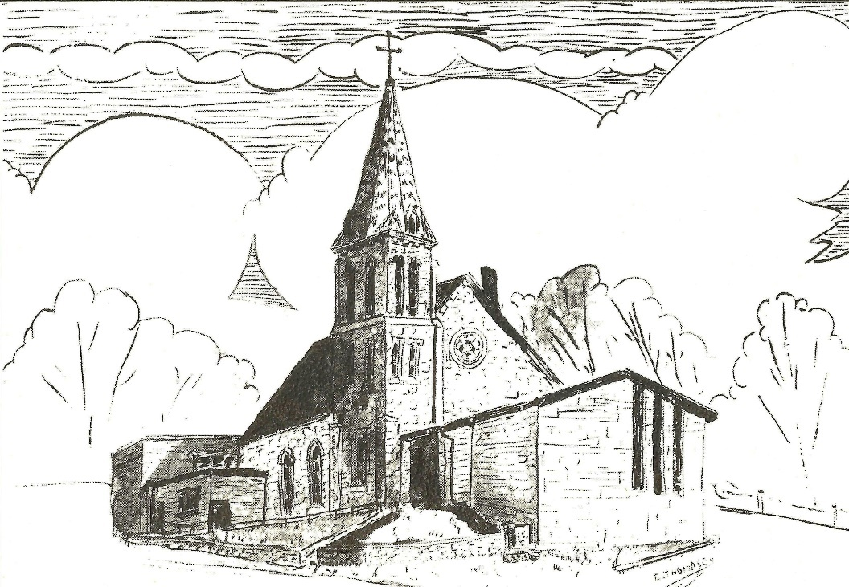
Established 1874

Rev. Kerry B. Eversole, Pastor
Deacon Cindy Cordes-Eversole, Associate in Ministry

Mailing Address: P.O. Box 314, Lanesboro, MN 55949-0314
Physical Address: 200 Kenilworth Ave S, Lanesboro, Minn.

Telephone: 507.467.3344
E-mail Address: bethlehem@acegroup.cc
Website: www.staronthehill.com
Facebook Page: www.facebook.com/BethlehemLutheranLanesboro/

Office Hours: Tuesday, Wednesday, Thursday 10 a.m. to 3 p.m.
Parsonage Phone: 507.467.3017

Pastor Kerry’s Cell Phone: 507.951.3954

Bethlehem Lutheran Church
Lanesboro, Minnesota

Mission, WELCA Thankoffering, and
World Communion Sunday

October 2, 2022

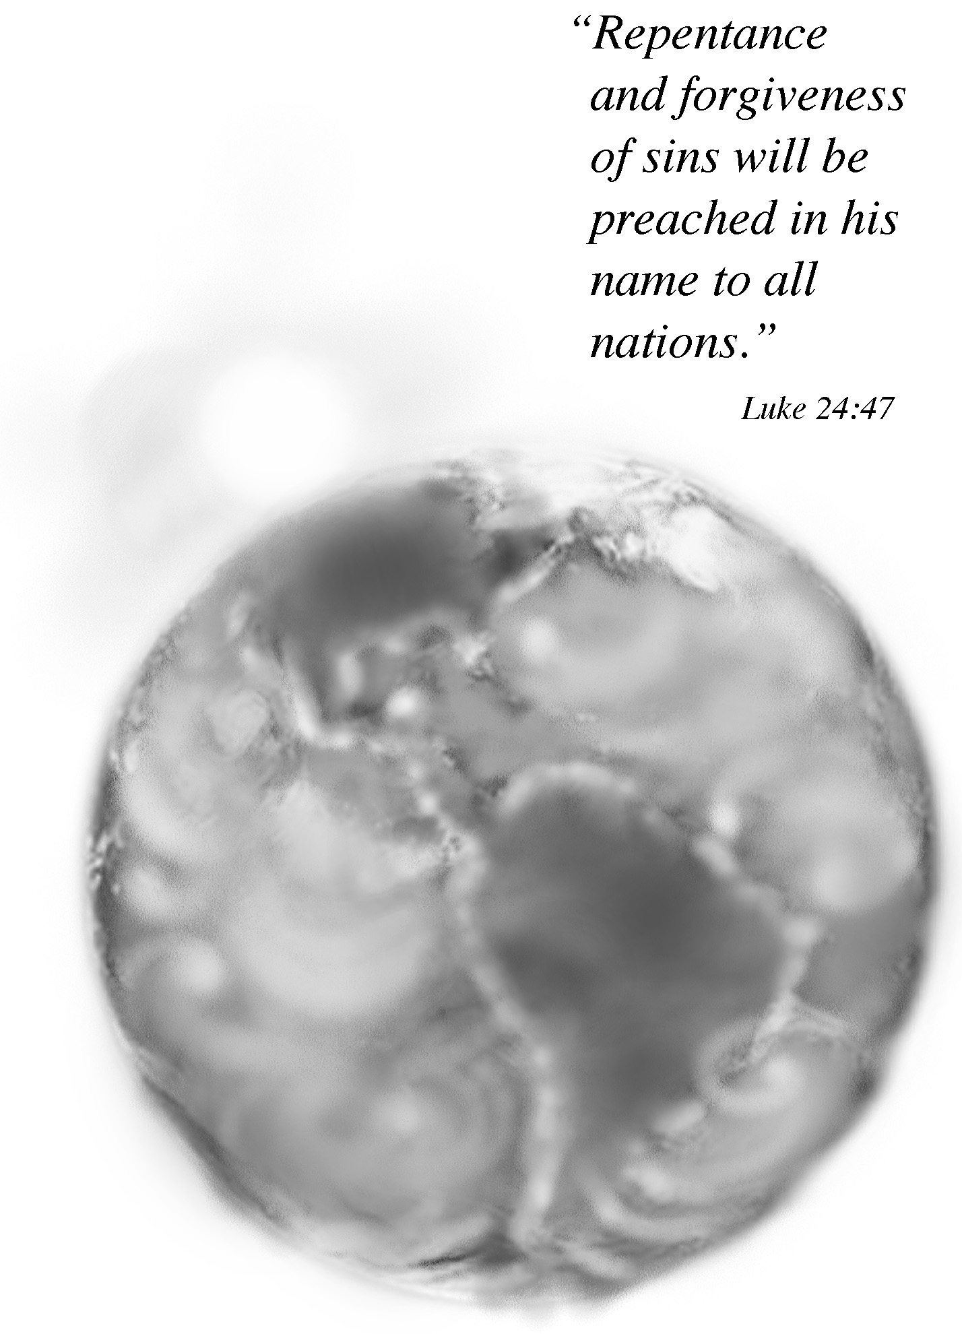

Welcome to worship at Bethlehem Lutheran Church

We are “The star on the hill” — You are the light of the world … let your light shine before others, so that they may see your good works and give glory to your Father in heaven. Matthew 5:14-16

COVID-19 Practices — Out of love for God and Neighbor

1) Use hand sanitizer upon entry. Wash your hands and use hand sanitizer often while in the facility.
2) Members and visitors who are vaccinated and boosted are not required to wear a mask.
3) Members and visitors are free to wear a mask if they wish to do so.
4) Unvaccinated and not boosted members and visitors must wear a mask.
5) There are no physical distancing requirements, but you are welcome to keep a distance from others in the sanctuary as you are able.
6) All are welcome to enjoy coffee fellowship in the dining room following worship.

Worship Book and Hymns. This morning’s service is printed in the bulletin. All the hymns can be found in Evangelical Lutheran Worship (ELW), “the red book”, which are in the pew racks. Hymns in ELW are indicated by a large bold number in the left or right margin of each page.

Abbreviations. Throughout this worship folder hymns are signified by the pound symbol (#), P: refers to the presiding minister or preacher, A: denotes an assisting minister, and C: and/or bold text indicates the congregation.

Offering. Later in our service, we will be receiving an offering. The offering is an opportunity to worship God with our money. We know that the money you give to Bethlehem Lutheran represents your lives—your time, talents, and hard work. We recognize that and we appreciate your generosity. Your support not only helps all of us to fulfill God’s call on our lives, but it also makes an impact, and we thank you! Lastly, our visitors are not expected to give. After all, you are our guests! We’re glad you’re here and we want you to feel welcomed!

Mistakes do not happen in our worship service;
only unexpected events which are opportunities for joy!

An signifies that you may stand as you are comfortably able.

Gathering

Introduction to the Day. On this Seventeenth Sunday after Pentecost, we hear God’s call and commission to spread God’s word and do God’s will and work throughout the world!

Global Mission in the Evangelical Lutheran Church in America. “As you therefore have received Christ Jesus the Lord, continue to live your lives in him, rooted and built up in him and established in the faith” (Colossians 2:6–7a). These words, written by the apostle Paul to the young church in Colossae, are the core of our work as the Evangelical Lutheran Church in America walks with more than 80 companion churches in other countries to participate in God’s reconciling mission through proclamation and service. As part of a global Lutheran community, we gratefully receive the witness of global brothers and sisters whose faith, hospitality, resilience, and zeal energize us and our own congregations. In response, we share our gifts and talents to address the root causes of poverty and hunger, fight malaria and HIV and AIDS, build communities that coexist in peace, and prepare women and men to preach the good news of Jesus Christ throughout the world. In other words, we seek to accompany our global companions. Accompaniment is defined as walking together in a solidarity that practices interdependence and mutuality. In short, the ELCA’s Global Mission work is about walking side by side with companion churches and institutions, talking together, listening, and consulting with one another about how we will participate in God’s mission together, and share God’s love in Jesus Christ among people of every nation.

Accompanying Global Partners in the Southeastern Minnesota Synod. Kathy Chatelaine, the Director for Global Mission/Companion Synods, says that there has been a paradigm shift in global ministries in recent years. In the past, one of the primary purposes of global partnerships between congregations was for the Global North to provide financial resources to the Global South. Today, congregations and ministries are intentionally forming accompaniment-focused relationships where ‘radical hospitality’ is mutually practiced. The Southeastern Minnesota Synod has relationships with three church bodies. 1) The Central Diocese of the Evangelical Lutheran Church in Tanzania. This relationship began in late 1989 and today includes support for secondary schools at Iambi, Ihanja and Kijota, the Lutheran Institute at Kiomboi, an education ministry at Mwangaza, as well as a hospital at Iambi, and other general ministries throughout the Central Diocese. 2) The Evangelical Lutheran Church in Colombia (Iglesia Evangelica Luterana de Colombia – IELCO). This partnership began in 1994 and has made possible the establishment of four Lutheran secondary schools, congregational partnerships, food insecurity and other national ministries. 3) The Evangelical Lutheran Church Africa—South Sudan. Our synod is raising money to support Rev. Wal Reat who is serving in the Gambella region on the border of South Sudan, for Reconciliation Lutheran Church, Community Center, and Clinic in Juba, and for Rev. Mawien Ariik and others serving various Lutheran worshipping communities.

A special welcome to our Mission Sunday guest speaker, Rev. Deborah Lyanga. Deborah is an ordained pastor in the Central Diocese of the Evangelical Lutheran Church in Tanzania. Currently, she lives in Owatonna and worships at Our Savior’s Lutheran.

Continued on the next page.
She is working as a Partnership Liaison along with Kathy Chatelaine to nurture existing relationships and to build new partnerships between congregations in the Southeastern Minnesota Synod and the Central Diocese. She is married to Pr. Emmanuel Kaghondi and they are blessed with two boys, Mercy and Abner.

Women of the ELCA Thankoffering Sunday. Today we also celebrate the ministry of the Women of the ELCA through their Thankofferings and benevolent projects. Lutheran Women have been gathering for offering services since the early 1900s. Please take a moment this morning to thank our WELCA members for their part in this important ministry! Since the 2021 ingathering, the women of Bethlehem have completed 30 quilts, 32 school kits, four personal care kits, and two baby care kits. They will be packed and shipped to Lutheran World Relief this week for distribution around the world.

Where did Lutheran World Relief Quilts and Kits go in 2021? LWR reports that in 2021, 361,225 neighbors in need in 19 countries were served with 3,230 blankets, 122,400, quilts, 60,030, personal care kits, 103,880 school kits, 38,850 baby care kits, 915 fabric kits, and 31,920 face masks.

PRELUDE Heidi Dybing

RINGING OF THE BELL

OPENING HYMN Oh, for a Thousand Tongues to Sing ELW # 886

Stanzas 1, 2, 3 and 4

GREETING

P: The grace of our Lord Jesus Christ, the love of God, and the communion of the Holy Spirit be with you all.

C: And also with you.

PRAYER OF THE DAY

P: Eternal God, by your word creation sprang forth, and humankind was given the breath of life; by your word you called us to be your people; and by your word you caused the light of your Son Jesus Christ to shine among us, and to reconcile the world to yourself. Eternal God, we praise you and bless you that you have sent us in the power of your Spirit to proclaim the good news of your love in word and in deed to all nations.

Continued on the next page.

P: We thank you that in all parts of the earth a community of love has been gathered together by our prayers and labors and that in every place your servants call upon your name; to the increase of your kingdom and your power and your glory.

C: Amen.

Hearing God’s Word of Mission and Ministry

FIRST READING Psalm 48:1-2, 8-14

¹Great is the Lord and greatly to be praised
in the city of our God.
His holy mountain, ²beautiful in elevation,
is the joy of all the earth,
Mount Zion, in the far north,
the city of the great King.
⁸As we have heard, so have we seen
in the city of the Lord of hosts,
in the city of our God,
which God establishes forever.
⁹We ponder your steadfast love, O God,
in the midst of your temple.
¹⁰Your name, O God, like your praise,
reaches to the ends of the earth.
Your right hand is filled with victory.
¹¹Let Mount Zion be glad;
let the towns of Judah rejoice
because of your judgments.
¹²Walk about Zion; go all around it;
count its towers;
¹³consider well its ramparts;
go through its citadels,
that you may tell the next generation
¹⁴that this is God,
our God forever and ever.
He will be our guide forever.

SECOND READING Romans 10:11-17

The scripture says, “No one who believes in him will be put to shame.” ¹²For there is no distinction between Jew and Greek; the same Lord is Lord of all and is generous to all who call on him. ¹³For, “Everyone who calls on the name of the Lord shall be saved.”
¹⁴But how are they to call on one in whom they have not believed? And how are they to believe in one of whom they have never heard? And how are they to hear without someone to proclaim him? ¹⁵And how are they to proclaim him unless they are sent? As it its written, “How beautiful are the feet of those who bring good news!” ¹⁶But not all have obeyed the good news; for Isaiah says, “Lord, who has believed our message?” ¹⁷So faith comes from what is heard, and what is heard comes through the word of Christ.

GOSPEL Luke 24:13-16, 28-36, 44-49

P: Announcement of the Gospel.

All: Halle, Halle, Hallelujah ELW # 172

¹³Now on [the same day Jesus rose from the dead and appeared to Mary Magdalene and the other women] two of them were going to a village called Emmaus, about seven miles from Jerusalem, ¹⁴and talking with each other about all these things that had happened. ¹⁵While they were talking and discussing, Jesus himself came near and went with them, ¹⁶but their eyes were kept from recognizing him.
²⁸As they came near the village to which they were going, he walked ahead as if he were going on. ²⁹But they urged him strongly, saying, “Stay with us, because it is almost evening and the day is now nearly over.” So he went in to stay with them.
³⁰When he was at the table with them, he took bread, blessed and broke it, and gave it to them. ³¹Then their eyes were opened, and they recognized him; and he vanished from their sight. … ³³That same hour they got up and returned to Jerusalem; and they found the eleven and their companions gathered together. ³⁴They were saying, “The Lord has risen indeed, and he has appeared to Simon!” ³⁵Then they told what had happened … how he had been made known to them in the breaking of the bread.
³⁶ While they were talking about this, Jesus himself stood among them and said to them, “Peace be with you.”
⁴⁴Then he said to them, “These are my words that I spoke to you while I was still with you—that everything written about me in the law of Moses, the

Continued on the next page.
prophets, and the psalms must be fulfilled.” ⁴⁵Then he opened their minds to understand the scriptures, ⁴⁶and he said to them, “Thus it is written, that the Messiah is to suffer and to rise from the dead on the third day, ⁴⁷and that repentance and forgiveness of sins is to be proclaimed in his name to all nations, beginning from Jerusalem. ⁴⁸You are witnesses of these things. ⁴⁹And see, I am sending upon you what my Father promised; so stay here in the city until you have been clothed with power from on high.”

P: Affirmation of the Gospel.

All: Halle, Halle, Hallelujah ELW # 172

MISSION PRESENTATION Rev. Deborah Lyanga

Responding to God’s Word of Mission and Ministry

HYMN OF THE DAY We All Are One in Mission ELW # 576

PRAYER OF INTERCESSIONS

Each petition ends with these words and response:

P: God of grace,

C: hear our prayer.

Concluding petition and response:

P: Gathered together in the sweet communion of the Holy Spirit, gracious God, we offer these and all our prayers to you; through Jesus Christ, our Savior.

C: Amen.

OFFERING Music by Heidi Dybing

At this point in our service, we worship God with our money. The ushers will pass plates down the pews to receive your gifts of cash and checks made out to Bethlehem Lutheran Church. You can even give online at secure.myvanco.com/L-Z22R/. Your gifts support the worship, faith formation, administration, Women’s, and other ministries of Bethlehem Lutheran Church, as well as the mission of the Southeastern Minnesota Synod, and the whole Evangelical Lutheran Church in America. God bless your giving and your generosity. And thank you!

OFFERING SONG For the Fruit of All Creation ELW # 679

Stanzas 1 and 2

BLESSING OF PROJECTS AND OFFERINGS

P: Heavenly Father, your love shines in our lives with light and power through your Son, Jesus Christ! We cannot count the many ways your love has touched us. May the love you have given us spread out to others through the fruits of our labors.

All: We dedicate the quilts and kits we have created to your service, O Lord, trusting that your love will go wherever each quilt or kit is sent, making it more than just a piece of material, a collection of items — making each thing we have made an expression of love.

There is no way we can imagine the power and effect an act of love can have on another person’s life — how you can use something as small as a blanket or school supplies or food or even money to radiate your love from us to the world. May all these gifts be used in your service and become blessings for all those who receive them.

P: Lord, we know that all we possess comes from your loving hand. Give us grace to honor you with all our being: draw our hearts to you, guide our minds, fill our imaginations, and control our wills so that we may be wholly yours. Use us as you will, always to your glory, and to the welfare of all people.

All: Amen.

God’s Word of Mission and Ministry in the Holy Meal

GREAT THANKSGIVING

Dialogue

P: The Lord be with you.

C: And also with you.

P: Lift up your hearts.

C: We lift them to the Lord.

P: Let us give thanks to the Lord our God.

C: It is right to give our thanks and praise.

Thanksgiving at the Table

P: Blessed are you, Lord of heaven and earth.

In mercy for our fallen world you gave your only Son, that all those who believe in him should not perish but have eternal life.

We give thanks to you for the salvation you have prepared for us through Jesus Christ.

Send now your Holy Spirit into our hearts, that we may receive our Lord with a living faith as he comes to us in his holy supper.

C: Amen. Come, Lord Jesus.

P: In the night in which he was betrayed, our Lord Jesus took bread, and gave thanks; broke it, and gave it to his disciples, saying: Take and eat; this is my body, given for you. Do this for the remembrance of me.

Again, after supper, he took the cup, gave thanks, and gave it for all to drink, saying: This cup is the new covenant in my blood, shed for you and for all people for the forgiveness of sin. Do this for the remembrance of me.

Lord’s Prayer Traditional Wording

P: Gathered into one by the Holy Spirit, let us pray as Jesus taught us.

All: Our Father, who art in heaven, hallowed be thy name, thy kingdom come, thy will be done, on earth as it is in heaven. Give us this day our daily bread; and forgive us our trespasses, as we forgive those who trespass against us; and lead us not into temptation, but deliver us from evil. For thine is the kingdom, and the power, and the glory, forever and ever. Amen.

INVITATION TO COMMUNION

P: Speak to us, O Lord, in the breaking of the bread, and make us one with you.

COMMUNION

What We Believe

Who May Receive. We welcome all baptized Christians to the Lord's Table. In our parish baptized children who have entered the 5th grade are instructed in this sacrament and receive their First Communion; younger children come to the altar and receive a blessing. If your baptized child has received such instruction, or if you want your baptized child to receive Communion, then he or she is welcome to partake.

Proper Preparation. In his Small Catechism, Martin Luther asks, “When is a person rightly prepared to receive this sacrament?” He answers, “Fasting and other outward preparations serve a good purpose. However, that person is well prepared and worthy who believes these words, given and shed for you for the remission of sins. But anyone who does not believe these words, or doubts them, is neither prepared nor worthy, for the words for you require simply a believing heart.”

Real Presence. We believe that the bread and wine truly are the body and blood of Christ given and shed for the forgiveness of sins.

Distribution

Holy Communion will be served in procession, one side of the sanctuary at a time; please keep some distance from the person in front of you. The ushers will direct you when to make your way to the front of the church using the center aisle. You will receive the elements near the chancel. Please extend your hands, palms up, if you will be receiving the bread. Gluten-free wafers are also available; please ask for one. Proceed to your right or to your left depending on which side of the sanctuary you are seated on to receive the wine. White grape juice is also available in the center ring of each tray for those who prefer an alcohol-free element. You may say “Amen” after receiving each element.

Music During Communion by Heidi Dybing

PRAYER AFTER COMMUNION

P: Holy and compassionate God, in bread and wine you give us gifts that form us to be humble and courageous. May your words come to life in our serving and in our witness, that we might speak a living voice of healing and justice to all the world, through Jesus Christ, our rock and our redeemer.

C: Amen.

Sending

BLESSING

P: Now may the clear and compelling call of God, the Father, Son, and Holy Spirit, guide you in making Christ known to everyone, through all that you say and do.

C: Amen.

SENDING HYMN To Be Your Presence ELW # 546

DISMISSAL

A: Go forth into the world to serve God with gladness; be of good courage; hold fast to that which is good; render to no one evil for evil; strengthen the fainthearted; support the weak; help the afflicted; honor all people; love and serve God, rejoicing in the power of the Holy Spirit.

C: Thanks be to God.

RINGING OF THE BELL

POSTLUDE

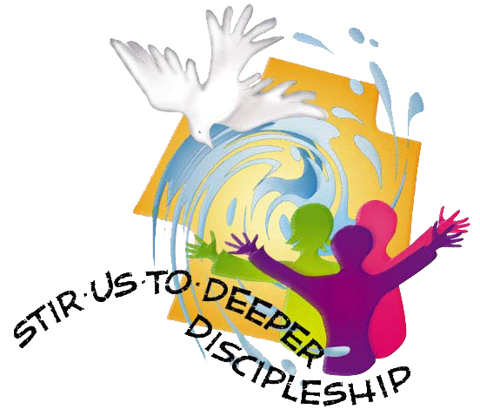
Today’s Assistants and Ministers

Greeters & Ushers …..............................................…...… Mike & Laura Willford and family
Organist/Pianist ……………………..…………………….………..………………. Heidi Dybing
Presiding Minister …………...………………….……………. Deacon Cindy Cordes-Eversole
Guest Speaker ……………………………………….………………….. Rev. Deborah Lyanga
Reader ……………………………………….……...…...…....…….…….…………. Phil Rogers
Altar Care and Communion Preparation ……..………..……………… Mike & Laura Willford
Refreshments ………….......................................................….……… Mike & Laura Willford
Custodian ……………………….………………..……………………………. Wayne Lukkason

Presence Last Week and September Presents

Attendance Last Sunday, September 25 = 52
Average Sunday Worship Attendance for September = 44

September Contributions: General Fund = $ Designated Giving = $
Jan-Sep Income = $ Jan-Sep Expenses = $ Deficit = $

This Week in Our Congregation

Today, October 2 — Mission, WELCA Thankoffering, World Communion, and the
Seventeenth Sunday after Pentecost

Refreshments in the Fellowship Hall for everyone following worship
7th- & 8th-grade Confirmation classes at Bethlehem Lutheran 10:15 AM

Tuesday, October 4

Men’s breakfast at Home Sweet Home in Lanesboro 7:00 AM
Pastor Kerry at Harmony Care Center, Harmony, for chapel 2:00 PM

Wednesday, October 5

WELCA Sew Day 9:00 AM
Deacon Cindy at Chosen Valley Care Center, Chatfield, for chapel 12:30 & 1:30 PM
Monthly Service Group Coordinators Meeting 6:30 PM
10th-graders get ready to affirm their baptism 7:00 PM at Bethlehem Lutheran

Next Sunday, October 9 — Eighteenth Sunday after Pentecost

Worship 9:00 AM
7th- & 8th-grade Confirmation classes at Bethlehem Lutheran 10:15 AM

News and Notes

Confirmation Sessions. 7th- & 8th-graders meet today following worship at approximately 10:15 a.m. 10th-grade confirmands meet on Wednesday, October 5, at 7 pm, at Bethlehem Lutheran Church.

Monthly Service Group Coordinators Meeting Wednesday, October 5. All monthly service group co-chairs are asked to meet Wednesday, October 5 at 6:30 pm in the church dining hall to discuss possible changes to the monthly service groups. Your attendance is greatly appreciated!

The WELCA is looking for someone to take our Lutheran World Relief quilts and kits to Good Shepherd Lutheran Church in La Crosse on Saturday, October 8 anytime between 7:00and 11:00 am. Please contact Kim Wagner 507-459-1166 or 467-2452.

The WELCA has canceled this year's Cookie Walk. We still would appreciate your donations as our expenses continue. Locally, WELCA helps support its Quilters and Knitters groups, gifts for confirmands and graduating seniors, Preston food shelf, Good Earth Village, and Christmas in Fillmore County, just to name a few. Donations may be sent to WELCA Treasurer Harriet Lawston, P.O. Box 408, Lanesboro, MN 55949.

Bethlehem is hosting a Drive Thru Fall Dinner on Sunday, November 13. Please mark your calendar and watch for volunteer opportunities.

Got a Great Idea? Take advantage of the opportunity to share your suggestions, ideas, and comments to uplift Bethlehem Lutheran Church. You will find one Suggestion Box located in the Narthex and one in the Dining Hall. You will find note paper in the church pews and with the boxes. Just slip your written comments in the box. The Stewardship Committee will manage the boxes and forward the information to the appropriate committee for consideration.
Community Activities

Union Prairie Lutheran Church Ham & Meatball Supper today! Serving from 12:00 noon to 6:00 pm. Ham, meatballs, mashed potatoes & gravy, squash, corn, lefse, buns, and homemade pies. Cost: $17. Carry-out only.

The Billy Graham Evangelistic Association presents the GOD LOVES YOU 2022 TOUR with Franklin Graham and music guests, today, at Soldiers Memorial Field Park, Rochester, at 4 PM.

St. Columban Catholic Church, Preston, Pork Dinner, next Sunday, October 9. Serving from 11:00 am to 1:00 pm or until gone. Natural pork loin, mashed potatoes, gravy, dressing, corn, coleslaw, applesauce, buns, and homemade pie. $15 per dinner. Carry-out only.

Good Earth Village 2022 Rekindle: Fall Youth Rretreats. Grades 3-5 & 6-8: Oct 21 – 22. Grades 9-12: Nov 4 – 5. Arrive Friday at 7:00 pm - Depart Saturday at 4:30 pm.
Rekindle Youth Retreats are fun and energy-filled retreats, staffed by our summer counselors, where youth have the opportunity to go on hikes, play games, and worship. We will explore how to rekindle our faith in small groups and engage with one another in a community centered around learning and growing. This one-night program is a chance for youth to have time away from the busyness of life and rekindle camp relationships and spark new friendships. Come, join us for Rekindle this fall at Good Earth Village! The cost is $60 per youth with a $25 non-refundable deposit due at the time of registration. To register, call 507-346-2494 or go to goodearthvillage.org.

Prayer Requests

In Our Community. For our church members and friends living with chronic illness and other diseases, who are homebound, residing in care facilities, and hospitalized. See the newsletter for our members living in area nursing homes. And let us not forget those sick and dying of COVID-19, those entrusted with the authority of government, justice, and law enforcement, as well as our fallen and wounded soldiers and those still serving.

In Our Synod. Bishop Regina Hassanally invites the people and congregations of our synod to commit to praying this week for the following faith communities: LeSueur River Lutheran Church, New Richland; Bethel Lutheran Church, Northfield; Our Savior’s Lutheran Church, Austin; Trinity Lutheran Church, Blue Earth; Mijuhu Lutheran Church, Tanzania; Yerusalemu Ilunda Lutheran Church, Tanzania; and Kier Wan Lutheran Parish, South Sudan.

Acknowledgments

Portions of this morning’s order of worship are from the Global Worship Service of Word and Prayer published by the ELCA Division for Global Mission, 1999.

Other worship texts and readings are from sundaysandseasons.com, © 2022 Augsburg Fortress. Used by permission under Augsburg Fortress Liturgies Annual License SAS103296.

Permission to project, live stream, or podcast liturgy and music content under copyright to or administered by Augsburg Fortress provided under Augsburg Fortress Liturgies Annual License SAS103296.

Permission to Podcast / Stream provided by Christian Copyright Licensing International, Inc., under License # 11459672. Additional fee paid. www.ccli.com.

Permission to Podcast / Stream provided by One License, Inc., under License # A-735588. Additional fee paid. www.onelicense.net.



World Communion Sunday is a celebration that is observed each year by several Christian denominations on the first Sunday of October. The celebration is a promotion of Christian unity and ecumenical cooperation, and focuses on an observance of the Eucharist, Holy Communion, or the Lord’s Supper, as the meal is variously called.

Today, along with celebrating Mission and the ministry of Women of the ELCA, we will be partaking in the remembrance of the night of Jesus’s betrayal, breaking bread together, drinking the cup with one another, and his sacrifice for the sake of the world.

Many of you have probably heard of World Communion Sunday but may not know where the celebration originated. It began at Shadyside Presbyterian Church in Pittsburgh, Pennsylvania in 1933. The Rev. Hugh Thompson Kerr and his congregation wanted to demonstrate the connection of Christian churches, regardless of denomination. Rev. Kerr chose the sacrament of Holy Communion to symbolize this interrelation and unity. In 1940, the Federal Council of Churches of Christ in America, the predecessor body of the National Councils of Churches of Christ, adopted World-Wide Communion Sunday. Since then, the celebration has grown into an international ecumenical celebration.

