Bethlehem Lutheran Church
Established 1874

Rev. Kerry B. Eversole, Pastor
Deacon Cindy Cordes-Eversole, Associate in Ministry

Mailing Address: P.O. Box 314, Lanesboro, MN 55949-0314
Physical Address: 200 Kenilworth Ave S, Lanesboro, Minn.

Telephone: 507.467.3344
E-mail Address: bethlehem@acegroup.cc
Website: www.staronthehill.com
Facebook Page: www.facebook.com/BethlehemLutheranLanesboro/

Office Hours: Tuesday, Wednesday, Thursday 10 a.m. to 3 p.m.
Parsonage Phone: 507.467.3017
Pastor Kerry’s Cell Phone: 507.951.3954

Bethlehem Lutheran Church
Lanesboro, Minnesota

Sixteenth Sunday after Pentecost

September 25, 2022

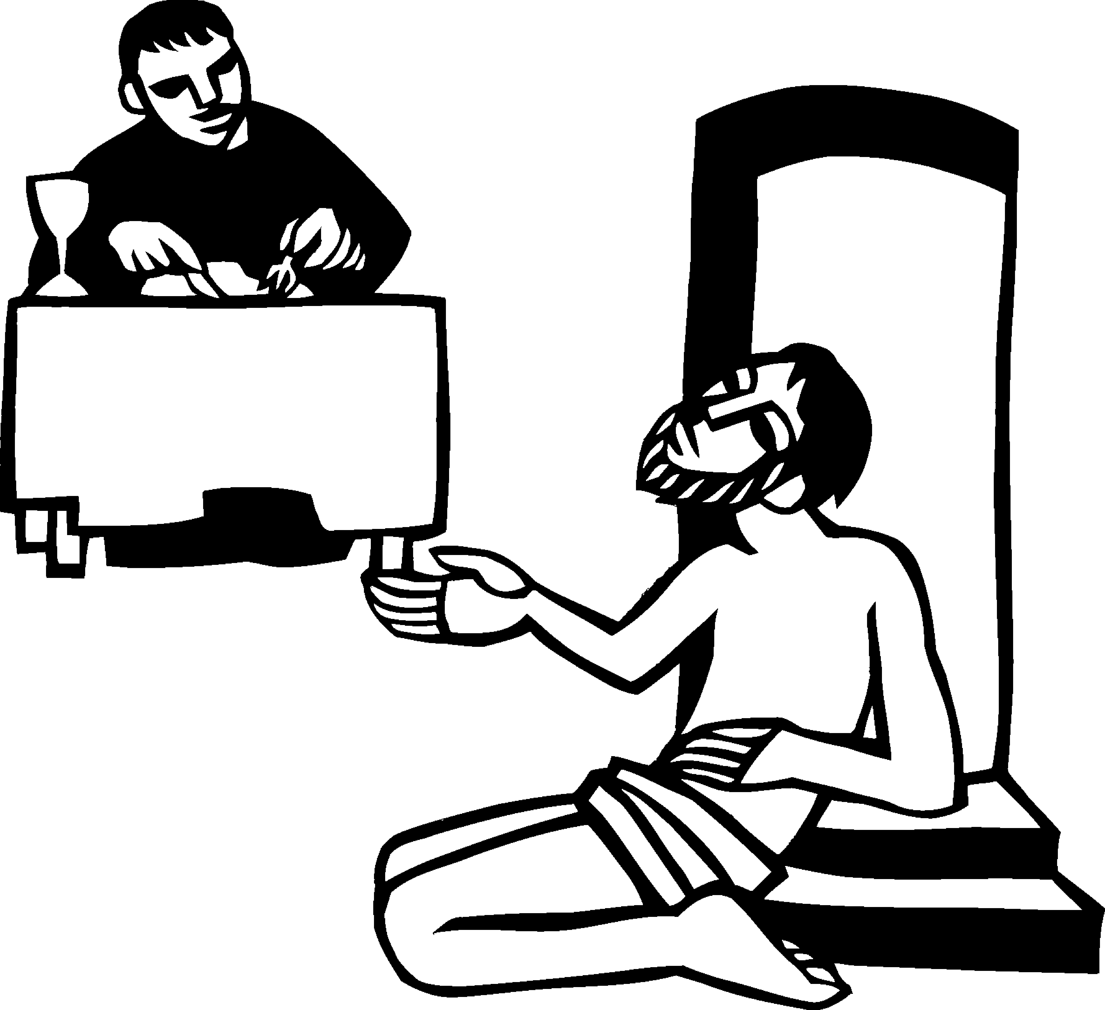
Jesus told a parable about a rich man who was dressed in purple and fine linen and who feasted sumptuously every day. At his gate lay a poor man named Lazarus, covered with sores, who longed to satisfy his hunger with what fell from the rich man’s table; and the dogs would come and lick his sores. The poor man died and was carried away by the angels to be with Abraham. The rich man also died and was buried and taken to Hades where he was tormented. Luke 16:19-22
Welcome to worship at Bethlehem Lutheran Church

We are “The star on the hill” — You are the light of the world … let your light shine before others, so that they may see your good works and give glory to your Father in heaven. Matthew 5:14-16

COVID-19 Practices — Out of love for God and Neighbor

1) Use hand sanitizer upon entry. Wash your hands and use hand sanitizer often while in the facility.
2) Members and visitors who are vaccinated and boosted are not required to wear a mask.
3) Members and visitors are free to wear a mask if they wish to do so.
4) Unvaccinated and not boosted members and visitors must wear a mask.
5) There are no physical distancing requirements, but you are welcome to keep a distance from others in the sanctuary as you are able.
6) All are welcome to enjoy coffee fellowship in the dining room following worship.

Worship Book and Hymns. This morning’s service is printed in the bulletin. All the hymns can be found in Evangelical Lutheran Worship (ELW), “the red book”, which are in the pew racks. Hymns in ELW are indicated by a large bold number in the left or right margin of each page.

Abbreviations. Throughout this worship folder hymns are signified by the pound symbol (#), P: refers to the presiding minister or preacher, A: denotes an assisting minister, and C: and/or bold text indicates the congregation.

Offering. Later in our service, we will be receiving an offering. The offering is an opportunity to worship God with our money. We know that the money you give to Bethlehem Lutheran represents your lives—your time, talents, and hard work. We recognize that and we appreciate your generosity. Your support not only helps all of us to fulfill God’s call on our lives, but it also makes an impact, and we thank you! Lastly, our visitors are not expected to give. After all, you are our guests! We’re glad you’re here and we want you to feel welcomed!

Mistakes do not happen in our worship service;
only unexpected events which are opportunities for joy!

An signifies that you may stand as you are comfortably able.

Gathering

The Holy Spirit calls us together as the people of God.

Introduction to the Day. Consideration of and care for those in need especially those “at our gate,” visible to us, of whom we are aware is an essential component of good stewardship. It is in the sharing of wealth that we avoid the snare of wealth. It is the one whom death could not hold—who comes to us risen from the dead—who can free us from the death grip of greed.

MUSIC AS WE COME TOGETHER Karen Schreiber

RINGING OF THE BELL

WELCOME

CALL TO WORSHIP Psalm 146

¹Hallelujah! Praise the Lord, O my soul!

²I will praise the Lord as long as I live; I will sing praises to my God while I have my being.

³Put not your trust in rulers, in mortals in whom there is no help.

⁴When they breathe their last, they return to earth, and in that day their thoughts perish.

⁵Happy are they who have the God of Jacob for their help, whose hope is in the Lord their God;

⁶who made heaven and earth, the seas, and all that is in them; who keeps promises forever;

⁷who gives justice to those who are oppressed, and food to those who hunger. The Lord sets the captive free.

⁸The Lord opens the eyes of the blind; the Lord lifts up those who are bowed down; the Lord loves the righteous.

⁹The Lord cares for the stranger; the Lord sustains the orphan and widow, but frustrates the way of the wicked.

¹⁰The Lord shall reign forever, your God, O Zion, throughout all generations. Hallelujah!

OPENING SONG Gather Us In ELW # 532

Stanzas 1, 2 and 4
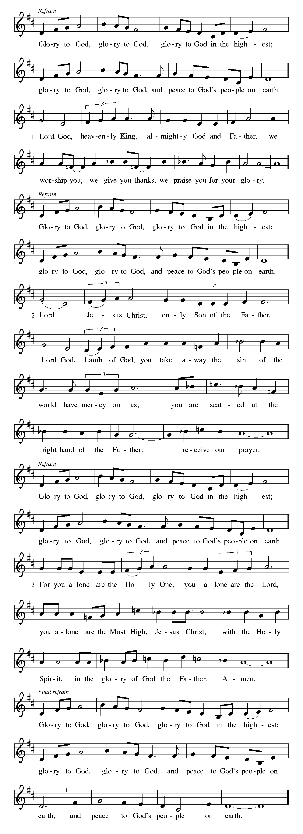GREETING

P: The grace of our Lord Jesus Christ, the love of God, and the communion of the Holy Spirit be with you all.

C: And also with you.

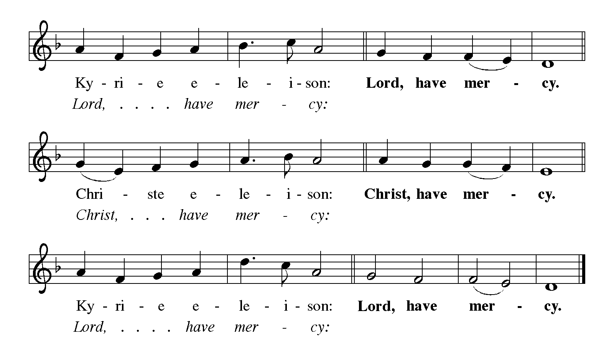KYRIE Sung in unison ELW p. 213

CANTICLE OF PRAISE Glory to God ELW pp. 213-215

Continued on the next page.

Continued on the next page.

Continued on the next page.

PRAYER OF THE DAY

P: Let us pray together. O God, rich in mercy,

All: you look with compassion on this troubled world. Feed us with your grace, and grant us the treasure that comes only from you, through Jesus Christ, our Savior and Lord. Amen.

Word

God speaks to us in scripture reading, preaching, and song.

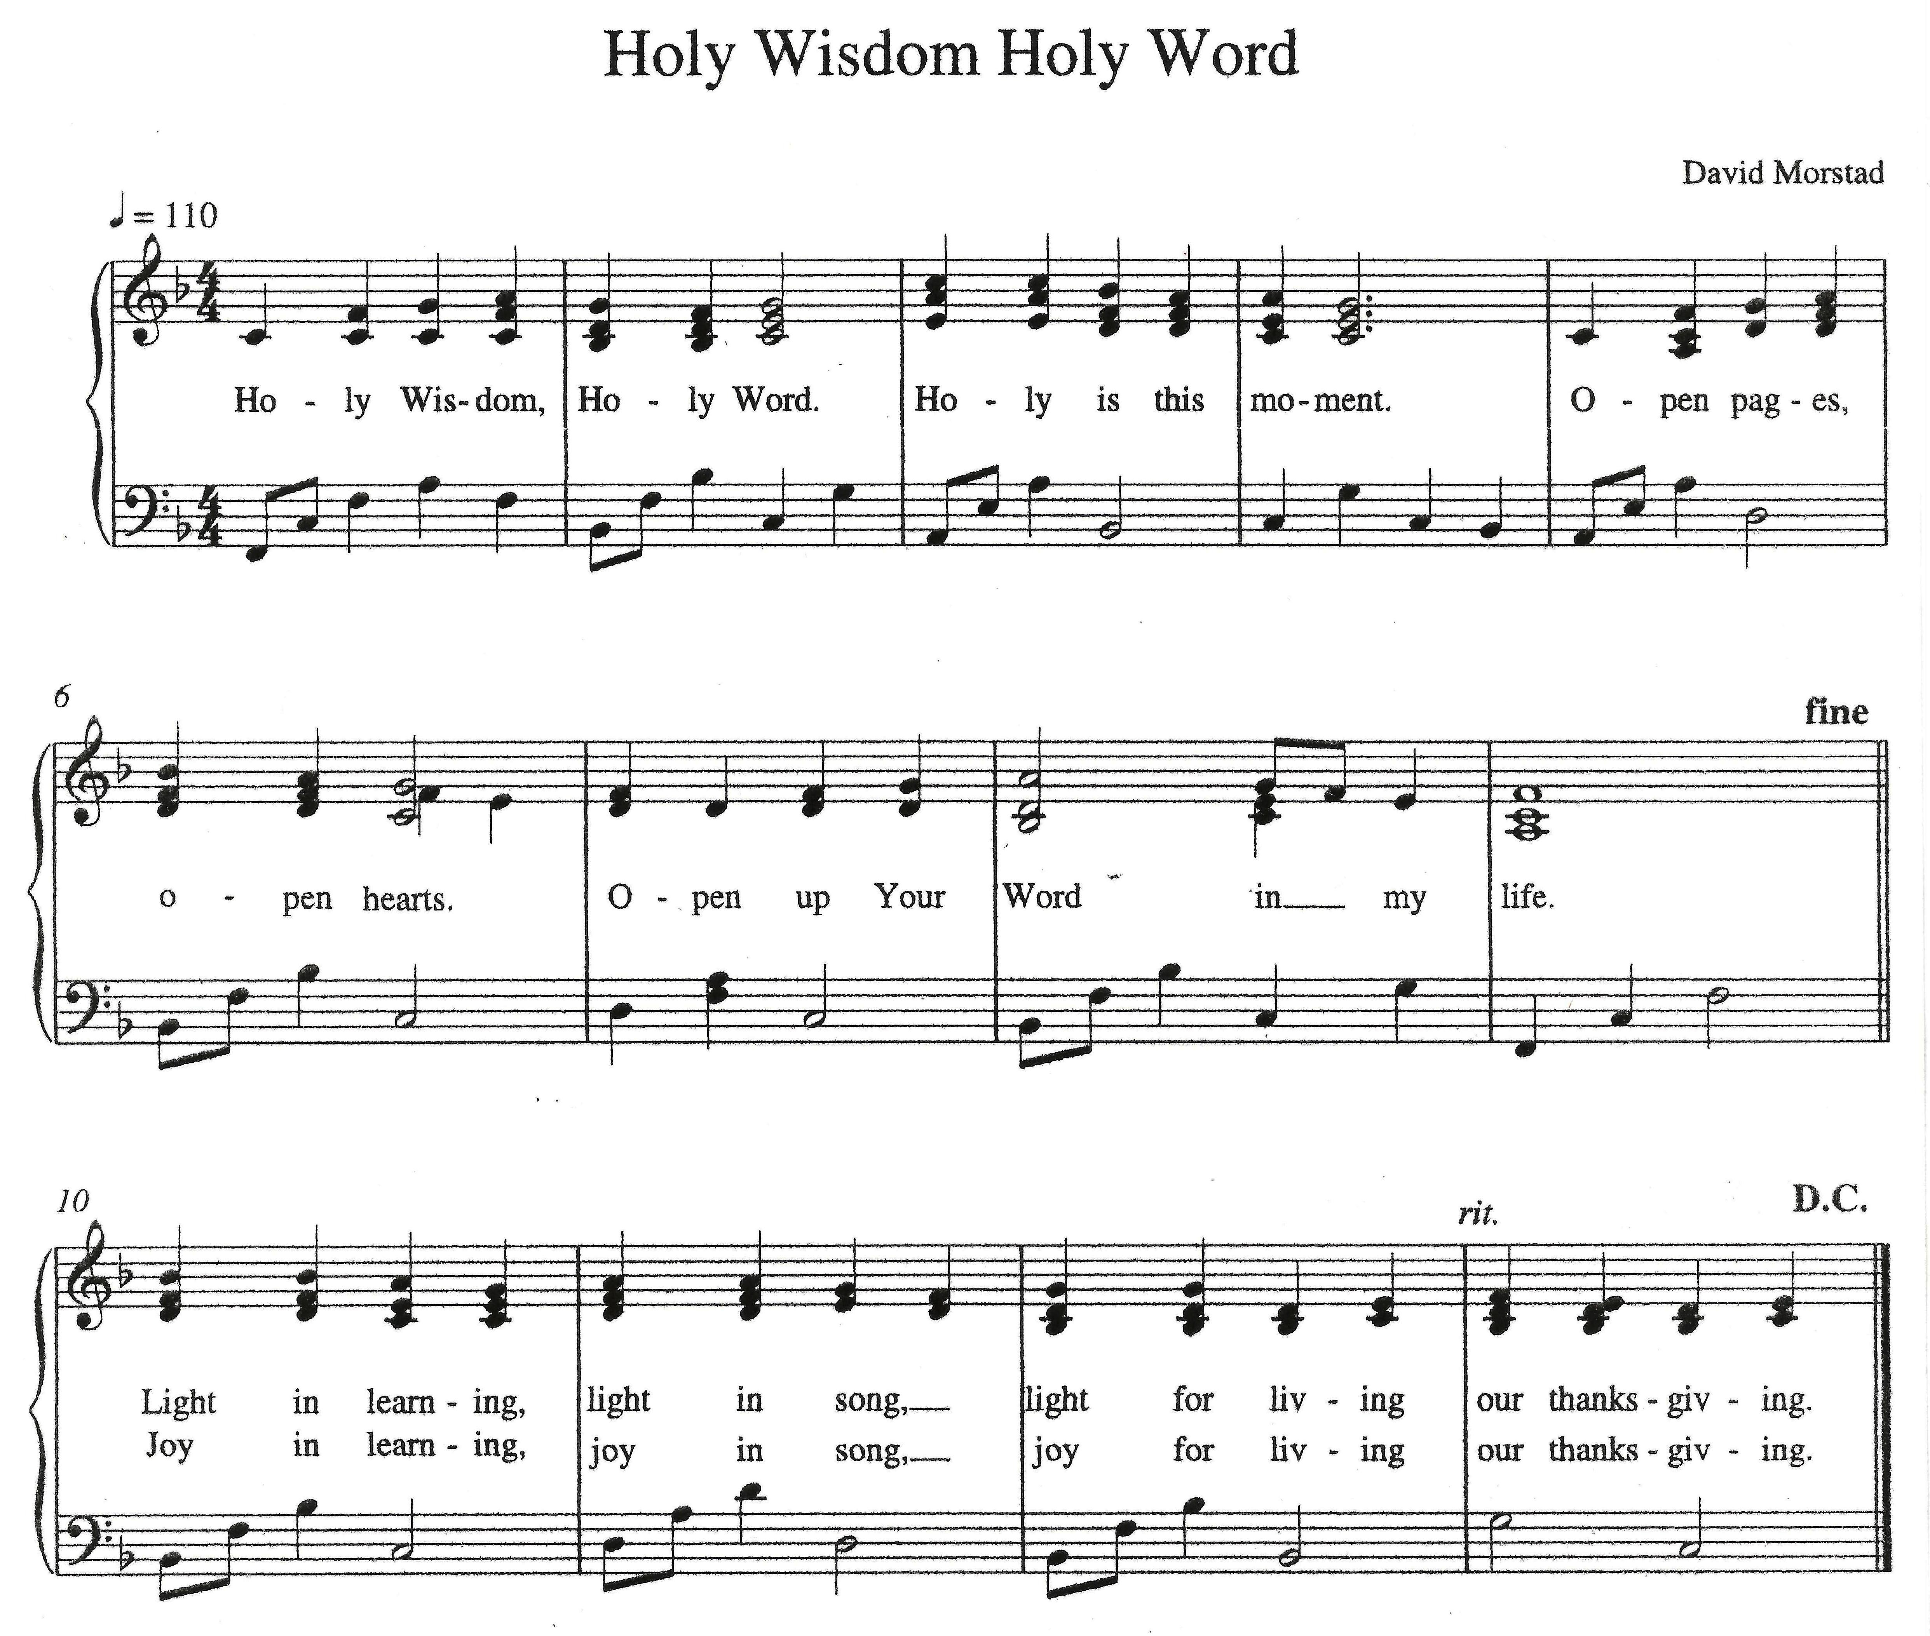SCRIPTURE SONG Holy Wisdom, Holy Word David Morstad

FIRST READING Amos 6:1a, 4-7

The prophet Amos announces that Israel’s great wealth is a cause not for rejoicing but rather sorrow, because God’s people have forgotten how to share their wealth with the poor. The wealthy will be the first to go into exile when judgment comes.

^{1a}Alas for those who are at ease in Zion,
and for those who feel secure on Mount Samaria,
⁴Alas for those who lie on beds of ivory,
and lounge on their couches, and eat lambs from the flock,
and calves from the stall;
⁵who sing idle songs to the sound of the harp,
and like David improvise on instruments of music;
⁶who drink wine from bowls,
and anoint themselves with the finest oils,
but are not grieved over the ruin of Joseph!
⁷Therefore they shall now be the first to go into exile,
and the revelry of the loungers shall pass away.

SECOND READING 1 Timothy 6:6-19

Timothy is reminded of the confession he made at his baptism and of its implications for daily life. His priorities will be different from those of people who merely want to be rich.

⁶Of course, there is great gain in godliness combined with contentment; ⁷for we brought nothing into the world, so that we can take nothing out of it; ⁸but if we have food and clothing, we will be content with these. ⁹But those who want to be rich fall into temptation and are trapped by many senseless and harmful desires that plunge people into ruin and destruction. ¹⁰For the love of money is a root of all kinds of evil, and in their eagerness to be rich some have wandered away from the faith and pierced themselves with many pains.
¹¹But as for you, man of God, shun all this; pursue righteousness, godliness, faith, love, endurance, gentleness. ¹²Fight the good fight of the faith; take hold of the eternal life, to which you were called and for which you made the good confession in the presence of many witnesses. ¹³In the presence of God, who gives life to all things, and of Christ Jesus, who in his testimony before Pontius Pilate made the good confession, I charge you ¹⁴to keep the commandment without spot or blame until the manifestation of our Lord Jesus Christ, ¹⁵which he will bring about at the right time—he who is the blessed and only Sovereign, the King of kings and Lord of lords. ¹⁶It is he alone who has immortality and

Continued on the next page.
dwells in unapproachable light, whom no one has ever seen or can see; to him be honor and eternal dominion. Amen.
¹⁷As for those who in the present age are rich, command them not to be haughty, or to set their hopes on the uncertainty of riches, but rather on God who richly provides us with everything for our enjoyment. ¹⁸They are to do good, to be rich in good works, generous, and ready to share, ¹⁹thus storing up for themselves the treasure of a good foundation for the future, so that they may take hold of the life that really is life.

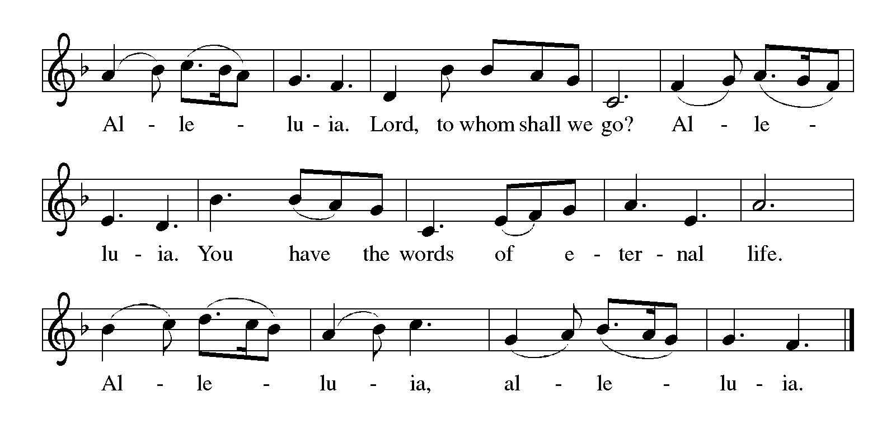GOSPEL ACCLAMATION Alleluia ELW p. 216

GOSPEL Luke 16:19-31

Jesus tells a parable in which the poor one is “lifted up” and the rich one is “sent away empty.” Jesus makes it clear that this ethic of merciful reversal is not new but is as old as Moses and the prophets.

[Jesus said:] ¹⁹“There was a rich man who was dressed in purple and fine linen and who feasted sumptuously every day. ²⁰And at his gate lay a poor man named Lazarus, covered with sores, ²¹who longed to satisfy his hunger with what fell from the rich man’s table; even the dogs would come and lick his sores. ²²The poor man died and was carried away by the angels to be with Abraham. The rich man also died and was buried. ²³In Hades, where he was being tormented, he looked up and saw Abraham far away with Lazarus by his

Continued on the next page.
side. ²⁴He called out, ‘Father Abraham, have mercy on me, and send Lazarus to dip the tip of his finger in water and cool my tongue; for I am in agony in these flames.’ ²⁵But Abraham said, ‘Child, remember that during your lifetime you received your good things, and Lazarus in like manner evil things; but now he is comforted here, and you are in agony. ²⁶Besides all this, between you and us a great chasm has been fixed, so that those who might want to pass from here to you cannot do so, and no one can cross from there to us.’ ²⁷He said, ‘Then, father, I beg you to send him to my father’s house—²⁸for I have five brothers—that he may warn them, so that they will not also come into this place of torment.’ ²⁹Abraham replied, ‘They have Moses and the prophets; they should listen to them.’ ³⁰He said, ‘No, father Abraham; but if someone goes to them from the dead, they will repent.’ ³¹He said to him, ‘If they do not listen to Moses and the prophets, neither will they be convinced even if someone rises from the dead.’ ”

SERMON

SONG OF THE DAY Christ Be Our Light ELW # 715

Stanzas 1, 2, 3 and 5

PRAYERS OF GOD’S PEOPLE

After the petition, all sing Lord, Listen to Your Children Praying ELW # 752

Thanksgiving

We give thanks for God’s word.

OFFERING Music by Karen Schreiber

At this time we are going to worship God with our money. The ushers will pass plates down the pews to receive your gifts of cash, checks made out to Bethlehem Lutheran Church, and online giving at secure.myvanco.com/L-Z22R/. Your offering supports the worship, faith formation, administration, and other ministries of Bethlehem Lutheran Church, as well as the mission of the Southeastern Minnesota Synod, and the whole Evangelical Lutheran Church in America. God bless your giving and your generosity. And thank you!

SONG AS THE GIFTS ARE RECEIVED ELW # 678

God Whose Giving Knows No Ending

Sung to Joyful, Joyful We Adore Thee ELW # 836

THANKSGIVING FOR THE WORD ELW p. 220

P: Praise and thanks to you, holy God, for by your Word you made all things: you spoke light into darkness, called forth beauty from chaos, and brought life into being. For your Word of life, O God,

C: we give you thanks and praise.

P: By your Word you called your people Israel to tell of your wonderful gifts: freedom from captivity, water on the desert journey, a pathway home from exile, wisdom for life with you. For your Word of life, O God,

C: we give you thanks and praise.

P: Through Jesus, your Word made flesh, you speak to us and call us to witness: forgiveness through the cross, life to those entombed by death, the way of your self-giving love. For your Word of life, O God,

C: we give you thanks and praise.

P: Send your Spirit of truth, O God; rekindle your gifts within us: renew our faith, increase our hope, and deepen our love, for the sake of a world in need. Faithful to your Word, O God, draw near to all who call on you; through Jesus Christ, our Savior and Lord, to whom, with you and the Holy Spirit, be honor and glory forever.

C: Amen.

LORD’S PRAYER Traditional Wording ELW p. 221

P: Gathered into one by the Holy Spirit, let us pray as Jesus taught us.

All: Our Father, who art in heaven, hallowed be thy name, thy kingdom come, thy will be done, on earth as it is in heaven. Give us this day our daily bread; and forgive us our trespasses, as we forgive those who trespass against us; and lead us not into temptation, but deliver us from evil. For thine is the kingdom, and the power, and the glory, forever and ever. Amen.

Sending

God blesses us and sends us in mission to the world.

ANNOUNCEMENTS

BENEDICTION

P: God, who gives life to all things and frees us from despair,
bless you with truth and peace.
And may the holy Trinity, ☩ one God,
guide you always in faith, hope, and love.

C: Amen.

DEPARTING SONG Canticle of the Turning ELW # 723

DISMISSAL

A: Go in peace, with Christ beside you.

C: Thanks be to God.

RINGING OF THE BELL

SENDING MUSIC Karen Schreiber



Acknowledgments

Graphics, worship texts, service music, and readings are from sundaysandseasons.com, © 2022 Augsburg Fortress. Used by permission under Augsburg Fortress Liturgies Annual License SAS103296.

Permission to project, live stream, or podcast liturgy and music content under copyright to or administered by Augsburg Fortress provided under Augsburg Fortress Liturgies Annual License SAS103296.

Permission to Podcast / Stream provided by Christian Copyright Licensing International, Inc., under License # 11459672. Additional fee paid. www.ccli.com.

Permission to Podcast / Stream provided by One License, Inc., under License # A-735588. Additional fee paid. www.onelicense.net.

Holy Wisdom, Holy Word Text and Music: David Morstad, My Word! The Bible for EveryOne 2009-2010 Christian Education Planning Guide developed by ELCA Christian Education of the Evangelical Outreach and Congregational Mission unit. Copyright © 2009 Evangelical Lutheran Church in America. All rights reserved. Permission is granted to photocopy this resource provided copies are for local use only and each copy carries all copyright acknowledgments.



Today’s Assistants and Ministers

Greeters & Ushers …................…...… Walter & Susie Bradley and Bryan & Melissa Guber
Organist/Pianist ……………………………………….………..………………. Karen Schreiber
Presiding Minister and Preacher …………...………………. Deacon Cindy Cordes-Eversole
Reader ……………………………………….……...…...…....…….…….…………. Phil Rogers
Altar Care ……..……………………………………...…………………….……… Susie Bradley
Refreshments ………….......….……… Walter & Susie Bradley and Bryan & Melissa Guber
Custodian ……………………….………………..……………………………. Wayne Lukkason

Presence Last Week and August Presents

Attendance Last Sunday, September 18 = 50
Average Sunday Worship Attendance for August = 45

August Contributions: General Fund = $9,530 Designated Giving = $220
Jan-Aug Income = $98,983 Jan-Aug Expenses = $113,056 Deficit = $14.073

This Week in Our Congregation

Today, September 25 — Sixteenth Sunday after Pentecost

Refreshments in the Fellowship Hall for everyone following worship
7th- & 8th-grade Confirmation classes at Bethlehem Lutheran 10:15 AM

Tuesday, September 27

Men’s breakfast at Home Sweet Home in Lanesboro 7:00 AM

Wednesday, September 28

10th-graders get ready to affirm their baptism 7:00 PM at Fountain Lutheran

Next Sunday, October 2 — WELCA Mission and Thankoffering Sunday

Worship with Holy Communion 9:00 AM
7th- & 8th-grade Confirmation classes at Bethlehem Lutheran 10:15 AM

News and Notes

Confirmation Sessions. 7th- & 8th-graders meet today following worship at approximately 10:15 a.m. 10th-grade confirmands meet on Wednesday, September 28, at 7 pm, at Fountain Lutheran Church.

WELCA Mission and Thankoffering service, next Sunday, October 2. Guest speaker is Rev. Deborah Lyanga, a pastor in our companion synod, the Evangelical Lutheran Church of Tanzania—Central Diocese. Blessing of guilts and Holy Communion (and its Worldwide Communion Sunday).

Monthly Service Group Coordinators Meeting Wednesday, October 5. All monthly service group co-chairs are asked to meet Wednesday, October 5 at 6:30 PM in the church dining hall to discuss possible changes to the monthly service groups. Attendance is greatly appreciated.

The WELCA has canceled this year's Cookie Walk. We still would appreciate your donations as our expenses continue. Locally, WELCA helps support its Quilters and Knitters groups, gifts for confirmands and graduating seniors, Preston food shelf, Good Earth Village, and Christmas in Fillmore County, just to name a few. Donations may be sent to WELCA Treasurer Harriet Lawston, P.O. Box 408, Lanesboro, MN 55949.

Got a Great Idea? Take advantage of the opportunity to share your suggestions, ideas, and comments to uplift Bethlehem Lutheran Church. You will find one Suggestion Box located in the Narthex and one in the Dining Hall. You will find note paper in the church pews and with the boxes. Just slip your written comments in the box. The Stewardship Committee will manage the boxes and forward the information to the appropriate committee for consideration.

Community Activities

A Celebration of Life for Pauline O. Reinhardt will be held today, from 1:00 to 3:00 p.m., at Fountain Lutheran Church. Pauline died Saturday, September 3, 2022, at home surrounded by her family. A private burial will be held for her immediate family.

The Billy Graham Evangelistic Association presents the GOD LOVES YOU 2022 TOUR with Franklin Graham and music guests, Sunday, October 2, at Soldiers Memorial Field Park, Rochester, at 4 PM.

Prayer Requests

In Our Community. For our church members and friends living with chronic illness and other diseases, who are homebound, residing in care facilities, and hospitalized. See the newsletter for our members living in area nursing homes. And let us not forget those sick and dying of COVID-19, those entrusted with the authority of government, justice, and law enforcement, as well as our fallen and wounded soldiers and those still serving.

In Our Synod. Bishop Regina Hassanally invites the people and congregations of our synod to commit to praying this week for the following faith communities: Cross of Glory Lutheran Church, Hartland; Trinity Lutheran Church, Hayfield; Ilongero Lutheran Church, Tanzania; Ishenga Lutheran Church, Tanzania; and Torpuot Lutheran Parish, South Sudan.

