Bethlehem Lutheran Church
Established 1874

Rev. Kerry B. Eversole, Pastor
Deacon Cindy Cordes-Eversole, Associate in Ministry

Mailing Address: P.O. Box 314, Lanesboro, MN 55949-0314
Physical Address: 200 Kenilworth Ave S, Lanesboro, Minn.

Telephone: 507.467.3344
E-mail Address: bethlehem@acegroup.cc
Website: www.staronthehill.com
Facebook Page: www.facebook.com/BethlehemLutheranLanesboro/

Office Hours: Tuesday, Wednesday, Thursday 10 a.m. to 3 p.m.
Parsonage Phone: 507.467.3017
Pastor Kerry’s Cell Phone: 507.951.3954

Bethlehem Lutheran Church
Lanesboro, Minnesota

Fifteenth Sunday after Pentecost

September 18, 2022


Jesus told a parable about a manager who was squandering his master’s property. When he was exposed, the dishonest manager changed the bills that people owed his master so they might welcome him into their homes when he was dismissed. The master commended the dishonest manager because he had acted astutely. Jesus proclaimed, if only the children of light acted so. “No slave can serve two masters; for a slave will either hate the one and love the other, or be devoted to the one and despise the other. You cannot serve God and wealth.” Luke 16:1-13
Welcome to worship at Bethlehem Lutheran Church

We are “The star on the hill” — You are the light of the world … let your light shine before others, so that they may see your good works and give glory to your Father in heaven. Matthew 5:14-16

COVID-19 Practices — Out of love for God and Neighbor

1) Use hand sanitizer upon entry. Wash your hands and use hand sanitizer often while in the facility.
2) Members and visitors who are vaccinated and boosted are not required to wear a mask.
3) Members and visitors are free to wear a mask if they wish to do so.
4) Unvaccinated and not boosted members and visitors must wear a mask.
5) There are no physical distancing requirements, but you are welcome to keep a distance from others in the sanctuary as you are able.
6) All are welcome to enjoy coffee fellowship in the dining room following worship.

Worship Book and Hymns. This morning’s service is printed in the bulletin. All the hymns can be found in Evangelical Lutheran Worship (ELW), “the red book”, which are in the pew racks. Hymns in ELW are indicated by a large bold number in the left or right margin of each page.

Abbreviations. Throughout this worship folder hymns are signified by the pound symbol (#), P: refers to the presiding minister or preacher, A: denotes an assisting minister, and C: and/or bold text indicates the congregation.

Offering. Later in our service, we will be receiving an offering. The offering is an opportunity to worship God with our money. We know that the money you give to Bethlehem Lutheran represents your lives—your time, talents, and hard work. We recognize that and we appreciate your generosity. Your support not only helps all of us to fulfill God’s call on our lives, but it also makes an impact, and we thank you! Lastly, our visitors are not expected to give. After all, you are our guests! We’re glad you’re here and we want you to feel welcomed!

Mistakes do not happen in our worship service;
only unexpected events which are opportunities for joy!

An signifies that you may stand as you are comfortably able.

Gathering

The Holy Spirit calls us together as the people of God.

Introduction to the Day. Today we are invited to consider what it means to be managers (rather than owners) of all that we have. As we do so, it is crucial to recognize that we are bought with a price. “Christ Jesus, himself human, … gave himself a ransom for all.” Apart from the generosity of God we have nothing—we are nothing. By God’s gracious favor we have everything we need.

PRELUDE

RINGING OF THE BELL

WELCOME

OPENING HYMN You Servants of God ELW # 825

GREETING ELW p. 165

P: The grace of our Lord Jesus Christ, the love of God, and the communion of the Holy Spirit be with you all.

C: And also with you.

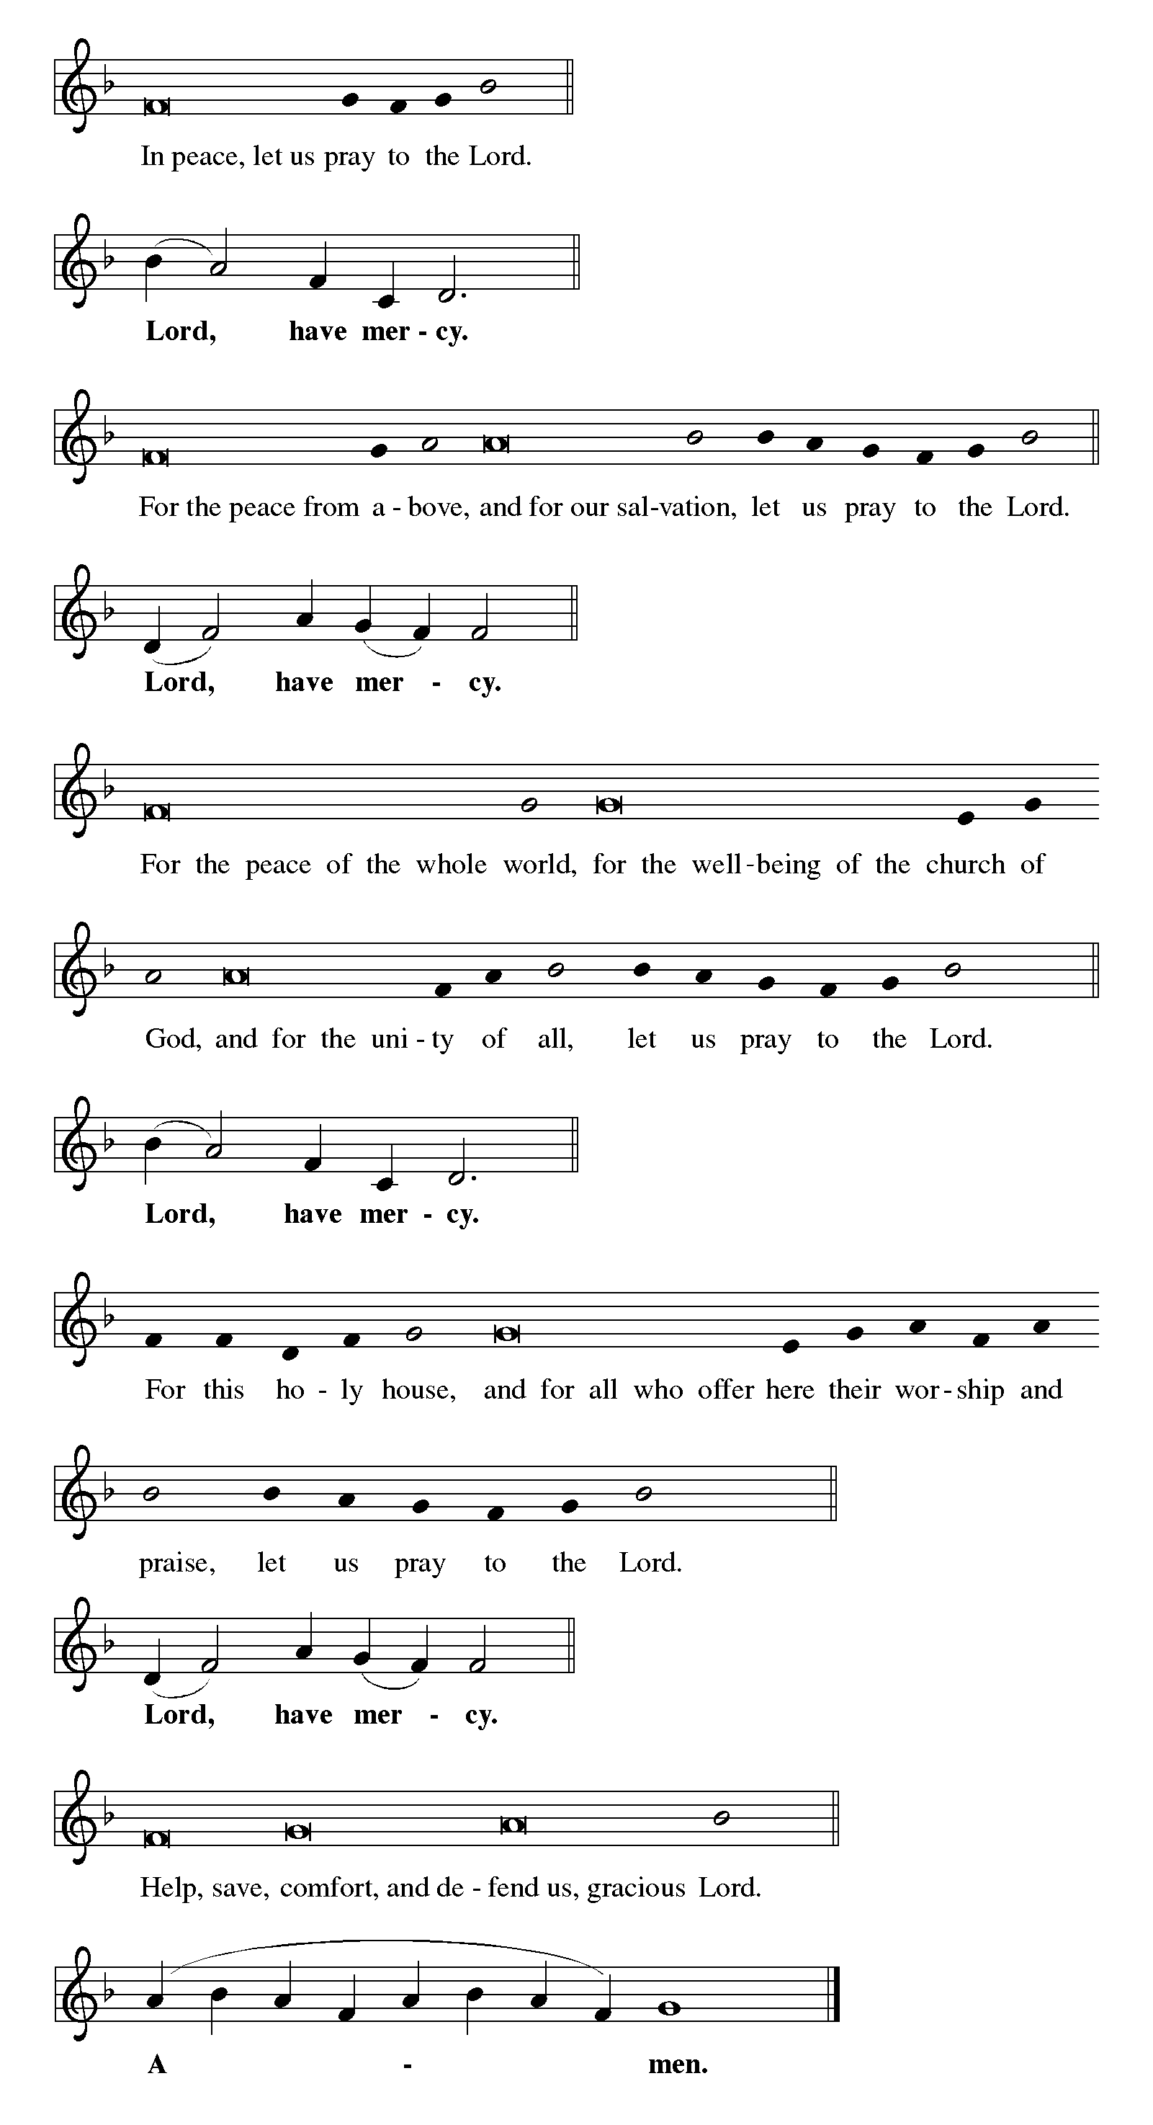KYRIE ELW p. 165

Continued on the next page.

KYRIE continued ELW pp. 165-166

Continued on the next page.

KYRIE concluded ELW p. 166

CANTICLE OF PRAISE Glory to God ELW p. 167
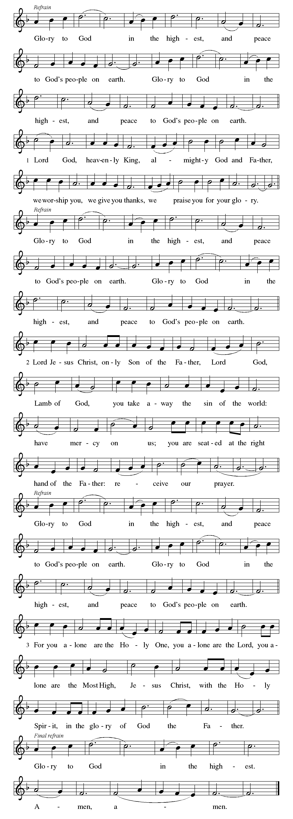

Continued on the next page.

CANTICLE OF PRAISE continued ELW pp. 167-168

Continued on the next page.
CANTICLE OF PRAISE concluded ELW p. 168

PRAYER OF THE DAY

P: God among us, we gather in the name of your Son to learn love for one another. Keep our feet from evil paths. Turn our minds to your wisdom and our hearts to the grace revealed in your Son, Jesus Christ, our Savior and Lord.

C: Amen.

Word

God speaks to us in scripture reading, preaching, and song.

FIRST READING Amos 8:4-7

Amos was called by God to prophesy in the Northern Kingdom of Israel. Peace and prosperity in Israel led to corrupt business practices and oppression of the poor. The prophet declares that God will not tolerate such a situation.

⁴Hear this, you that trample on the needy,
and bring to ruin the poor of the land,
⁵saying, “When will the new moon be over
so that we may sell grain;
and the sabbath,
so that we may offer wheat for sale?
We will make the ephah small and the shekel great,
and practice deceit with false balances,
⁶buying the poor for silver
and the needy for a pair of sandals,
and selling the sweepings of the wheat.”
⁷The Lord has sworn by the pride of Jacob:
Surely I will never forget any of their deeds.

A: The word of the Lord.

C: Thanks be to God.

SECOND READING 1 Timothy 2:1-7

The pastoral epistles offer insight into how early Christians understood many practical matters, such as church administration and worship. The church’s focused prayer for others is an expression of the single-minded passion God has toward us in Jesus.

Continued on the next page.

¹First of all, then, I urge that supplications, prayers, intercessions, and thanksgivings be made for everyone, ²for kings and all who are in high positions, so that we may lead a quiet and peaceable life in all godliness and dignity. ³This is right and is acceptable in the sight of God our Savior, ⁴who desires everyone to be saved and to come to the knowledge of the truth. ⁵For
there is one God;
there is also one mediator between God and humankind,
Christ Jesus, himself human,
⁶who gave himself a ransom for all
—this was attested at the right time. ⁷For this I was appointed a herald and an apostle (I am telling the truth, I am not lying), a teacher of the Gentiles in faith and truth.

A: The word of the word.

C: Thanks be to God.

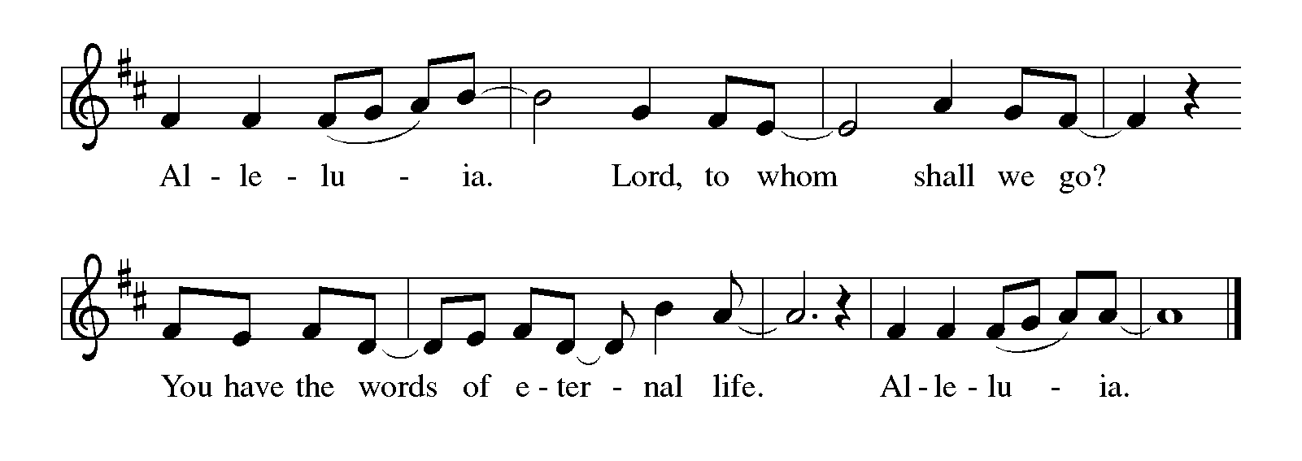GOSPEL ACCLAMATION Alleluia ELW p. 171

GOSPEL Luke 16:1-13

P: Announcement of the Gospel.

C: Glory to you, O Lord.

Jesus tells the curious story of a dishonest manager who cheats his employer and then is commended by him for having acted so shrewdly. Jesus wonders why his own followers are less creative and diligent in their stewardship given that they are managers of a far more valuable household.

Continued on the next page.

¹Then Jesus said to the disciples, “There was a rich man who had a manager, and charges were brought to him that this man was squandering his property. ²So he summoned him and said to him, ‘What is this that I hear about you? Give me an accounting of your management, because you cannot be my manager any longer.’ ³Then the manager said to himself, ‘What will I do, now that my master is taking the position away from me? I am not strong enough to dig, and I am ashamed to beg. ⁴I have decided what to do so that, when I am dismissed as manager, people may welcome me into their homes.’ ⁵So, summoning his master’s debtors one by one, he asked the first, ‘How much do you owe my master?’ ⁶He answered, ‘A hundred jugs of olive oil.’ He said to him, ‘Take your bill, sit down quickly, and make it fifty.’ ⁷Then he asked another, ‘And how much do you owe?’ He replied, ‘A hundred containers of wheat.’ He said to him, ‘Take your bill and make it eighty.’ ⁸And his master commended the dishonest manager because he had acted shrewdly; for the children of this age are more shrewd in dealing with their own generation than are the children of light. ⁹And I tell you, make friends for yourselves by means of dishonest wealth so that when it is gone, they may welcome you into the eternal homes.
¹⁰“Whoever is faithful in a very little is faithful also in much; and whoever is dishonest in a very little is dishonest also in much. ¹¹If then you have not been faithful with the dishonest wealth, who will entrust to you the true riches? ¹²And if you have not been faithful with what belongs to another, who will give you what is your own? ¹³No slave can serve two masters; for a slave will either hate the one and love the other, or be devoted to the one and despise the other. You cannot serve God and wealth.”

P: Affirmation of the Gospel.

C: Praise to you, O Christ.

SERMON

HYMN OF THE DAY Let Justice Flow Like Streams ELW # 717

PRAYERS OF INTERCESSION

Each petition ends with these words and response:

A: God of grace,

C: hear our prayer.

Continued on the next page.

Concluding petition and response:

A: Gathered together in the sweet communion of the Holy Spirit, gracious God, we offer these and all our prayers to you; through Jesus Christ, our Savior.

C: Amen.

THE PEACE

P: The peace of the Lord be with you always.

C: And also with you.

We invite you to share the peace with one another. The peace isn’t an informal “Good morning!” Rather, it’s a sign that we open ourselves to the healing and reconciling power of God’s love and then offer ourselves to be agents of that love in the world. In view of the ongoing COVID-19 pandemic, no physical contact is required (fist bumping, shaking hands, holding hands, embracing). We invite you to simply place your hand over your heart and, while making eye contact, say, “Peace be with you”.

Meal

God feeds us with the presence of Jesus Christ.

OFFERING AND MUSIC

At this time we are going to worship God with our money. The ushers will pass plates down the pews to receive your gifts of cash, checks made out to Bethlehem Lutheran Church, and online giving at secure.myvanco.com/L-Z22R/. Your offering supports the worship, faith formation, administration, and other ministries of Bethlehem Lutheran Church, as well as the mission of the Southeastern Minnesota Synod, and the whole Evangelical Lutheran Church in America. God bless your giving and your generosity. And thank you!

ASSEMBLY SONG We Are an Offering ELW # 692

OFFERING PRAYER

P: Gracious God, in your great love you richly provide for our needs. Make of these gifts a banquet of blessing, and make us ready to share with all in need; through Jesus Christ, who sets a table for all.

C: Amen.

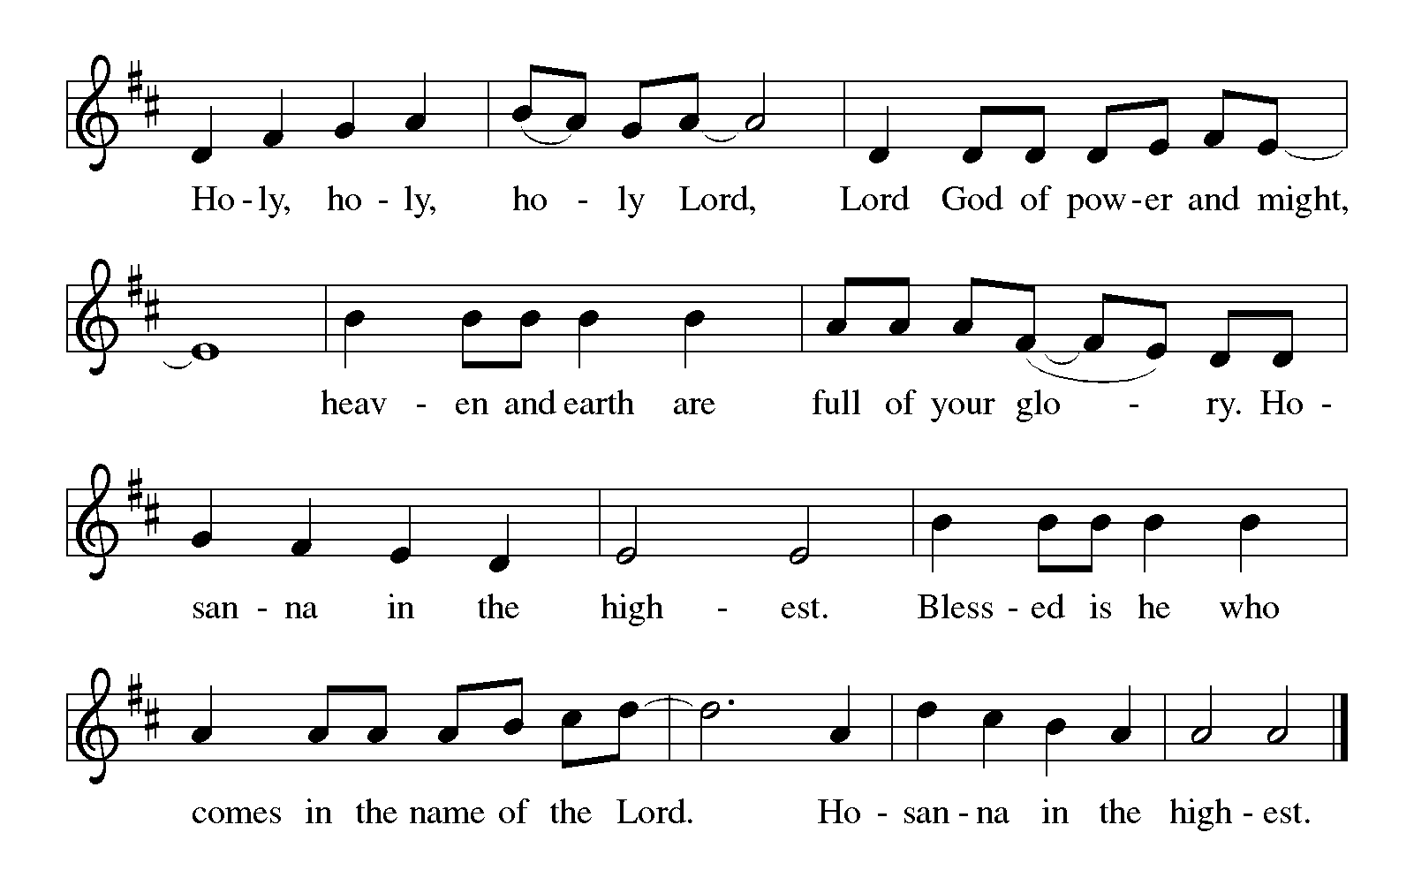THE GREAT THANKSGIVING

Dialogue ELW p. 172

P: The Lord be with you.

C: And also with you.

P: Lift up your hearts.

C: We lift them to the Lord.

P: Let us give thanks to the Lord our God.

C: It is right to give our thanks and praise.

PREFACE

P: It is indeed right, our duty and our joy, that we should at all times and in all places give thanks and praise to you, almighty and merciful God, through our Savior Jesus Christ; who on this day overcame death and the grave, and by his glorious resurrection opened to us the way of everlasting life. And so, with all the choirs of angels, with the church on earth and the hosts of heaven, we praise your name and join their unending hymn:

HOLY, HOLY, HOLY (the angels’ song) ELW p. 173

Continued on the next page.

THANKSGIVING AT THE TABLE

P: You are indeed holy, almighty and merciful God. You are most holy, and great is the majesty of your glory.

You so loved the world that you gave your only Son, so that everyone who believes in him may not perish but have eternal life.

We give you thanks for his coming into the world to fulfill for us your holy will and to accomplish all things for our salvation.

In the night in which he was betrayed, our Lord Jesus took bread, and gave thanks; broke it, and gave it to his disciples, saying: Take and eat; this is my body, given for you. Do this for the remembrance of me.

Again, after supper, he took the cup, gave thanks, and gave it for all to drink, saying: This cup is the new covenant in my blood, shed for you and for all people for the forgiveness of sin. Do this for the remembrance of me.

For as often as we eat of this bread and drink from this cup,
we proclaim the Lord's death until he comes.

C: Christ has died. Christ is risen. Christ will come again.

P: Remembering, therefore, his salutary command, his life-giving passion and death, his glorious resurrection and ascension, and the promise of his coming again, we give thanks to you, O Lord God Almighty, not as we ought but as we are able; we ask you mercifully to accept our praise and thanksgiving and with your Word and Holy Spirit to bless us, your servants, and these your own gifts of bread and wine, so that we and all who share in the body and blood of Christ may be filled with heavenly blessing and grace, and, receiving the forgiveness of sin, may be formed to live as your holy people and be given our inheritance with all your saints.

To you, O God, Father, Son, and Holy Spirit, be all honor and glory in your holy church, now and forever.

C: Amen.

LORD'S PRAYER Traditional Wording ELW p. 173

P: Gathered into one by the Holy Spirit, let us pray as Jesus taught us.

All: Our Father, who art in heaven, hallowed be thy name, thy kingdom come, thy will be done, on earth as it is in heaven. Give us this day our daily bread; and forgive us our trespasses, as we forgive those who trespass against us; and lead us not into temptation, but deliver us from evil. For thine is the kingdom, and the power, and the glory, forever and ever. Amen.

INVITATION TO COMMUNION

P: Christ invites you to this table. Come, taste and see.

COMMUNION

What We Believe

Who May Receive. We welcome all baptized Christians to the Lord's Table. In our parish baptized children who have entered the 5th grade are instructed in this sacrament and receive their First Communion; younger children come to the altar and receive a blessing. If your baptized child has received such instruction, or if you want your baptized child to receive Communion, then he or she is welcome to partake.

Proper Preparation. In his Small Catechism, Martin Luther asks, "When is a person rightly prepared to receive this sacrament?" He answers, "Fasting and other outward preparations serve a good purpose. However, that person is well prepared and worthy who believes these words, given and shed for you for the remission of sins. But anyone who does not believe these words, or doubts them, is neither prepared nor worthy, for the words for you require simply a believing heart.”

Real Presence. We believe that the bread and wine truly are the body and blood of Christ given and shed for the forgiveness of sins.

Distribution

Holy Communion will be served in procession, one side of the sanctuary at a time; please keep some distance from the person in front of you. The ushers will direct you when to make your way to the front of the church using the center aisle. You will receive the elements near the chancel. Please extend your hands, palms up, if you will be receiving the bread. Gluten-free wafers are also available; please ask for one. Proceed to your right or to your left depending on which side of the sanctuary you are seated on to receive the wine. White grape juice is also available in the center ring of each tray for those who prefer an alcohol-free element. You may say “Amen” after receiving each element.
Continued on the next page.
If you will not be receiving Communion, keep your hands folded for a blessing. Place your empty cup in the basket and then return to your seat by the side aisle.

Congregational Songs During Distribution

You Satisfy the Hungry Heart ELW # 484 Sts. 1, 2, 3 & 5

Son of God, Eternal Savior ELW # 655 Sts. 1, 2 & 3

We Give Thee but Thine Own ELW # 686 Sts. 1, 2 & 4

Be Thou My Vision ELW # 793 Sts. 1, 2 & 4

PRAYER AFTER COMMUNION

P: God of the abundant table, you have refreshed our hearts in this meal with bread for the journey. Give us your grace on the road that we might serve our neighbors with joy; for the sake of Jesus Christ, our Lord.

C: Amen.

Sending

God blesses us and sends us in mission to the world.

ANNOUNCEMENTS

BENEDICTION

P: God, who gives life to all things and frees us from despair,
bless you with truth and peace.
And may the holy Trinity, ☩ one God,
guide you always in faith, hope, and love.

C: Amen.

DEPARTING HYMN We Are Called ELW # 720

DISMISSAL

A: Go in peace, with Christ beside you.

C: Thanks be to God.

RINGING OF THE BELL

POSTLUDE

Today’s Assistants and Ministers

Greeters & Ushers …................. ......…...… Tim & Lori Anderson and Bryan & Teri Benson
Organist/Pianist ………………………………………………………..………………. Sue Holst
Presiding Minister and Preacher ………………………………………. Pastor Kerry Eversole
Reader ……………………………………….………...…....…….…….…………. Lee Peterson
Altar Care & Communion Preparation ……..…………………………….……… Elva Albrecht
Refreshments ………….......... ....…..….……… Ron & Cheryl Flaa and TJ & Aimee Stettler
Custodian ……………………….………………..……………………………. Wayne Lukkason

Presence Last Week and August Presents

Attendance Last Sunday, September 11 = 40 to 50 attended Church in the Country
Average Sunday Worship Attendance for August = 45

August Contributions: General Fund = $9,530 Designated Giving = $220
Jan-Aug Income = $98,983 Jan-Aug Expenses = $113,056 Deficit = $14.073

This Week in Our Congregation

Today, September 18 — Fifteenth Sunday after Pentecost

Refreshments in the Fellowship Hall for everyone following worship
7th- & 8th-grade Confirmation classes at Bethlehem 10:15 AM

Tuesday, September 20

Men’s breakfast at Home Sweet Home in Lanesboro 7:00 AM

Wednesday, September 21

10th-graders get ready to affirm their baptism 7:00 PM at Bethlehem Lutheran
Please note the time and meeting place

Next Sunday, September 25 — Sixteenth Sunday after Pentecost

Worship 9:00 AM
7th- & 8th-grade Confirmation classes at Bethlehem 10:15 AM

News and Notes

Confirmation Sessions. 7th- & 8th-graders begin meeting today at Bethlehem at approximately 10:15 a.m. 10th-grade confirmands meet on Wednesday, September 21 to continue getting ready to affirm their baptism later this fall. The meeting time is 7 pm. The meeting place this week is Bethlehem Lutheran Church.

WELCA has canceled this year's Cookie Walk. We still would appreciate your donations as our expenses continue. Locally, WELCA helps support its Quilters and Knitters groups, gifts for confirmands and graduating seniors, Preston food shelf, Good Earth Village, and Christmas in Fillmore County, just to name a few. Donations may be sent to WELCA Treasurer Harriet Lawston, P.O. Box 408, Lanesboro, MN 55949.

News and Notes continued

WELCA Mission and Thankoffering Sunday, October 2. Guest speaker is Rev. Deborah Lyanga, a pastor in our companion synod, the Evangelical Lutheran Church of Tanzania—Central Diocese. Blessing of guilts and Holy Communion (it’s Worldwide Communion Sunday). Mark your calendar!

Community Activities

Pauline O. Reinhardt, 84, of Fountain, died Saturday, September 3, 2022, at home surrounded by her family. A Celebration of Life for Pauline will be held next Sunday, September 25, from 1:00 to 3:00 p.m. at Fountain Lutheran Church. A private burial will be held for her immediate family.

The Billy Graham Evangelistic Association presents the GOD LOVES YOU 2022 TOUR with Franklin Graham and music guests, Sunday, October 2, at Soldiers Memorial Field Park, Rochester, at 4 PM.

Prayer Requests

In Our Community. For our church members and friends living with chronic illness and other diseases, who are homebound, residing in care facilities, and hospitalized. See the newsletter for our members living in area nursing homes. And let us not forget those sick and dying of COVID-19, those entrusted with the authority of government, justice, and law enforcement, as well as our fallen and wounded soldiers and those still serving.

In Our Synod. Bishop Regina Hassanally invites the people and congregations of our synod to commit to praying this week for the following faith communities: Bear Lake Concordia Lutheran Church, Albert Lea; Saint Paul Lutheran Church, Pine Island; Kijota Lutheran Church, Tanzania; St. John Mwando Lutheran Church, Tanzania; and Pulroaa Lutheran Parish, South Sudan.

Acknowledgments

Graphics, worship texts, service music, and readings are from sundaysandseasons.com, © 2022 Augsburg Fortress. Used by permission under Augsburg Fortress Liturgies Annual License SAS103296.

Permission to project, live stream, or podcast liturgy and music content under copyright to or administered by Augsburg Fortress provided under Augsburg Fortress Liturgies Annual License SAS103296.

Permission to Podcast / Stream provided by Christian Copyright Licensing International, Inc., under License # 11459672. Additional fee paid. www.ccli.com.

Permission to Podcast / Stream provided by One License, Inc., under License # A-735588. Additional fee paid. www.onelicense.net.

