Bethlehem Lutheran Church
Established 1874

Rev. Kerry B. Eversole, Pastor
Deacon Cindy Cordes-Eversole, Associate in Ministry

Mailing Address: P.O. Box 314, Lanesboro, MN 55949-0314
Physical Address: 200 Kenilworth Ave S, Lanesboro, Minn.

Telephone: 507.467.3344
E-mail Address: bethlehem@acegroup.cc
Website: www.staronthehill.com
Facebook Page: www.facebook.com/BethlehemLutheranLanesboro/

Office Hours: Tuesday, Wednesday, Thursday 10 a.m. to 3 p.m.
Parsonage Phone: 507.467.3017
Pastor Kerry’s Cell Phone: 507.951.3954

Bethlehem Lutheran Church
Lanesboro, Minnesota

Thirteenth Sunday after Pentecost

September 4, 2022


Large crowds were traveling with Jesus. He turned to them and said, “Whoever comes to me and does not hate father and mother, wife and children, brothers and sisters, yes, and even life itself, cannot be my disciple. Whoever does not carry the cross and follow me cannot be my disciple.” Luke 14 25-27
Welcome to worship at Bethlehem Lutheran Church

We are “The star on the hill” — You are the light of the world … let your light shine before others, so that they may see your good works and give glory to your Father in heaven. Matthew 5:14-16

COVID-19 Practices — Out of love for God and Neighbor

1) Use hand sanitizer upon entry. Wash your hands and use hand sanitizer often while in the facility.
2) Members and visitors who are vaccinated and boosted are not required to wear a mask.
3) Members and visitors are free to wear a mask if they wish to do so.
4) Unvaccinated and not boosted members and visitors must wear a mask.
5) There are no physical distancing requirements, but you are welcome to keep a distance from others in the sanctuary as you are able.
6) All are welcome to enjoy coffee fellowship in the dining room following worship.

Worship Book and Hymns. This morning’s service is printed in the bulletin. All the hymns can be found in Evangelical Lutheran Worship (ELW), “the red book”, which are in the pew racks. Hymns in ELW are indicated by a large bold number in the left or right margin of each page.

Abbreviations. Throughout this worship folder hymns are signified by the pound symbol (#), P: refers to the presiding minister or preacher, A: denotes an assisting minister, and C: and/or bold text indicates the congregation.

Offering. Later in our service, we will be receiving an offering. The offering is an opportunity to worship God with our money. We know that the money you give to Bethlehem Lutheran represents your lives—your time, talents, and hard work. We recognize that and we appreciate your generosity. Your support not only helps all of us to fulfill God’s call on our lives, but it also makes an impact, and we thank you! Lastly, our visitors are not expected to give. After all, you are our guests! We’re glad you’re here and we want you to feel welcomed!

Mistakes do not happen in our worship service;
only unexpected events which are opportunities for joy!

An signifies that you may stand as you are comfortably able.

Gathering

The Holy Spirit calls us together as the people of God.

Introduction to the Day. Called to contemplate the cost of discipleship, we might be helped by translating Paul’s request to Philemon into our prayer of the day: Refresh my heart in Christ. Strengthened by the company and forgiveness of Christ in holy communion and recalling God’s grace in remembrance of baptism, we can be strengthened in this hour to “choose life”—to choose life in God as our own.

PRELUDE

RINGING OF THE BELL

WELCOME

OPENING HYMN Lift High the Cross ELW # 660

Stanzas 1 and 3

GREETING ELW p. 203

P: The grace of our Lord Jesus Christ, the love of God, and the communion of the Holy Spirit be with you all.

C: And also with you.

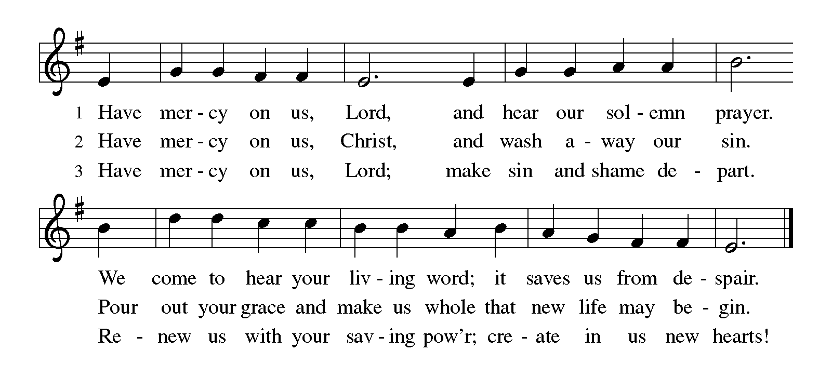KYRIE ELW p. 203

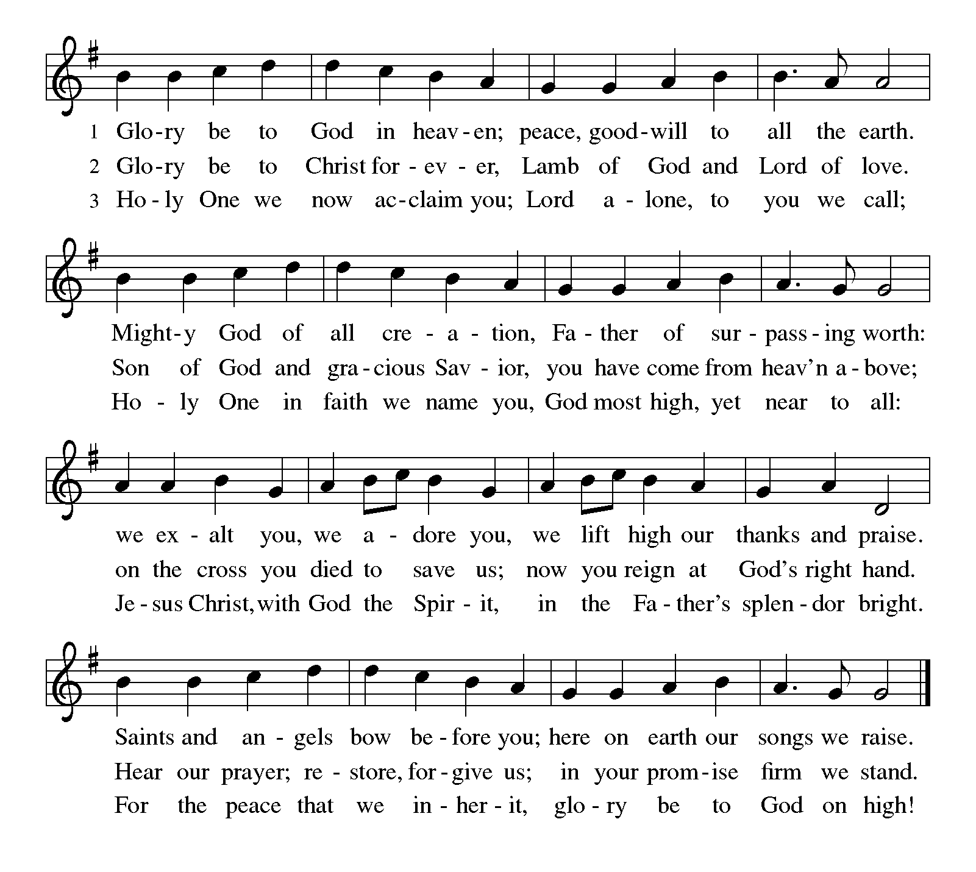CANTICLE OF PRAISE Glory Be to God ELW p. 204

PRAYER OF THE DAY

P: Direct us, O Lord God, in all our doings with your continual help, that in all our works, begun, continued, and ended in you, we may glorify your holy name; and finally, by your mercy, bring us to everlasting life, through Jesus Christ, our Savior and Lord.

C: Amen.

Word

God speaks to us in scripture reading, preaching, and song.

FIRST READING Deuteronomy 30:15-20

Moses speaks to the Israelites, who are about to enter the land promised to their ancestors. In this passage, he lays out the stark choice before them: choose life by loving and obeying the Lord; or choose death by following other gods.

¹⁵See, I have set before you today life and prosperity, death and adversity. ¹⁶If you obey the commandments of the Lord your God that I am commanding you today, by loving the Lord your God, walking in his ways, and observing his commandments, decrees, and ordinances, then you shall live and become numerous, and the Lord your God will bless you in the land that you are entering to possess. ¹⁷But if your heart turns away and you do not hear, but are led astray to bow down to other gods and serve them, ¹⁸I declare to you today that you shall perish; you shall not live long in the land that you are crossing the Jordan to enter and possess. ¹⁹I call heaven and earth to witness against you today that I have set before you life and death, blessings and curses. Choose life so that you and your descendants may live, ²⁰loving the Lord your God, obeying him, and holding fast to him; for that means life to you and length of days, so that you may live in the land that the Lord swore to give to your ancestors, to Abraham, to Isaac, and to Jacob.

A: The word of the Lord.

C: Thanks be to God.

SECOND READING Philemon 1-21

While Paul was in prison, he was aided by Onesimus, a man who had run away from Philemon, a slaveowner and a Christian friend of Paul. Paul told Onesimus to return to Philemon and encouraged Philemon to receive Onesimus back as a Christian brother.

¹Paul, a prisoner of Christ Jesus, and Timothy our brother,
To Philemon our dear friend and co-worker, ²to Apphia our sister, to Archippus our fellow soldier, and to the church in your house:
³Grace to you and peace from God our Father and the Lord Jesus Christ.
⁴When I remember you in my prayers, I always thank my God ⁵because I hear of your love for all the saints and your faith toward the Lord Jesus. ⁶I pray that the sharing of your faith may become effective when you perceive all the good that we may do for Christ. ⁷I have indeed received much joy and

Continued on the next page.
encouragement from your love, because the hearts of the saints have been refreshed through you, my brother.
⁸For this reason, though I am bold enough in Christ to command you to do your duty, ⁹yet I would rather appeal to you on the basis of love—and I, Paul, do this as an old man, and now also as a prisoner of Christ Jesus. ¹⁰I am appealing to you for my child, Onesimus, whose father I have become during my imprisonment. ¹¹Formerly he was useless to you, but now he is indeed useful both to you and to me. ¹²I am sending him, that is, my own heart, back to you. ¹³I wanted to keep him with me, so that he might be of service to me in your place during my imprisonment for the gospel; ¹⁴but I preferred to do nothing without your consent, in order that your good deed might be voluntary and not something forced. ¹⁵Perhaps this is the reason he was separated from you for a while, so that you might have him back forever, ¹⁶no longer as a slave but more than a slave, a beloved brother—especially to me but how much more to you, both in the flesh and in the Lord.
¹⁷So if you consider me your partner, welcome him as you would welcome me. ¹⁸If he has wronged you in any way, or owes you anything, charge that to my account. ¹⁹I, Paul, am writing this with my own hand: I will repay it. I say nothing about your owing me even your own self. ²⁰Yes, brother, let me have this benefit from you in the Lord! Refresh my heart in Christ. ²¹Confident of your obedience, I am writing to you, knowing that you will do even more than I say.

A: The word of the word.

C: Thanks be to God.

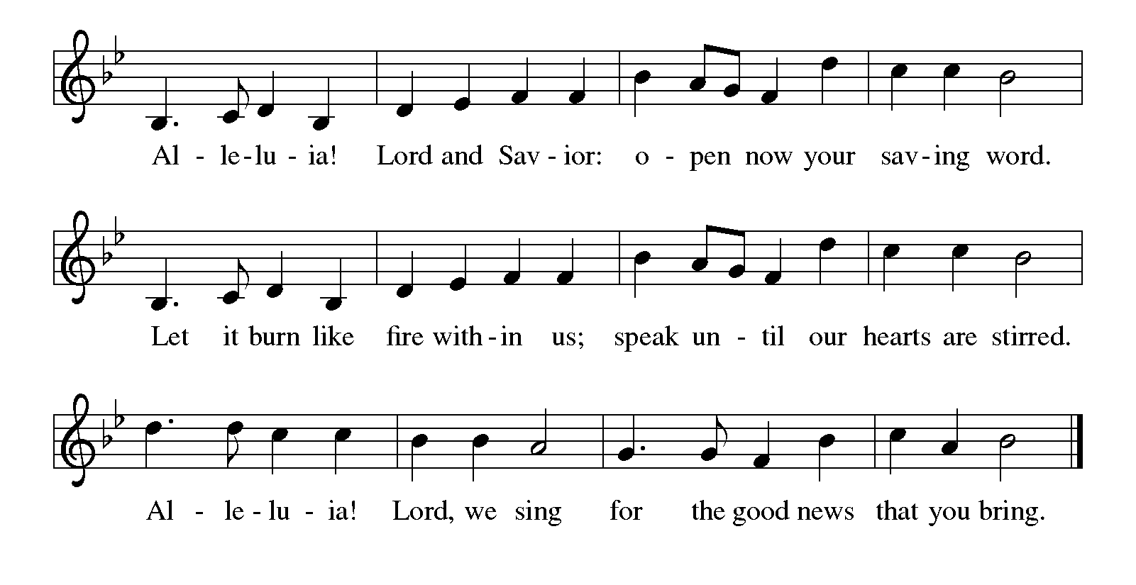GOSPEL ACCLAMATION Alleluia ELW p. 205

Continued on the next page.

GOSPEL Luke 14:25-33

P: Announcement of the Gospel.

C: Glory to you, O Lord.

Jesus speaks frankly about the costs of discipleship. Those who follow him should know from the outset that completing the course of discipleship will finally mean renouncing all other allegiances.

²⁵Now large crowds were traveling with [Jesus;] and he turned and said to them, ²⁶“Whoever comes to me and does not hate father and mother, wife and children, brothers and sisters, yes, and even life itself, cannot be my disciple. ²⁷Whoever does not carry the cross and follow me cannot be my disciple. ²⁸For which of you, intending to build a tower, does not first sit down and estimate the cost, to see whether he has enough to complete it? ²⁹Otherwise, when he has laid a foundation and is not able to finish, all who see it will begin to ridicule him, ³⁰saying, ‘This fellow began to build and was not able to finish. ³¹Or what king, going out to wage war against another king, will not sit down first and consider whether he is able with ten thousand to oppose the one who comes against him with twenty thousand? ³²If he cannot, then, while the other is still far away, he sends a delegation and asks for the terms of peace. ³³So therefore, none of you can become my disciple if you do not give up all your possessions.”

P: Affirmation of the Gospel.

C: Praise to you, O Christ.

SERMON

HYMN OF THE DAY Take Up Your Cross, the Savior Said ELW # 667

Sung to Christ Is Alive! Let Christians Sing ELW # 389

PRAYERS OF INTERCESSION

Each petition ends with these words and response:

A: God of grace,

C: hear our prayer.

Concluding petition and response:

A: Gathered together in the sweet communion of the Holy Spirit, gracious God, we offer these and all our prayers to you; through Jesus Christ, our Savior.

C: Amen.

THE PEACE

P: The peace of the Lord be with you always.

C: And also with you.

We invite you to share the peace with one another. The peace isn’t an informal “Good morning!” Rather, it’s a sign that we open ourselves to the healing and reconciling power of God’s love and then offer ourselves to be agents of that love in the world. In view of the ongoing COVID-19 pandemic, no physical contact is required (fist pumping, shaking hands, holding hands, embracing). We invite you to simply place your hand over your heart and, while making eye contact, say, “Peace be with you”.

Meal

God feeds us with the presence of Jesus Christ.

OFFERING AND MUSIC

At this time we are going to worship God with our money. The ushers will pass plates down the pews to receive your gifts of cash, checks made out to Bethlehem Lutheran Church, and online giving at secure.myvanco.com/L-Z22R/. Your offering supports the worship, faith formation, administration, and other ministries of Bethlehem Lutheran Church, as well as the mission of the Southeastern Minnesota Synod, and the whole Evangelical Lutheran Church in America. God bless your giving and your generosity. And thank you!

ASSEMBLY SONG Take My Life, That I May Be ELW # 583

Stanzas 1, 2 and 4

OFFERING PRAYER

P: Gracious God, in your great love you richly provide for our needs. Make of these gifts a banquet of blessing, and make us ready to share with all in need; through Jesus Christ, who sets a table for all.

C: Amen.

THE GREAT THANKSGIVING

Dialogue ELW p. 206

P: The Lord be with you.

C: And also with you.

P: Lift up your hearts.

C: We lift them to the Lord.

P: Let us give thanks to the Lord our God.

C: It is right to give our thanks and praise.

PREFACE

P: It is indeed right, our duty and our joy, that we should at all times and in all places give thanks and praise to you, almighty and merciful God, through our Savior Jesus Christ; who on this day overcame death and the grave, and by his glorious resurrection opened to us the way of everlasting life. And so, with all the choirs of angels, with the church on earth and the hosts of heaven, we praise your name and join their unending hymn:

HOLY, HOLY, HOLY (the angels’ song) ELW p. 207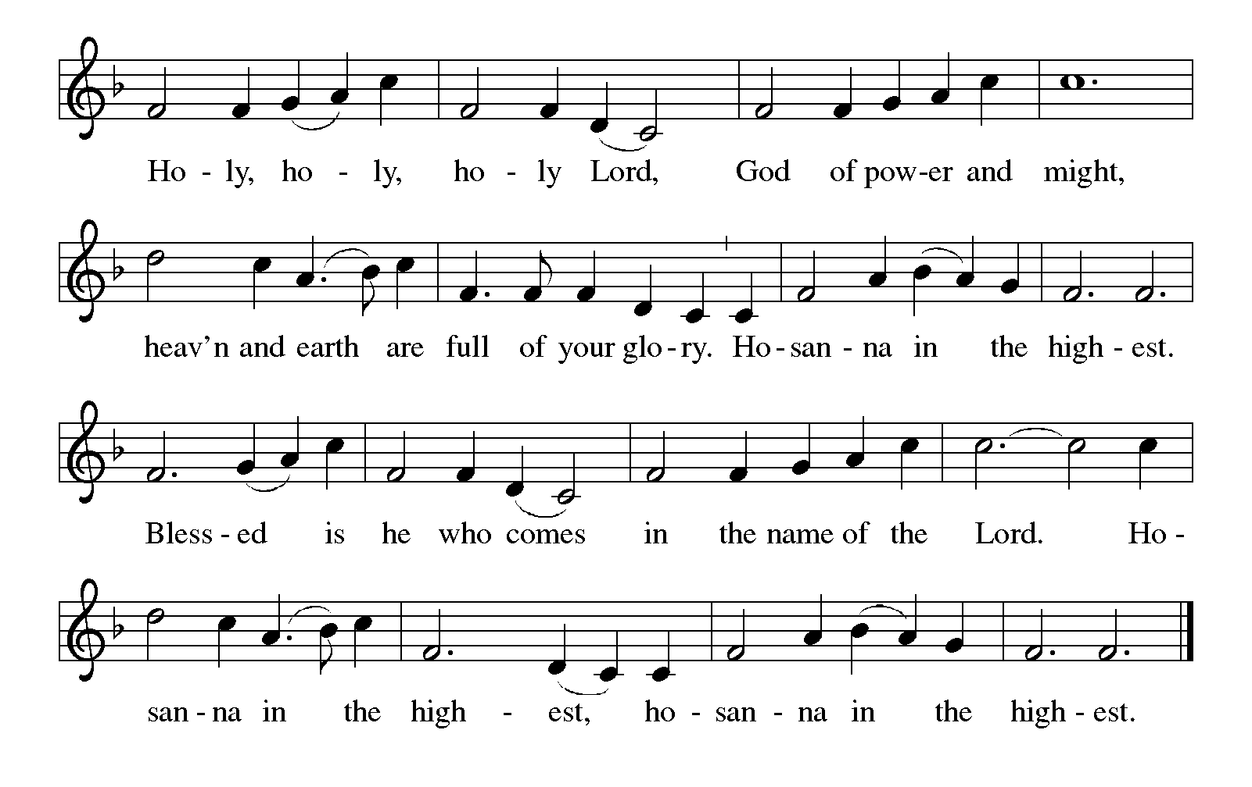

Continued on the next page.

THANKSGIVING AT THE TABLE

P: You are indeed holy, almighty and merciful God. You are most holy, and great is the majesty of your glory.

You so loved the world that you gave your only Son, so that everyone who believes in him may not perish but have eternal life.

We give you thanks for his coming into the world to fulfill for us your holy will and to accomplish all things for our salvation.

In the night in which he was betrayed, our Lord Jesus took bread, and gave thanks; broke it, and gave it to his disciples, saying: Take and eat; this is my body, given for you. Do this for the remembrance of me.

Again, after supper, he took the cup, gave thanks, and gave it for all to drink, saying: This cup is the new covenant in my blood, shed for you and for all people for the forgiveness of sin. Do this for the remembrance of me.

For as often as we eat of this bread and drink from this cup,
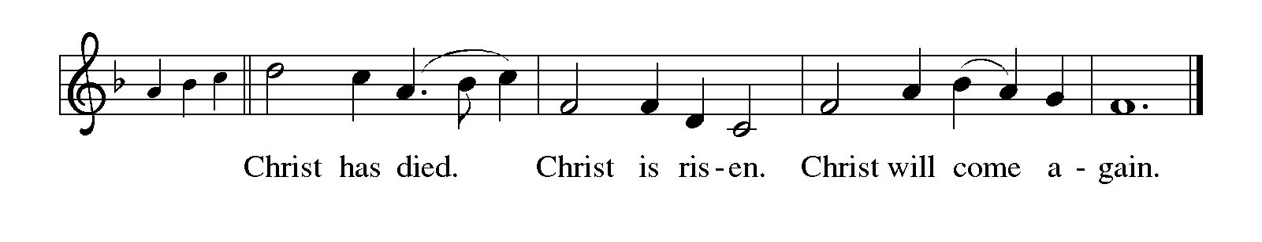we proclaim the Lord's death until he comes.

Continued on the next page.

THANKSGIVING AT THE TABLE continued

P: Remembering, therefore, his salutary command, his life-giving passion and death, his glorious resurrection and ascension, and the promise of his coming again, we give thanks to you, O Lord God Almighty, not as we ought but as we are able; we ask you mercifully to accept our praise and thanksgiving and with your Word and Holy Spirit to bless us, your servants, and these your own gifts of bread and wine, so that we and all who share in the body and blood of Christ may be filled with heavenly blessing and grace, and, receiving the forgiveness of sin, may be formed to live as your holy people and be given our inheritance with all your saints.

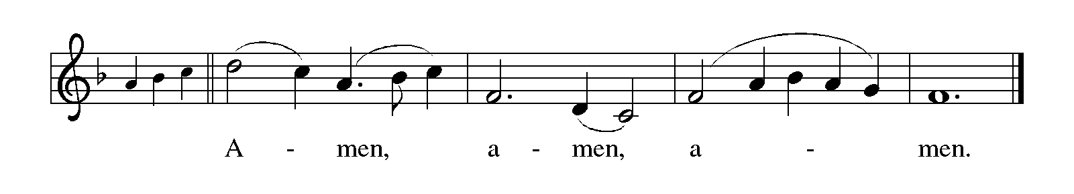To you, O God, Father, Son, and Holy Spirit, be all honor and glory in your holy church, now and forever.

LORD'S PRAYER Traditional Wording ELW p. 208

P: Gathered into one by the Holy Spirit, let us pray as Jesus taught us.

All: Our Father, who art in heaven, hallowed be thy name, thy kingdom come, thy will be done, on earth as it is in heaven. Give us this day our daily bread; and forgive us our trespasses, as we forgive those who trespass against us; and lead us not into temptation, but deliver us from evil. For thine is the kingdom, and the power, and the glory, forever and ever. Amen.

INVITATION TO COMMUNION

P: Christ invites you to this table. Come, taste and see.

COMMUNION

What We Believe

Who May Receive. We welcome all baptized Christians to the Lord's Table. In our parish baptized children who have entered the 5th grade are instructed in this sacrament and receive their First Communion; younger children come to the altar and receive a blessing. If your baptized child has received such instruction, or if you want your baptized child to receive Communion, then he or she is welcome to partake.

Proper Preparation. In his Small Catechism, Martin Luther asks, "When is a person rightly prepared to receive this sacrament?" He answers, "Fasting and other outward preparations serve a good purpose. However, that person is well prepared and worthy who believes these words, given and shed for you for the remission of sins. But anyone who does not believe these words, or doubts them, is neither prepared nor worthy, for the words for you require simply a believing heart.”

Real Presence. We believe that the bread and wine truly are the body and blood of Christ given and shed for the forgiveness of sins.

Distribution

Holy Communion will be served in procession, one side of the sanctuary at a time; please keep some distance from the person in front of you. The ushers will direct you when to make your way to the front of the church using the center aisle. You will receive the elements near the chancel. Please extend your hands, palms up, if you will be receiving the bread. Gluten-free wafers are also available; please ask for one. Proceed to your right or to your left depending on which side of the sanctuary you are seated on to receive the wine. White grape juice is also available in the center ring of each tray for those who prefer an alcohol-free element. You may say “Amen” after receiving each element. If you will not be receiving Communion, keep your hands folded for a blessing. Place your empty cup in the basket and then return to your seat by the side aisle.

Congregational Songs During Distribution

All Who Hunger, Gather Gladly ELW # 461 Sts. 1 & 3

Oh, That the Lord Would Guide My Ways ELW # 772 Sts. 1, 2 & 3

Will You Come and Follow Me ELW # 798 Sts. 1, 4 & 5

Change My Heart, O God ELW # 801

I Want to Walk as a Child of the Light ELW # 815 Sts. 1, 2 & 3

PRAYER AFTER COMMUNION

P: God of the abundant table, you have refreshed our hearts in this meal with bread for the journey. Give us your grace on the road that we might serve our neighbors with joy; for the sake of Jesus Christ, our Lord.

C: Amen.

Sending

God blesses us and sends us in mission to the world.

ANNOUNCEMENTS

BENEDICTION

P: God, who gives life to all things and frees us from despair,
bless you with truth and peace.
And may the holy Trinity, ☩ one God,
guide you always in faith, hope, and love.

C: Amen.

DEPARTING HYMN Let Us Ever Walk with Jesus ELW # 802

DISMISSAL

A: Go in peace, with Christ beside you.

C: Thanks be to God.

RINGING OF THE BELL

POSTLUDE


Today’s Assistants and Ministers

Greeters & Ushers …..........................................…...… Elva Albrecht, Harriet Lawston, and
Bob & Phyllis Penheiter
Organist/Pianist ………………………………………………………..………………. Sue Holst
Presiding Minister and Preacher ……………..……………. Deacon Cindy Cordes-Eversole
Reader ……………………………………….…….…....…….…….…………. Phyllis Penheiter
Altar Care & Communion Preparation ……..…………… Elva Albrecht and Harriet Lawston
Refreshments ………….............................…..….……… Elva Albrecht and Harriet Lawston
Custodian ……………………….………………..……………………………. Wayne Lukkason

Presence Last Week and August Presents

Attendance Last Sunday, August 28 = 37
Average Sunday Worship Attendance for July = 45

August Contributions: General Fund = $ Designated Giving = $
Jan-Aug Income = $ Jan-Aug Expenses = $ Deficit = $

This Week in Our Congregation

Today, September 4 — Thirteenth Sunday after Pentecost

Refreshments in the Fellowship Hall for everyone following worship

Tuesday, September 6

Men’s breakfast at Home Sweet Home in Lanesboro 7:00 AM

Wednesday, September 7

WELCA Business Meeting, Brunch and Sew Day beginning at 8:30 AM
10th-graders get ready to affirm their baptism 7:00 PM at Fountain Lutheran
Please note the time and meeting place

Next Sunday, September 11 — Fourteenth Sunday after Pentecost

Pre-recorded worship service online 9:00 AM
Church in the Country / Faith on the Farm 10:30 AM
Tom & Sue Holst Farm, 27842 Everyday Rd

News and Notes

10-Grade Confirmands meet for the first time on Wednesday, September 7 to begin getting ready to affirm their baptism later this fall. The meeting time is 7 pm. The meeting place is Fountain Lutheran Church. The meeting location will alternate each week.

WELCA Doings on Wednesday, September 7. Business Meeting at 8:30 am followed by brunch served by the WELCA officers in honor of our quilters and knitters. Sew Day after the brunch.

Church in the Country / Faith on the Farm, next Sunday, September 11, 10:30 a.m. The service will take place on the dairy farm of Tom & Sue Holst, 27842 Everyday Rd. Directions: Take MN Hwy 250 east out of Lanesboro to Everyday Road. Reminders: Be sure to bring a lawn chair for the service. A potluck dinner will follow the service. Bring some food to share if you plan on staying for the meal.

Confirmation Family Event, next Sunday, September 11, 6:00 p.m., at Bethlehem Lutheran Church. Calling all confirmation students, their parents, sisters and brothers, along with their godparents, mentors, and grandparents. Kathy Chatelaine, assistant to Bishop Hassanally for Global Ministry in our Southeastern Minnesota Synod, will be leading a special presentation: a Migrant Journey Interactive Experience. If others are interested, you are more than welcome to attend.

Community Activities

Join our team for the National Alliance of Mental Illness (NAMI) Lanesboro: Trail of Hope Walk, September 17 at 1:00 pm, Gateway Park (near the Coffee St. Walking Bridge). Support the impactful NAMI programs to bring mental wellness for all! Trail walk, interactive games, yoga, music, and fun for all ages! Learn more at namiwalks.org/southeastminnesota. Contact Julie Kiehne at julie.kiehne@gmail.com.

Prayer Requests

In Our Community. For our church members and friends living with chronic illness and other diseases, who are homebound, residing in care facilities, and hospitalized. See the newsletter for our members living in area nursing homes. And let us not forget those sick and dying of COVID-19, those entrusted with the authority of government, justice, and law enforcement, as well as our fallen and wounded soldiers and those still serving.

In Our Synod. Bishop Regina Hassanally invites the people and congregations of our synod to commit to praying this week for the following faith communities: Red Oak Grove Lutheran Church, Austin; Whalan Lutheran Church, Lanesboro; Epiphany Lutheran Church, Eagle Lake; Nuru Itaja Lutheran Church, Tanzania; Iambi Lutheran Church, Tanzania.Banytic Lutheran Parish, South Sudan; and Mission of San Juan, Bucaramanga, Colombia.

Acknowledgments

Graphics, worship texts, service music, and readings are from sundaysandseasons.com, © 2022 Augsburg Fortress. Used by permission under Augsburg Fortress Liturgies Annual License SAS103296.

Permission to project, live stream, or podcast liturgy and music content under copyright to or administered by Augsburg Fortress provided under Augsburg Fortress Liturgies Annual License SAS103296.

Permission to Podcast / Stream provided by Christian Copyright Licensing International, Inc., under License # 11459672. Additional fee paid. www.ccli.com.

Permission to Podcast / Stream provided by One License, Inc., under License # A-735588. Additional fee paid. www.onelicense.net.

