Bethlehem Lutheran Church
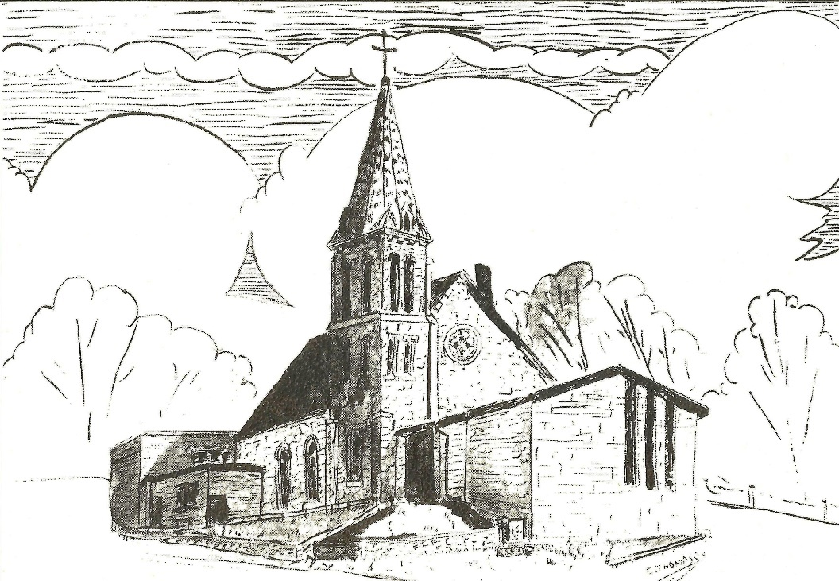
Established 1874

Rev. Kerry B. Eversole, Pastor
Deacon Cindy Cordes-Eversole, Associate in Ministry

Mailing Address: P.O. Box 314, Lanesboro, MN 55949-0314
Physical Address: 200 Kenilworth Ave S, Lanesboro, Minn.

Telephone: 507.467.3344
E-mail Address: bethlehem@acegroup.cc
Website: www.staronthehill.com
Facebook Page: www.facebook.com/BethlehemLutheranLanesboro/

Office Hours: Tuesday, Wednesday, Thursday 10 a.m. to 3 p.m.
Parsonage Phone: 507.467.3017

Pastor Kerry’s Cell Phone: 507.951.3954
Bethlehem Lutheran Church
Lanesboro, Minnesota

Twelfth Sunday after Pentecost

August 28, 2022

Jesus said, “When you give a luncheon or a dinner, do not invite your friends or your brothers or your relatives or rich neighbors, in case they may invite you in return, and you would be repaid. But when you give a banquet, invite the poor, the crippled, the lame, and the blind. And you will be blessed, because they cannot repay you, for you will be repaid at the resurrection of the righteous.” Luke 14 12-14
Welcome to worship at Bethlehem Lutheran Church

We are “The star on the hill” — You are the light of the world … let your light shine before others, so that they may see your good works and give glory to your Father in heaven. Matthew 5:14-16

COVID-19 Practices — Out of love for God and Neighbor

1) Use hand sanitizer upon entry. Wash your hands and use hand sanitizer often while in the facility.
2) Members and visitors who are vaccinated and boosted are not required to wear a mask.
3) Members and visitors are free to wear a mask if they wish to do so.
4) Unvaccinated and not boosted members and visitors must wear a mask.
5) There are no physical distancing requirements, but you are welcome to keep a distance from others in the sanctuary as you are able.
6) All are welcome to enjoy coffee fellowship in the dining room following worship.

Worship Book and Hymns. This morning’s service is printed in the bulletin. All the hymns can be found in Evangelical Lutheran Worship (ELW), “the red book”, or With One Voice (WOV), which are in the hymnal racks in each pew. Hymns in ELW are indicated by a large bold number in each page’s left or right margin.

Abbreviations. Throughout this worship folder hymns are signified by the pound symbol (#), P: refers to the presiding minister or preacher, A: denotes an assisting minister, and C: and/or bold text indicates the congregation.

Offering. Later in our service, we will be receiving an offering. The offering is an opportunity to worship God with our money. We know that the money you give to Bethlehem Lutheran represents your lives—your time, talents, and hard work. We recognize that and we appreciate your generosity. Your support not only helps all of us to fulfill God’s call on our lives, but it also makes an impact, and we thank you! Lastly, our visitors are not expected to give. After all, you are our guests! We’re glad you’re here and we want you to feel welcomed!

Mistakes do not happen in our worship service;
only unexpected events which are opportunities for joy!

An signifies that you may stand as you are comfortably able.
Gathering

The Holy Spirit calls us together as the people of God.

Introduction to the Day. Invited and inviting — that is the nature of the church. By God’s grace in holy baptism, we have a place at Christ’s banquet table. When, by the power of that same Spirit, humility and mutual love continue among us, the church can be even more inviting.

MUSIC AS WE COME TOGETHER Heidi Dybing

OPENING SONG All Are Welcome ELW # 641

Stanzas 1, 2, 3 and 4

GREETING

P: The grace of our Lord Jesus Christ, the love of God, and the communion of the Holy Spirit be with you all.

C: And also with you.

PRAYER OF THE DAY

P: Let us pray together. O God,

All: you resist those who are proud and give grace to those who are humble. Give us the humility of your Son, that we may embody the generosity of Jesus Christ, our Savior and Lord. Amen.

Word

God speaks to us in scripture reading, preaching, and song.

OLD TESTAMENT READING Psalm 112

¹Hallelujah! Happy are they who fear the Lord and have great delight in God’s commandments!

²Their descendants will be mighty in the land; the generation of the upright will be blessed.

³Wealth and riches will be in their house, and their righteousness will last forever.

⁴Light shines in the darkness for the upright; the righteous are merciful and full of compassion.

Continued on the next page.
⁵It is good for them to be generous in lending and to manage their affairs with justice.

⁶For they will never be shaken; the righteous will be kept in everlasting remembrance.

⁷They will not be afraid of any evil rumors; their heart is steadfast, trusting in the Lord.

⁸Their heart is established and will not shrink, until they see their desire upon their enemies.

⁹They have given freely to the poor, and their righteousness stands fast forever; they will hold up their head with honor.

¹⁰The wicked will see it and be angry; they will gnash their teeth and pine away; the desires of the wicked will perish.

NEW TESTAMENT READING Hebrews 13:1-8, 15-16

The conclusion of the letter to the Hebrews contains suggestions for the conduct of a holy life, all of which are shaped by God’s love toward us in Jesus Christ.

¹Let mutual love continue. ²Do not neglect to show hospitality to strangers, for by doing that some have entertained angels without knowing it. ³Remember those who are in prison, as though you were in prison with them; those who are being tortured, as though you yourselves were being tortured. ⁴Let marriage be held in honor by all, and let the marriage bed be kept undefiled; for God will judge fornicators and adulterers. ⁵Keep your lives free from the love of money, and be content with what you have; for he has said, “I will never leave you or forsake you.” ⁶So we can say with confidence,
“The Lord is my helper;
I will not be afraid.
What can anyone do to me?”
⁷Remember your leaders, those who spoke the word of God to you; consider the outcome of their way of life, and imitate their faith. ⁸Jesus Christ is the same yesterday and today and forever. ¹⁵Through him, then, let us continually offer a sacrifice of praise to God, that is, the fruit of lips that confess his name. ¹⁶Do not neglect to do good and to share what you have, for such sacrifices are pleasing to God.

SONG OF PRAISE For the Beauty of the Earth ELW # 879

Stanzas 1, 3, 4 and 5

GOSPEL Luke 14:1, 7-14

Jesus observes guests jockeying for position at the table. He uses the opportunity to teach his hearers to choose humility rather than self-exaltation. Jesus also makes an appeal for hosts to imitate God’s gracious hospitality to those in need.

¹On one occasion when Jesus was going to the house of a leader of the Pharisees to eat a meal on the sabbath, they were watching him closely.
⁷When he noticed how the guests chose the places of honor, he told them a parable. ⁸“When you are invited by someone to a wedding banquet, do not sit down at the place of honor, in case someone more distinguished than you has been invited by your host; ⁹and the host who invited both of you may come and say to you, ‘Give this person your place,’ and then in disgrace you would start to take the lowest place. ¹⁰But when you are invited, go and sit down at the lowest place, so that when your host comes, he may say to you, ‘Friend, move up higher’; then you will be honored in the presence of all who sit at the table with you. ¹¹For all who exalt themselves will be humbled, and those who humble themselves will be exalted.”
¹²He said also to the one who had invited him, “When you give a luncheon or a dinner, do not invite your friends or your brothers or your relatives or rich neighbors, in case they may invite you in return, and you would be repaid. ¹³But when you give a banquet, invite the poor, the crippled, the lame, and the blind. ¹⁴And you will be blessed, because they cannot repay you, for you will be repaid at the resurrection of the righteous.”

MUSIC MESSAGE Heidi Dybing

SERMON

SONG OF THE DAY There’s a Wideness in God’s Mercy ELW # 588

Responding

We respond to God’s word concerning the world and true value.

OFFERING Music by Heidi Dybing

At this time we are going to worship God with our money. The ushers will pass plates down the pews to receive your offering. We welcome your gifts of cash, checks made out to Bethlehem Lutheran Church, and online giving at secure.myvanco.com/L-Z22R/. Your offering supports the worship, faith formation, administration, and other ministries of Bethlehem Lutheran Church, as well as the mission of the Southeastern Minnesota Synod, and the whole Evangelical Lutheran Church in America. God bless your giving and your generosity. And thank you!
ASSEMBLY SONG We Are an Offering ELW # 692

PRAYERS OF GOD’S PEOPLE

After the last petition, all sing ELW # 752

Lord, Listen to Your Children Praying

LORD'S PRAYER Sung version

P: Gathered into one by the Holy Spirit, let us sing the prayer that Jesus taught us.

Sending

God blesses us and sends us in mission to the world.

ANNOUNCEMENTS

BLESSING

P: The God of peace,
Father,☩ Son, and Holy Spirit,
bless you, comfort you,
and show you the path of life
this day and always.

C: Amen.

DEPARTING SONG Rise Up, O Saints of God ELW # 669

DISMISSAL

A: Go in peace. Love your neighbor.

C: Thanks be to God.

SENDING MUSIC Heidi Dybing

Today’s Assistants and Ministers

Greeters & Ushers …..............................................…...… Gwen, Blaine, and Bryn Harmon
Pianist …………… …………… Heidi Dybing
Presiding Minister ………………………………….….…...……………. Pastor Kerry Eversole
Preacher …………………………………….…...……………. Deacon Cindy Cordes-Eversole
Reader ……………………………………….…….….....……….…….…………. Roger Bothun
Altar Care ……..……………………….……………………… Pastor Kerry and Deacon Cindy
Refreshments …………................................…..….……… Julia Borgen and Gwen Harmon
Custodian ……………………….………………..……………………………. Wayne Lukkason

Presence Last Week and July Presents

Attendance Last Sunday, August 21 = 35
Average Sunday Worship Attendance for July = 44

July Contributions: General Fund = $12,542 Designated Giving = $355
Jan-Jul Income = $89,453 Jan-Jul Expenses = $100,065 Deficit = $10,612

This Week in Our Congregation

Today, August 28 — Twelfth Sunday after Pentecost

Refreshments in the Fellowship Hall for everyone following worship

Tuesday, August 30

Men’s breakfast at Home Sweet Home in Lanesboro 7:00 AM

Wednesday, August 31

WELCA Bible study begins meeting again 9:00 AM

Next Sunday, September 4 — Thirteenth Sunday after Pentecost

Worship w/ Holy Communion 9:00 AM

News and Notes

Our sister congregation, Fountain Lutheran Church, is hosting Church in the Park, today at 11 am, in the City of Fountain Park. The Arnold-Bradley Band will be providing music. A potluck picnic will follow. We are cordially invited to attend! Bring your own lawn chair for the service, and food to share if you will be staying for the picnic.

LYO End of Summer Cookout, today at Tim & Jody Ruen’s rural campsite. Meet at the church at 6 pm to carpool. LYO will provide meat, drinks, s’mores, and paper products. Bring chips or a salad or a dessert to share, and a lawn chair! In case of rain, we’ll meet at the church.

Church in the Country / Faith on the Farm, Sunday, September 11, 10:30 a.m. The service will take place on the dairy farm of Tom & Sue Holst, 27842 Everyday Rd. Take MN Hwy 250 east out of Lanesboro to Everyday Road. Be sure to bring a lawn chair for the service. A potluck dinner will follow the service. Bring some food to share if you plan on staying for the meal.
The WELCA is collecting items for Lutheran World Relief School kits! School supplies are already available in the stores. If you would like to provide supplies for one or more kits, here are the items needed:

4 70-80 sheet spiral notebooks either wide- or college-ruled (no loose-leaf paper)
1 30-centimeter ruler or ruler with centimeters on one side and inches on the other
1 pair of blunt-end scissors
5 unsharpened #2 pencils 1 pencil sharpener 1 2-1/2" eraser
5 black or blue ballpoint pens (no gel ink) 1 box of 16 or 24 crayons
Cloth bags are available in the church narthex. Thank you for your help with this project!

Community Activities

Join our team for the National Alliance of Mental Illness (NAMI) Lanesboro: Trail of Hope Walk, September 17 at 1:00 pm, Gateway Park (near the Coffee St. Walking Bridge). Support the impactful NAMI programs to bring mental wellness for all! Trail walk, interactive games, yoga, music, and fun for all ages! Learn more at namiwalks.org/southeastminnesota. Contact Julie Kiehne at julie.kiehne@gmail.com.

Prayer Requests

In Our Community. For our church members and friends living with chronic illness and other diseases, who are homebound, residing in care facilities, and hospitalized. See the newsletter for our members living in area nursing homes. And let us not forget those sick and dying of COVID-19, those entrusted with the authority of government, justice, and law enforcement, as well as our fallen and wounded soldiers and those still serving.

In Our Synod. Bishop Regina Hassanally invites the people and congregations of our synod to commit to praying this week for the following faith communities: United Lutheran Church, Walters; Vang Lutheran Church, Dennison; Cross of Christ Lutheran Church, Houston; Sayuni Mipilo Lutheran Church, Tanzania; Iguguno Lutheran Church, Tanzania; and Jikmir Lutheran Parish, South Sudan.

Acknowledgments

Graphics, worship texts, service music, and readings are from sundaysandseasons.com, © 2022 Augsburg Fortress. Used by permission under Augsburg Fortress Liturgies Annual License SAS103296.

Permission to project, live stream, or podcast liturgy and music content under copyright to or administered by Augsburg Fortress provided under Augsburg Fortress Liturgies Annual License SAS103296.

Permission to Podcast / Stream provided by Christian Copyright Licensing International, Inc., under License # 11459672. Additional fee paid. www.ccli.com.

Permission to Podcast / Stream provided by One License, Inc., under License # A-735588. Additional fee paid. www.onelicense.net.

