Bethlehem Lutheran Church
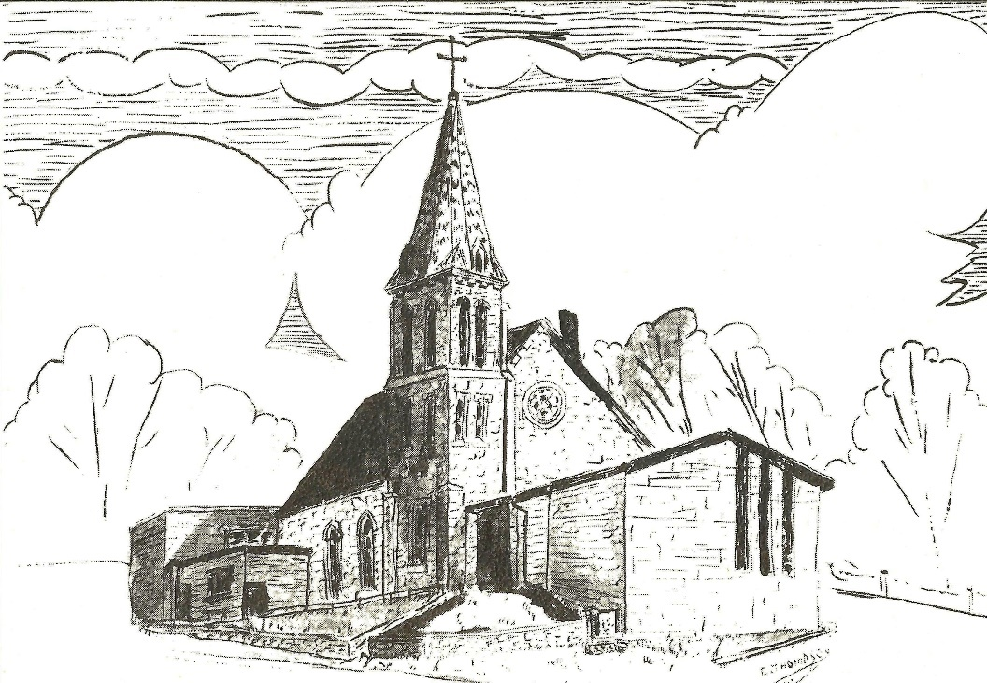
Established 1874

Rev. Kerry B. Eversole, Pastor
Deacon Cindy Cordes-Eversole, Associate in Ministry

Mailing Address: P.O. Box 314, Lanesboro, MN 55949-0314
Physical Address: 200 Kenilworth Ave S, Lanesboro, Minn.

Telephone: 507.467.3344
E-mail Address: bethlehem@acegroup.cc
Website: www.staronthehill.com
Facebook Page: www.facebook.com/BethlehemLutheranLanesboro/

Office Hours: Tuesday, Wednesday, Thursday 10 a.m. to 3 p.m.
Parsonage Phone: 507.467.3017

Pastor Kerry’s Cell Phone: 507.951.3954
Bethlehem Lutheran Church
Lanesboro, Minnesota

Eleventh Sunday after Pentecost

August 21, 2022

Jesus was teaching in one of the synagogues on the sabbath. A woman appeared who had a spirit that had crippled her for eighteen years. She was bent over and was quite unable to stand up straight. When Jesus saw her, he called her over and said, “Woman, you are set free from your ailment.” When he laid his hands on her, immediately she stood up straight and began praising God. Luke 13:10-13
Welcome to worship at Bethlehem Lutheran Church

We are “The star on the hill” — You are the light of the world … let your light shine before others, so that they may see your good works and give glory to your Father in heaven. Matthew 5:14-16

COVID-19 Practices — Out of love for God and Neighbor

1) Use hand sanitizer upon entry. Wash your hands and use hand sanitizer often while in the facility.
2) Members and visitors who are vaccinated and boosted are not required to wear a mask.
3) Members and visitors are free to wear a mask if they wish to do so.
4) Unvaccinated and not boosted members and visitors must wear a mask.
5) There are no physical distancing requirements, but you are welcome to keep a distance from others in the sanctuary as you are able.
6) All are welcome to enjoy coffee fellowship in the dining room following worship.

Worship Book and Hymns. This morning’s service is printed in the bulletin. All the hymns can be found in Evangelical Lutheran Worship (ELW), “the red book”, which are in the hymnal racks in each pew. Hymns in ELW are indicated by a large bold number in each page’s left or right margin.

Abbreviations. Throughout this worship folder hymns are signified by the pound symbol (#), P: refers to the presiding minister or preacher, A: denotes an assisting minister, and C: and/or bold text indicates the congregation.

Offering. Later in our service, we will be receiving an offering. The offering is an opportunity to worship God with our money. We know that the money you give to Bethlehem Lutheran represents your lives—your time, talents, and hard work. We recognize that and we appreciate your generosity. Your support not only helps all of us to fulfill God’s call on our lives, but it also makes an impact, and we thank you! Lastly, our visitors are not expected to give. After all, you are our guests! We’re glad you’re here and we want you to feel welcomed!

Mistakes do not happen in our worship service;
only unexpected events which are opportunities for joy!

An signifies that you may stand as you are comfortably able.
Gathering

The Holy Spirit calls us together as the people of God.

Introduction to the Day. Remember the sabbath day. Call the sabbath a delight. This is the Lord’s day, and the Lord will do for us what the Lord does: forgive us, feed us, help and heal us. Rejoice at all the wonderful things God is doing!

PRELUDE

OPENING HYMN O Day of Rest and Gladness ELW # 521

GREETING

P: The grace of our Lord Jesus Christ, the love of God, and the communion of the Holy Spirit be with you all.

C: And also with you.

PRAYER OF THE DAY

P: Let us pray together.

O God, mighty and immortal,

All: you know that as fragile creatures surrounded by great dangers, we cannot by ourselves stand upright. Give us strength of mind and body, so that even when we suffer because of human sin, we may rise victorious through your Son, Jesus Christ, our Savior and Lord. Amen.

Word

God speaks to us in scripture reading, preaching, and song.

FIRST READING Psalm 103:1-8, read responsively

¹Bless the Lord, O my soul, and all that is within me, bless God’s holy name.

²Bless the LORD, O my soul, and forget not all God’s benefits—

³who forgives all your sins and heals all your diseases.

⁴who redeems your life from the grave and crowns you with steadfast love and mercy;

Continued on the next page.

⁵who satisfies your desires with good things so that your youth is renewed like an eagle’s.

⁶O Lord, you provide vindication and justice for all who are oppressed.

⁷You made known your ways to Moses and your works to the children of Israel.

⁸Lord, you are full of compassion and mercy, slow to anger and abounding in steadfast love.

SECOND READING Hebrews 12:18-29

Using images of Moses, the writer presents a striking vision of the new covenant of God made possible in Christ. There is no longer fear; only awe in the new promise in Christ into which we are invited.

¹⁸You have not come to something that can be touched, a blazing fire, and darkness, and gloom, and a tempest, ¹⁹and the sound of a trumpet, and a voice whose words made the hearers beg that not another word be spoken to them. ²⁰(For they could not endure the order that was given, “If even an animal touches the mountain, it shall be stoned to death.” ²¹Indeed, so terrifying was the sight that Moses said, “I tremble with fear.”) ²²But you have come to Mount Zion and to the city of the living God, the heavenly Jerusalem, and to innumerable angels in festal gathering, ²³and to the assembly of the firstborn who are enrolled in heaven, and to God the judge of all, and to the spirits of the righteous made perfect, ²⁴and to Jesus, the mediator of a new covenant, and to the sprinkled blood that speaks a better word than the blood of Abel.
²⁵See that you do not refuse the one who is speaking; for if they did not escape when they refused the one who warned them on earth, how much less will we escape if we reject the one who warns from heaven! ²⁶At that time his voice shook the earth; but now he has promised, “Yet once more I will shake not only the earth but also the heaven.” ²⁷This phrase, “Yet once more,” indicates the removal of what is shaken—that is, created things—so that what cannot be shaken may remain. ²⁸Therefore, since we are receiving a kingdom that cannot be shaken, let us give thanks, by which we offer to God an acceptable worship with reverence and awe; ²⁹for indeed our God is a consuming fire.

A: The word of the Lord.

C: Thanks be to God.

GOSPEL Luke 13:10-17

P: Announcement of the Gospel.

C: Glory to you, O Lord.

Jesus heals a woman on the sabbath, offering her a new beginning for her life. When challenged by a narrow reading of the sabbath command, Jesus responds by expanding “sabbath work” to include setting people free from bondage.

¹⁰Now [Jesus] was teaching in one of the synagogues on the sabbath. ¹¹And just then there appeared a woman with a spirit that had crippled her for eighteen years. She was bent over and was quite unable to stand up straight. ¹²When Jesus saw her, he called her over and said, “Woman, you are set free from your ailment.” ¹³When he laid his hands on her, immediately she stood up straight and began praising God. ¹⁴But the leader of the synagogue, indignant because Jesus had cured on the sabbath, kept saying to the crowd, “There are six days on which work ought to be done; come on those days and be cured, and not on the sabbath day.” ¹⁵But the Lord answered him and said, “You hypocrites! Does not each of you on the sabbath untie his ox or his donkey from the manger, and lead it away to give it water? ¹⁶And ought not this woman, a daughter of Abraham whom Satan bound for eighteen long years, be set free from this bondage on the sabbath day?” ¹⁷When he said this, all his opponents were put to shame; and the entire crowd was rejoicing at all the wonderful things that he was doing.

P: Affirmation of the Gospel.

C: Praise to you, O Christ.

GOSPEL HYMN Praise to the Lord, the Almighty ELW # 858

Stanzas 1, 2 and 3

SERMON

HYMN OF THE DAY Love Divine, All Loves Excelling ELW # 631

PRAYERS OF INTERCESSION

Each petition ends with these words and response:

A: Merciful God,

C: receive our prayer.

Continued on the next page.
Concluding petition and response:

A: Receive the prayers of your children, merciful God, and hold us forever in your steadfast love; through Jesus Christ, our holy Wisdom.

C: Amen.

SHARING THE PEACE

P: The peace of the Lord be with you always.

C: And also with you.

We invite you to share the peace with one another. The peace isn’t a simple “Good morning!” Rather, it’s a sign that we open ourselves to the healing and reconciling power of God’s love and then offer ourselves to be agents of that love in the world. The words “Peace be with you” are appropriate and can be accompanied by a handshake, holding hands, an embrace, or even a kiss. Let each other know what “peace sign” you are comfortable exchanging.

Meal

God feeds us with the presence of Jesus Christ.

OFFERING

At this time we’re going to worship God with our money. The ushers will pass plates down the pews to receive your offering. We welcome your gifts of cash, checks made out to Bethlehem Lutheran Church, and online giving at secure.myvanco.com/L-Z22R/. Your offering supports the worship, faith formation, administration, and other ministries of Bethlehem Lutheran Church, as well as the mission of our Southeastern Minnesota Synod, and the whole Evangelical Lutheran Church in America. God bless your giving and generosity. And thank you!

ASSEMBLY SONG As the Grains of Wheat ELW # 465

OFFERING PRAYER

P: God of abundance: you have set before us a plentiful harvest. As we feast on your goodness, strengthen us to labor in your field, and equip us to bear fruit for the good of all, in the name of Jesus.

C: Amen.

Dialogue

P: The Lord be with you.

C: And also with you.

P: Lift up your hearts.

C: We lift them to the Lord.

P: Let us give thanks to the Lord our God.

C: It is right to give our thanks and praise.

PREFACE

P: It is indeed right, our duty and our joy, that we should at all times and in all places give thanks and praise to you, almighty and merciful God, through our Savior Jesus Christ; who on this day overcame death and the grave, and by his glorious resurrection opened to us the way of everlasting life. And so, with all the choirs of angels, with the church on earth and the hosts of heaven, we praise your name and join their unending hymn:

All: Holy, holy, holy Lord, God of power and might,
heav'n and earth are full of your glory.
Hosanna in the highest.
Blessed is he who comes in the name of the Lord.
Hosanna in the highest,
hosanna in the highest.

THANKSGIVING AT THE TABLE

P: Holy, mighty, and merciful Lord, heaven and earth are full of your glory. In great love you sent to us Jesus, your Son, who reached out to heal the sick and suffering, who preached good news to the poor, and who, on the cross, opened his arms to all.

In the night in which he was betrayed, our Lord Jesus took bread, and gave thanks; broke it, and gave it to his disciples, saying: Take and eat; this is my body, given for you. Do this for the remembrance of me.

Again, after supper, he took the cup, gave thanks, and gave it for all to drink, saying: This cup is the new covenant in my blood, shed for you and for all people for the forgiveness of sin. Do this for the remembrance of me.

Remembering, therefore, his death, resurrection, and ascension,
we await his coming in glory.

Continued on the next page.
Pour out upon us the Spirit of your love, O Lord, and unite the wills of all who share this heavenly food, the body and blood of Jesus Christ, our Lord; to whom, with you and the Holy Spirit, be all honor and glory, now and forever.

C: Amen.

LORD'S PRAYER Traditional Wording

P: Gathered into one by the Holy Spirit, let us pray as Jesus taught us.

All: Our Father, who art in heaven, hallowed be thy name, thy kingdom come, thy will be done, on earth as it is in heaven. Give us this day our daily bread; and forgive us our trespasses, as we forgive those who trespass against us; and lead us not into temptation, but deliver us from evil. For thine is the kingdom, and the power, and the glory, forever and ever. Amen.

INVITATION TO COMMUNION

P: In Christ’s presence there is fullness of joy. Come to the banquet.

COMMUNION

What We Believe

Who May Receive. We welcome all baptized Christians to the Lord's Table. In our parish baptized children who have entered the 5th grade are instructed in this sacrament and receive their First Communion; younger children come to the altar and receive a blessing. If your baptized child has received such instruction, or if you want your baptized child to receive Communion, then he or she is welcome to partake.

Proper Preparation. In his Small Catechism, Martin Luther asks, "When is a person rightly prepared to receive this sacrament?" He answers, "Fasting and other outward preparations serve a good purpose. However, that person is well prepared
and worthy who believes these words, given and shed for you for the remission of sins. But anyone who does not believe these words, or doubts them, is neither prepared nor worthy, for the words for you require simply a believing heart.”

Real Presence. We believe that the bread and wine truly are the body and blood of Christ given and shed for the forgiveness of sins.

Distribution

Holy Communion will be served in procession, one side of the sanctuary at a time; please keep some distance from the person in front of you. The ushers will direct you when to make your way to the front of the church using the center aisle. You will receive the elements near the chancel. Please extend your hands, palms up, if you will be receiving the bread. Gluten-free wafers are also available; please ask for one. Proceed to your right or to your left depending on which side of the sanctuary you are seated on to receive the wine. White grape juice is also available in the center ring of each tray for those who prefer an alcohol-free element. You may say “Amen” after receiving each element. If you will not be receiving Communion, keep your hands folded for a blessing. Place your empty cup in the basket and then return to your seat by the side aisle.

Congregational Songs During Distribution

Here Is Bread ELW # 483

There is a Balm in Gilead ELW # 614

God, Whose Almighty Word ELW # 673

Great Is Thy Faithfulness ELW # 733

PRAYER AFTER COMMUNION

P: Life-giving God, through this meal you have bandaged our wounds and fed us with your mercy. Now send us forth to live for others, both friend and stranger, that all may come to know your love. This we pray in the name of Jesus.

C: Amen.

Sending

God blesses us and sends us in mission to the world.

ANNOUNCEMENTS

BLESSING

P: The God of peace,
Father, ☩ Son, and Holy Spirit,
bless you, comfort you,
and show you the path of life
this day and always.

C: Amen.

DEPARTING HYMN To Be Your Presence ELW # 546

DISMISSAL

P: Go in peace. Love your neighbor.

C: Thanks be to God.

POSTLUDE

Good Earth Village is excited to announce that GoodStock is back!!

A weekend filled with music, faith, and fun has returned and all are welcome! The event begins Saturday, August 27th with the Second Annual GoodStock Color Trail Run. This year we will feature a Short (about 1 mile) and Long Trail (just under 3 miles). After this we begin an afternoon of live music featuring A Sign Ahead, Six Mile Grove, and our headliner Comptemorary Christrain music artist Jonny Diaz. We will also have food trucks, the Village Market, wagon rides, and Family Fun Zone. We will conclude the event on Sunday, August 28th with an outdoor worship that everyone is welcome to join!

Saturday, August 27th

1:30 PM - Grounds open and check in for Color Trail Run
2:00 PM - GoodStock Color Trail Run (Short and Log Trail)
- Market, Food, and Family Fun Zone open
3:00 PM - A Sign Ahead (on stage)
5:00 PM - Six Mile Grove (on stage)
7:00 PM - Jonny Diaz (on stage)

Sunday, August 28th

9:30 AM - Coffee and Rolls in Log Lodge
10:00 AM - Outdoor Worship Service

Today’s Assistants and Ministers

Greeters & Ushers …..........................................…...… Roger Bothun and Curt & Jean Hall
Presiding Minister ………………………….…...……………. Deacon Cindy Cordes-Eversole
Reader ……………………………………….…….….....……….…….…………. Roger Bothun
Altar Care & Communion Preparation ……..……………… Julia Borgen and Gwen Harmon
Refreshments …………..........................…..….……… Julie Norby and Ed & Cheryl Brekke
Custodian ……………………….………………..……………………………. Wayne Lukkason

Presence Last Week and July Presents

Attendance Last Sunday, August 14 = 60
Average Sunday Worship Attendance for July = 44

July Contributions: General Fund = $12,542 Designated Giving = $355
Jan-Jul Income = $89,453 Jan-Jul Expenses = $100,065 Deficit = $10,612

This Week in Our Congregation

Today, August 21 — Eleventh Sunday after Pentecost

Refreshments in the Fellowship Hall for everyone following worship

Tuesday, August 23

Men’s breakfast at Home Sweet Home in Lanesboro 7:00 AM

Wednesday, August 24

WELCA Outing to Cresco, Iowa 9:30 AM

Thursday, August 25

Pastor Kerry at Park Lane Estates, Preston, for Bible study/chapel 9:30 AM

Next Sunday, August 28 — Twelfth Sunday after Pentecost

Worship 9:00 AM

News and Notes

This year’s WELCA OUTING is set for Wednesday, August 24! We’ll leave the church at 9:30 a.m. for Cresco, Iowa, and a tour of Bethany Housewares, with lunch afterward. Afternoon options are still being explored. Sign up in Dining Room by August 21.

The WELCA is collecting items for Lutheran World Relief School kits! School supplies are already available in the stores. If you would like to provide supplies for one or more kits, here are the items needed:

4 70-80 sheet spiral notebooks either wide- or college-ruled (no loose-leaf paper)
1 30-centimeter ruler or ruler with centimeters on one side and inches on the other
1 pair of blunt-end scissors
5 unsharpened #2 pencils 1 pencil sharpener 1 2-1/2" eraser
5 black or blue ballpoint pens (no gel ink) 1 box of 16 or 24 crayons
Cloth bags are available in the church narthex. Thank you for your help with this project!
Community Activities

Our sister congregation, Fountain Lutheran Church, is hosting Church in the Park, next Sunday, August 28, 11 am, in the City of Fountain Park. The Arnold-Bradley Band will be providing music. A potluck picnic will follow. We are cordially invited to attend! Bring your own lawn chair, and food to share if you will be staying for the picnic.

Prayer Requests

In Our Community. For our church members and friends living with chronic illness and other diseases, who are homebound, residing in care facilities, and hospitalized. See the newsletter for our members living in area nursing homes. And let us not forget those sick and dying of COVID-19, those entrusted with the authority of government, justice, and law enforcement, as well as our fallen and wounded soldiers and those still serving.

In Our Synod. Bishop Regina Hassanally invites the people and congregations of our synod to commit to praying this week for the following faith communities: Dale Lutheran Church, Kenyon; Jackson Lake Lutheran Church, Amboy; Aurora Lutheran Church, Owatonna; Trondhjem Lutheran Church, Hayward; Mitume Ghata Lutheran Church, Tanzania; and Kinyangiri Lutheran Church, Tanzania.

Acknowledgments

Graphics, worship texts, service music, and readings are from sundaysandseasons.com, © 2022 Augsburg Fortress. Used by permission under Augsburg Fortress Liturgies Annual License SAS103296.

Permission to project, live stream, or podcast liturgy and music content under copyright to or administered by Augsburg Fortress provided under Augsburg Fortress Liturgies Annual License SAS103296.

Permission to Podcast / Stream provided by Christian Copyright Licensing International, Inc., under License # 11459672. Additional fee paid. www.ccli.com.

Permission to Podcast / Stream provided by One License, Inc., under License # A-735588. Additional fee paid. www.onelicense.net.

