Bethlehem Lutheran Church
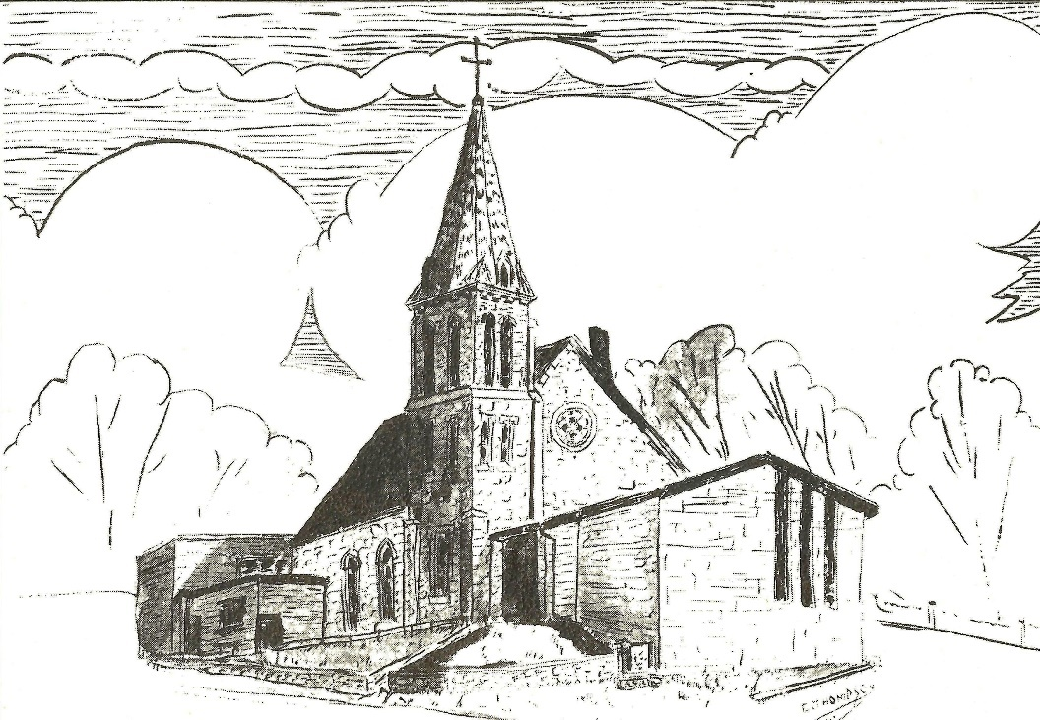
Established 1874

Rev. Kerry B. Eversole, Pastor
Deacon Cindy Cordes-Eversole, Associate in Ministry

Mailing Address: P.O. Box 314, Lanesboro, MN 55949-0314
Physical Address: 200 Kenilworth Ave S, Lanesboro, Minn.

Telephone: 507.467.3344
E-mail Address: bethlehem@acegroup.cc
Website: www.staronthehill.com
Facebook Page: www.facebook.com/BethlehemLutheranLanesboro/

Office Hours: Tuesday, Wednesday, Thursday 10 a.m. to 3 p.m.
Parsonage Phone: 507.467.3017

Pastor Kerry’s Cell Phone: 507.951.3954
Bethlehem Lutheran Church
Lanesboro, Minnesota

Tenth Sunday after Pentecost

August 14, 2022

Jesus said, “I came to bring fire to the earth, and how I wish it were already kindled! I have a baptism with which to be baptized, and what stress I am under until it is completed! Do you think that I have come to bring peace to the earth? No, I tell you, but rather division!” Luke 12:49-51
Welcome to worship at Bethlehem Lutheran Church

We are “The star on the hill” — You are the light of the world … let your light shine before others, so that they may see your good works and give glory to your Father in heaven. Matthew 5:14-16

COVID-19 Practices — Out of love for God and Neighbor

1) Use hand sanitizer upon entry. Wash your hands and use hand sanitizer often while in the facility.
2) Members and visitors who are vaccinated and boosted are not required to wear a mask.
3) Members and visitors are free to wear a mask if they wish to do so.
4) Unvaccinated and not boosted members and visitors must wear a mask.
5) There are no physical distancing requirements, but you are welcome to keep a distance from others in the sanctuary as you are able.
6) All are welcome to enjoy coffee fellowship in the dining room following worship.

Worship Book and Hymns. This morning’s service is printed in the bulletin. All the hymns can be found in Evangelical Lutheran Worship (ELW), “the red book”, which are in the hymnal racks in each pew. Hymns in ELW are indicated by a large bold number in each page’s left or right margin.

Abbreviations. Throughout this worship folder hymns are signified by the pound symbol (#), P: refers to the presiding minister or preacher, A: denotes an assisting minister, and C: and/or bold text indicates the congregation.

Offering. Later in our service, we will be receiving an offering. The offering is an opportunity to worship God with our money. We know that the money you give to Bethlehem Lutheran represents your lives—your time, talents, and hard work. We recognize that and we appreciate your generosity. Your support not only helps all of us to fulfill God’s call on our lives, it does makes an impact and we thank you! Lastly, our visitors are not expected to give. After all, you are our guests! We want you to feel welcomed!

Mistakes do not happen in our worship service;
only unexpected events which are opportunities for joy!

An signifies that you may stand as you are comfortably able.
Gathering

The Holy Spirit calls us together as the people of God.

Introduction to the Day. The word of God is a refining fire. Jesus is the great divide in human history. He invites our undivided attention and devotion. Today in worship we are surrounded by a great “cloud of witnesses”. In the word and the sacraments we are invited yet again to look to Jesus, “the pioneer and perfecter of our faith”.

PRELUDE

OPENING HYMN Praise, My Soul, the God of Heaven ELW # 864

GREETING

P: The grace of our Lord Jesus Christ, the love of God, and the communion of the Holy Spirit be with you all.

C: And also with you.

PRAYER OF THE DAY

P: O God, judge eternal, you love justice and hate oppression, and you call us to share your zeal for truth. Give us courage to take our stand with all victims of bloodshed and greed, and, following your servants and prophets, to look to the pioneer and perfecter of our faith, your Son, Jesus Christ, our Savior and Lord.

C: Amen.

Word

God speaks to us in scripture reading, preaching, and song.

FIRST READING Jeremiah 23:23-29

Because Jeremiah preaches the unpopular message of God’s judgment, he suffers rejection. Today’s reading distinguishes between the true prophet, like Jeremiah, who speaks God’s word, and the false prophet who misleads the people through dreams. One is like wheat; the other like worthless straw.

²³Am I a God near by, says the Lord, and not a God far off? ²⁴Who can hide in secret places so that I cannot see them? says the Lord. Do I not fill heaven and earth? says the Lord. ²⁵I have heard what the prophets have said who

Continued on the next page.
prophesy lies in my name, saying, “I have dreamed, I have dreamed!” ²⁶How long? Will the hearts of the prophets ever turn back—those who prophesy lies, and who prophesy the deceit of their own heart? ²⁷They plan to make my people forget my name by their dreams that they tell one another, just as their ancestors forgot my name for Baal. ²⁸Let the prophet who has a dream tell the dream, but let the one who has my word speak my word faithfully. What has straw in common with wheat? says the Lord. ²⁹Is not my word like fire, says the Lord, and like a hammer that breaks a rock in pieces?

SECOND READING Hebrews 11:29--12:2

The author of Hebrews presents us with rich stories of faith. In a long list of biblical heroes, we find examples of trust in God that enabled them to face the trials of life faithfully. In addition to this “cloud of witnesses,” we have Jesus, the perfect model of faithful endurance.

²⁹By faith the people passed through the Red Sea as if it were dry land, but when the Egyptians attempted to do so they were drowned. ³⁰By faith the walls of Jericho fell after they had been encircled for seven days. ³¹By faith Rahab the prostitute did not perish with those who were disobedient, because she had received the spies in peace.
³²And what more should I say? For time would fail me to tell of Gideon, Barak, Samson, Jephthah, of David and Samuel and the prophets—³³who through faith conquered kingdoms, administered justice, obtained promises, shut the mouths of lions, ³⁴quenched raging fire, escaped the edge of the sword, won strength out of weakness, became mighty in war, put foreign armies to flight. ³⁵Women received their dead by resurrection. Others were tortured, refusing to accept release, in order to obtain a better resurrection. ³⁶Others suffered mocking and flogging, and even chains and imprisonment. ³⁷They were stoned to death, they were sawn in two, they were killed by the sword; they went about in skins of sheep and goats, destitute, persecuted, tormented—³⁸of whom the world was not worthy. They wandered in deserts and mountains, and in caves and holes in the ground.
³⁹Yet all these, though they were commended for their faith, did not receive what was promised, ⁴⁰since God had provided something better so that they would not, apart from us, be made perfect.
^{12:1}Therefore, since we are surrounded by so great a cloud of witnesses, let us also lay aside every weight and the sin that clings so closely, and let us run with perseverance the race that is set before us, ²looking to Jesus the pioneer and perfecter of our faith, who for the sake of the joy that was set before him endured the cross, disregarding its shame, and has taken his seat at the right hand of the throne of God.
HYMN OF PRAISE Faith of Our Fathers ELW # 812

GOSPEL Luke 12:49-56

P: Announcement of the Gospel.

C: Glory to you, O Lord.

Jesus delivers harsh words about the purifying and potentially divisive effects of obedience to God’s call. The way of the cross often leads followers to encounter hostility and rejection, even from those they love.

[Jesus said:] ⁴⁹“I came to bring fire to the earth, and how I wish it were already kindled! ⁵⁰I have a baptism with which to be baptized, and what stress I am under until it is completed! ⁵¹Do you think that I have come to bring peace to the earth? No, I tell you, but rather division! ⁵²From now on five in one household will be divided, three against two and two against three; ⁵³they will be divided:
father against son
and son against father,
mother against daughter
and daughter against mother,
mother-in-law against her daughter-in-law
and daughter-in-law against mother-in-law.”
⁵⁴He also said to the crowds, “When you see a cloud rising in the west, you immediately say, ‘It is going to rain’; and so it happens. ⁵⁵And when you see the south wind blowing, you say, ‘There will be scorching heat’; and it happens. ⁵⁶You hypocrites! You know how to interpret the appearance of earth and sky, but why do you not know how to interpret the present time?”

P: Affirmation of the Gospel.

C: Praise to you, O Christ.

SERMON

HYMN OF THE DAY My Faith Looks Up to Thee ELW # 759

Responding

We respond to God’s word about faith.

SACRAMENT OF HOLY BAPTISM ELW p. 227

BAPTISM HYMN You Are Mine ELW # 581

SHARING THE PEACE

P: The peace of the Lord be with you always.

C: And also with you.

We invite you to share the peace with one another. The peace isn’t a simple “Good morning!” Rather, it’s a sign that we open ourselves to the healing and reconciling power of God’s love and then offer ourselves to be agents of that love in the world. The words “Peace be with you” are appropriate and can be accompanied by a handshake, holding hands, an embrace, or even a kiss. Let each other know what “peace sign” you are comfortable exchanging.

OFFERING

At this time we’re going to worship God with our money. The ushers will pass plates down the pews to receive your offering. We welcome your gifts of cash, checks made out to Bethlehem Lutheran Church, and online giving at secure.myvanco.com/L-Z22R/. Your offering supports the worship, faith formation, administration, and other ministries of Bethlehem Lutheran Church, as well as the mission of our Southeastern Minnesota Synod, and the whole Evangelical Lutheran Church in America. God bless your giving and generosity. And thank you!

ASSEMBLY SONG I Want to Walk as a Child of the Light ELW # 815

PRAYERS OF INTERCESSION

Each petition ends with these words and response:

A: Merciful God,

C: receive our prayer.

Concluding petition and response:

A: Receive the prayers of your children, merciful God, and hold us forever in your steadfast love; through Jesus Christ, our holy Wisdom.

C: Amen.

LORD'S PRAYER Traditional Wording

P: Gathered into one by the Holy Spirit, let us pray as Jesus taught us.

All: Our Father, who art in heaven, hallowed be thy name, thy kingdom come, thy will be done, on earth as it is in heaven. Give us this day our daily bread; and forgive us our trespasses, as we forgive those who trespass against us; and lead us not into temptation, but deliver us from evil. For thine is the kingdom, and the power, and the glory, forever and ever. Amen.

Sending

God blesses us and sends us in mission to the world.

ANNOUNCEMENTS

BLESSING

P: The God of peace,
Father,☩ Son, and Holy Spirit,
bless you, comfort you,
and show you the path of life
this day and always.

C: Amen.

DEPARTING HYMN Lead On, O King Eternal ELW # 805

DISMISSAL

P: Go in peace. Love your neighbor.

C: Thanks be to God.

POSTLUDE

Today’s Assistants and Ministers

Greeters & Ushers …...........................…...… Mark Hermanson and Lester & Dianne Dunn
Presiding Minister ………………………….……………………………. Pastor Kerry Eversole
Reader …………………………………………….….....……….…….…………. Kathryn Wade
Altar Care ……..……………………………………………… Pastor Kerry and Deacon Cindy
Refreshments ………….....…..….……… Lester & Dianne Dunn and Bill & Sherri Briggman
Custodian ……………………….………………..……………………………. Wayne Lukkason

Presence Last Week and July Presents

Attendance Last Sunday, August 7 = 49
Average Sunday Worship Attendance for July = 44

July Contributions: General Fund = $12,542 Designated Giving = $355
Jan-Jul Income = $89,453 Jan-Jul Expenses = $100,065 Deficit = $10,612

This Week in Our Congregation

Today, August 14 — Tenth Sunday after Pentecost

Refreshments in the Fellowship Hall for everyone following worship

Tuesday, August 16

Men’s breakfast at Home Sweet Home in Lanesboro 7:00 AM

Thursday, August 18

Pastor Kerry at Good Shepherd Lutheran Home, Rushford, for chapel 1:30 PM

Next Sunday, August 21 — Eleventh Sunday after Pentecost

Worship with Holy Communion 9:00 AM

Prayer Requests

In Our Community. For our church members and friends living with chronic illness and other diseases, who are homebound, residing in care facilities, and hospitalized. See the newsletter for our members living in area nursing homes. And let us not forget those sick and dying of COVID-19, those entrusted with the authority of government, justice, and law enforcement, as well as our fallen and wounded soldiers and those still serving.

In Our Synod. Bishop Regina Hassanally invites the people and congregations of our synod to commit to praying this week for the following faith communities: Fountain Lutheran Church, Fountain: Calvary Lutheran Church, Mankato: Trinity Lutheran Church, West Concord; Mruma Lutheran Church, Tanzania; Dominiki Lutheran Church, Tanzania; and Jokow Wareda Lutheran Parish, South Sudan.

News and Notes

Members of the Stringwood Summer Music Camp are playing in our worship this morning. Join these young artists at a free concert at Bethlehem this afternoon at 1 pm.
Baptized today is Thomas Sidney Fitzpatrick, son of Caitlin Fitzpatrick & Kevin Biehl. Thomas’s godparents are Natalie & David Vitone, and his grandparents are Jenny (née Johnson) & Tom Fitzpatrick.

Wedding next Saturday, August 20. Karlee Ruen, daughter of Mark & Pam Ruen, and Tyler Spande will be married at the Joy Ridge Event Center in Chatfield next Saturday, August 20. We invite your prayers as Karlee and Tyler anticipate their new life together.

A WELCA OUTING is scheduled for Wednesday, August 24! We’ll leave the church at 9:30 a.m. for Cresco, Iowa, and a tour of Bethany Housewares, with lunch afterward. Afternoon options are still being explored. Sign up in Dining Room by August 21.

The WELCA is collecting items for Lutheran World Relief School kits! School supplies are already available in the stores. If you would like to provide supplies for one or more kits, here are the items needed:

4 70-80 sheet spiral notebooks either wide- or college-ruled (no loose-leaf paper)
1 30-centimeter ruler or ruler with centimeters on one side and inches on the other
1 pair of blunt-end scissors
5 unsharpened #2 pencils 1 pencil sharpener 1 2-1/2" eraser
5 black or blue ballpoint pens (no gel ink) 1 box of 16 or 24 crayons
Cloth bags are available in the church narthex Thank you for your help with this project!

Community Activities

Grace Lutheran Church WELCA Supper & Song, today, at the church in Peterson. Supper is at 6:00 pm. Music begins at 7:00 pm. Please join us for food and fun!

Chamber Music at Bethlehem, Wednesday, August 17, 7:30 p.m. Artaria, Minnesota’s foremost teaching and performing string quartet, are presenting two concerts at Bethlehem as part of their Stringwood Chamber Music Festival. Enjoy Artaria and other guest performers this Wednesday, August 17, at 7:30 p.m. Pay at the door. $20 for adults; students are free.

Acknowledgments

Graphics, worship texts, service music, and readings are from sundaysandseasons.com, © 2022 Augsburg Fortress. Used by permission under Augsburg Fortress Liturgies Annual License SAS103296.

Permission to project, live stream, or podcast liturgy and music content under copyright to or administered by Augsburg Fortress provided under Augsburg Fortress Liturgies Annual License SAS103296.

Permission to Podcast / Stream provided by Christian Copyright Licensing International, Inc., under License # 11459672. Additional fee paid. www.ccli.com.

Permission to Podcast / Stream provided by One License, Inc., under License # A-735588. Additional fee paid. www.onelicense.net.

