Bethlehem Lutheran Church
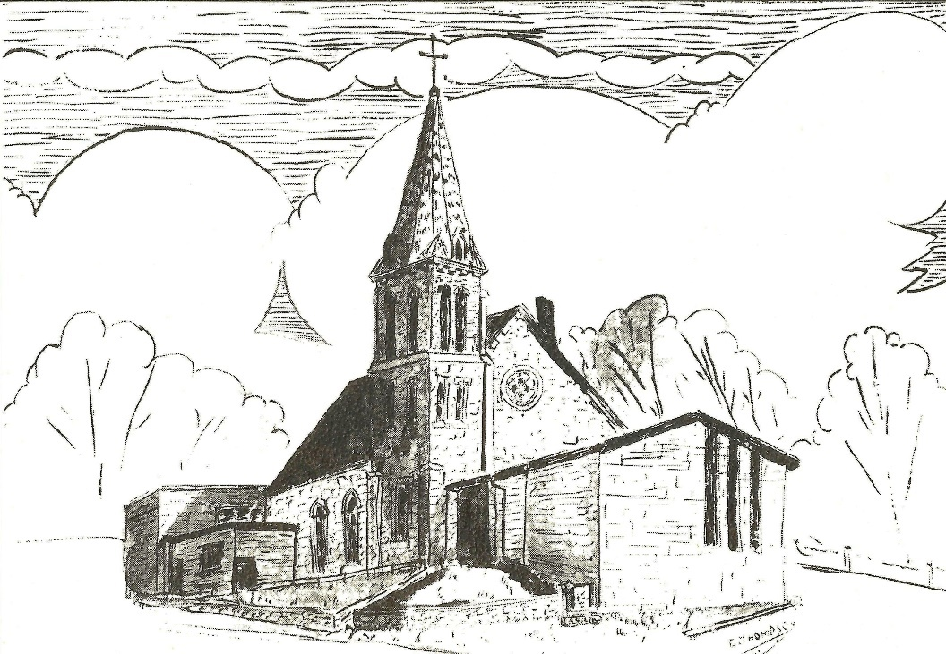
Established 1874

Rev. Kerry B. Eversole, Pastor
Deacon Cindy Cordes-Eversole, Associate in Ministry

Mailing Address: P.O. Box 314, Lanesboro, MN 55949-0314
Physical Address: 200 Kenilworth Ave S, Lanesboro, Minn.

Telephone: 507.467.3344
E-mail Address: bethlehem@acegroup.cc
Website: www.staronthehill.com
Facebook Page: www.facebook.com/BethlehemLutheranLanesboro/

Office Hours: Tuesday, Wednesday, Thursday 10 a.m. to 3 p.m.
Parsonage Phone: 507.467.3017

Pastor Kerry’s Cell Phone: 507.951.3954
Bethlehem Lutheran Church
Lanesboro, Minnesota

Ninth Sunday after Pentecost

August 7, 2022

Jesus said, “Do not be afraid, little flock, for it is your Father’s good pleasure to give you the kingdom. Sell your possessions, and give alms. Make purses for yourselves that do not wear out, an unfailing treasure in heaven, where no thief comes near and no moth destroys. ³⁴For where your treasure is, there your heart will be also.” Luke 12:32-34
Welcome to worship at Bethlehem Lutheran Church

We are “The star on the hill” — You are the light of the world … let your light shine before others, so that they may see your good works and give glory to your Father in heaven. Matthew 5:14-16

COVID-19 Practices — Out of love for God and Neighbor

1) Use hand sanitizer upon entry. Wash your hands and use hand sanitizer often while in the facility.
2) Members and visitors who are vaccinated and boosted are not required to wear a mask.
3) Members and visitors are free to wear a mask if they wish to do so.
4) Unvaccinated and not boosted members and visitors must wear a mask.
5) There are no physical distancing requirements, but you are welcome to keep a distance from others in the sanctuary as you are able.
6) All are welcome to enjoy coffee fellowship in the dining room following worship.

Worship Book and Hymns. This morning’s service is printed in the bulletin. All the hymns can be found in Evangelical Lutheran Worship (ELW), “the red book”, which are in the hymnal racks in each pew. Hymns in ELW are indicated by a large bold number in each page’s left or right margin.

Abbreviations. Throughout this worship folder hymns are signified by the pound symbol (#), P: refers to the presiding minister or preacher, A: denotes an assisting minister, and C: and/or bold text indicates the congregation.

Mistakes do not happen in our worship service;
only unexpected events which are opportunities for joy!

An signifies that you may stand as you are comfortably able.

Gathering

The Holy Spirit calls us together as the people of God.

Introduction to the Day. Jesus says, “It is your Father’s good pleasure to give you the kingdom.” It is God’s promise from the beginning—to Abraham, to the early church, and to the “little flock” of which we are a part in today’s assembly. Faith, God’s baptismal gift, trusts the promises of God. Have no fear.

PRELUDE

OPENING HYMN For the Beauty of the Earth ELW # 879

Stanzas 1, 2, 4 and 5

SACRAMENT OF HOLY BAPTISM ELW p. 227

BAPTISM HYMN Thy Holy Wings ELW # 613

GREETING

P: The grace of our Lord Jesus Christ, the love of God, and the communion of the Holy Spirit be with you all.

C: And also with you.

PRAYER OF THE DAY

P: Almighty God, you sent your Holy Spirit to be the life and light of your church. Open our hearts to the riches of your grace, that we may be ready to receive you wherever you appear, through Jesus Christ, our Savior and Lord. Amen.

Word

God speaks to us in scripture reading, preaching, and song.

FIRST READING Hebrews 11:1-3, 8-16

Abraham and Sarah exemplify the vision of faith that people of God enact in every age. Their hope and trust in God’s promise allowed them to face an unknown future and to receive the promise of God.

Continued on the next page.

¹Now faith is the assurance of things hoped for, the conviction of things not seen. ²Indeed, by faith our ancestors received approval. ³By faith we
understand that the worlds were prepared by the word of God, so that what is seen was made from things that are not visible.
⁸By faith Abraham obeyed when he was called to set out for a place that he was to receive as an inheritance; and he set out, not knowing where he was going. ⁹By faith he stayed for a time in the land he had been promised, as in a foreign land, living in tents, as did Isaac and Jacob, who were heirs with him of the same promise. ¹⁰For he looked forward to the city that has foundations, whose architect and builder is God. ¹¹By faith he received power of procreation, even though he was too old—and Sarah herself was barren—because he considered him faithful who had promised. ¹²Therefore from one person, and this one as good as dead, descendants were born, “as many as the stars of heaven and as the innumerable grains of sand by the seashore.”
¹³All of these died in faith without having received the promises, but from a distance they saw and greeted them. They confessed that they were strangers and foreigners on the earth, ¹⁴for people who speak in this way make it clear that they are seeking a homeland. ¹⁵If they had been thinking of the land that they had left behind, they would have had opportunity to return. ¹⁶But as it is, they desire a better country, that is, a heavenly one. Therefore God is not ashamed to be called their God; indeed, he has prepared a city for them.

A: The word of the Lord.

C: Thanks be to God.

GOSPEL ACCLAMATION Halle, Halle, Hallelujah ELW # 172

GOSPEL Luke 12:32-38, 40

P: Announcement of the Gospel.

C: Glory to you, O Lord.

Jesus encourages disciples to invest their hearts and live fully into God’s reign. Instead of facing life with fear, those who know God’s generosity are always ready to receive from God and to give to others.

[Jesus said:] ³²“Do not be afraid, little flock, for it is your Father’s good pleasure to give you the kingdom. ³³Sell your possessions, and give alms. Make purses for yourselves that do not wear out, an unfailing treasure in heaven, where no thief comes near and no moth destroys. ³⁴For where your treasure is, there your heart will be also.

Continued on the next page.
³⁵“Be dressed for action and have your lamps lit; ³⁶be like those who are waiting
for their master to return from the wedding banquet, so that they may open the door for him as soon as he comes and knocks. ³⁷Blessed are those slaves whom the master finds alert when he comes; truly I tell you, he will fasten his belt and have them sit down to eat, and he will come and serve them. ³⁸If he comes during the middle of the night, or near dawn, and finds them so, blessed are those slaves.
⁴⁰You also must be ready, for the Son of Man is coming at an unexpected hour.”

P: Affirmation of the Gospel.

C: Praise to you, O Christ.

SERMON

HYMN OF THE DAY Have No Fear, Little Flock ELW # 764

PRAYERS OF INTERCESSION

Each petition ends with these words and response:

A: Merciful God,

C: receive our prayer.

Concluding petition and response:

A: Receive the prayers of your children, merciful God, and hold us forever in your steadfast love; through Jesus Christ, our holy Wisdom.

C: Amen.

Meal

God feeds us with the presence of Jesus Christ.

OFFERING

ASSEMBLY SONG Children of the Heavenly Father ELW # 781

OFFERING PRAYER

P: God of abundance: you have set before us a plentiful harvest. As we feast on your goodness, strengthen us to labor in your field, and equip us to bear fruit for the good of all, in the name of Jesus.

C: Amen.

Dialogue

P: The Lord be with you.

C: And also with you.

P: Lift up your hearts.

C: We lift them to the Lord.

P: Let us give thanks to the Lord our God.

C: It is right to give our thanks and praise.

PREFACE

P: It is indeed right, our duty and our joy, that we should at all times and in all places give thanks and praise to you, almighty and merciful God, through our Savior Jesus Christ; who on this day overcame death and the grave, and by his glorious resurrection opened to us the way of everlasting life. And so, with all the choirs of angels, with the church on earth and the hosts of heaven, we praise your name and join their unending hymn:

All: Holy, holy, holy Lord, God of power and might,
heav'n and earth are full of your glory.
Hosanna in the highest.
Blessed is he who comes in the name of the Lord.
Hosanna in the highest,
hosanna in the highest.

THANKSGIVING AT THE TABLE

P: Holy, mighty, and merciful Lord, heaven and earth are full of your glory. In great love you sent to us Jesus, your Son, who reached out to heal the sick and suffering, who preached good news to the poor, and who, on the cross, opened his arms to all.
In the night in which he was betrayed, our Lord Jesus took bread, and gave thanks; broke it, and gave it to his disciples, saying: Take and eat; this is my body, given for you. Do this for the remembrance of me.

Again, after supper, he took the cup, gave thanks, and gave it for all to drink, saying: This cup is the new covenant in my blood, shed for you and for all people for the forgiveness of sin. Do this for the remembrance of me.

Remembering, therefore, his death, resurrection, and ascension,
we await his coming in glory.

Continued on the next page.
P: Pour out upon us the Spirit of your love, O Lord, and unite the wills of all who share this heavenly food, the body and blood of Jesus Christ, our Lord; to whom, with you and the Holy Spirit, be all honor and glory, now and forever.

C: Amen.

LORD'S PRAYER Traditional Wording

P: Gathered into one by the Holy Spirit, let us pray as Jesus taught us.

All: Our Father, who art in heaven, hallowed be thy name, thy kingdom come, thy will be done, on earth as it is in heaven. Give us this day our daily bread; and forgive us our trespasses, as we forgive those who trespass against us; and lead us not into temptation, but deliver us from evil. For thine is the kingdom, and the power, and the glory, forever and ever. Amen.

INVITATION TO COMMUNION

P: In Christ’s presence there is fullness of joy. Come to the banquet.

COMMUNION

What We Believe

Who May Receive. We welcome all baptized Christians to the Lord's Table. In our parish baptized children who have entered the 5th grade are instructed in this sacrament and receive their First Communion; younger children come to the altar and receive a blessing. If your baptized child has received such instruction, or if you want your baptized child to receive Communion, then he or she is welcome to partake.

Proper Preparation. In his Small Catechism, Martin Luther asks, "When is a person rightly prepared to receive this sacrament?" He answers, "Fasting and other outward preparations serve a good purpose. However, that person is well prepared
and worthy who believes these words, given and shed for you for the remission of sins. But anyone who does not believe these words, or doubts them, is neither prepared nor worthy, for the words for you require simply a believing heart.”

Real Presence. We believe that the bread and wine truly are the body and blood of Christ given and shed for the forgiveness of sins.

Continued on the next page.

Distribution

Holy Communion will be served in procession, one side of the sanctuary at a time; please keep some distance from the person in front of you. The ushers will direct you when to make your way to the front of the church using the center aisle. You will receive the elements near the chancel. Please extend your hands, palms up, if you will be receiving the bread. Gluten-free wafers are also available; please ask for one. Proceed to your right or to your left depending on which side of the sanctuary you are seated on to receive the wine. White grape juice is also available in the center ring of each tray for those who prefer an alcohol-free element. You may say “Amen” after receiving each element. If you will not be receiving Communion, keep your hands folded for a blessing. Place your empty cup in the basket and then return to your seat by the side aisle.

Congregational Songs During Distribution

One Bread, One Body ELW # 496 Sts. 1, 2 & 3

Jesus, Priceless Treasure ELW # 775 Sts. 1, 2 & 3

The God of Abraham Praise ELW # 831 Sts. 1, 3 & 4

PRAYER AFTER COMMUNION

P: Life-giving God, through this meal you have bandaged our wounds and fed us with your mercy. Now send us forth to live for others, both friend and stranger, that all may come to know your love. This we pray in the name of Jesus.

C: Amen.

Sending

God blesses us and sends us in mission to the world.

ANNOUNCEMENTS

BLESSING

P: The God of peace,
Father,☩ Son, and Holy Spirit,
bless you, comfort you,
and show you the path of life
this day and always.

C: Amen.

DEPARTING HYMN Blessed Assurance ELW # 638

DISMISSAL

P: Go in peace. Love your neighbor.

C: Thanks be to God.

POSTLUDE

Today’s Assistants and Ministers

Greeters & Ushers …...........................................…...… Kate Glor and Gary & Kathy Wade
Organist/Pianist ……..………………………….….….…..………..……...……..…… Sue Holst
Presiding Minister ………………………….……………………………. Pastor Kerry Eversole
Reader ………………………………………………..…….....……….…….…………. Kate Glor
Altar Care & Communion Preparation ……..……………… Gwen Harmon and Kathy Wade
Refreshments ……………………………..…...….……… Kate Glor and Gary & Kathy Wade
Custodian ……………………….………………..……………………………. Wayne Lukkason

Presence Last Week and July Presents

Attendance Last Sunday, July 31 = 40
Average Sunday Worship Attendance for July = 44

July Contributions: General Fund = N/A Designated Giving = N/A
Jan-Jul Income = N/A Jan-Jul Expenses = N/A Deficit = N/A

This Week in Our Congregation

Today, August 7 — Ninth Sunday after Pentecost

Refreshments in the Fellowship Hall for everyone following worship

Tuesday, August 9

Men’s breakfast at Home Sweet Home in Lanesboro 7:00 AM

Wednesday, August 10

Church Council 6:30 PM

Thursday, August 11

Deacon Cindy at Park Lane Estates, Preston, for Bible study/chapel 9:30 AM

Next Sunday, August 14 — Tenth Sunday after Pentecost

Worship with Holy Baptism 9:00 AM

Prayer Requests

In Our Community. For our church members and friends living with chronic illness and other diseases, who are homebound, residing in care facilities, and hospitalized. See the newsletter for our members living in area nursing homes. And let us not forget those sick and dying of COVID-19, those entrusted with the authority of government, justice, and law enforcement, as well as our fallen and wounded soldiers and those still serving.

In Our Synod. Bishop Regina Hassanally invites the people and congregations of our synod to commit to praying this week for the following faith communities: Trinity Lutheran Church, Thompson; Hegre Lutheran Church, Kenyon; St. John’s Lutheran Church, Northfield; St. Augustine Ngamu Lutheran Church, Tanzania; Sayuni Kinyambuli Lutheran Church, Tanzania; and CELCO (Colégio de la Evangélica Luterana de Colombia) San Lucas, Bogotá.
News and Notes

Baptized today is Edmund Elmer Burgeson, son of Trisha (née Reps) & Ty Burgeson. Edmund’s godparents are Samantha & CJ Dvorak and Jenna & Chris Eswangen.

The WELCA is collecting items for Lutheran World Relief School kits! School supplies are already available in the stores. If you would like to provide supplies for one or more kits, here are the items needed:

4 70-80 sheet spiral notebooks either wide- or college-ruled (no loose-leaf paper)
1 30-centimeter ruler or ruler with centimeters on one side and inches on the other
1 pair of blunt-end scissors
5 unsharpened #2 pencils 1 pencil sharpener 1 2-1/2" eraser
5 black or blue ballpoint pens (no gel ink) 1 box of 16 or 24 crayons
Cloth bags are available in the church narthex Thank you for your help with this project!

Community Activities

Buffalo Bill Days Outdoor Worship Service, today, 10:30 a.m., at the Sylvan Park Gazebo. Highway 30, the praise band from North Prairie Lutheran Church, will be leading the service. A free-will offering will be received to support the Fillmore County Food Shelves.

Chamber Music at Bethlehem, Wednesday, August 10, 7:30 p.m. Artaria, Minnesota’s foremost teaching and performing string quartet, are presenting two concerts at Bethlehem as part of their Stringwood Chamber Music Festival. Enjoy Artaria and other guest performers on Wednesday, August 10 and 17, at 7:30 p.m. Pay at the door. $20 for adults; students are free.

Members of the Stringwood Summer Music Camp will be performing in our worship next Sunday, August 14. These young artists will also perform a concert at Bethlehem on Sunday afternoon at 1:00 p.m. Everyone is welcome to the free event.

Acknowledgments

Graphics, worship texts, service music, and readings are from sundaysandseasons.com, © 2022 Augsburg Fortress. Used by permission under Augsburg Fortress Liturgies Annual License SAS103296.

Permission to project, live stream, or podcast liturgy and music content under copyright to or administered by Augsburg Fortress provided under Augsburg Fortress Liturgies Annual License SAS103296.

Permission to Podcast / Stream provided by Christian Copyright Licensing International, Inc., under License # 11459672. Additional fee paid. www.ccli.com.

Permission to Podcast / Stream provided by One License, Inc., under License # A-735588. Additional fee paid. www.onelicense.net.

