Bethlehem Lutheran Church
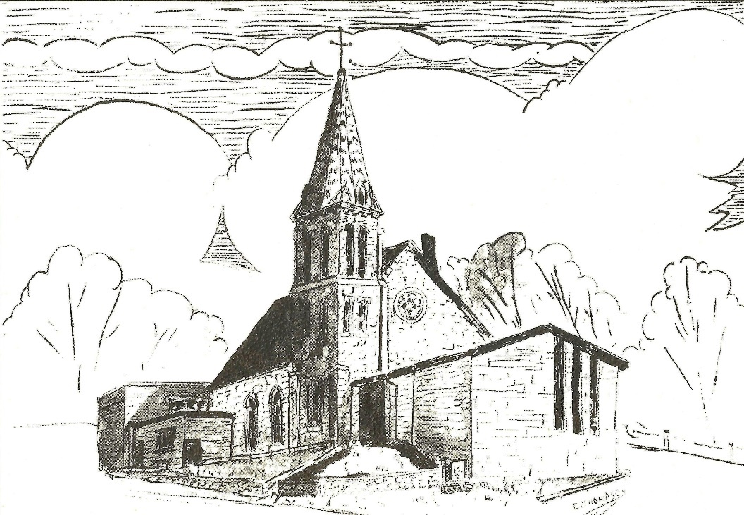
Established 1874

Rev. Kerry B. Eversole, Pastor
Deacon Cindy Cordes-Eversole, Associate in Ministry

Mailing Address: P.O. Box 314, Lanesboro, MN 55949-0314
Physical Address: 200 Kenilworth Ave S, Lanesboro, Minn.

Telephone: 507.467.3344
E-mail Address: bethlehem@acegroup.cc
Website: www.staronthehill.com
Facebook Page: www.facebook.com/BethlehemLutheranLanesboro/

Office Hours: Tuesday, Wednesday, Thursday 10 a.m. to 3 p.m.
Parsonage Phone: 507.467.3017

Pastor Kerry’s Cell Phone: 507.951.3954
Bethlehem Lutheran Church
Lanesboro, Minnesota

Eighth Sunday after Pentecost

July 31, 2022

Jesus said, “Take care! Be on your guard against all kinds of greed; for one’s life does not consist in the abundance of possessions.” Then he told a parable: “The land of a rich man produced abundantly. And he thought to himself…Soul, you have ample goods laid up for many years; relax, eat, drink, be merry.’ But God said to him, ‘You fool! This very night your life is being demanded of you. And the things you have prepared, whose will they be?’ Luke 12 15-21
Welcome to worship at Bethlehem Lutheran Church

We are “The star on the hill” — You are the light of the world … let your light shine before others, so that they may see your good works and give glory to your Father in heaven. Matthew 5:14-16

COVID-19 Practices — Out of love for God and Neighbor

1) Use hand sanitizer upon entry. Wash your hands and use hand sanitizer often while in the facility.
2) Members and visitors who are vaccinated and boosted are not required to wear a mask.
3) Members and visitors are free to wear a mask if they wish to do so.
4) Unvaccinated and not boosted members and visitors must wear a mask.
5) There are no physical distancing requirements, but you are welcome to keep a distance from others in the sanctuary as you are able.
6) All are welcome to enjoy coffee fellowship in the dining room following worship.

Worship Book and Hymns. This morning’s service is printed in the bulletin. All the hymns can be found in Evangelical Lutheran Worship (ELW), “the red book”, or With One Viice (WOV), which are in the hymnal racks in each pew. Hymns in ELW are indicated by a large bold number in the left or right margin of each page.

Abbreviations. Throughout this worship folder hymns are signified by the pound symbol (#), P: refers to the presiding minister or preacher, A: denotes an assisting minister, and C: and/or bold text indicates the congregation.

Mistakes do not happen in our worship service;
only unexpected events which are opportunities for joy!

An signifies that you may stand as you are comfortably able.

Gathering

The Holy Spirit calls us together as the people of God.

Introduction to the Day. Today’s readings offer instruction and encouragement for all who are occasionally overwhelmed by the “unhappy business” of life. Jesus urges us to take care and be on guard against all kinds of greed. We who have died with Christ in holy baptism have also been raised with him and are encouraged to elevate our thinking, seeking the “things that are above”. To that end, we seek the inspiration of God’s word and the nourishment of the sacraments.

MUSIC AS WE COME TOGETHER Heidi Dybing

OPENING SONG Gather Us In / Here In This Place ELW # 532

Stanzas 1, 2 and 4

GREETING

P: The grace of our Lord Jesus Christ, the love of God, and the communion of the Holy Spirit be with you all.

C: And also with you.

PRAYER OF THE DAY

P: Let us pray together.

Benevolent God,

All: you are the source, the guide, and the goal of our lives. Teach us to love what is worth loving, to reject what is offensive to you, and to treasure what is precious in your sight, through Jesus Christ, our Savior and Lord. Amen.

Word

God speaks to us in scripture reading, preaching, and song.

OLD TESTAMENT READING Ecclesiastes 1:2, 12-14; 2:18-23

The teacher of wisdom who wrote Ecclesiastes sees that working for mere accumulation of wealth turns life into an empty game, a “vanity of vanities.” Nevertheless, he asserts in the next verse that it is good to find enjoyment in one’s work because such enjoyment is a gift from God.

²Vanity of vanities, says the Teacher,
vanity of vanities! All is vanity.
¹²I, the Teacher, when king over Israel in Jerusalem, ¹³applied my mind to seek and to search out by wisdom all that is done under heaven; it is an unhappy business that God has given to human beings to be busy with. ¹⁴I saw all the deeds that are done under the sun; and see, all is vanity and a chasing after wind.
^{2:18}I hated all my toil in which I had toiled under the sun, seeing that I must leave it to those who come after me ¹⁹—and who knows whether they will be wise or foolish? Y et they will be master of all for which I toiled and used my wisdom under the sun. This also is vanity. ²⁰So I turned and gave my heart up to despair concerning all the toil of my labors under the sun, ²¹because sometimes one who has toiled with wisdom and knowledge and skill must leave all to be enjoyed by another who did not toil for it. This also is vanity and a great evil. ²²What do mortals get from all the toil and strain with which they toil under the sun? ²³For all their days are full of pain, and their work is a vexation; even at night their minds do not rest. This also is vanity.

NEW TESTAMENT READING Colossians 3:1-11

Life in Christ includes a radical reorientation of our values. Just as the newly baptized shed their old clothes and put on new garments, so Christians are called to let go of greed and take hold of a life shaped by God’s love in Christ.

¹So if you have been raised with Christ, seek the things that are above, where Christ is, seated at the right hand of God. ²Set your minds on things that are above, not on things that are on earth, ³for you have died, and your life is hidden with Christ in God. ⁴When Christ who is your life is revealed, then you also will be revealed with him in glory.
⁵Put to death, therefore, whatever in you is earthly: fornication, impurity, passion, evil desire, and greed (which is idolatry). ⁶On account of these the wrath of God is coming on those who are disobedient. ⁷These are the ways you also once followed, when you were living that life. ⁸But now you must get rid of all such things—anger, wrath, malice, slander, and abusive language from your mouth. ⁹Do not lie to one another, seeing that you have stripped off the old self with its practices ¹⁰and have clothed yourselves with the new self, which is being renewed in knowledge according to the image of its creator. ¹¹In that renewal there is no longer Greek and Jew, circumcised and uncircumcised, barbarian, Scythian, slave and free; but Christ is all and in all!

SONG OF PRAISE Now All the Vault of Heaven Resounds ELW # 367

Stanzas 1, 3 and 4

GOSPEL Luke 12:13-21

In God’s reign, the “rich will be sent away empty.” Jesus uses a parable to warn against identifying the worth of one’s life with the value of one’s possessions rather than one’s relationship with God.

¹³Someone in the crowd said to [Jesus,] “Teacher, tell my brother to divide the family inheritance with me.” ¹⁴But he said to him, “Friend, who set me to be a judge or arbitrator over you?” ¹⁵And he said to them, “Take care! Be on your guard against all kinds of greed; for one’s life does not consist in the abundance of possessions.” ¹⁶Then he told them a parable: “The land of a rich man produced abundantly. ¹⁷And he thought to himself, ‘What should I do, for I have no place to store my crops? ¹⁸Then he said, ‘I will do this: I will pull down my barns and build larger ones, and there I will store all my grain and my goods. ¹⁹And I will say to my soul, Soul, you have ample goods laid up for many years; relax, eat, drink, be merry.’ ²⁰But God said to him, ‘You fool! This very night your life is being demanded of you. And the things you have prepared, whose will they be?’ ²¹So it is with those who store up treasures for themselves but are not rich toward God.”

SERMON Deacon Cindy

SONG OF THE DAY Son of God, Eternal Savior ELW # 655

Stanzas 1, 2 and 3

Responding

We respond to God’s word concerning the world and true value.

OFFERING Music by Heidi Dybing

ASSEMBLY SONG Be Thou My Vision ELW # 793

PRAYERS OF GOD’S PEOPLE

After the last petition, all sing ELW # 752

Lord, Listen to Your Children Praying

LORD'S PRAYER Sung version

P: Gathered into one by the Holy Spirit, let us sing the prayer that Jesus taught us.

Sending

God blesses us and sends us in mission to the world.

ANNOUNCEMENTS

BLESSING

P: The God of peace,
Father,☩ Son, and Holy Spirit,
bless you, comfort you,
and show you the path of life
this day and always.

C: Amen.

DEPARTING SONG God of Grace and God of Glory ELW # 705

DISMISSAL

A: Go in peace. Love your neighbor.

C: Thanks be to God.

SENDING MUSIC

Today’s Assistants and Ministers

Greeters & Ushers …...................................................…...… Ed Taylor and Jennifer Wood
Pianist ……..…………………………………….….…..………..……...……..…… Heidi Dybing
Worship Leader …………………………………….…....….…………… Pastor Kerry Eversole
Preacher ………………………………………………………. Deacon Cindy Cordes-Eversole
Reader ………………………………………………..…….....……….…….…………. Ed Taylor
Altar Care ……..………...…………………...…………………………… Pastor Kerry Eversole
Refreshments …………………………………..…….....………..…...….……… Jennifer Wood
Custodian ……………………….………………..……………………………. Wayne Lukkason

Presence Last Week and June Presents

Attendance Last Sunday, July 24 = 37
Average Sunday Worship Attendance for June = 40

June Contributions: General Fund = $8,892 Designated Giving = $565
Jan-Jun Income = $76,911 Jan-Jun Expenses = $87,333 Deficit = $10,422

This Week in Our Congregation

Today, July 31 — Eighth Sunday after Pentecost

Refreshments in the Fellowship Hall for everyone following worship

Tuesday, August 2

Men’s breakfast at Home Sweet Home in Lanesboro 7:00 AM
Deacon Cindy at Harmony Care Center, Harmony, for chapel 2:00 PM

Wednesday, August 3

Pastor Kerry at Chosen Valley Care Center, Chatfield, for chapel 12:30 & 1:30 PM

Next Sunday, August 7 — Ninth Sunday after Pentecost

Worship w/ Baptism and Communion 9:00 AM

Prayer Requests

In Our Community. For our church members and friends living with chronic illness and other diseases, who are homebound, residing in care facilities, and hospitalized. See the newsletter for our members living in area nursing homes. And let us not forget those sick and dying of COVID-19, those entrusted with the authority of government, justice, and law enforcement, as well as our fallen and wounded soldiers and those still serving.

In Our Synod. Bishop Regina Hassanally invites the people and congregations of our synod to commit to praying this week for the following faith communities: First Lutheran Church, Blooming Prairie; Solor Lutheran Church, Webster; Redeemer Lutheran Church, Alden; Ngimu Lutheran Church, Tanzania; Igengu Lutheran Church, Tanzania; and CELCO (Colégio de la Evangélica Luterana de Colombia) Paz de Ariporo.

News and Notes

The WELCA is collecting items for Lutheran World Relief School kits! School supplies are already available in the stores. If you would like to provide supplies for one or more kits, here are the items needed:

4 70-80 sheet spiral notebooks either wide- or college-ruled (no loose-leaf paper)
1 30-centimeter ruler or ruler with centimeters on one side and inches on the other
1 pair of blunt-end scissors
5 unsharpened #2 pencils 1 pencil sharpener 1 2-1/2" eraser
5 black or blue ballpoint pens (no gel ink) 1 box of 16 or 24 crayons
Cloth bags are available in the church narthex.
Thank you for your help with this project!

Community Activities

Fountain United Methodist Church is having an outdoor service today at 11 a.m., in the City of Fountain Park just east of the baseball field. Music by Matt and Brenda Stier. A potluck picnic will follow. Sloppy joes will be provided. Fountain Lutheran Church members and others are cordially invited to attend.

Buffalo Bill Days Outdoor Worship Service, next Sunday, August 7, 10:30 a.m., Sylvan Park Gazebo. Free will offering to support the Fillmore County Food Shelves.

Acknowledgments

Graphics, worship texts, service music, and readings are from sundaysandseasons.com, © 2022 Augsburg Fortress. Used by permission under Augsburg Fortress Liturgies Annual License SAS103296.

Permission to project, live stream, or podcast liturgy and music content under copyright to or administered by Augsburg Fortress provided under Augsburg Fortress Liturgies Annual License SAS103296.

Permission to Podcast / Stream provided by Christian Copyright Licensing International, Inc., under License # 11459672. Additional fee paid. www.ccli.com.

Permission to Podcast / Stream provided by One License, Inc., under License # A-735588. Additional fee paid. www.onelicense.net.

