Bethlehem Lutheran Church
Established 1874

Rev. Kerry B. Eversole, Pastor
Deacon Cindy Cordes-Eversole, Associate in Ministry

Mailing Address: P.O. Box 314, Lanesboro, MN 55949-0314
Physical Address: 200 Kenilworth Ave S, Lanesboro, Minn.

Telephone: 507.467.3344
E-mail Address: bethlehem@acegroup.cc
Website: www.staronthehill.com
Facebook Page: www.facebook.com/BethlehemLutheranLanesboro/

Office Hours: Tuesday, Wednesday, Thursday 10 a.m. to 3 p.m.
Parsonage Phone: 507.467.3017
Pastor Kerry’s Cell Phone: 507.951.3954

Bethlehem Lutheran Church
Lanesboro, Minnesota

Fourth Sunday after Pentecost

July 3, 2022


Jesus appointed seventy and sent them ahead of him in pairs to every town and place where he intended to go. Jesus said to them, “Whenever you enter a town and its people welcome you, eat what is set before you; cure the sick, and say to them, ‘The kingdom of God has come near to you.’ But whenever you enter a town and they do not welcome you, go out into its streets and say, ‘Even the dust of your town that clings to our feet, we wipe off in protest against you.’” Luke 10 1, 8-15
Welcome to worship at Bethlehem Lutheran Church
and our celebration of the Season after Pentecost,
the Time of the Church!

We are “The star on the hill” — Let your light shine!

COVID-19 Practices — Out of love for God and Neighbor

1) Use hand sanitizer upon entry. Wash your hands and use hand sanitizer often while in the facility.
2) Members and visitors who are vaccinated and boosted are not required to wear a mask.
3) Members and visitors are free to wear a mask if they wish to do so.
4) Unvaccinated and not boosted members and visitors must wear a mask.
5) There are no physical distancing requirements, but you are welcome to keep a distance from others in the sanctuary as you are able.
6) All are welcome to enjoy coffee fellowship in the dining room following worship.

Worship Book and Hymns. This morning’s service is printed in the bulletin. All the hymns can be found in Evangelical Lutheran Worship (ELW), “the red book”, which are in the pew racks. Hymns in ELW are indicated by a large bold number in the left or right margin of each page.

Abbreviations. Throughout this worship folder hymns are signified by the pound symbol (#), P: refers to the presiding minister or preacher, A: denotes an assisting minister, and C: and/or bold text indicates the congregation.

Mistakes do not happen in our worship service;
only unexpected events which are opportunities for joy!

An signifies that you may stand as you are comfortably able.

Introduction to the Day. God is the source of our nourishment. Jesus’s invitation to “take and eat . . . take and drink” is repeated often. In holy communion, in the word read and proclaimed, in the assembly of the people of God, the dominion of God has come near. Rejoice! Your name is written in heaven.

Gathering

The Holy Spirit calls us together as the people of God.

PRELUDE

CONFESSION AND FORGIVENESS

P: Blessed be the holy Trinity, ☩ one God, who forgives all our sin, whose mercy endures forever.

C: Amen.

P: Almighty God, to whom all hearts are open, all desires known, and from whom no secrets are hid: cleanse the thoughts of our hearts by the inspiration of your Holy Spirit, that we may perfectly love you and worthily magnify your holy name, through Jesus Christ our Lord.

C: Amen.

P: The Bible teaches that if we say we have no sin, we deceive ourselves, and the truth is not in us. But if we confess our sins, God who is faithful and just will forgive our sins and cleanse us from all unrighteousness. Therefore, let us confess our sin in the presence of God and of one another.

Most merciful God,

All: we confess that we are captive to sin and cannot free ourselves. We have sinned against you in thought, word, and deed, by what we have done and by what we have left undone. We have not loved you with our whole heart; we have not loved our neighbors as ourselves. For the sake of your Son, Jesus Christ, have mercy on us. Forgive us, renew us, and lead us, so that we may delight in your will and walk in your ways, to the glory of your holy name. Amen.

P: God, who is rich in mercy, loved us even when we were dead in sin and made us alive together with Christ. By grace you have been saved. In the name of ☩ Jesus Christ, your sins are forgiven. Almighty God strengthen you with power through the Holy Spirit, that Christ may live in your hearts through faith.

C: Amen.

OPENING HYMN Spread, Oh, Spread, Almighty Word ELW # 663

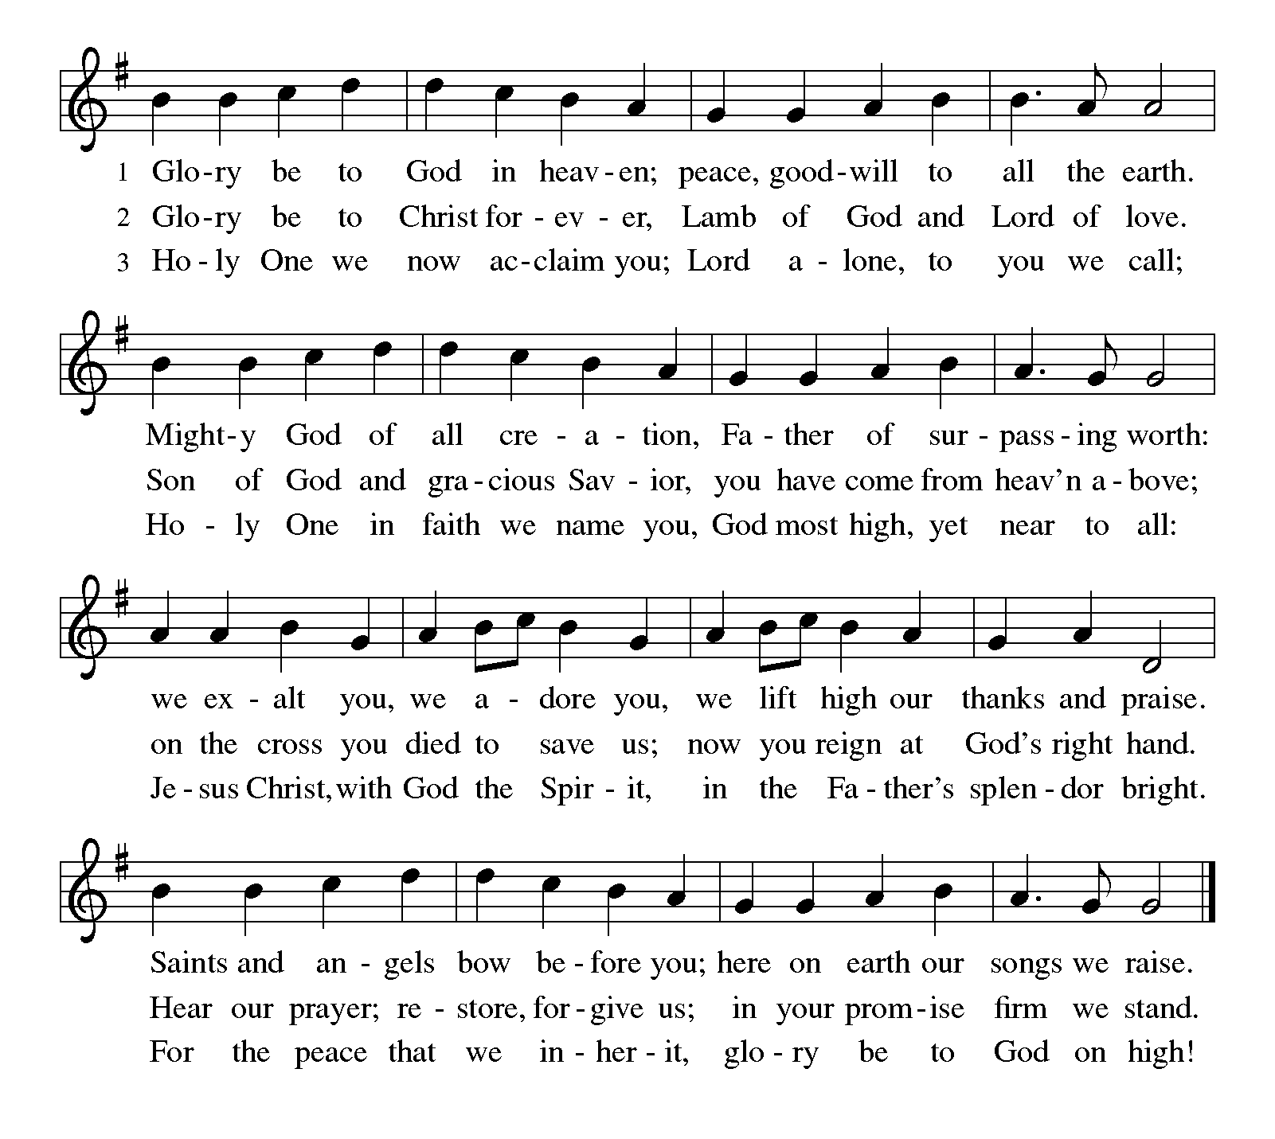GREETING ELW p. 203

P: The grace of our Lord Jesus Christ, the love of God, and the communion of the Holy Spirit be with you all.

C: And also with you.

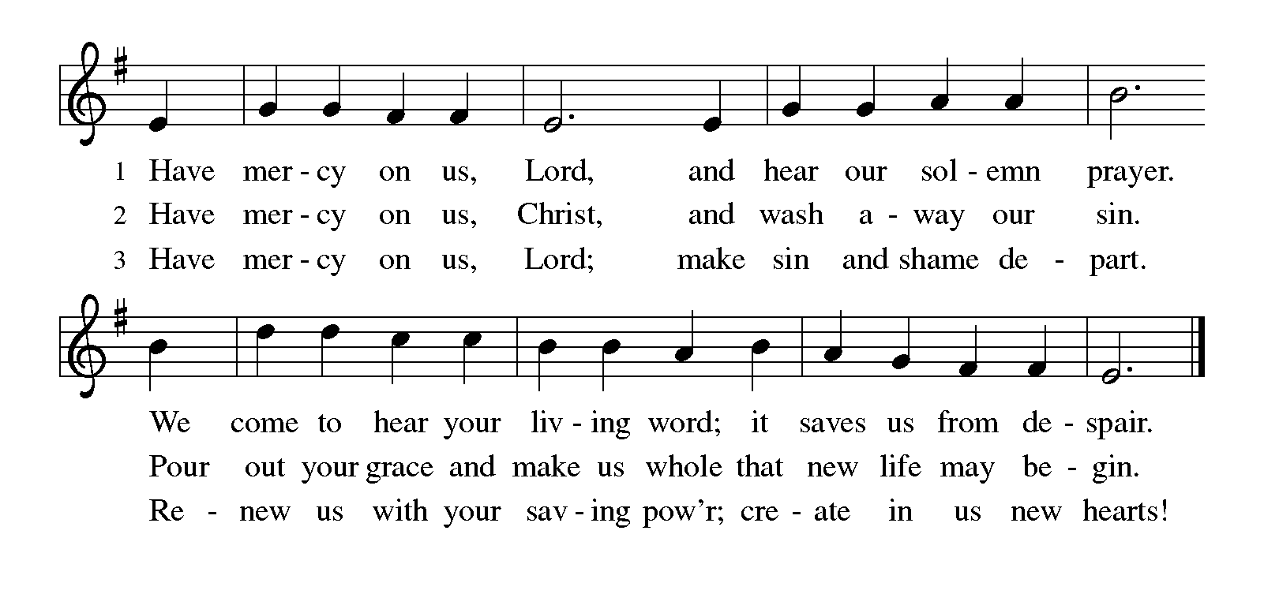KYRIE ELW p. 203

CANTICLE OF PRAISE Glory Be to God ELW p. 204

Continued on the next page.

PRAYER OF THE DAY

P: O God, the Father of our Lord Jesus, you are the city that shelters us, the mother who comforts us. With your Spirit accompany us on our life’s journey, that we may spread your peace in all the world, through your Son, Jesus Christ, our Savior and Lord.

C: Amen.

Word

God speaks to us in scripture reading, preaching, and song.

FIRST READING Isaiah 66:10-14

Those who returned from the exile found that the hopes for the glorious restoration of Judah were not completely fulfilled. For these disappointed people, the prophet envisions salvation in the image of a nursing woman. Mother Jerusalem and a mothering God remind the community how they are sustained and supported.

¹⁰Rejoice with Jerusalem, and be glad for her,
all you who love her;
rejoice with her in joy,
all you who mourn over her—
¹¹that you may nurse and be satisfied
from her consoling breast;

Continued on the next page.
that you may drink deeply with delight
from her glorious bosom.
¹²For thus says the Lord:
I will extend prosperity to her like a river,
and the wealth of the nations like an overflowing stream;
and you shall nurse and be carried on her arm,
and dandled on her knees.
¹³As a mother comforts her child,
so I will comfort you;
you shall be comforted in Jerusalem.
¹⁴You shall see, and your heart shall rejoice;
your bodies shall flourish like the grass;
and it shall be known that the hand of the Lord is with his servants,
and his indignation is against his enemies.

A: The word of the Lord.

C: Thanks be to God.

PSALM 66:1-9

¹Be joyful in God, all you lands; be joyful, all the earth.

²Sing the glory of God’s name; sing the glory of God’s praise.

³Say to God, “How awesome are your deeds! Because of your great strength your enemies cringe before you.

⁴All the earth bows down before you, sings to you, sings out your name.”

⁵Come now and see the works of God, how awesome are God’s deeds toward all people.

⁶God turned the sea into dry land, so that they went through the water on foot, and there we rejoiced in God.

⁷Ruling forever in might, God keeps watch over the nations; let no rebels exalt themselves.

⁸Bless our God, you peoples; let the sound of praise be heard.

⁹Our God has kept us among the living and has not allowed our feet to slip.

All the earth bows down before you and sings out your name.

SECOND READING Galatians 6:7-16

Continued on the next page.

In the close of his letter to the Galatians, Paul encourages them to live as people made right with God through faith in Jesus Christ. Here Paul offers practical advice about how believers exercise common concern for one other in “the family of faith.”

⁷Do not be deceived; God is not mocked, for you reap whatever you sow. ⁸If you sow to your own flesh, you will reap corruption from the flesh; but if you sow to the Spirit, you will reap eternal life from the Spirit. ⁹So let us not grow weary in doing what is right, for we will reap at harvest time, if we do not give up. ¹⁰So then, whenever we have an opportunity, let us work for the good of all, and especially for those of the family of faith.
¹¹See what large letters I make when I am writing in my own hand! ¹²It is those who want to make a good showing in the flesh that try to compel you to be circumcised—only that they may not be persecuted for the cross of Christ. ¹³Even the circumcised do not themselves obey the law, but they want you to be circumcised so that they may boast about your flesh. ¹⁴May I never boast of anything except the cross of our Lord Jesus Christ, by which the world has been crucified to me, and I to the world. ¹⁵For neither circumcision nor
uncircumcision is anything; but a new creation is everything! ¹⁶As for those who will follow this rule—peace be upon them, and mercy, and upon the Israel of God.

A: The word of the word.

C: Thanks be to God.

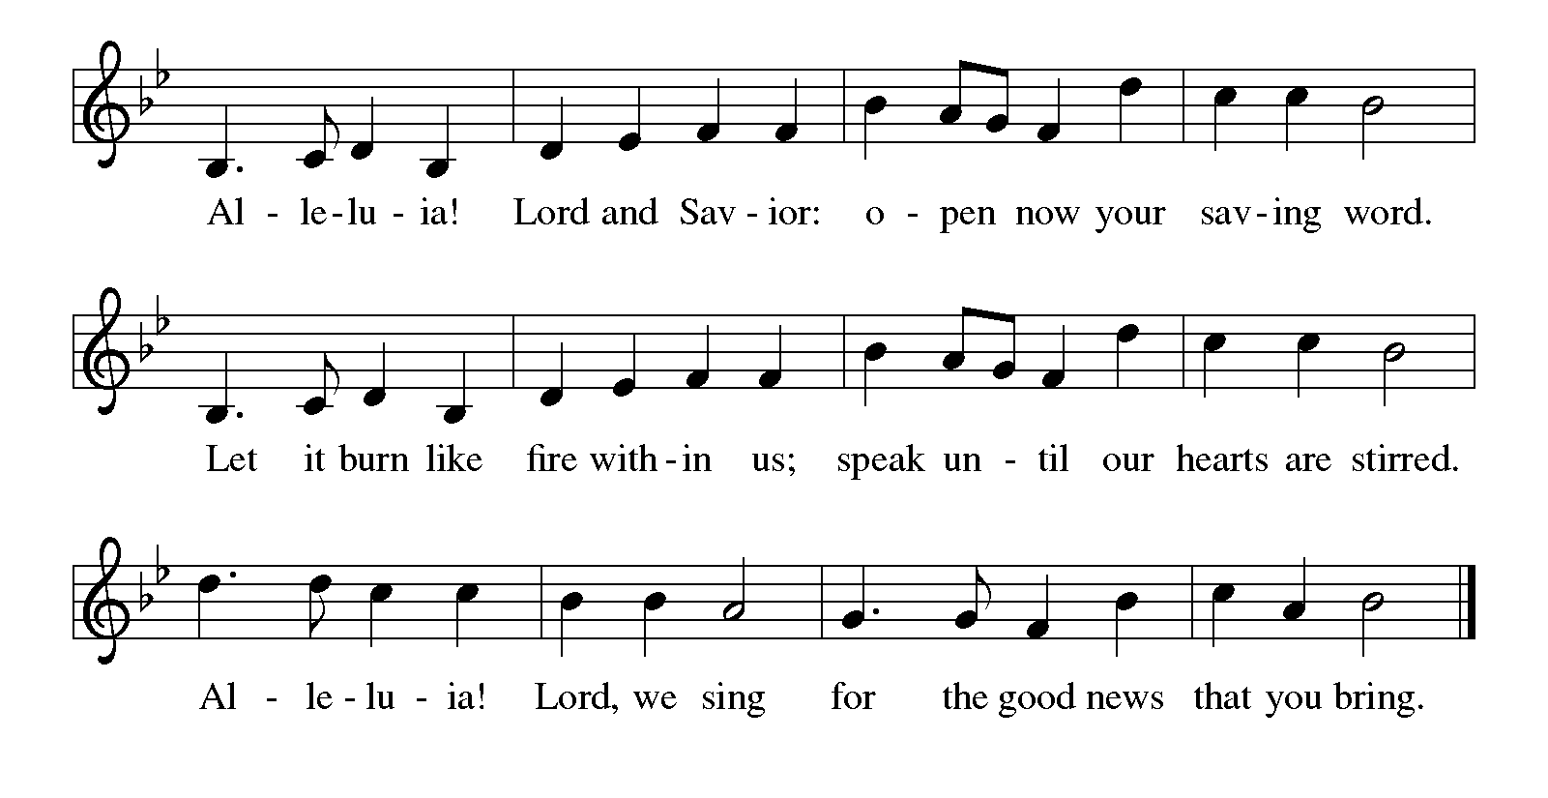GOSPEL ACCLAMATION Alleluia ELW p. 205

GOSPEL Luke 10:1-11, 16-20

P: Announcement of the Gospel.

C: Glory to you, O Lord.

Jesus commissions harvesters and laborers to go where he would go and do what he would do. Risking hardship and danger in exchange for the experience of great joy, they offer peace and healing as signs that the reign of God is near.

¹After this the Lord appointed seventy others and sent them on ahead of him in pairs to every town and place where he himself intended to go. ²He said to them, “The harvest is plentiful, but the laborers are few; therefore ask the Lord of the harvest to send out laborers into his harvest. ³Go on your way. See, I am sending you out like lambs into the midst of wolves. ⁴Carry no purse, no bag, no sandals; and greet no one on the road. ⁵Whatever house you enter, first say, ‘Peace to this house!’ ⁶And if anyone is there who shares in peace, your peace will rest on that person; but if not, it will return to you. ⁷Remain in the same house, eating and drinking whatever they provide, for the laborer deserves to be paid. Do not move about from house to house. ⁸Whenever you enter a town and its people welcome you, eat what is set before you; ⁹cure the sick who are there, and say to them, ‘The kingdom of God has come near to you.’ ¹⁰But whenever you enter a town and they do not welcome you, go out into its streets and say, ¹¹‘Even the dust of your town that clings to our feet, we wipe off in protest against you. Yet know this: the kingdom of God has come near.’ ”
¹⁶“Whoever listens to you listens to me, and whoever rejects you rejects me, and whoever rejects me rejects the one who sent me.”
¹⁷The seventy returned with joy, saying, “Lord, in your name even the demons submit to us!” ¹⁸He said to them, “I watched Satan fall from heaven like a flash of lightning. ¹⁹See, I have given you authority to tread on snakes and scorpions, and over all the power of the enemy; and nothing will hurt you. ²⁰Nevertheless, do not rejoice at this, that the spirits submit to you, but rejoice that your names are written in heaven.”

P: Affirmation of the Gospel.

C: Praise to you, O Christ.

SERMON

HYMN OF THE DAY To Be Your Presence ELW # 546

PRAYERS OF INTERCESSION

Each petition ends with these words and response:

A: Lord, in your mercy,

C: hear our prayer.

Concluding petition and response:

A: Into your hands, gracious God, we commend all for whom we pray, trusting in your mercy; through Jesus Christ, our Savior.

C: Amen.

Meal

God feeds us with the presence of Jesus Christ.

OFFERING AND MUSIC

ASSEMBLY SONG We All Are One in Mission ELW # 576

Stanzas 1 and 2

OFFERING PRAYER

P: Holy God, gracious and merciful, you bring forth food from the earth and nourish your whole creation. Turn our hearts toward those who hunger in any way, that all may know your care; and prepare us now to feast on the bread of life, Jesus Christ, our Savior and Lord.

C: Amen.

Dialogue ELW p. 206

P: The Lord be with you.

C: And also with you.

P: Lift up your hearts.

C: We lift them to the Lord.

P: Let us give thanks to the Lord our God.

C: It is right to give our thanks and praise.

PREFACE

P: It is indeed right, our duty and our joy, that we should at all times and in all places give thanks and praise to you, almighty and merciful God, through our Savior Jesus Christ; who on this day overcame death and the grave, and by his glorious resurrection opened to us the way of everlasting life. And so, with all the choirs of angels, with the church on earth and the hosts of heaven, we praise your name and join their unending hymn:

HOLY, HOLY, HOLY (the angels’ song) ELW p. 207
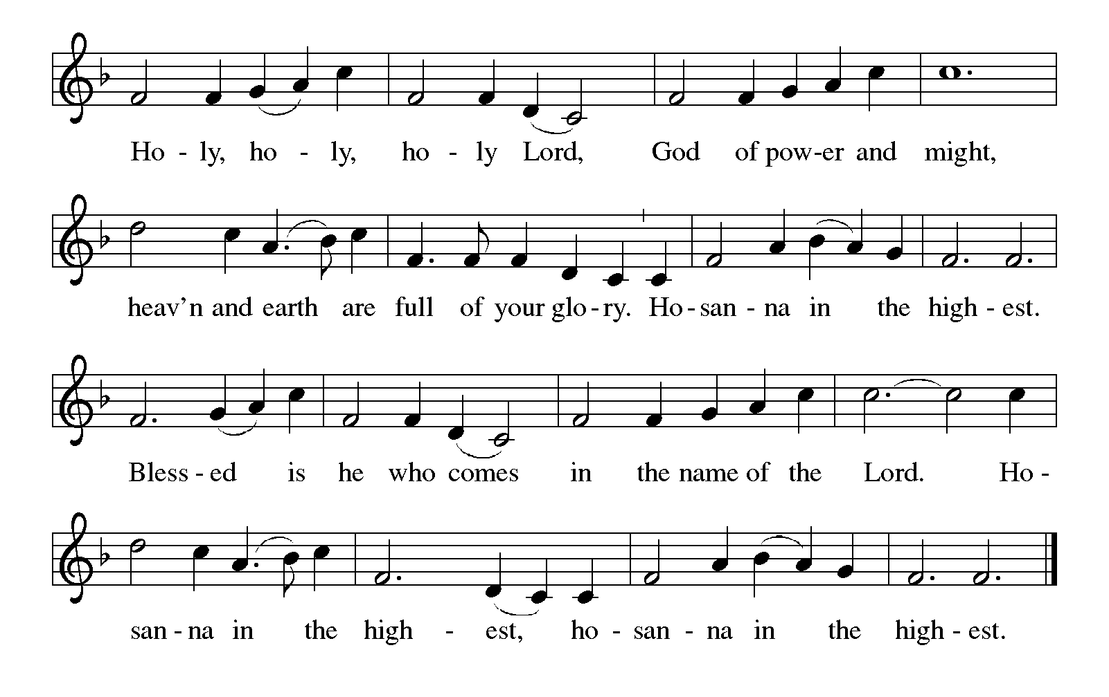

THANKSGIVING AT THE TABLE

P: You are indeed holy, almighty and merciful God. You are most holy, and great is the majesty of your glory.

You so loved the world that you gave your only Son, so that everyone who believes in him may not perish but have eternal life.

We give you thanks for his coming into the world to fulfill for us your holy will and to accomplish all things for our salvation.

Continued on the next page.
P: In the night in which he was betrayed, our Lord Jesus took bread, and gave thanks; broke it, and gave it to his disciples, saying: Take and eat; this is my body, given for you. Do this for the remembrance of me.

Again, after supper, he took the cup, gave thanks, and gave it for all to drink, saying: This cup is the new covenant in my blood, shed for you and for all people for the forgiveness of sin. Do this for the remembrance of me.

For as often as we eat of this bread and drink from this cup,
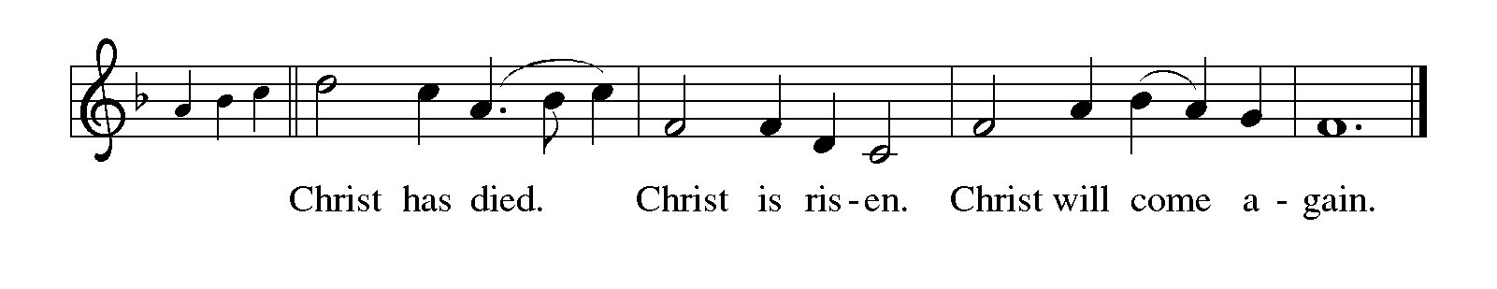we proclaim the Lord's death until he comes.

P: Remembering, therefore, his salutary command, his life-giving passion and death, his glorious resurrection and ascension, and the promise of his coming again, we give thanks to you, O Lord God Almighty, not as we ought but as we are able; we ask you mercifully to accept our praise and thanksgiving and with your Word and Holy Spirit to bless us, your servants, and these your own gifts of bread and wine, so that we and all who share in the body and blood of Christ may be filled with heavenly blessing and grace, and, receiving the forgiveness of sin, may be formed to live as your holy people and be given our inheritance with all your saints.

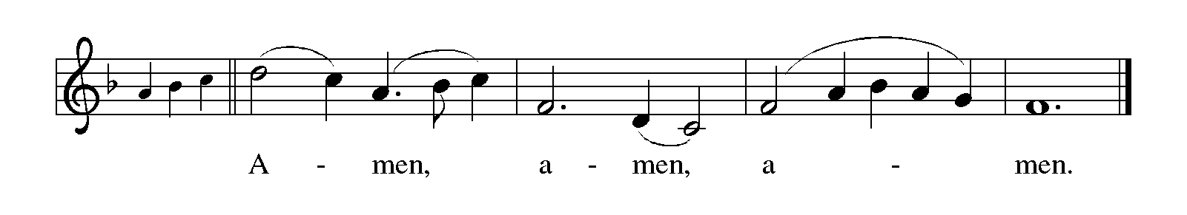To you, O God, Father, Son, and Holy Spirit, be all honor and glory in your holy church, now and forever.

LORD'S PRAYER Traditional Wording ELW p. 208

P: Gathered into one by the Holy Spirit, let us pray as Jesus taught us.

All: Our Father, who art in heaven, hallowed be thy name, thy kingdom come, thy will be done, on earth as it is in heaven. Give us this day our daily bread; and forgive us our trespasses, as we forgive those who trespass against us; and lead us not into temptation, but deliver us from evil. For thine is the kingdom, and the power, and the glory, forever and ever. Amen.
INVITATION TO COMMUNION

P: Dear friends, come, taste and see that the Lord is good.

COMMUNION

What We Believe

Who May Receive. We welcome all baptized Christians to the Lord's Table. In our parish baptized children who have entered the 5th grade are instructed in this sacrament and receive their First Communion; younger children come to the altar and receive a blessing. If your baptized child has received such instruction, or if you want your baptized child to receive Communion, then he or she is welcome to partake.

Proper Preparation. In his Small Catechism, Martin Luther asks, "When is a person rightly prepared to receive this sacrament?" He answers, "Fasting and other outward preparations serve a good purpose. However, that person is well prepared and worthy who believes these words, given and shed for you for the remission of sins. But anyone who does not believe these words, or doubts them, is neither prepared nor worthy, for the words for you require simply a believing heart.”

Real Presence. We believe that the bread and wine truly are the body and blood of Christ given and shed for the forgiveness of sins.

Distribution

Holy Communion will be served in procession, one side of the sanctuary at a time; please keep some distance from the person in front of you. The ushers will direct you when to make your way to the front of the church using the center aisle. You will receive the elements near the chancel. Please extend your hands, palms up, if you will be receiving the bread. Gluten-free wafers are also available; please ask for one. Proceed to your right or to your left depending on which side of the sanctuary you are seated on to receive the wine. White grape juice is also available in the center ring of each tray for those who prefer an alcohol-free element. You may say “Amen” after receiving each element. If you will not be receiving Communion, keep your hands folded for a blessing. Place your empty cup in the basket and then return to your seat by the side aisle.

Congregational Songs During Distribution

O Living Bread from Heaven ELW # 542 Sts. 1, 2 & 4

In Christ Called to Baptize ELW # 575 Sts. 1, 2 & 3

Thy Holy Wings ELW # 613 Sts. 1, 2 & 3

Great Is Thy Faithfulness ELW # 733 Sts. 1, 2 & 3

PRAYER AFTER COMMUNION

P: God of abundance, with this bread of life and cup of salvation you have united us with Christ, making us one with all your people. Now send us forth in the power of your Spirit, that we may proclaim your redeeming love to the world and continue forever in the risen life of Jesus Christ, our Lord.

C: Amen.

Sending

God blesses us and sends us in mission to the world.

ANNOUNCEMENTS

BENEDICTION

P: The Lord bless you and keep you.
The Lord's face shine on you with grace and mercy.
The Lord look upon you with favor and ☩ give you peace.

C: Amen.

DEPARTING HYMN God of Our Fathers

Printed on the next page

DISMISSAL

A: Go in peace. Love your neighbor.

C: Thanks be to God.

POSTLUDE



God of Our Fathers
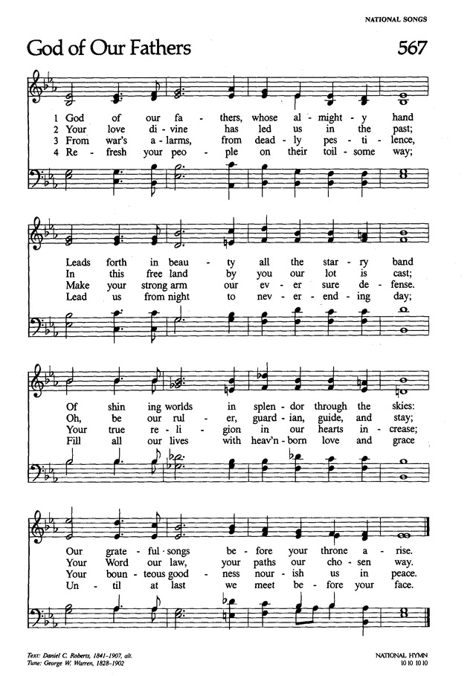

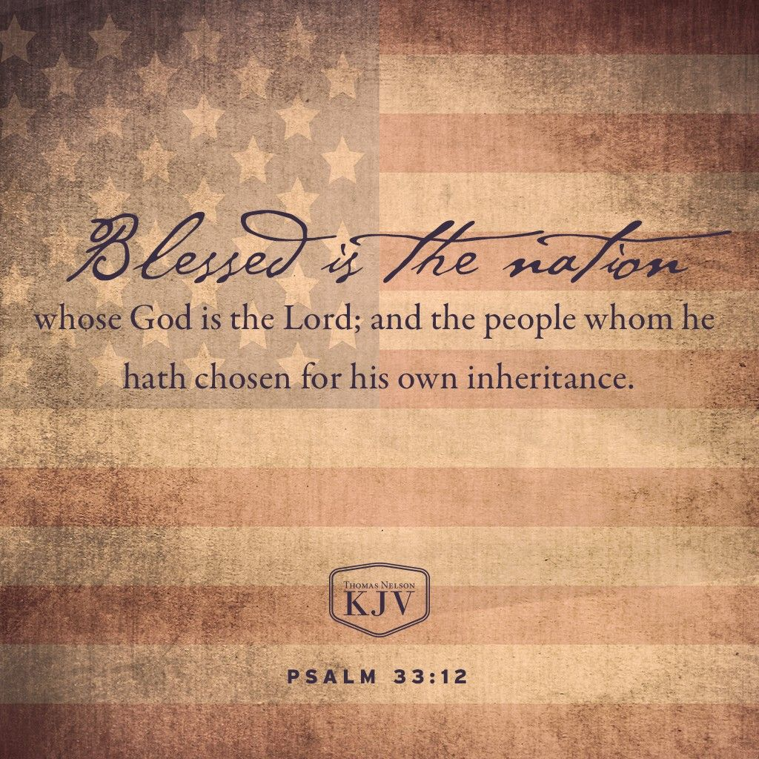

Today’s Assistants and Ministers

Greeters & Ushers …...................................................…...… Ed Taylor and Jennifer Wood
Pianist ……..……………………………….…………………..……...……..…… Sharon Boyum
Presiding Minister …………………………....….…………… Deacon Cindy Cordes-Eversole
Reader …………………………………………………...…....……….…….…………. Ed Taylor
Altar Care & Communion Preparation ……..………...………………………… Jennifer Wood
Refreshments …………………………………………..…...….……… Mark & Elaine Edwards
Custodian ……………………….………………..……………………………. Wayne Lukkason

Presence Last Week and June Presents

Attendance Last Sunday, June 26 = 32
Average Sunday Worship Attendance for June = 40

June Contributions: General Fund = $ Designated Giving = $
Jan-Jun Income = $ NA Jan-Jun Expenses = $NA Deficit = $NA

This Week in Our Congregation

Today, July 3 — Fourth Sunday after Pentecost

Refreshments in the Fellowship Hall for everyone following worship

Monday, July 4 — Independence Day — Church Office Closed

Tuesday, July 5

Men’s breakfast at Home Sweet Home in Lanesboro 7:00 AM

Wednesday, July 6

Pastor Kerry at Chosen Valley Care Center, Chatfield, for chapel 1:30 PM

Thursday, July 7

Pastor Kerry at Good Shepherd Lutheran Home, Rushford, for chapel 1:30 PM

Next Sunday, July 10 — Fifth Sunday after Pentecost

Worship 9:00 AM

News and Notes

We need your help with a fundraiser! Bethlehem is staffing a shift at the Buffalo Bill Days Beer & Brat Pavilion on Saturday, August 6, from 2 to 6 p.m. A sign-up sheet is on the counter in the Fellowship Hall / Dining Room. Our shift is broken up into 2-hour segments. We need ticket sellers, grillers, food, and beer handlers. Come and serve the many visitors to Lanesboro and labor in love for our church!

News and Notes continued

Help at a funeral lunch needed on Monday, July 18. Dar Witman’s sister, Sharon Dodd, will be buried in the Lanesboro Cemetery at 11 a.m. on Monday, July 18. After the graveside service, the family will be gathering at the Sons of Norway Lodge for fellowship and lunch. The meal will be catered, but they need help serving. Please call Deacon Cindy at 467-3344 or 507-676-5002 if you can be of service to the family.

Prayer Requests

In Our Community. For our church members and friends living with chronic illness and other diseases, who are homebound, residing in care facilities, and hospitalized. See the newsletter for our members living in area nursing homes. And let us not forget those sick and dying of COVID-19, those entrusted with the authority of government, justice, and law enforcement, as well as our fallen and wounded soldiers and those still serving.

In Our Synod. Bishop Regina Hassanally invites the people and congregations of our synod to commit to praying this week for the following faith communities: Trinity Lutheran Church, Albert Lea; First Lutheran Church, Red Wing; Mazoezi Maluga Lutheran Church, Tanzania; Isanzu Lutheran Church, Tanzania; Iambi Hospital, Tanzania; and Palliative Care Program, Iambi Hospital, Tanzania.

Acknowledgments

Graphics, worship texts, service music, and readings are from sundaysandseasons.com, © 2022 Augsburg Fortress. Used by permission under Augsburg Fortress Liturgies Annual License SAS103296.

Permission to project, live stream, or podcast liturgy and music content under copyright to or administered by Augsburg Fortress provided under Augsburg Fortress Liturgies Annual License SAS103296.

Permission to Podcast / Stream provided by Christian Copyright Licensing International, Inc., under License # 11459672. Additional fee paid. www.ccli.com.

Permission to Podcast / Stream provided by One License, Inc., under License # A-735588. Additional fee paid. www.onelicense.net.

God of Our Fathers Text: Daniel Crane Roberts, 1841-1907, alt., Public Domain. Music: George William Warren, 1828-1902. Tune: NATIONAL HYMN, Public Domain.

