Bethlehem Lutheran Church
Established 1874

Rev. Kerry B. Eversole, Pastor
Deacon Cindy Cordes-Eversole, Associate in Ministry

Mailing Address: P.O. Box 314, Lanesboro, MN 55949-0314
Physical Address: 200 Kenilworth Ave S, Lanesboro, Minn.

Telephone: 507.467.3344
E-mail Address: bethlehem@acegroup.cc
Website: www.staronthehill.com
Facebook Page: www.facebook.com/BethlehemLutheranLanesboro/

Office Hours: Tuesday, Wednesday, Thursday 10 a.m. to 3 p.m.
Parsonage Phone: 507.467.3017
Pastor Kerry’s Cell Phone: 507.951.3954

Bethlehem Lutheran Church
Lanesboro, Minnesota

Second Sunday after Pentecost
Father’s Day

June 19, 2022

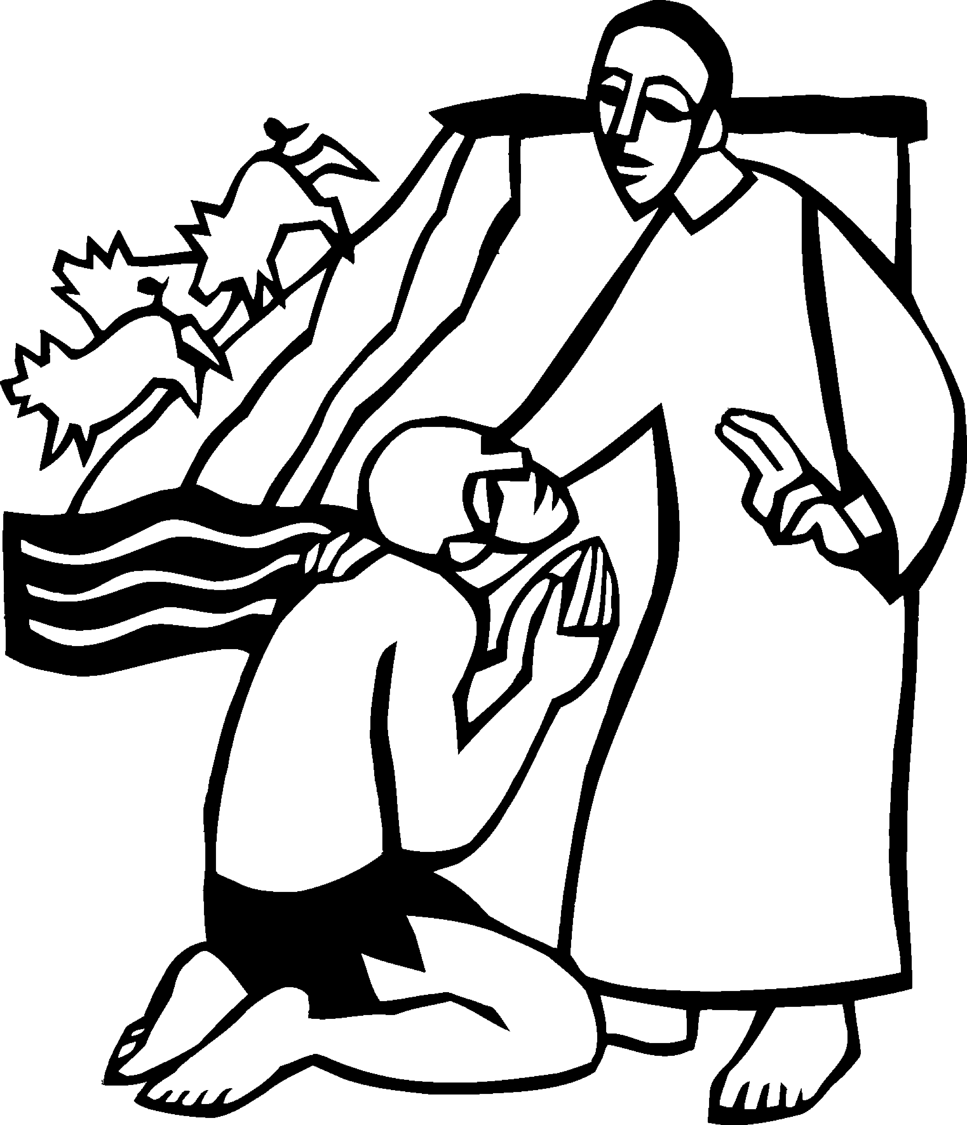

When Jesus arrived in the country of the Gerasenes, a man of the city who had demons met him. Jesus allowed the demons to come out of the man and enter a herd of swine which then rushed down the steep bank into the lake and drowned. Jesus told the man to return to his home and declare how much God had done for him. Luke 8 26, 33, 39
Welcome to worship at Bethlehem Lutheran Church!
We are in the Season after Pentecost,
the Time of the Church.

COVID-19 Practices — Out of love for God and Neighbor

1) Use hand sanitizer upon entry. Wash your hands and use hand sanitizer often while in the facility.
2) Members and visitors who are vaccinated and boosted are not required to wear a mask.
3) Members and visitors are free to wear a mask if they wish to do so.
4) Unvaccinated and not boosted members and visitors must wear a mask.
5) There are no physical distancing requirements, but you are welcome to keep a distance from others in the sanctuary as you are able.
6) All are welcome to enjoy coffee fellowship in the dining room following worship.

Worship Book and Hymns. This morning’s service is printed in the bulletin. All the hymns can be found in Evangelical Lutheran Worship (ELW), “the red book”, which are in the pew racks. Hymns in ELW are indicated by a large bold number in the left or right margin of each page.

Abbreviations. Throughout this worship folder hymns are signified by the pound symbol (#), P: refers to the presiding minister or preacher, A: denotes an assisting minister, and C: and/or bold text indicates the congregation.

Mistakes do not happen in our worship service;
only unexpected events which are opportunities for joy!

An signifies that you may stand as you are comfortably able.

Introduction to the Day. This Sunday’s texts paint startling pictures of the horrific nature of sin. The church’s repeated celebration of word and sacrament counters that tragic reality in a continued presentation of the death and resurrection of Jesus until he comes again. It is a dramatic declaration of “how much God has done for [us].”

Gathering

The Holy Spirit calls us together as the people of God.

PRELUDE

OPENING HYMN Praise the One Who Breaks the Darkness ELW # 843

GREETING ELW p. 203

P: The grace of our Lord Jesus Christ, the love of God, and the communion of the Holy Spirit be with you all.

C: And also with you.

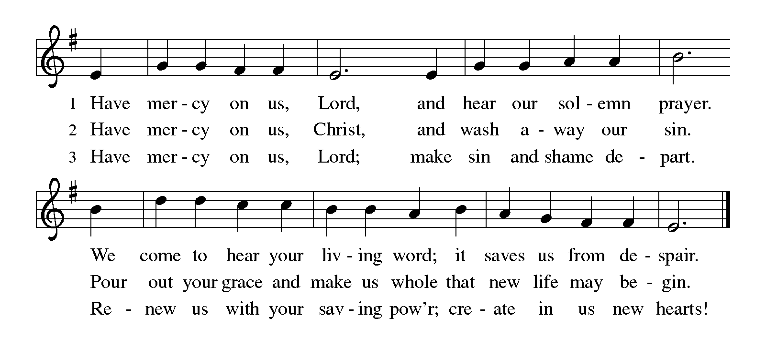KYRIE ELW p. 203

CANTICLE OF PRAISE Glory Be to God ELW p. 204

Printed on the next page.

PRAYER OF THE DAY

P: Let us pray.

O Lord God, we bring before you the cries of a sorrowing world. In your mercy set us free from the chains that bind us, and defend us from everything that is evil, through Jesus Christ, our Savior and Lord.

C: Amen.

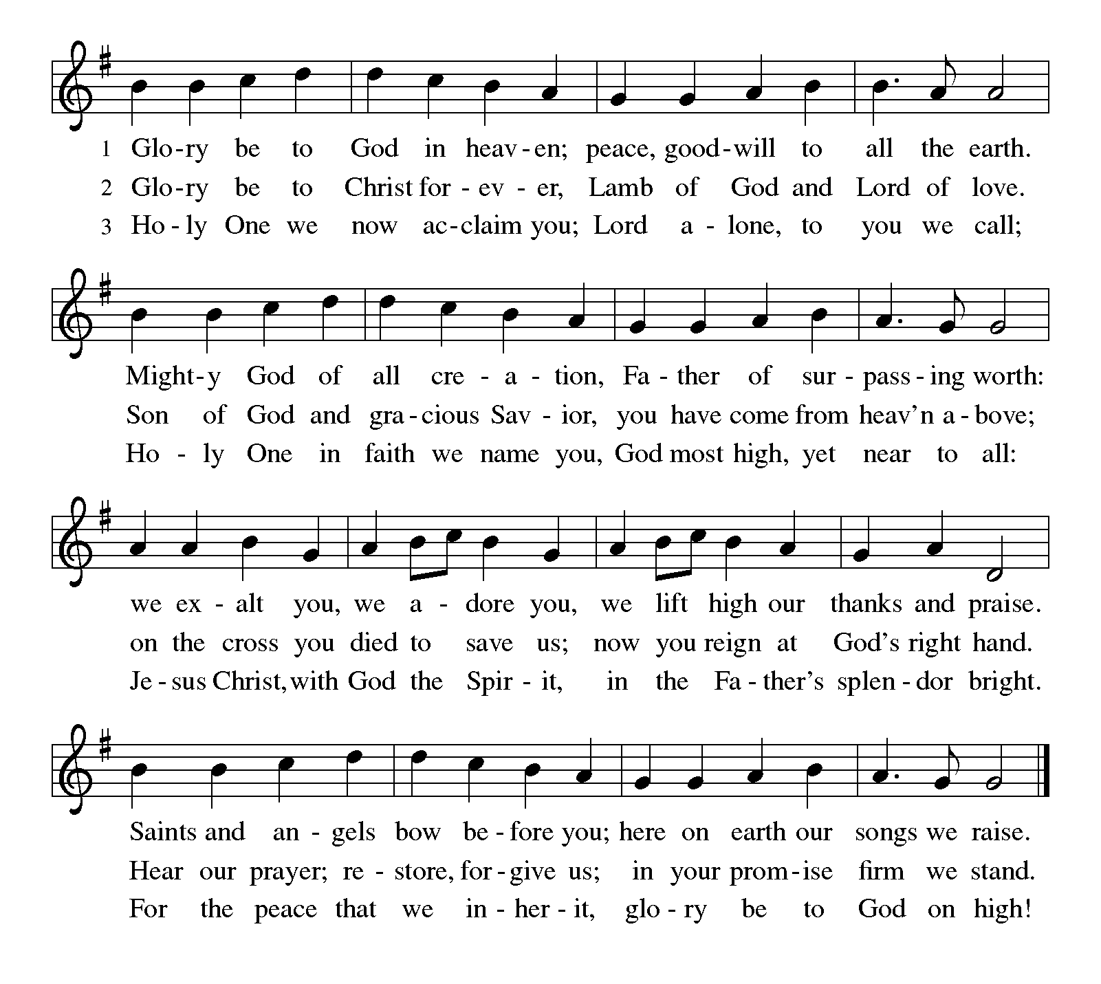Word

God speaks to us in scripture reading, preaching, and song.

FIRST READING Isaiah 65:1-9

The prophet announces God’s impatience. The people’s self-absorption is idolatry, and images of practices that displease God fill this reading. Like a vintner who crushes the grape to release the wine, God will use Israel’s exile to establish a new community of the faithful.

¹I was ready to be sought out by those who did not ask,
to be found by those who did not seek me.
I said, “Here I am, here I am,”
to a nation that did not call on my name.
²I held out my hands all day long
to a rebellious people,
who walk in a way that is not good,
following their own devices;
³a people who provoke me
to my face continually,
sacrificing in gardens
and offering incense on bricks;
⁴who sit inside tombs,
and spend the night in secret places;
who eat swine’s flesh,
with broth of abominable things in their vessels;
⁵who say, “Keep to yourself,
do not come near me, for I am too holy for you.”
These are a smoke in my nostrils,
a fire that burns all day long.
⁶See, it is written before me:
I will not keep silent, but I will repay;
I will indeed repay into their laps
⁷their iniquities and their ancestors’ iniquities together,
says the Lord;
because they offered incense on the mountains
and reviled me on the hills,
I will measure into their laps
full payment for their actions.

Continued on the next page.
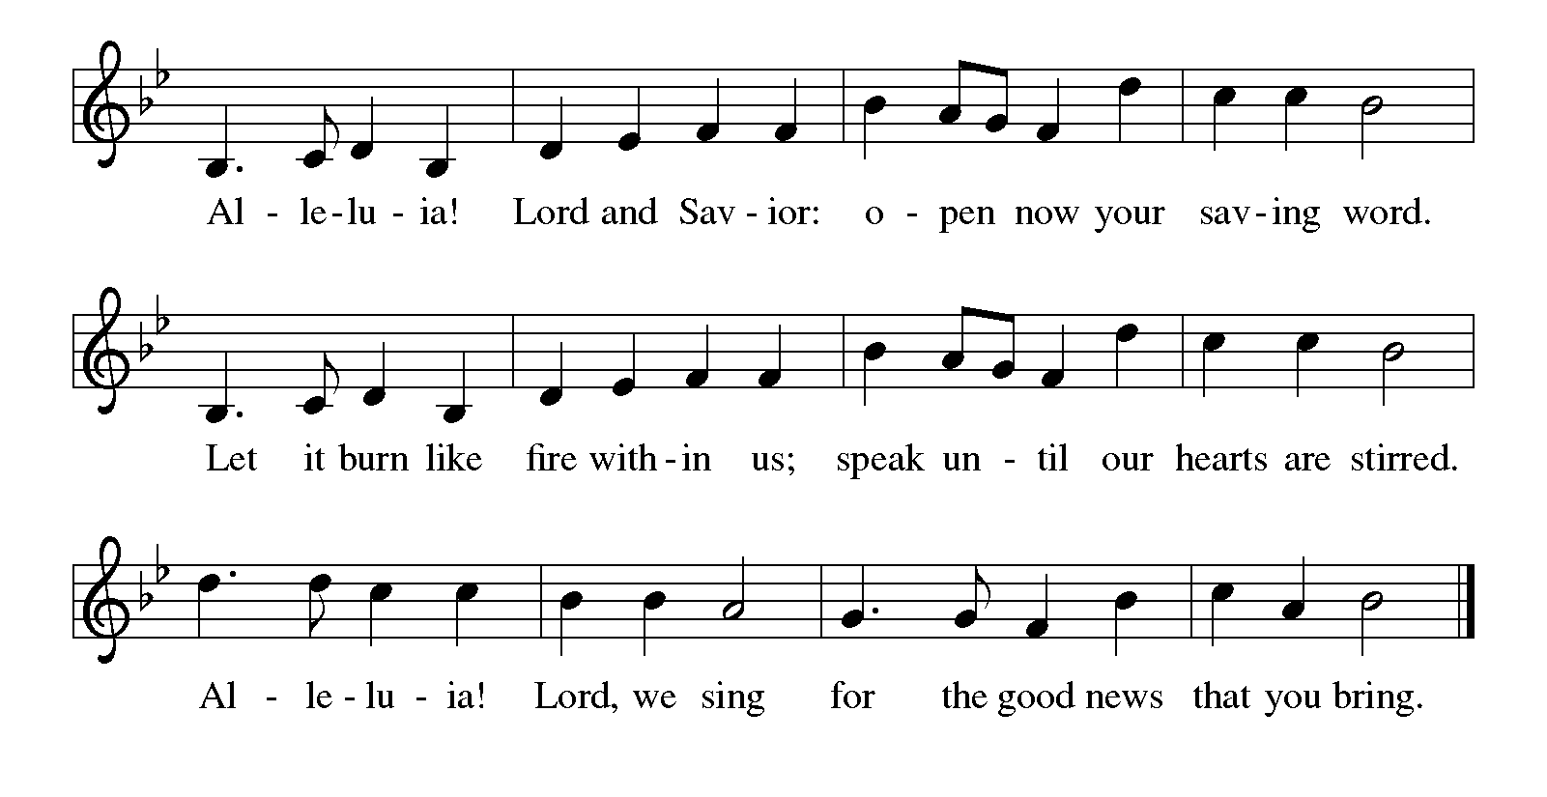⁸Thus says the Lord:
As the wine is found in the cluster,
and they say, “Do not destroy it,
for there is a blessing in it,”
so I will do for my servants’ sake,
and not destroy them all.
⁹I will bring forth descendants from Jacob,
and from Judah inheritors of my mountains;
my chosen shall inherit it,
and my servants shall settle there.

A: The word of the Lord.

C: Thanks be to God.

HYMN Here I Am, Lord ELW # 574

Stanzas 1 and 2

SECOND READING Galatians 3:23-29

For Paul, baptism is a powerful bond that unites people not only with God but with other believers. Those who call themselves children of God experience a transformation that removes prejudices of race, social class, or gender in favor of true unity in Christ.

²³Now before faith came, we were imprisoned and guarded under the law until faith would be revealed. ²⁴Therefore the law was our disciplinarian until Christ came, so that we might be justified by faith. ²⁵But now that faith has come, we are no longer subject to a disciplinarian, ²⁶for in Christ Jesus you are all children of God through faith. ²⁷As many of you as were baptized into Christ have clothed yourselves with Christ. ²⁸There is no longer Jew or Greek, there is no longer slave or free, there is no longer male and female; for all of you are one in Christ Jesus. ²⁹And if you belong to Christ, then you are Abraham’s offspring, heirs according to the promise.

A: The word of the word.

C: Thanks be to God.

GOSPEL ACCLAMATION Alleluia ELW p. 205

Printed on the next page.

GOSPEL Luke 8:26-39

P: Announcement of the Gospel.

C: Glory to you, O Lord.

Jesus’s mission includes foreigners and his authority extends to the casting out of demons. Some who witness Jesus’ work are seized with confusion and fear, but the man who was healed is commissioned to give testimony to God’s mercy and power.

²⁶Then [Jesus and his disciples] arrived at the country of the Gerasenes, which is opposite Galilee. ²⁷As he stepped out on land, a man of the city who had demons met him. For a long time he had worn no clothes, and he did not live in a house but in the tombs. ²⁸When he saw Jesus, he fell down before him and shouted at the top of his voice, “What have you to do with me, Jesus, Son of the Most High God? I beg you, do not torment me”—²⁹for Jesus had commanded the unclean spirit to come out of the man. (For many times it had seized him; he was kept under guard and bound with chains and shackles, but he would break the bonds and be driven by the demon into the wilds.) ³⁰Jesus then asked him, “What is your name?” He said, “Legion”; for many demons had entered him. ³¹They begged him not to order them to go back into the abyss.
³²Now there on the hillside a large herd of swine was feeding; and the demons begged Jesus to let them enter these. So he gave them permission. ³³Then the demons came out of the man and entered the swine, and the herd rushed

Continued on the next page.
down the steep bank into the lake and was drowned.
³⁴When the swineherds saw what had happened, they ran off and told it in the city and in the country. ³⁵Then people came out to see what had happened, and when they came to Jesus, they found the man from whom the demons had gone sitting at the feet of Jesus, clothed and in his right mind. And they were afraid. ³⁶Those who had seen it told them how the one who had been possessed by demons had been healed. ³⁷Then all the people of the surrounding country of the Gerasenes asked Jesus to leave them; for they were seized with great fear. So he got into the boat and returned. ³⁸The man from whom the demons had gone begged that he might be with him; but Jesus sent him away, saying, ³⁹“Return to your home, and declare how much God has done for you.” So he went away, proclaiming throughout the city how much Jesus had done for him.

P: Affirmation of the Gospel.

C: Praise to you, O Christ.

SERMON

HYMN OF THE DAY God of Grace and God of Glory ELW # 705

BLESSING OF FATHERS

PRAYERS OF INTERCESSION

Each petition ends with these words and response:

A: God of grace,

C: hear our prayer.

Concluding petition and response:

A: God of every time and place, in Jesus’s name and filled with your Holy Spirit, we entrust these spoken prayers and those in our hearts into your holy keeping.

C: Amen.

Meal

God feeds us with the presence of Jesus Christ.

OFFERING Music by Sharon Boyum

ASSEMBLY SONG Take My Life, That I May Be ELW # 685

Stanzas 1, 4, 5 and 6

OFFERING PRAYER

A: God of abundance: you have set before us a plentiful harvest. As we feast on your goodness, strengthen us to labor in your field, and equip us to bear fruit for the good of all, in the name of Jesus.

C: Amen.

Dialogue ELW p. 206

P: The Lord be with you.

C: And also with you.

P: Lift up your hearts.

C: We lift them to the Lord.

P: Let us give thanks to the Lord our God.

C: It is right to give our thanks and praise.

PREFACE

P: It is indeed right, our duty and our joy, that we should at all times and in all places give thanks and praise to you, almighty and merciful God, through our Savior Jesus Christ; who on this day overcame death and the grave, and by his glorious resurrection opened to us the way of everlasting life. And so, with all the choirs of angels, with the church on earth and the hosts of heaven, we praise your name and join their unending hymn:

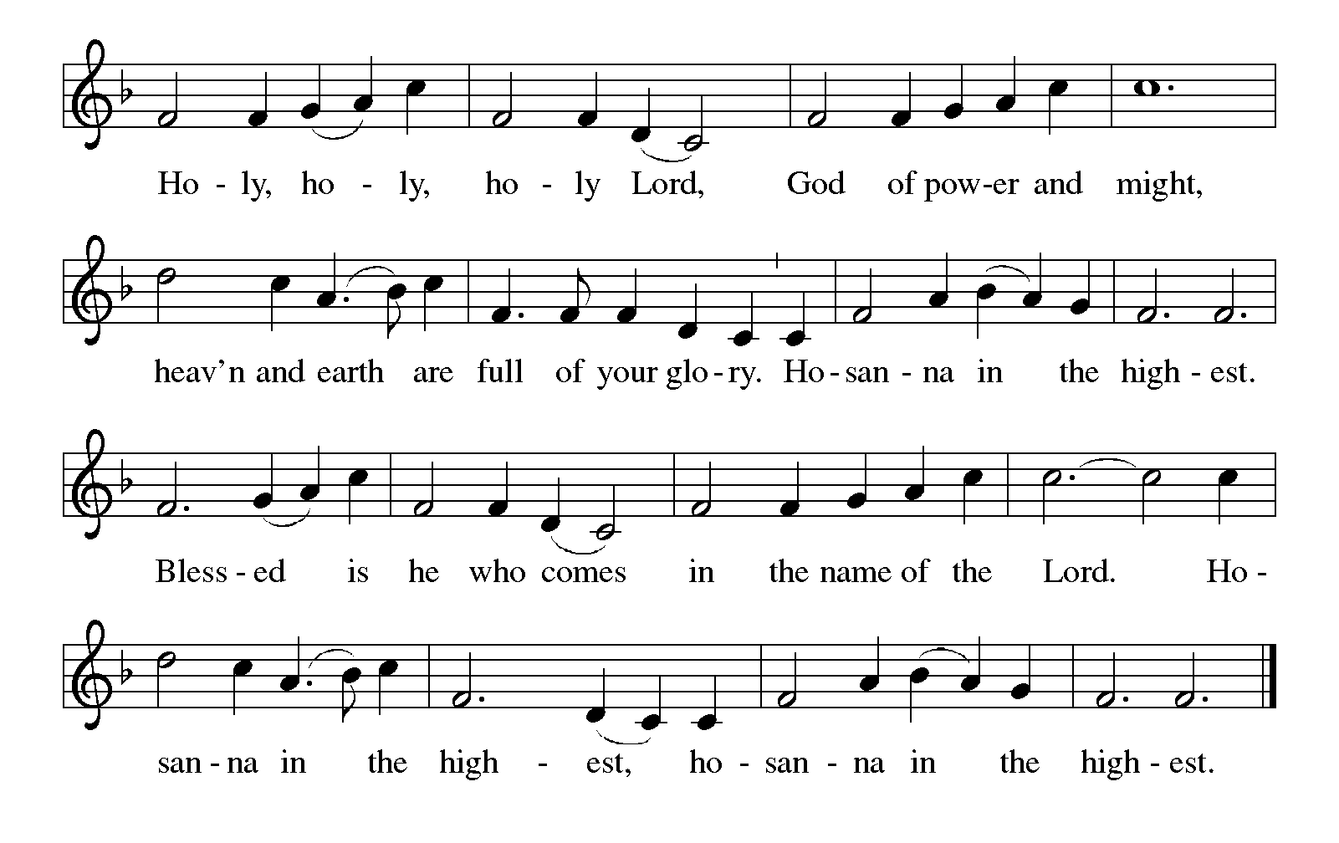HOLY, HOLY, HOLY (the angels’ song) ELW p. 207

Continued on the next page.

THANKSGIVING AT THE TABLE

P: Holy, mighty, and merciful Lord, heaven and earth are full of your glory. In great love you sent to us Jesus, your Son, who reached out to heal the sick and suffering, who preached good news to the poor, and who, on the cross, opened his arms to all.

In the night in which he was betrayed, our Lord Jesus took bread, and gave thanks; broke it, and gave it to his disciples, saying: Take and eat; this is my body, given for you. Do this for the remembrance of me.

Again, after supper, he took the cup, gave thanks, and gave it for all to drink, saying: This cup is the new covenant in my blood, shed for you and for all people for the forgiveness of sin. Do this for the remembrance of me.

Remembering, therefore, his death, resurrection, and ascension, we await his coming in glory.

Pour out upon us the Spirit of your love, O Lord, and unite the wills of all who share this heavenly food, the body and blood of Jesus Christ, our Lord; to whom, with you and the Holy Spirit, be all honor and glory, now and forever.

C: Amen.

LORD'S PRAYER Traditional Wording ELW p. 208

Continued on the next page.
P: Gathered into one by the Holy Spirit, let us pray as Jesus taught us.

All: Our Father, who art in heaven, hallowed be thy name, thy kingdom come, thy will be done, on earth as it is in heaven. Give us this day our daily bread; and forgive us our trespasses, as we forgive those who trespass against us; and lead us not into temptation, but deliver us from evil. For thine is the kingdom, and the power, and the glory, forever and ever. Amen.

INVITATION TO COMMUNION

P: In Christ’s presence there is fullness of joy. Come to the banquet.

COMMUNION

What We Believe

Who May Receive. We welcome all baptized Christians to the Lord's Table. In our parish baptized children who have entered the 5th grade are instructed in this sacrament and receive their First Communion; younger children come to the altar and receive a blessing. If your baptized child has received such instruction, or if you want your baptized child to receive Communion, then he or she is welcome to partake.

Proper Preparation. In his Small Catechism, Martin Luther asks, "When is a person rightly prepared to receive this sacrament?" He answers, "Fasting and other outward preparations serve a good purpose. However, that person is well prepared and worthy who believes these words, given and shed for you for the remission of sins. But anyone who does not believe these words, or doubts them, is neither prepared nor worthy, for the words for you require simply a believing heart.”

Real Presence. We believe that the bread and wine truly are the body and blood of Christ given and shed for the forgiveness of sins.

Distribution

Holy Communion will be served in procession, one side of the sanctuary at a time; please keep some distance from the person in front of you. The ushers will direct you when to make your way to the front of the church using the center aisle. You will receive the elements near the chancel. Please extend your hands, palms up, if you will be receiving the bread. Gluten-free wafers are also available; please ask for one. Proceed to your right or to your left depending on which side of the sanctuary you are seated on to receive the wine. White grape juice is also available in the center ring of each tray for those who prefer an alcohol-free element. You may say “Amen” after receiving each element. If you will not be receiving Communion, keep your hands folded for a blessing. Place your empty cup in the basket and then return to your seat by the side aisle.

Congregational Songs During Distribution

One Bread, One Body ELW # 496 Sts. 1 & 2

We Come to You for Healing, Lord ELW # 617 Sts. 1, 3 & 5

How Sweet the Name of Jesus Sounds ELW # 620 Sts. 1, 2, 4 & 5

I Love to Tell the Story ELW # 661 Sts. 1, 2 & 3

PRAYER AFTER COMMUNION

A: Life-giving God, through this meal you have bandaged our wounds and fed us with your mercy. Now send us forth to live for others, both friend and stranger, that all may come to know your love. This we pray in the name of Jesus.

C: Amen.

Sending

God blesses us and sends us in mission to the world.

ANNOUNCEMENTS

BENEDICTION

P: The God of peace, Father, ☩ Son, and Holy Spirit,
bless you, comfort you, and show you the path of life
this day and always.

C: Amen.

CLOSING HYMN Rise, Shine, You People! ELW # 665

DISMISSAL

A: Go in peace. Love your neighbor.

C: Thanks be to God.

POSTLUDE

Today’s Assistants and Ministers

Greeters & Ushers ….....................................................................…...… Mark & Pam Ruen
Pianist ……..……………………………….…………………..……...……..…… Sharon Boyum
Presiding Minister …………………………....….…………… Deacon Cindy Cordes-Eversole
Reader ……………………………………………………....……….…….…………. Phil Rogers
Altar Care & Communion Preparation ……..…………………………… Phil & Kathie Rogers
Refreshments ………………………..…...….……… Mark & Pam Ruen and Jennifer Rogers
Custodian ……………………….………………..……………………………. Wayne Lukkason

Presence Last Week and May Presents

Attendance Last Sunday, June 12 = 40
Average Sunday Worship Attendance for May = 54

May Contributions: General Fund = $10,236 Designated Giving = $49,881
Jan-May Income = $68,019 Jan-May Expenses = $73,184 Deficit = $5,165

This Week in Our Congregation

Today, June 19 — Second Sunday after Pentecost — Father’s Day

Refreshments in the Fellowship Hall for everyone following worship

Tuesday, June 21

Men’s breakfast at Home Sweet Home in Lanesboro 7:00 AM

Thursday, June 23

Pastor Kerry at Park Lane Estates for Bible study/chapel 9:30 PM

Next Sunday, June 26 — Third Sunday after Pentecost

Worship 9:00 AM

News and Notes

Thank you for contributing to our weekly noisy offering! Loose change totaling $100.97 was recently donated by our congregation to the SEMCAC Food Shelf in Preston.

Christ in Our Home devotion books for July, August and September are available on the stone railing in the narthex.

We need your help with a fundraiser! Bethlehem is staffing a shift at the Buffalo Bill Days Beer & Brat Pavilion on Saturday, August 6, from 2 to 6 p.m. A sign-up sheet is on the counter in the Fellowship Hall / Dining Room. Our shift is broken up into 2-hour segments. We need ticket sellers, grillers, food, and beer handlers. Come and serve the many visitors to Lanesboro and labor in love for our church!

Looking for a Father’s Day gift? Consider A Father’s Kiss by Jack Uldrich. Jack is an author, speaker and consultant based in Minneapolis. He lives there with his wife Cindy and their two children Meghan and Sean. Jack is the brother of Lanesboro resident Catie Glynn, who is an actress and executive coach. The books are on display and for sale in the Fellowship Hall. All proceeds go to Bethlehem Lutheran Church.
Prayer Requests

In Our Community. For our church members and friends living with chronic illness and other diseases, who are homebound, residing in care facilities, and hospitalized. See the newsletter for our members living in area nursing homes. And let us not forget those sick and dying of COVID-19, those entrusted with the authority of government, justice, and law enforcement, as well as our fallen and wounded soldiers and those still serving.

In Our Synod. Bishop Regina Hassanally invites the people and congregations of our synod to commit to praying this week for the following faith communities: Arendahl Lutheran Church, Peterson; Mount Olive Lutheran Church, Rochester; Our Savior’s Lutheran Church, Owatonna; Urughu Lutheran Church, Tanzania; Nduguti Lutheran Church, Tanzania; Ecovida and Food Security Ministry, Colombia; and Comuna Trece, Colombia.

Acknowledgments

Graphics, worship texts, service music, and readings are from sundaysandseasons.com © 2022 Augsburg Fortress. Used by permission under Augsburg Fortress Liturgies Annual License SAS103296.

Permission to project, live stream, or podcast liturgy and music content under copyright to or administered by Augsburg Fortress provided under Augsburg Fortress Liturgies Annual License SAS103296.

Permission to Podcast / Stream provided by Christian Copyright Licensing International, Inc., under License # 11459672. Additional fee paid. www.ccli.com.

Permission to Podcast / Stream provided by One License, Inc., under License # A-735588. Additional fee paid. www.onelicense.net.


Upcoming Commemorations

Tuesday, June 21

Onesimos Nesib, translator, evangelist, died 1931

Onesimos Nesib (oh-ness-ee-mus neh-seeb) was born in Ethiopia. He was captured by slave traders and taken from his Galla homeland to Eritrea, where he was bought, freed, and educated by Swedish missionaries. He translated the Bible into Galla and returned to his homeland to preach the gospel there. His tombstone includes a verse from Jeremiah 22:29, "O land, land, land, hear the word of the Lord!" The commemoration of Onesimos is a good opportunity to focus on missions during the summer months.

Friday, June 24

John the Baptist

The birth of John the Baptist is celebrated exactly six months before Christmas Eve. For Christians in the Northern Hemisphere, these two dates are deeply symbolic. John said that he must decrease as Jesus must increase. John was born as the days are longest and then steadily decrease. Jesus was born as the days are shortest and then steadily increase. In many countries, this day is celebrated with customs associated with the summer solstice, the astronomical first day of summer, and daylight hours begin to wane.

Saturday, June 25

Presentation of the Augsburg Confession, 1530

On this day in 1530, the German and Latin editions of the Augsburg Confession were presented to the Emperor Charles of the Holy Roman Empire. The Augsburg Confession was written by Philipp Melanchthon and endorsed by Martin Luther and consists of a summary of points in which the reformers saw their teaching as either agreeing with or differing from that of the Roman Catholic Church of the time. In 1580 when the Book of Concord was drawn up, the unaltered Augsburg Confession was included as the principal Lutheran confession.

Saturday, June 25

Philipp Melanchthon, renewer of the church, died 1560

Though he died on April 19, Philipp Melanchthon (meh-lahnk-ton) is commemorated today because of his connection with the Augsburg Confession. Colleague and co-reformer with Martin Luther, Melanchthon was a brilliant scholar, known as "the teacher of Germany". The University of Wittenberg hired him as its first professor of Greek, and there he became a friend of Luther. Melanchthon was a popular professor--even his classes at six in the morning had as many as six hundred students. As a reformer he was known for his conciliatory spirit and for finding areas of agreement with fellow Christians. He was never ordained.

