Bethlehem Lutheran Church
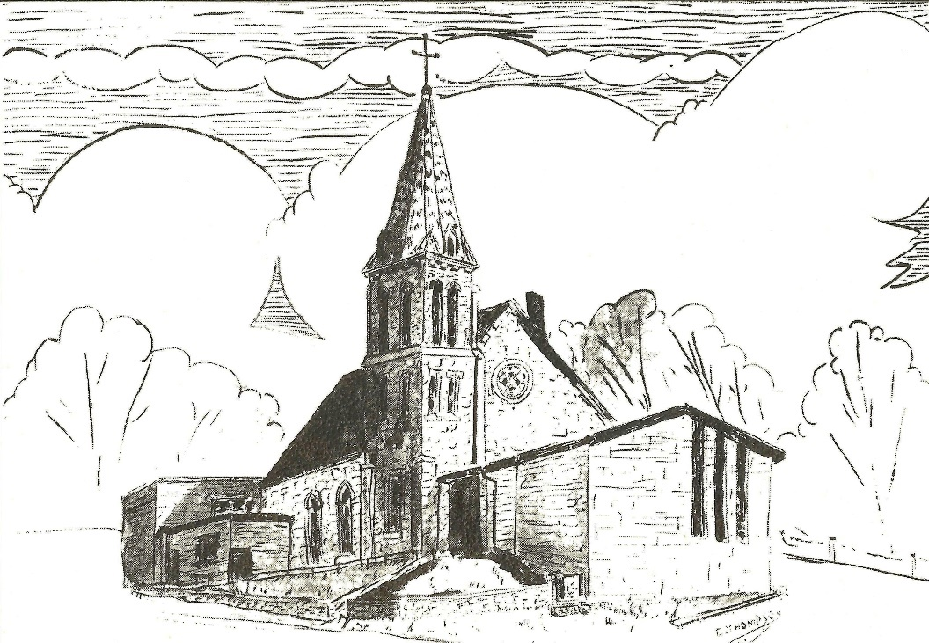
Established 1874

Rev. Kerry B. Eversole, Pastor
Deacon Cindy Cordes-Eversole, Associate in Ministry

Mailing Address: P.O. Box 314, Lanesboro, MN 55949-0314
Physical Address: 200 Kenilworth Ave S, Lanesboro, Minn.

Telephone: 507.467.3344
E-mail Address: bethlehem@acegroup.cc
Website: www.staronthehill.com
Facebook Page: www.facebook.com/BethlehemLutheranLanesboro/

Office Hours: Tuesday, Wednesday, Thursday 10 a.m. to 3 p.m.
Parsonage Phone: 507.467.3017

Pastor Kerry’s Cell Phone: 507.951.3954

Bethlehem Lutheran Church
Lanesboro, Minnesota

The Holy Trinity
First Sunday after Pentecost

June 12, 2022



Jesus said, “When the Spirit of truth comes, he will guide you into all the truth; for he will not speak on his own, but will speak whatever he hears, and he will declare to you the things that are to come.” John 16:13

Welcome to worship at Bethlehem Lutheran Church
and our celebration of the Holy One
who is the Holy Three!

COVID-19 Practices — Out of love for God and Neighbor

1) Use hand sanitizer upon entry. Wash your hands and use hand sanitizer often while in the facility.
2) Members and visitors who are vaccinated and boosted are not required to wear a mask.
3) Members and visitors are free to wear a mask if they wish to do so.
4) Unvaccinated and not boosted members and visitors must wear a mask.
5) There are no physical distancing requirements, but you are welcome to keep a distance from others in the sanctuary as you are able.
6) All are welcome to enjoy coffee fellowship in the dining room following worship.

Worship Book and Hymns. This morning’s service is printed in the bulletin. All the hymns can be found in Evangelical Lutheran Worship (ELW), “the red book”, which are in the pew racks. Hymns in ELW are indicated by a large bold number in the left or right margin of each page.

Abbreviations. Throughout this worship folder hymns are signified by the pound symbol (#), P: refers to the presiding minister or preacher, A: denotes an assisting minister, and C: and/or bold text indicates the congregation.

Introduction to the Day. Today we celebrate the Holy Trinity. “O Lord, our Sovereign, how majestic is your name in all the earth!” declares the psalmist. Paul writes that through Jesus we have peace with God, whose love pours into our hearts through the Holy Spirit, giving us lasting hope. Jesus himself promises that the Spirit of truth will come who will teach us all things. We celebrate the gracious One-in-Three, eternal Three-in-One, as we worship in this congregation; as we share word and water, bread and wine; and as we bring God’s love and hope to our neighbors.

Mistakes do not happen in our worship service;
only unexpected events which are opportunities for joy!

An signifies that you may stand as you are comfortably able.

Gathering

The Holy Spirit calls us together as the people of God.

PRELUDE

CONFESSION AND FORGIVENESS

All may make the sign of the cross, the sign marked at baptism, as the presiding minister begins.

P: Blessed be the holy Trinity,☩ one God, whose steadfast love endures forever.

C: Amen.

P: Let us confess our sin in the presence of God and of one another.

Silence is kept for reflection.

P: Merciful God,

All: we confess that we have not followed your path but have chosen our own way. Instead of putting others before ourselves, we long to take the best seats at the table. When met by those in need, we have too often passed by on the other side. Set us again on the path of life. Save us from ourselves and free us to love our neighbors. Amen.

P: Hear the good news! God does not deal with us according to our sins but delights in granting pardon and mercy. In the name of ☩ Jesus Christ, your sins are forgiven. You are free to love as God loves.

C: Amen.

OPENING HYMN Come, Thou Almighty King ELW # 408
APOSTOLIC GREETING

P: The grace of our Lord Jesus Christ, the love of God, and the communion of the Holy Spirit be with you all.

C: And also with you.

PRAYER OF THE DAY

P: Let us pray together.

God of heaven and earth,

All: before the foundation of the universe and the beginning of time you are the Triune God: Author of creation, eternal Word of salvation, life-giving Spirit of wisdom. Guide us to all truth by your Spirit, that we may proclaim all that Christ has revealed and rejoice in the glory he shares with us. Glory and praise to you, Father, Son, Holy Spirit, now and forever. Amen.

God’s Word of Trinity

God speaks to us in scripture reading, preaching, and song

FIRST READING Proverbs 8:1-4, 22-31

In the Bible, wisdom is portrayed in terms sometimes human and sometimes divine. Often, wisdom is personified as feminine. In this passage, Woman Wisdom is depicted not only as the first creation of God, but also as God’s helper, rejoicing in God’s creation, especially in human beings.

¹Does not wisdom call,
and does not understanding raise her voice?
²On the heights, beside the way,
at the crossroads she takes her stand;
³beside the gates in front of the town,
at the entrance of the portals she cries out:
⁴“To you, O people, I call,
and my cry is to all that live.
²²The Lord created me at the beginning of his work,
the first of his acts of long ago.
²³Ages ago I was set up,
at the first, before the beginning of the earth.

Continued on the next page.

²⁴When there were no depths I was brought forth,
when there were no springs abounding with water.
²⁵Before the mountains had been shaped,
before the hills, I was brought forth—
²⁶when he had not yet made earth and fields,
or the world’s first bits of soil.
²⁷When he established the heavens, I was there,
when he drew a circle on the face of the deep,
²⁸when he made firm the skies above,
when he established the fountains of the deep,
²⁹when he assigned to the sea its limit,
so that the waters might not transgress his command,
when he marked out the foundations of the earth,
³⁰then I was beside him, like a master worker;
and I was daily his delight,
rejoicing before him always,
³¹rejoicing in his inhabited world
and delighting in the human race.”

A: The word of the Lord.

C: Thanks be to God.

PSALM 8

IN WORD selected verses

¹O Lord, our Sovereign,
how majestic is your name in all the earth!
You have set your glory above the heavens.
³When I look at your heavens, the work of your fingers,
the moon and the stars that you have established;
⁴what are humans that you are mindful of them,
mortals that you care for them?
⁵ Yet you have made them a little lower than God
and crowned them with glory and honor.
⁶ You have given them dominion over the works of your hands;
you have put all things under their feet….
⁹O Lord our Sovereign,
how majestic is your name in all the earth!

IN SONG How Majestic Is Your Name by Karen and Jeb Schreiber

SECOND READING Romans 5:1-5

Paul describes the life of faith with reference to God, Jesus, and the Holy Spirit. Even now, we have peace with God through Jesus, and our hope for the future is grounded in the love of God that we experience through Christ’s Holy Spirit.

¹Therefore, since we are justified by faith, we have peace with God through our Lord Jesus Christ, ²through whom we have obtained access to this grace in which we stand; and we boast in our hope of sharing the glory of God. ³And not only that, but we also boast in our sufferings, knowing that suffering produces endurance, ⁴and endurance produces character, and character produces hope, ⁵and hope does not disappoint us, because God’s love has been poured into our hearts through the Holy Spirit that has been given to us.

A: The word of the Lord.

C: Thanks be to God.

GOSPEL ACCLAMATION Holy God, We Praise Your Name ELW # 414

Stanza 1, 2 and 4

GOSPEL John 16:12-15

P: Announcement of the Gospel.

C: Glory to you, O Lord.

Jesus’s ongoing presence with the disciples after his death, resurrection, and ascension will be made known through the coming Spirit who will guide them and communicate to them Jesus’ will and glory.

[Jesus said,] ¹²“I still have many things to say to you, but you cannot bear them now. ¹³When the Spirit of truth comes, he will guide you into all the truth; for he will not speak on his own, but will speak whatever he hears, and he will declare to you the things that are to come. ¹⁴He will glorify me, because he will take what is mine and declare it to you. ¹⁵All that the Father has is mine. For this reason I said that he will take what is mine and declare it to you.”

P: Affirmation of the Gospel.

C: Praise to you, O Christ.

SERMON Deacon Cindy

HYMN OF THE DAY Holy, Holy, Holy, Lord God Almighty ELW # 413

Responding to God’s Word of Trinity

NICENE CREED

P: We have been made God’s people through our baptism into Christ. Living together in trust and hope, we confess our faith.

All: We believe in one God, the Father, the Almighty, maker of heaven and earth, of all that is, seen and unseen.

We believe in one Lord, Jesus Christ, the only Son of God, eternally begotten of the Father, God from God, Light from Light, true God from true God, begotten, not made, of one Being with the Father; through him all things were made. For us and for our salvation he came down from heaven, was incarnate of the Holy Spirit and the virgin Mary and became truly human. For our sake he was crucified under Pontius Pilate; he suffered death and was buried. On the third day he rose again in accordance with the scriptures; he ascended into heaven and is seated at the right hand of the Father. He will come again in glory to judge the living and the dead, and his kingdom will have no end.

We believe in the Holy Spirit, the Lord, the giver of life, who proceeds from the Father and the Son, who with the Father and the Son is worshiped and glorified, who has spoken through the prophets. We believe in one holy catholic and apostolic church. We acknowledge one baptism for the forgiveness of sins. We look for the resurrection of the dead, and the life of the world to come. Amen.

OFFERING Music by Karen and Jeb Schreiber

ASSEMBLY SONG Spirit Song

Printed on the next page.

Spirit Song
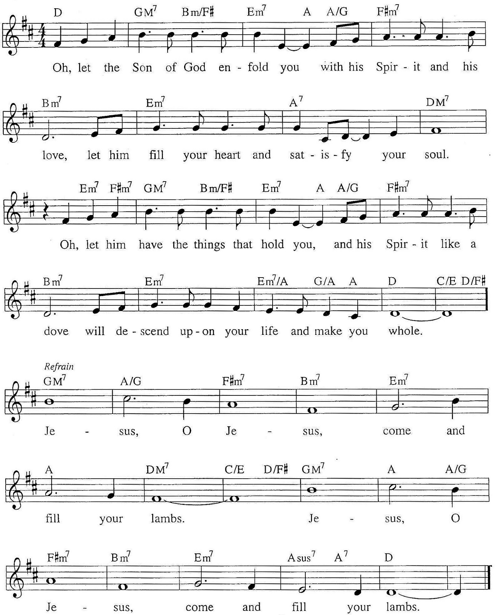
PRAYERS OF INTERCESSION

Each prayer ends with these words and response:

A: God of grace,

C: hear our prayer.

Concluding prayer and response:

A: God of every time and place, in Jesus’s name and filled with your Holy Spirit, we entrust these spoken prayers and those in our hearts into your holy keeping.

C: Amen.

LORD’S PRAYER Traditional Wording

P: Almighty Creator and ever-living God: we worship your glory, eternal Three-in-One, and we praise your power, majestic One-in-Three. Keep us steadfast in this faith, defend us in all adversity, and bring us at last into your presence, where you live in endless joy and love, Father, Son, and Holy Spirit, one God. And now we pray as your Son, Jesus, taught us:

All: Our Father, who art in heaven, hallowed be thy name, thy kingdom come, thy will be done, on earth as it is in heaven. Give us this day our daily bread; and forgive us our trespasses, as we forgive those who trespass against us; and lead us not into temptation, but deliver us from evil. For thine is the kingdom, and the power, and the glory, forever and ever. Amen.

Sending

God blesses us and sends us in mission to the world.

ANNOUNCEMENTS

BLESSING

P: The God of peace, Father, ☩ Son, and Holy Spirit,
bless you, comfort you, and show you the path of life
this day and always.

C: Amen.

DEPARTING HYMN Come, Join the Dance of Trinity ELW # 412

DISMISSAL

A: Go in peace. Love your neighbor.

C: Thanks be to God.

POSTLUDE

Commemorations

Tuesday, June 14

Basil the Great, Bishop of Caesarea, died 379;
Gregory, Bishop of Nyssa, died around 385;
Gregory of Nazianzus, Bishop of Constantinople, died around 389;
Macrina, teacher, died around 379

The Cappadocian fathers, as the three men in this group are known, explored the mystery of the Holy Trinity. Basil's Longer Rule and Shorter Rule form the basis for Eastern monastic life to this day. Gregory of Nazianzus (nah-zee-an-zus) defended orthodox Christianity in Constantinople. Gregory of Nyssa, Basil's younger brother, wrote on the spiritual life. Macrina (muh-cree-nuh), older sister of Basil and Gregory of Nyssa (niss-uh), was the leader of a community dedicated to asceticism, meditation, and prayer.

Friday, June 17

Emanuel Nine, martyrs, died 2015

On June 17, 2015, Clementa C. Pinckney, Cynthia Marie Graham Hurd, Susie Jackson, Ethel Lee Lance, DePayne Middleton-Doctor, Tywanza Sanders, Daniel Lee Simmons, Sharonda Coleman-Singleton, and Myra Thompson were murdered by a self-professed white supremacist while they were gathered for Bible study and prayer at the Emanuel African Methodist Episcopal Church (often referred to as Mother Emanuel) in Charleston, South Carolina. Pastors Pinckney and Simmons were both graduates of the Lutheran Theological Southern Seminary. A resolution to commemorate June 17 as a day of repentance for the martyrdom of the Emanuel Nine was adopted by the Churchwide Assembly of the Evangelical Lutheran Church in America on August 8, 2019. Congregations of the ELCA are encouraged reaffirm their commitment to repenting of the sins of racism and white supremacy which continue to plague this church, to venerate the martyrdom of the Emanuel Nine, and to mark this day of penitence with study and prayer.

Today’s Assistants and Ministers

Greeters & Ushers …............................................…...… Lois Peterson, Mavis Musselman,
Joan Groszbach, and Phil & Kathie Rogers
Organist-Pianist ……..………………………….…………………..……...……..…… Sue Holst
Presiding Minister …………………………....….…………… Deacon Cindy Cordes-Eversole
Reader ……………………………………………………....……….…….…………. Phil Rogers
Altar Care ……..…………………………………..………..……………… Phil & Kathie Rogers
Refreshments ………….….……… Lois Peterson, Mavis Musselman, and Joan Groszbach
Custodian ……………………….………………..……………………………. Wayne Lukkason

Presence Last Week and May Presents

Attendance Last Sunday, June 5 = 49
Average Sunday Worship Attendance for May = 54

May Contributions: General Fund = $10,236 Designated Giving = $49,881
Jan-May Income = $68,019 Jan-May Expenses = $73,184 Deficit = $5,165

This Week in Our Congregation

Today, June 12 — The Holy Trinity — First Sunday after Pentecost

Refreshments in the Fellowship Hall for everyone following worship

Tuesday, June 14

Men’s breakfast at Home Sweet Home in Lanesboro 7:00 AM
Pastor Kerry at Harmony Care Center, Harmony, for chapel 2:00 PM

Thursday, June 16

Deacon Cindy at Good Shepherd Lutheran Home, Rushford, for chapel 1:30 PM

Next Sunday, June 19 — Second Sunday after Pentecost — Father’s Day

Worship with Blessing of Fathers and Holy Communion 9:00 AM

News and Notes

Oak trim from the Sunday school room windows that were recently replaced is available to take free of charge, but a donation to the Window & Roof fund would be greatly appreciated. Please contact Vern Groen (467-2909 or 507-458-3005) to arrange to pick up.

Prayer Requests

In Our Community. For our church members and friends living with chronic illness and other diseases, who are homebound, residing in care facilities, and hospitalized. See the newsletter for our members living in area nursing homes. And let us not forget those sick and dying of COVID-19, those entrusted with the authority of government, justice, and law enforcement, as well as our fallen and wounded soldiers and those still serving.

Prayer Requests continued

In Our Synod. Bishop Regina Hassanally invites the people and congregations of our synod to commit to praying this week for the following faith communities: Grace Lutheran Church, Mankato; Zion Lutheran Church, Ellendale/Lemond; Christ the King Lutheran Church, Mankato; Ushora Lutheran Church, Tanzania; Mazoezi Igurubi Lutheran Church, Tanzania; and Disabilities Learning and Education Ministry, Colombia.

Acknowledgments

Graphics, worship texts, service music, and readings are from sundaysandseasons.com © 2022 Augsburg Fortress. Used by permission under Augsburg Fortress Liturgies Annual License SAS103296.

Permission to project, live stream, or podcast liturgy and music content under copyright to or administered by Augsburg Fortress provided under Augsburg Fortress Liturgies Annual License SAS103296.

Permission to Podcast / Stream provided by Christian Copyright Licensing International, Inc., under License # 11459672. Additional fee paid. www.ccli.com.

Permission to Podcast / Stream provided by One License, Inc., under License # A-735588. Additional fee paid. www.onelicense.net.

How Majestic Is Your Name Text and Music: Michael W Smith. © 1981 Meadowgreen Music Company (Admin. by Capitol CMG Publishing). Used by permission of Christian Copyright Licensing International under CCLI License # 11459672. CCLI Song # 26007. All rights reserved. www.ccli.com.

Spirit Song Text and Music: John Wimber. © 1979 Mercy / Vineyard Publishing (Admin. by Integrity Music). Used by permission of Christian Copyright Licensing International under CCLI License # 11459672. CCLI Song # 27824. All rights reserved. www.ccli.com.

