Bethlehem Lutheran Church
Established 1874


Rev. Kerry B. Eversole, Pastor
Cindy Cordes-Eversole, Deacon

Mailing Address: P.O. Box 314, Lanesboro, MN 55949-0314
Physical Address: 200 Kenilworth Ave S, Lanesboro, Minn.

Telephone: 507.467.3344
E-mail Address: bethlehem@acegroup.cc
Website: www.staronthehill.com
Facebook Page: www.facebook.com/BethlehemLutheranLanesboro/

Office Hours: Tuesday, Wednesday, Thursday 10 a.m. to 3 p.m.
Parsonage Phone: 507.467.3017
Pastor Kerry’s Cell Phone: 507.951.3954

Bethlehem Lutheran Church
Lanesboro, Minnesota

Day of Pentecost
Last Sunday of Easter

June 5, 2022

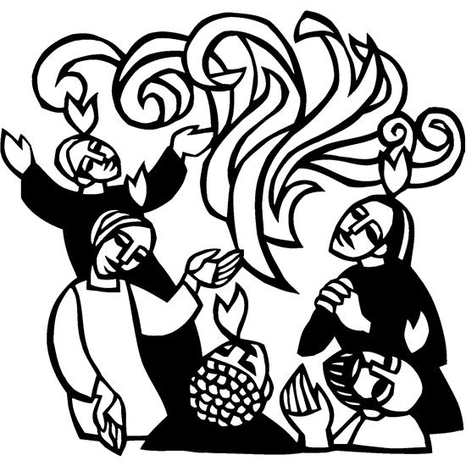
On the day of Pentecost, there came a sound like the rush of a violent wind, and it filled the entire house where the disciples were. Divided tongues, as of fire, appeared among them, and a tongue rested on each of them. All of them were filled with the Holy Spirit and began to speak in other languages, as the Spirit gave them ability. (Acts 2:1-4)
Welcome to worship at Bethlehem Lutheran Church
and our conclusion to the Easter season!

COVID-19 Practices — Out of love for God and Neighbor

1) Use hand sanitizer upon entry. Wash your hands and use hand sanitizer often while in the facility.
2) Members and visitors who are vaccinated and boosted are not required to wear a mask.
3) Members and visitors are free to wear a mask if they wish to do so.
4) Unvaccinated and not boosted members and visitors must wear a mask.
5) There are no physical distancing requirements, but you are welcome to keep a distance from others in the sanctuary as you are able.
6) All are welcome to enjoy coffee fellowship in the dining room following worship.

Worship Book and Hymns. This morning’s service is printed in this bulletin but can also be found with all the hymns in Evangelical Lutheran Worship (ELW), “the red book” in the pew bookracks, and on the pews. Hymns in ELW are indicated by a large bold number in each page’s left or right margin.

Abbreviations. Hymns are signified throughout this worship folder by the pound symbol (#). P: refers to the presiding minister or preacher, A: denotes an assisting minister, and C: and/or bold text indicates the congregation.

Mistakes do not happen in our worship service;
only unexpected events which are opportunities for joy!

An signifies that you may stand as you are comfortably able.

Introduction to the Day. On the fiftieth day of Easter, the church celebrates the Holy Spirit, through whom and in whom the people of God are created and re-created. Pentecost is often called the birthday of the church, but really it is a day of promises fulfilled. Acts tells the story of the Spirit being poured out in wind and fire and empowering the disciples to witness to the power of God among all nations, power that heals, forgives, inspires, and unites. Paul says that the Spirit makes us children of God in baptism. In John’s gospel, Jesus announces that the Father will give an Advocate, the Spirit of truth, after his ascension. Today the church prays that God would send forth the flame of the Holy Spirit and fill it with an abundance of gifts needed to carry out its baptismal mission. We pray that the Holy Spirit would lend fire to our words and strength to our witness. We ask that God would send us forth to proclaim with boldness the wondrous work of raising Jesus Christ, who is our life and our hope.
Gathering

The Holy Spirit calls us together as the people of God.

PRELUDE

RINGING OF THE BELL

SALUTATION

CALL TO WORSHIP

A: Sisters and brothers, we are gathered here this morning to celebrate the festival of Pentecost.

C: We have come to celebrate the sending of the Holy Spirit, just as Jesus promised.

A: We also are gathered here this morning to celebrate the birthday of the Christian Church.

C: We have come hoping that the Holy Spirit might fill our lives, just as it has filled God’s people throughout the ages.

A: We pray that the Spirit will stir us to love and to serve and to witness to God’s grace and mercy in Jesus Christ.

C: We are in awe of God’s power at work in and through us.

OPENING HYMN Gracious Spirit, Heed Our Pleading ELW # 401

Stanzas 1, 2, 3 and 5

GREETING

P: Alleluia! Christ is risen!

C: Christ is risen indeed! Alleluia!

P: The joy and peace of the risen and ascended Lord Jesus Christ, the love of God, and the communion of the Holy Spirit be with you all.

C: And also with you.

PRAYER OF THE DAY

P: God our creator, the resurrection of your Son offers life to all the peoples of earth. By your Holy Spirit, kindle in us the fire of your love, empowering our lives for service and our tongues for praise, through Jesus Christ, our Savior and Lord, who lives and reigns with you and the Holy Spirit, one God, now and forever.

C: Amen.

The Good News of God’s Spirit Among Us

God speaks to us in scripture reading, preaching, and song.

FIRST READING Acts 2:1-21

Originally Pentecost was a Jewish thanksgiving-type festival celebrated seven weeks after Passover, perhaps celebrating the giving of the Law on Mount Sinai after the Exodus. On this Pentecost, the Holy Spirit is poured out upon the entire community of believers just as Jesus promised before he ascended into heaven (Luke 24:49; Acts 1:8), and the scriptures had prophesied (Joel 2:28-32). Through signs of wind, fire, and a variety of languages, the entire community bears witness to God’s activity before the gathered and astonished people assembled in Jerusalem for the festival.

When the day of Pentecost had come, they were all together in one place. ²And suddenly from heaven there came a sound like the rush of a violent wind, and it filled the entire house where they were sitting. ³Divided tongues, as of fire, appeared among them, and a tongue rested on each of them. ⁴All of them were filled with the Holy Spirit and began to speak in other languages, as the Spirit gave them ability.
⁵Now there were devout Jews from every nation under heaven living in Jerusalem. ⁶And at this sound the crowd gathered and was bewildered, because each one heard them speaking in the native language of each. ⁷Amazed and astonished, they asked, “Are not all these who are speaking Galileans? ⁸And how is it that we hear, each of us, in our own native language? ⁹Parthians, Medes, Elamites, and residents of Mesopotamia, Judea and Cappadocia, Pontus and Asia, ¹⁰Phrygia and Pamphylia, Egypt and the parts of Libya belonging to Cyrene, and visitors from Rome, both Jews and proselytes, ¹¹Cretans and Arabs—in our own languages we hear them speaking about God's deeds of power.” ¹²All were amazed and perplexed, saying to one another, “What does this mean?” ¹³But others

Continued on the next page.
sneered and said, “They are filled with new wine.”
¹⁴But Peter, standing with the eleven, raised his voice and addressed them, “Men of Judea and all who live in Jerusalem, let this be known to you, and listen to what I say. ¹⁵Indeed, these are not drunk, as you suppose, for it is only nine o'clock in the morning. ¹⁶No, this is what was spoken through the prophet Joel:
¹⁷‘In the last days it will be, God declares,
that I will pour out my Spirit upon all flesh,
and your sons and your daughters shall prophesy,
and your young men shall see visions,
and your old men shall dream dreams.
¹⁸Even upon my slaves, both men and women,
in those days I will pour out my Spirit;
and they shall prophesy.
¹⁹And I will show portents in the heaven above
and signs on the earth below,
blood, and fire, and smoky mist.
²⁰The sun shall be turned to darkness
and the moon to blood,
before the coming of the Lord's great and glorious day.
²¹Then everyone who calls on the
name of the Lord shall be saved.’”

A: Word of God, word of life.

C: Thanks be to God.

SECOND READING Romans 8:14-17

Here Paul speaks about the mystery of baptism: through the Holy Spirit we are claimed, gathered, and welcomed into Christ’s body, the church. And we receive a new name in our adoption: child of God.

¹⁴For all who are led by the Spirit of God are children of God. ¹⁵For you did not receive a spirit of slavery to fall back into fear, but you have received a spirit of adoption. When we cry, “Abba! Father!” ¹⁶it is that very Spirit bearing witness with our spirit that we are children of God, ¹⁷and if children, then heirs, heirs of God and joint heirs with Christ—if, in fact, we suffer with him so that we may also be glorified with him.

A: Word of God, word of life.

C: Thanks be to God.

GOSPEL ACCLAMATION

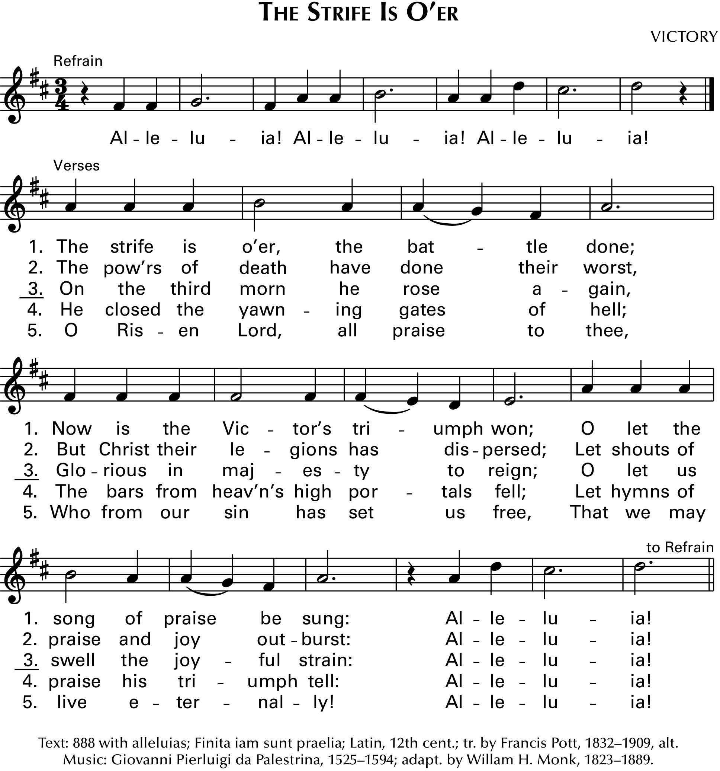“Alleluias” are from The Strife Is O’er, the Battle Done ELW # 366

P: Come, Holy Spirit, fill the hearts of your faithful, and kindle in us the fire of your love.

GOSPEL John 14:8-17

P: Announcement of the Gospel.

C: Glory to you, O Lord.

Though the disciples struggle with Jesus’s nature and identity, they receive the promise that they too will be identified with God and God’s mission. Though he must leave them now, Jesus promises the coming of the Advocate whom God will send to comfort and enlighten them.

⁸Philip said to [Jesus,] “Lord, show us the Father, and we will be satisfied.” ⁹Jesus said to him, “Have I been with you all this time, Philip, and you still do not know me? Whoever has seen me has seen the Father. How can you say, ‘Show us the Father’? ¹⁰Do you not believe that I am in the Father and the Father is in me? The words that I say to you I do not speak on my own; but the Father who dwells in me does his works. ¹¹Believe me that I am in the Father and the Father is in me; but if you do not, then believe me because of the works themselves. ¹²Very truly, I tell you, the one who believes in me will also do the works that I do and, in fact, will do greater works than these, because I am going to the Father. ¹³I will do whatever you ask in my name, so that the Father may be glorified in the Son. ¹⁴If in my name you ask me for anything, I will do it.

Continued on the next page.
¹⁵“If you love me, you will keep my commandments. ¹⁶And I will ask the Father, and he will give you another Advocate, to be with you forever. ¹⁷This is the Spirit of truth, whom the world cannot receive, because it neither sees him nor knows him. You know him, because he abides with you, and he will be in you.

P: Affirmation of the Gospel.

C: Praise to you, O Christ.

SERMON

HYMN OF THE DAY Come, Gracious Spirit, Heavenly Dove ELW # 404

Stanzas 1, 2, 3 and 4

Sung to The Church of Christ in Every Age ELW # 729

AFFIRMATION OF BAPTISM ELW pp. 234-237

PRAYERS OF INTERCESSION

Each petition ends with these words and response:

P: God of new life,

C: hear our prayer.

Concluding petition and response:

P: We raise these prayers to you, and those we carry in our hearts, trusting in your abundant mercy and your life-giving Spirit; through Jesus Christ, our Savior.

C: Amen.

The Good News of God’s Spirit Among Us
in the Holy Meal

OFFERING

ASSEMBLY SONG What Have We to Offer?

Printed on the next page.

What Have We to Offer?
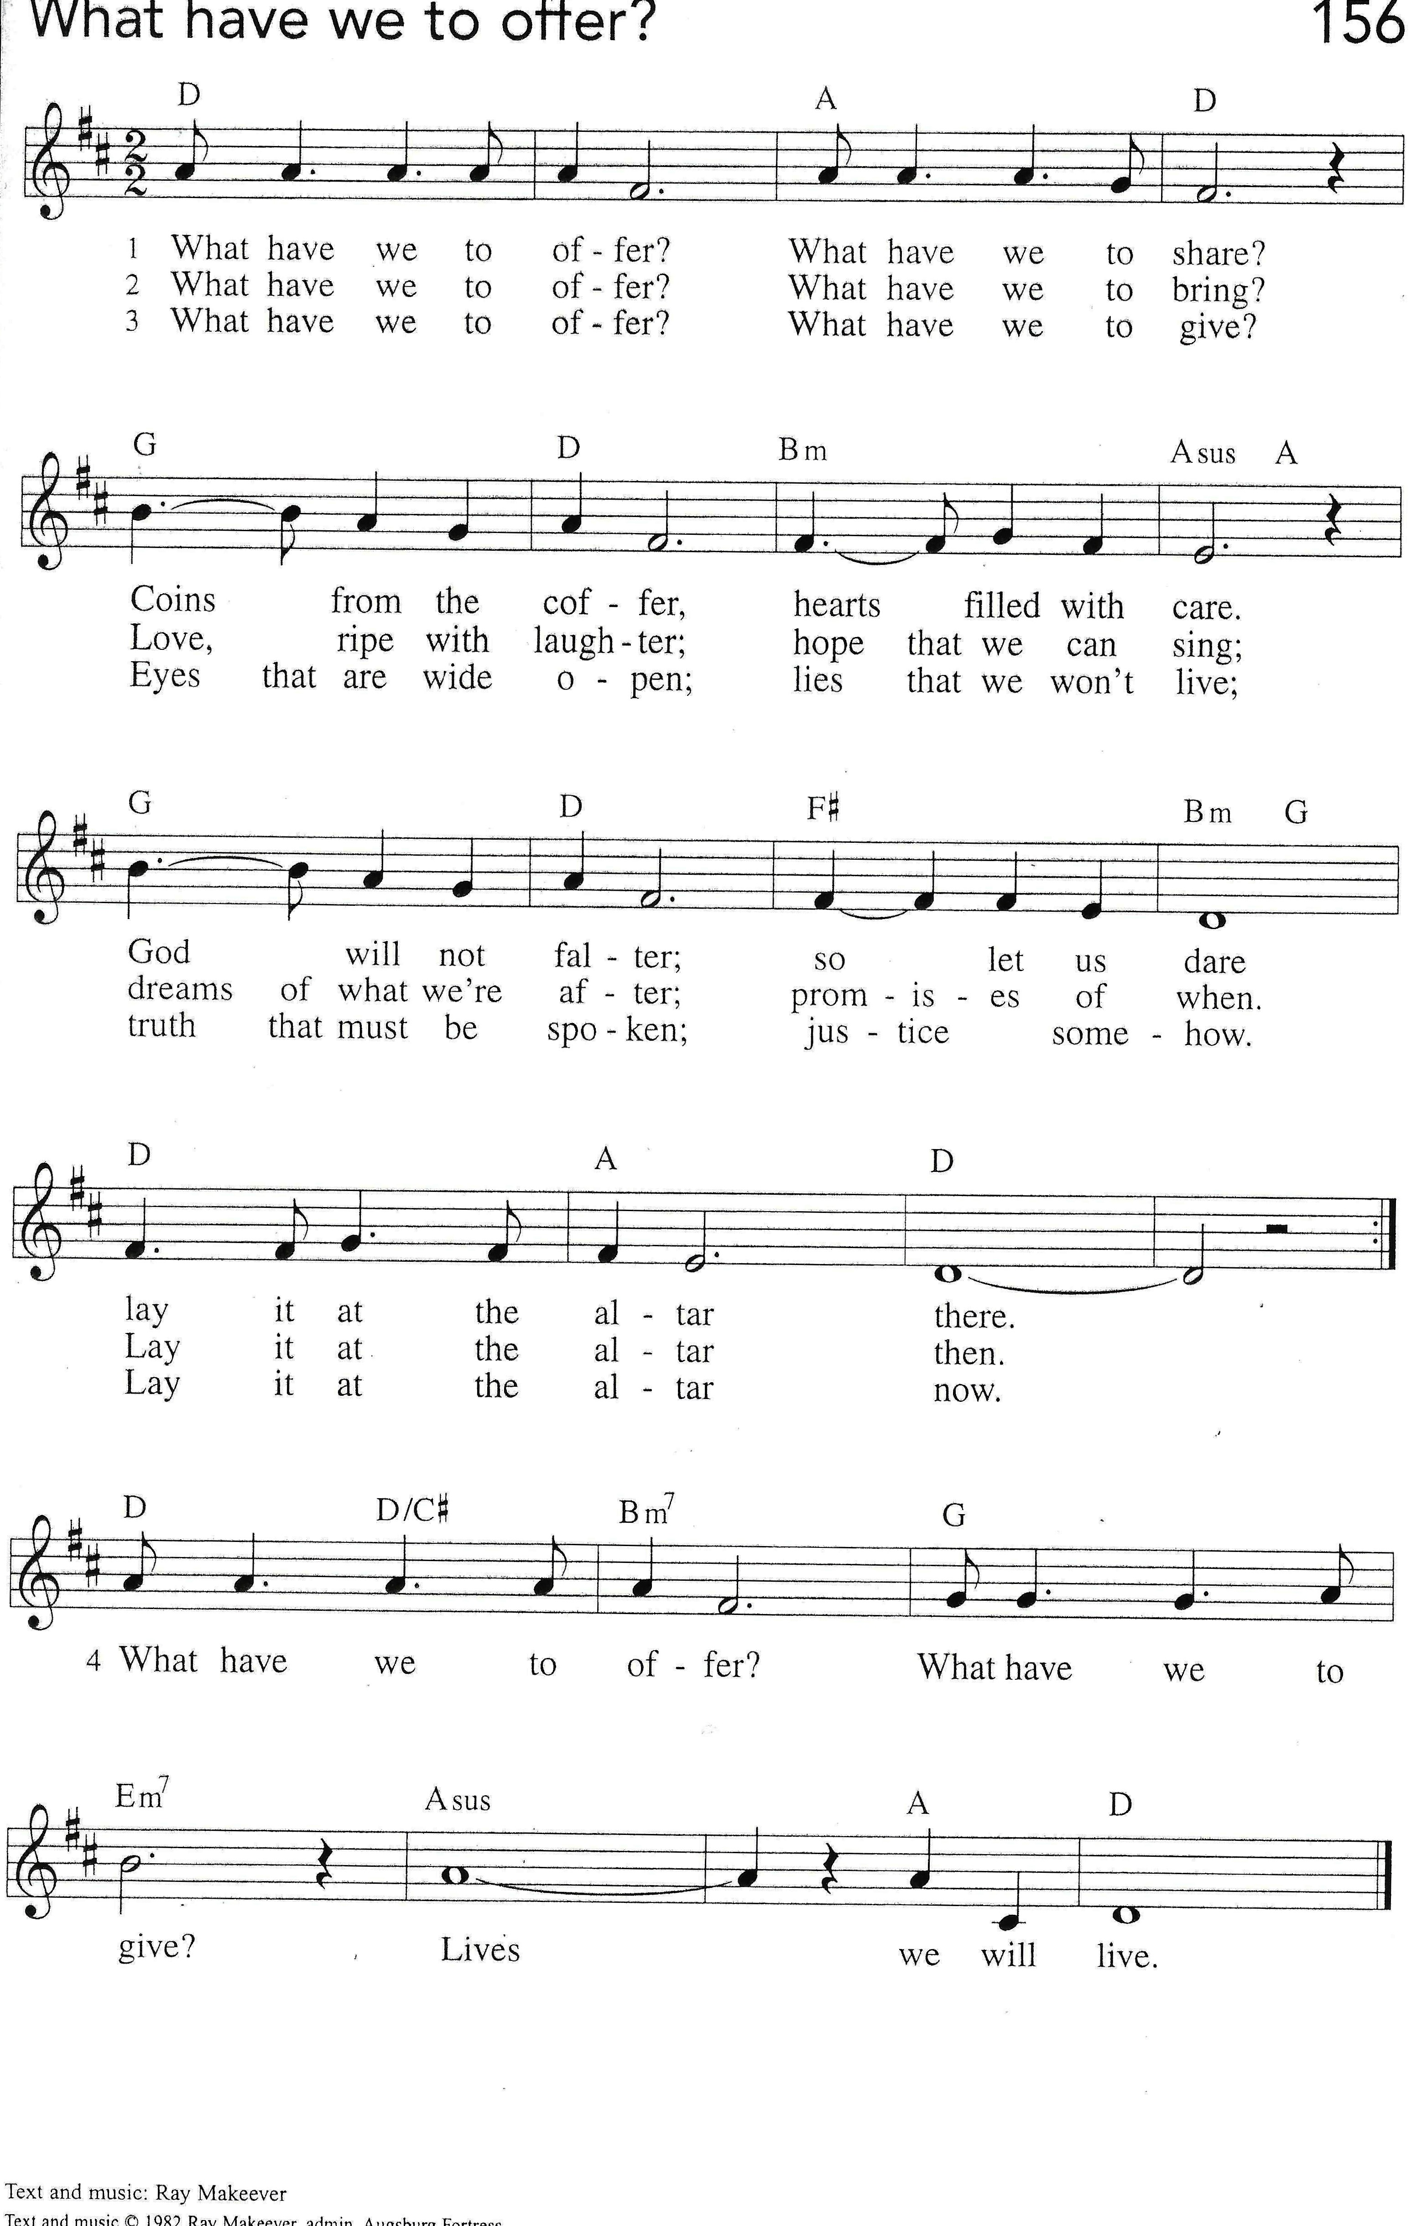
OFFERING PRAYER

A: Living God, you gather the wolf and the lamb to feed together in your peaceable reign, and you welcome us all at your table. Reach out to us through this meal, and show us your wounded and risen body, so that we may be nourished and believe in Jesus Christ, our Savior and Lord.

C: Amen.

GREAT THANKSGIVING

Dialogue

P: This morning we gather as part of a worldwide Easter community.

C: We come to share in the salvation that God’s Son, Jesus, has won for us.

P: Jesus took the bad news of sin, guilt, and death, and changed it into Good News through his dying and rising for us.

C: We are here to celebrate that Good News and the presence of the risen Jesus with us in Spirit and in his holy supper.

Words of Institution

P: In the night in which he was betrayed, our Lord Jesus took bread, and gave thanks; broke it, and gave it to his disciples, saying: Take and eat; this is my body, given for you. Do this for the remembrance of me.

Again, after supper, he took a cup of wine, gave thanks, and gave it for all to drink saying: This cup is the new covenant in my blood, shed for you and for all people for the forgiveness of sin. Do this for the remembrance of me.”

C: We thank you, O Lord, for this bread and wine, your body and blood, given and shed in love for us. Accept us, forgive us, and heal us that our lives might be pleasing to you.

Lord’s Prayer Traditional Wording

P: Gathered into one by the Holy Spirit, let us pray as Jesus taught us.

All: Our Father, who art in heaven, hallowed be thy name, thy kingdom come, thy will be done, on earth as it is in heaven. Give us this day our daily bread; and forgive us our trespasses, as we forgive those who trespass against us; and lead us not into temptation, but deliver us from evil. For thine is the kingdom, and the power, and the glory, forever and ever. Amen.
INVITATION TO COMMUNION

P: The risen Christ dwells with us here.
All who are hungry, all who are thirsty, come.

COMMUNION

What We Believe

Who May Receive. We welcome all baptized Christians to the Lord's Table. In our parish baptized children who have entered the 5th grade are instructed in this sacrament and receive their First Communion; younger children come to the altar and receive a blessing. If your baptized child has received such instruction, or if you want your baptized child to receive Communion, then he or she is welcome to partake.

Proper Preparation. In his Small Catechism, Martin Luther asks, "When is a person rightly prepared to receive this sacrament?" He answers, "Fasting and other outward preparations serve a good purpose. However, that person is well prepared and worthy who believes these words, given and shed for you for the remission of sins. But anyone who does not believe these words, or doubts them, is neither prepared nor worthy, for the words for you require simply a believing heart.”

Real Presence. We believe that the bread and wine truly are the body and blood of Christ given and shed for the forgiveness of sins.

Distribution

Holy Communion will be served in procession. The ushers will direct you down the center aisle. You will receive the elements near the chancel. Please extend your hands, palms up, if you will be receiving the bread. Gluten-free wafers are also available; please ask for one. Proceed to your right or to your left, depending on which side of the sanctuary you are seated, to receive the wine. White grape juice is available in the center ring of each tray for those who prefer an alcohol-free element. You may say “Amen” after receiving each element. If you will not be receiving Communion, keep your hands folded. Place your empty cup in the basket and then return to your seat by the side aisle.

Congregational Songs During Communion

Spirit of Gentleness ELW # 396 Stanzas 1, 2 & 3

Holy Spirit, Truth Divine ELW # 398 Stanzas 1, 2, 3 & 5

O Holy Spirit, Root of Life ELW # 399 Stanzas 1, 2 & 3

The Spirit Sends Us Forth to Serve ELW # 551 Stanzas 1, 2, 3 & 4

Seek Ye First WOV # 783 Stanzas 1, 2 & 3
PRAYER AFTER COMMUNION

A: We give you thanks, generous God, for in this bread and cup we have tasted the new heaven and earth where hunger and thirst are no more. Send us from this table as witnesses to the resurrection, that through our lives, all may know life in Jesus’s name.

C: Amen.

Sending

God blesses us and sends us in mission to the world.

ANNOUNCEMENTS

BLESSING

P: God, the Author of life,
Christ, the living Cornerstone, and
the life-giving Spirit of adoption,
☩ bless you now and forever.

C: Amen.

CLOSING HYMN O Day Full of Grace ELW # 627

Stanzas 1, 2, 3 and 4

DISMISSAL

P: Alleluia! Christ is risen.

C: Christ is risen indeed. Alleluia!

P: Go in peace. Tell what God has done.

C: Thanks be to God. Alleluia!

RINGING OF THE BELL

POSTLUDE

Today’s Assistants and Ministers

Greeters & Ushers …............................................................…...… Pat & Chris Troendle
Organist-Pianist ……..…………………………………………..……...……..…… Sue Holst
Presiding Minister ……………………………..….….….…………… Pastor Kerry Eversole
Reader ……………………………………….……….…….…………. Pat or Chris Troendle
Altar Care & Communion Preparation ……..……………………… Troendles and Rogers
Refreshments ………………….…….……… Duane & Melissa Gilbertson and Pam Ruen
Custodian ……………………………………..……………………………. Wayne Lukkason

Presence Last Week and May Presents

Attendance Last Sunday, May 29 = 36
Average Sunday Worship Attendance for May = 54

May Contributions: General Fund = $ Designated Giving = $
Jan-May Income = $ Jan-May Expenses = $ Deficit = $

This Week in Our Congregation

Today, June 5 — Day of Pentecost — Last Sunday of Easter

Refreshments in the Fellowship Hall for everyone following worship

Tuesday, June 7

Men’s breakfast at Home Sweet Home in Lanesboro 7:00 AM

Wednesday, June 8

Church Council Meeting 6:30 PM

Next Sunday, June 12 — The Holy Trinity — First Sunday after Pentecost

Worship 9:00 AM

Community Activities

Commencement for the Lanesboro High School Class of 2022, today, 1:30 pm, in the LPS Gymnasium.

Interment of Robert “Bebop” Hegg, next Saturday, June 11, at the Lanesboro Cemetery, for family and invited friends only. Public reception at the American Legion at 2:00 p.m.

Prayer Requests

In Our Community. For our church members and friends living with chronic illness and other diseases, who are homebound, residing in care facilities, and hospitalized. See the newsletter for our members living in area nursing homes. And let us not forget those sick and dying of COVID-19, those entrusted with the authority of government, justice, and law enforcement, as well as our fallen and wounded soldiers and those still serving.
In Our Synod. Bishop Regina Hassanally invites the people and congregations of our synod to commit to praying this week for the following faith communities: Bethlehem Lutheran Church, Lanesboro; First Lutheran Church, Lake City; First English Lutheran Church, Faribault; Mukulu Lutheran Church, Tanzania; Nkonkilangi Lutheran Church, Tanzania; and Justice y Vida Ministry, Colombia.

Acknowledgments

Graphics, worship texts, service music, and readings are from sundaysandseasons.com © 2022 Augsburg Fortress. Used by permission under Augsburg Fortress Liturgies Annual License SAS103296.

Permission to project, live stream, or podcast liturgy and music content under copyright to or administered by Augsburg Fortress provided under Augsburg Fortress Liturgies Annual License SAS103296.

Permission to Podcast / Stream provided by Christian Copyright Licensing International, Inc., under License # 11459672. Additional fee paid. www.ccli.com.

Permission to Podcast / Stream provided by One License, Inc., under License # A-735588. Additional fee paid. www.onelicense.net.

The Call to Worship, Communion Dialogue, and Words of Institution are reprinted by permission of the publisher from Plain Talk Before God: The Language of Worship, compiled by Handt A. Hanson and Paul Y. Murakami. Copyright © 1992 Prince of Peace Publishing, Inc./Changing Church, Inc.

What Have We to Offer? Text and music: Ray Makeever © 1982 Ray Makeever, admin. Augsburg Fortress. Reprinted under One License # A-735588. www.onelicense.net.

