Bethlehem Lutheran Church
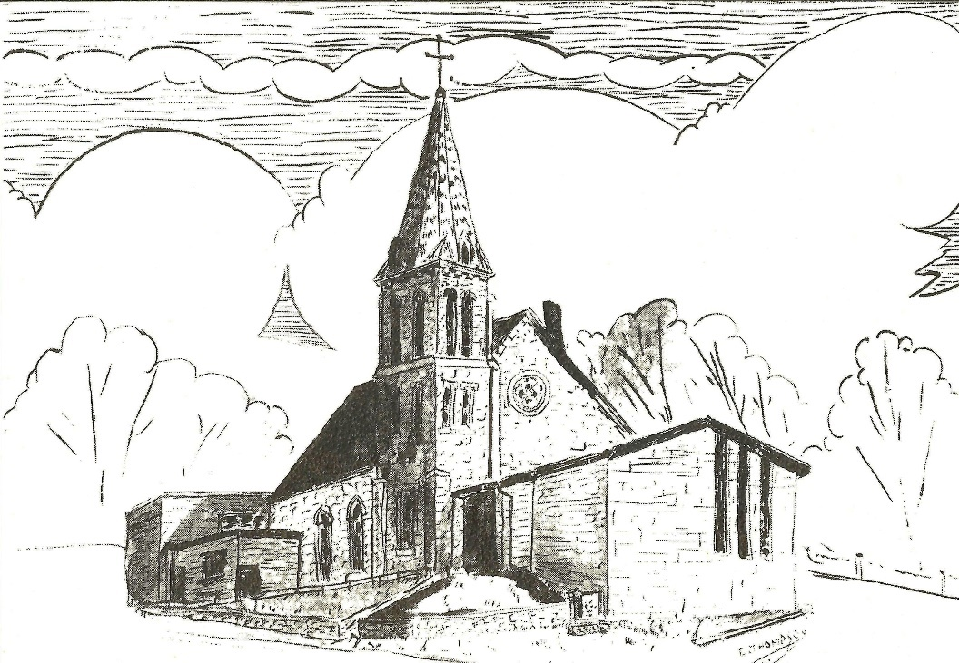Established 1874

Rev. Kerry B. Eversole, Pastor
Deacon Cindy Cordes-Eversole, Associate in Ministry

Mailing Address: P.O. Box 314, Lanesboro, MN 55949-0314
Physical Address: 200 Kenilworth Ave S, Lanesboro, Minn.

Telephone: 507.467.3344
E-mail Address: bethlehem@acegroup.cc
Website: www.staronthehill.com
Facebook Page: www.facebook.com/BethlehemLutheranLanesboro

Office Hours: Tuesday, Wednesday, Thursday 10 a.m. to 3 p.m.
Parsonage Phone: 507.467.3017
Pastor Kerry’s Cell Phone: 507.951.3954

Bethlehem Lutheran Church
Lanesboro, Minnesota

Sixth Sunday of Easter

May 22, 2022


Jesus said to his disciples, “Peace I leave with you; my peace I give to you. I do not give to you as the world gives. Do not let your hearts be troubled, and do not let them be afraid.” John 14:27
Welcome to worship at Bethlehem Lutheran Church
and our continuing celebration of Easter!

COVID-19 Practices — Out of love for God and Neighbor

1) Use hand sanitizer upon entry. Wash your hands and use hand sanitizer often while in the facility.
2) Members and visitors who are vaccinated and boosted are not required to wear a mask.
3) Members and visitors are free to wear a mask if they wish to do so.
4) Unvaccinated and not boosted members and visitors must wear a mask.
5) There are no physical distancing requirements, but you are welcome to keep a distance from others in the sanctuary as you are able.
6) All are welcome to enjoy coffee fellowship in the dining room following worship.

Worship Book and Hymns. This morning’s service is printed in this bulletin but can also be found with all the hymns in Evangelical Lutheran Worship (ELW), “the red book” in the pew bookracks, and on the pews. Hymns in ELW are indicated by a large bold number in each page’s left or right margin.

Abbreviations. Hymns are signified throughout this worship folder by the pound symbol (#). P: refers to the presiding minister or preacher, A: denotes an assisting minister, and C: and/or bold text indicates the congregation.

Mistakes do not happen in our worship service;
only unexpected events which are opportunities for joy!

An signifies that you may stand as you are comfortably able.

Introduction to the Season and the Day. We are deep in the fifty-day celebration of the Easter mystery, often referred to as the “week of weeks”. We turn to John the evangelist during these seven Sundays to provide sign after sign of Jesus’s victory over death.

For the sixth Sunday of Easter, visions abound in the readings. Paul has a vision about what to do. John has a vision of what will be. Jesus provides visions of peace that surpasses human understanding and power beyond human imagination.

Gathering

The Holy Spirit calls us together as the people of God.

MUSIC AS WE COME TOGETHER

RINGING OF THE BELL

WORDS OF WELCOME

THANKSGIVING FOR BAPTISM

P: Alleluia! Christ is risen!

C: Christ is risen indeed! Alleluia!

P: In the waters of baptism, we have passed over from death to life with Jesus Christ, and we are a new creation. For this saving mystery, and this water, let us bless God, who was, who is, and who is to come.

Water is poured into the font as the presiding minister gives thanks.

P: We thank you, God, for your river of life, flowing freely from your throne: through the earth, through every living thing, and through cities and towns,

You rescued Noah and his family from the flood; You opened wide the sea for the Israelites. Now in these waters, you flood us with mercy, and our sin is drowned forever. You open the gate of righteousness, and we pass safely through.

In Jesus Christ, you calm and trouble the waters. You nourish us and enclose us in safety. You call us forth and send us out. In lush and barren places, you are with us. You have become our salvation.

Now breathe upon this water and awaken your church once more.
Claim us again as your beloved and holy people.
Quench our thirst; cleanse our hearts; wipe away every tear.

To you, our Beginning and our End, our Shepherd and Lamb, be honor, glory, praise, and thanksgiving, now and forever.

C: Amen.

OPENING HYMN Alleluia! Jesus Is Risen! ELW # 377

GREETING ELW p. 213

P: The grace of our Lord Jesus Christ, the love of God, and the communion of the Holy Spirit be with you all.

C: And also with you.

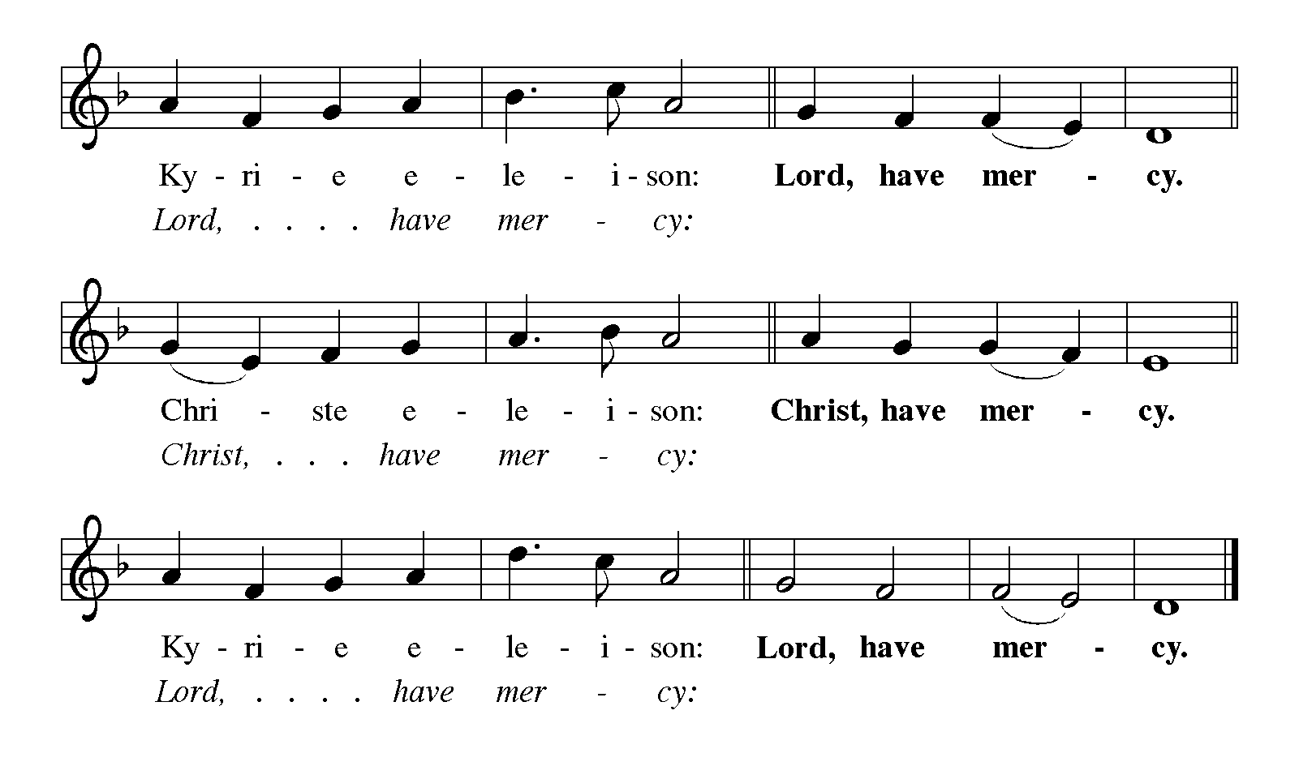KYRIE ELW p. 213

SONG OF PRAISE Blessing, Honor, and Glory ELW # 433

PRAYER OF THE DAY

P: Let us pray together.

Bountiful God,

All: you gather your people into your realm, and you promise us food from your tree of life. Nourish us with your word, that empowered by your Spirit we may love one another and the world you have made, through Jesus Christ, our Savior and Lord, who lives and reigns with you and the Holy Spirit, one God, now and forever. Amen.

The Good News of Easter

God speaks to us in scripture reading, preaching, and song.

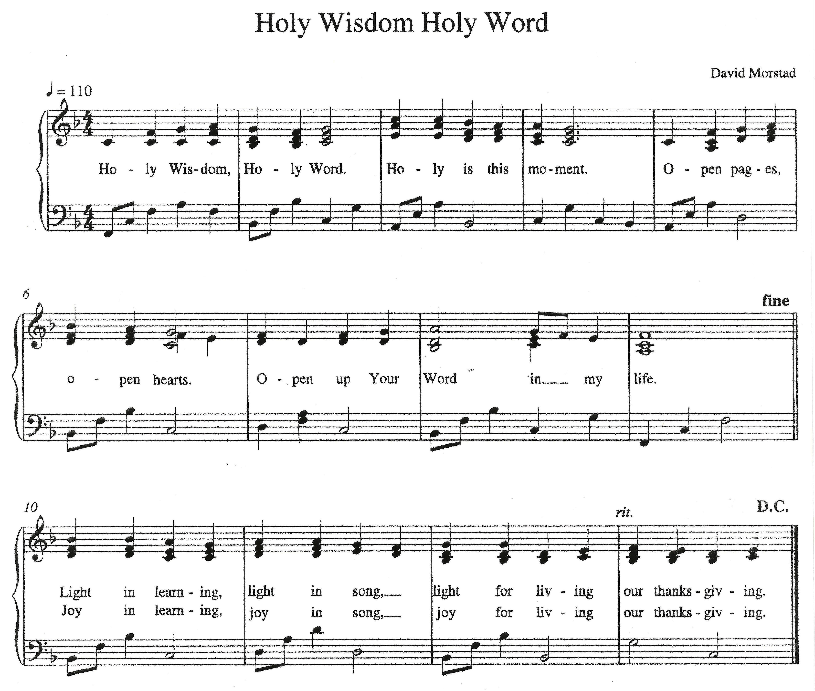SCRIPTURE SONG Holy Wisdom, Holy Word

FIRST READING Acts 16:9-15

A vision compels Paul to move his ministry into Greece. There he meets Lydia, an important person in the business community, whose heart has been opened by God to receive the gospel. Her conversion and baptism provide the impetus for the founding of the church at Philippi.

Continued on the next page.

⁹During the night Paul had a vision: there stood a man of Macedonia pleading with him and saying, “Come over to Macedonia and help us.” ¹⁰When he had seen the vision, we immediately tried to cross over to Macedonia, being convinced that God had called us to proclaim the good news to them.
¹¹We set sail from Troas and took a straight course to Samothrace, the following day to Neapolis, ¹²and from there to Philippi, which is a leading city of the district of Macedonia and a Roman colony. We remained in this city for some days. ¹³On the sabbath day we went outside the gate by the river, where we supposed there was a place of prayer; and we sat down and spoke to the women who had gathered there. ¹⁴A certain woman named Lydia, a worshiper of God, was listening to us; she was from the city of Thyatira and a dealer in purple cloth. The Lord opened her heart to listen eagerly to what was said by Paul. ¹⁵When she and her household were baptized, she urged us, saying, “If you have judged me to be faithful to the Lord, come and stay at my home.” And she prevailed upon us.

A: Word of God, word of life.

C: Thanks be to God.

PSALM 67

May God be merciful to us and bless us; may the light of God’s face shine upon us.

Let your way be known upon earth, your saving health among all nations.

Let the peoples praise you, O God; let all the peoples praise you.

Let the nations be glad and sing for joy, for you judge the peoples with equity and guide all the nations on earth.

Let the peoples praise you, O God; let all the peoples praise you.

The earth has brought forth its increase; God, our own God, has blessed us.

May God give us blessing, and may all the ends of the earth stand in awe.

Let the nations be glad and sing for joy.

SECOND READING Revelation 21:10, 22—22:5

John’s vision of a new Jerusalem coming out of heaven provides continuity with God’s past actions. Yet in this new city, God’s presence replaces the temple, and the glory of God and the Lamb supplants sun and moon.

¹⁰And in the spirit [one of the angels] carried me away to a great, high mountain and showed me the holy city Jerusalem coming down out of heaven from God.
²²I saw no temple in the city, for its temple is the Lord God the Almighty and the Lamb. ²³And the city has no need of sun or moon to shine on it, for the glory of God is its light, and its lamp is the Lamb. ²⁴The nations will walk by its light, and the kings of the earth will bring their glory into it. ²⁵Its gates will never be shut by day—and there will be no night there. ²⁶People will bring into it the glory and the honor of the nations. ²⁷But nothing unclean will enter it, nor anyone who practices abomination or falsehood, but only those who are written in the Lamb’s book of life.
^{22:1}Then the angel showed me the river of the water of life, bright as crystal, flowing from the throne of God and of the Lamb ²through the middle of the street of the city. On either side of the river is the tree of life with its twelve kinds of fruit, producing its fruit each month; and the leaves of the tree are for the healing of the nations. ³Nothing accursed will be found there anymore. But the throne of God and of the Lamb will be in it, and his servants will worship him; ⁴they will see his face, and his name will be on their foreheads. ⁵And there will be no more night; they need no light of lamp or sun, for the Lord God will be their light, and they will reign forever and ever.

A: The word of the Lord.

C: Thanks be to God.

GOSPEL ACCLAMATION Alleluia ELW p. 216

Printed on the next page.

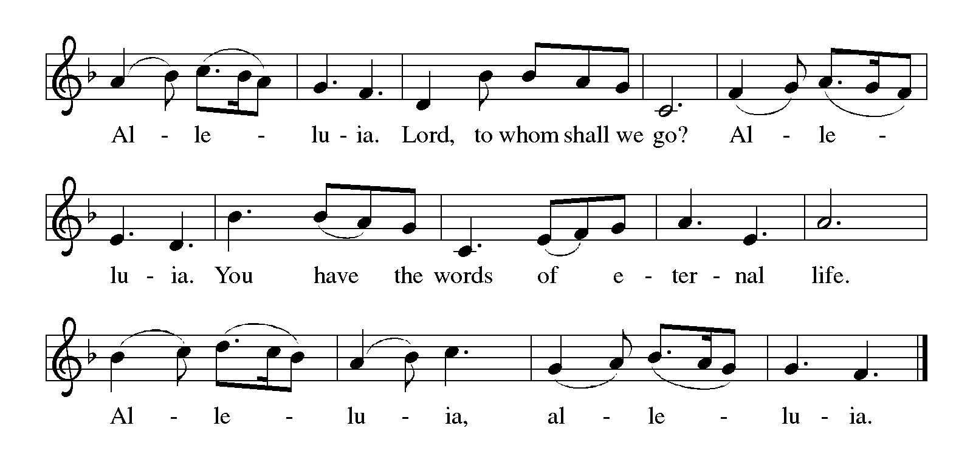

GOSPEL John 14:23-29

P: Announcement of the Gospel.

C: Glory to you, O Lord.

As Jesus talks of returning to the Father, he promises to send the Advocate, the Holy Spirit, who will teach Jesus’ followers and remind them of all that Jesus taught. Even more, those in whom God makes a home will experience a peace that overcomes fear.

²³Jesus answered [Judas (not Iscariot),] “Those who love me will keep my word, and my Father will love them, and we will come to them and make our home with them. ²⁴Whoever does not love me does not keep my words; and the word that you hear is not mine, but is from the Father who sent me.
²⁵“I have said these things to you while I am still with you. ²⁶But the Advocate, the Holy Spirit, whom the Father will send in my name, will teach you everything, and remind you of all that I have said to you. ²⁷Peace I leave with you; my peace I give to you. I do not give to you as the world gives. Do not let your hearts be troubled, and do not let them be afraid. ²⁸You heard me say to you, ‘I am going away, and I am coming to you.’ If you loved me, you would rejoice that I am going to the Father, because the Father is greater than I. ²⁹And now I have told you this before it occurs, so that when it does occur, you may believe.”

P: Affirmation of the Gospel.

C: Praise to you, O Christ.
SERMON

SONG OF THE DAY Love Divine, All Loves Excelling ELW # 631

PRAYERS OF GOD’S PEOPLE

After the last petition, all sing ELW # 752

Lord, Listen to Your Children Praying

Thanksgiving

We give thanks for God’s Easter word.

OFFERING AND MUSIC

SONG AS THE GIFTS ARE RECEIVED When Peace Like a River ELW # 785

Stanzas 1, 2 and 3

THANKSGIVING FOR THE WORD ELW p. 220

P: Praise and thanks to you, holy God, for by your Word you made all things: you spoke light into darkness, called forth beauty from chaos, and brought life into being. For your Word of life, O God,

C: we give you thanks and praise.

P: By your Word you called your people Israel to tell of your wonderful gifts: freedom from captivity, water on the desert journey, a pathway home from exile, wisdom for life with you. For your Word of life, O God,

C: we give you thanks and praise.

P: Through Jesus, your Word made flesh, you speak to us and call us to witness: forgiveness through the cross, life to those entombed by death, the way of your self-giving love. For your Word of life, O God,

C: we give you thanks and praise.

P: Send your Spirit of truth, O God; rekindle your gifts within us: renew our faith, increase our hope, and deepen our love, for the sake of a world in need. Faithful to your Word, O God, draw near to all who call on you; through Jesus Christ, our Savior and Lord, to whom, with you and the Holy Spirit, be honor and glory forever.

C: Amen.

LORD’S PRAYER Traditional Wording ELW p. 221

P: Gathered into one by the Holy Spirit, let us pray as Jesus taught us.

All: Our Father, who art in heaven, hallowed be thy name, thy kingdom come, thy will be done, on earth as it is in heaven. Give us this day our daily bread; and forgive us our trespasses, as we forgive those who trespass against us; and lead us not into temptation, but deliver us from evil. For thine is the kingdom, and the power, and the glory, forever and ever. Amen.

Sending

God blesses us and sends us in mission to the world.

ANNOUNCEMENTS

BLESSING

P: God, the Author of life, Christ, the living Cornerstone, and the life-giving Spirit of adoption, ☩ bless you now and forever.

C: Amen.

DEPARTING SONG My Life Flows on in Endless Song ELW # 763

DISMISSAL

P: Alleluia! Christ is risen.

C: Christ is risen indeed. Alleluia!

P: Go in peace. Tell what God has done.

C: Thanks be to God. Alleluia!

RINGING OF THE BELL

SENDING MUSIC

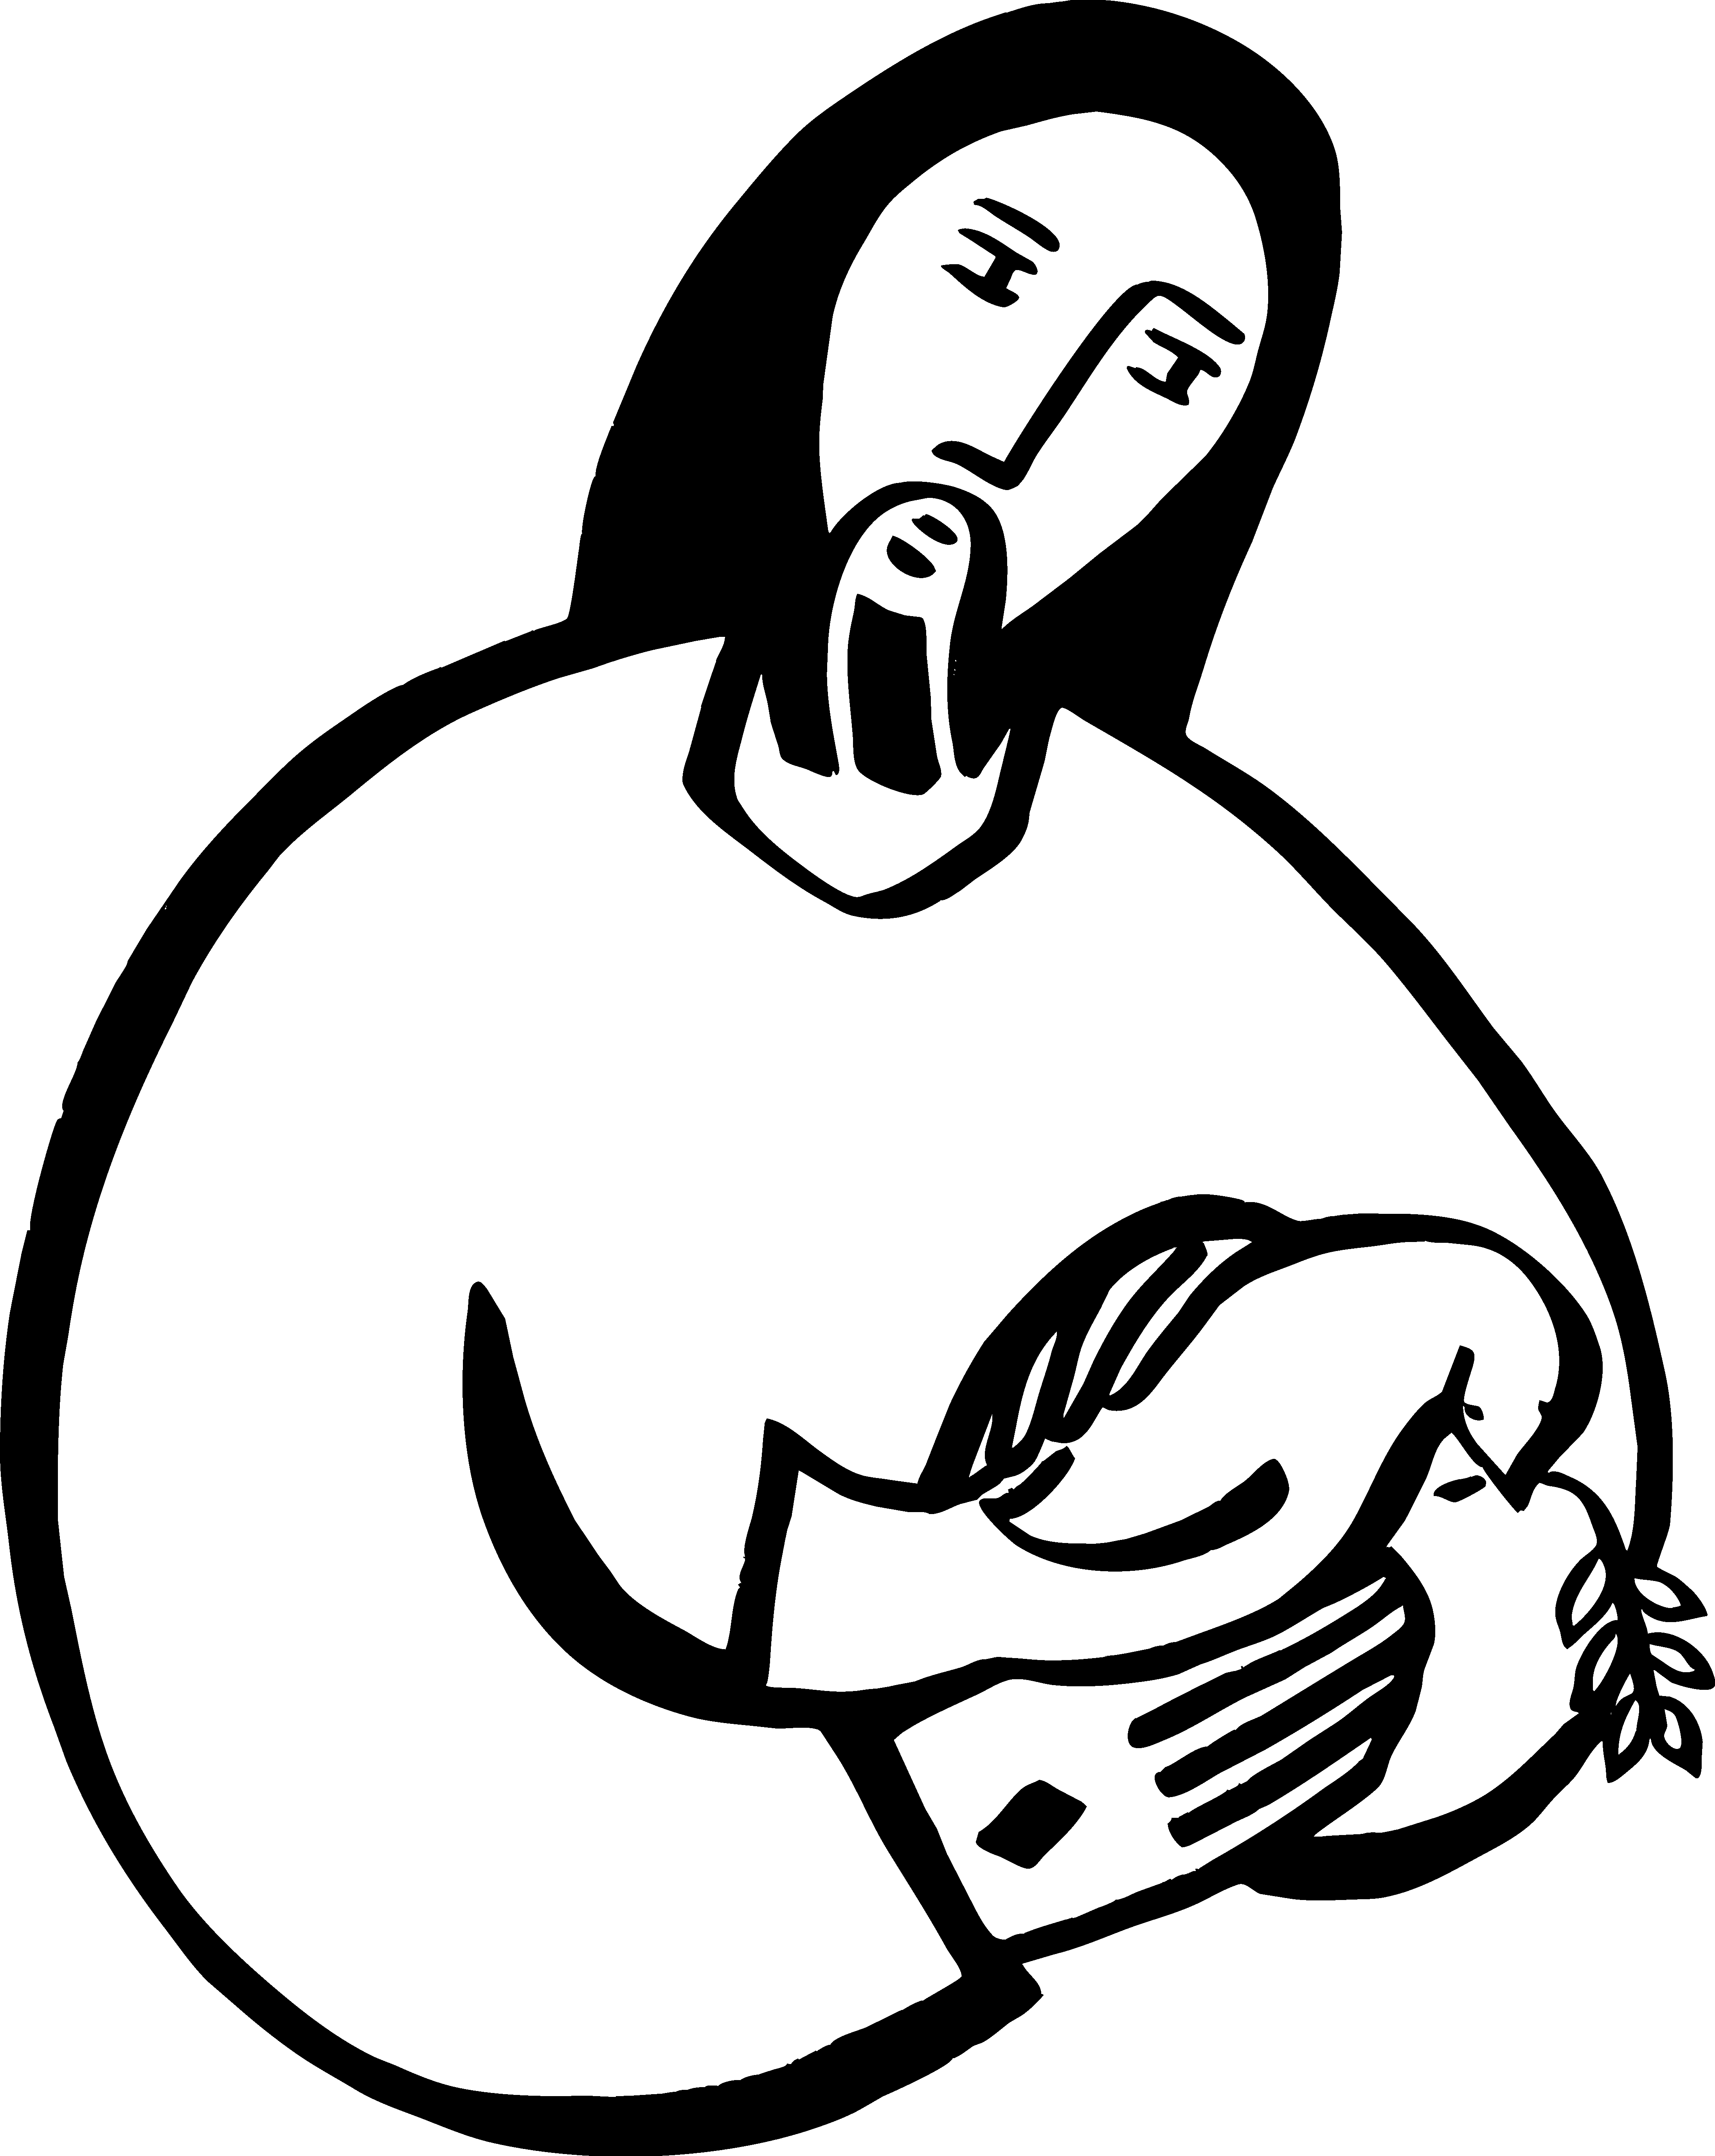

Today’s Assistants and Ministers

Greeters & Ushers …............................................................…...… Tim & Julie Kiehne and
Dave Ruen
Music Accompaniests ……..………………...…………..…… Sue Holst and the Praise Band
Presiding Minister …………………………………….……….….…………… Pastor Kay Wold
Reader ……………………………………………..…………..…….…….…………. Tim Kiehne
Altar Care ……………………………………………………….……………… Wayne Lukkason
Refreshments ………………..…….…….……… Brunch provided by the May Service Group
Custodian ………………………………………………………………………. Wayne Lukkason

Presence Last Week and April Presents

Attendance Last Sunday, May 15 = 48
Average Sunday Worship Attendance for April = 98

April Contributions: General Fund = $20,964 Designated Giving = $1,910
Jan-Apr Income = $57,782 Jan-Apr Expenses = $59,301 Deficit = $1,519

This Week in Our Congregation

Today, May 22 — Sixth Sunday of Easter

Brunch in the Fellowship Hall for everyone following worship

Tuesday, May 24

Men’s breakfast at Home Sweet Home in Lanesboro 7:00 AM

Wednesday, May 25

WELCA Bible Study 9:00 AM

Thursday, May 26

Pastor Kerry at Park Lane Estates, Preston, for Bible study/chapel 9:30 AM
Pastor Kerry at Good Shepherd Lutheran Home, Rushford for chapel 1:30 PM

Next Sunday, May 29 — Seventh Sunday of Easter — Memorial Day Weekend

Worship 9:00 AM

News and Notes

Pastor Kerry and Deacon Cindy are on vacation today. They are attending their son Matthew’s graduation from Luther College in Decorah, Iowa.

Please warmly welcome Pastor Kay Wold who is filling in for Pastor Kerry and Deacon Cindy.

Brunch following worship today! Come and enjoy the first of several after-worship food and fellowship gatherings for our congregation. The May Service Group is providing egg bake, muffins, fruit, juice, milk, coffee, and tea for all to enjoy. A freewill offering will be received for the Bethlehem Roof Repair Fund.
News and Notes continued

Rhu-dog Stand needs your help. We are asking for your help to staff the Rhu-dog stand at Lanesboro’s Rhubarb Festival on Saturday, June 4, in Sylvan Park. Profits from this year’s Rhu-dog stand will go to Bethlehem’s general fund and roof fund. Please sign up to work on the sheet in the fellowship hall. This is a fun and easy fundraiser for our congregation, and it’s a great day to be in Sylvan Park!

Prayer Requests

In Our Community. For our church members and friends living with chronic illness and other diseases, who are homebound, residing in care facilities, and hospitalized. See the newsletter for our members living in area nursing homes. And let us not forget those sick and dying of COVID-19, those entrusted with the authority of government, justice, and law enforcement, as well as our fallen and wounded soldiers and those still serving.

In Our Synod. Bishop Regina Hassanally invites the people and congregations of our synod to commit to praying this week for the following faith communities: Good Shepherd Lutheran Church, Rochester; Greenfield Lutheran Church, Harmony; Ulemo Lutheran Church, Tanzania; Ntwike Lutheran Church, Tanzania; Ihanja Technical School, Tanzania; and Asivida Ministry, Colombia.

Acknowledgments

Graphics, worship texts, service music, and readings are from sundaysandseasons.com © 2022 Augsburg Fortress. Used by permission under Augsburg Fortress Liturgies Annual License SAS103296.

Permission to project, live stream, or podcast liturgy and music content under copyright to or administered by Augsburg Fortress provided under Augsburg Fortress Liturgies Annual License SAS103296.

Permission to Podcast / Stream provided by Christian Copyright Licensing International, Inc., under License # 11459672. Additional fee paid. www.ccli.com.

Permission to Podcast / Stream provided by One License, Inc., under License # A-735588. Additional fee paid. www.onelicense.net.

Holy Wisdom, Holy Word Text and Music: David Morstad, My Word! The Bible for Everyone 2009-2010 Christian Education Planning Guide developed by ELCA Christian Education of the Evangelical Outreach and Congregational Mission unit. Copyright © 2009 Evangelical Lutheran Church in America. Permission is granted to photocopy this resource provided copies are for local use only and each copy carries this copyright notice.

