Bethlehem Lutheran Church
Established 1874

Rev. Kerry B. Eversole, Pastor
Deacon Cindy Cordes-Eversole, Associate in Ministry

Mailing Address: P.O. Box 314, Lanesboro, MN 55949-0314
Physical Address: 200 Kenilworth Ave S, Lanesboro, Minn.

Telephone: 507.467.3344
E-mail Address: bethlehem@acegroup.cc
Website: www.staronthehill.com
Facebook Page: www.facebook.com/BethlehemLutheranLanesboro

Office Hours: Tuesday, Wednesday, Thursday 10 a.m. to 3 p.m.
Parsonage Phone: 507.467.3017
Pastor Kerry’s Cell Phone: 507.951.3954

Bethlehem Lutheran Church
Lanesboro, Minnesota

Fifth Sunday of Easter

May 15, 2022


Jesus said, “I give you a new commandment, that you love one another. Just as I have loved you, you also should love one another. By this everyone will know that you are my disciples, if you have love for one another.” John 13:34-35
Welcome to worship at Bethlehem Lutheran Church
and our continuing celebration of Easter!

COVID-19 Practices — Out of love for God and Neighbor

1) Use hand sanitizer upon entry. Wash your hands and use hand sanitizer often while in the facility.
2) Members and visitors who are vaccinated and boosted are not required to wear a mask.
3) Members and visitors are free to wear a mask if they wish to do so.
4) Unvaccinated and not boosted members and visitors must wear a mask.
5) There are no physical distancing requirements, but you are welcome to keep a distance from others in the sanctuary as you are able.
6) All are welcome to enjoy coffee fellowship in the dining room following worship.

Worship Book and Hymns. This morning’s service is printed in this bulletin but can also be found with all the hymns in Evangelical Lutheran Worship (ELW), “the red book” in the pew bookracks, and on the pews. Hymns in ELW are indicated by a large bold number in each page’s left or right margin.

Abbreviations. Throughout this worship folder, the number symbol (#) signifies hymns, P: refers to the presiding minister or preacher, A: denotes an assisting minister, and C: and/or bold text indicates the congregation.

Mistakes do not happen in our worship service;
only unexpected events which are opportunities for joy!

An signifies that you may stand as you are comfortably able.

Introduction to the Season and the Day. We are deep in the fifty-day celebration of the Easter mystery, often referred to as a “week of weeks”. We turn to John the evangelist during these seven Sundays to provide sign after sign of Jesus’s victory over death.

On this fifth Sunday of Easter, we hear again that Easter initiates a new day. It anticipates a new heaven and a new earth. The risen Christ is making all things new. In the mystery of holy baptism, God has made new people of us. Today Jesus invites us to see everyone in a new light—through the lens of love.

Gathering

The Holy Spirit calls us together as the people of God.

PRELUDE

RINGING OF THE BELL

SALUTATION

OPENING HYMN Now All the Vault of Heaven Resounds ELW # 367

Stanzas 1, 2 and 3

GREETING

P: Alleluia! Christ is risen!

C: Christ is risen indeed! Alleluia!

P: The joy and peace of our risen Savior, the love of God, and the communion of the Holy Spirit be with you all.

C: And also with you.

KYRIE ELW p. 138
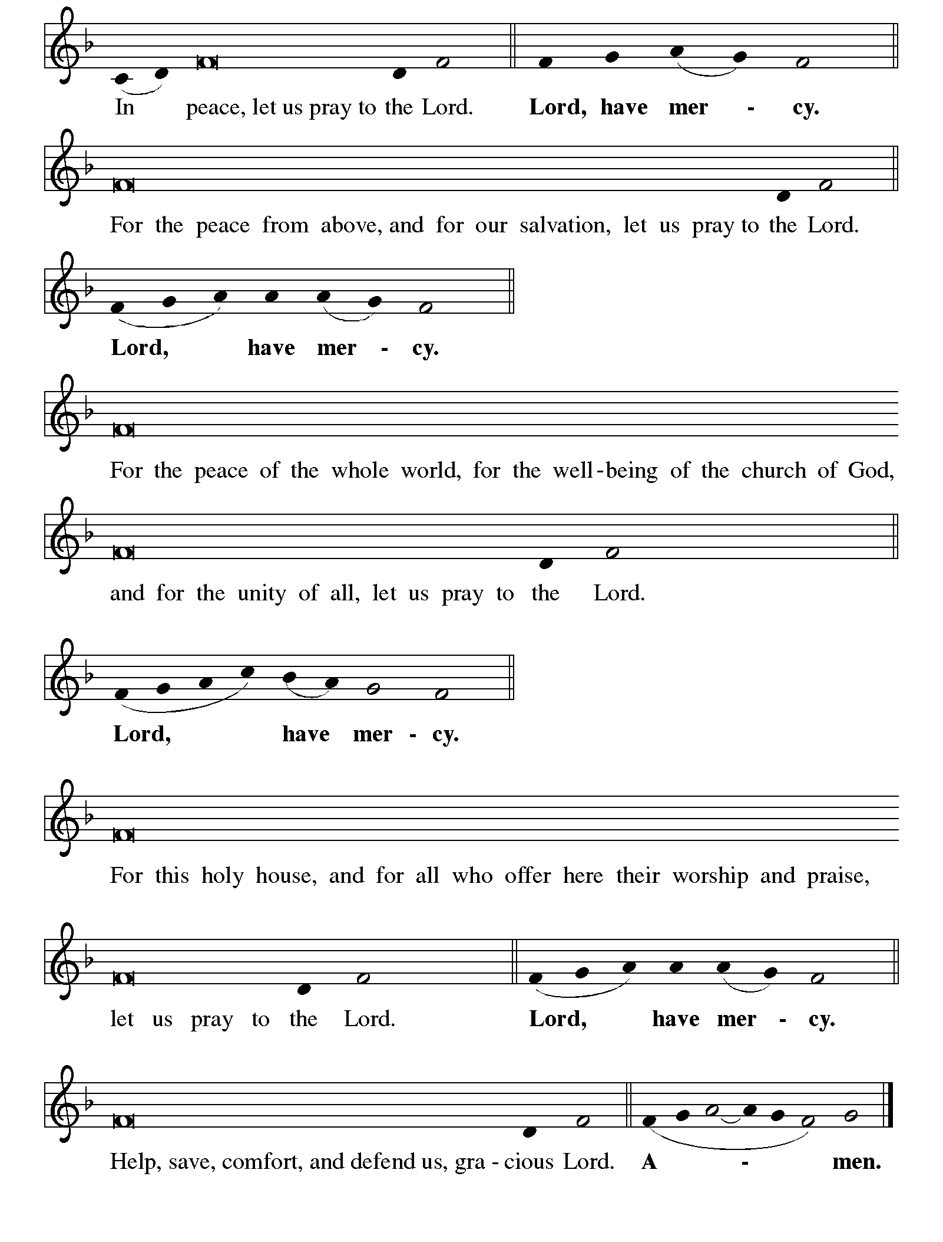

Continued on the next page

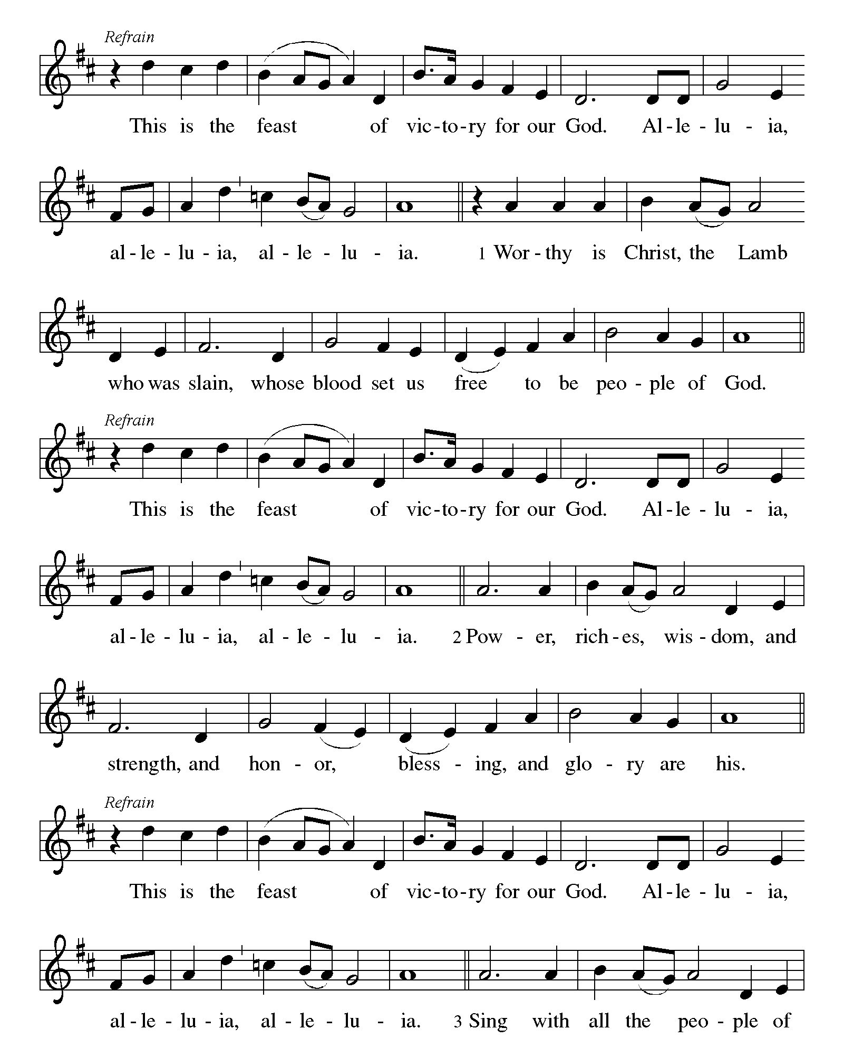KYRIE concluded ELW pp. 138-139

CANTICLE OF PRAISE This is the Feast ELW p. 140

Printed on the next page.

Continued on the next page.

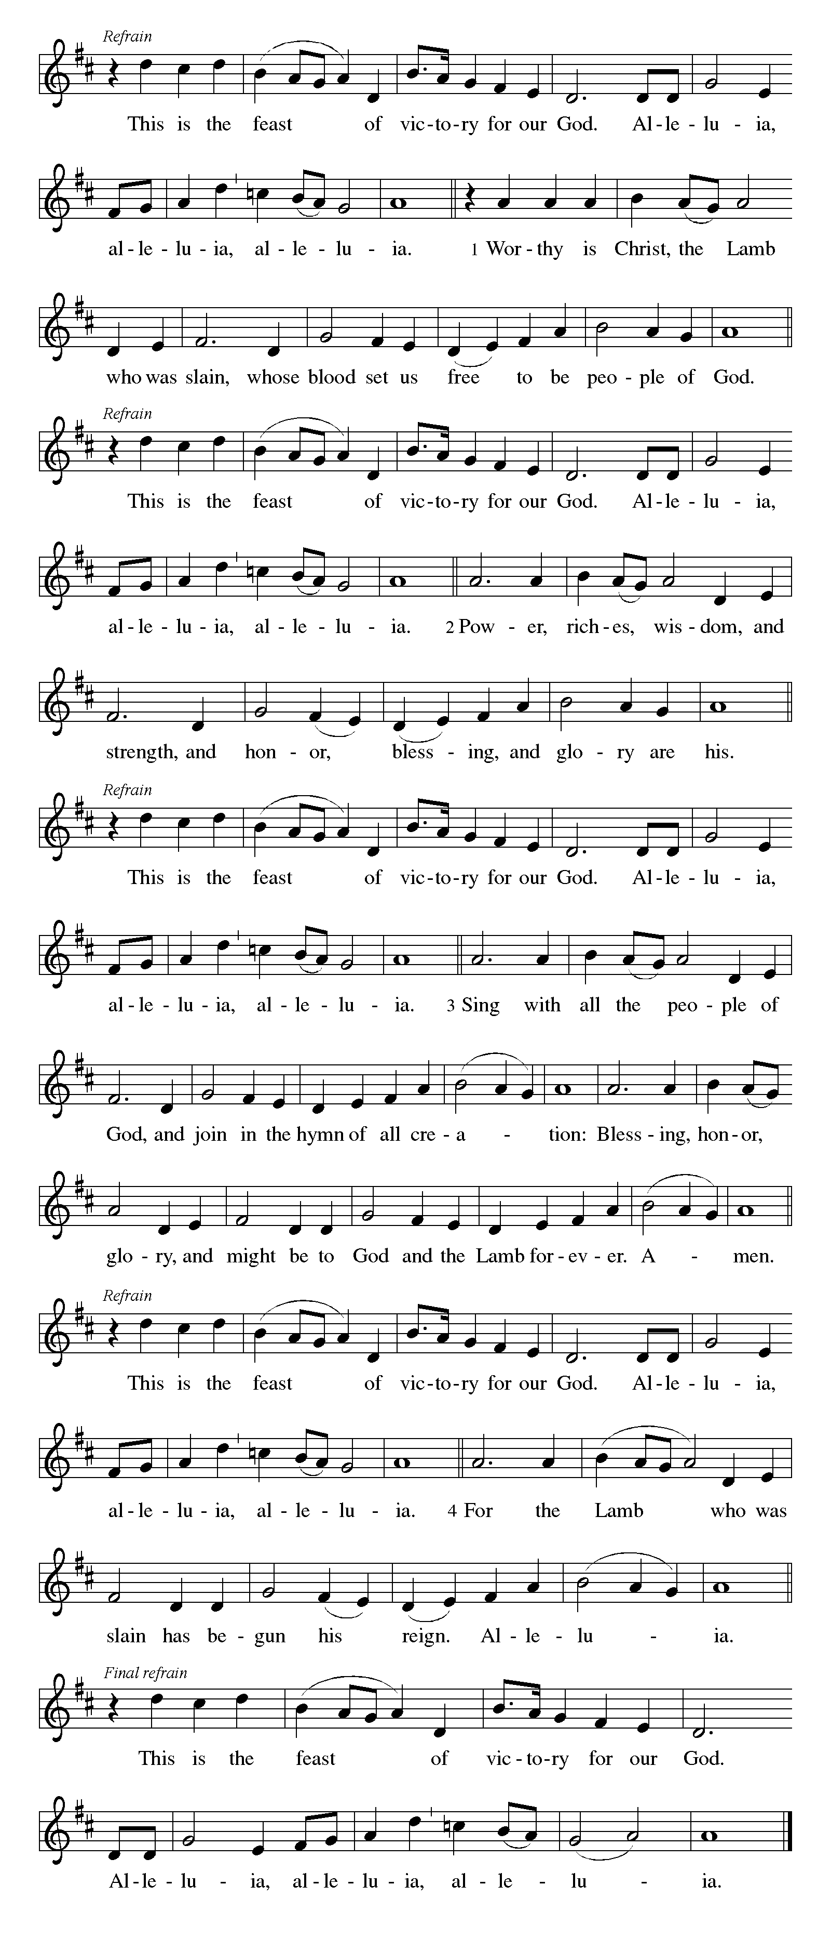CANTICLE OF PRAISE continued ELW p. 141

Continued on the next page.

CANTICLE OF PRAISE concluded ELW p. 141

PRAYER OF THE DAY

P: O Lord God, you teach us that without love, our actions gain nothing. Pour into our hearts your most excellent gift of love, that, made alive by your Spirit, we may know goodness and peace, through your Son, Jesus Christ, our Savior and Lord, who lives and reigns with you and the Holy Spirit, one God, now and forever.

C: Amen.

The Good News of Easter

God speaks to us in scripture reading, preaching, and song.

FIRST READING Acts 11:1-18

In defense of his earlier baptism of non-Jewish believers, Peter demonstrates to the members of the Jerusalem church that God’s intention to love Gentiles as well as Jews is revealed in Jesus’s testimony. In this way, the mission to the Gentiles is officially authorized.

¹Now the apostles and the believers who were in Judea heard that the Gentiles had also accepted the word of God. ²So when Peter went up to Jerusalem, the circumcised believers criticized him, ³saying, “Why did you go to uncircumcised men and eat with them?” ⁴Then Peter began to explain it to them, step by step, saying, ⁵“I was in the city of Joppa praying, and in a trance I saw a vision. There was something like a large sheet coming down from heaven, being lowered by its four corners; and it came close to me. ⁶As I looked at it closely I saw four-footed animals, beasts of prey, reptiles, and birds of the air. ⁷I also

Continued on the next page.
heard a voice saying to me, ‘Get up, Peter; kill and eat.’ ⁸But I replied, ‘By no means, Lord; for nothing profane or unclean has ever entered my mouth.’ ⁹But a second time the voice answered from heaven, ‘What God has made clean, you must not call profane.’ ¹⁰This happened three times; then everything was pulled up again to heaven. ¹¹At that very moment three men, sent to me from Caesarea, arrived at the house where we were. ¹²The Spirit told me to go with them and not to make a distinction between them and us. These six brothers also accompanied me, and we entered the man’s house. ¹³He told us how he had seen the angel standing in his house and saying, ‘Send to Joppa and bring Simon, who is called Peter; ¹⁴he will give you a message by which you and your entire household will be saved.’ ¹⁵And as I began to speak, the Holy Spirit fell upon them just as it had upon us at the beginning. ¹⁶And I remembered the word of the Lord, how he had said, ‘John baptized with water, but you will be baptized with the Holy Spirit.’ ¹⁷If then God gave them the same gift that he gave us when we believed in the Lord Jesus Christ, who was I that I could hinder God?” ¹⁸When they heard this, they were silenced. And they praised God, saying, “Then God has given even to the Gentiles the repentance that leads to life.”

A: Word of God, word of life.

C: Thanks be to God.

SECOND READING Revelation 21:1-6

John’s vision shows us that in the resurrection the new age has dawned; God dwells with us already. Yet we wait for the time when the tears that cloud our vision will be wiped away. Then we will see the new heaven, new earth, and new Jerusalem.

¹I saw a new heaven and a new earth; for the first heaven and the first earth had passed away, and the sea was no more. ²And I saw the holy city, the new Jerusalem, coming down out of heaven from God, prepared as a bride adorned for her husband. ³And I heard a loud voice from the throne saying,
“See, the home of God is among mortals.
He will dwell with them;
they will be his peoples,
and God himself will be with them;
⁴he will wipe every tear from their eyes.
Death will be no more;
mourning and crying and pain will be no more,
for the first things have passed away.”

Continued on the next page.
⁵And the one who was seated on the throne said, “See, I am making all things new.” Also he said, “Write this, for these words are trustworthy and true.” ⁶Then he said to me, “It is done! I am the Alpha and the Omega, the beginning and the end. To the thirsty I will give water as a gift from the spring of the water of life.”

A: Word of God, word of life.

C: Thanks be to God.

GOSPEL ACCLAMATION

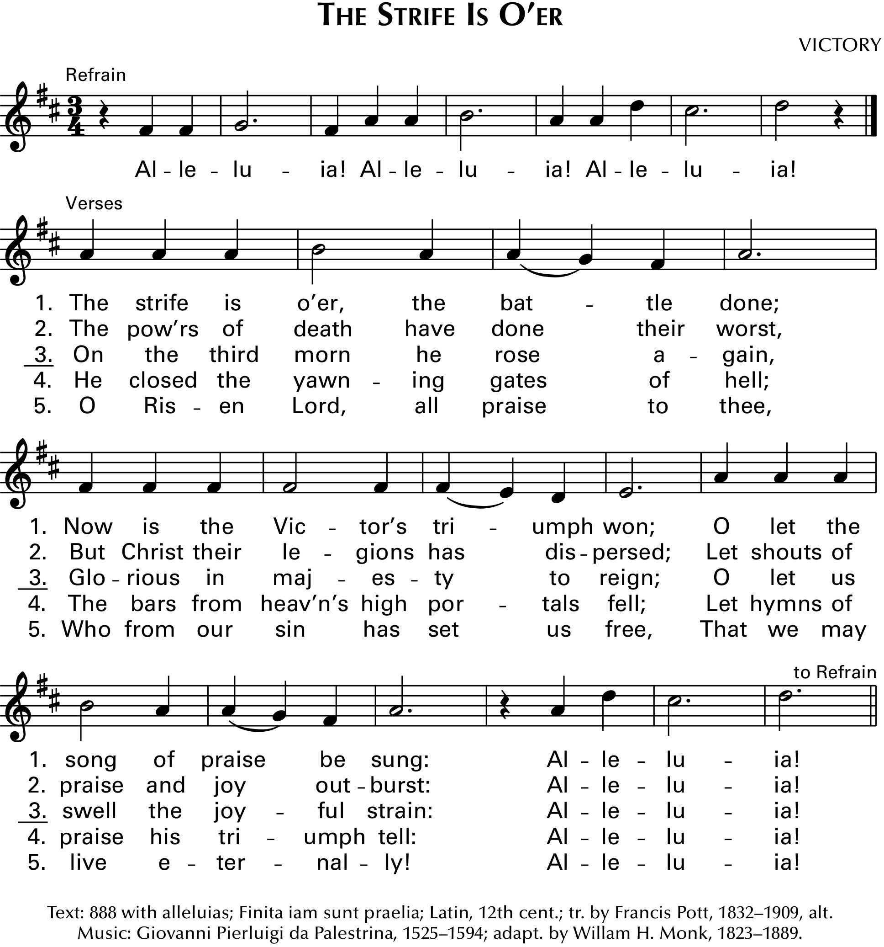“Alleluias” are from The Strife Is O’er, the Battle Done ELW # 366

P: Everyone will know that you are my disciples if you have love for one another. John 13:35

GOSPEL John 13:31-35

P: Announcement of the Gospel.

C: Glory to you, O Lord.

After washing the disciples’ feet, predicting his betrayal, and then revealing his betrayer, Jesus speaks of his glorification on the cross. This deep complicated love of Jesus, even to death on the cross, will be the distinctive mark of Jesus’ community.

³¹When he had gone out, Jesus said, “Now the Son of Man has been glorified, and God has been glorified in him. ³²If God has been glorified in him, God will also glorify him in himself and will glorify him at once. ³³Little children, I am with you only a little longer. You will look for me; and as I said to the Jews so now I say to you, ‘Where I am going, you cannot come.’ ³⁴I give you a new

Continued on the next page.
commandment, that you love one another. Just as I have loved you, you also should love one another. ³⁵By this everyone will know that you are my disciples, if you have love for one another.”

P: Affirmation of the Gospel.

C: Praise to you, O Christ.

SERMON

HYMN OF THE DAY O Christ, Your Heart Compassionate ELW # 722

PROFESSION OF FAITH Nicene Creed ELW p. 104

P: With the whole church, let us confess our faith.

All: We believe in one God, the Father, the Almighty, maker of heaven and earth, of all that is, seen and unseen.

We believe in one Lord, Jesus Christ, the only Son of God, eternally begotten of the Father, God from God, Light from Light, true God from true God, begotten, not made, of one Being with the Father; through him all things were made. For us and for our salvation he came down from heaven, was incarnate of the Holy Spirit and the virgin Mary and became truly human. For our sake he was crucified under Pontius Pilate; he suffered death and was buried. On the third day he rose again in accordance with the scriptures; he ascended into heaven and is seated at the right hand of the Father. He will come again in glory to judge the living and the dead, and his kingdom will have no end.

We believe in the Holy Spirit, the Lord, the giver of life, who proceeds from the Father and the Son, who with the Father and the Son is worshiped and glorified, who has spoken through the prophets. We believe in one holy catholic and apostolic church. We acknowledge one baptism for the forgiveness of sins. We look for the resurrection of the dead, and the life of the world to come. Amen.

PRAYERS OF GOD’S PEOPLE

Each petition ends with these words and response:

P: God of new life,

C: hear our prayer.

Concluding petition and response:

P: We raise these prayers to you, and those we carry in our hearts, trusting in your abundant mercy and your life-giving Spirit; through Jesus Christ, our Savior.

C: Amen.

The Good News of Easter in the Holy Meal

God feeds us with the presence of Jesus Christ.

OFFERING AND MUSIC

ASSEMBLY SONG Blest Be the Tie That Binds ELW # 656

Stanzas 1, 3 and 4

OFFERING PRAYER

P: Living God, you gather the wolf and the lamb to feed together in your peaceable reign, and you welcome us all at your table. Reach out to us through this meal, and show us your wounded and risen body, that we may be nourished and believe in Jesus Christ, our Savior and Lord. Amen.

GREAT THANKSGIVING

Dialogue ELW p. 144

Printed on the next page.

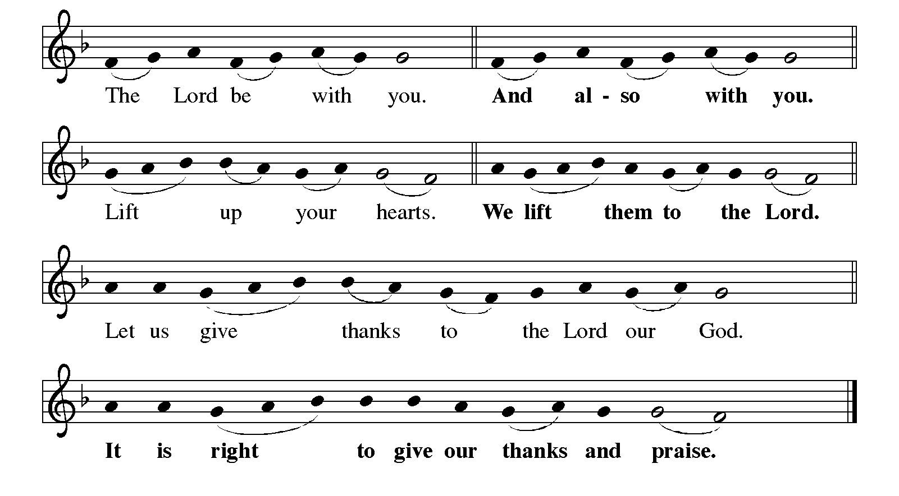

Preface

P: It is indeed right, our duty and our joy, that we should at all times and in all places give thanks and praise to you, almighty and merciful God, for the glorious resurrection of our Savior Jesus Christ, the true Paschal Lamb who gave himself to take away our sin; who in dying has destroyed death, and in rising has brought us to eternal life. And so, with Mary Magdalene and Peter and all the witnesses of the resurrection, with earth and sea and all their creatures, and with angels and archangels, cherubim and seraphim, we praise your name and join their unending hymn:

Holy, Holy, Holy (the angels’ song) ELW p. 144

Printed on the next page.

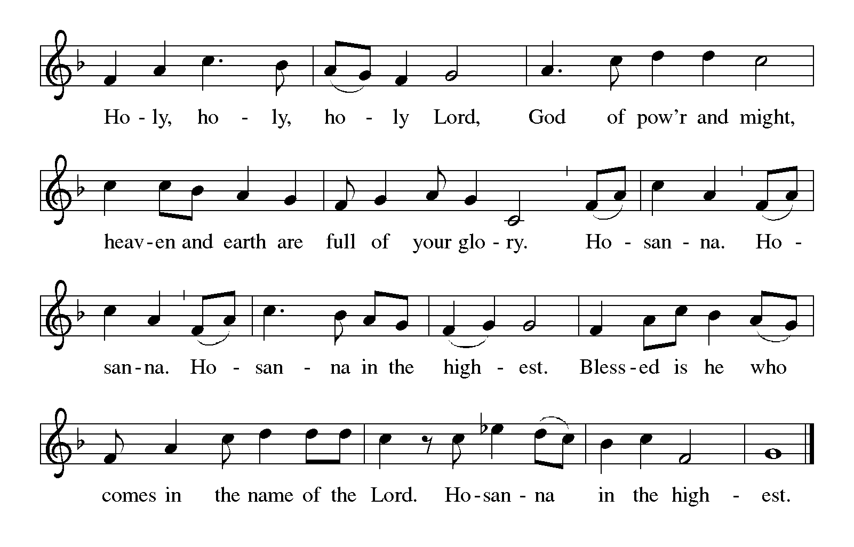

Thanksgiving at the Table

P: You are indeed holy, almighty and merciful God. You are most holy, and great is the majesty of your glory.

You so loved the world that you gave your only Son, so that everyone who believes in him may not perish but have eternal life.

We give you thanks for his coming into the world to fulfill for us your holy will and to accomplish all things for our salvation.

In the night in which he was betrayed, our Lord Jesus took bread, and gave thanks; broke it, and gave it to his disciples, saying: Take and eat; this is my body, given for you. Do this for the remembrance of me.

Again, after supper, he took the cup, gave thanks, and gave it for all to drink, saying: This cup is the new covenant in my blood, shed for you and for all people for the forgiveness of sin. Do this for the remembrance of me.

Continued on the next page.
P: For as often as we eat of this bread and drink from this cup, we proclaim the Lord's death until he comes.

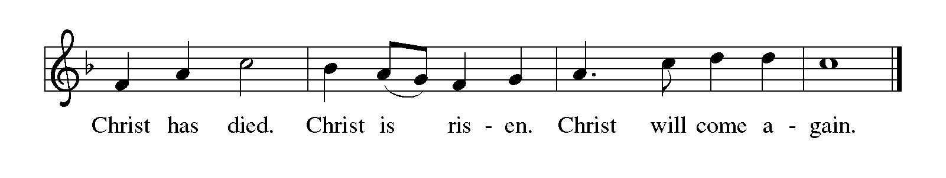
P: Remembering, therefore, his salutary command, his life-giving passion and death, his glorious resurrection and ascension, and the promise of his coming again, we give thanks to you, O Lord God Almighty, not as we ought but as we are able; we ask you mercifully to accept our praise and thanksgiving and with your Word and Holy Spirit to bless us, your servants, and these your own gifts of bread and wine, so that we and all who share in the body and blood of Christ may be filled with heavenly blessing and grace, and, receiving the forgiveness of sin, may be formed to live as your holy people and be given our inheritance with all your saints.

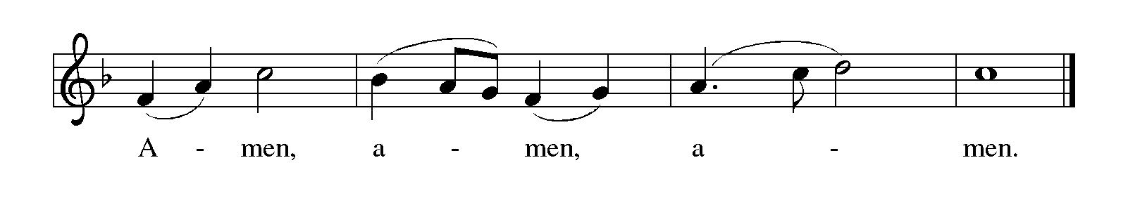To you, O God, Father, Son, and Holy Spirit, be all honor and glory in your holy church, now and forever.

Lord’s Prayer Traditional Wording ELW p. 145

P: Gathered into one by the Holy Spirit, let us pray as Jesus taught us.

All: Our Father, who art in heaven, hallowed be thy name, thy kingdom come, thy will be done, on earth as it is in heaven. Give us this day our daily bread; and forgive us our trespasses, as we forgive those who trespass against us; and lead us not into temptation, but deliver us from evil. For thine is the kingdom, and the power, and the glory, forever and ever. Amen.

INVITATION TO COMMUNION

P: The risen Christ dwells with us here. All who are hungry, all who are thirsty, come.

COMMUNION

What We Believe

Who May Receive. We welcome all baptized Christians to the Lord's Table. In our parish baptized children who have entered the 5th grade are instructed in this sacrament and receive their First Communion; younger children come to the altar and receive a blessing. If your baptized child has received such instruction, or if you want your baptized child to receive Communion, then he or she is welcome to partake.

Proper Preparation. In his Small Catechism, Martin Luther asks, "When is a person rightly prepared to receive this sacrament?" He answers, "Fasting and other outward preparations serve a good purpose. However, that person is well prepared and worthy who believes these words, given and shed for you for the remission of sins. But anyone who does not believe these words, or doubts them, is neither prepared nor worthy, for the words for you require simply a believing heart.”

Real Presence. We believe that the bread and wine truly are the body and blood of Christ given and shed for the forgiveness of sins.

Distribution

Holy Communion will be served in procession, one side of the sanctuary at a time. The ushers will direct you when to make your way to the front of the church using the center aisle. You will receive the elements near the chancel. Please extend your hands, palms up, if you will be receiving the bread. Gluten-free wafers are also available; please ask for one. Proceed to your right or to your left to receive the wine. White grape juice is also available in the center ring of each tray for those who prefer an alcohol-free element. You may say “Amen” after receiving each element. If you will not be receiving Communion, keep your hands folded. Place your empty cup in the basket and then return to your seat by the side aisle.

Congregational Songs During Communion

Lamb of God ELW p. 146

Where Charity and Love Prevail ELW # 359

Jerusalem, My Happy Home ELW # 628

Joyful, Joyful We Adore Thee ELW # 836

Jesu, Jesu, Fill Us with Your Love ELW # 708

PRAYER AFTER COMMUNION

A: We give you thanks, generous God, for in this bread and cup we have tasted the new heaven and earth where hunger and thirst are no more. Send us from this table as witnesses to the resurrection, that through our lives, all may know life in Jesus’s name.

C: Amen.

Sending

God blesses us and sends us in mission to the world.

ANNOUNCEMENTS

BLESSING

P: God, the Author of life, Christ, the living Cornerstone, and the life-giving Spirit of adoption, ☩ bless you now and forever.

C: Amen.

DEPARTING HYMN Christ Is Alive! Let Christians Sing ELW # 389

Stanzas 1, 2, 3 and 5

DISMISSAL

A: Alleluia! Christ is risen.

C: Christ is risen indeed. Alleluia!

A: Go in peace. Tell what God has done.

C: Thanks be to God. Alleluia!

RINGING OF THE BELL

POSTLUDE

Peace and joy to you this Easter season!

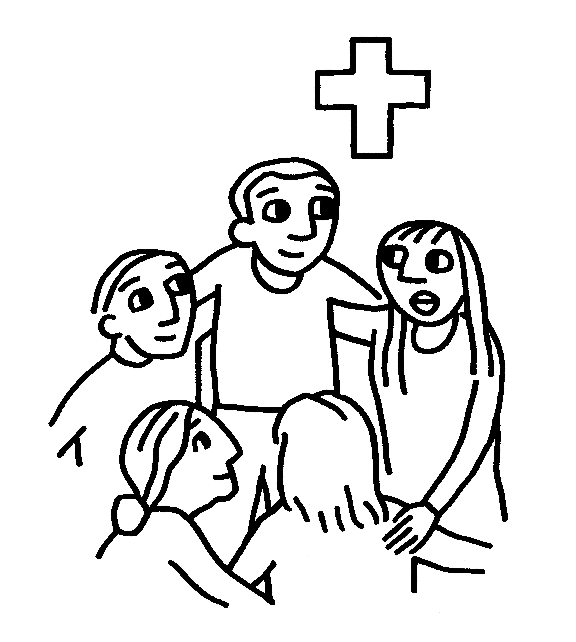

Today’s Assistants and Ministers

Greeters & Ushers ….................................................................…...… Mike & Kristen Kelly
Organist-Pianist ……………….……………………………………...…………..…… Sue Holst
Presiding Minister ……………………………………….….…………… Pastor Kerry Eversole
Reader ……………………………………………..…………..…….…….…………. Dave Ruen
Altar Care & Communion Preparation …………………………………....……… Kristen Kelly
Refreshments ………………………...………….……… Mike & Kristen Kelly and Karen Dahl
Custodian ………………………………………………………………………. Wayne Lukkason

Presence Last Week and April Presents

Attendance Last Sunday, May 8 = 76
Average Sunday Worship Attendance for April = 98

April Contributions: General Fund = $20,964 Designated Giving = $1,910
Jan-Apr Income = $57,782 Jan-Apr Expenses = $59,301 Deficit = $1,519

This Week in Our Congregation

Today, May 15 — Fifth Sunday of Easter

Refreshments in the Fellowship Hall for everyone following worship
Last 7th- & 8th-grade Confirmation session for this school year 10:15 AM
June Service Group meets in the Fellowship Hall following worship
Praise Band Rehearsal 10:30 AM

Tuesday, May 17

Men’s breakfast at Home Sweet Home in Lanesboro 7:00 AM

Saturday, May 21

Pastor Kerry presides at the marriage of Casey Swanson and Scott Lawler 3:00 PM

Next Sunday, May 22 — Sixth Sunday of Easter

Worship with the Praise Band 9:00 AM

News and Notes

Pastor Kerry and Deacon Cindy will be on vacation next Sunday, May 22 to attend their son Matthew’s graduation from Luther College in Decorah, Iowa. Pastor Kay Wold will be the guest preacher and worship leader along with the Praise Band.

Brunch following worship next Sunday, May 22. Come and enjoy the first of several after-worship food and fellowship gatherings for our congregation. The May service group will be providing egg bake, muffins, fruit, juice, milk, coffee, and tea for all to enjoy. A freewill offering will be received for the Bethlehem Roof Repair Fund.

Prayer Requests

In Our Community. For our church members and friends living with chronic illness and other diseases, who are homebound, residing in care facilities, and hospitalized. See the newsletter for our members living in area nursing homes. And let us not forget those sick and dying of COVID-19, those entrusted with the authority of government, justice, and law enforcement, as well as our fallen and wounded soldiers, and those still serving.

In Our Synod. Bishop Regina Hassanally invites the people and congregations of our synod to commit to praying this week for the following faith communities: Mansfield Lutheran Church, Alden; Trinity Lutheran Church, Owatonna; St. Olaf College Student Congregation, Northfield; Tyeme Lutheran Church, Tanzania; Amani Lutheran Church, Tanzania; and Preventative Mental Health Ministry, Colombia.

Acknowledgments

Graphics, worship texts, service music, and readings are from sundaysandseasons.com © 2022 Augsburg Fortress. Used by permission under Augsburg Fortress Liturgies Annual License SAS103296.

Permission to project, live stream, or podcast liturgy and music content under copyright to or administered by Augsburg Fortress provided under Augsburg Fortress Liturgies Annual License SAS103296.

Permission to Podcast / Stream provided by Christian Copyright Licensing International, Inc., under License # 11459672. Additional fee paid. www.ccli.com.

Permission to Podcast / Stream provided by One License, Inc., under License # A-735588. Additional fee paid. www.onelicense.net.

