Bethlehem Lutheran Church
Established 1874

Rev. Kerry B. Eversole, Pastor
Deacon Cindy Cordes-Eversole, Associate in Ministry

Mailing Address: P.O. Box 314, Lanesboro, MN 55949-0314
Physical Address: 200 Kenilworth Ave S, Lanesboro, Minn.

Telephone: 507.467.3344
E-mail Address: bethlehem@acegroup.cc
Website: www.staronthehill.com
Facebook Page: www.facebook.com/BethlehemLutheranLanesboro

Office Hours: Tuesday, Wednesday, Thursday 10 a.m. to 3 p.m.
Parsonage Phone: 507.467.3017
Pastor Kerry’s Cell Phone: 507.951.3954

Bethlehem Lutheran Church
Lanesboro, Minnesota

Fourth Sunday of Easter—Shepherd Sunday
Senior Recognition — Mother’s Day

May 8, 2022


Jesus said to the Jews while in the temple, “The works that I do in my Father’s name testify to me; but you do not believe, because you do not belong to my sheep. My sheep hear my voice. I know them, and they follow me. I give them eternal life, and they will never perish. No one will snatch them out of my hand.” John 10:25-28
Welcome to worship at Bethlehem Lutheran Church
and our continuing celebration of Easter!

COVID-19 Practices — Out of love for God and Neighbor

1) Use hand sanitizer upon entry. Wash your hands and use hand sanitizer often while in the facility.
2) Members and visitors who are vaccinated and boosted are not required to wear a mask.
3) Members and visitors are free to wear a mask if they wish to do so.
4) Unvaccinated and not boosted members and visitors must wear a mask.
5) There are no physical distancing requirements, but you are welcome to keep a distance from others in the sanctuary as you are able.
6) All are welcome to enjoy coffee fellowship in the dining room following worship.

Worship Book and Hymns. This morning’s service is printed in this bulletin but can also be found with all the hymns in Evangelical Lutheran Worship (ELW), “the red book” in the pew bookracks, and on the pews. Hymns in ELW are indicated by a large bold number in each page’s left or right margin.

Abbreviations. Hymns are signified throughout this worship folder by the pound symbol (#). P: refers to the presiding minister or preacher, A: denotes an assisting minister, and C: and/or bold text indicates the congregation.

Mistakes do not happen in our worship service;
only unexpected events which are opportunities for joy!

An signifies that you may stand as you are comfortably able.

Introduction to the Season and the Day. We are in the midst of a fifty-day celebration of the Easter mystery, often referred to as the “week of weeks”. We turn to John the evangelist during these seven Sundays to provide sign after sign of Jesus’s victory over death.

On this fourth Sunday of Easter, we hear that the gift of new life, of eternal life, is the gift of the risen Christ. It is the promise of Jesus. It was true for Dorcas in Joppa. It was true for those “who have come out of the great ordeal” in the Revelation to John. It is true for us and for all the baptized: Surely goodness and mercy shall follow us all the days of our lives, and we will dwell in the house of the Lord forever.

Gathering

The Holy Spirit calls us together as the people of God.

PRELUDE

RINGING OF THE BELL

SALUTATION

OPENING HYMN Good Christian Friends, Rejoice and Sing ELW # 385

THANKSGIVING FOR BAPTISM

P: Alleluia! Christ is risen!

C: Christ is risen indeed! Alleluia!

P: In the waters of baptism, we have passed over from death to life with Jesus Christ, and we are a new creation. For this saving mystery, and this water, let us bless God, who was, who is, and who is to come.

Water is poured into the font as the presiding minister gives thanks.

P: We thank you, God, for your river of life, flowing freely from your throne: through the earth, through every living thing, and through cities and towns,

You rescued Noah and his family from the flood; You opened wide the sea for the Israelites. Now in these waters, you flood us with mercy, and our sin is drowned forever. You open the gate of righteousness, and we pass safely through.

In Jesus Christ, you calm and trouble the waters. You nourish us and enclose us in safety. You call us forth and send us out. In lush and barren places, you are with us. You have become our salvation.

Now breathe upon this water and awaken your church once more.
Claim us again as your beloved and holy people.
Quench our thirst; cleanse our hearts; wipe away every tear.

To you, our Beginning and our End, our Shepherd and Lamb, be honor, glory, praise, and thanksgiving, now and forever.

C: Amen.

CANTICLE OF PRAISE We Know That Christ Is Raised ELW # 449

Stanzas 1, 2 and 3

GREETING

P: The joy and peace of our risen Savior, the love of God, and the communion of the Holy Spirit be with you all.

C: And also with you.

PRAYER OF THE DAY

P: Let us pray together.

O God of peace,

All: you brought again from the dead our Lord Jesus Christ, the great shepherd of the sheep. By the blood of your eternal covenant, make us complete in everything good that we may do your will, and work among us all that is well-pleasing in your sight, through Jesus Christ, our Savior and Lord, who lives and reigns with you and the Holy Spirit, one God, now and forever. Amen.

The Good News of Easter

God speaks to us in scripture reading, preaching, and song.

FIRST READING Acts 9:36-43

Dorcas was a faithful and devoted woman of charity in the community of Joppa. Her kindness and her work with clothing were well-known, especially among the widows in town. When she fell ill and died, Peter raised her back to life through the power of prayer.

³⁶Now in Joppa there was a disciple whose name was Tabitha, which in Greek is Dorcas. She was devoted to good works and acts of charity. ³⁷At that time she became ill and died. When they had washed her, they laid her in a room upstairs. ³⁸Since Lydda was near Joppa, the disciples, who heard that Peter was there, sent two men to him with the request, “Please come to us without delay.” ³⁹So Peter got up and went with them; and when he arrived, they took him to the room upstairs. All the widows stood beside him, weeping and showing tunics and other clothing that Dorcas had made while she was with them. ⁴⁰Peter put all of them outside, and then he knelt down and prayed. He turned to the body and said, “Tabitha, get up.” Then she opened her eyes, and seeing Peter, she sat up. ⁴¹He gave her his hand and helped her up. Then calling the saints and widows, he showed her to be alive. ⁴²This became known throughout Joppa, and many believed in the Lord. ⁴³Meanwhile he stayed in Joppa for some time with a certain Simon, a tanner.

Continued on the next page.
A: Word of God, word of life.

C: Thanks be to God.

PSALM 23

¹The LORD is my shepherd, I shall not want.
²He makes me lie down in green pastures;
he leads me beside still waters;
³he restores my soul.
He leads me in right paths
for his name's sake.
⁴Even though I walk through the darkest valley,
I fear no evil;
for you are with me;
your rod and your staff —
they comfort me.
⁵You prepare a table before me
in the presence of my enemies;
you anoint my head with oil;
my cup overflows.
⁶Surely goodness and mercy shall follow me
all the days of my life,
and I shall dwell in the house of the LORD
my whole life long.

PSALM HYMN My Shepherd, You Supply My Need ELW # 782

SECOND READING Revelation 7:9-17

Christ is the shepherd who leads his faithful to springs of the water of life. Christ is also the lamb who vanquishes sin and suffering.

⁹After this I looked, and there was a great multitude that no one could count, from every nation, from all tribes and peoples and languages, standing before the throne and before the Lamb, robed in white, with palm branches in their hands. ¹⁰They cried out in a loud voice, saying,
“Salvation belongs to our God who is seated on the throne, and to the Lamb!”
¹¹And all the angels stood around the throne and around the elders and the four living creatures, and they fell on their faces before the throne and worshiped God, ¹²singing,

Continued on the next page.

“Amen! Blessing and glory and wisdom
and thanksgiving and honor
and power and might
be to our God forever and ever! Amen.”
¹³Then one of the elders addressed me, saying, “Who are these, robed in white, and where have they come from?” ¹⁴I said to him, “Sir, you are the one that knows.” Then he said to me, “These are they who have come out of the great
ordeal; they have washed their robes and made them white in the blood of the Lamb.
¹⁵For this reason they are before the throne of God,
and worship him day and night within his temple,
and the one who is seated on the throne will shelter them.
¹⁶They will hunger no more, and thirst no more;
the sun will not strike them,
nor any scorching heat;
¹⁷for the Lamb at the center of the throne will be their shepherd,
and he will guide them to springs of the water of life,
and God will wipe away every tear from their eyes.”

A: Word of God, word of life.

C: Thanks be to God.

GOSPEL ACCLAMATION Blessing and Honor ELW # 854

Stanzas 1 and 4

GOSPEL John 10:22-30

P: Announcement of the Gospel.

C: Glory to you, O Lord.

Jesus responds to questions about his identity with the remarkable claim that he and the Father are one. Those who understand this are his sheep; they hear his voice, follow, and will never be snatched from his hand.

²²At that time the festival of the Dedication took place in Jerusalem. It was winter, ²³and Jesus was walking in the temple, in the portico of Solomon. ²⁴So the Jews gathered around him and said to him, “How long will you keep us in suspense? If you are the Messiah, tell us plainly.” ²⁵Jesus answered, “I have told you, and you do not believe. The works that I do in my Father’s name testify to me; ²⁶but you do not believe, because you do not belong to my sheep.

Continued on the next page.
²⁷My sheep hear my voice. I know them, and they follow me. ²⁸I give them eternal life, and they will never perish. No one will snatch them out of my hand. ²⁹What my Father has given me is greater than all else, and no one can snatch it out of the Father’s hand. ³⁰The Father and I are one.”

P: Affirmation of the Gospel.

C: Praise to you, O Christ.

CHILDREN’S MESSAGE

SERMON

HYMN OF THE DAY Savior, like a Shepherd Lead Us ELW # 789

Stanzas 1, 2 and 4

Responding to the Good news of Easter

BLESSING OUR GRADUATES A Litany of Faith and Courage

P: God of Abraham and Sarah, you led your people in the past; lead our graduates now.

A: Grant them the strength of Noah to face laughter and scorn, the courage of Ruth to leave behind the old and familiar, the hope of Jeremiah to invest in the future, and the unselfishness of Esther to put their own lives in danger for the sake of others.

P: God of Moses and Miriam, you delivered your chosen people and led them through the wilderness. Give our graduates protection, guidance, power, and strength on their journey through life.

A: God of Deborah and Gideon, you have given us leaders to bring us back when we wander from you. Give our daughters and sons leaders and deliverers and grant them wisdom to follow them.

P: God of Peter and John and Mary Magdalene, you have called us to follow Jesus. Teach our children to work together in mutual responsibility, side-by-side, neither tagging behind nor shoving to the front.

A: God of Paul and Pricilla and Aquila, your apostles risked their lives for the sake of the gospel. Fill our children with enthusiasm for your word, and help them to say as did Isaiah, “Here am I. Send me.”

Continued on the next page.

P: Use our children in building up the church, in joining its various expressions and congregations for ministry to the whole world.

A: God of our Lord Jesus Christ, who gave himself in love for the whole world, teach these young men and women so to love. Grant them the Spirit of Christ, who came not to be served, but to serve.

P: Gracious God, I ask you to also bless the parents of these young people, who have raised their children and nourished them in the Christian faith. Give them strength in your continuing presence and give them many joyful reunions with their daughters and sons.

A: And now, let us all join in saying to our graduates:

All: Go out into the world in peace; be of good courage; hold fast to what is good; return no one evil for evil; strengthen the fainthearted; support the weak; help the suffering; honor all people; love and serve our God, rejoicing in the power of the Holy Spirit. Amen.

ANTHEM Let Us Serve Him Bethlehem Choir

BLESSING OF MOTHERS

OFFERING

OFFERING SONG Love Divine, All Loves Excelling ELW # 631

Stanzas 1 and 2

PRAYERS OF GOD’S PEOPLE

Each petition ends with these words and response:

P: God of new life,

C: hear our prayer.

Concluding petition and response:

P: We raise these prayers to you, and those we carry in our hearts, trusting in your abundant mercy and your life-giving Spirit; through Jesus Christ, our Savior.

C: Amen.

LORD’S PRAYER Traditional Wording

P: Gathered into one by the Holy Spirit, let us pray as Jesus taught us.

All: Our Father, who art in heaven, hallowed be thy name, thy kingdom come, thy will be done, on earth as it is in heaven. Give us this day our daily bread; and forgive us our trespasses, as we forgive those who trespass against us; and lead us not into temptation, but deliver us from evil. For thine is the kingdom, and the power, and the glory, forever and ever. Amen.

Sending

God blesses us and sends us in mission to the world.

ANNOUNCEMENTS

BLESSING

P: God, the Author of life, Christ, the living Cornerstone, and the life-giving Spirit of adoption, ☩ bless you now and forever.

C: Amen.

DEPARTING HYMN Have No Fear, Little Flock ELW # 764

DISMISSAL

P: Alleluia! Christ is risen.

C: Christ is risen indeed. Alleluia!

P: Go in peace. Tell what God has done.

C: Thanks be to God. Alleluia!

RINGING OF THE BELL

POSTLUDE

Peace and joy to you this Easter season!

Bethlehem Lutheran Church Youth
who are members of the
Class of 2022

Amanda Amdahl, Lanesboro High School
Reece Benson, Lanesboro High School
Carson Berg, Fillmore Central High School
Carter Clarke, Lanesboro High School
Allyse Gehrke, Lanesboro High School
Colby Miehlisch, Lanesboro High School
Jacob Peterson, Lanesboro High School
Jordan Peterson, Lanesboro High School
Tate Pieper, Lanesboro High School
Adam Ruen, Lanesboro High School
Brielle Ruen, Lanesboro High School
Carson Ruen, Lanesboro High School
Trevor Ruen, Lanesboro High School
Seth Semmen, Lanesboro High School



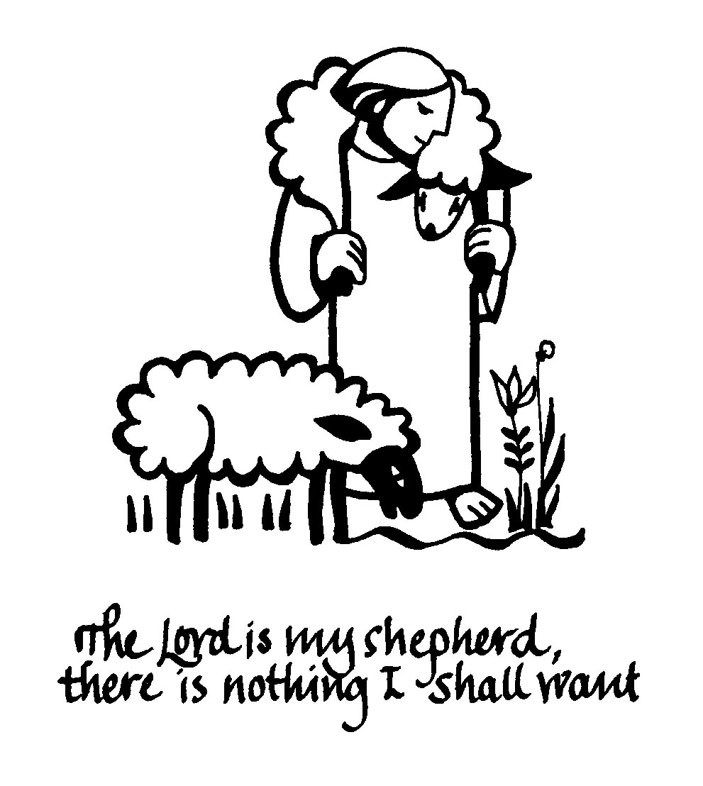

Today’s Assistants and Ministers

Greeters & Ushers …......................................................…...… Gary & Judy Kingsbury and
Chris Olson
Organist-Pianist ……………….……………………………………...…………..…… Sue Holst
Choir Director …………………………………………………….……………….. Jayna Kendell
Presiding Minister ……………………………………….….…………… Pastor Kerry Eversole
Reader ……………………………………………..…………..…….…….…………. Dave Ruen
Refreshments ………………………………….………….…….……… Dave & Joan Ruen and
Tim & Julie Kiehne
Custodian ………………………………………………………………………. Wayne Lukkason

Acknowledgments

Graphics, worship texts, service music, and readings are from sundaysandseasons.com © 2022 Augsburg Fortress. Used by permission under Augsburg Fortress Liturgies Annual License SAS103296.

Permission to project, live stream, or podcast liturgy and music content under copyright to or administered by Augsburg Fortress provided under Augsburg Fortress Liturgies Annual License SAS103296.

Permission to Podcast / Stream provided by Christian Copyright Licensing International, Inc., under License # 11459672. Additional fee paid. www.ccli.com.

Permission to Podcast / Stream provided by One License, Inc., under License # A-735588. Additional fee paid. www.onelicense.net.

The Litany of Faith and Courage is reprinted by permission of the publisher from Bread for the Journey: Resources for Worship, edited by Ruth C. Duck. Copyright © 1981 The Pilgrim Press.

Presence Last Week and April Presents

Attendance Last Sunday, May 1 = 66
Average Sunday Worship Attendance for April = 98

April Contributions: General Fund = $ Designated Giving = $
Jan-Apr Income = $ Jan-Apr Expenses = $ Deficit = $

This Week in Our Congregation

Today, May 8 — Fourth Sunday of Easter — Senior Recognition — Mother’s Day

Sunday School after the children’s sermon
Refreshments in the Fellowship Hall for everyone following worship
7th- & 8th-grade Confirmation session 10:15 AM
Choir Rehearsal 10:15 AM

This Week in Our Congregation continued

Tuesday, May 10

Men’s breakfast at Home Sweet Home in Lanesboro 7:00 AM

Wednesday, May 11

Church Council 6:30 PM

Next Sunday, May 15 — Fifth Sunday of Easter

Easter Worship with Holy Communion 9:00 AM
June Service Group meets in the Fellowship Hall following worship
7th- & 8th-grade Confirmation session 10:15 AM

Prayer Requests

In Our Community. For our church members and friends living with chronic illness and other diseases, who are homebound, residing in care facilities, and hospitalized. See the newsletter for our members living in area nursing homes. And let us not forget those sick and dying of COVID-19, those entrusted with the authority of government, justice, and law enforcement, as well as our fallen and wounded soldiers, and those still serving.

In Our Synod. Bishop Regina Hassanally invites the people and congregations of our synod to commit to praying this week for the following faith communities: Bricelyn Lutheran Church, Bricelyn; Our Savior’s Lutheran Church, Rochester; St. Paul Kyengege Lutheran Church, Tanzania; Wembere Lutheran Church, Tanzania; and The True Vine Ministry, Colombia.

News and Notes

Audio-Visual Training Session Saturday, May 14, 9:00 a.m. If you would like to learn how to turn the PA on and off and or how to operate the laptop, software, and camera to broadcast our Sunday and other services, be at the church at 9 am on Saturday, May 14.

Pastor Kerry and Deacon Cindy will be on vacation Sunday, May 22 to attend their son Matthew’s graduation from Luther College in Decorah, Iowa. Pastor Kay Wold will be the guest preacher and worship leader along with the Praise Band.

Brunch following worship on Sunday, May 22. Come and enjoy the first of several after-worship food and fellowship gatherings for our congregation. The May service group will be providing egg bake, muffins, fruit, juice, milk, coffee, and tea for all to enjoy. A freewill offering will be received for the Bethlehem Roof Repair Fund.

Sunday Best, today, 2 pm, Sons of Norway Lodge, Lanesboro. “Sunday Best” is a fashion show bringing together authentic historic fashions, models in period costumes, and live music. Antique wedding gowns from the Lanesboro History Museum will be displayed while live models portray local brides, grooms, and others in their Sunday best. Refreshments will be served. Admission: $15, under 18 $5. Proceeds support the LHM and History Alive!

