Bethlehem Lutheran Church
Established 1874

Rev. Kerry B. Eversole, Pastor
Deacon Cindy Cordes-Eversole, Associate in Ministry

Mailing Address: P.O. Box 314, Lanesboro, MN 55949-0314
Physical Address: 200 Kenilworth Ave S, Lanesboro, Minn.

Telephone: 507.467.3344
E-mail Address: bethlehem@acegroup.cc
Website: www.staronthehill.com
Facebook Page: www.facebook.com/BethlehemLutheranLanesboro

Office Hours: Tuesday, Wednesday, Thursday 10 a.m. to 3 p.m.
Parsonage Phone: 507.467.3017
Pastor Kerry’s Cell Phone: 507.951.3954

Bethlehem Lutheran Church
Lanesboro, Minnesota

Third Sunday of Easter

May 1, 2022

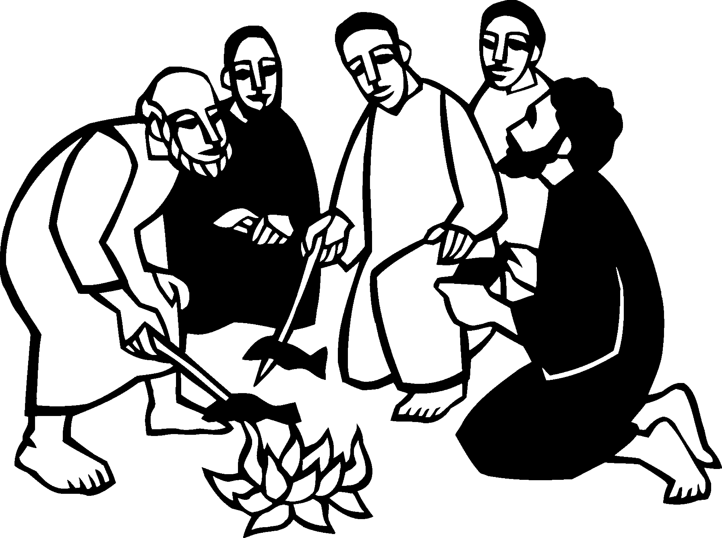
When they had finished breakfast, Jesus said to Simon Peter, “Simon, son of John, do you love me more than these?” He said to him, “Yes, Lord; you know that I love you.” Jesus said to him, “Feed my lambs.” A second time he said to him, “Simon son of John, do you love me?” He said to him, “Yes, Lord; you know that I love you.” Jesus said to him, “Tend my sheep.” He said to him the third time, “Simon son of John, do you love me?” And he said to him, “Lord, you know everything; you know that I love you.” Jesus said to him, “Feed my sheep. John 21:15-17
Welcome to worship at Bethlehem Lutheran Church
and our continuing celebration of Easter!

COVID-19 Practices — Out of love for God and Neighbor

1) Use hand sanitizer upon entry. Wash your hands and use hand sanitizer often while in the facility.
2) Members and visitors who are vaccinated and boosted are not required to wear a mask.
3) Members and visitors are free to wear a mask if they wish to do so.
4) Unvaccinated and not boosted members and visitors must wear a mask.
5) There are no physical distancing requirements, but you are welcome to keep a distance from others in the sanctuary as you are able.
6) All are welcome to enjoy coffee fellowship in the dining room following worship.

Worship Book and Hymns. This morning’s service is printed in this bulletin but can also be found with all the hymns in Evangelical Lutheran Worship (ELW), “the red book” in the pew bookracks, and on the pews. Hymns in ELW are indicated by a large bold number in each page’s left or right margin.

Abbreviations. Hymns are signified throughout this worship folder by the pound symbol (#). P: refers to the presiding minister or preacher, A: denotes an assisting minister, and C: and/or bold text indicates the congregation.

Mistakes do not happen in our worship service;
only unexpected events which are opportunities for joy!

An signifies that you may stand as you are comfortably able.

Introduction to the Season and the Day. We are in the midst of a fifty-day celebration of the Easter mystery, often referred to as a “week of weeks”. We turn to John the evangelist during these seven Sundays to provide sign after sign of Jesus’s victory over death. On this third Sunday of Easter, the disciples make a big splash and eat breakfast with the risen Jesus. Wading in the water (remembering baptism) and eating with Jesus (celebrating holy communion) is our weekly encounter with the risen Christ. Jesus asks us again and again: Do you love me? And Jesus invites us, again and again, to follow him, bringing the Easter life to others.

Gathering

The Holy Spirit calls us together as the people of God.

PRELUDE

RINGING OF THE BELL

EASTER PROCLAMATION

P: Alleluia! Christ is risen!

C: Christ is risen indeed! Alleluia!

OPENING HYMN Christ the Lord Is Risen Today! ELW # 373

Stanzas 1, 2, 3, 5 and 6

GREETING

P: Alleluia! Christ is risen!

C: Christ is risen indeed! Alleluia!

P: The joy and peace of our risen Savior, the love of God, and the communion of the Holy Spirit be with you all.

C: And also with you.

KYRIE ELW p. 138
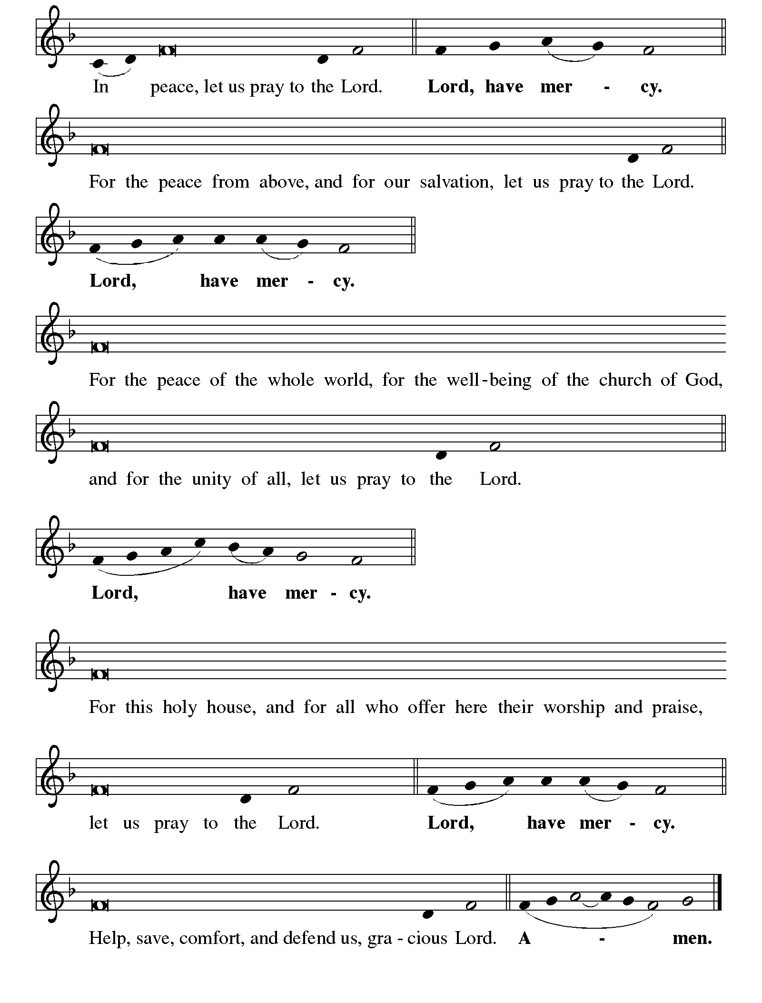

Continued on the next page
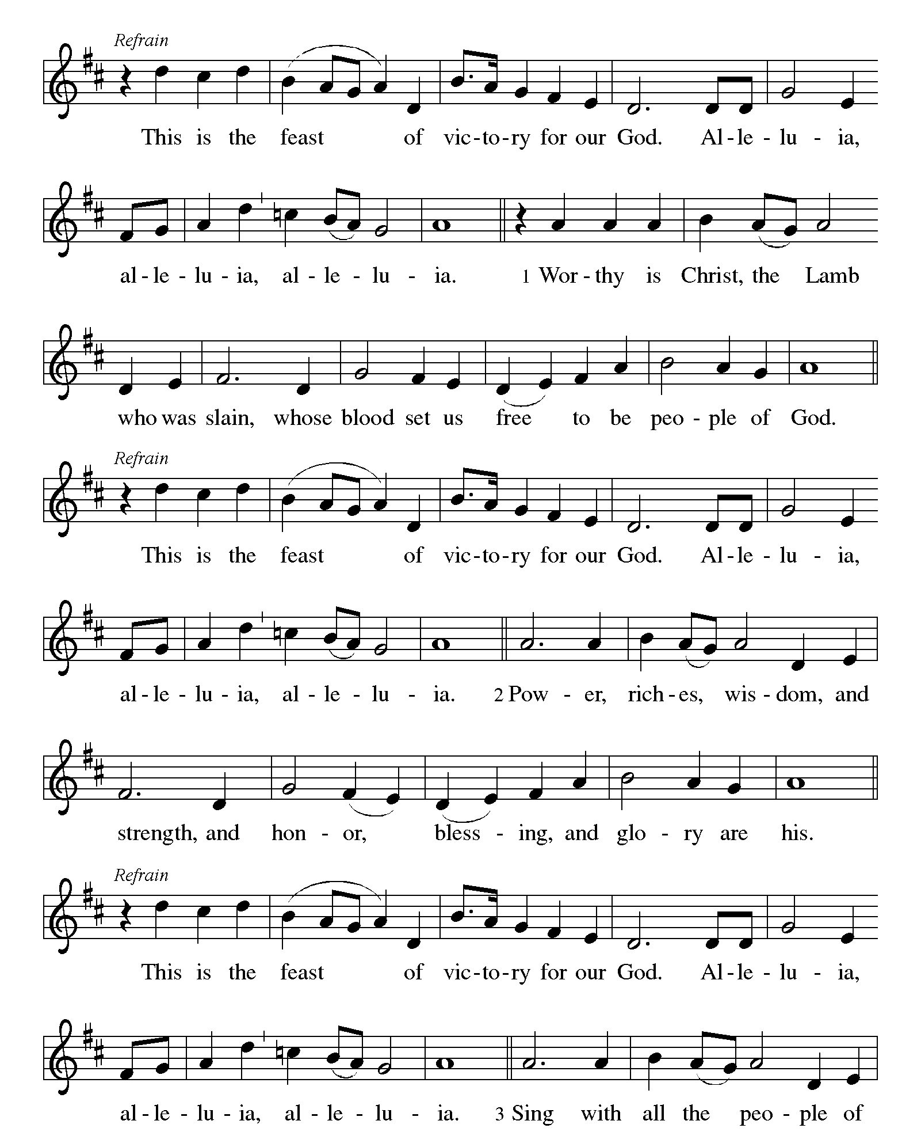KYRIE concluded ELW pp. 138-139

CANTICLE OF PRAISE This is the Feast ELW p. 140

Printed on the next page.

Continued on the next page.

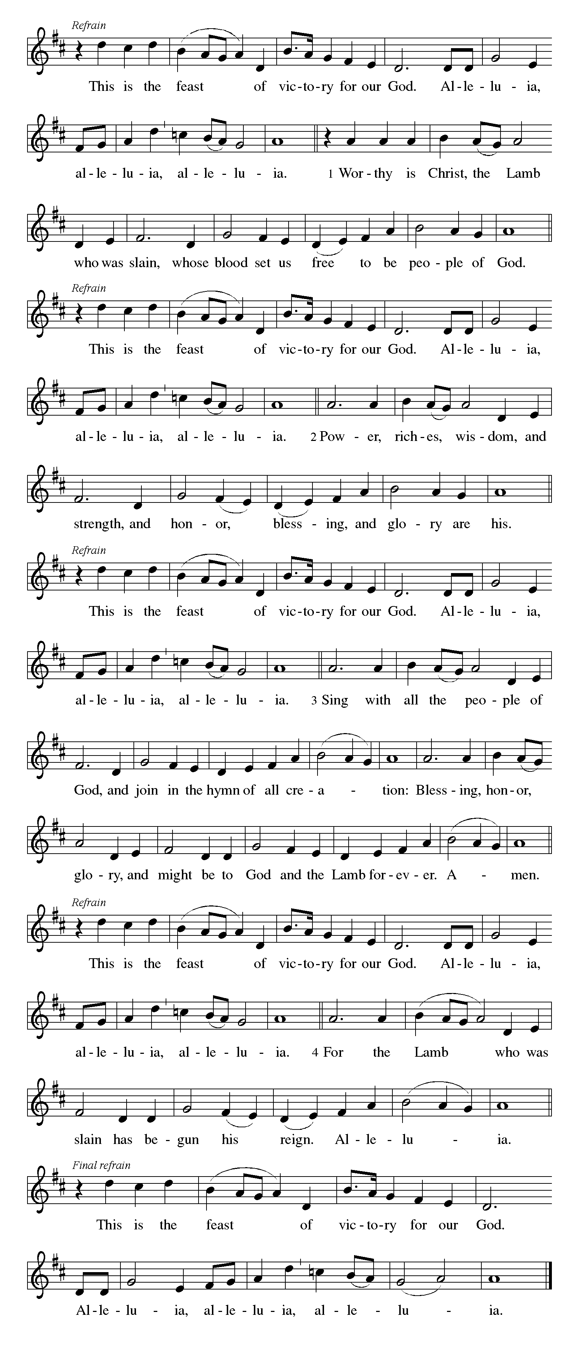CANTICLE OF PRAISE continued ELW p. 141

Continued on the next page.

CANTICLE OF PRAISE concluded ELW p. 141

PRAYER OF THE DAY

P: Eternal and all-merciful God, with all the angels and all the saints we laud your majesty and might. By the resurrection of your Son, show yourself to us and inspire us to follow Jesus Christ, our Savior and Lord, who lives and reigns with you and the Holy Spirit, one God, now and forever.

C: Amen.

The Good News of Easter

God speaks to us in scripture reading, preaching, and song.

FIRST READING Acts 9:1-6

Saul (later called Paul) was an ardent persecutor of all who followed the Way of Christ. This reading recounts the story of his transformation beginning with an encounter with Jesus Christ on the way to Damascus.

¹Saul, still breathing threats and murder against the disciples of the Lord, went to the high priest ²and asked him for letters to the synagogues at Damascus, so that if he found any who belonged to the Way, men or women, he might bring them bound to Jerusalem. ³Now as he was going along and approaching Damascus, suddenly a light from heaven flashed around him. ⁴He fell to the ground and heard a voice saying to him, “Saul, Saul, why do you persecute me?” ⁵He asked, “Who are you, Lord?” The reply came, “I am Jesus, whom you are persecuting. ⁶But get up and enter the city, and you will be told what you are to do.”

Continued on the next page.

A: Word of God, word of life.

C: Thanks be to God.

SECOND READING Revelation 5:11-14

The vision of John recorded in Revelation offers a glimpse of cosmic worship around the throne. At its center is “the Lamb who was slain.”

¹¹Then I looked, and I heard the voice of many angels surrounding the throne and the living creatures and the elders; they numbered myriads of myriads and thousands of thousands, ¹²singing with full voice,
“Worthy is the Lamb that was slaughtered
to receive power and wealth and wisdom and might
and honor and glory and blessing!”
¹³Then I heard every creature in heaven and on earth and under the earth and in the sea, and all that is in them, singing,
“To the one seated on the throne and to the Lamb
be blessing and honor and glory and might
forever and ever!”
¹⁴And the four living creatures said, “Amen!” And the elders fell down and worshiped.

A: Word of God, word of life.

C: Thanks be to God.

GOSPEL ACCLAMATION

“Alleluias” are from The Strife Is O’er, the Battle Done ELW # 366

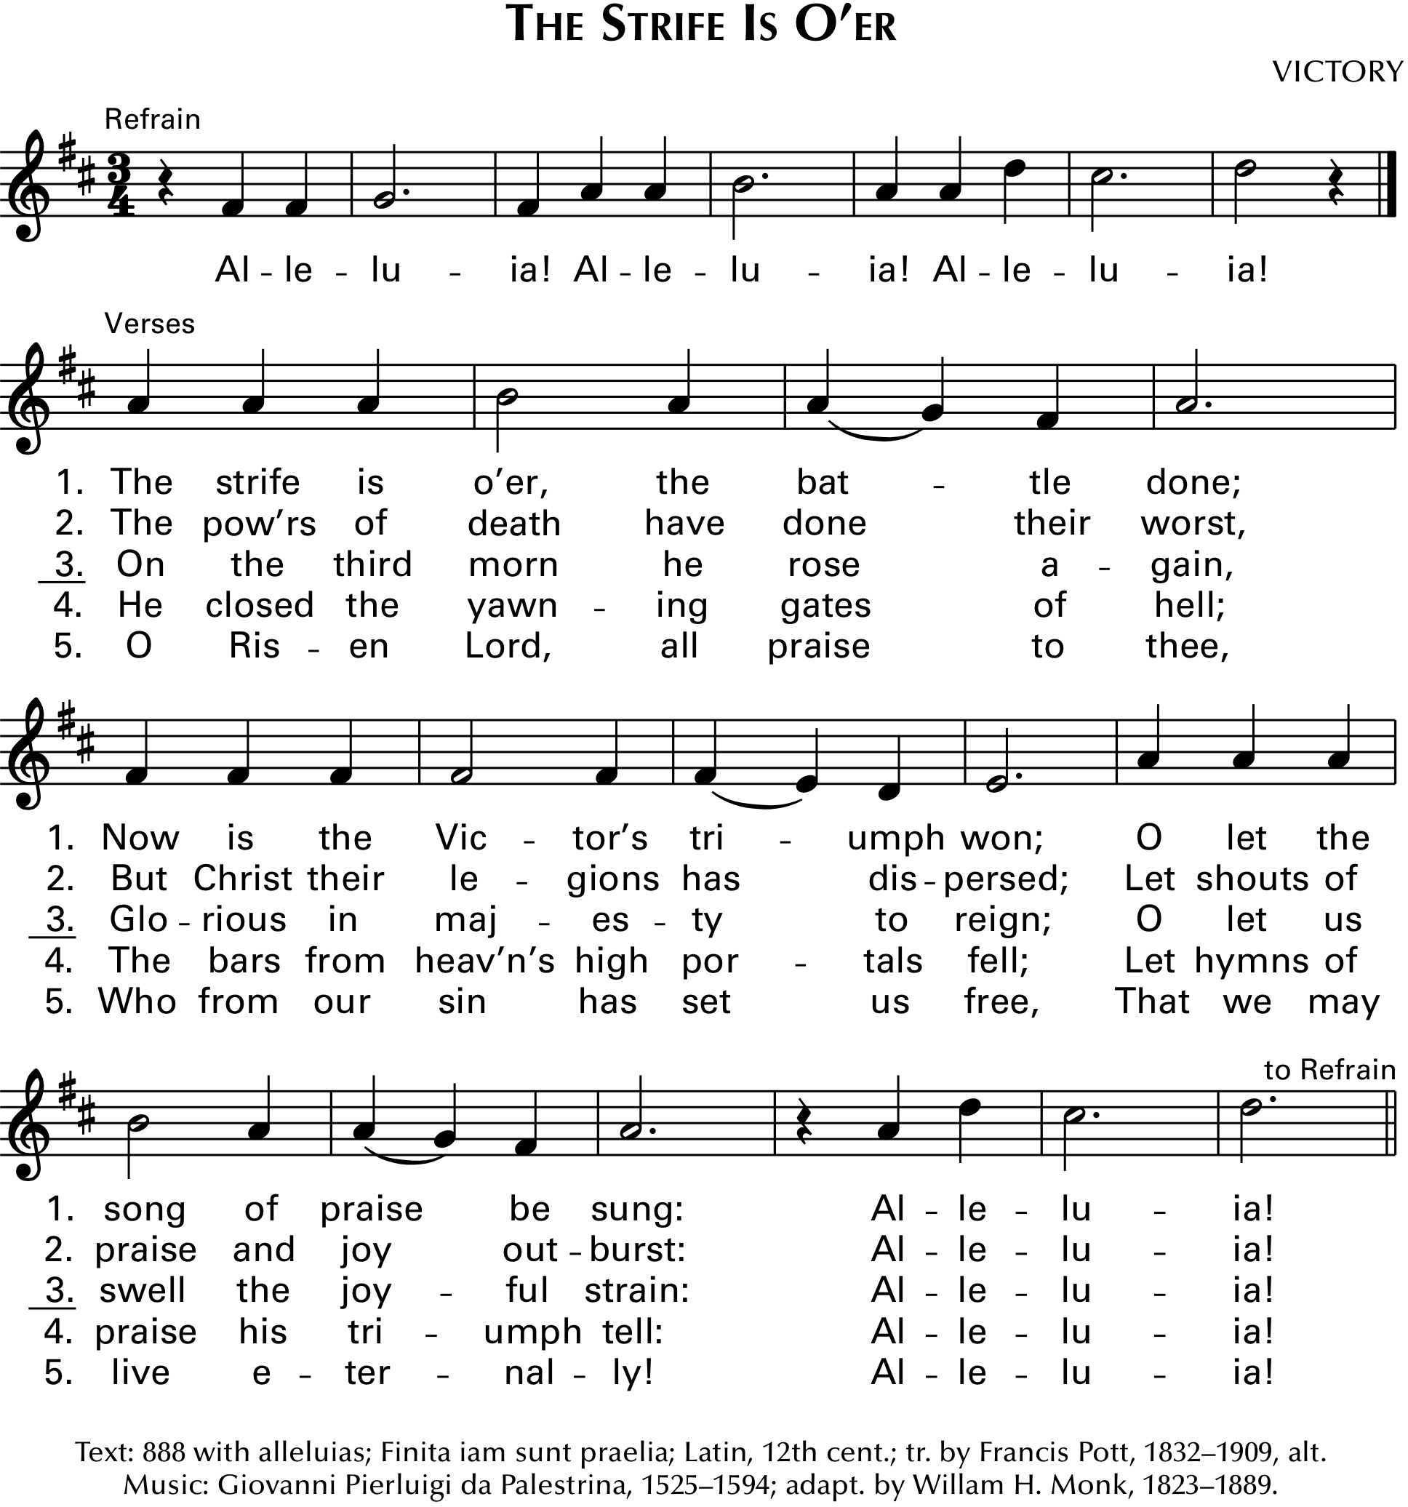

P: Our hearts burn within us while you open to us the scriptures. Luke 24:32

GOSPEL John 21:1-19

P: Announcement of the Gospel.

C: Glory to you, O Lord.

The risen Christ appears again to his disciples by the sea where they were first called. After echoes of the fishing and feeding miracles, he gives a final reminder of the cost of a disciple’s love and obedience.

¹After [he appeared to his followers in Jerusalem,] Jesus showed himself again to the disciples by the Sea of Tiberias; and he showed himself in this way. ²Gathered there together were Simon Peter, Thomas called the Twin, Nathanael of Cana in Galilee, the sons of Zebedee, and two others of his disciples. ³Simon Peter said to them, “I am going fishing.” They said to him, “We will go with you.” They went out and got into the boat, but that night they caught nothing.
⁴Just after daybreak, Jesus stood on the beach; but the disciples did not know that it was Jesus. ⁵Jesus said to them, “Children, you have no fish, have you?” They answered him, “No.” He said to them, “Cast the net to the right side of the boat, and you will find some.” So they cast it, and now they were not able to haul it in because there were so many fish. ⁷That disciple whom Jesus loved said to Peter, “It is the Lord!” When Simon Peter heard that it was the Lord, he put on some clothes, for he was naked, and jumped into the sea. ⁸But the other disciples came in the boat, dragging the net full of fish, for they were not far from the land, only about a hundred yards off.
⁹When they had gone ashore, they saw a charcoal fire there, with fish on it, and bread. ¹⁰Jesus said to them, “Bring some of the fish that you have just caught.” ¹¹So Simon Peter went aboard and hauled the net ashore, full of large fish, a hundred fifty-three of them; and though there were so many, the net was not torn. ¹²Jesus said to them, “Come and have breakfast.” Now none of the disciples dared to ask him, “Who are you?” because they knew it was the Lord. ¹³Jesus came and took the bread and gave it to them, and did the same with the fish. ¹⁴This was now the third time that Jesus appeared to the disciples after he was raised from the dead.
¹⁵When they had finished breakfast, Jesus said to Simon Peter, “Simon son of John, do you love me more than these?” He said to him, “Yes, Lord; you know that I love you.” Jesus said to him, “Feed my lambs.” ¹⁶A second time he said to him, “Simon son of John, do you love me?” He said to him, “Yes, Lord; you know that I love you.” Jesus said to him, “Tend my sheep.” ¹⁷He said to him the third time, “Simon son of John, do you love me?” Peter felt hurt because he

Continued on the next page.
said to him the third time, “Do you love me?” And he said to him, “Lord, you know everything; you know that I love you.” Jesus said to him, “Feed my sheep. ¹⁸Very truly, I tell you, when you were younger, you used to fasten your own belt and to go wherever you wished. But when you grow old, you will stretch out your hands, and someone else will fasten a belt around you and take you where you do not wish to go.” ¹⁹(He said this to indicate the kind of death by which he would glorify God.) After this he said to him, “Follow me.”

P: Affirmation of the Gospel.

C: Praise to you, O Christ.

CHILDREN’S MESSAGE

SERMON

HYMN OF THE DAY Christ Is Alive! Let Christians Sing ELW # 389

Stanzas 1, 2, 4 and 5

PROFESSION OF FAITH Nicene Creed ELW p. 104

P: With the whole church, let us confess our faith.

All: We believe in one God, the Father, the Almighty, maker of heaven and earth, of all that is, seen and unseen.

We believe in one Lord, Jesus Christ, the only Son of God, eternally begotten of the Father, God from God, Light from Light, true God from true God, begotten, not made, of one Being with the Father; through him all things were made. For us and for our salvation he came down from heaven, was incarnate of the Holy Spirit and the virgin Mary and became truly human. For our sake he was crucified under Pontius Pilate; he suffered death and was buried. On the third day he rose again in accordance with the scriptures; he ascended into heaven and is seated at the right hand of the Father. He will come again in glory to judge the living and the dead, and his kingdom will have no end.

We believe in the Holy Spirit, the Lord, the giver of life, who proceeds from the Father and the Son, who with the Father and the Son is worshiped and glorified, who has spoken through the prophets. We believe in one holy catholic and apostolic church. We acknowledge one baptism for the forgiveness of sins. We look for the resurrection of the dead, and the life of the world to come. Amen.
PRAYERS OF GOD’S PEOPLE

Each petition ends with these words and response:

A: God of new life,

C: hear our prayer.

Concluding petition and response:

A: We raise these prayers to you, and those we carry in our hearts, trusting in your abundant mercy and your life-giving Spirit; through Jesus Christ, our Savior.

C: Amen.

The Good News of Easter in the Holy Meal

God feeds us with the presence of Jesus Christ.

OFFERING

ASSEMBLY SONG Now All the Vault of Heaven Resounds ELW # 367

Stanzas 1 and 3

OFFERING PRAYER

A: Let us pray together.

Living God

C: you gather the wolf and the lamb to feed together in your peaceable reign, and you welcome us all at your table. Reach out to us through this meal, and show us your wounded and risen body, that we may be nourished and believe in Jesus Christ, our Savior and Lord. Amen.

GREAT THANKSGIVING

Dialogue ELW p. 144
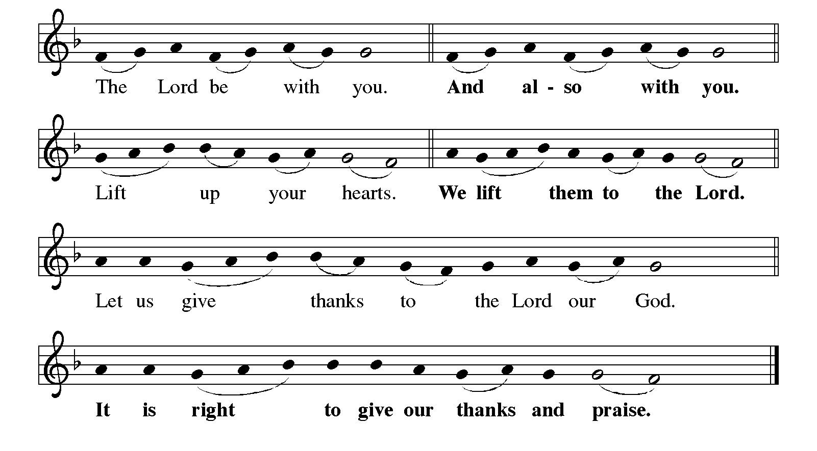

Continued on the next page.

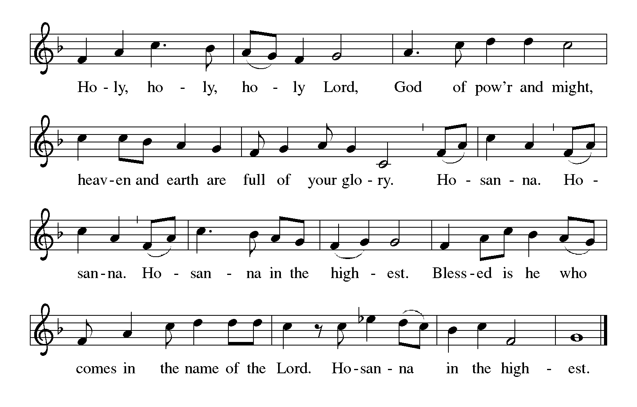Dialogue concluded ELW p. 144

Preface

P: It is indeed right, our duty and our joy, that we should at all times and in all places give thanks and praise to you, almighty and merciful God, for the glorious resurrection of our Savior Jesus Christ, the true Paschal Lamb who gave himself to take away our sin; who in dying has destroyed death, and in rising has brought us to eternal life. And so, with Mary Magdalene and Peter and all the witnesses of the resurrection, with earth and sea and all their creatures, and with angels and archangels, cherubim and seraphim, we praise your name and join their unending hymn:

Holy, Holy, Holy (the angels’ song) ELW p. 144

Printed on the next page.

Thanksgiving at the Table ELW p. 145

P: You are indeed holy, almighty and merciful God. You are most holy, and great is the majesty of your glory.

You so loved the world that you gave your only Son, so that everyone who believes in him may not perish but have eternal life.

We give you thanks for his coming into the world to fulfill for us your holy will and to accomplish all things for our salvation.

In the night in which he was betrayed, our Lord Jesus took bread, and gave thanks; broke it, and gave it to his disciples, saying: Take and eat; this is my body, given for you. Do this for the remembrance of me.

Again, after supper, he took the cup, gave thanks, and gave it for all to drink, saying: This cup is the new covenant in my blood, shed for you and for all people for the forgiveness of sin. Do this for the remembrance of me.

Continued on the next page.

P: For as often as we eat of this bread and drink from this cup, we proclaim the Lord's death until he comes.

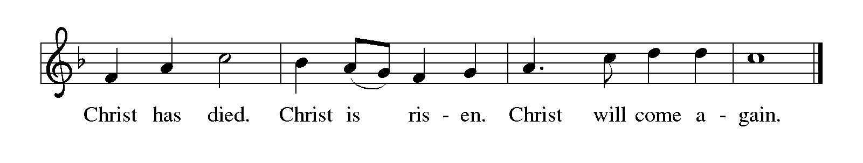
P: Remembering, therefore, his salutary command, his life-giving passion and death, his glorious resurrection and ascension, and the promise of his coming again, we give thanks to you, O Lord God Almighty, not as we ought but as we are able; we ask you mercifully to accept our praise and thanksgiving and with your Word and Holy Spirit to bless us, your servants, and these your own gifts of bread and wine, so that we and all who share in the body and blood of Christ may be filled with heavenly blessing and grace, and, receiving the forgiveness of sin, may be formed to live as your holy people and be given our inheritance with all your saints.

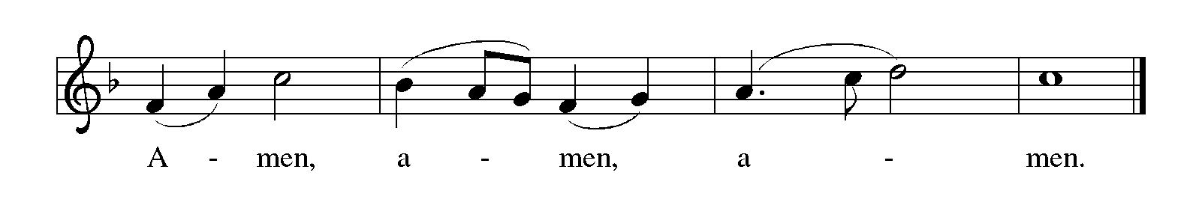To you, O God, Father, Son, and Holy Spirit, be all honor and glory in your holy church, now and forever.

Lord’s Prayer Traditional Wording ELW p. 145

P: Gathered into one by the Holy Spirit, let us pray as Jesus taught us.

All: Our Father, who art in heaven, hallowed be thy name, thy kingdom come, thy will be done, on earth as it is in heaven. Give us this day our daily bread; and forgive us our trespasses, as we forgive those who trespass against us; and lead us not into temptation, but deliver us from evil. For thine is the kingdom, and the power, and the glory, forever and ever. Amen.

INVITATION TO COMMUNION

P: The risen Christ dwells with us here. All who are hungry, all who are thirsty, come.

COMMUNION

What We Believe

Who May Receive. We welcome all baptized Christians to the Lord's Table. In our parish baptized children who have entered the 5th grade are instructed in this sacrament and receive their First Communion; younger children come to the altar and receive a blessing. If your baptized child has received such instruction, or if you want your baptized child to receive Communion, then he or she is welcome to partake.

Proper Preparation. In his Small Catechism, Martin Luther asks, "When is a person rightly prepared to receive this sacrament?" He answers, "Fasting and other outward preparations serve a good purpose. However, that person is well prepared and worthy who believes these words, given and shed for you for the remission of sins. But anyone who does not believe these words, or doubts them, is neither prepared nor worthy, for the words for you require simply a believing heart.”

Real Presence. We believe that the bread and wine truly are the body and blood of Christ given and shed for the forgiveness of sins.

Distribution

Holy Communion will be served in procession, one side of the sanctuary at a time. The ushers will direct you when to make your way to the front of the church using the center aisle. You will receive the elements near the chancel. Please extend your hands, palms up, if you will be receiving the bread. Gluten-free wafers are also available; please ask for one. Proceed to your right or to your left to receive the wine. White grape juice is also available in the center ring of each tray for those who prefer an alcohol-free element. You may say “Amen” after receiving each element. If you will not be receiving Communion, keep your hands folded. Place your empty cup in the basket and then return to your seat by the side aisle.

Music During Distribution by Heidi Dybing

PRAYER AFTER COMMUNION

A: We give you thanks, generous God, for in this bread and cup we have tasted the new heaven and earth where hunger and thirst are no more. Send us from this table as witnesses to the resurrection, that through our lives, all may know life in Jesus’s name.

C: Amen.

Sending

God blesses us and sends us in mission to the world.

ANNOUNCEMENTS

BLESSING

P: God, the Author of life, Christ, the living Cornerstone, and the life-giving Spirit of adoption, ☩ bless you now and forever.

C: Amen.

DEPARTING HYMN That Easter Day with Joy Was Bright ELW # 384

DISMISSAL

A: Alleluia! Christ is risen.

C: Christ is risen indeed. Alleluia!

A: Go in peace. Tell what God has done.

C: Thanks be to God. Alleluia!

RINGING OF THE BELL

POSTLUDE

Peace and joy to you this Easter season!



Today’s Assistants and Ministers

Greeters & Ushers ….............................................................…...… Dave & Joan Ruen and
Tim & Julie Kiehne
Pianist ……………….……………………………………………...…………..…… Heidi Dybing
Presiding Minister ……………………………….…………… Deacon Cindy Cordes-Eversole
Reader ……………………………………………..…………..…….…….…………. Dave Ruen
Altar Care & Communion Preparation ………………………………………….…. Joan Ruen
Refreshments ………………………………….………….…….……… Dave & Joan Ruen and
Tim & Julie Kiehne

Acknowledgments

Graphics, worship texts, service music, and readings are from sundaysandseasons.com © 2022 Augsburg Fortress. Used by permission under Augsburg Fortress Liturgies Annual License SAS103296.

Permission to project, live stream, or podcast liturgy and music content under copyright to or administered by Augsburg Fortress provided under Augsburg Fortress Liturgies Annual License SAS103296.

Permission to Podcast / Stream provided by Christian Copyright Licensing International, Inc., under License # 11459672. Additional fee paid. www.ccli.com.

Permission to Podcast / Stream provided by One License, Inc., under License # A-735588. Additional fee paid. www.onelicense.net.

Presence Last Week and March Presents

Attendance Last Sunday, April 24 = 45
Average Sunday Worship Attendance for April = 98

March Contributions: General Fund = $11,511 Designated Giving = $466
Jan-Mar Income = $36,818 Jan-Mar Expenses = $44,664 Deficit = $7,846

This Week in Our Congregation

Today, May 1 — Third Sunday of Easter — May Day

Sunday School after the children’s sermon
Refreshments in the Fellowship Hall for everyone following worship
7th- & 8th-grade Confirmation session 10:15 AM
Choir Rehearsal 10:15 AM

Tuesday, May 3

Men’s breakfast at Home Sweet Home in Lanesboro 7:00 AM

Wednesday, May 4

WELCA Sew Day 9:00 AM
This Week in Our Congregation continued

Thursday, May 5

Deacon Cindy at Good Shepherd Lutheran Home, Rushford, for chapel 1:30 PM

Saturday, May 7

Pastor Kerry at the Southeastern Minnesota Synod Assembly in Mankato 9 AM-5 PM

Next Sunday, May 8 — Fourth Sunday of Easter — Mother’s Day

Easter Worship with Senior Recognition 9:00 AM
7th- & 8th-grade Confirmation session 10:15 AM

Prayer Requests

In Our Community. For our church members and friends living with chronic illness and other diseases, who are homebound, residing in care facilities, and hospitalized. See the newsletter for our members living in area nursing homes. And let us not forget those sick and dying of COVID-19, those entrusted with the authority of government, justice, and law enforcement, as well as our fallen and wounded soldiers and those still serving.

In Our Synod. Bishop Regina Hassanally invites the people and congregations of our synod to commit to praying this week for the following faith communities: Zion Lutheran Church, Lake Crystal; Our Savior’s Lutheran Church, Faribault; Moland Lutheran Church, Kenyon; Nuer Sudanese Worshipping Community in Owatonna; Kisonga Lutheran Church, Tanzania; and Light and Life Ministry, Colombia.

News and Notes

IMAGINE: ENDLESS POSSIBILITIES IN GOD’S GRACE. Southeastern Minnesota Synod Assembly 2022. May 7, in Mankato. This year’s gathering is a one-day, in-person event, held at the Mayo Clinic Health System Event Center in Mankato. The Keynote Speaker is Rozella Haydée White. The ELCA Churchwide Representative is Rev. Keith Fry. The assembly offering will support campus ministry, Good Earth Village, and the Continuing Education/Sabbatical fund. semnsynod.org/pages/2022-synod-assembly.

Class of 2022! Mark your calendar! Senior recognition during worship next Sunday, May 8, along with a blessing of our mothers!

Sunday Best, May 8, 2 pm, Sons of Norway Lodge, Lanesboro. “Sunday Best” is a fashion show bringing together authentic historic fashions, models in period costumes, and live music. Antique wedding gowns from the Lanesboro History Museum will be displayed while live models portray local brides, grooms, and others in their Sunday best. Refreshments will be served. Admission: $15, under 18 $5. Proceeds support the LHM and History Alive!

Pastor Kerry and Deacon Cindy will be on vacation Sunday, May 22 to attend their son Matthew’s graduation from Luther College in Decorah, Iowa. Pastor Kay Wold will be the guest preacher and worship leader along with the Praise Band.

