Bethlehem Lutheran Church
Established 1874


Rev. Kerry B. Eversole, Pastor
Cindy Cordes-Eversole, Deacon

Mailing Address: P.O. Box 314, Lanesboro, MN 55949-0314
Physical Address: 200 Kenilworth Ave S, Lanesboro, Minn.

Telephone: 507.467.3344
E-mail Address: bethlehem@acegroup.cc
Website: www.staronthehill.com
Facebook Page: www.facebook.com/BethlehemLutheranLanesboro/

Office Hours: Tuesday, Wednesday, Thursday 10 a.m. to 3 p.m.
Parsonage Phone: 507.467.3017
Pastor Kerry’s Cell Phone: 507.951.3954

Bethlehem Lutheran Church
Lanesboro, Minnesota

Fifth Sunday in Lent

April 3, 2022


Six days before the Passover, Jesus came to Bethany, the home of Lazarus, whom he had raised from the dead. His sisters gave a dinner for Jesus. Martha served, and Lazarus was one of those at the table with him. Mary took a pound of costly perfume made of pure nard, anointed Jesus’ feet, and wiped them with her hair. The house was filled with the fragrance of the perfume. John 12:1-3
Welcome to worship at Bethlehem Lutheran Church!
We are “The star on the hill”
“You are the light of the world…let your light shine!”
Matthew 5:14-16

COVID-19 Practices
1) Use hand sanitizer upon entry. Wash your hands and use hand sanitizer often while in the facility.
2) Members and visitors who are vaccinated and boosted are not required to wear a mask.
3) Members and visitors are free to wear a mask if they wish to do so.
4) Unvaccinated and not boosted members and visitors must wear a mask.
5) There are no physical distancing requirements, but you are welcome to keep a distance from others in the sanctuary as you are able.
6) All are welcome to enjoy coffee fellowship in the dining room following worship.

Worship Book and Hymns. This morning’s service is printed in the bulletin. The hymns can be found in Evangelical Lutheran Worship (ELW), “the red book”, which are in the pew racks. Hymns in ELW are indicated by a large bold number in the left or right margin of each page.

Abbreviations. Throughout this worship folder hymns are signified by the pound symbol (#), P: refers to the presiding minister or preacher, A: denotes an assisting minister, and C: and/or bold text indicates the congregation.

Mistakes do not happen in our worship service;
only unexpected events which are opportunities for joy!

An signifies that you may stand, as you are comfortably able.

Introduction to the Season and the Day. On Ash Wednesday we began the season of Lent and our annual baptismal journey with Jesus to his death on the cross and his glorious resurrection. These forty days of Lent are like no other. It is our opportune time to return to the God who rescues; to receive the gifts of God’s grace; to believe with the heart and confess with the mouth the wonder of God’s love in Jesus. Today we hear that our God makes all things new. In the first reading God promises it. In the gospel Mary anticipates it, anointing Jesus’s feet with costly perfume in preparation for the day of his burial. In the second reading Paul recalls his transformation from the persecutor Saul into an apostle. In baptism, God’s new person (you!) rises daily from the deadly mire of trespasses and sins.
Gathering

The Holy Spirit calls us together as the people of God.

PRELUDE

RINGING OF THE BELL

OPENING HYMN In the Cross of Christ I Glory ELW # 324

GREETING ELW p. 203

P: The grace of our Lord Jesus Christ, the love of God, and the communion of the Holy Spirit be with you all.

C: And also with you.

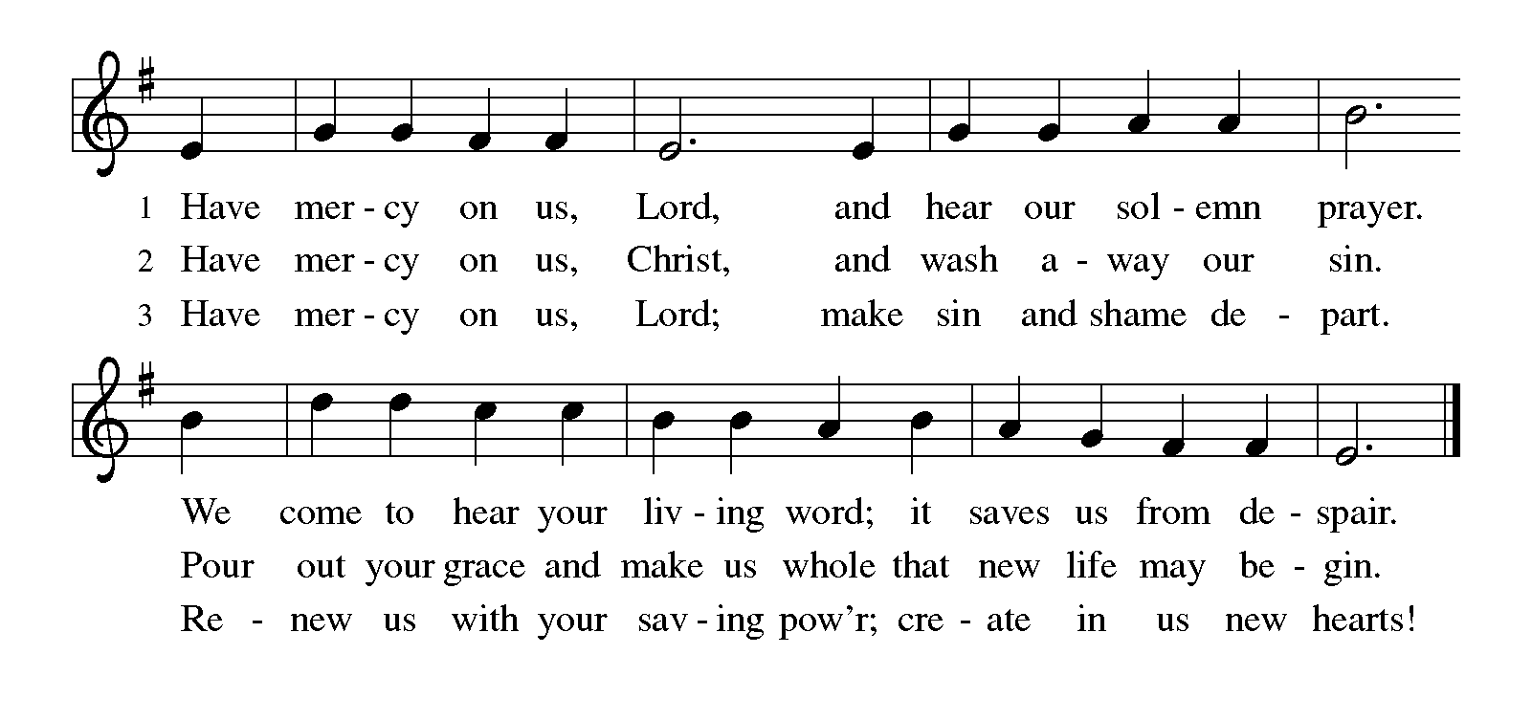KYRIE ELW p. 203

CANTICLE OF PRAISE My Hope Is Built on Nothing Less ELW # 597

PRAYER OF THE DAY

P: Creator God, you prepare a new way in the wilderness, and your grace waters our desert. Open our hearts to be transformed by the new thing you are doing, that our lives may proclaim the extravagance of your love given to all through your Son, Jesus Christ, our Savior and Lord, who lives and reigns with you and the Holy Spirit, one God, now and forever.

C: Amen.
God’s Lenten Word

God speaks to us in scripture reading, preaching, and song.

FIRST READING Isaiah 43:16-21

The prophet declares that long ago God performed mighty deeds and delivered Israel from Egyptian bondage through the waters of the sea. Now, God is about to do a new thing, bringing the exiles out of Babylon and through the wilderness in a new Exodus.

¹⁶Thus says the Lord,
who makes a way in the sea,
a path in the mighty waters,
¹⁷who brings out chariot and horse,
army and warrior;
they lie down, they cannot rise,
they are extinguished, quenched like a wick:
¹⁸Do not remember the former things,
or consider the things of old.
¹⁹I am about to do a new thing;
now it springs forth, do you not perceive it?
I will make a way in the wilderness
and rivers in the desert.
²⁰The wild animals will honor me,
the jackals and the ostriches;
for I give water in the wilderness,
rivers in the desert,
to give drink to my chosen people,
²¹the people whom I formed for myself
so that they might declare my praise.

A: The word of the Lord.

C: Thanks be to God.

PSALM 126

¹When the Lord restored the fortunes of Zion, then were we like those who dream.

²Then was our mouth filled with laughter, and our tongue with shouts of joy. Then they said among the nations, “The Lord has done great things for them.”

³The Lord has done great things for us, and we are glad indeed.
⁴Restore our fortunes, O Lord, like the watercourses of the Negeb.

⁵Those who sowed with tears will reap with songs of joy.

⁶Those who go out weeping, carrying the seed, will come again with joy, shouldering their sheaves.

SECOND READING Philippians 3:4b-14

Writing to Christians in Philippi, Paul admits that his heritage and reputation could give him more reason than most people to place confidence in his spiritual pedigree. But the overwhelming grace of God in Jesus calls Paul to a new set of values.

[Paul writes:] ^{4b}If anyone else has reason to be confident in the flesh, I have more: ⁵circumcised on the eighth day, a member of the people of Israel, of the tribe of Benjamin, a Hebrew born of Hebrews; as to the law, a Pharisee; ⁶as to zeal, a persecutor of the church; as to righteousness under the law, blameless.
⁷Yet whatever gains I had, these I have come to regard as loss because of Christ. ⁸More than that, I regard everything as loss because of the surpassing value of knowing Christ Jesus my Lord. For his sake I have suffered the loss of all things, and I regard them as rubbish, in order that I may gain Christ ⁹and be found in him, not having a righteousness of my own that comes from the law, but one that comes through faith in Christ, the righteousness from God based on faith. ¹⁰I want to know Christ and the power of his resurrection and the sharing of his sufferings by becoming like him in his death, ¹¹if somehow I may attain the resurrection from the dead.
¹²Not that I have already obtained this or have already reached the goal; but I press on to make it my own, because Christ Jesus has made me his own. ¹³Beloved, I do not consider that I have made it my own; but this one thing I do: forgetting what lies behind and straining forward to what lies ahead, ¹⁴I press on toward the goal for the prize of the heavenly call of God in Christ Jesus.

A: The word of the Lord.

C: Thanks be to God.

LENTEN ACCLAMATION Return to the Lord ELW p. 151

Printed on the next page.

GOSPEL John 12:1-9

P: Announcement of the Gospel.

C: Glory to you, O Lord.

Judas willfully misinterprets as waste Mary’s extravagant act of anointing Jesus’s feet with costly perfume. Jesus recognizes that her lavish gift is both an expression of love and an anticipation of his burial.

¹Six days before the Passover Jesus came to Bethany, the home of Lazarus, whom he had raised from the dead. ²There they gave a dinner for him. Martha served, and Lazarus was one of those at the table with him. ³Mary took a pound of costly perfume made of pure nard, anointed Jesus’ feet, and wiped them with her hair. The house was filled with the fragrance of the perfume. ⁴But Judas Iscariot, one of his disciples (the one who was about to betray him), said, ⁵“Why was this perfume not sold for three hundred denarii and the money given to the poor?” ⁶(He said this not because he cared about the poor, but because he was a thief; he kept the common purse and used to steal what was put into it.) ⁷Jesus said, “Leave her alone. She bought it so that she might keep it for the day of my burial. ⁸You always have the poor with you, but you do not always have me.”

P: Affirmation of the Gospel.

C: Praise to you, O Christ.

SERMON

HYMN OF THE DAY Jesus, Keep Me Near the Cross ELW # 335

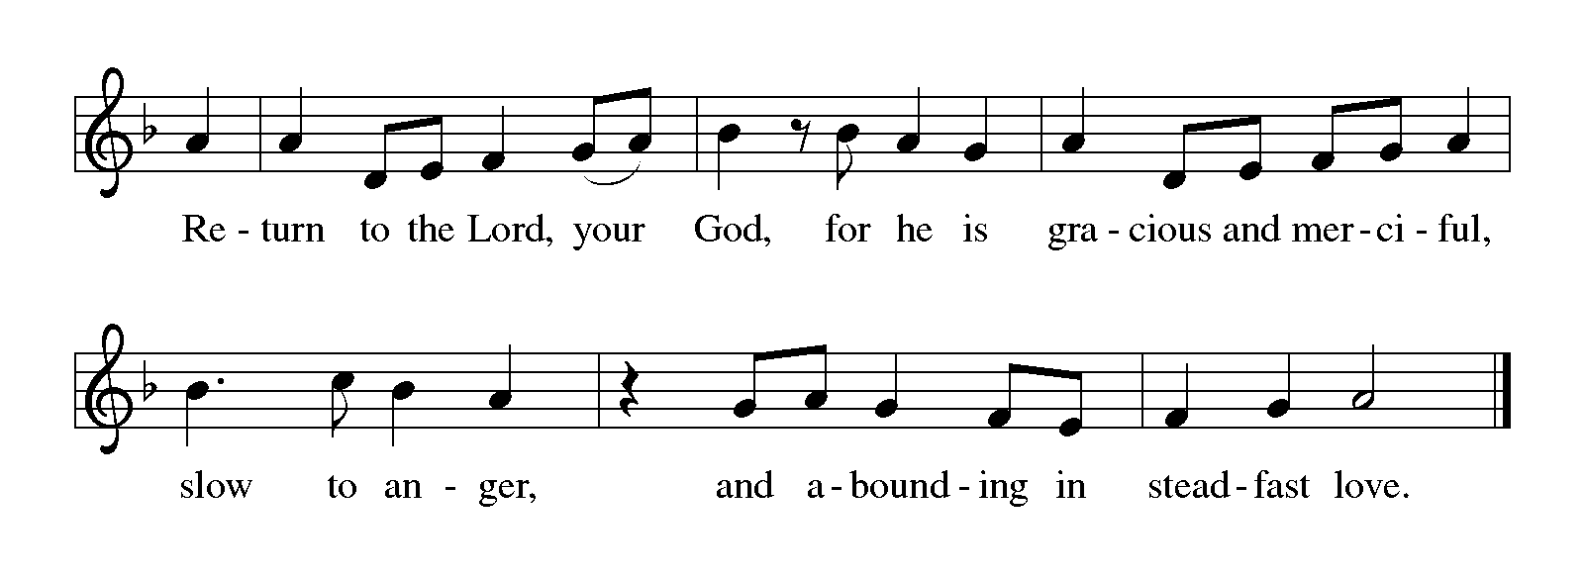PRAYERS OF INTERCESSION

Each petition ends with these words and response:

A: Merciful God.

C: receive our prayer.

Concluding petition and response:

A: Accept the prayers we bring, O God, on behalf of a world in need, for the sake of Jesus Christ.

C: Amen.

God’s Lenten Word in the Holy Meal

God feeds us with the presence of Jesus Christ.

OFFERING AND MUSIC

ASSEMBLY SONG Take My Life, That I May Be ELW # 685

Stanzas 1, 2, 4 and 6

OFFERING PRAYER

A: Extravagant God, you have blessed us with the fullness of creation. Now we gather at your feast where you offer us the food that satisfies. Take and use what we offer here, come among us, and feed us with the body and blood of Christ, in whose name we pray.

C: Amen.

GREAT THANKSGIVING

Dialogue ELW p. 206

P: The Lord be with you.

C: And also with you.

P: Lift up your hearts.

C: We lift them to the Lord.

P: Let us give thanks to the Lord our God.

C: It is right to give our thanks and praise.

Preface

P: It is indeed right, our duty and our joy, that we should at all times and in all places give thanks and praise to you, almighty and merciful God, through our Savior Jesus Christ. You call your people to cleanse their hearts and prepare with joy for the paschal feast, that, renewed in the gift of baptism, we may come to the fullness of your grace. And so, with all the choirs of angels, with the church on earth and the hosts of heaven, we praise your name and join their unending hymn:

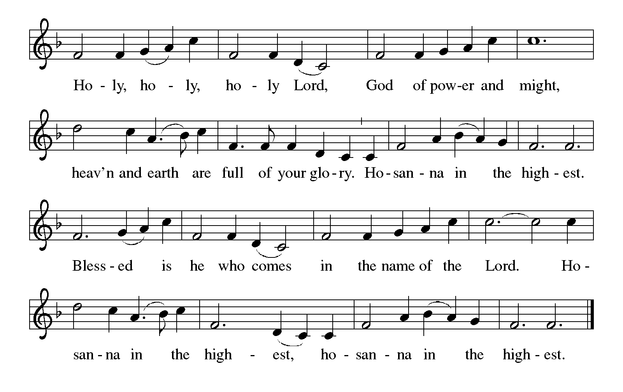Holy, Holy, Holy (the angels’ song) ELW p. 207

Thanksgiving at The Table

P: Blessed are you, O God of the universe. Your mercy is everlasting, and your faithfulness endures from age to age.

Praise to you for creating the heavens and the earth.
Praise to you for saving the earth from the waters of the flood.
Praise to you for bringing the Israelites safely through the sea.

Continued on the next page.

Praise to you for leading your people through the wilderness
to the land of milk and honey.
Praise to you for the words and deeds of Jesus, your anointed one.
Praise to you for the death and resurrection of Christ.
Praise to you for your Spirit poured out on all nations.

In the night in which he was betrayed, our Lord Jesus took bread, and gave thanks; broke it, and gave it to his disciples, saying: Take and eat; this is my body, given for you. Do this for the remembrance of me.

Again, after supper, he took the cup, gave thanks, and gave it for all to drink, saying: This cup is the new covenant in my blood, shed for you and for all people for the forgiveness of sin. Do this for the remembrance of me.

With this bread and cup, we remember our Lord's passover from death to life as we proclaim the mystery of faith:

C: Christ has died. Christ is risen. Christ will come again.

P: O God of resurrection and new life: Pour out your Holy Spirit on us and on these gifts of bread and wine. Bless this feast. Grace our table with your presence.

C: Come, Holy Spirit.

Reveal yourself to us in the breaking of the bread. Raise us up as the body of Christ for the world. Breathe new life into us. Send us forth, burning with justice, peace, and love.

C: Come, Holy Spirit.

P: With your holy ones of all times and places, with the earth and all its creatures, with sun and moon and stars, we praise you, O God, blessed and holy Trinity, now and forever.

C: Amen.

Lord’s Prayer Traditional Wording ELW p. 208

P: Lord, remember us in your kingdom and teach us to pray.

All: Our Father, who art in heaven, hallowed be thy name, thy kingdom come, thy will be done, on earth as it is in heaven. Give us this day our daily bread; and forgive us our trespasses, as we forgive those who trespass against us; and lead us not into temptation, but deliver us from evil. For thine is the kingdom, and the power, and the glory, forever and ever. Amen.
Invitation to Communion

P: Here is food and drink for the journey. Take and be filled.

COMMUNION

What We Believe

Who May Receive. We welcome all baptized Christians to the Lord's Table. In our parish baptized children who have entered the 5th grade are instructed in this sacrament and receive their First Communion; younger children come to the altar and receive a blessing. If your baptized child has received such instruction, or if you want your baptized child to receive Communion, then he or she is welcome to partake.

Proper Preparation. In his Small Catechism, Martin Luther asks, “When is a person rightly prepared to receive this sacrament?” He answers, “Fasting and other outward preparations serve a good purpose. However, that person is well prepared and worthy who believes these words, given and shed for you for the remission of sins. But anyone who does not believe these words, or doubts them, is neither prepared nor worthy, for the words for you require simply a believing heart.”

Real Presence. We believe that the bread and wine truly are the body and blood of Christ given and shed for the forgiveness of sins.

Distribution

Holy Communion will be served in procession. The ushers will direct you down the center aisle. You will receive the elements near the chancel. Extend your hands, palms up, if you will be receiving the bread. Gluten-free wafers are available; please ask for one. Proceed to your right or to your left to receive the wine. White grape juice is also available in the center ring of each tray for those who prefer an alcohol-free element. You may say “Amen” after receiving each element. If you will not be receiving Communion, keep your hands folded. Place your empty cup in the basket and then return to your seat by the side aisle.

Congregational Songs During Communion

Lamb of God ELW p. 208

We Come to the Hungry Feast ELW # 479

Jesus, the Very Thought of You ELW # 754

Be Thou My Vision ELW # 793

Let Us Ever Walk with Jesus ELW # 802

PRAYER AFTER COMMUNION

P: Blessed Jesus, in this rich meal of grace, you have fed us with your body, the bread of life. Now send us forth to bear your life-giving hope to a world in need.

C: Amen.

Sending

God blesses us and sends us in mission to the world.

ANNOUNCEMENTS

BLESSING

P: You are children of God, anointed with the oil of gladness and strengthened for the journey. Almighty God, motherly, majestic, and mighty, ☩ bless you this day and always.

C: Amen.

DEPARTING HYMN Beneath the Cross of Jesus ELW # 338

Stanzas 1, 3 and 4

DISMISSAL

A: Go in peace. Jesus meets you on the way.

C: Thanks be to God.

RINGING OF THE BELL

POSTLUDE

Commemorations

Wednesday, April 6

Albrecht Dürer, died 1528; Matthias Grünewald, died 1529; and
Lucas Cranach, died 1553; artists

These great artists revealed through their work the mystery of salvation and the wonder of creation. Dürer's (dyoo-rer) work reflected the apocalyptic spirit of his time, when famine, plague, and social and religious upheaval were common. He was sympathetic to the reform work of Luther but remained Roman Catholic. At his death, Luther wrote to a friend, “Affection bids us mourn for one who was the best.”
Grünewald (gree-neh-vahld) was born Mathis Neithardt, and is sometimes referred to as "Master Mathis" or "Mathis the Painter" (Mathis der Maler); the name Grünewald was applied to him after his death. His paintings are known for their dramatic forms, vivid colors, and depiction of light. Several religious works are included in his small surviving corpus, the most famous being the Isenheim Altarpiece.
Lucas Cranach (krah-nakh) the Elder was born in southern Germany and studied in Vienna, but then moved to Wittenberg, where he spent most of his career as a court painter to the Saxon electors. His work includes many fine religious examples and several portraits of Martin Luther, although he also painted secular subjects. Besides being one of the greatest German painters of his time, Cranach was also widely known for his woodcuts, some of which illustrated the first German printing of the New Testament.
With Good Friday just over a week away, give some thought to the ways in which the art of these three people might highlight your celebration of the mystery of Christ's passion.

Saturday, April 9

Dietrich Bonhoeffer, theologian, died 1945

Bonhoeffer (bon-heh-fer) was a German theologian who, at the age of 25, became a lecturer in systematic theology at the University of Berlin. In 1933, and with Hitler's rise to power, Bonhoeffer became a leading spokesman for the Confessing Church, a resistance movement against the Nazis. He was arrested in 1943. He was linked to a failed attempt on Hitler's life and sent to Buchenwald, then later to Schönberg prison. After leading a worship service on April 8, 1945, at Schönberg prison, he was taken away to be hanged the next day. His last words as he left were, "This is the end, but for me the beginning of life."
A hymn written by Bonhoeffer shortly before his death includes the line “By gracious powers so wonderfully sheltered, and confidently waiting come what may, we know that God is with us night and morning, and never fails to greet us each new day” (ELW 626, stanza 1). Bonhoeffer's courage is a bold witness to the paschal mystery of Christ's dying and rising of the upcoming Three Days.

Today’s Assistants and Ministers

Greeters & Ushers ….............................................…...… Nathan Boyum and Lee Peterson
Pianist ……………….………………………….…..………………………..…… Sharon Boyum
Presiding Minister ……………………………….…………… Deacon Cindy Cordes-Eversole
Reader ……………………………………….…………..…….…………………. Sharon Boyum
Altar Care & Communion Preparation ………………..………. Pastor Kerry & Deacon Cindy
Refreshments …………………………………...…………….……… Nathan & Sharon Boyum

Acknowledgments

Graphics, worship texts, service music, and readings are from sundaysandseasons.com © 2022 Augsburg Fortress. Used by permission under Augsburg Fortress Liturgies Annual License SAS103296.

Permission to project, live stream, or podcast liturgy and music content under copyright to or administered by Augsburg Fortress provided under Augsburg Fortress Liturgies Annual License SAS103296.

Permission to Podcast / Stream provided by Christian Copyright Licensing International, Inc., under License # 11459672. Additional fee paid. www.ccli.com.

Permission to Podcast / Stream provided by One License, Inc., under License # A-735588. Additional fee paid. www.onelicense.net.

Presence Last Week and March Presents

Attendance Last Sunday, March 27 = 42
Average Sunday Worship Attendance for March = 53

March Contributions: General Fund = $ Designated Giving = $
Jan-Mar Income = $ Jan-Mar Expenses = $ Deficit = $

This Week in Our Congregation

Today, April 3 — Fifth Sunday in Lent
Sunday School after the children’s sermon
Refreshments in the Fellowship Hall for everyone following worship
7th- & 8th-grade Confirmation session 10:15 AM
Choir Rehearsal 10:15 AM

Tuesday, April 1
Men’s breakfast at Home Sweet Home, Lanesboro 7:00 AM

Wednesday, April 6
WELCA Sew Day 9:00 AM
Deacon Cindy at Chosen Valley Care Center in Chatfield for chapel 1:00 PM
Midweek Lenten Worship ONLINE only posted before 7:00 PM

Saturday, April 9
Drive-thru Dinner 11:00 AM – 2:00 PM
This Week in Our Congregation continued

Next Sunday, April 10 — Palm Sunday / Sunday of the Passion
Worship with choir anthem 9:00 AM
NO 7th- & 8th-grade Confirmation session

Prayer Requests

In Our Community. For our church members and friends living with chronic illness and other diseases, who are homebound, residing in care facilities, and hospitalized. See the newsletter for our members living in area nursing homes. And let us not forget those sick and dying of COVID-19, those entrusted with the authority of government, justice, and law enforcement, as well as our fallen and wounded soldiers and those still serving.

In Our Synod. Bishop Regina Hassanally invites the people and congregations of our synod to commit to praying this week for the following faith communities: Good Shepherd Lutheran Church, Wells; St. Paul’s of German Lake, Cleveland; West Freeborn Lutheran Church, Hartland; St. Paul Lutheran Church, Le Center; United Lutheran Church, Frost; Dinka Sudanese Worshipping Community in Austin; and Nzega Lutheran Church, Tanzania.

News and Notes

Drive-thru Dinner at Bethlehem Lutheran Church, next Saturday, April 9, 11 am to 2 pm. Ham, Au Gratin Potatoes, Baked Beans, and dinner roll. $12 per meal.

Are you missing a coat? Lois Peterson has a Liz Claibome (L) coat, deep red, not bright red, with a red satin lining, black collar, and cuffs. It looks just like hers but is a different size. Please contact her if you think it is yours. 507-467-2904 mimip23@acegroup.cc

Tech Team members and webmaster needed. The church council is looking for computer geeks and other interested helpers to work with Cam Dahl to broadcast our Sunday and other services. The council is also looking for volunteers who would enjoy keeping our congregation’s website up to date. Please contact Cam (507-512-0278) or Brett Clarke (507-459-8722) or Pastor Kerry (507-951-3954).

IN VIEW OF GOD’S MERCY
A SERIES OF SERVICES FOR THE SEASON OF LENT

Continue to join us during Lent for this series of services in which we explore the richness of God’s mercy toward us in Jesus: through his life, his death on the cross, and his glorious resurrection. In response, we are called by God to be living sacrifices for Jesus, displaying our devotion to him in both word and deed.

Each service in this worship series will focus our eyes of faith on the meaning behind God’s mercy made manifest in Christ. Here are the themes and scriptures for the other midweek services during this special time of repentance and reflection.

The remainder of the midweek services will be held only online. NO in-person worship and NO light suppers before any of the services. Services will be posted on our Facebook page before 7:00 p.m.

Week 5 • April 6 • Mercy in Service • Hebrews 6:10
In response to God’s kindness to us in Jesus, we serve in mercy the needs of those around us by Christ’s example.

