Bethlehem Lutheran Church
Established 1874

Rev. Kerry B. Eversole, Pastor
Deacon Cindy Cordes-Eversole, Associate in Ministry

Mailing Address: P.O. Box 314, Lanesboro, MN 55949-0314
Physical Address: 200 Kenilworth Ave S, Lanesboro, Minn.

Telephone: 507.467.3344
E-mail Address: bethlehem@acegroup.cc
Website: www.staronthehill.com
Facebook Page: www.facebook.com/BethlehemLutheranLanesboro

Office Hours: Tuesday, Wednesday, Thursday 10 a.m. to 3 p.m.
Parsonage Phone: 507.467.3017
Pastor Kerry’s Cell Phone: 507.951.3954

Welcome to worship at Bethlehem Lutheran Church
and the festival of the

Resurrection of Our Lord
Easter Day

April 17, 2022

COVID-19 Practices Out of Love for God and Neighbor
1) Use hand sanitizer upon entry. Wash your hands and use hand sanitizer often while in the facility.
2) Members and visitors who are vaccinated and boosted are not required to wear a mask.
3) Members and visitors are free to wear a mask if they wish to do so.
4) Unvaccinated and not boosted members and visitors must wear a mask.
5) There are no physical distancing requirements, but you are welcome to keep a distance from others in the sanctuary as you are able.

Worship Book and Hymns. This morning’s service is printed in this bulletin but can also be found with all the hymns in Evangelical Lutheran Worship (ELW), “the red book” in the pew bookracks, and on the pews. Hymns in ELW are indicated by a large bold number in the left or right margin of each page.

Abbreviations. Throughout this worship folder hymns are signified by the pound symbol (#). P: refers to the presiding minister or preacher, A: denotes an assisting minister, and C: and/or bold text indicates the congregation.

Mistakes do not happen in our worship service;
only unexpected events which are opportunities for joy!

An signifies that you may stand as you are comfortably able.

Introduction to Easter Day. On the first day of the week, God began creation, transforming darkness into light. On this, the “eighth day” of the week, Jesus was raised from the dead. Paul writes that “The last enemy to be destroyed is death” (1 Corinthians 15:26). Today we gather together with astonishment and joy to celebrate this new creation.
Christ is risen, and we have been set free from the bonds of death. Christ is risen, and we are forgiven. Christ is risen, and with the women at the tomb and Peter, we are amazed. Let us rejoice: Christ is risen indeed! Alleluia!
Gathering

The Holy Spirit calls us together as the people of God.

PRELUDE

RINGING OF THE BELL

EASTER PROCLAMATION

P: Alleluia! Christ is risen!

C: Christ is risen indeed! Alleluia!

PROCESSIONAL HYMN Jesus Christ Is Risen Today ELW # 365

Stanzas 1, 2, 3 and 4

GREETING

P: Alleluia! Christ is risen!

C: Christ is risen indeed! Alleluia!

P: The joy and peace of our risen Savior, the love of God, and the communion of the Holy Spirit be with you all.

C: And also with you.

KYRIE ELW p. 138
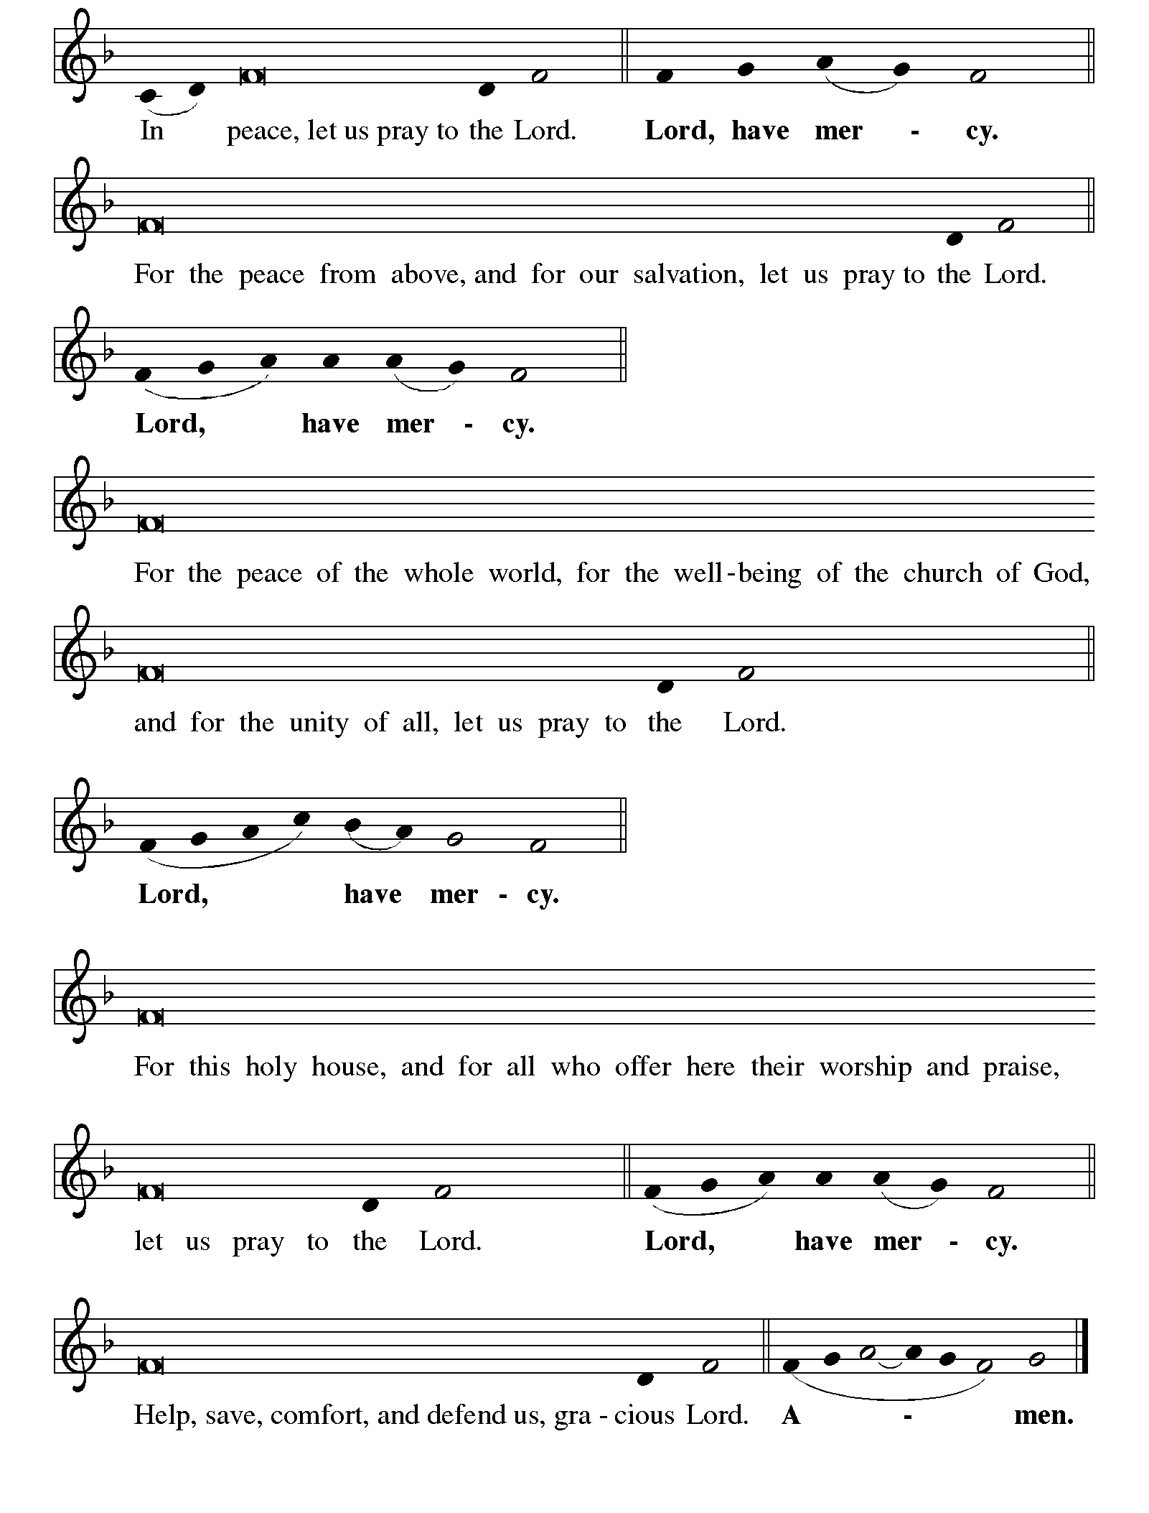

Continued on the next page
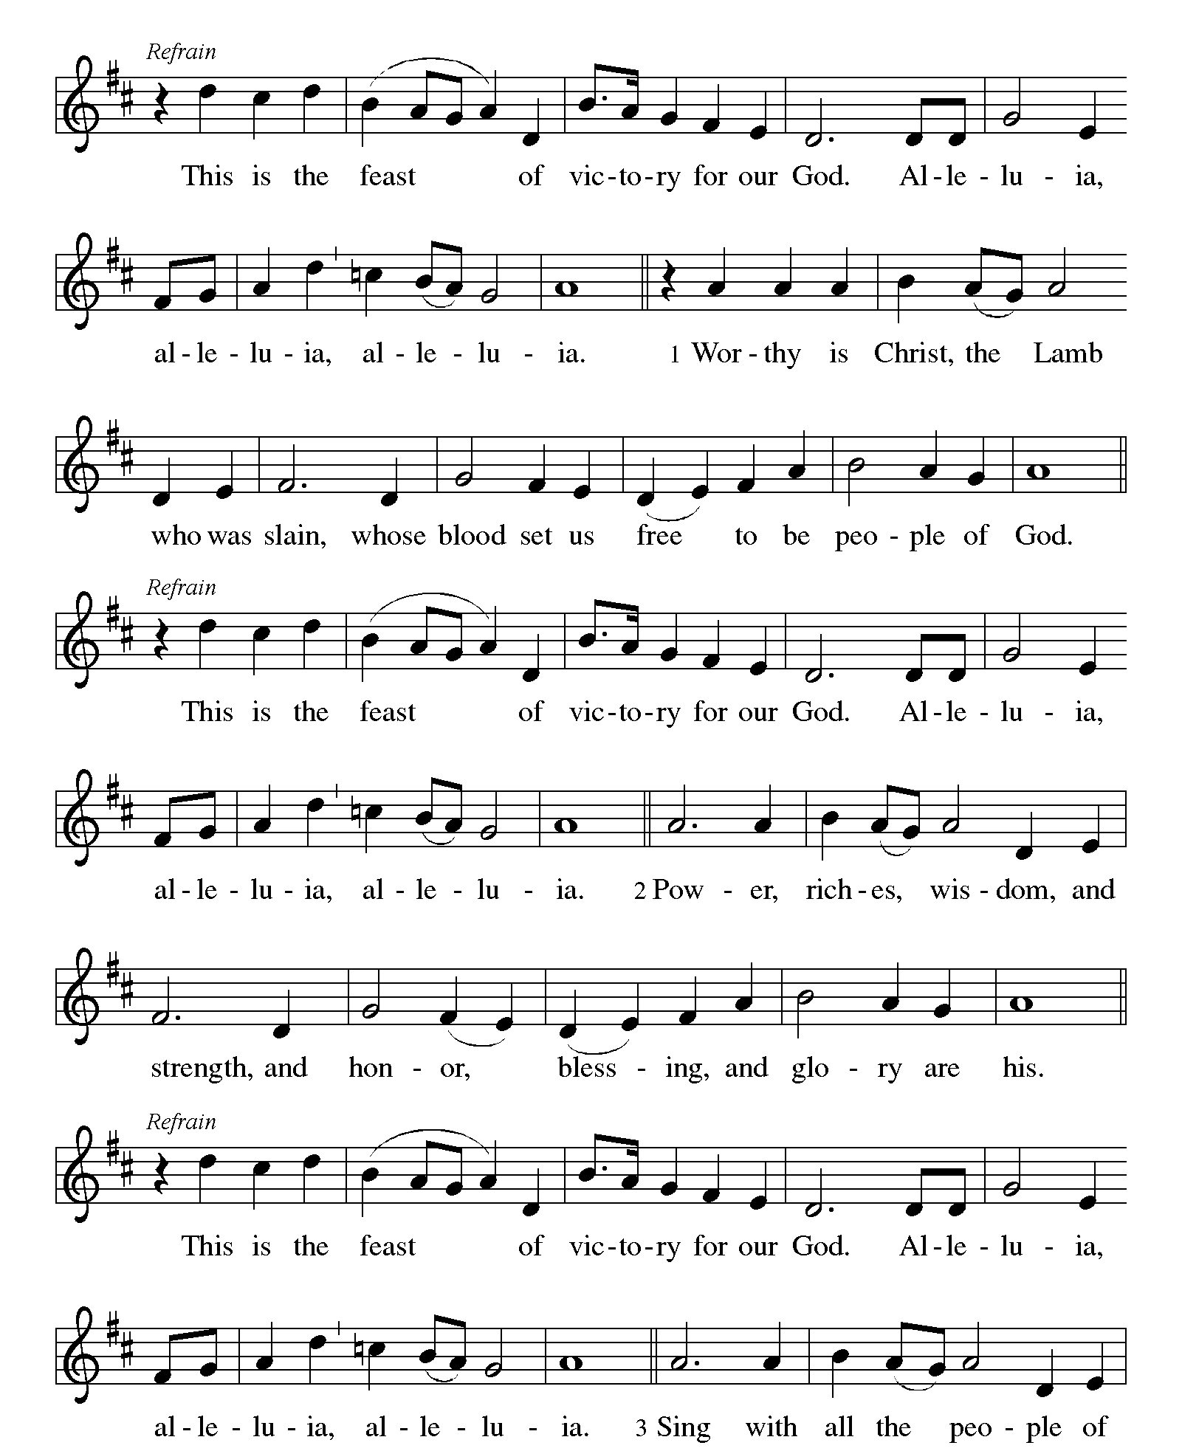KYRIE concluded ELW pp. 138-139

CANTICLE OF PRAISE This is the Feast ELW p. 140

Printed on the next page.

Continued on the next page.

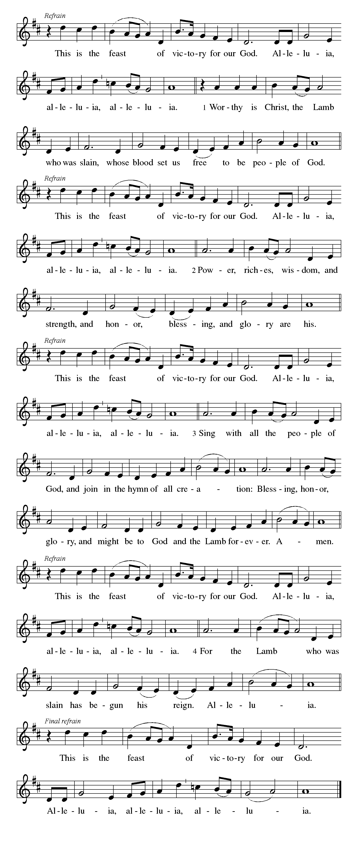CANTICLE OF PRAISE continued ELW p. 141

Continued on the next page.

CANTICLE OF PRAISE concluded ELW p. 141

PRAYER OF THE DAY

P: God of mercy, we no longer look for Jesus among the dead, for he is alive and has become the Lord of life. Increase in our minds and hearts the risen life we share with Christ and help us to grow as your people toward the fullness of eternal life with you, through Jesus Christ, our Savior and Lord, who lives and reigns with you and the Holy Spirit, one God, now and forever.

C: Amen.

The Good News of Easter

God speaks to us in scripture reading, preaching, and song.

FIRST READING Acts 10:34-43

Peter’s sermon, delivered at the home of Cornelius, a Roman army officer, sums up the essential message of Christianity. Everyone, regardless of whether they are Jew or Gentile, who believes in Jesus, whose life, death, and resurrection fulfilled the words of the prophets, receives forgiveness of sins through his name.

³⁴Peter began to speak to the people: “I truly understand that God shows no partiality, ³⁵but in every nation anyone who fears him and does what is right is acceptable to him. ³⁶You know the message he sent to the people of Israel, preaching peace by Jesus Christ—he is Lord of all. ³⁷That message spread throughout Judea, beginning in Galilee after the baptism that John announced: ³⁸how God anointed Jesus of Nazareth with the Holy Spirit and with power; how he went about doing good and healing all who were oppressed by the devil, for

Continued on the next page.
God was with him. ³⁹We are witnesses to all that he did both in Judea and in Jerusalem. They put him to death by hanging him on a tree; ⁴⁰but God raised him on the third day and allowed him to appear, ⁴¹not to all the people but to us who were chosen by God as witnesses, and who ate and drank with him after he rose from the dead. ⁴²He commanded us to preach to the people and to testify that he is the one ordained by God as judge of the living and the dead. ⁴³All the prophets testify about him that everyone who believes in him receives forgiveness of sins through his name.”

A: Word of God, word of life.

C: Thanks be to God.

ANTHEM Mary Told the Good News Bethlehem Choir

PSALM 118:1-2, 14-16, 19-24 (RSV)

¹O give thanks to the Lord, for he is good; his steadfast love endures forever!

²Let Israel say, “His steadfast love endures forever.”

¹⁴The Lord is my strength and my song; he has become my salvation.

¹⁵Hark, glad songs of victory in the tents of the righteous: “The right hand of the Lord does valiantly;

¹⁶the right hand of the Lord is exalted; the right hand of the Lord does valiantly.”

¹⁹Open to me the gates of righteousness, that I may enter through them and give thanks to the Lord.

²⁰This is the gate of the Lord; the righteous shall enter through it.

²¹I thank you that you have answered me and have become my salvation.

²²The stone which the builders rejected has become the head of the corner.

²³This is the Lord’s doing; it is marvelous in our eyes.

²⁴This is the day which the Lord has made; let us rejoice and be glad in it.

²⁴This is the day which the Lord has made; let us rejoice and be glad in it.

GOSPEL ACCLAMATION

“Alleluias” are from The Strife Is O’er, the Battle Done ELW # 366

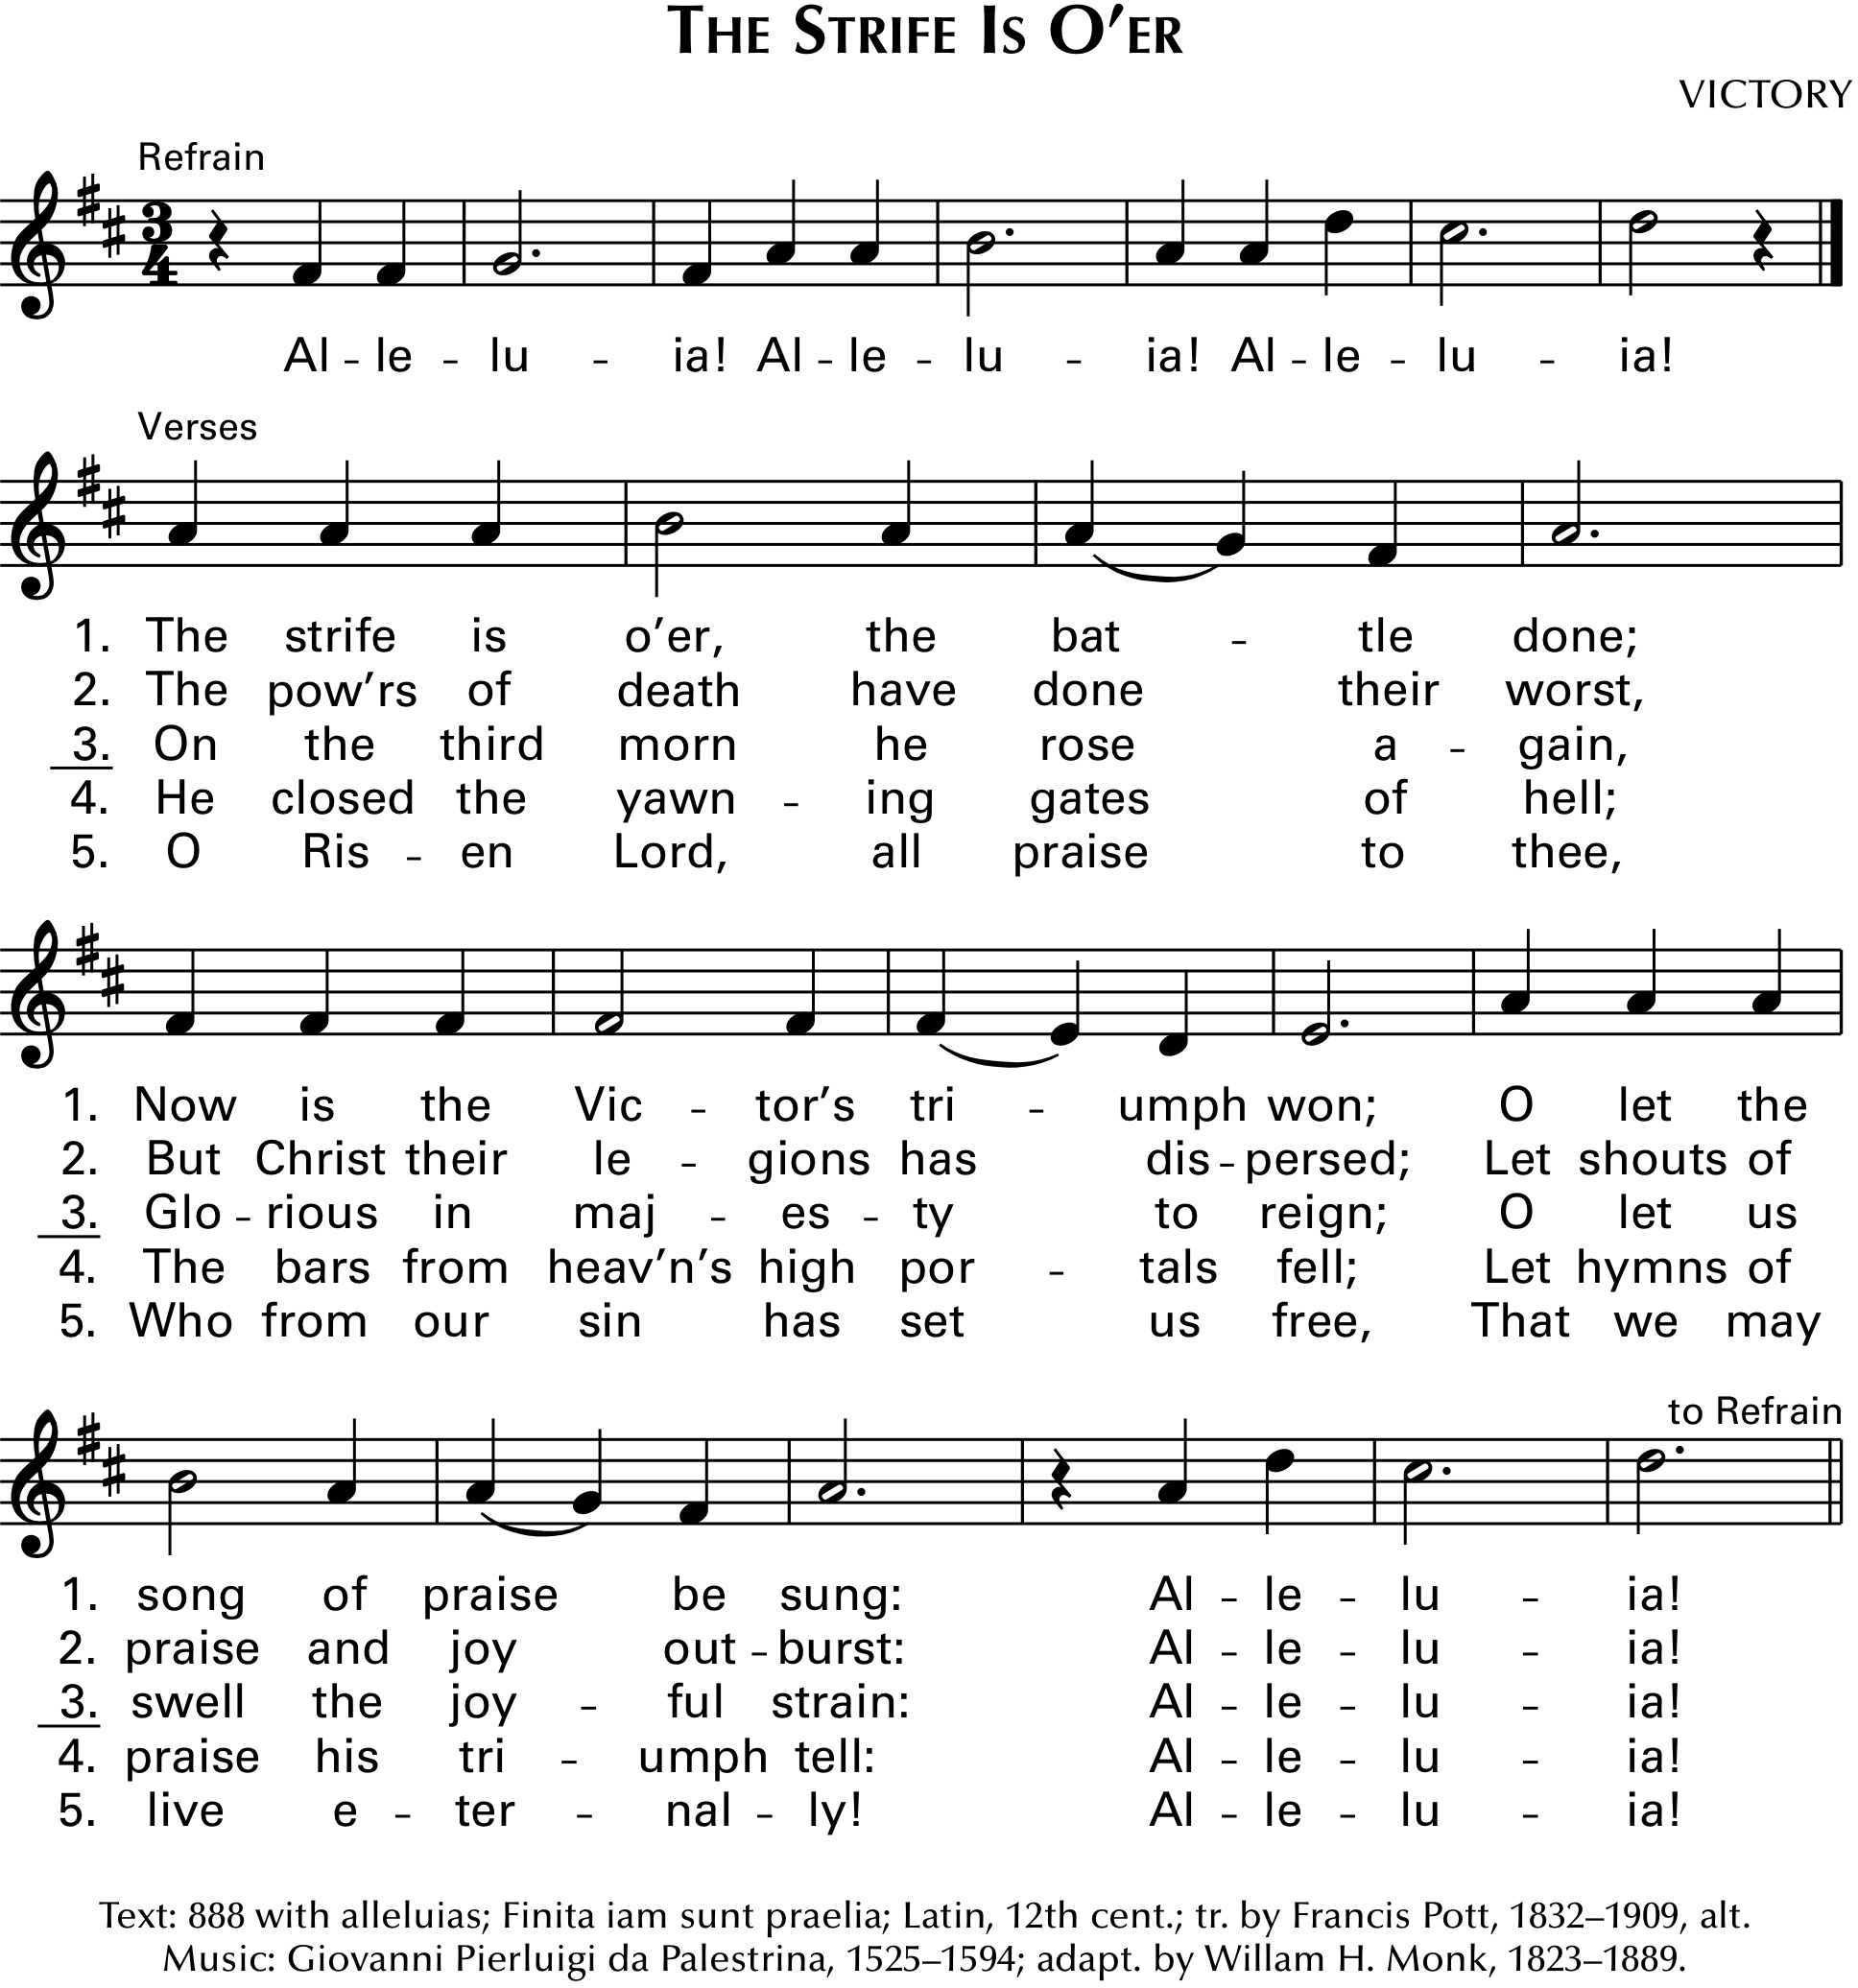

P: Christ, our paschal lamb, has been sacrificed. Therefore, let us keep the feast. 1 Corinthians 5:7, 8

GOSPEL Luke 24:1-12

Announcement of the Gospel.

P: The Holy Gospel according to Saint Luke, the twenty-fourth chapter.

C: Glory to you, O Lord.

Evidently expecting to find Jesus’s corpse, some of the women among his followers go to the tomb with embalming spices. After a perplexing encounter with the empty tomb and angelic visitors, the women become the first to proclaim the amazing news of resurrection.

¹On the first day of the week, at early dawn,[the women] came to the tomb, taking the spices that they had prepared. ²They found the stone rolled away from the tomb, ³but when they went in, they did not find the body. ⁴While they were perplexed about this, suddenly two men in dazzling clothes stood beside them. ⁵The women were terrified and bowed their faces to the ground, but the men said to them, “Why do you look for the living among the dead? He is not here, but has risen. ⁶Remember how he told you, while he was still in Galilee, ⁷that the Son of Man must be handed over to sinners, and be crucified, and on the third day rise again.” ⁸Then they remembered his words, ⁹and

Continued on the next page.
returning from the tomb, they told all this to the eleven and to all the rest. ¹⁰Now it was Mary Magdalene, Joanna, Mary the mother of James, and the other women with them who told this to the apostles. ¹¹But these words seemed to them an idle tale, and they did not believe them. ¹²But Peter got up and ran to the tomb; stooping and looking in, he saw the linen cloths by themselves; then he went home, amazed at what had happened.

Affirmation of the Gospel.

P: The Easter Gospel of our Lord.

C: Praise to you, O Christ.

CHILDREN’S MESSAGE

SERMON in view of GOD’S MERCY—Mercy in the Open Tomb

HYMN OF THE DAY The Day of Resurrection ELW # 361

PROFESSION OF FAITH Nicene Creed ELW p. 104

P: With the whole church, let us confess our faith.

All: We believe in one God, the Father, the Almighty, maker of heaven and earth, of all that is, seen and unseen.

We believe in one Lord, Jesus Christ, the only Son of God, eternally begotten of the Father, God from God, Light from Light, true God from true God, begotten, not made, of one Being with the Father; through him all things were made. For us and for our salvation he came down from heaven, was incarnate of the Holy Spirit and the virgin Mary and became truly human. For our sake he was crucified under Pontius Pilate; he suffered death and was buried. On the third day he rose again in accordance with the scriptures; he ascended into heaven and is seated at the right hand of the Father. He will come again in glory to judge the living and the dead, and his kingdom will have no end.

We believe in the Holy Spirit, the Lord, the giver of life, who proceeds from the Father and the Son, who with the Father and the Son is worshiped and glorified, who has spoken through the prophets. We believe in one holy catholic and apostolic church. We acknowledge one baptism for the forgiveness of sins. We look for the resurrection of the dead, and the life of the world to come. Amen.

PRAYERS OF GOD’S PEOPLE

Each petition ends with these words and response:

A: God of new life,

C: hear our prayer.

Concluding petition and response:

A: In the hope of new life in Christ, we raise these prayers to you, and those we carry in our hearts, trusting in your abundant and ever-present mercy.

C: Amen.

The Good News of Easter in the Holy Meal

God feeds us with the presence of Jesus Christ.

OFFERING

ASSEMBLY SONG Come, Let Us Eat ELW # 491

Stanzas 1, 2 and 3

OFFERING PRAYER

A: Let us pray.

Living God

C: you gather the wolf and the lamb to feed together in your peaceable reign, and you welcome us all at your table. Reach out to us through this meal, and show us your wounded and risen body, that we may be nourished and believe in Jesus Christ, our Savior and Lord. Amen.

GREAT THANKSGIVING

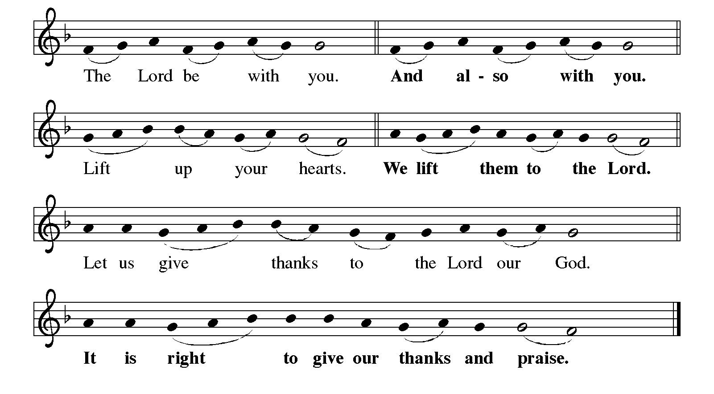Dialogue ELW p. 144

Continued on the next page.

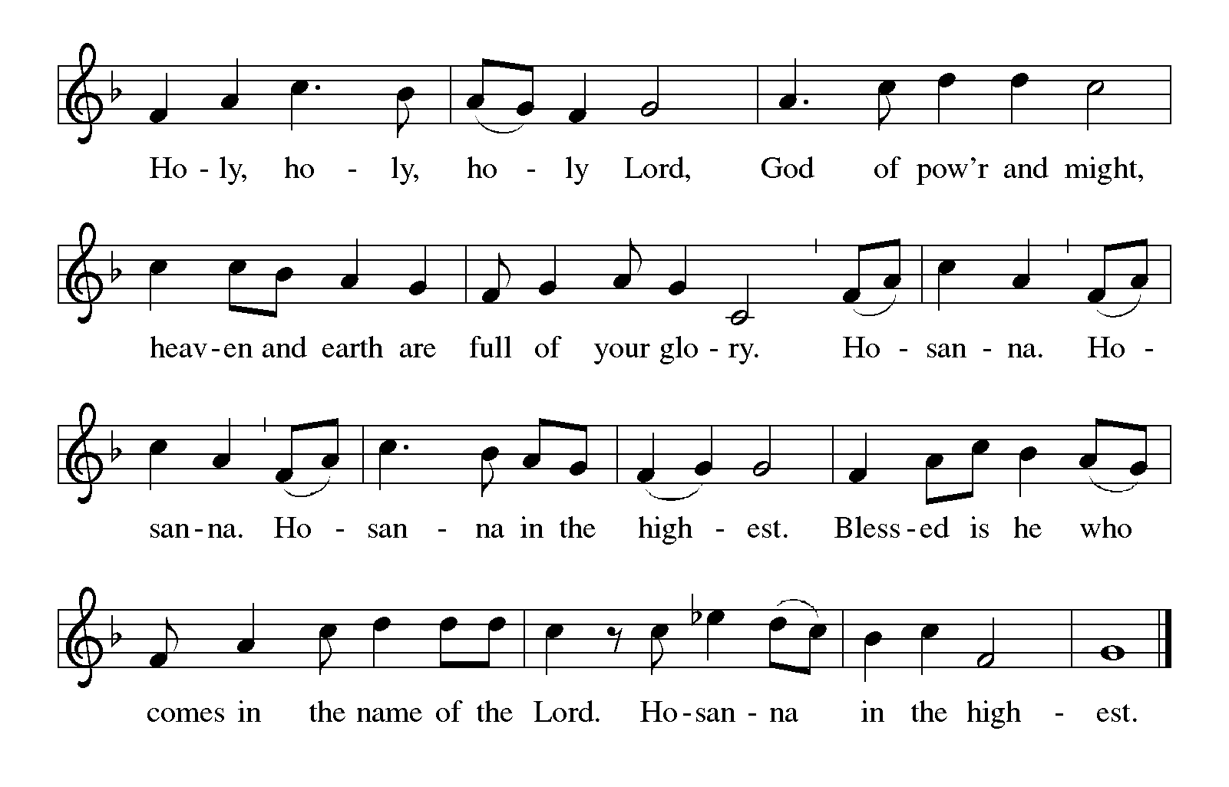Dialogue concluded ELW p. 144

Preface

P: It is indeed right, our duty and our joy, that we should at all times and in all places give thanks and praise to you, almighty and merciful God, for the glorious resurrection of our Savior Jesus Christ, the true Paschal Lamb who gave himself to take away our sin; who in dying has destroyed death, and in rising has brought us to eternal life. And so, with Mary Magdalene and Peter and all the witnesses of the resurrection, with earth and sea and all their creatures, and with angels and archangels, cherubim and seraphim, we praise your name and join their unending hymn:

Holy, Holy, Holy (the angels’ song) ELW p. 144

Printed on the next page.

Thanksgiving at the Table ELW p. 145

P: You are indeed holy, almighty and merciful God. You are most holy, and great is the majesty of your glory.

You so loved the world that you gave your only Son, so that everyone who believes in him may not perish but have eternal life.

We give you thanks for his coming into the world to fulfill for us your holy will and to accomplish all things for our salvation.

In the night in which he was betrayed, our Lord Jesus took bread, and gave thanks; broke it, and gave it to his disciples, saying: Take and eat; this is my body, given for you. Do this for the remembrance of me.

Again, after supper, he took the cup, gave thanks, and gave it for all to drink, saying: This cup is the new covenant in my blood, shed for you and for all people for the forgiveness of sin. Do this for the remembrance of me.

Continued on the next page.

P: For as often as we eat of this bread and drink from this cup, we proclaim the Lord's death until he comes.

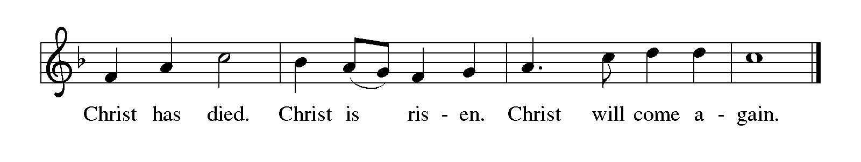
P: Remembering, therefore, his salutary command, his life-giving passion and death, his glorious resurrection and ascension, and the promise of his coming again, we give thanks to you, O Lord God Almighty, not as we ought but as we are able; we ask you mercifully to accept our praise and thanksgiving and with your Word and Holy Spirit to bless us, your servants, and these your own gifts of bread and wine, so that we and all who share in the body and blood of Christ may be filled with heavenly blessing and grace, and, receiving the forgiveness of sin, may be formed to live as your holy people and be given our inheritance with all your saints.

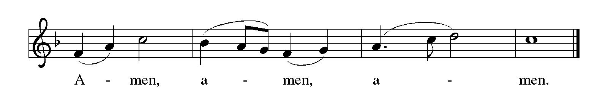To you, O God, Father, Son, and Holy Spirit, be all honor and glory in your holy church, now and forever.

Lord’s Prayer Traditional Wording ELW p. 145

P: Gathered into one by the Holy Spirit, let us pray as Jesus taught us.

All: Our Father, who art in heaven, hallowed be thy name, thy kingdom come, thy will be done, on earth as it is in heaven. Give us this day our daily bread; and forgive us our trespasses, as we forgive those who trespass against us; and lead us not into temptation, but deliver us from evil. For thine is the kingdom, and the power, and the glory, forever and ever. Amen.

INVITATION TO COMMUNION

P: The risen Christ dwells with us here. All who are hungry, all who are thirsty, come.

COMMUNION

What We Believe

Who May Receive. We welcome all baptized Christians to the Lord's Table. In our parish baptized children who have entered the 5th grade are instructed in this sacrament and receive their First Communion; younger children come to the altar and receive a blessing. If your baptized child has received such instruction, or if you want your baptized child to receive Communion, then he or she is welcome to partake.

Proper Preparation. In his Small Catechism, Martin Luther asks, "When is a person rightly prepared to receive this sacrament?" He answers, "Fasting and other outward preparations serve a good purpose. However, that person is well prepared and worthy who believes these words, given and shed for you for the remission of sins. But anyone who does not believe these words, or doubts them, is neither prepared nor worthy, for the words for you require simply a believing heart.”

Real Presence. We believe that the bread and wine truly are the body and blood of Christ given and shed for the forgiveness of sins.

Distribution

Holy Communion will be served in procession with physical distancing and one side of the sanctuary at a time. The ushers will direct you when to make your way to the front of the church using the center aisle. You will receive the elements near the chancel. Please extend your hands, palms up, if you will be receiving the bread. Gluten-free wafers are also available; please ask for one. Proceed to your right or to your left to receive the wine. White grape juice is also available in the center ring of each tray for those who prefer an alcohol-free element. You may say “Amen” after receiving each element. If you will not be receiving Communion, keep your hands folded. Place your empty cup in the basket and then return to your seat by the side aisle.

Congregational Songs During Distribution

At the Lamb’s High Feast We Sing ELW # 362 sts. 1, 2, 4 & 7

Come, You Faithful, Raise the Strain ELW # 363 sts. 1, 2, 3 & 5

Christ the Lord Is Risen Today; Alleluia! ELW # 369 sts.1, 2 & 4

Continued on the next page.
Congregational Songs During Distribution continued

Christ the Lord Is Risen Today! ELW # 373 sts. 1, 2, 3 & 5

Now the Green Blade Rises ELW # 379 sts. 1, 2 & 3

I Know That My Redeemer Lives! ELW # 619 sts. 1, 2, 4, 7 & 8

PRAYER AFTER COMMUNION

A: Wellspring of joy, through this meal you have put gladness in our hearts. Satisfy the hunger still around us, and send us as joyful witnesses, that your love may bring joy to the hearts of all people, through Jesus Christ our Lord.

C: Amen.

Sending

God blesses us and sends us in mission to the world.

BLESSING

P: God, the Author of life, Christ, the living Cornerstone, and the life-giving Spirit of adoption, ☩ bless you now and forever.

C: Amen.

DEPARTING HYMN Thine Is the Glory ELW # 376

DISMISSAL

A: Alleluia! Christ is risen.

C: Christ is risen indeed. Alleluia!

A: Go in peace. Tell what God has done.

C: Thanks be to God. Alleluia!

RINGING OF THE BELL

POSTLUDE

Have a joyous Easter!



Acknowledgments

The sermon theme and picture above are from in view of GOD’S MERCY. By David Peter. Art and design: Lindsay Taylor. © 2022 Creative Communications for the Parish, a division of Bayard, Inc., 1564 Fencorp Dr., Fenton, MO 63026. www.creativecommunications.com. All rights reserved. Purchase of this kit gives the purchaser the copyright release to use the material in any format for use in worship.

Graphics, worship texts, service music, and readings are from sundaysandseasons.com © 2022 Augsburg Fortress. Used by permission under Augsburg Fortress Liturgies Annual License SAS103296.

Permission to project, live stream, or podcast liturgy and music content under copyright to or administered by Augsburg Fortress provided under Augsburg Fortress Liturgies Annual License SAS103296.

Permission to Podcast / Stream provided by Christian Copyright Licensing International, Inc., under License # 11459672. Additional fee paid. www.ccli.com.

Permission to Podcast / Stream provided by One License, Inc., under License # A-735588. Additional fee paid. www.onelicense.net.

Prayer Requests

In Our Community. For our church members and friends living with chronic illness and other diseases, who are homebound, residing in care facilities, and hospitalized. See the newsletter for our members living in area nursing homes. And let us not forget those sick and dying of COVID-19, those entrusted with the authority of government, justice, and law enforcement, as well as our fallen and wounded soldiers and those still serving.

In Our Synod. Bishop Regina Hassanally invites the people and congregations of our synod to commit to praying this week for Easter peace and justice in all places.

News and Notes

Are you missing a coat? Lois Peterson has a Liz Claibome (L) coat, deep red, not bright red, with a red satin lining, black collar, and cuffs. It looks just like hers but is a different size. Please contact her if you think it is yours. 507-467-2904. mimip23@acegroup.cc

Highway 16 Clean Up, Saturday, April 23. Our spring clean-up of Minnesota Highway 16 beginning at the intersection with Highway 52 (John Deere corner) and continuing two miles east, will be Saturday, April 23. Meet at the church at 9:00 a.m. to get garbage bags and vests. In case of inclement weather, the alternate day will be Saturday, May 7.

WELCA Root River Conference Spring Gathering, Saturday, April 30, Chatfield Lutheran Church. Registration and coffee begin at 8:00 am. The program starts at 9:00 am and concludes with lunch. $10 per person.

This Week in Our Congregation

Today, Sunday, April 17 — Resurrection of Our Lord / Easter Day

NO Refreshments following worship this morning
NO Sunday school
NO 7 & 8 grade Confirmation session
Enjoy Easter Day and dinner with your family!

Tuesday, April 12

Men’s breakfast at Home Sweet Home, Lanesboro 7:00 AM

Next Sunday, April 24 — Second Sunday of Easter

Easter Worship with the Praise Band 9:00 AM
7 & 8 grade Confirmation session 10:15 AM

We gratefully acknowledge the following individuals and families who donated Easter Lilies and other flowers to decorate the church this Easter season.
We sincerely apologize for any omissions.

In loving memory of Gerald & Marge Parker
from the Parker family

In loving memory of Gloria Ruen, Howard & Lyla Ruen,
Andrew Ruen and John Ruen
from Charles Ruen

In loving memory of Andrew Ruen, Gloria Ruen, and Alden Jallo
from David & Joan Ruen and family

In loving memory of Gloria Ruen and Andrew Ruen
from Mark & Pam Ruen

In loving memory of Blake Overland
from Erik & Laurie Overland and family

In loving memory of Lynn & Alice Iverson
from Jim & Becky Iverson and family

In loving memory of Eric Hall and Kris Hall
from Curt & Jean Hall and family

In loving memory of Wallace & Gladys Bradley and Katelyn Guber
from Walter & Susie Bradley and family

In loving memory of Robert & Dartha Eversole and Henry & Evalee Cordes
from Kerry & Cindy Cordes-Eversole and family

